**Front end issue list(website)**

1.Server is too slow that’s the reason order not placing properly when we upload large logo etc…

2.**Error in cart page:** Cannot add item to the shopping cart(when user choose custom band)—1 day

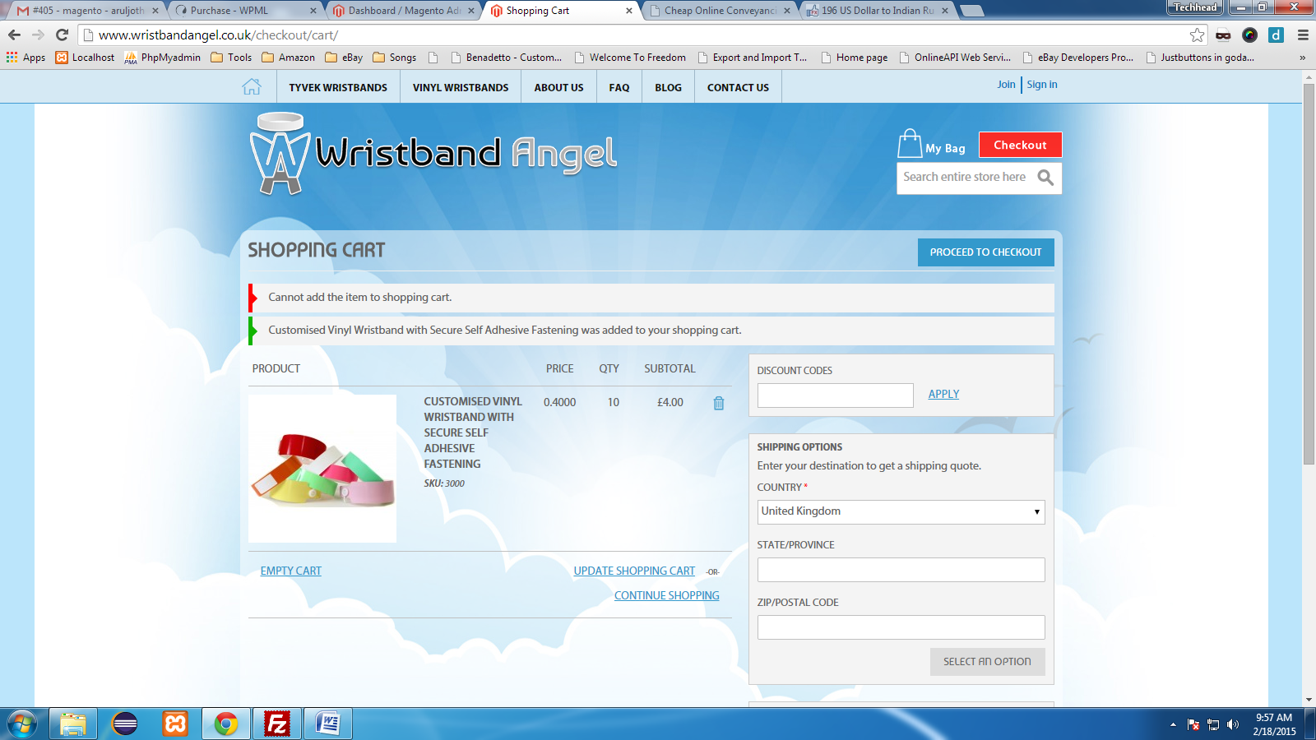

3. when we addd orders for multiples of the same custom band (eg 15mm tyvek, 2 orders with

difffereent text) it rolls them into one item, rather than listing them as 2 seperate ones in the

checkout.  we need it so people can order multiple versions of the custom bands and they will each

show as a seperate product in the checkout and in Magento admin**(its major issue in website here old development code entirely wrong we need to change each and every code for this ,Here product list ,price,price in total,quantity are wrong we need to correct all) see below code they did eveything in static**

If you want add new colors to the custom band in feature-

<http://www.wristbandangel.co.uk/wristbanddesigner/index/designtools/product/109/>

<?php

if($wristband_design_type == 'tyvek') {?> <li data-hex="#ffffff" title = "White"><div class="swatch"></div></li>

<li data-hex="#4edcca" title = "Aqua"><div class="swatch"></div></li> <li data-hex="#f9a01b" title = "Neon Orange"><div class="swatch"></div></li> <li data-hex="#e51937" title = "Red"><div class="swatch"></div></li> <li data-hex="#0083cb" title = "Neon Blue"><div class="swatch"></div></li> <li data-hex="#7ac142" title = "Neon Green"><div class="swatch"></div></li>

<li data-hex="#00573d" title = "Dark Green"><div class="swatch"></div></li> <li data-hex="#e0e612" title = "Neon Yellow"><div class="swatch"></div></li> <li data-hex="#d10084" title = "Neon Pink"><div class="swatch"></div></li> <li data-hex="#ffff00" title = "Yellow"><div class="swatch"></div></li> <li data-hex="#5b4099" title = "Purple"><div class="swatch"></div></li>

<li data-hex="#a8a9ad" title = "Silver Metalic"><div class="swatch"></div></li>

<li data-hex="#a39161" title = "Gold Metalic"><div class="swatch"></div></li>

<?php

}else{

?>

<li data-hex="#f9a01b" title = "Orange"><div class="swatch"></div></li>

<li data-hex="#ffffff" title = "White"><div class="swatch"></div></li>

<li data-hex="#fff200" title = "Yellow"><div class="swatch"></div></li>

<?php if($wristband_size == 'sv19mm' || $wristband_size == 'sv29mm'){ ?>

<li data-hex="#7ac142" title = "Neon Green"><div class="swatch"></div></li>

<?php } else{ ?>

<li data-hex="#7ac142" title = "Green"><div class="swatch"></div></li>

<?php } ?>

<li data-hex="#ef80b3" title = "Neon Pink"><div class="swatch"></div></li>

<?php if($wristband_size == 'sv19mm' || $wristband_size == 'sv29mm'){} else{ ?>

<li data-hex="#b6dba4" title = "Lime"><div class="swatch"></div></li>

<?php } ?>

<li data-hex="#e51937" title = "Red"><div class="swatch"></div></li>

<!--<li data-hex="#ef80b3" title = "pink"><div class="swatch"></div></li>-->

<?php } ?>

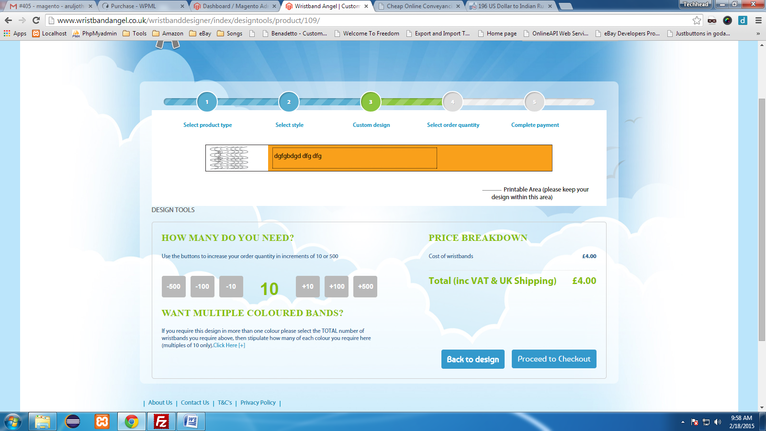

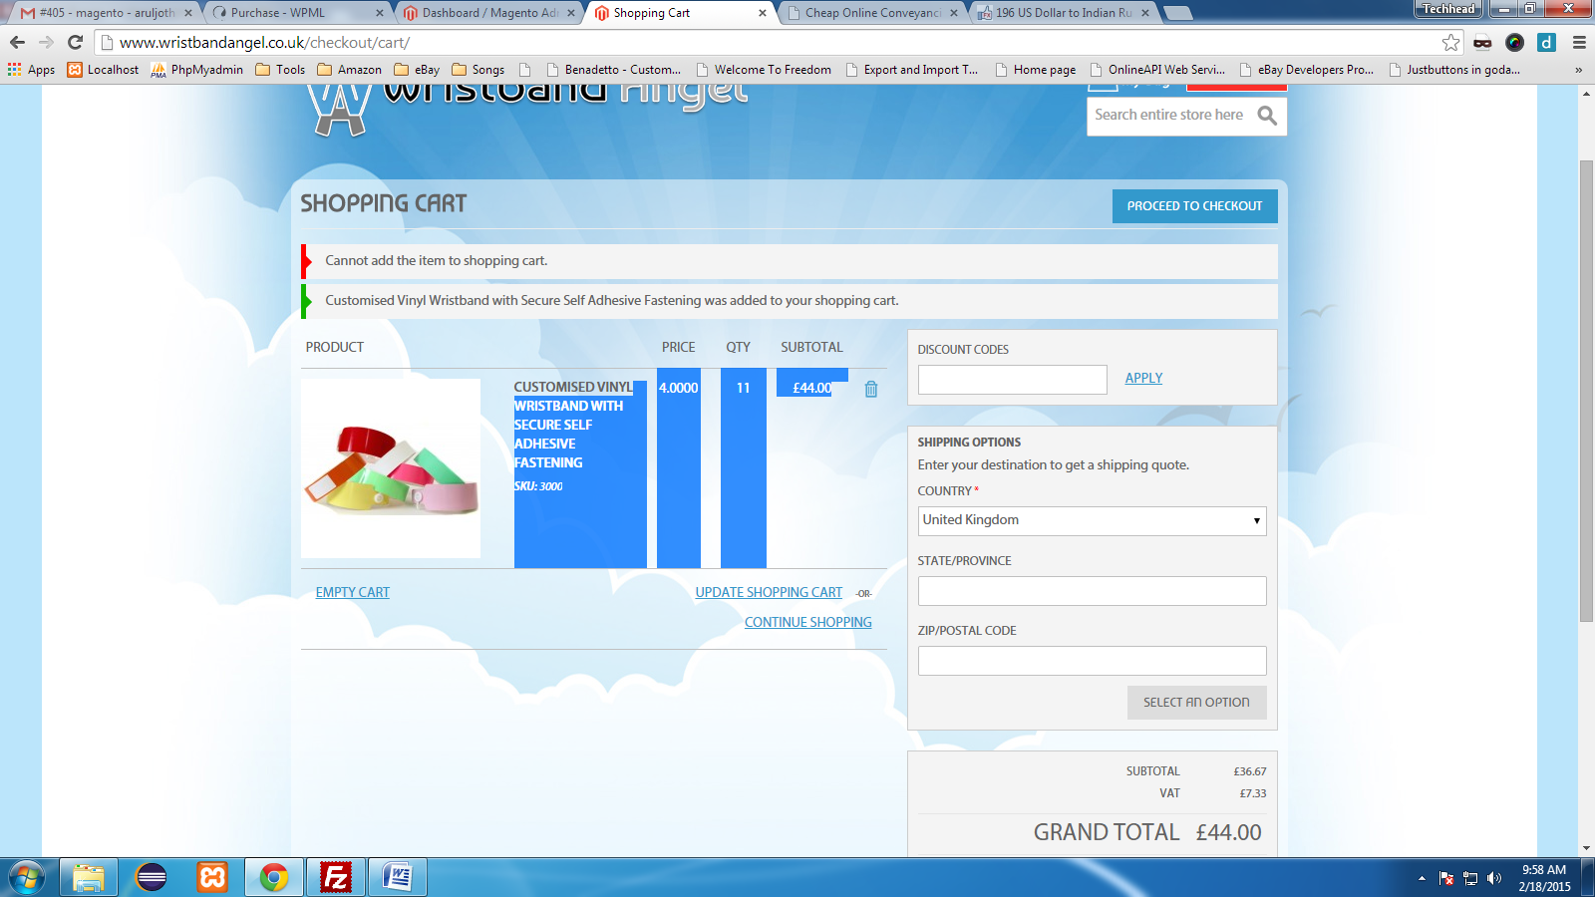

**We need 8 days time to complete point 3**

4. In the checkout we need each listed item to be clickable and show the design they created with a

breakdown of the details (eg, line one text, font etc**)(explain this is we need to need to disply products in checkout)**

5.incorporate an image of the band and info about the text and fonts used on the order confirmation

which is sent out by magento**.--- 2 days**

**Problem in Administrator:**

1.We cannot able to add any new in admin as custom product because they used in coding only one single product ID so it work only for that product only

2.In admin there is no option for changing custom product colors,font etc because all are in static custom code for particular product only

3.When we correct custom product issue(point number 4) we need to make this option also in admin we need to provide all product option within single order---2 days

**Note:**

**In admin if we want the following option we need to develop new code---it take more than 20 days**

1.We cannot able to add any new in admin as custom product because they used in coding only one single product ID so it work only for that product only

2.In admin there is no option for changing custom product colors,font etc because all are in static custom code for particular product only

**Remaining corrections are we can modify existing code**

**Note:All work we can able to done after completing point 3**