**This document refers to the problems of the section 2a (additional tasks) and to some general problems which came up / were noticed in combination with section 2a.**

**Date: 16.04.2015**

**Section 2a Problems / Notes:**

**1)** After approving a craftsman they are automatically in the category "CarpenterA"

So we assume that you chose that as default category. Is it possible to make a

uncategorized category that's not shown in the front end. (As you mentioned in the additional task document). So the craftsman can choose a category after he is logged in in the "Edit My Profile" section.

*Note: When we try to change the category in the "Edit My Profile" section, it does*

*not work in the front end. The craftsman is still in the same category as before.*

*We think it is part of Ref. No. 2b – Right!?*

**2)** After approving a premium account we note that the Menu in the front end

(Craftsman Detail Page) is in the wrong order.

Correct would be --> CompanyName, Our Company, References, Images, Contact

*We noted the problem by creating a craftsman with direct payment for one year.*

*http://bo.stallioni.com/suchlokal/rubnerpremiumone/*

*Please check if thats also a problem in other cases. Sometimes it seems to work.*

**3)** We can't see the craftsman information which we entered in the

registration after approving a craftsman in the back end. For example country, province etc...

http://bo.stallioni.com/suchlokal/rubnerfree/

*Sometimes it seems to work - we did not noticed in which cases....*

**4)** When we try to create a new craftsman with the type --> NO ACCOUNT

in the "Create User management" section it seems like the detail page gets not created.

**5)** When we unapprove a craftsman he should not show up anymore in the front end.

Move him back to the uncategorized category. And when we delete the user

delete it's hub. (Detail Page's + Informations)

**General Problems / Notes:**

**Subcategory List:**

**1)** If no province for a craftsman is give do not show the province section in the company detail page or in the subcategories list. Just hide that point.

At the moment you show: Province: **no**

Example:

<http://bo.stallioni.com/suchlokal/rubnerpremiumonepaypal/>

This point is a problem in the **subcategory list** and in the **craftsman detail page**

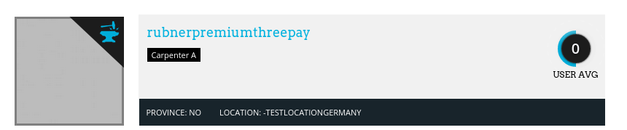

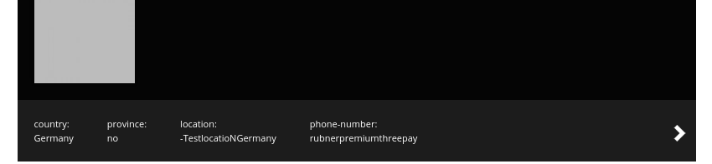

**2)** Please hide the rating in the subcategory section if there are 0 votes.

That's the case for example after aproving a craftsman.

**My Company Section:**

**1)** Can you please create 2-3 craftsman of type no account so that we can test

the my company functionality? Because of (**Section 2a Problems / Notes: Point 4)**

*Note that in the "Registered Via MyCompany" section we must be able to see the*

*informations before the user clicked on registration in compareation to the informations*

*after the user clicked on registration.*

**Craftsman Detail Page:**

**1)** We told you that if the user enters a Location you should show that beside the District. So for example: "Coimbatore - NameOfLocatioN" When only a Location exists an no District do not show the "-" in front of the location name.

Link: http://bo.stallioni.com/suchlokal/rubnerpremiumthreepay/



**Login:**

**1)** If the user enters a non valid username / password. Don't show the 404 Page. Just verify and show the user an error in the login box.

**Craftsman – (Free / Premium One Year / Premium Three Years):**

**1)** It should be possible for the registered user to upgrade from a free account to a premium account. And from a premium account to a free account or to change from one year subscription to three year subscription.

So when they click again on the “For Craftsman” Button in the front end end choose another package the must have the possibility to upgrade / downgrade.

**Registration:**

**1)** When a user made an error in typing the 'password' or 'confirm password' section you show the message --> “Your Password not match” - thats ok.

When the user corrects the error first in the 'confirm password' and then in the password section you show the message that the password does not match (but it does). So hide this message in that specific case.

**2)** In the "Email Address" section you should only check if the email address is valid. At the moment it seems like it's not possible to store the same email address for 2 different companies.

**3)** When the user entered an invalid mail address you hide the "Continue" Button. **Never** hide that button. When the user clicks on the button show him the error message.

**4)** Please check in the "Company Name" section if the entered company name is already registered. If so show the user a warning/note. Example:

---

"CompanyName" - This company is already registered. If it's yours continue over the My Company button. - CompanyName (with Link)

---

**!IMPORTANT!**

It should be possible to continue the registration even if that error occurs. Because sometimes it may happen that some companies have the same name. So this should be a Warning/Note to the user not an error.

**5)** Is is possible to show the user that something is loading after clicking on registration / direct payment etc? Sometimes the connection is very bad so the user might think at that important point that something went wrong...

**Admin Back End:**

**1)** After a user registered, the Admin must be able to see all the informations. All these informations should be seen in the Admin back end when we click on a specific user. the same list as in the Admin back end in "Users registered via my company" should be fine. **(+ Possibility to edit Informations if needed)**