Name: Suryawanshi Sai Dhananjay

Class: MCA-I Sem-II

PRN: 2421100252

Roll No: 55

**Assignment No: 01**

**01.Admission Form**

<!DOCTYPE html>

<html lang="en">

<head>

<meta charset="UTF-8">

<meta name="viewport" content="width=device-width, initial-scale=1.0">

<title>Document</title>

</head>

<body>

<img src="C:\Users\Admin\Desktop\suhani\image2" width="130" height="130" align="left">

<img src="C:\Users\Admin\Desktop\suhani\image2" width="130" height="130" align="right">

<center>

<h1>Bharati Vidyapeeth Demeed To Be University Pune</h1>

<h2>Yashwantrao Mohite Institute Of Management Karad, Malkapur</h2><br>

<hr>

<a href="file:///C:/Users/Admin/Desktop/A.WST/cet.html" target="_blank">

<img src="C:\Users\Admin\Documents\Utkarsha chavan html\ymimk" width="700" height="500">

</a>

</center>

</body>

</html>

**Output**

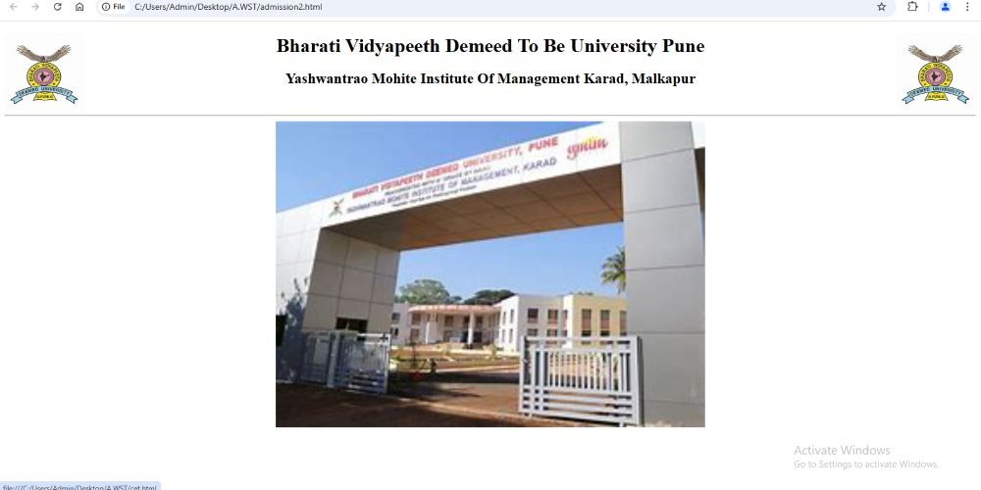

**02.Cet Form**

<!DOCTYPE html>

<html>

<head>

<title>CET FORM</title>

<style>

.bvdu{

display:flex;

justify-content:left;

align-items:left;

margin:0 0 50px 0;

height:150px;

}

h2{

text-align:center;

font-size:50px;

}

.ymim{

display:flex;

justify-content:right;

align-items:right;

margin:0 0 50px 0;

height:150px;

}

table{

text-align:center;

font-size:40px;

}

</style>

</head>

<body>

<center>

<div class="bvdu">

<img src="C:\Users\Admin\Desktop\suhani\imageslogo.jpeg">

<span><h2>Bharati Vidyapeeth <br>Yashwantrao Mohite Institute Of Management Karad</h2></span>

<div class="ymim">

<img src="C:\Users\Admin\Desktop\suhani\imageslogo.jpeg">

</div>

</div>

<hr>

<br>

<table border="1">

<tr>

<th>Course</th>

<th>Date of Entrance</th>

<th>CET Fees</th>

</tr>

<tr>

<td>MCA</td>

<td>12/7/2025</td>

<td>2500</td>

</tr>

<tr>

<td>BCA</td>

<td>12/7/2025</td>

<td>2500</td>

</tr>

<tr>

<td>MBA</td>

<td>12/7/2025</td>

<td>2500</td>

</tr>

<tr>

<td>BBA</td>

<td>12/7/2025</td>

<td>2500</td>

</tr>

</center>

</body>

</html>

**Output**

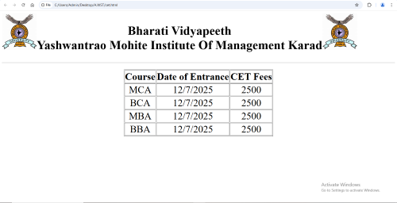

Name: Suryawanshi Sai Dhananjay

Class: MCA-I Sem-II

PRN: 2421100252

Roll No: 55

**Assignment No:02**

**01.Frameset cols**

<!DOCTYPE html>

<html lang="en">

<head>

<meta charset="UTF-8">

<meta name="viewport" content="width=device-width, initial-scale=1.0">

<title>Document</title>

</head>

<frameset cols="20%,50%,25%">

<frame src="https://www.javatpoint.com/html-tutorial">

<frame src="https://www.javatpoint.com/html-with-css">

<frame src="https://www.javatpoint.com/javascript-tutorial">

</frameset>

**</html>**

**Output**

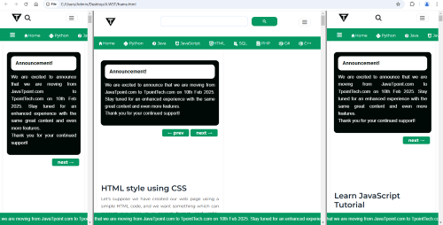

**02.Frameset rows**

<!DOCTYPE html>

<html lang="en">

<head>

<meta charset="UTF-8">

<meta name="viewport" content="width=device-width, initial-scale=1.0">

<title>Document</title>

</head>

<frameset rows="20%,50%,25%">

<frame src="https://www.javatpoint.com/html-tutorial">

<frame src="https://www.javatpoint.com/html-with-css">

<frame src="https://www.javatpoint.com/javascript-tutorial">

</frameset>

</html>

**Output**

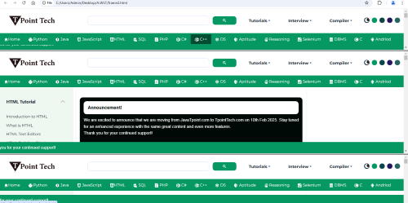

Name: Suryawanshi Sai Dhananjay

Class: MCA-I Sem-II

PRN: 2421100252

Roll No: 55

**Assignment No:03**

**01.List**

<!DOCTYPE html>

<html lang="en">

<head>

<meta charset="UTF-8">

<meta name="viewport" content="width=device-width, initial-scale=1.0">

<title>Document</title>

</head>

<body>

<center><h1><u>MCA PROGRAMES</u></h1></center>

<hr color="lightgreen" size="3">

<h2>Web Supporting Technologies:</h2>

<ol>

<li>Baiscs of internet</li><br>

<ul style="color:blueviolet">

<li>internet and intranet</li>

<li>introduction to www</li>

<li>client and server</li>

</ul><br>

<li>Introduction to HTML</li><br>

<ul style="color:blueviolet">

<li>concepts of tags</li>

<li>structure of HTML</li>

<li>text formating</li>

</ul><br>

<li>Cascading Style Sheets</li><br>

<ul style="color:blueviolet">

<li>introduction to css</li>

<li>types of styles sheet</li>

<li>css properties</li>

</ul><br>

</ol>

<hr color="lightgreen" size="3">

<h2>Data Warehousing and Data Minning:</h2>

<ol>

<li>Bussiness Intelligence</li><br>

<ul style="color:blueviolet">

<li>Bussiness Environment</li>

<li>Decision Support System</li>

<li>Decision Making</li>

</ul><br>

<li>Data Warehousing</li><br>

<ul style="color:blueviolet">

<li>OLTP and OLAP</li>

<li>introduction to Data warehouse</li>

<li>Data Marts</li>

</ul><br>

</ol>

<hr color="lightgreen" width="100%" size="3" >

<dl>

<dt>Introduction to internet:</dt><br>

<dd style="color:blueviolet">The Internet is a global network that connects millions of computers and devices worldwide, enabling them to communicate and share information. It uses the Internet Protocol Suite (TCP/IP) to ensure reliable data transmission across diverse devices and locations</dd>

</dl>

</body>

</html>

**Output**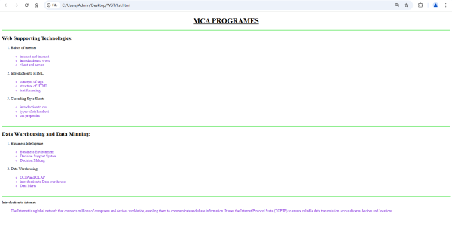

Name: Suryawanshi Sai Dhananjay

Class: MCA-I Sem-II

PRN: 2421100252

Roll No: 55

**Assignment No:04**

**01.Audio and Video**

<!DOCTYPE html>

<html lang="en">

<head>

<meta charset="UTF-8">

<meta name="viewport" content="width=device-width, initial-scale=1.0">

<title>Document</title>

</head>

<center>

<body style="background-color: aqua;" >

<img src="C:\Users\Admin\Desktop\suhani\image2" width="100" align="left" >

<img src="C:\Users\Admin\Desktop\suhani\image2" width="100" align="right">

<h1>Bharati Vidyapeeth<br>Yashwantrao Mohite Institute Of Management Karad</h1>

<br>

<hr>

<h1>The Audio Element</h1>

<audio controls>

<source src="https://gaana.com/song/blue-3007" type="">

Your browser does not support the audio element.

</audio>

<h1>The video element</h1>

<video width="320" height="240" controls>

<source src="http://media.geeksforgeeks.org/wp-content/uploads/20190616234019/Canvas.move_.mp4" type="">

sample video

</video>

</body>

</center>

</html>

**Output**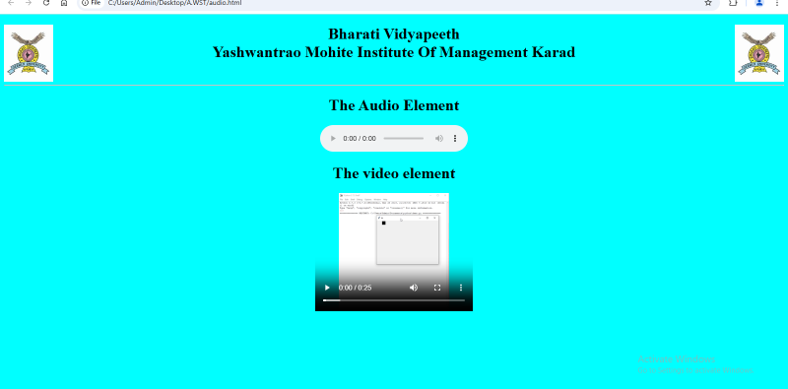

Name: Suryawanshi Sai Dhananjay

Class: MCA-I Sem-II

PRN: 2421100252

Roll No: 55

**Assignment No:05**

**1.Time Table**

<!Doctype>

<html>

<head>

<title>Time table</title>

<style>

body{

background-color:lightgrey

}

h2{

text-align:center;

color:red

}

h3{

text-align:center;

color:green

}

table{

text-align:center;

}

th{

background-color:lightSalmon

}

td{

background-color:lightPink

}

</style>

</head>

<body>

<h2>BHARATI VIDYAPEETH TO BE UNIVERSITY,PUNE<br>

YASHWANTRAO MOHITE INSTITUTE OF MANAGEMENT KARAD<h2>

<h3>ACADEMIC YEAR 2024-25<br> MCA-I SEM-II(2024-25)</h3>

<hr>

<h3 style="color:red">Time Table<h3>

<center>

<table border=1>

<tr>

<th></th>

<th>MON</th>

<th>TUE</th>

<th>WED</th>

<th>THU</th>

<th>FRI</th>

<th>SAT</th>

<th>Lecture hall/Lab</th>

</tr>

<tr>

<td>10:30-11:30PM</td>

<td>CC<br>[ppp]</td>

<td>CC<br>[ppp]</td>

<td>CC<br>[ppp]</td>

<td>PYTHON<br>[AS]</td>

<td>PYTHON<br>[AS]</td>

<td>PYTHON<br>[AS]</td>

<td>Multi</td>

</tr>

<tr>

<td>11:30-12:30PM</td>

<td>PYTHON-Lab<br>[AS]</td>

<td>PYTHON-Lab<br>[AS]</td>

<td>PYTHON-Lab<br>[AS]</td>

<td>WST Lab<br>[AAP]</td>

<td>WST Lab<br>[AAP]</td>

<td>WST Lab<br>[AAP]</td>

<td>Lab-3</td>

</tr>

<tr>

<td>12:30-1:30PM</td>

<td>WST<br>[AJ]</td>

<td>WST<br>[AJ]</td>

<td>WST<br>[AJ]</td>

<td>OOSE<br>[PRR]</td>

<td>OOSE<br>[PRR]</td>

<td>OOSE<br>[PRR]</td>

<td>Lab-3</td>

</tr>

<tr>

<td>1:30-2:00PM</td>

<th colspan="7">BREAK</th>

</tr>

<tr>

<td>2:00-3:00</td>

<td>DWDM<br>[SVD]</td>

<td>DWDM<br>[SVD]</td>

<td>DWDM<br>[SVD]</td>

<td>DT<br>[PRR]</td>

<td>DT<br>[PRR]</td>

<td>DWDM<br>[SVD]</td>

<td>Lab-3</td>

</tr>

</table>

<br>

<table border=1>

<tr>

<th>SR.NO</th>

<th></th>

<th>Subject Name</th>

<th>Faculty Name</th>

</tr>

<tr>

<td>201</td>

<td><a href="C:\Users\Admin\Desktop\Notes\OOSE.pdf">OOSE</a></td>

<td>Object Oriented Software Engineering</td>

<td>Prof.P.R.Rasal</td>

</tr>

<tr>

<td>202</td>

<td><a href="C:\Users\Admin\Desktop\Notes\CC.pdf">CC</td>

<td>Cloud Computing Concepts</td>

<td>Dr.P.P.Patil<br><b>Class Coordinator</b></td>

</tr>

<tr>

<td>203</td>

<td><a href="C:\Users\Admin\Desktop\Notes\PYTHON.pdf">DS</td>

<td>Data Structure using Python</td>

<td>Mrs.Ashwini Sarate</td>

</tr>

<tr>

<td>204</td>

<td><a href="C:\Users\Admin\Desktop\Notes\DWDM.pdf">DWDM</td>

<td>Data Warehouse and Data Minig</td>

<td>Dr.Mrs.Sheetal Deshmukh</td>

</tr>

<tr>

<td>205</td>

<td><a href="C:\Users\Admin\Desktop\Notes\WST.pdf">WST</td>

<td>Web Supporting Technologies</td>

<td>Mrs.Archana Jadhav </td>

</tr>

<tr>

<td>206</td>

<td><a href="C:\Users\Admin\Desktop\Notes\python lab.pdf">Lab on DS</td>

<td>Lab on Data Structure using Python</td>

<td>Mrs.Ashwini Sarate</td>

</tr>

<tr>

<td>207</td>

<td></td>

<td>Minor Project-I</td>

<td>Dr.P.P.Patil</td>

</tr>

<tr>

<td>208<br><hr>209</td>

<td></td>

<td>MOOCS-II*<br><br><a href="C:\Users\Admin\Desktop\Notes\Digiital

Technology.pdf">Open Courde-II**-Digital <br>Technology</td>

<td>Dr.P.P.Patil<hr>Prof.P.R.Rasal</td>

</tr>

</table>

</center>

</body>

</html>

**Output**

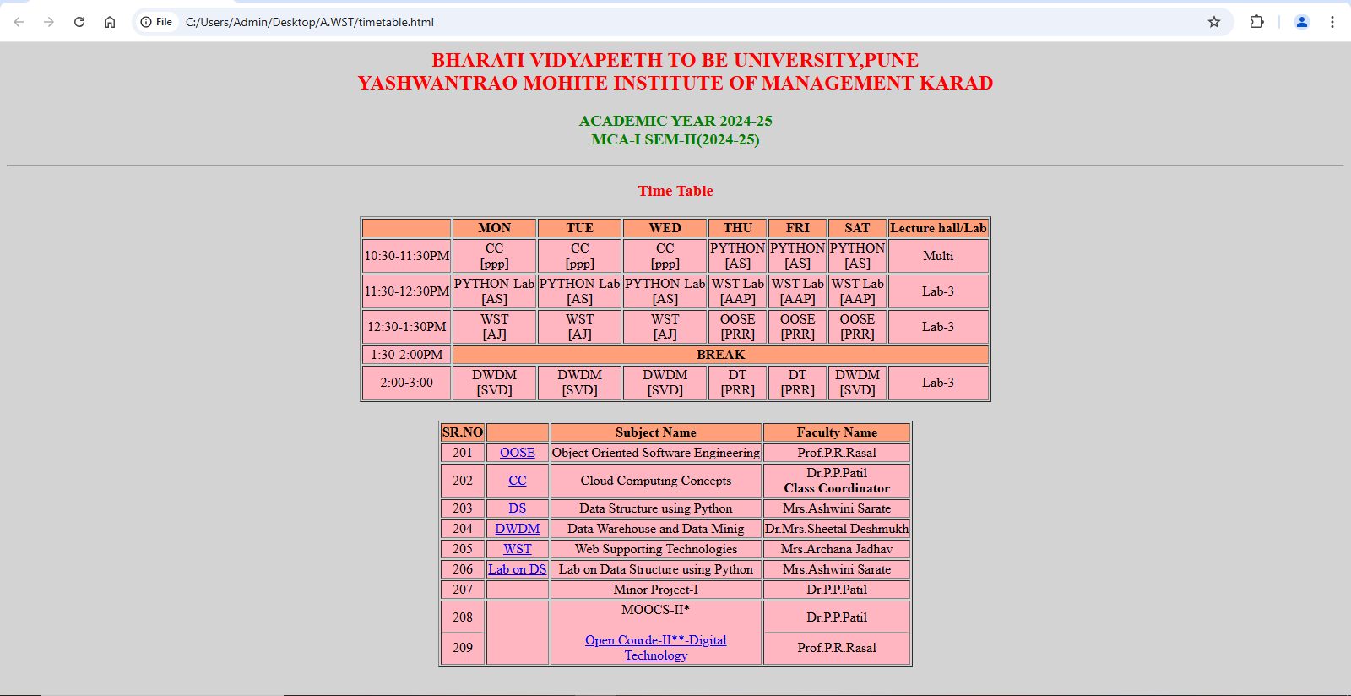

Name: Suryawanshi Sai Dhananjay

Class: MCA-I Sem-II

PRN: 2421100252

Roll No: 55

**Assignment No:06**

**01.Registration Form**

<!DOCTYPE html>

<html lang="en">

<head>

<meta charset="UTF-8">

<meta name="viewport" content="width=device-width, initial-scale=1.0">

<title>Document</title>

</head>

<body>

<div style="width: 90%; margin: auto; padding: 50px; border: 1px solid black; border-radius: 10px; background-color: pink;">

<h1 style="text-align: center;">Yashwantrao Mohite Institute of Management karad</h1>

<h2 style="text-align: center;">Student Registration Form</h2>

<form action="#" method="post">

<label for="fname">First Name:</label>

<input type="text" id="fname" name="fname" required>

(required)<br><br>

<label for="mname">Middle Name:</label>

<input type="text" id="mname" name="mname" required>

(required)<br><br>

<label for="lname">Last Name:</label>

<input type="text" id="lname" name="lname" required>

(required)<br><br>

<label for="mothername">Mother's Name:</label>

<input type="text" id="mothername" name="mothername" required>

(required)<br><br>

<label>Gender:</label>

<input type="radio" name="Gender" value="male">Male

<input type="radio" name="Gender" value="female">Female

<input type="radio" name="Gender" value="other">Other<br><br>

<label for="dob">Date Of Birth:</label>

<input type="date" id="dob" name="dob"><br><br>

<label for="address">Address:</label>

<textarea id="address" name="address" rows="3" cols="30"></textarea><br><br>

<label for="mobile">Mobile No:</label>

<input type="text" id="mobile" name="mobile"><br><br>

<label for="email">Email Address:</label>

<input type="email" id="email" name="email"><br><br>

<label>Department:</label>

<select name="department">

<option value="">Select</option>

<option value="managment">Management</option>

<option value="computer">Computer</option>

</select><br><br>

<label>Courses:</label>

<select name="course">

<option value="">Select</option>

<option value="bba">BBA</option>

<option value="mba">MBA</option>

<option value="bca">BCA</option>

<option value="mca">MCA</option>

</select><br><br>

<label>Subjects:</label>

<select name="subject">

<option value="">Select</option>

<option value="math">Math</option>

<option value="management">Management</option>

<option value="c programming">C Programming</option>

<option value="python programming">Python Programming</option>

<option value="oose">OOSE</option>

<option value="cloud computing">Cloud Computing</option>

<option value="finance">Finance</option>

<option value="marketing">Marketing</option>

<option value="hr management">HR Management</option>

</select><br><br>

<button type="Submit">Submit</button>

<button type="reset">Reset</button>

<button type="exit">Exit</button>

</form>

</div>

</body>

</html>

**Output**

