**Output: (Routing and forwarding table)**

**Steps:**

1. Enter source node (For a=0, b=1, c=2, d=3):

**Put source: 0 (for a=0)**

1. It shows the shortest path from source node ‘a’ to all other nodes and total cost of the shortest path.
2. Then routing and forwarding table are created (Internal Implementation)
3. To show the shortest path from source to any destination,

**Put destination: 3 (for d=3)**

1. It shows the routing and forwarding table (both are merged) including following values:
   * 1. Source Node
     2. Interface
     3. Next Hope
     4. Cost
2. Final statement includes: shortest path from source to destination, representation of nodes and interfaces,

Here shortest path from A – D is -> a 1 b 1 c 1 d and cost: 6

* 1. **For path a – d**

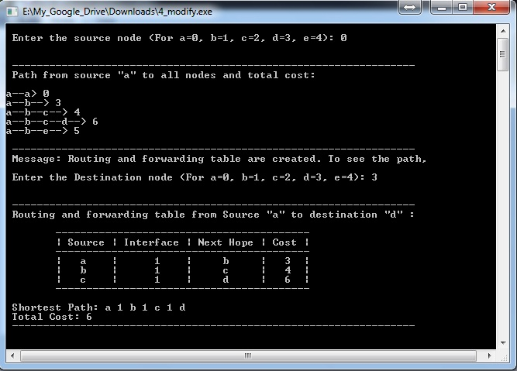

* 1. **For path a – e**

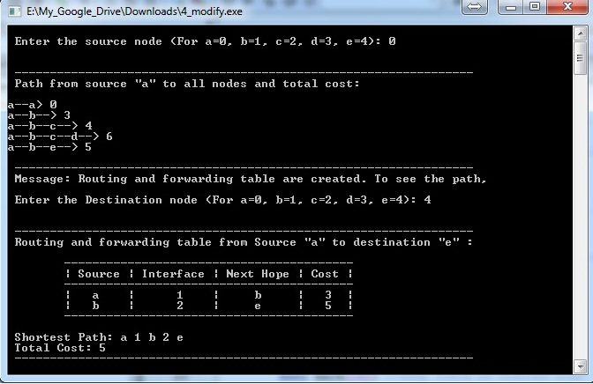

* 1. **For path a - b**

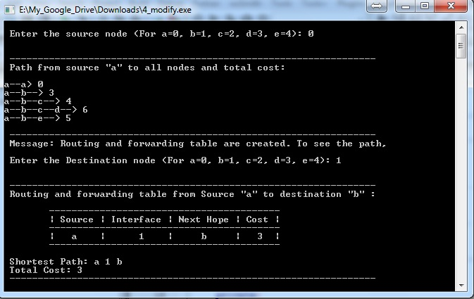

* 1. **For path a – c**

