**Screenshot of programs running**

1. **For 10 KB file (File name: file10KB.txt)**

**command line:** ./client trig.sci.csueastbay.edu 50123 10000

Hostname: trig.sci.csueastbay.edu

Port number: 50123

File size: 10000

* **Sending first packet of length 1000, Seq. No. 1**

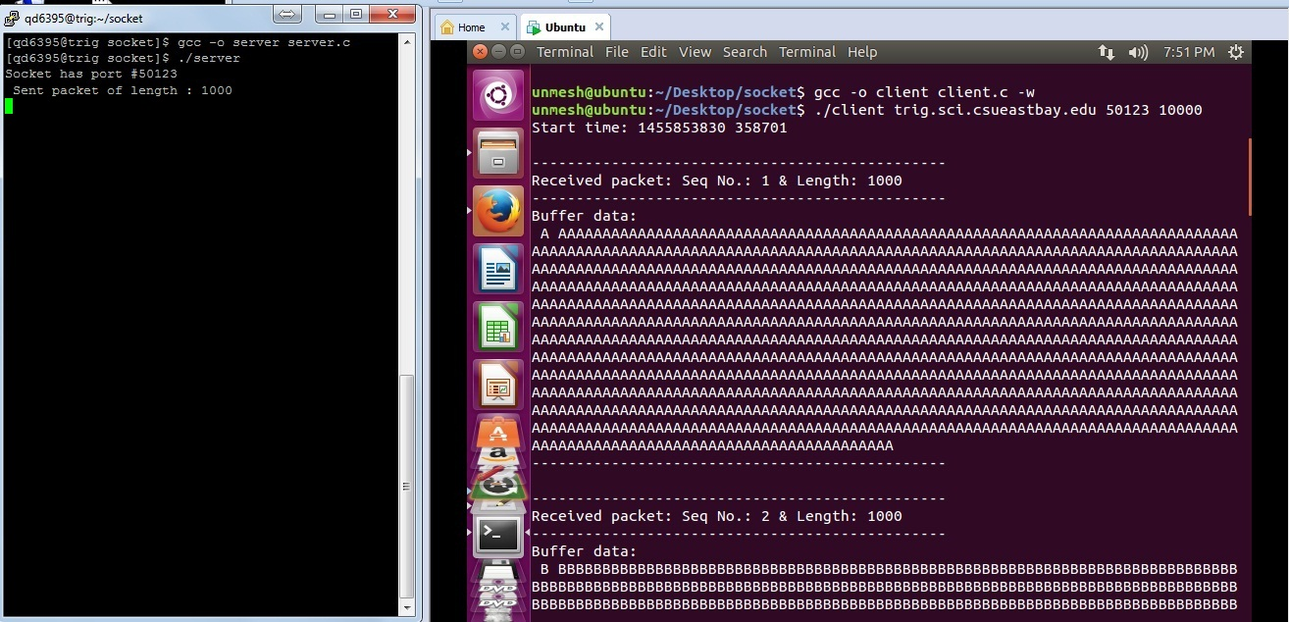

* **Sending last packet of length 1000, Seq. No. 10**

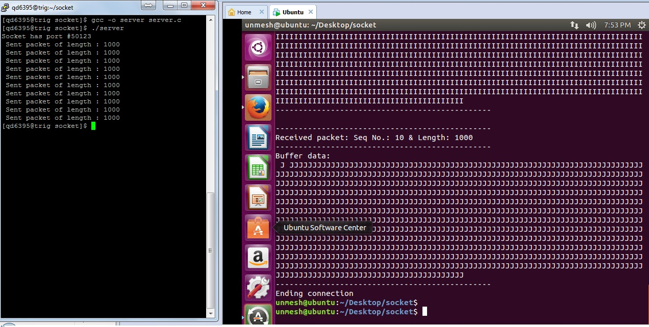

1. **For 20 KB file (File name: file20KB.txt)**

**command line:** ./client trig.sci.csueastbay.edu 50123 20000

Hostname: trig.sci.csueastbay.edu

Port number: 50123

File size: 20000

* **Sending first packet of length 1000, Seq. No. 1**

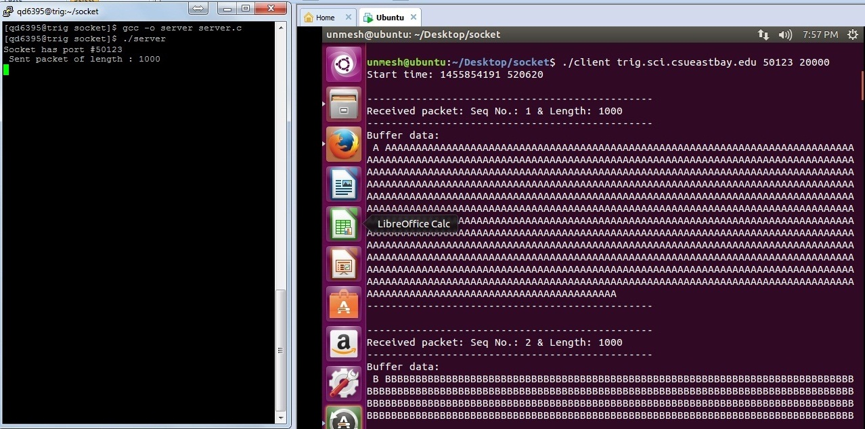

* **Sending last packet of length 1000, Seq. No. 20**

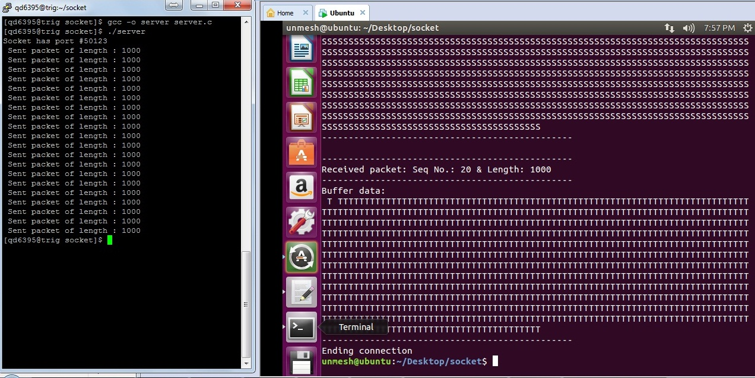

1. **For 30 KB file (File name: file30KB.txt)**

**command line:** ./client trig.sci.csueastbay.edu 50123 30000

Hostname: trig.sci.csueastbay.edu

Port number: 50123

File size: 30000

* **Sending first packet of length 1000, Seq. No. 1**

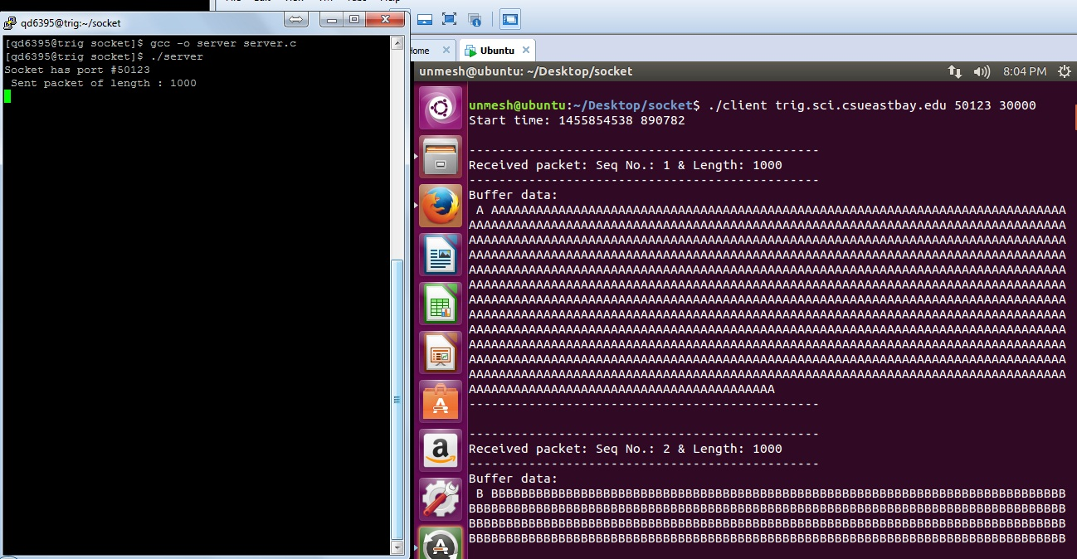

* **Sending last packet of length 1000, Seq. No. 30**

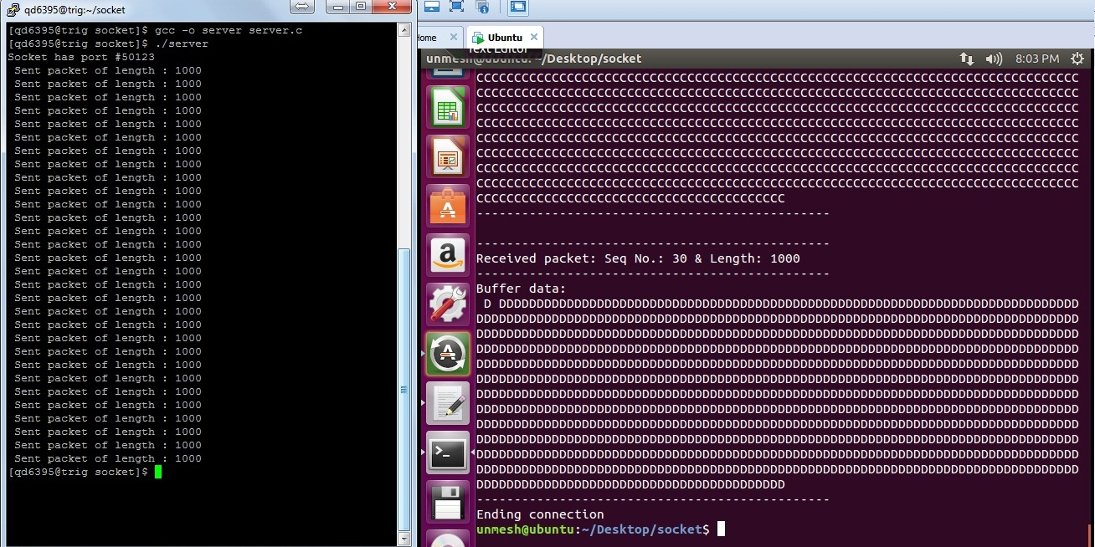

1. **For 40 KB file (File name: file40KB.txt)**

**command line:** ./client trig.sci.csueastbay.edu 50123 40000

Hostname: trig.sci.csueastbay.edu

Port number: 50123

File size: 40000

* **Sending first packet of length 1000, Seq. No. 1**

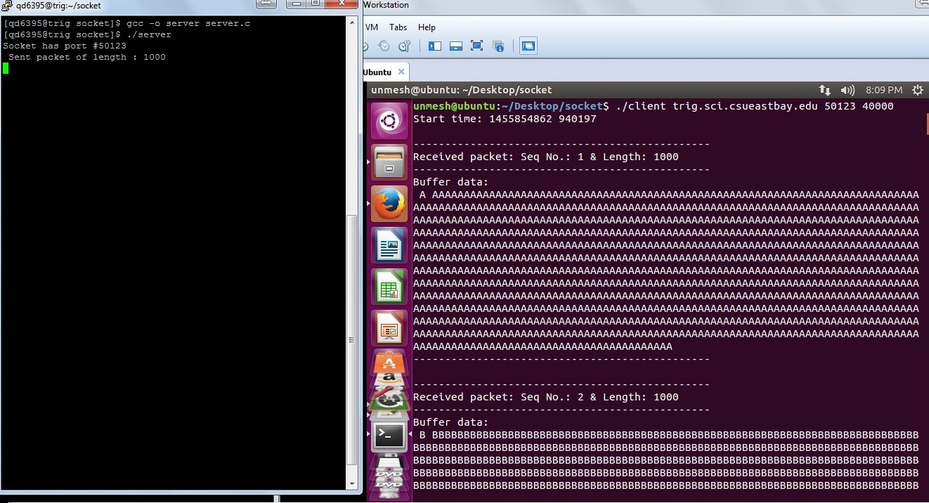

* **Sending last packet of length 1000, Seq. No. 40**

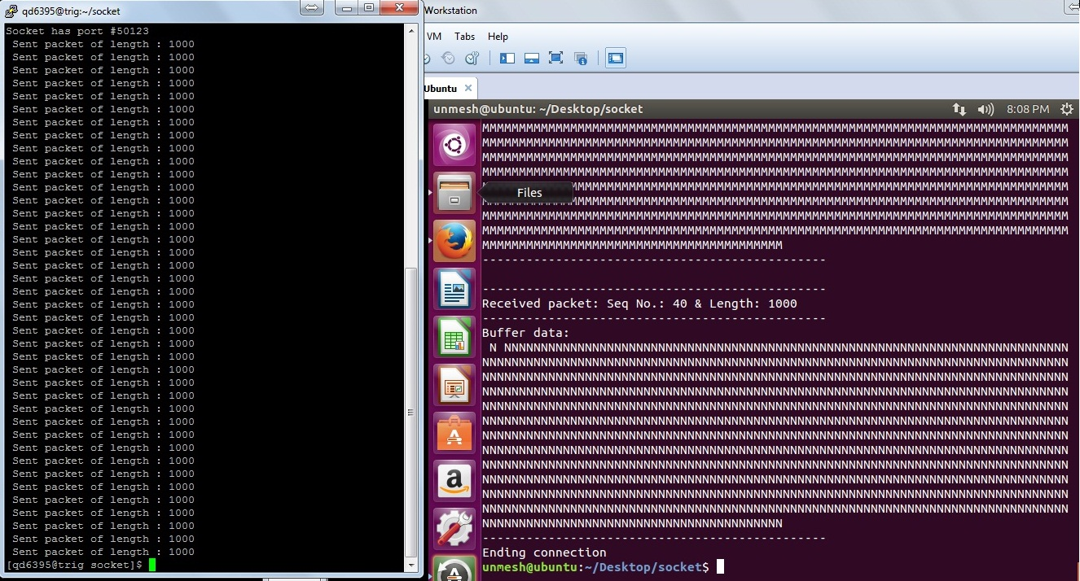

1. **For 50 KB file (File name: file50KB.txt)**

**command line:** ./client trig.sci.csueastbay.edu 50123 50000

Hostname: trig.sci.csueastbay.edu

Port number: 50123

File size: 50000

* **Sending first packet of length 1000, Seq. No. 1**

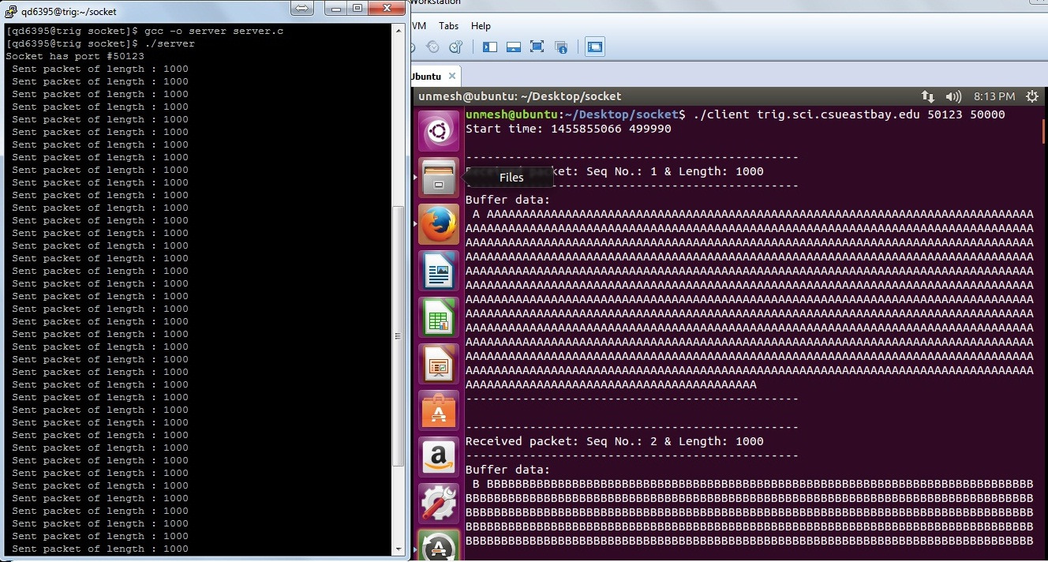

* **Sending last packet of length 1000, Seq. No. 50**

