**Assignment No.: 3 – Web browser application**

**Name: Unmesh Suryawanshi, Net id: qd6395**

* **Screenshot of program following a web page request and following a link:**

1. **Providing input (URL):**

<http://www.mcs.csueastbay.edu/~leann/Pgm3/start.html>

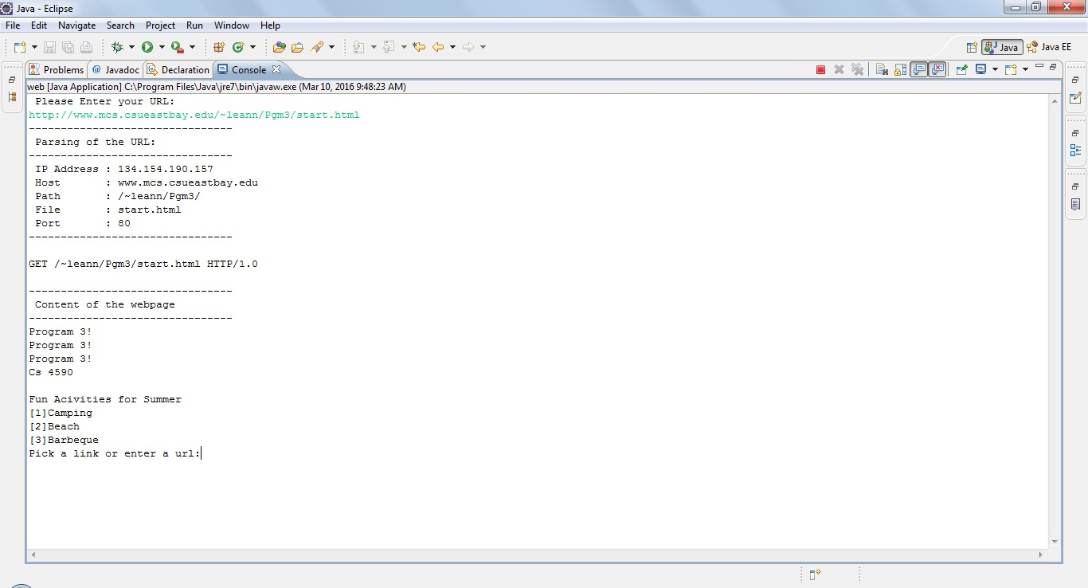

1. **Open Web page [1] Camping from Homepage and Web page [2] Beach from web page Camping**

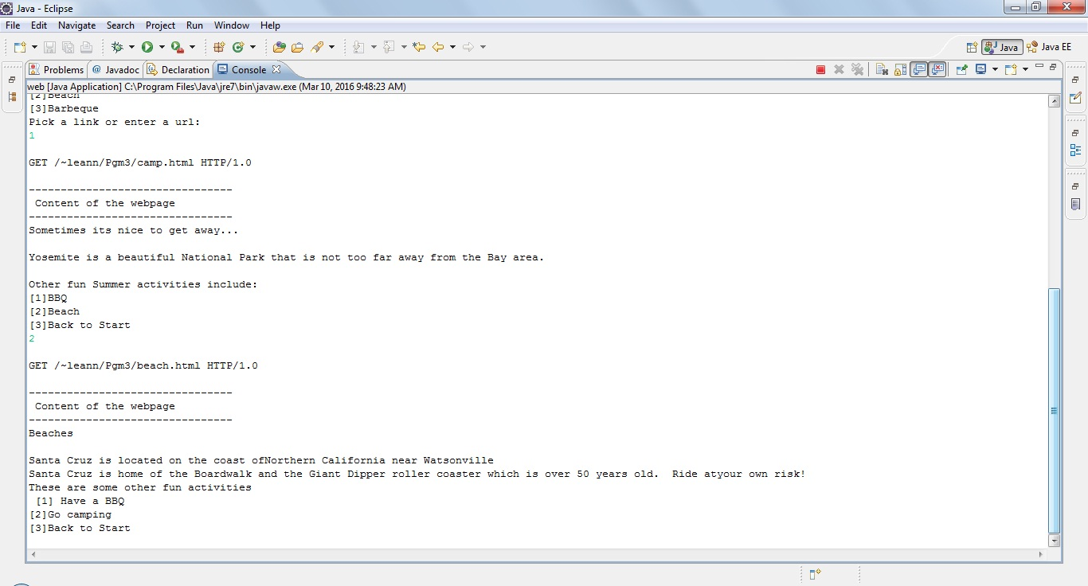

1. **Open Web page [1] Have a BBQ from web page Beach and again going back to home page from web page Have a BBQ**

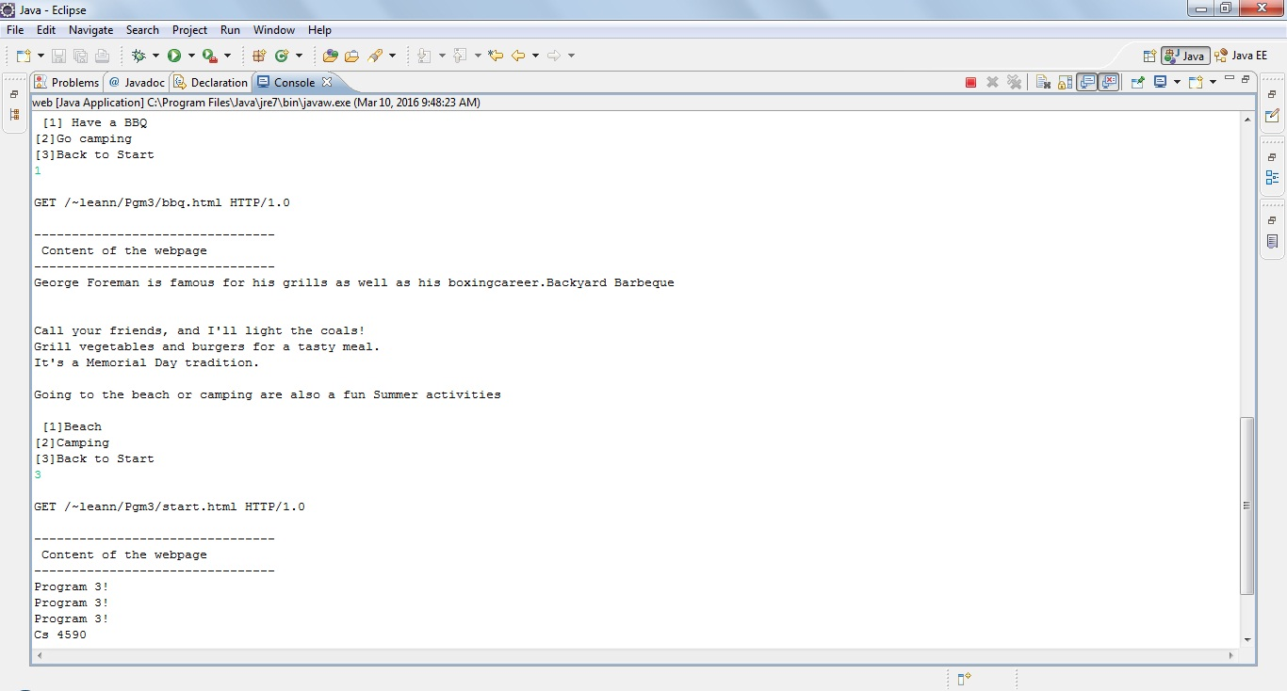

1. **Open Web page [2] Beach from home page**

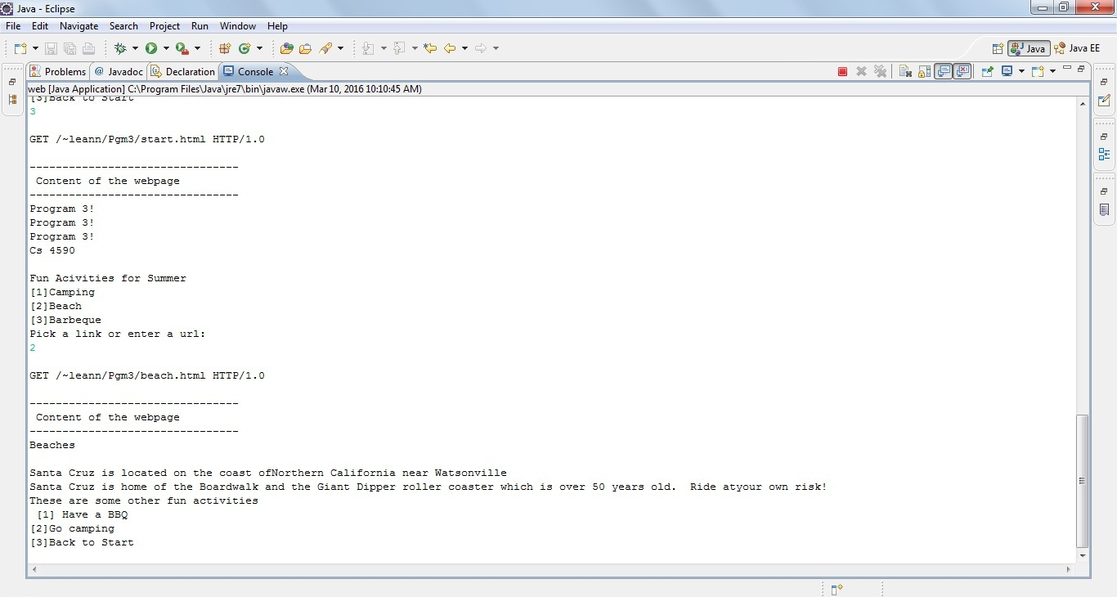

1. **Open Web page [3] Barbeque from home page**

**If user provided by user is wrong that is if web page is not available, then program will terminate**

