Q1)

package cc1;

import java.util.List;

import org.openqa.selenium.By;

import org.openqa.selenium.WebDriver;

import org.openqa.selenium.WebElement;

import org.openqa.selenium.chrome.ChromeDriver;

import org.openqa.selenium.chrome.ChromeOptions;

import io.github.bonigarcia.wdm.WebDriverManager;

public class q1 {

public static void main(String[] args) {

// TODO Auto-generated method stub

ChromeOptions co = new ChromeOptions();

co.addArguments("--remote-allow-origins=*");

WebDriverManager.chromedriver().setup();

WebDriver driver = new ChromeDriver();

driver.get("https://www.saucedemo.com/");

driver.manage().window().maximize();

driver.findElement(By.xpath("/html/body/div/div/div[2]/div[1]/div/div/form/div[1]/input")).sendKeys("standard_user");

driver.findElement(By.xpath("/html/body/div/div/div[2]/div[1]/div/div/form/div[2]/input")).sendKeys("secret_sauce");

driver.findElement(By.xpath("/html/body/div/div/div[2]/div[1]/div/div/form/input")).click();

driver.findElement(By.xpath("/html/body/div/div/div/div[2]/div/div/div/div[1]/div[2]/div[2]/button")).click();

String remove = driver.findElement(By.xpath("/html/body/div/div/div/div[2]/div/div/div/div[1]/div[2]/div[2]/button")).getText();

if(remove.equals("Remove"))

{

System.out.println("User is able to add product to cart");

}

else

{

System.out.println("User is not able to add product to cart");

}

driver.findElement(By.xpath("/html/body/div/div/div/div[1]/div[1]/div[3]/a")).click();

boolean presents = driver.findElement(By.xpath("/html/body/div/div/div/div[2]/div/div[1]/div[3]")).isDisplayed();

System.out.print("Contents Displayed in cart : "+presents);

driver.findElement(By.xpath("/html/body/div/div/div/div[2]/div/div[2]/button[2]")).click();

if(driver.findElement(By.xpath("/html/body/div/div/div/div[1]/div[2]/span")).getText().equals("Checkout: Your Information"))

{

System.out.println("Your Information displayed");

}

else

{

System.out.println("Your Information not displayed");

}

driver.findElement(By.xpath("/html/body/div/div/div/div[2]/div/form/div[1]/div[1]/input")).sendKeys("Surya");

driver.findElement(By.xpath("/html/body/div/div/div/div[2]/div/form/div[1]/div[2]/input")).sendKeys("y");

driver.findElement(By.xpath("/html/body/div/div/div/div[2]/div/form/div[1]/div[3]/input")).sendKeys("qwertyui");

driver.findElement(By.xpath("/html/body/div/div/div/div[2]/div/form/div[2]/input")).click();

String overview = driver.findElement(By.xpath("/html/body/div/div/div/div[1]/div[2]/span")).getText();

if(overview.equals("Checkout: Overview"))

{

System.out.println("Product overview is displayed");

}

else

{

System.out.println("Product overview is not displayed");

}

List<WebElement> items = driver.findElements(By.xpath("//div[@class=\"inventory_item_name\"]"));

List<WebElement> price = driver.findElements(By.xpath("//div[@class=\"inventory_item_price\"]"));

for(int i=0;i<items.size();i++)

{

System.out.println(items.get(i).getText()+" - "+price.get(i).getText());

}

String actualTitle = driver.getTitle();

String expectedTitle = "Swag Labs";

if(actualTitle.equals(expectedTitle))

{

System.out.println("Title matches");

}

else

{

System.out.println("Title Not matches");

}

String actualURL = driver.getCurrentUrl();

String expectedURL = "https://www.saucedemo.com/checkout-step-two.html";

if(actualURL.equals(expectedURL))

{

System.out.println("URL matches");

}

else

{

System.out.println("URL Not matches");

}

}

}

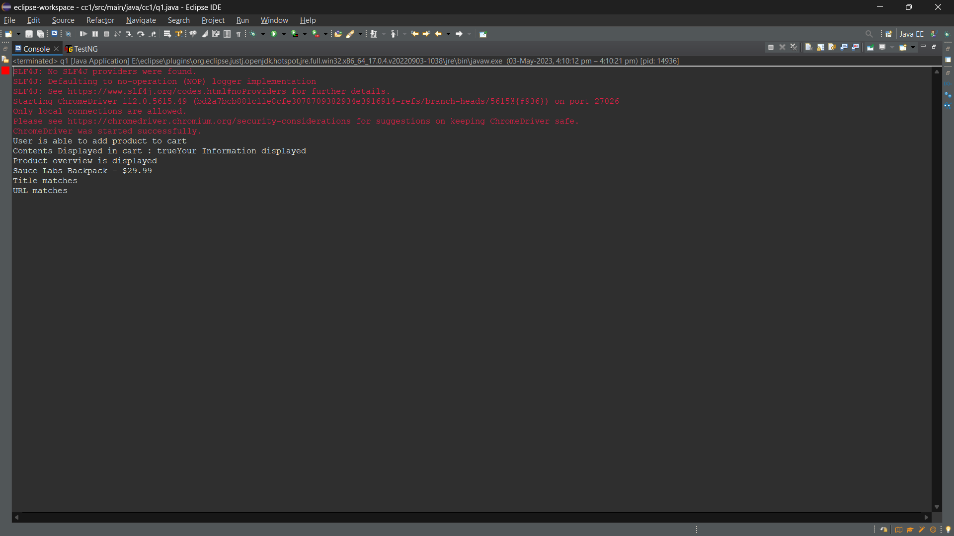

Q2)

package com.test.cc1;

import org.openqa.selenium.By;

import org.openqa.selenium.WebDriver;

import org.openqa.selenium.chrome.ChromeDriver;

import org.openqa.selenium.chrome.ChromeOptions;

import io.github.bonigarcia.wdm.WebDriverManager;

public class question_2 {

public static void main(String[] args) throws InterruptedException {

ChromeOptions co=new ChromeOptions();

co.addArguments("--remote-allow-origins=*");

WebDriverManager.chromedriver().setup();

WebDriver driver;

driver=new ChromeDriver();

driver.get("https://www.saucedemo.com/");

driver.manage().window().maximize();

Thread.sleep(4000);

driver.findElement(By.xpath("//*[@id=\"user-name\"]")).click();

driver.findElement(By.xpath("//*[@id=\"user-name\"]")).sendKeys("standard_user");

driver.findElement(By.xpath("//*[@id=\"password\"]")).click();

driver.findElement(By.xpath("//*[@id=\"password\"]")).sendKeys("secret_sauce");

driver.findElement(By.xpath("//*[@id=\"login-button\"]")).click();

Thread.sleep(4000);

driver.findElement(By.xpath("//*[@id=\"header_container\"]/div[2]/div/span/select")).click();

driver.findElement(By.xpath("//*[@id=\"header_container\"]/div[2]/div/span/select/option[1]")).click();

String f1 = driver.findElement(By.xpath("//*[@id=\"header_container\"]/div[2]/div/span/select")).getText();

Thread.sleep(3000);

System.out.println("Filtering from: " + f1);

Thread.sleep(3000);

String p1 = driver.findElement(By.xpath("//*[@id=\"item_4_title_link\"]/div")).getText();

System.out.println("First product name: " + p1);

driver.findElement(By.xpath("//*[@id=\"header_container\"]/div[2]/div/span/select")).click();

driver.findElement(By.xpath("//*[@id=\"header_container\"]/div[2]/div/span/select/option[2]")).click();

String f2 = driver.findElement(By.xpath("//*[@id=\"header_container\"]/div[2]/div/span/select")).getText();

Thread.sleep(3000);

System.out.println("Filtering from: " + f2);

String p2 = driver.findElement(By.xpath("//*[@id=\"item_3_title_link\"]/div")).getText();

Thread.sleep(3000);

System.out.println("First product name: " + p2);

driver.findElement(By.xpath("//*[@id=\"header_container\"]/div[2]/div/span/select")).click();

driver.findElement(By.xpath("//*[@id=\"header_container\"]/div[2]/div/span/select/option[3]")).click();

Thread.sleep(3000);

String f3 = driver.findElement(By.xpath("//*[@id=\"header_container\"]/div[2]/div/span/select")).getText();

Thread.sleep(3000);

System.out.println("Filtering from: " + f3);

String p3 = driver.findElement(By.xpath("//*[@id=\"item_3_title_link\"]/div")).getText();

Thread.sleep(3000);

System.out.println("First product name: " + p3);

driver.findElement(By.xpath("//*[@id=\"header_container\"]/div[2]/div/span/select")).click();

driver.findElement(By.xpath("//*[@id=\"header_container\"]/div[2]/div/span/select/option[4]")).click();

String f4 = driver.findElement(By.xpath("//*[@id=\"header_container\"]/div[2]/div/span/select")).getText();

System.out.println("Filtering from: " + f4);

String p4 = driver.findElement(By.xpath("//*[@id=\"item_5_title_link\"]/div")).getText();

System.out.println("First product name: " + p4);

driver.close();

}

}

