**DAY_3 NAME:SURYA Y**

**ROLL_NO:727721EUCS162**

**CE_1**

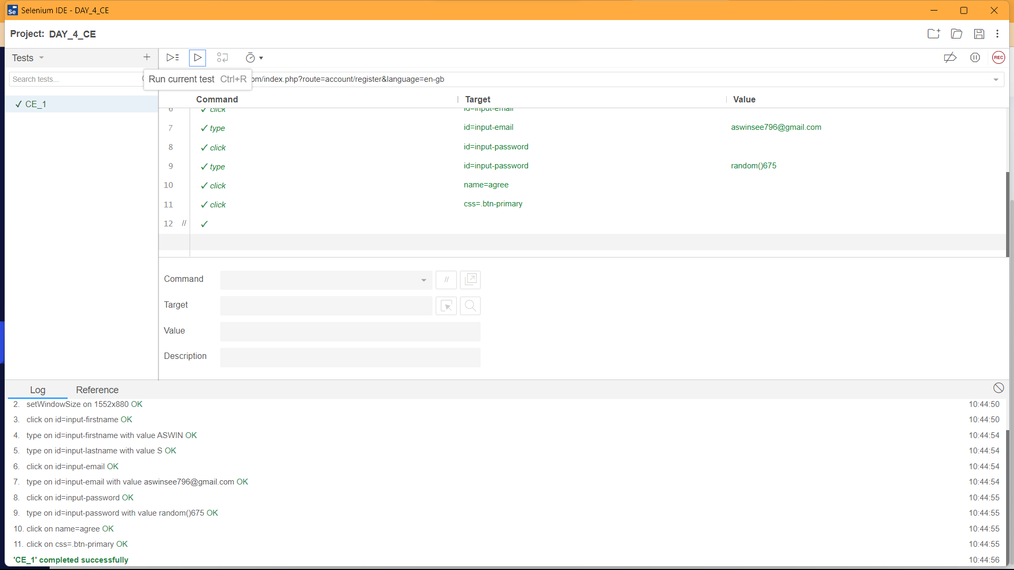

**OUTPUT:**

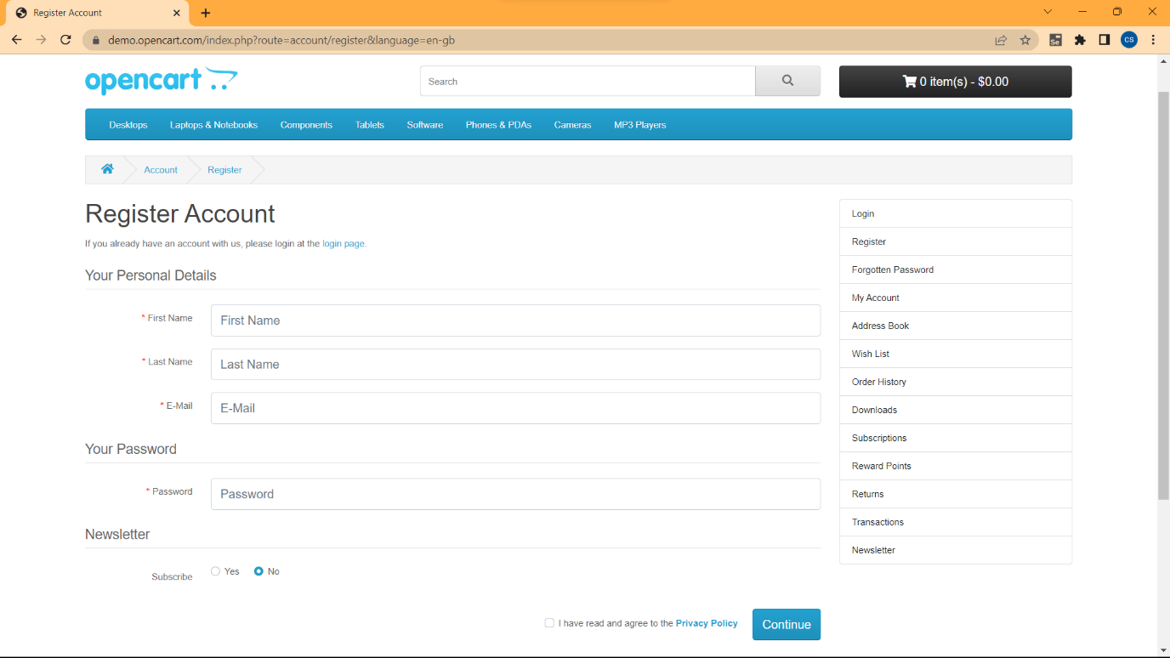

**CE_2:**

**package com.day_4;**

**import org.openqa.selenium.By;**

**import org.openqa.selenium.WebDriver;**

**import org.openqa.selenium.WebElement;**

**import org.openqa.selenium.chrome.ChromeDriver;**

**import org.openqa.selenium.chrome.ChromeOptions;**

**import io.github.bonigarcia.wdm.WebDriverManager;**

**public class CE_1 {**

**public static void main(String[] args) throws InterruptedException {**

**// TODO Auto-generated method stub**

**ChromeOptions co = new ChromeOptions();**

**co.addArguments("--remote-allow-origins=.");**

**WebDriverManager.chromedriver();**

**WebDriver driver = new ChromeDriver();**

**driver.get("https://demo.opencart.com/index.php?route=account/register&language=en-gb");**

**driver.manage().window().maximize();**

**WebElement fname = driver.findElement(By.id("input-firstname"));**

**fname.sendKeys("Ashwin");**

**WebElement lname = driver.findElement(By.id("input-lastname"));**

**lname.sendKeys("S");**

**WebElement email = driver.findElement(By.id("input-email"));**

**email.sendKeys("aswinsee796@gmail.com");**

**WebElement pass = driver.findElement(By.id("input-password"));**

**pass.sendKeys("Random");**

**Thread.sleep(4000);**

**WebElement rad = driver.findElement(By.id("input-newsletter-yes"));**

**rad.click();**

**WebElement button = driver.findElement(By.xpath("//button[@class=\"btn btn-primary\"]"));**

**button.click();**

**}**

**}**

**OUTPUT:**

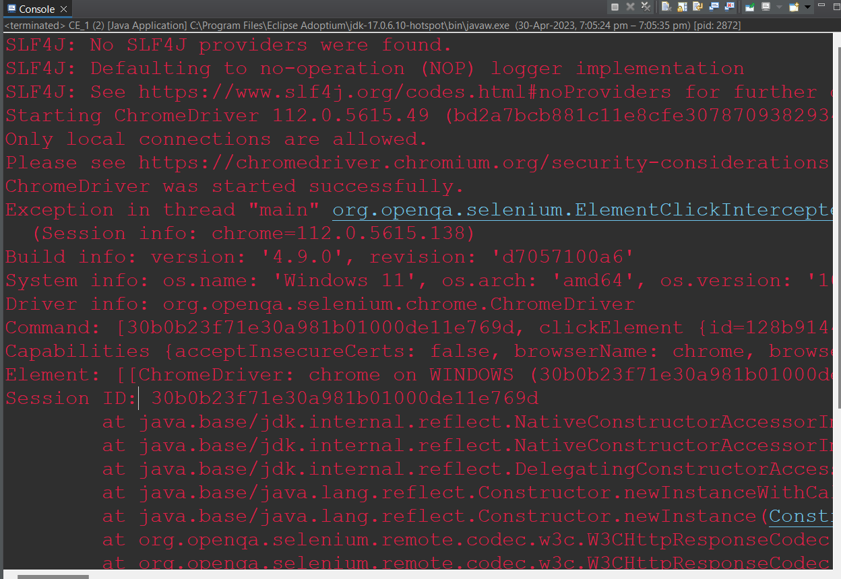

**CE_3**

**package com.day_4;**

**import org.openqa.selenium.By;**

**import org.openqa.selenium.WebDriver;**

**import org.openqa.selenium.WebElement;**

**import org.openqa.selenium.chrome.ChromeDriver;**

**import org.openqa.selenium.chrome.ChromeOptions;**

**import io.github.bonigarcia.wdm.WebDriverManager;**

**public class CE_2 {**

**public static void main(String[] args) throws InterruptedException {**

**ChromeOptions co = new ChromeOptions();**

**co.addArguments("--remote-allow-origins=.");**

**WebDriverManager.chromedriver();**

**WebDriver driver = new ChromeDriver();**

**driver.get("https://demo.opencart.com/index.php?route=checkout/voucher&language=en-gb");**

**driver.manage().window().maximize();**

**WebElement Rname = driver.findElement(By.xpath("//*[@id=\"input-to-name\"]"));**

**Rname.sendKeys("Ashwin");**

**WebElement Remail = driver.findElement(By.xpath("//*[@id=\"input-to-email\"]"));**

**Remail.sendKeys("aswinsee796@gmail.com");**

**WebElement yname = driver.findElement(By.xpath("//*[@id=\"input-from-name\"]"));**

**yname.sendKeys("Suman");**

**WebElement yemail = driver.findElement(By.xpath("//*[@id=\"input-from-email\"]"));**

**yemail.sendKeys("suman@gmail.com");**

**Thread.sleep(3000);**

**WebElement rad = driver.findElement(By.xpath("//*[@id=\"input-theme-7\"]"));**

**rad.click();**

**WebElement message = driver.findElement(By.xpath("//*[@id=\"input-message\"]"));**

**message.sendKeys("i have a gift for u");**

**WebElement amt = driver.findElement(By.xpath("//*[@id=\"input-amount\"]"));**

**amt.sendKeys("000");**

**Thread.sleep(2000);**

**WebElement cbox = driver.findElement(By.xpath("//*[@id=\"form-voucher\"]/div[8]/div/div/input"));**

**cbox.click();**

**WebElement button = driver.findElement(By.xpath("//*[@id=\"form-voucher\"]/div[8]/div/button"));**

**button.click();**

**}**

**}**

**OUTPUT:**

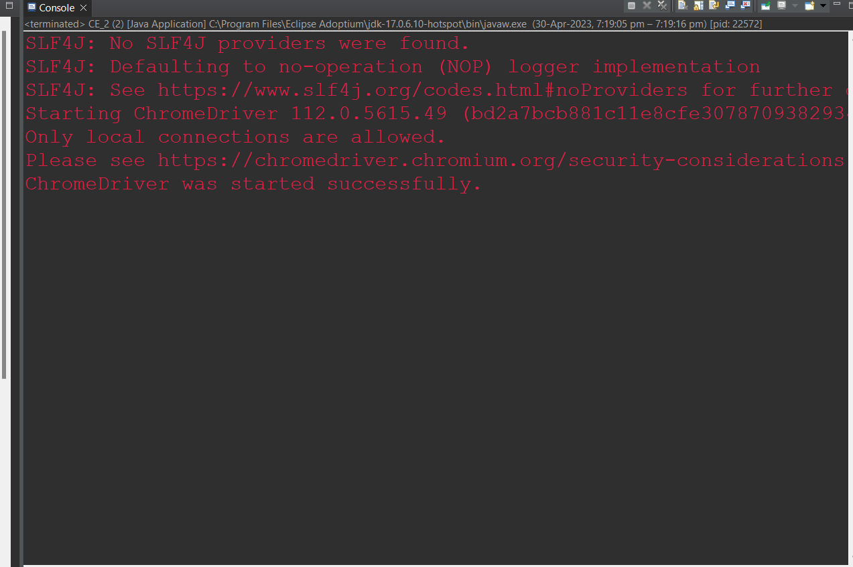

**CE_4**

**package com.day_4;**

**import org.openqa.selenium.By;**

**import org.openqa.selenium.WebDriver;**

**import org.openqa.selenium.WebElement;**

**import org.openqa.selenium.chrome.ChromeDriver;**

**import org.openqa.selenium.chrome.ChromeOptions;**

**import io.github.bonigarcia.wdm.WebDriverManager;**

**public class CE_3 {**

**public static void main(String[] args) {**

**ChromeOptions co = new ChromeOptions();**

**co.addArguments("--remote-allow-origins=.");**

**WebDriverManager.chromedriver();**

**WebDriver driver = new ChromeDriver();**

**driver.navigate().to("https://j2store.net/free/index.php/shop");**

**driver.manage().window().maximize();**

**WebElement cloth = driver.findElement(By.xpath("//*[@id=\"j2store_categories_mod\"]/li[2]/a"));**

**cloth.click();**

**driver.navigate().back();**

**driver.navigate().forward();**

**driver.navigate().refresh();**

**driver.close();**

**}**

**}**

**OUTPUT:**

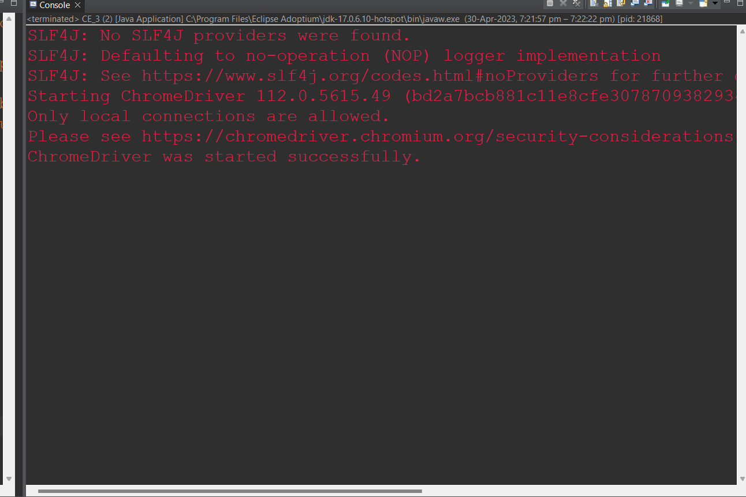

**CE_5(A)**

**package com.day_4;**

**import org.openqa.selenium.WebDriver;**

**import org.openqa.selenium.chrome.ChromeDriver;**

**import org.openqa.selenium.chrome.ChromeOptions;**

**import io.github.bonigarcia.wdm.WebDriverManager;**

**public class CE_4 {**

**public static void main(String[] args) {**

**ChromeOptions co = new ChromeOptions();**

**co.addArguments("--remote-allow-origins=.");**

**WebDriverManager.chromedriver();**

**WebDriver driver = new ChromeDriver();**

**driver.get("https://j2store.net/free/");**

**String actualUrl = driver.getCurrentUrl();**

**String expectedUrl = "https://j2store.net/free/";**

**if(expectedUrl.equals(actualUrl)) {**

**System.out.println("It matches");**

**}**

**else {**

**System.out.println("It doesn't matches");**

**}**

**}**

**}**

**OUTPUT:**

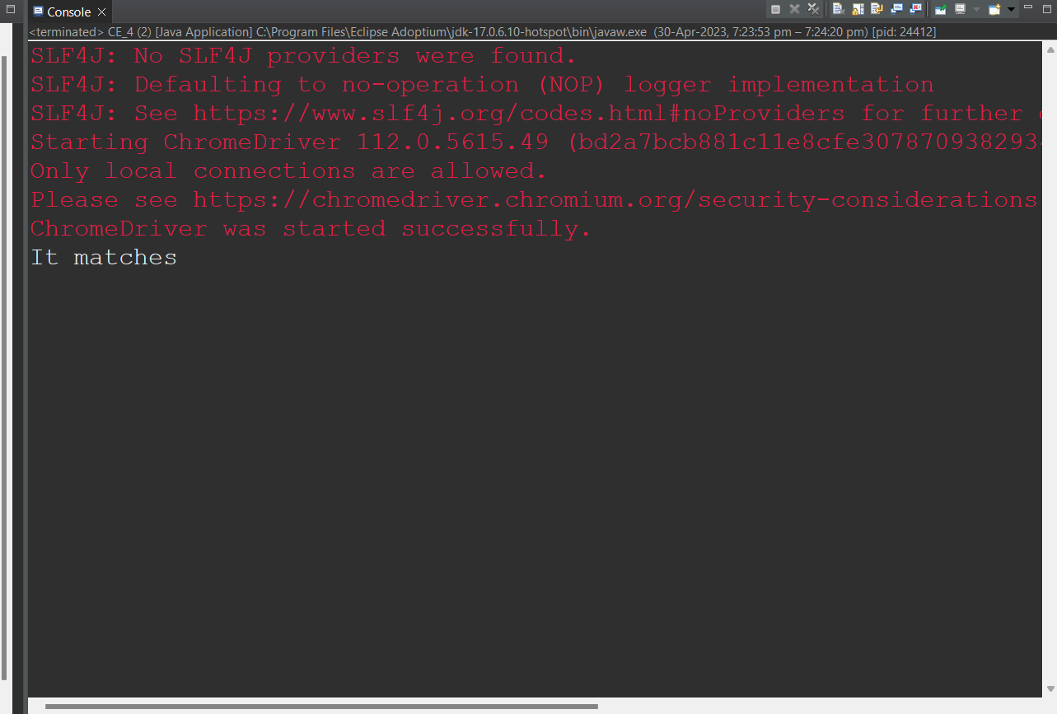

**CE_5(B)**

**package com.day_4;**

**import java.util.List;**

**import org.openqa.selenium.By;**

**import org.openqa.selenium.WebDriver;**

**import org.openqa.selenium.WebElement;**

**import org.openqa.selenium.chrome.ChromeDriver;**

**import org.openqa.selenium.chrome.ChromeOptions;**

**import io.github.bonigarcia.wdm.WebDriverManager;**

**public class CE_5 {**

**public static void main(String[] args) {**

**ChromeOptions co = new ChromeOptions();**

**co.addArguments("--remote-allow-origins=*");**

**WebDriverManager.chromedriver().setup();**

**WebDriver driver = new ChromeDriver();**

**driver.get("https://j2store.net/free/");**

**driver.manage().window().maximize();**

**driver.findElement(By.xpath("/html/body/div[2]/div/div[2]/div/div/div/div/ul/li[1]/a/img")).click();**

**List<WebElement> names = driver.findElements(By.xpath("//h2[@itemprop='name']"));**

**for(int i = 0; i < names.size(); i++) {**

**System.out.println(names.get(i).getText());**

**}**

**}**

**}**

**OUTPUT:**

