**DAY_5 NAME: SURYA Y**

**ROLL_NO:727721EUCS162**

**CE_1**

**package com.day_6;**

**import org.testng.annotations.Test;**

**import io.github.bonigarcia.wdm.WebDriverManager;**

**import org.testng.annotations.BeforeMethod;**

**import org.openqa.selenium.WebDriver;**

**import org.openqa.selenium.chrome.ChromeDriver;**

**import org.openqa.selenium.chrome.ChromeOptions;**

**import org.testng.Assert;**

**import org.testng.annotations.AfterMethod;**

**public class CE_1 {**

**WebDriver driver;**

**@Test**

**public void check() {**

**driver.get("https://demo.wpeverest.com/user-registration/guest-registration-form/");**

**String exceptedTitle ="Guest Registration Form – User Registration";**

**String actualTitle = driver.getTitle();**

**Assert.assertEquals(exceptedTitle,actualTitle);**

**}**

**@BeforeMethod**

**public void beforeMethod() {**

**ChromeOptions co = new ChromeOptions();**

**co.addArguments("--remote-allow-origins=.");**

**WebDriverManager.chromedriver();**

**driver = new ChromeDriver();**

**}**

**@AfterMethod**

**public void afterMethod() {**

**driver.close();**

**}**

**}**

**OUTPUT:**

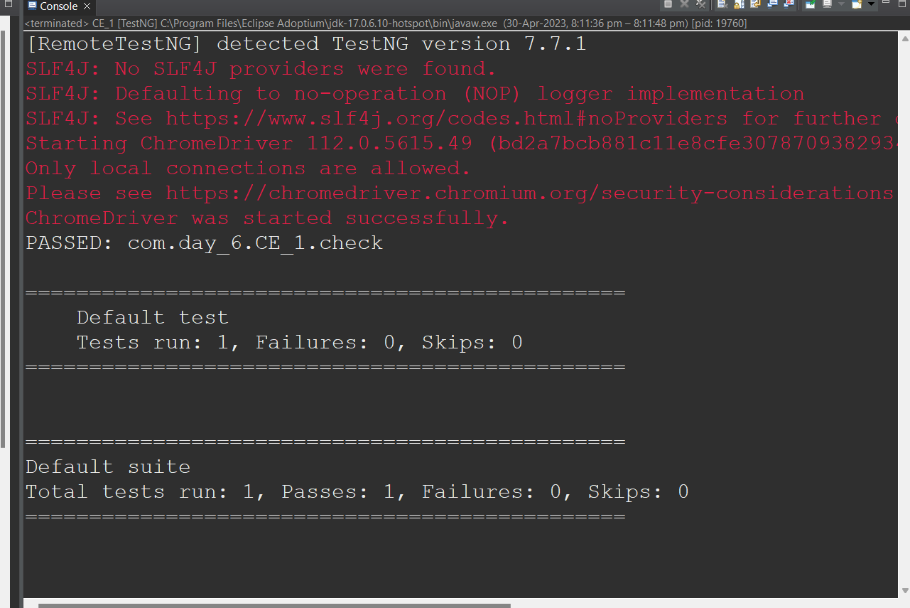

**CE_2**

**package com.day_6;**

**import org.testng.annotations.Test;**

**import org.testng.annotations.BeforeMethod;**

**import org.testng.Assert;**

**import org.testng.annotations.AfterMethod;**

**public class CE_2 {**

**@Test(priority=1)**

**public void add() {**

**int a = 10;**

**int b = 20;**

**int sum =0;**

**sum= a+b;**

**System.out.println(sum);**

**Assert.assertEquals(sum, 30);**

**}**

**@Test(priority=3)**

**public void sub() {**

**int a = 70;**

**int b = 60;**

**int sub = 0;**

**sub = a-b;**

**System.out.println(sub);**

**Assert.assertEquals(sub, 10);**

**}**

**@Test(priority=4)**

**public void mul() {**

**int a = 5;**

**int b = 8;**

**int mul = 0;**

**mul = a*b;**

**System.out.println(mul);**

**Assert.assertEquals(mul, 40);**

**}**

**@Test(priority=2)**

**public void div() {**

**int a = 6;**

**int b = 3;**

**int div =0;**

**div = a/b;**

**System.out.println(div);**

**Assert.assertEquals(div,2);**

**}**

**@BeforeMethod**

**public void beforeMethod() {**

**}**

**@AfterMethod**

**public void afterMethod() {**

**}**

**}**

**OUTPUT:**

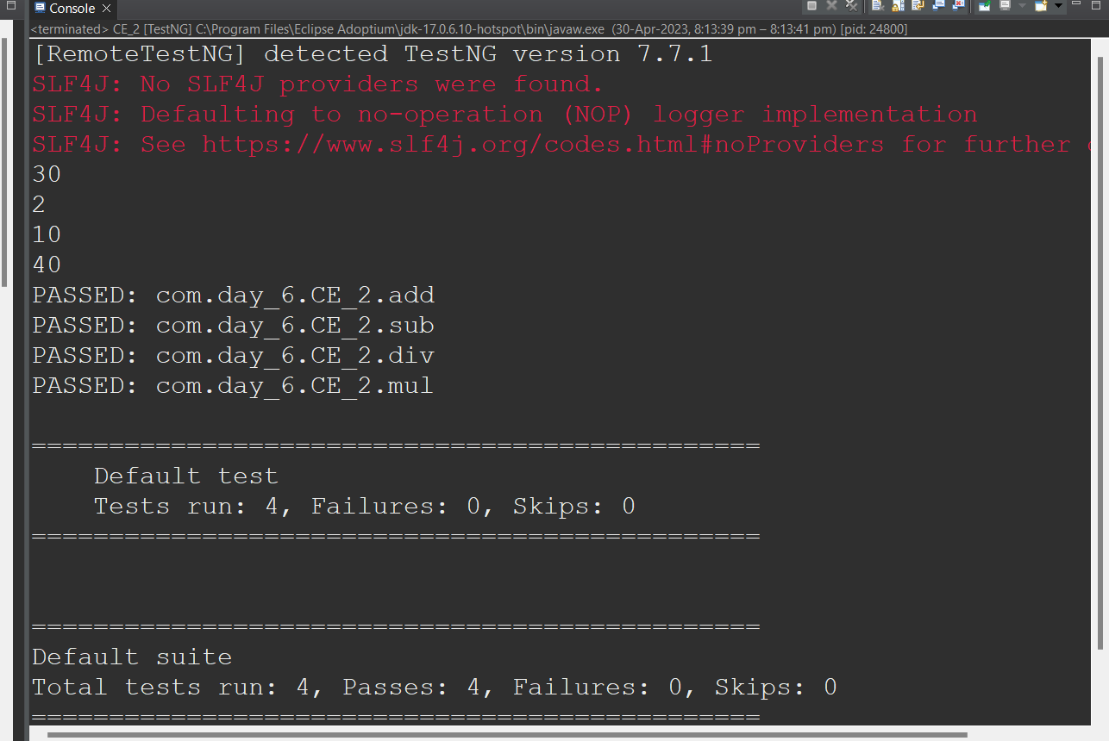

**CE_3**

**package com.day_6;**

**import org.testng.annotations.Test;**

**import io.github.bonigarcia.wdm.WebDriverManager;**

**import org.testng.annotations.BeforeMethod;**

**import org.openqa.selenium.By;**

**import org.openqa.selenium.WebDriver;**

**import org.openqa.selenium.WebElement;**

**import org.openqa.selenium.chrome.ChromeDriver;**

**import org.openqa.selenium.chrome.ChromeOptions;**

**import org.testng.Assert;**

**import org.testng.annotations.AfterMethod;**

**public class CE_3 {**

**WebDriver driver;**

**@Test**

**public void check() throws InterruptedException {**

**WebElement uname=driver.findElement(By.name("username"));**

**uname.sendKeys("Admin");**

**WebElement pass = driver.findElement(By.name("password"));**

**pass.sendKeys("admin123");**

**WebElement button = driver.findElement(By.xpath("//*[@id=\"app\"]/div[1]/div/div[1]/div/div[2]/div[2]/form/div[3]/button"));**

**button.click();**

**Thread.sleep(4000);**

**String text=driver.findElement(By.xpath("//*[@id=\"app\"]/div[1]/div[1]/header/div[1]/div[1]")).getText();**

**Assert.assertEquals("Dashboard",text);**

**}**

**@BeforeMethod**

**public void beforeMethod() throws InterruptedException {**

**ChromeOptions co = new ChromeOptions();**

**co.addArguments("--remote-allow-origins=*");**

**WebDriverManager.chromedriver().setup();**

**driver = new ChromeDriver();**

**driver.get("https://opensource-demo.orangehrmlive.com/web/index.php/auth/login");**

**driver.manage().window().maximize();**

**Thread.sleep(4000);**

**}**

**@AfterMethod**

**public void afterMethod() throws InterruptedException {**

**Thread.sleep(4000);**

**driver.close();**

**}**

**}**

**OUTPUT:**

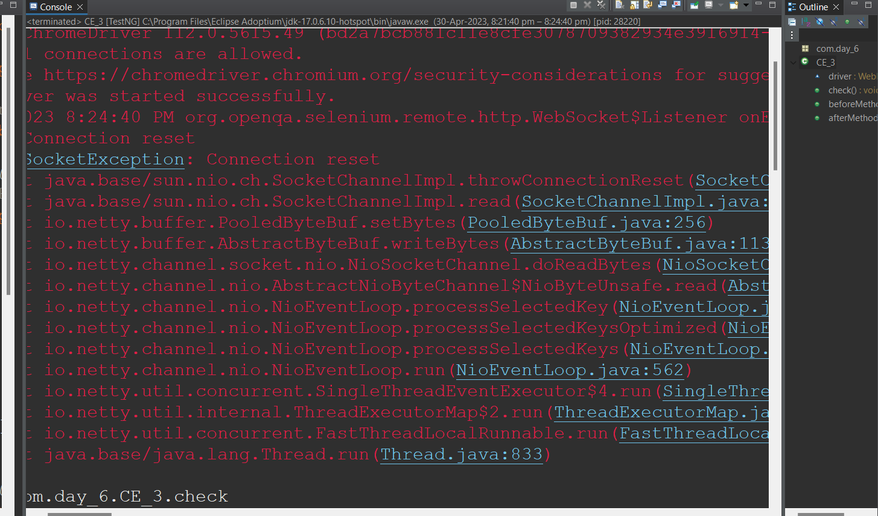

**CE_4**

**package com.day6;**

**import org.testng.annotations.Test;**

**import io.github.bonigarcia.wdm.WebDriverManager;**

**import org.testng.annotations.BeforeMethod;**

**import org.openqa.selenium.By;**

**import org.openqa.selenium.WebDriver;**

**//import org.openqa.selenium.WebElement;**

**import org.openqa.selenium.chrome.ChromeDriver;**

**import org.openqa.selenium.chrome.ChromeOptions;**

**import org.testng.Assert;**

**import org.testng.annotations.AfterClass;**

**import org.testng.annotations.AfterMethod;**

**import org.testng.annotations.BeforeClass;**

**public class CE_4 {**

**WebDriver d;**

**@Test**

**public void login() throws InterruptedException {**

**d.findElement(By.xpath("//*[@id=\"app\"]/div[1]/div/div[1]/div/div[2]/div[2]/form/div[1]/div/div[2]/input")).sendKeys("Admin");**

**d.findElement(By.xpath("//*[@id=\"app\"]/div[1]/div/div[1]/div/div[2]/div[2]/form/div[2]/div/div[2]/input")).sendKeys("admin123");**

**Thread.sleep(3000);**

**d.findElement(By.xpath("//*[@id=\"app\"]/div[1]/div/div[1]/div/div[2]/div[2]/form/div[3]/button")).click();**

**Thread.sleep(4000);**

**String title = d.findElement(By.xpath("//*[@id=\"app\"]/div[1]/div[1]/header/div[1]/div[1]/span/h6")).getText();**

**Assert.assertEquals("Dashboard", title);**

**}**

**@Test(dependsOnMethods= {"login"})**

**public void logout() {**

**d.findElement(By.xpath("//*[@id=\"app\"]/div[1]/div[1]/header/div[1]/div[2]/ul/li/span/p")).click();**

**d.findElement(By.xpath("//*[@id=\"app\"]/div[1]/div[1]/header/div[1]/div[2]/ul/li/ul/li[4]/a")).click();**

**String Title=d.getTitle();**

**System.out.println(Title);**

**Assert.assertEquals("OrangeHRM", Title);**

**}**

**@BeforeClass**

**public void beforeclass() throws InterruptedException {**

**ChromeOptions co= new ChromeOptions();**

**co.addArguments("--remote-allow-origins=*");**

**WebDriverManager.chromedriver().setup();**

**d=new ChromeDriver();**

**d.get("https://opensource-demo.orangehrmlive.com/web/index.php/auth/login");**

**d.manage().window().maximize();**

**Thread.sleep(4000);**

**}**

**@AfterClass**

**public void afterclass() {**

**}**

**@BeforeMethod**

**public void beforeMethod() throws InterruptedException {**

**}**

**@AfterMethod**

**public void afterMethod() {**

**//   d.close():**

**}**

**}**

**OUTPUT:**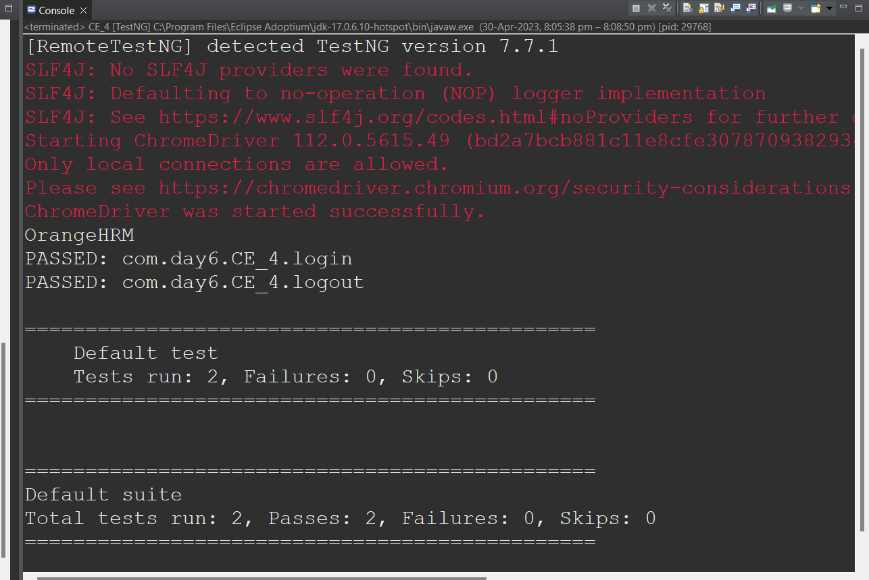

**CE_5**

**package com.day_6;**

**import org.testng.annotations.Test;**

**import io.github.bonigarcia.wdm.WebDriverManager;**

**import org.testng.annotations.BeforeMethod;**

**import org.openqa.selenium.By;**

**import org.openqa.selenium.WebDriver;**

**import org.openqa.selenium.chrome.ChromeDriver;**

**import org.openqa.selenium.chrome.ChromeOptions;**

**import org.testng.Assert;**

**import org.testng.annotations.AfterMethod;**

**public class CE_5 {**

**WebDriver driver;**

**@Test (groups= {"SmokeTest"})**

**public void testcase1() throws InterruptedException {**

**Thread.sleep(3000);**

**String s = driver.getTitle();**

**Assert.assertEquals(s, "Domain Names, Websites, Hosting & Online Marketing Tools - GoDaddy IN");**

**}**

**@Test (groups= {"RegressionTest"})**

**public void testcase2() throws InterruptedException {**

**// Thread.sleep(5000);**

**driver.findElement(By.xpath("/html/body/header/div/section/div/div[1]/nav/div[2]/div[1]/ul/li[1]/button")).click();**

**driver.findElement(By.xpath("/html/body/header/div/section/div/div[1]/nav/div[2]/div[1]/ul/li[1]/div/div[2]/div[1]/ul/li[2]/a")).click();**

**Thread.sleep(5000);**

**String actual = driver.findElement(By.xpath("/html/body/main/section[1]/section/section/div/div/section/div/h2/span")).getText();**

**Assert.assertEquals(actual, "It all starts with a domain.");**

**}**

**@BeforeMethod**

**public void beforeMethod() {**

**ChromeOptions co=new ChromeOptions();**

**co.addArguments("--remote-allow-origins=*");**

**WebDriverManager.chromedriver().setup();**

**driver=new ChromeDriver();**

**driver.get("https://www.godaddy.com/en-in");**

**driver.manage().window().maximize();**

**}**

**@AfterMethod**

**public void afterMethod() {**

**driver.close();**

**}**

**}**

**OUTPUT:**

