1.

package Day9;

import org.testng.annotations.Test;

import org.testng.annotations.DataProvider;

public class CE1 {

@Test(dataProvider = "dp",priority=1)

public void add(Integer n1, Integer n2) {

System.out.println("add"+(n1+n2));

}

@Test(dataProvider = "dp",priority=2)

public void sub(Integer n1, Integer n2) {

System.out.println("sub:"+(n1-n2));

}

@Test(dataProvider = "dp",priority=3)

public void mul(Integer n1, Integer n2) {

System.out.println("mul:"+(n1*n2));

}

@Test(dataProvider = "dp",priority=4)

public void div(Integer n1, Integer n2) {

System.out.println("div:"+(n1/n2));

}

@DataProvider

public Object[][] dp() {

return new Object[][] {

new Object[] { 40, 10},

new Object[] { 7, 2 },

};

}

}

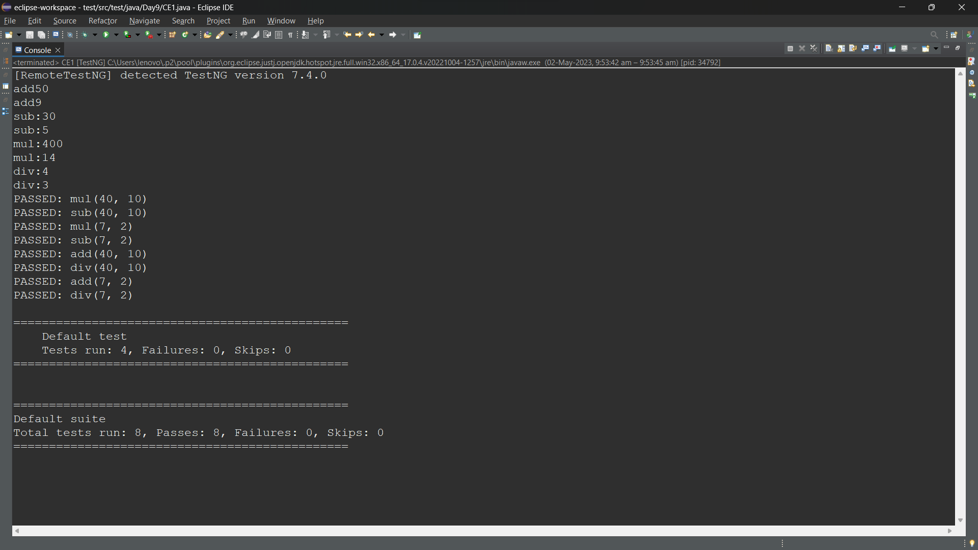

2.

<?xml version="1.0" encoding="UTF-8"?>

<!DOCTYPE suite SYSTEM "https://testng.org/testng-1.0.dtd">

<suite name="Suite" parallel="methods">

<groups>

</groups>

<test thread-count="5" name="Test">

<classes>

<class name="Day9.CE2"/>

</classes>

</test> <!-- Test -->

</suite> <!-- Suite -->

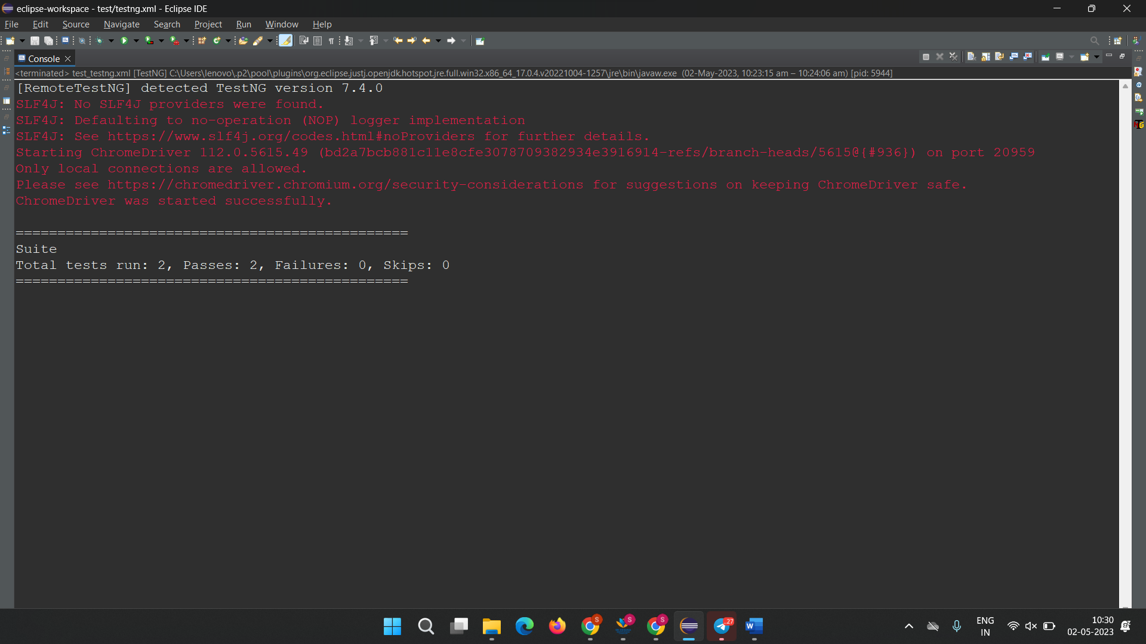

3.

package Day9;

import org.testng.annotations.Test;

import io.github.bonigarcia.wdm.WebDriverManager;

import org.testng.annotations.BeforeMethod;

import org.testng.annotations.Parameters;

import org.junit.Assert;

import org.openqa.selenium.By;

import org.openqa.selenium.WebDriver;

import org.openqa.selenium.WebElement;

import org.openqa.selenium.chrome.ChromeDriver;

import org.openqa.selenium.chrome.ChromeOptions;

import org.openqa.selenium.edge.EdgeDriver;

import org.testng.annotations.AfterMethod;

public class CE3 {

WebDriver driver;

@Test

public void f() throws InterruptedException {

driver.findElement(By.xpath("//*[@id=\"app\"]/div[1]/div/div[1]/div/div[2]/div[2]/form/div[1]/div/div[2]/input")).sendKeys("Admin");

WebElement pswrd = driver.findElement(By.xpath("//*[@id=\"app\"]/div[1]/div/div[1]/div/div[2]/div[2]/form/div[2]/div/div[2]/input"));

pswrd.sendKeys("admin123");

Thread.sleep(6000);

driver.findElement(By.xpath("//*[@id=\"app\"]/div[1]/div/div[1]/div/div[2]/div[2]/form/div[3]/button")).submit();

Thread.sleep(6000);

WebElement dash = driver.findElement(By.xpath("//*[@id=\"app\"]/div[1]/div[1]/header/div[1]/div[1]/span/h6"));

String get=dash.getText();

Assert.assertEquals(get, "Dashboard");

}

@BeforeMethod

@Parameters("browser")

public void beforeMethod(String browser) throws InterruptedException {

ChromeOptions co = new ChromeOptions();

WebDriverManager.chromedriver().setup();

if (browser.equals("chrome")) {

driver = new ChromeDriver();

}

else if (browser.equals("edge")) {

driver = new EdgeDriver();

}

else {

throw new IllegalArgumentException("Invalid browser value: " + browser);

}

driver.get("https://opensource-demo.orangehrmlive.com/web/index.php/auth/login");

driver.manage().window().maximize();

Thread.sleep(4000);

}

@AfterMethod

public void afterMethod() {

driver.quit();

}

}



4.

package Day9;

import org.testng.annotations.Test;

import io.github.bonigarcia.wdm.WebDriverManager;

import org.testng.annotations.BeforeMethod;

import org.testng.annotations.Parameters;

import org.junit.Assert;

import org.openqa.selenium.By;

import org.openqa.selenium.WebDriver;

import org.openqa.selenium.WebElement;

import org.openqa.selenium.chrome.ChromeDriver;

import org.openqa.selenium.chrome.ChromeOptions;

import org.openqa.selenium.edge.EdgeDriver;

import org.testng.annotations.AfterMethod;

public class CE3 {

WebDriver driver;

@Test

public void f() throws InterruptedException {

driver.findElement(By.xpath("//*[@id=\"app\"]/div[1]/div/div[1]/div/div[2]/div[2]/form/div[1]/div/div[2]/input")).sendKeys("Admin");

WebElement pswrd = driver.findElement(By.xpath("//*[@id=\"app\"]/div[1]/div/div[1]/div/div[2]/div[2]/form/div[2]/div/div[2]/input"));

pswrd.sendKeys("admin123");

Thread.sleep(6000);

driver.findElement(By.xpath("//*[@id=\"app\"]/div[1]/div/div[1]/div/div[2]/div[2]/form/div[3]/button")).submit();

Thread.sleep(6000);

WebElement dash = driver.findElement(By.xpath("//*[@id=\"app\"]/div[1]/div[1]/header/div[1]/div[1]/span/h6"));

String get=dash.getText();

Assert.assertEquals(get, "Dashboard");

}

@BeforeMethod

@Parameters("browser")

public void beforeMethod(String browser) throws InterruptedException {

ChromeOptions co = new ChromeOptions();

WebDriverManager.chromedriver().setup();

if (browser.equals("chrome")) {

driver = new ChromeDriver();

}

else if (browser.equals("edge")) {

driver = new EdgeDriver();

}

else {

throw new IllegalArgumentException("Invalid browser value: " + browser);

}

driver.get("https://opensource-demo.orangehrmlive.com/web/index.php/auth/login");

driver.manage().window().maximize();

Thread.sleep(4000);

}

@AfterMethod

public void afterMethod() {

driver.quit();

}

}

5.

package Day9;

import org.testng.annotations.Test;

import io.github.bonigarcia.wdm.WebDriverManager;

import org.testng.annotations.BeforeMethod;

import org.junit.Assert;

import org.openqa.selenium.By;

import org.openqa.selenium.WebDriver;

import org.openqa.selenium.WebElement;

import org.openqa.selenium.chrome.ChromeDriver;

import org.openqa.selenium.chrome.ChromeOptions;

import org.testng.annotations.AfterMethod;

public class CE5 {

WebDriver driver;

@Test

public void validation() throws InterruptedException {

driver.findElement(By.xpath("//*[@id=\"app\"]/div[1]/div/div[1]/div/div[2]/div[2]/form/div[1]/div/div[2]/input")).sendKeys("Suvitha");

// un.sendKeys("Admin");

WebElement pswrd = driver.findElement(By.xpath("//*[@id=\"app\"]/div[1]/div/div[1]/div/div[2]/div[2]/form/div[2]/div/div[2]/input"));

pswrd.sendKeys("12345");

driver.findElement(By.xpath("//*[@id=\"app\"]/div[1]/div/div[1]/div/div[2]/div[2]/form/div[3]/button")).click();

Thread.sleep(2000);

WebElement dash = driver.findElement(By.xpath("//*[@id=\"app\"]/div[1]/div[1]/header/div[1]/div[1]/span/h6"));

String get=dash.getText();

Assert.assertEquals(get, "Dashboard");

}

@BeforeMethod

public void beforeMethod() throws InterruptedException {

ChromeOptions co=new ChromeOptions();

co.addArguments("--remote-allow-origins=*");

WebDriverManager.chromedriver().setup();

driver=new ChromeDriver();

driver.get("https://opensource-demo.orangehrmlive.com/web/index.php/auth/login");

Thread.sleep(2000);

driver.manage().window().maximize();

}

@AfterMethod

public void afterMethod() {

driver.close();

}

}

LISTNER CLASS:

package Day9;

import org.testng.ITestContext;

import org.testng.ITestListener;

import org.testng.ITestResult;

public class Listener_01 implements ITestListener{

public void onTestStart(ITestResult result) {

// **TODO** Auto-generated method stub

System.***out***.println("onTestStart/ Test has started"+result.getName());

}

public void onTestSuccess(ITestResult result) {

// **TODO** Auto-generated method stub

System.***out***.println("onTestSuccess/ Test success"+result.getName());

}

public void onTestFailure(ITestResult result) {

// **TODO** Auto-generated method stub

System.***out***.println("onTestFailure/ Test Failure"+result.getName());

}

public void onTestSkipped(ITestResult result) {

// **TODO** Auto-generated method stub

System.***out***.println("onTestSkipped/ Test Skipped"+result.getName());

}

public void onTestFailedButWithinSuccessPercentage(ITestResult result) {

// **TODO** Auto-generated method stub

System.***out***.println("onTestFailedButWithinSuccessPercentage"+result.getName());

}

public void onTestFailedWithTimeout(ITestResult result) {

// **TODO** Auto-generated method stub

System.***out***.println("onTestFailedWithTimeout"+result.getName());

}

public void onStart(ITestContext context) {

// **TODO** Auto-generated method stub

System.***out***.println("START");

}

public void onFinish(ITestContext context) {

// **TODO** Auto-generated method stub

System.***out***.println("FINISHED");

}

}

