Directives: HTML markup:
<level-one>
<level-two>
<level-three>
Hello {{name}}
</level-three>
</level-two>
</level-one>

var app = angular.module('plunker', []);

function createDirective(name){
return function(){
return {
restrict: 'E',
compile: function(tElem, tAttrs){
console.log(name + ': compile => ' + tElem.html());
return {
pre: function(scope, iElem, iAttrs){
console.log(name + ': pre link => ' + iElem.html());
},
post: function(scope, iElem, iAttrs){
console.log(name + ': post link => ' + iElem.html());
}
}
}
}
}
}

app.directive('levelOne', createDirective('levelOne'));
app.directive('levelTwo', createDirective('levelTwo'));
app.directive('levelThree', createDirective('levelThree'));
evelOne: compile =>
<level-two>  <level-three>  Hello {{name}}  </level-three>  </level-two>  levelTwo: compile =>  <level-three>  Hello {{name}}  </level-three>  levelThree: compile =>  Hello {{name}}  levelOne: pre link =>  <level-two>  <level-three class="ng-binding">  Hello {{name}}  </level-three>  </level-two>  levelTwo: pre link =>  <level-three class="ng-binding">  Hello {{name}}  </level-three> | levelThree: pre link =>  Hello {{name}}  levelThree: post link =>  Hello {{name}}  levelTwo: post link =>  <level-three class="ng-binding">  Hello {{name}}  </level-three>  levelOne: post link =>  <level-two>  <level-three class="ng-binding">  Hello {{name}}  </level-three>  </level-two>

Observation
Printing the DOM reveals something very interesting: the DOM is different during the compile and pre-link function.

So what is happening here?

Compile
We already learned that AngularJS processes the DOM when it detects that the DOM is ready.
So when AngularJS starts traversing the DOM, it bumps into the <level-one> element and knows from its directive definition that some action needs to be performed.
Because a compile function is defined in the levelOne directive definition object, it is called and the element's DOM is passed as an argument to the function.
If you look closely you can see that, at this point, the DOM of the element is still the DOM that is initially created by the browser using the original HTML markup.
In AngularJS the original DOM is often referred to as the the template element, hence also the reason I personally use tElem as the parameter name in the compilefunction, which stands for template element.
Once the compile function of the levelOne directive has run, AngularJS recursively traverses deeper into the DOM and repeats the same compilation step for the <level-two> and <level-three> elements.

Post-link
Before digging into the pre-link functions, let's first have a look at the post-linkfunctions.
If you create a directive that only has a link function, AngularJS treats the function as a post-link function. Hence the reason to discuss it here first.
After AngularJS travels down the DOM and has run all the compile functions, it traverses back up again and runs all associated post-link functions.
The DOM is now traversed in the opposite direction and thus the post-link functions are called in reverse order. So while the reversed order looked strange a few minutes ago, it is now starting to make perfect sense.
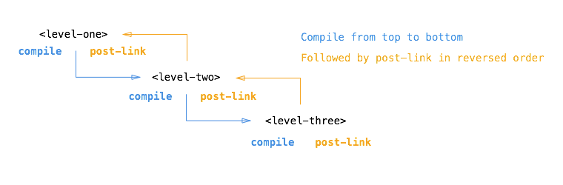
This reverse order guarantees that the post-link functions of all child elements have run by the time the post-link function of the parent element is run.
So when the post-link function of <level-one> is executed, we are guaranteed that the post-link function of <level-two> and the post-link function of <level-three> have already run.
This is the exact reason why it is considered the safest and default place to add your directive logic.
But what about the element's DOM? Why is it different here?
Once AngularJS has called the compile function of a directive, it creates an instanceelement of the template element (often referred to as stamping out instances) and provides a scope for the instance. The scope can be a new scope or an existing one, a child scope or an isolate scope, depending on the scope property of the corresponding directive definition object.
So by the time the linking occurs, the instance element and scope are already available and they are passed by AngularJS as arguments to the post-link function.
I personally always use iElem as parameter name in a link function to refer to the element instance.
So the post-link function (and pre-link function) receive the instance element as argument instead of the template element.
Hence the difference in the log output.

Pre-link
When writing a post-link function, you are guaranteed that the post-link functions of all child elements have already been executed.
In most cases that makes perfect sense and therefore it is the most often used place to write directive code.
However, AngularJS provides an additional hook, the pre-link function, where you can run code before any of the child element's post-link functions have run.
That is worth repeating:
The pre-link function is guaranteed to run on an element instance before any post-link function of its child elements has run.
So while it made perfect sense for post-link functions to be called in reverse order, it now makes perfect sense to call all pre-link functions in the original order again.
This also implies that a pre-link function of an element is run before any of its child elements pre-link functions as well, so for the sake of completeness:
A pre-link function of an element is guaranteed to run before any pre-link or post-link function of any of its child elements.
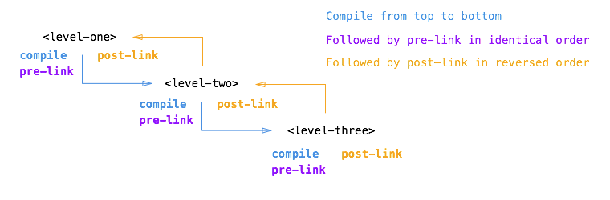

Looking back
If we now look back at the original output, we can clearly recognize what is happening:
// HERE THE ELEMENTS ARE STILL THE ORIGINAL TEMPLATE ELEMENTS

// COMPILE PHASE
// levelOne: compile function is called on original DOM
// levelTwo: compile function is called on original DOM
// levelThree: compile function is called on original DOM

// AS OF HERE, THE ELEMENTS HAVE BEEN INSTANTIATED AND
// ARE BOUND TO A SCOPE
// (E.G. NG-REPEAT WOULD HAVE MULTIPLE INSTANCES)

// PRE-LINK PHASE
// levelOne: pre link function is called on element instance
// levelTwo: pre link function is called on element instance
// levelThree: pre link function is called on element instance

// POST-LINK PHASE (Notice the reverse order)
// levelThree: post link function is called on element instance
// levelTwo: post link function is called on element instance
// levelOne: post link function is called on element instance

Summary
In retrospect we can describe the different functions and their use cases as follows:

Compile function
Use the compile function to change the original DOM (template element) before AngularJS creates an instance of it and before a scope is created.
While there can be multiple element instances, there is only one template element. The ng-repeat directive is a perfect example of such a scenario. That makes the compilefunction the perfect place to make changes to the DOM that should be applied to all instances later on, because it will only be run once and thus greatly enhances performance if you are stamping out a lot of instances.
The template element and attributes are passed to the compile function as arguments, but no scope is available yet:
/**
* Compile function
*
* @param tElem - template element
* @param tAttrs - attributes of the template element
*/
function(tElem, tAttrs){

// ...

};

Pre-link function
Use the pre-link function to implement logic that runs when AngularJS has already compiled the child elements, but before any of the child element's post-link functions have been called.
The scope, instance element and instance attributes are passed to the pre-link function as arguments:
/**
* Pre-link function
*
* @param scope - scope associated with this istance
* @param iElem - instance element
* @param iAttrs - attributes of the instance element
*/
function(scope, iElem, iAttrs){

// ...

};
Here you can see example code of official AngularJS directives that use a pre-link function.

Post-link function
Use the post-link function to execute logic, knowing that all child elements have been compiled and all pre-link and post-link functions of child elements have been executed.
This is the reason the post-link function is considered the safest and default place for your code.
The scope, instance element and instance attributes are passed to the post-link function as arguments:
/**
* Post-link function
*
* @param scope - scope associated with this istance
* @param iElem - instance element
* @param iAttrs - attributes of the instance element
*/
function(scope, iElem, iAttrs){

// ...

};

tranclusion:
A mysterious word I had never heard of before until I met AngularJS. I seriously thought Misko Hevery had invented the word himself, but it appeared to be an existing word:
In computer science, transclusion is the inclusion of a document or part of a document into another document by reference (Wikepedia).
In AngularJS, transclusion is the mechanism that allows you to grab the content of the DOM element of your directive and include it anywhere in the directive's template.
So in the context of AngularJS, we could rephrase the original definition as:
In AngularJS, transclusion is the inclusion of the directive's DOM element content into the directive's template
In this article we investigate the influence of transclusion on the compile, pre-linkand post-link functions inside an AngularJS directive.
This article is a follow-up article on "The nitty-gritty of compile and link functions inside AngularJS directives".

The code
Because this article is an extension to part 1, we will use the same code we already discussed previously.
Consider the following HTML markup:
<level-one>
<level-two>
<level-three>
Hello {{name}}
</level-three>
</level-two>
</level-one>
and the following JavaScript:
var app = angular.module('plunker', []);

function createDirective(name){
return function(){
return {
restrict: 'E',
compile: function(tElem, tAttrs){
console.log(name + ': compile');
return {
pre: function(scope, iElem, iAttrs){
console.log(name + ': pre link');
},
post: function(scope, iElem, iAttrs){
console.log(name + ': post link');
}
}
}
}
}
}

app.directive('levelOne', createDirective('levelOne'));
app.directive('levelTwo', createDirective('levelTwo'));
app.directive('levelThree', createDirective('levelThree'));
providing the following console output:
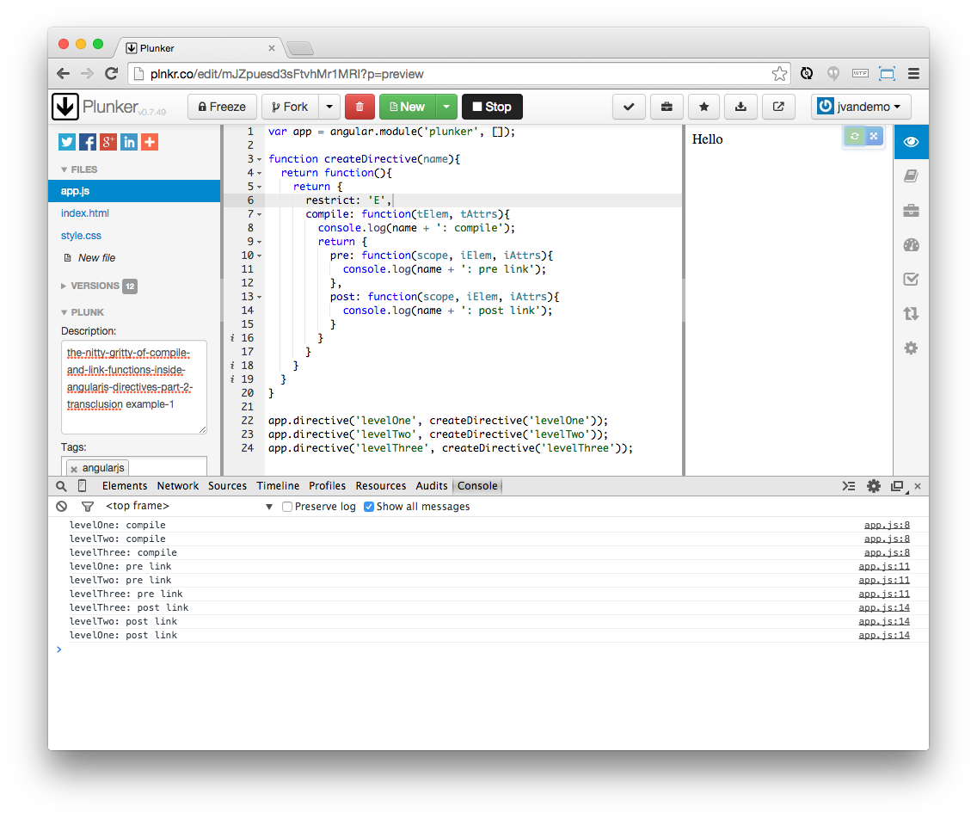
which can be summarized as:
// COMPILE PHASE
// levelOne: compile function is called
// levelTwo: compile function is called
// levelThree: compile function is called

// PRE-LINK PHASE
// levelOne: pre link function is called
// levelTwo: pre link function is called
// levelThree: pre link function is called

// POST-LINK PHASE (Notice the reverse order)
// levelThree: post link function is called
// levelTwo: post link function is called
// levelOne: post link function is called
and visualized as:

To try it out for yourself, just open this plnkr and take a look at the console.
This is all explained in part 1 so make sure to read it first if you are interested in learning more about how directives without transclusion work.

So let's add transclusion
Transclusion is enabled by adding a transclude property to the directive definition object:
var app = angular.module('plunker', []);

function createDirective(name){
return function(){
return {
restrict: 'E',
transclude: true,
compile: function(tElem, tAttrs){
console.log(name + ': compile');
return {
pre: function(scope, iElem, iAttrs){
console.log(name + ': pre link');
},
post: function(scope, iElem, iAttrs){
console.log(name + ': post link');
}
}
}
}
}
}

app.directive('levelOne', createDirective('levelOne'));
app.directive('levelTwo', createDirective('levelTwo'));
app.directive('levelThree', createDirective('levelThree'));
Adding transclude: true tells AngularJS to capture the content of the directive and make it available in the directive's template. The ng-transclude attribute can then be used inside the template to specify where you want AngularJS to restore the content.
But before we add the ng-transclude attribute to template, let's have a look at what we get so far:
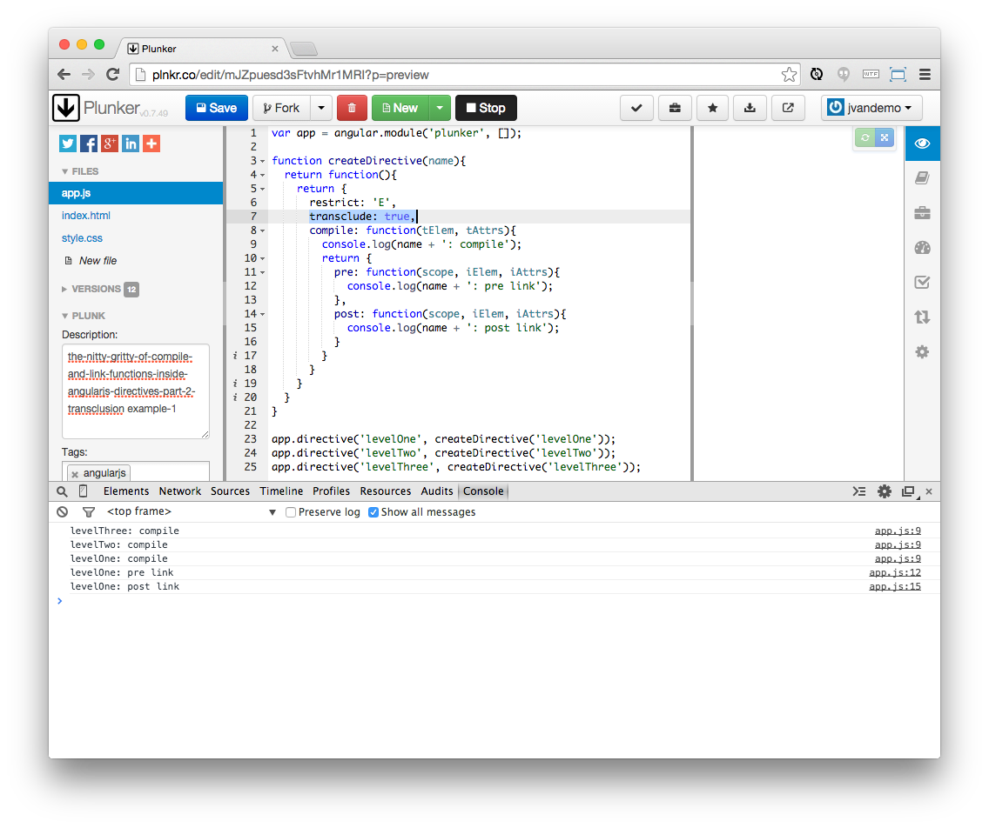
To try it out for yourself, just open this plnkr and take a look at the console.

Interesting
First of all notice how the order of the compile functions is reversed:
// COMPILE PHASE (Notice the reverse order)
// levelThree: compile function is called
// levelTwo: compile function is called
// levelOne: compile function is called

// PRE-LINK PHASE
// levelOne: pre link function is called

// POST-LINK PHASE
// levelOne: post link function is called
and even though we haven't transcluded the actual content yet using ng-transclude, all compile functions are called:

So what is happening?
When AngularJS processes the levelOne directive, it sees that the transcludeproperty is set to true in the definition object.
AngularJS now knows it first needs to process the content of the directive's element before it can make the processed content available inside the template.
To accomplish that, AngularJS first needs to process all child elements. So it starts travelling down the element's DOM.
When processing levelOne's content, it encounters the levelTwo directive and recursively repeats the same process until it has no more child elements to process.
As soon as the complete child DOM has been processed, AngularJS is ready to start applying the directives' compile, post-link and pre-link functions.
Since we haven't specified an ng-transclude attribute yet, the processed content is never put back into the DOM and we end up with a black hole where all child elements of levelOne disappear.
This is rarely useful in real situations, but for the purpose of experimentation it demonstrates how all compile functions are called, even if the content is not effectively transcluded.

Now let's add ng-transclude
To get a complete picture of what's happening, let's add a template property to our directive definition object with a string value of <div ng-transclude></div> to tell AngularJS where to put the transcluded content:
var app = angular.module('plunker', []);

function createDirective(name){
return function(){
return {
restrict: 'E',
transclude: true,
template: '<div ng-transclude></div>',
compile: function(tElem, tAttrs){
console.log(name + ': compile');
return {
pre: function(scope, iElem, iAttrs){
console.log(name + ': pre link');
},
post: function(scope, iElem, iAttrs){
console.log(name + ': post link');
}
}
}
}
}
}

app.directive('levelOne', createDirective('levelOne'));
app.directive('levelTwo', createDirective('levelTwo'));
app.directive('levelThree', createDirective('levelThree'));
and check the output again:
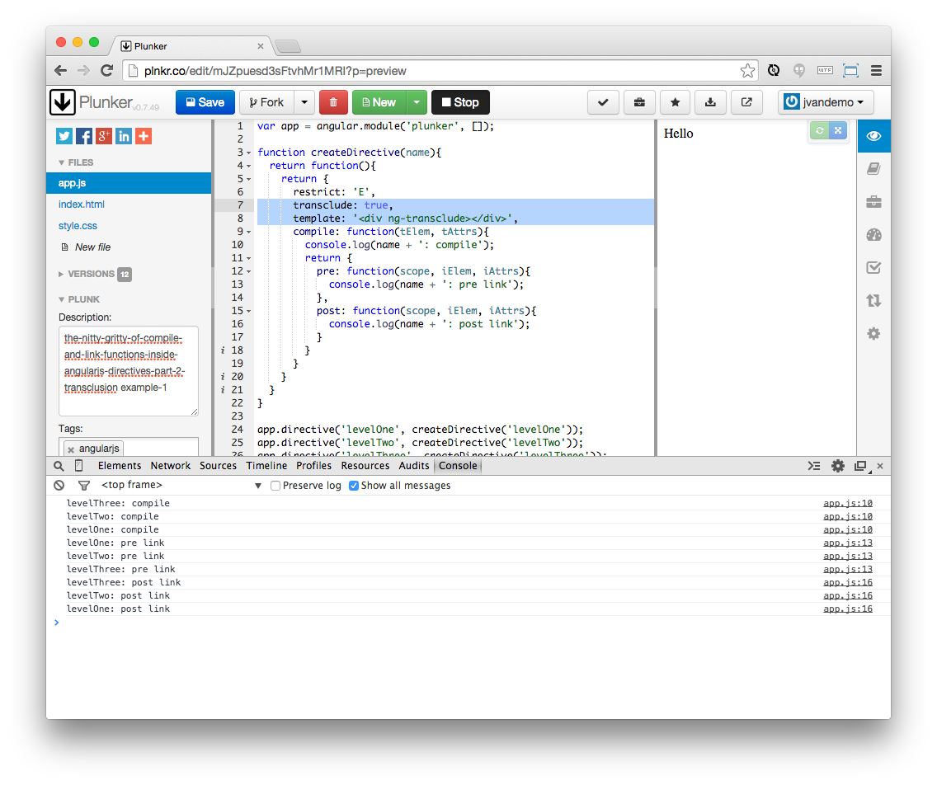
To try it out for yourself, just open this plnkr and take a look at the console.

Let's analyze further
If we summarize the output:
// COMPILE PHASE (Notice the reverse order)
// levelThree: compile function is called
// levelTwo: compile function is called
// levelOne: compile function is called

// PRE-LINK PHASE
// levelOne: pre link function is called
// levelTwo: pre link function is called
// levelThree: pre link function is called

// POST-LINK PHASE (Notice the reverse order)
// levelThree: post link function is called
// levelTwo: post link function is called
// levelOne: post link function is called
we can see that transclusion appears to reverse the order in which the compile functions are called.
Let's compare the difference visually:

Without transclusion

With transclusion

So why is transclusion reversing the order in which the compile functions are called?
If we look back at the initial output and how we defined transclusion earlier:
In AngularJS, transclusion is the inclusion of the directive's DOM element content into the directive's template
then we can quickly deduce that AngularJS needs to process the element's DOM content before it can make it available inside the template.
However, the element's child elements can also contain directives that apply transclusion themselves.
So AngularJS has to recursively traverse the DOM first to check if transclusion is enabled in child elements and then compile the DOM backwards to make sure all DOM changes correctly "bubble up" again to the top before the processed DOM is ready to be added to the original directive's template.
The initial black hole that we created before we included the ng-transclude attribute is a perfect example of this.
Finally, when compilation has finished, the pre-link and post-link functions are called in the same way as explained in part 1.

