Sept 1 2015 https://css-tricks.com/gulp-for-beginners/
Gulp: Automation of tasks
$ npm init // # ... from within our project folder
The npm init command creates a package.json
Now install gulp
$ npm install gulp --save-dev
This time, we're installing Gulp into project instead of installing it globally, which is why there are some differences in the command.
Gulp is a tool that helps you out with several tasks when it comes to web development. It's often used to do front end tasks like:
- Spinning up a web server
- Reloading the browser automatically whenever a file is saved//detect change are refresh the browse
- Using preprocessors like Sass or LESS
- Optimizing assets like CSS, JavaScript, and images
- :::::::::::::::::::::::::
In app folder structure, we'll use the app folder for development purposes, while the dist(as in "distribution") folder is used to contain optimized files for the production site.

let's begin by creating your first Gulp task in gulpfile.js, which stores all Gulp configurations.

:::::::::::::
var gulp = require('gulp');

hello refers to the name of the task…

'gulp.task('hello', function() {
console.log('Hello Zell');
});
We can run this task with gulp hello in the command line.
$ gulp hello // Hello Zell

Preprocessing with Gulp
We can compile Sass to CSS in Gulp with the help of a plugin called gulp-sass. You can install gulp-sass into your project by using the npm install command like we did for gulp.
We'd also want to use the --save-dev flag to ensure that gulp-sass gets added to devDependencies in package.json.
$ npm install gulp-sass --save-dev
We have to require gulp-sass from the node_modules folder just like we did with gulp before we can use the plugin.
var gulp = require('gulp');
// Requires the gulp-sass plugin
var sass = require('gulp-sass');

task for saas:

gulp.task('sass', function(){
return gulp.src('app/scss/styles.scss')
.pipe(sass()) // Converts Sass to CSS with gulp-sass
.pipe(gulp.dest('app/css'))
});

Watching Sass files for changes
Gulp provides us with a watch method that checks to see if a file was saved. The syntax for the watch method is:
gulp.task('watch', function(){
gulp.watch('app/scss/**/*.scss', ['sass']);
// Other watchers
})

Live-reloading with Browser Sync
Browser Sync helps make web development easier by spinning up a web server that helps us do live-reloading easily.
$ npm install browser-sync --save-dev
var browserSync = require('browser-sync').create();

gulp.task('browserSync', function() {
browserSync.init({
server: {
baseDir: 'app'
},
})
})

Optimizing CSS and JavaScript files
Developers have two tasks to perform when we try to optimize CSS and JavaScript files for production: minification and concatenation.
One problem developers face when automating this process is that it's difficult to concatenate your scripts in the correct order. Say we have included 3 script tags in index.html.
<body>
<!-- other stuff -->
<script src="js/lib/a-library.js"></script>
<script src="js/lib/another-library.js"></script>
<script src="js/main.js"></script>
</body>These scripts are located in two different directories. It'll be difficult to concatenate them with traditional plugins like gulp-concatenate.
Thankfully, there's a useful Gulp plugin, gulp-useref that solves this problem.
$ npm install gulp-useref --save-dev
$ npm install gulp-uglify --save-dev

// Other requires...
var uglify = require('gulp-uglify');
var gulpIf = require('gulp-if');

gulp.task('useref', function(){
return gulp.src('app/*.html')
.pipe(useref())
// Minifies only if it's a JavaScript file
.pipe(gulpIf('*.js', uglify()))
.pipe(gulp.dest('dist'))
});
Gulp should now automatically minify the `main.min.js` file whenever you run the useref task.
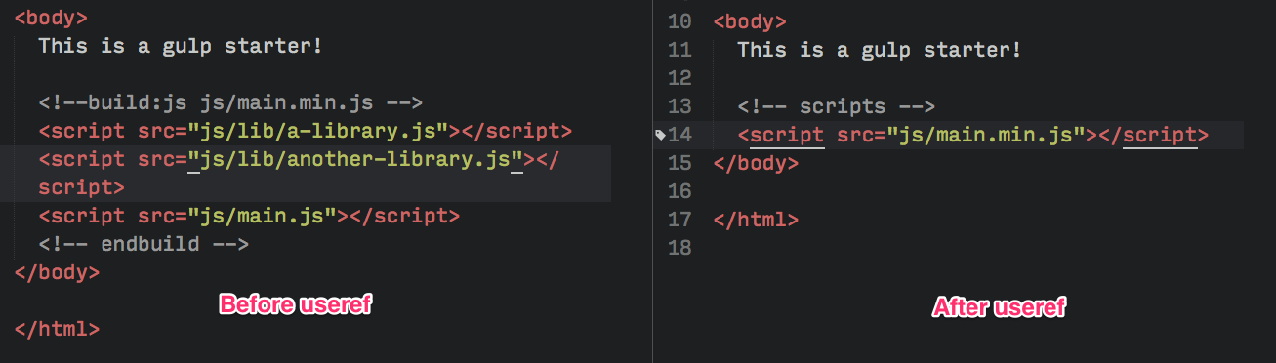

Optimizing Images
You've probably guessed it by now; we need to use gulp-imagemin to help us with optimizing images.
$ npm install gulp-imagemin --save-dev
var imagemin = require('gulp-imagemin');
We can minify png, jpg, gif and even svg with the help of gulp-imagemin. Let's create an images task for this optimization process.
gulp.task('images', function(){
return gulp.src('app/images/**/*.+(png|jpg|gif|svg)')
.pipe(imagemin())
.pipe(gulp.dest('dist/images'))
});

Cleaning up generated files automatically
Since we're generating files automatically, we'll want to make sure that files that are no longer used don't remain anywhere without us knowing.
npm install del --save-dev
var del = require('del');

The del function takes in an array of node globs which tells it what folders to delete.
Setting it up with a Gulp task is almost like the first "hello" example we had.
gulp.task('clean:dist', function() {
return del.sync('dist');
})
Now Gulp will delete the `dist` folder for you whenever gulp clean:dist is run.

Combining Gulp tasks
Let's summarise what we've done. So far, we have created two distinct sets of Gulp tasks.
The first set is for a development process, where we compiled Sass to CSS, watched for changes, and reloaded the browser accordingly.
The second set is for an optimization process, where we ready all files for the production website. We optimized assets like CSS, JavaScript, and images in this process and copied fonts over from app to dist.
We've already grouped the first set of tasks together into a simple workflow with the gulp watch command:
gulp.task('watch', ['browserSync', 'sass'], function (){
// ... watchers
})
The second set consists of tasks that we need to run to create the production website. This includes clean:dist, sass, useref, images and fonts.
If we went by the same train of thought, we could create a build task to combine everything together.
gulp.task('build', [`clean`, `sass`, `useref`, `images`, `fonts`], function (){
console.log('Building files');
})

Dynamic environments for your gulp tasks
https://medium.com/wolox-driving-innovation/dynamic-environments-for-your-gulp-tasks-27fada475c7e
:: transpile the es6 code using babel import babel from 'gulp-babel';

We use eslint import eslint from 'gulp-eslint';

when working on big projects that have different user environments (qa, stage, production, etc), you’ll probably find yourself rewriting some of your gulp tasks for each new environment that your team needs.

import gulp from 'gulp';
import uglify from 'gulp-uglify';
import eslint from 'gulp-eslint';
import babel from 'gulp-babel';
import concat from 'gulp-concat';
import sourcemaps from 'gulp-sourcemaps';
import gulpif from 'gulp-if';
import globalConfig from './config';
const taskOptions = globalConfig.getConfigKeys(); // below page has config of diff. tasks
const localConfig = {
src: './src/js/**/*.js',
dest: './build/js/',
buildFileName: 'all.js'
};
gulp.task('js', () =>
gulp.src(localConfig.src)
.pipe(gulpif(taskOptions.lint, eslint()))
.pipe(gulpif(taskOptions.lint, eslint.format()))
.pipe(gulpif(taskOptions.sourcemaps, sourcemaps.init()))
.pipe(babel())
.pipe(gulpif(taskOptions.concat, concat(localConfig.buildFileName)))
.pipe(gulpif(taskOptions.minify, uglify()))
.pipe(gulpif(taskOptions.sourcemaps, sourcemaps.write()))
.pipe(gulp.dest(localConfig.dest))
);
gulp.task('build', ['js', 'css', 'vendor']);

default {
/**
* concat
* Enables/Disables source files concatenation
*/
concat: true,
/**
* lint
* Enables/Disables source code linting
*/
lint: false,
/**
* minify
* Enables/Disables source code minification
*/
minify: true,
/**
* sourcemaps
* Enables/Disables js and sass sourcemaps
*/
sourcemaps: false
}

Did you see what happened? We didn’t need new tasks, we didn’t need long rules. The only thing that is needed is a configuration file, so flexible that you can set up your environment to do whatever you want and even create new rules, and so scalable that you can have the number of environments you want.
So, whenever you want you gulp tasks to be executed for a special environment, just specify it with the env param.

ADDITIONAL articles:

Gulp.task(‘scripts’, function(){
Gulp.src([‘/bowercomponet/jquery.js’, ‘/bowercomponet/abc.js’])
.pipe(concat(app.js)
.pipe(gulp.dest(‘./public.js));
})
npm sctipts are command line scripts which you run under shell(terminal).
Gulp is focused on configuration..
Gulp is focused on code.

What are bundlers:Modules with dependencies.
Everything can be bundled: js,jsx,css,less,png,svg,json,csv etc ect

+++++++++++++++++++++
Bundler definitions:
require : every one used this in node.js syntax is below
var myCommonJSModule = require(‘my-module’);
ES6: angular2 used this. Syntax is below
Import myES2015Module from ‘/ src/service/my-module’
Define: used in in jquery
Define([‘my-module’], function (myAMDModule) {} );

Bundler now also want to bundles JPEG+CSS+PNG+JSON+SVG+WHATEVER
Solution:
- Browserfy is no more useful
- Webpac: bundler/plugins/loaders/optimizer/code-splitter/dev-tool

++++++++++++++++++++++
bower install dependencies:
bower install angular // creates bower folder along with angular dependency loaded , see below..

> bower_components
>angular
>bootstrap
>jquery
>customLib

ng build --prod –aot // minifies bundle

