

Mini Project

G Rithwik Surya

Problem Statement:
Build a complete pipeline that reads a CSV file from Blob Storage and processes it using Azure Data Factory.

Requirements:
- Source: CSV file in Blob
- Use: Linked Service + Dataset + Pipeline
- Process: Copy Data + Metadata check
- Destination: New file/location

- Created a resouce group with a name of mini_project_week4
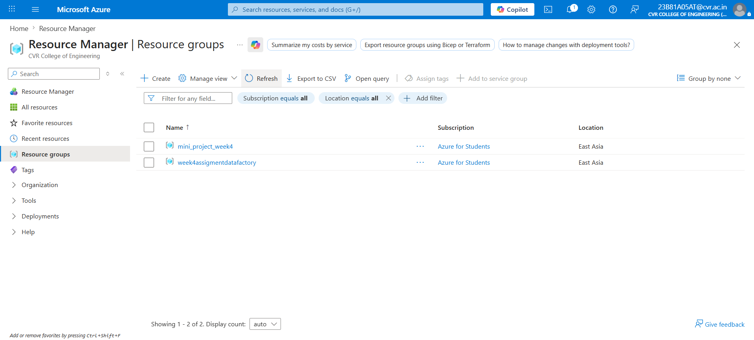

- Created a storage account as a blob storage
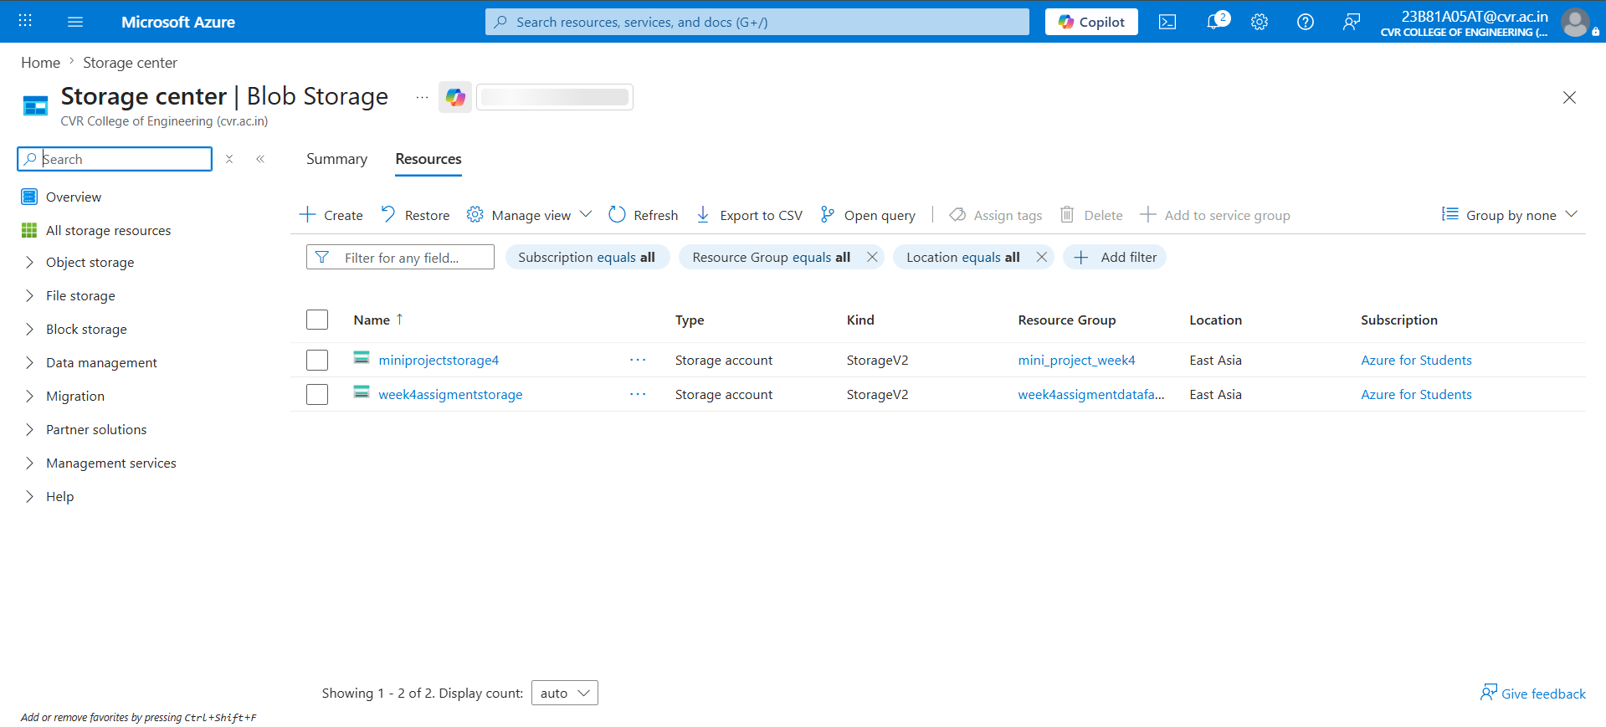

- Created two containers for source and destination in the storage account
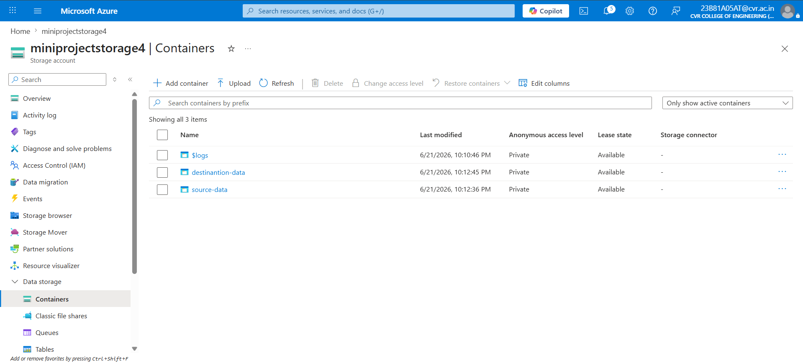

4 . added dataset into souce-data container
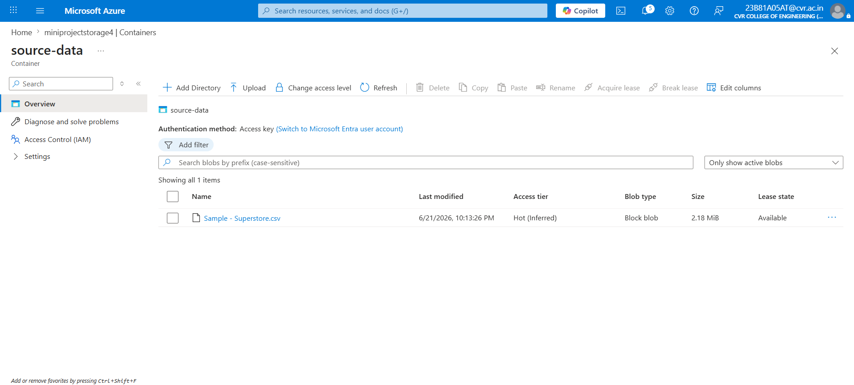

5 created a datafactory to create and run pipelines
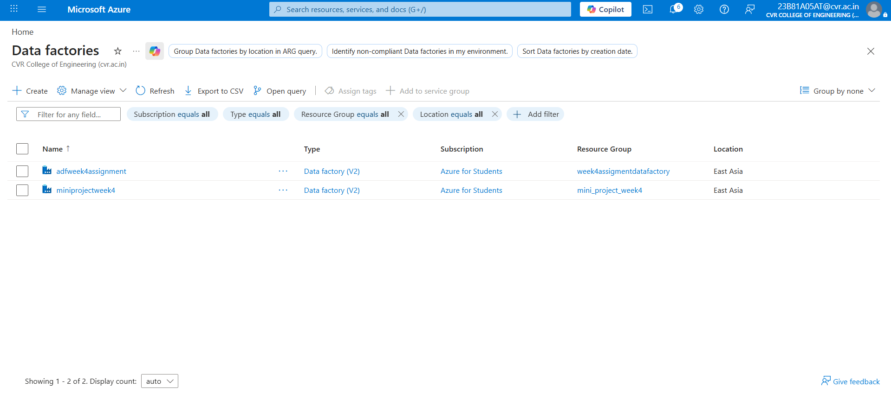

6 created a linked service
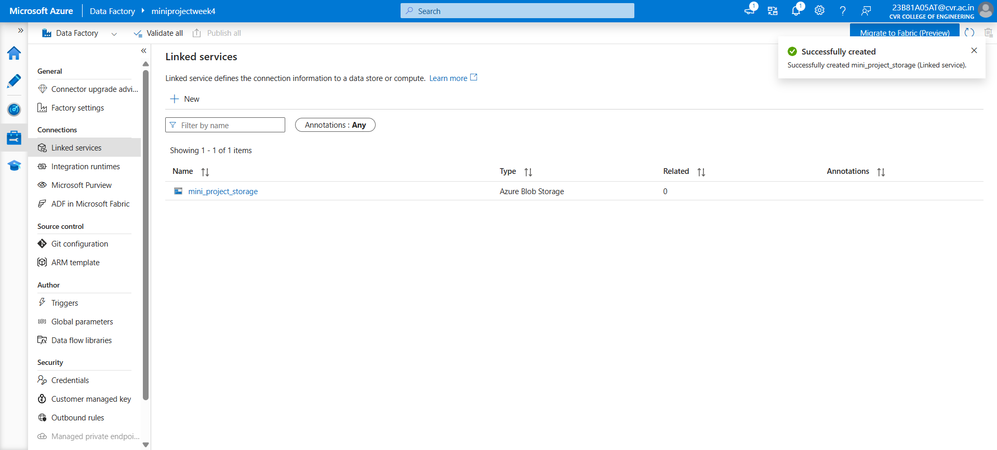

7 created two datasets as source-data and destination-data

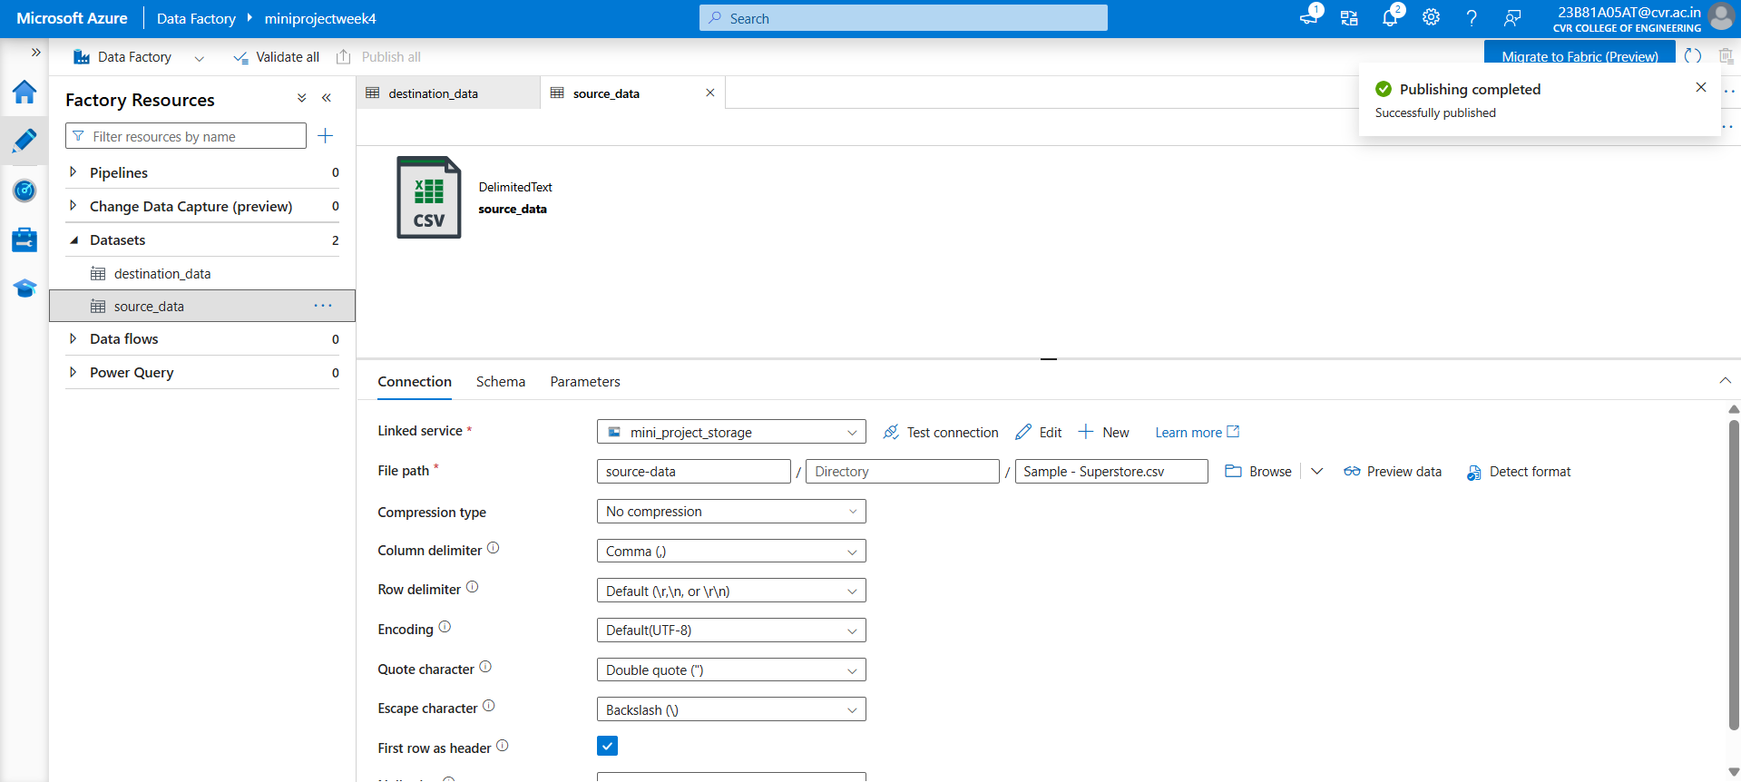

8 created a pipe line to run copy activity pipeline

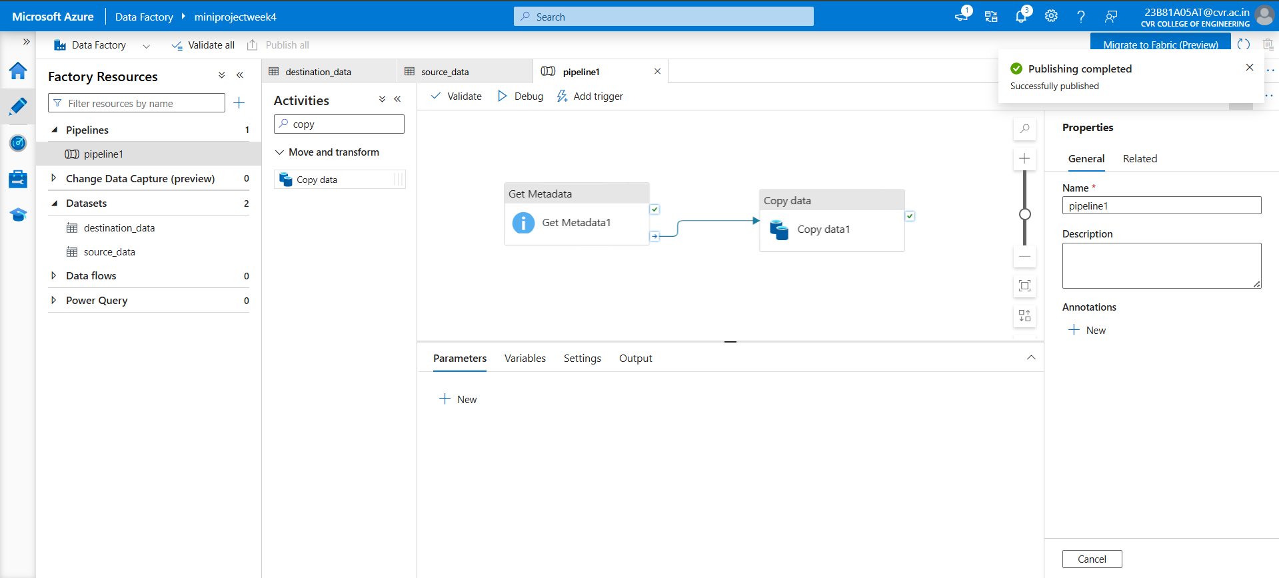

9 ran the pipeline using debug

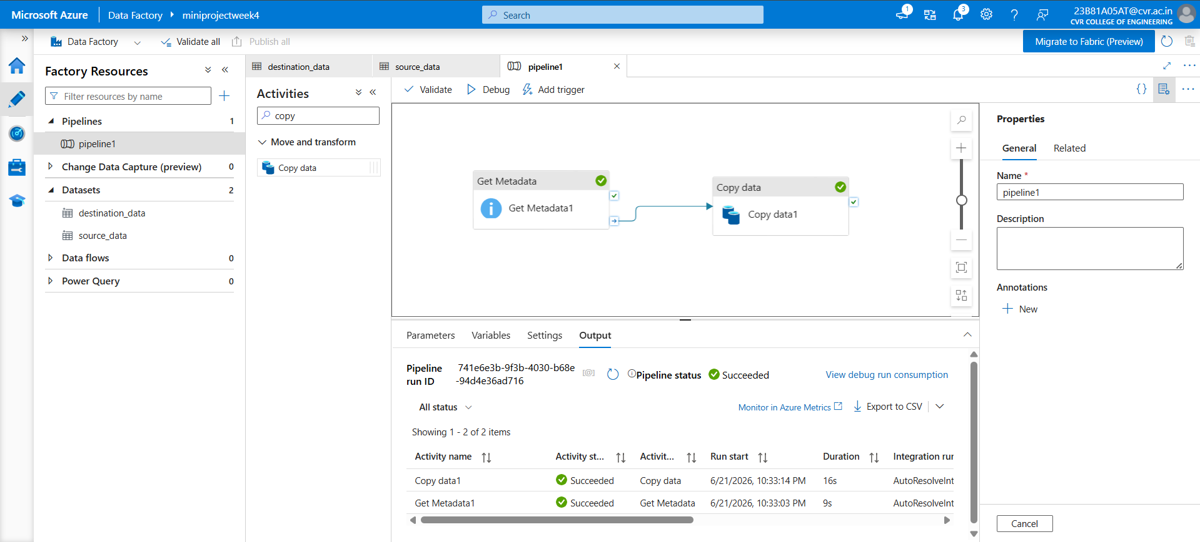

Gave the output as pipeline ran successfully

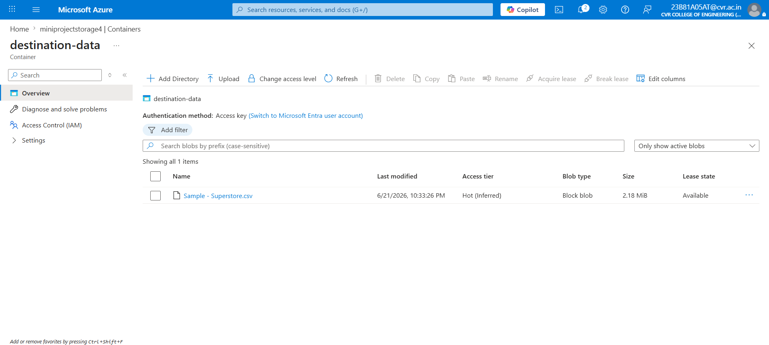
Data is copied to destination folder

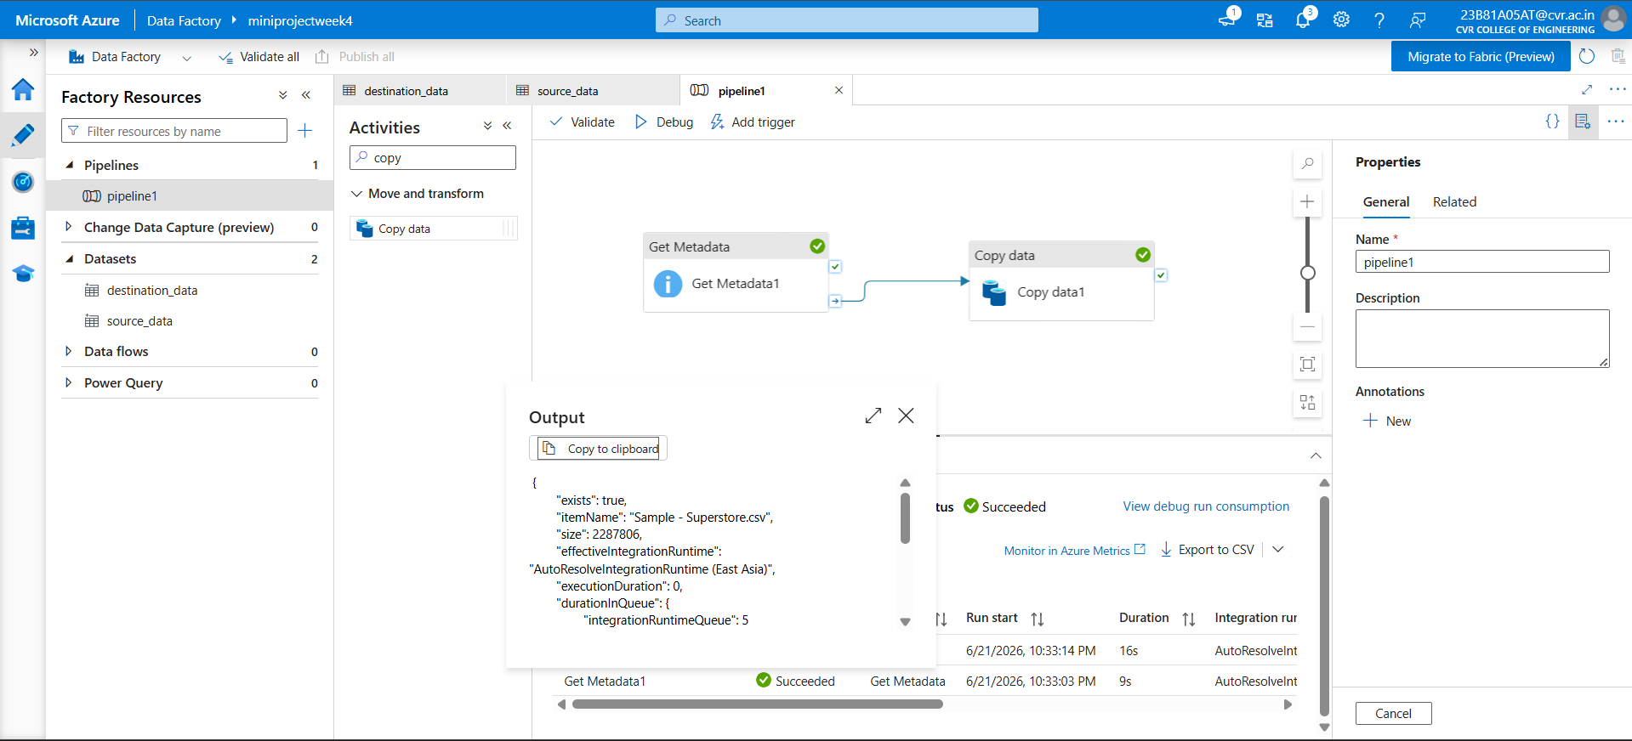
{
"exists": true,
"itemName": "Sample - Superstore.csv",
"size": 2287806,
"effectiveIntegrationRuntime": "AutoResolveIntegrationRuntime (East Asia)",
"executionDuration": 0,
"durationInQueue": {
"integrationRuntimeQueue": 5
},
"billingReference": {
"activityType": "PipelineActivity",
"billableDuration": [
{
"meterType": "AzureIR",
"duration": 0.016666666666666666,
"unit": "Hours"
}
]
}
}

Meta data validated and meta data output

