

Azure Cloud Fundamentals and Data Pipeline Implementation using ADF

G Rithwik Surya

Task 1:

- Explore Azure Portal :

- Logged into microsoft azure using a student account

- Create a Resource Group :

A resource group is created in azure to organize and manage all resources required for the project. Resource groups helps in management and monitoring

- Created a resource group with ane ‘week4assignmenmtdatafactory’
- Selected the student plan subscription and ‘east asia’

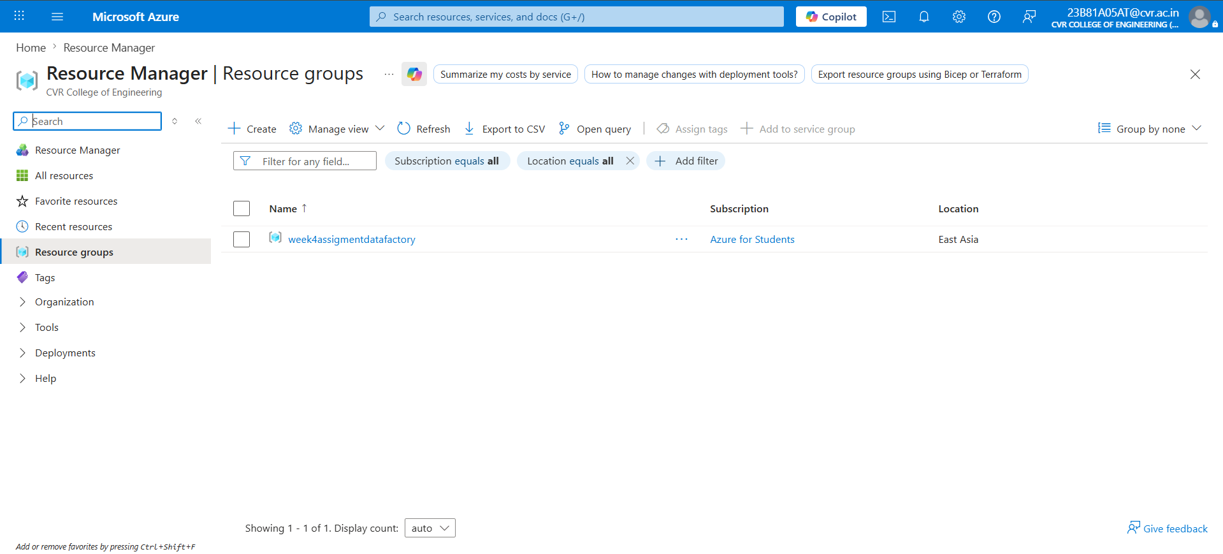

Task 2: Storage Setup

- Create a Storage Account :

A storage account is a cloud storage service in azure used to store and manage data

- Created a new storage account with name as ‘week4assignmentstorage’
- Assigned this storage account to the resource group that i had already created ‘week4assignmenmtdatafactory’
- Selected the student plan and east asia region
- Selected azure blob storage or azure data lake storage
- Blob storage is used because as we are storing csv files blob storage is the best and the effective option as it allows to store unstructued data and also its easy to integrate with azure data factory
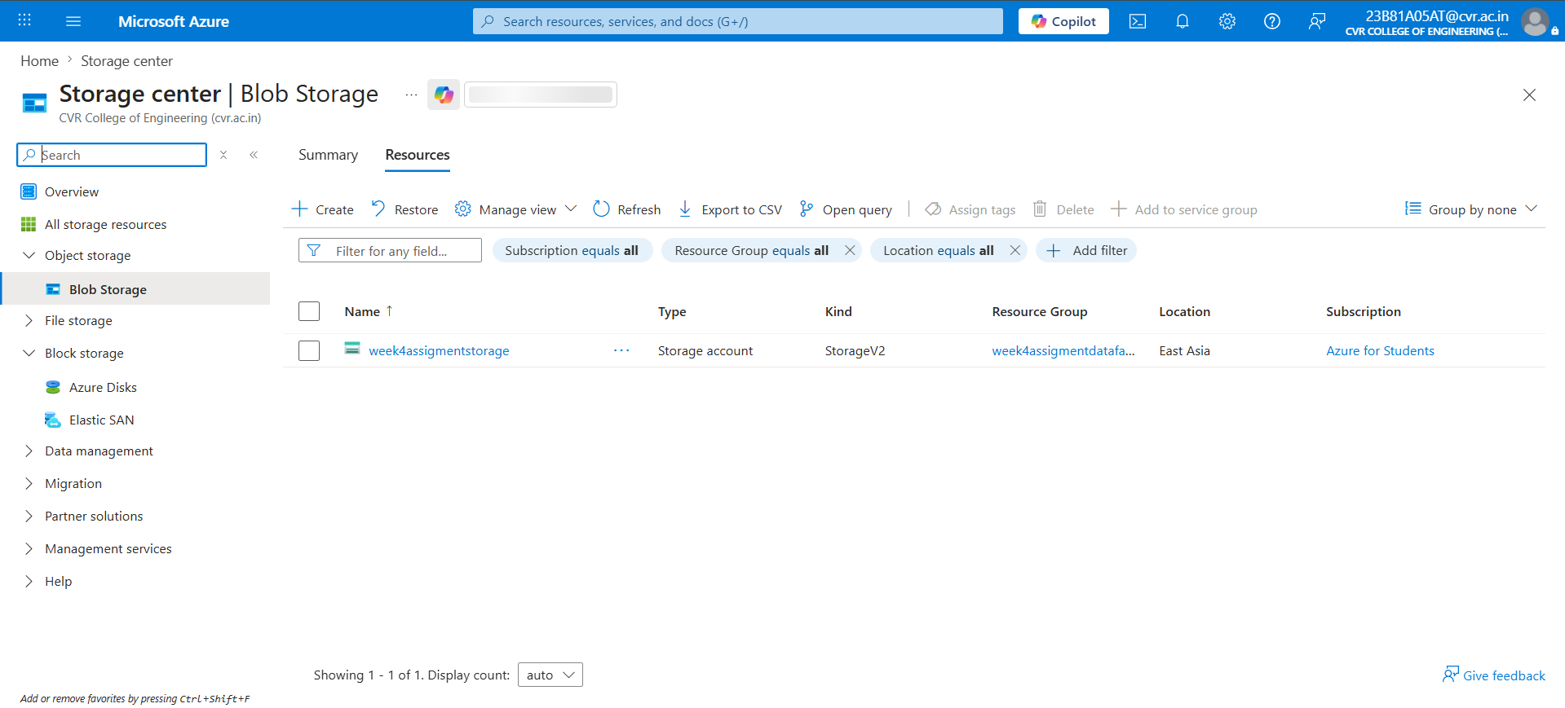

- Create a Blob Container :

A blob container is within azure blob storage used to store the files and organize them ,multiple files could be uploaded and managed in a container.

- Created two containers as source-data and processed-data one to store the raw files and another one is to store the copied file
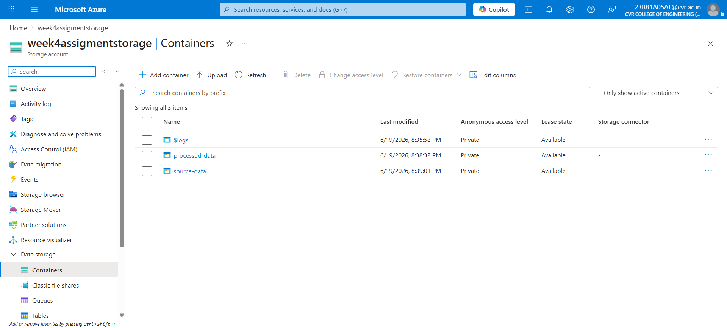

- Upload a CSV file :

We need to upload the dataset into the containers

- Uploaded the sample_superstore.csv dataset into the source-data
- And created a sample file named as cleaned_dataset inside processed-data to store the copied file
- Along with these two files also uploaded 3 files named as customer1 ,customer 2 and customer 3 to run for each activity in adf

Source-data

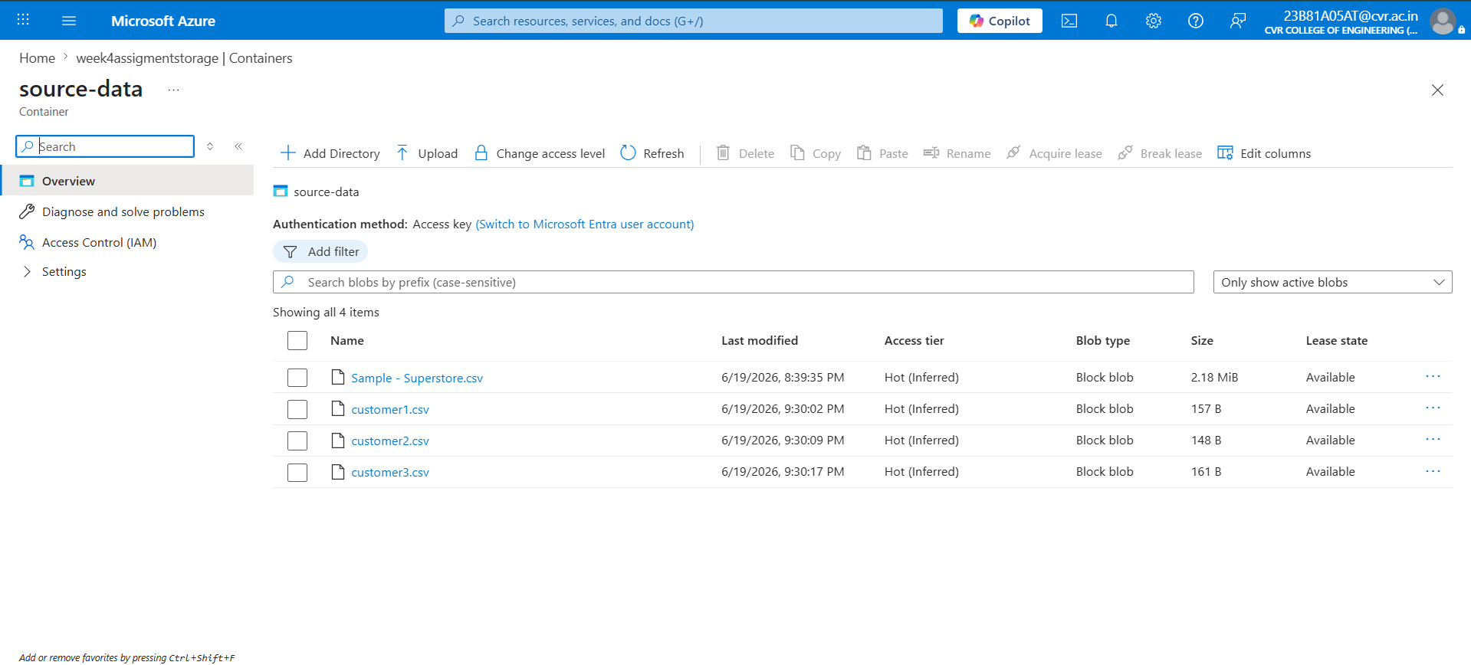

Processed-data

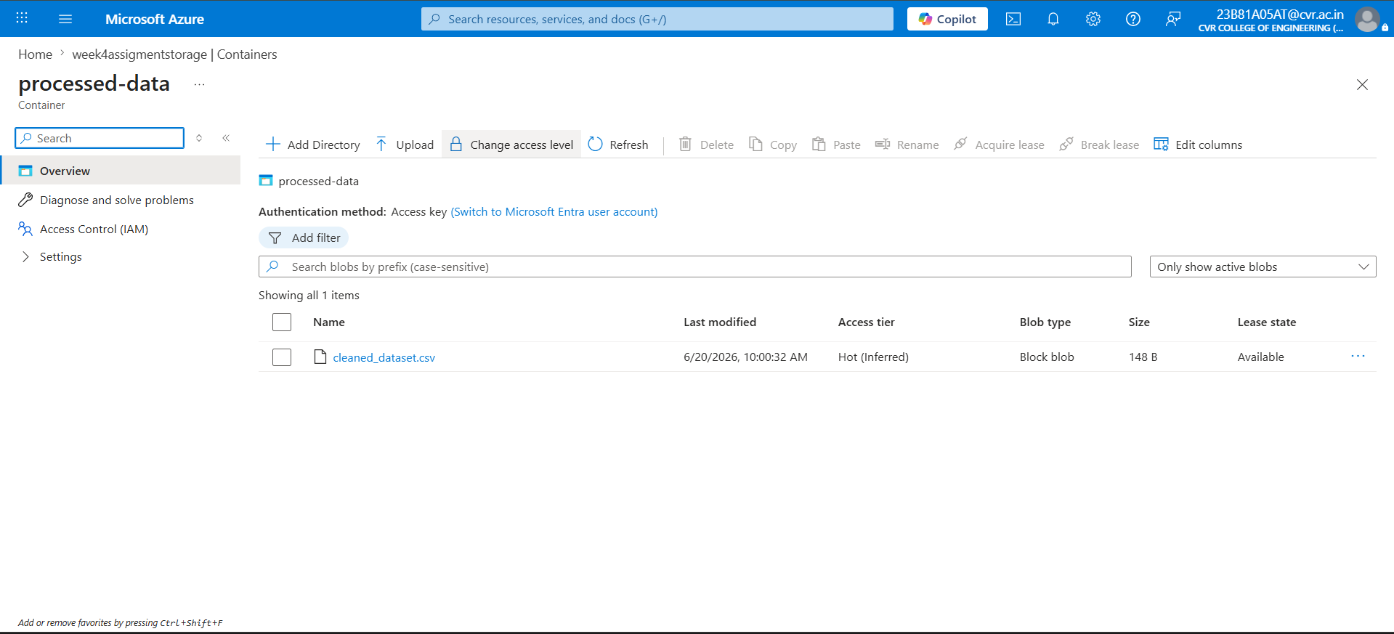

Task 3: ADF Basics

- Create Azure Data Factory :

Azure data factory is a cloud based data integration service that enables users to create and manage pipelines.It is a cloud based elt and etl service

- Created a azure data factory with the name ‘adfweek4assignment’
- Selected the students account and resource group as ‘week4assigmentdatafactory ’ where the region was east asia same as resource group
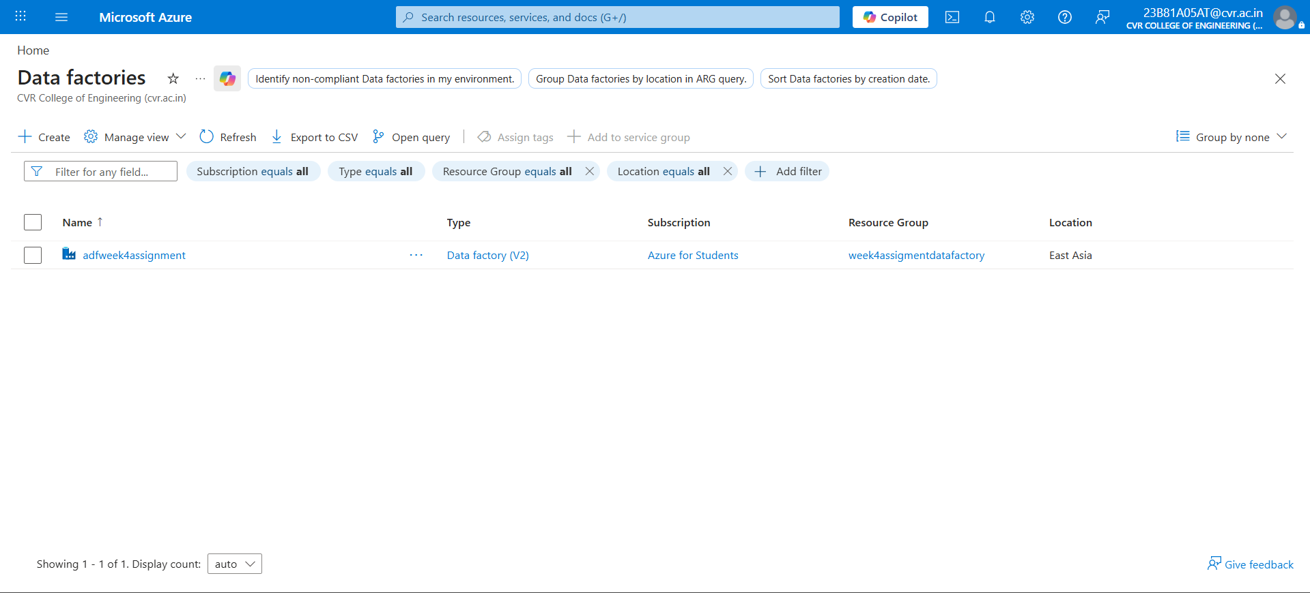

2.Explore ADF UI (Author, Monitor, Manage) :

- Author: Used to create and design data pipelines, datasets, linked services, and data flows in Azure Data Factory
- Monitor: Used to track pipeline executions and identify errors during execution.
- Manage: Used to configure connections, integration runtimes triggers and other settings in Azure Data Factory.
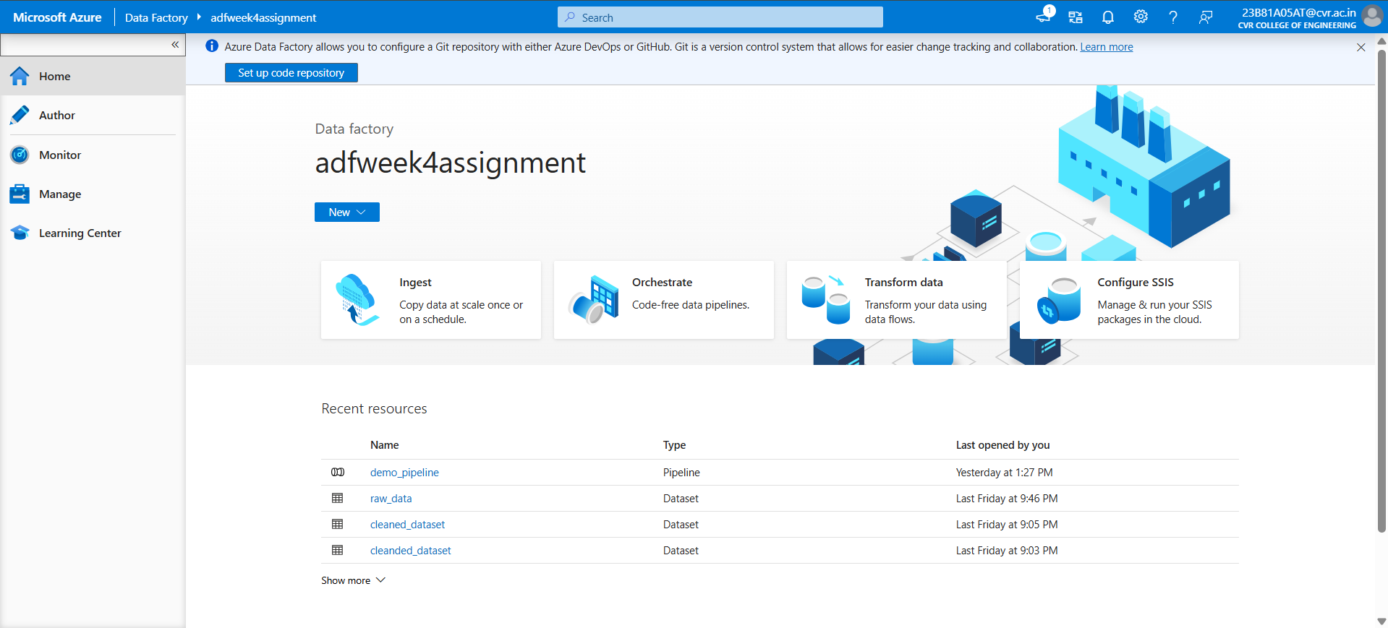

3.Create Linked Service (Blob Storage) :

Linked Service is a connection configuration in Azure Data Factory that allows ADF to connect to external data sources and destinations
- For creating a linked service selected azure blob storage datastore and names the service as ‘ls_blobstorage’
- Selected subscription for students
- To test whether the linked service working or not click on test connection and apply
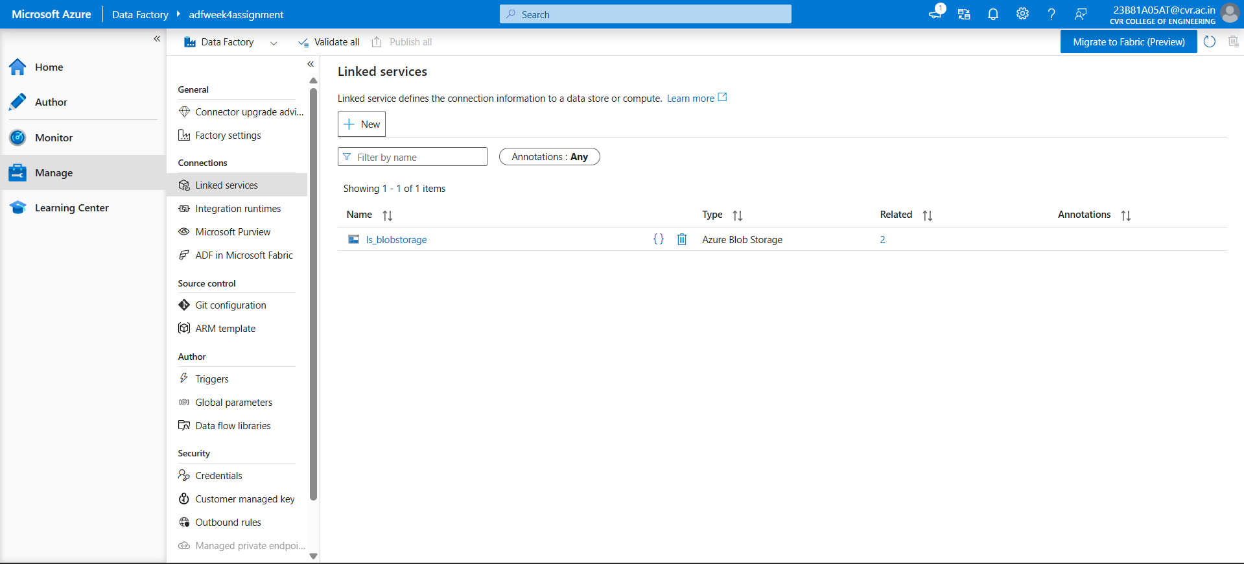

4.Create datasets (source + destination) :

To create datasets we need to go to author and click on datasets

- Selected azure blob storage for data store type and as the data i uploaded is a csv file selected delimitedText for the file type
- And gave the names as raw_data for one and another one is cleanded_dataset and added the ls_blobstorage link service to them.
- Added the parameters to configure multiple files
- Configured the file path for both datasets. For the raw_dataset, since multiple files need to be processed dynamically, the file name was parameterized using @dataset().rawfile_data
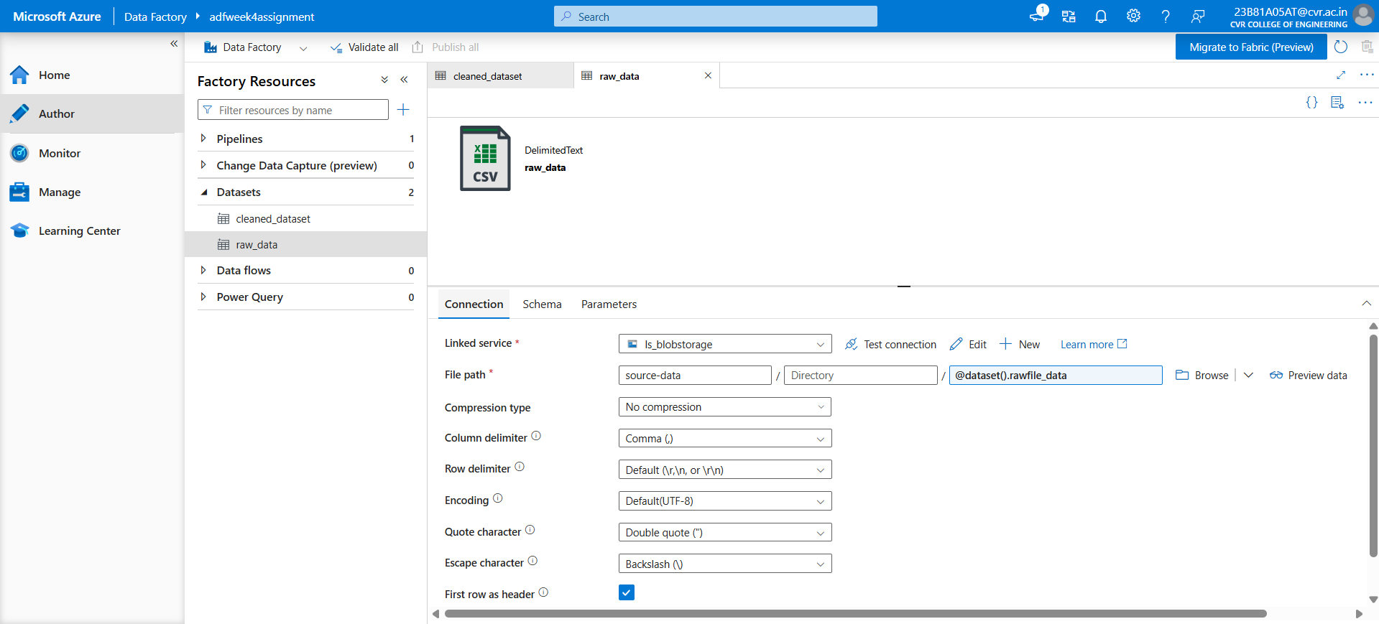

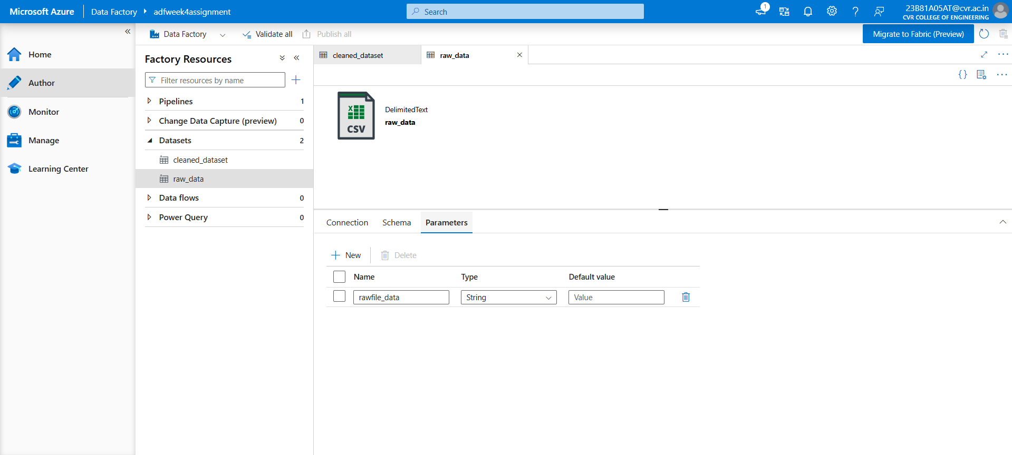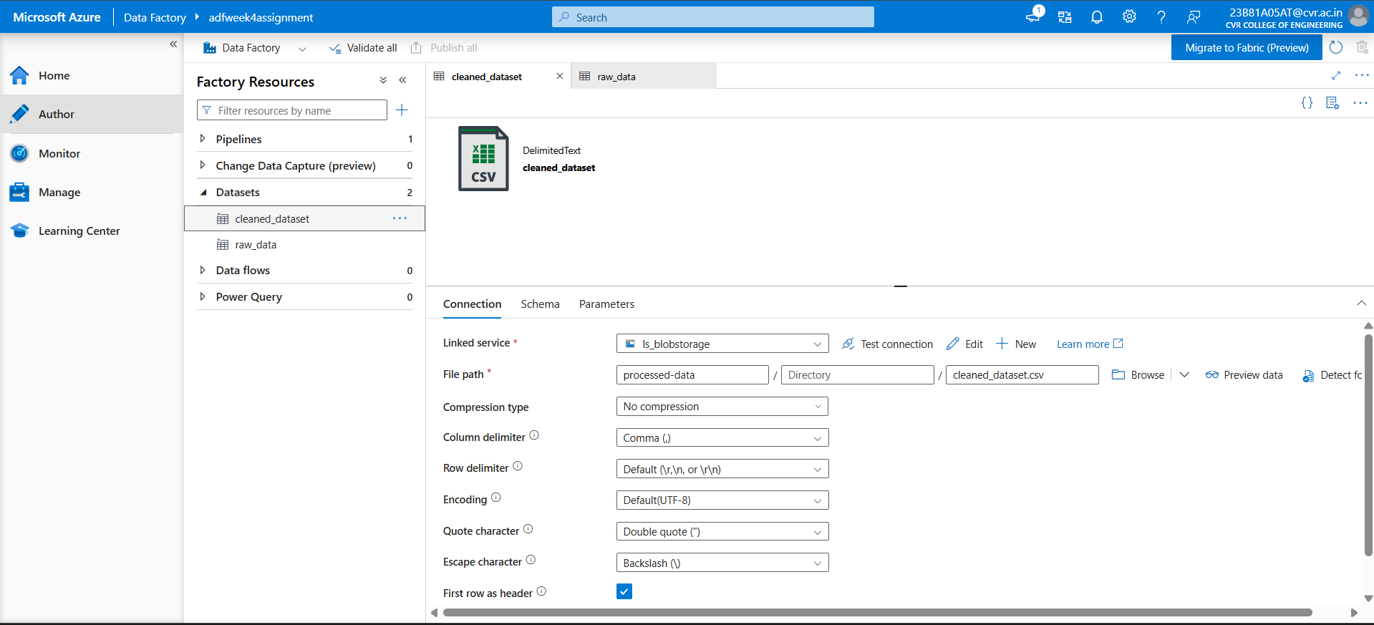

5.Use Get Metadata activity :

Get Metadata Activity is used to retrieve information about a file or folder before processing it in a pipeline

- Created a pipeline and named it as meta_data_pipeline
- Added multiple fields as
- Exists,last modified and item name
- And published everything after that to check clicked on debug
- It showed as successed
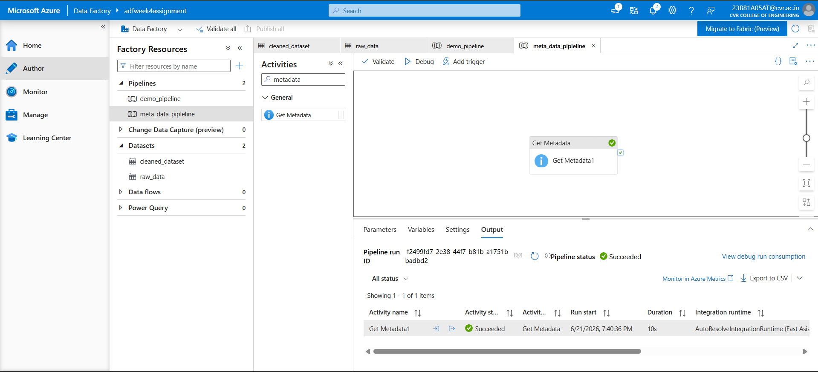

Task 4: Pipeline Development:

1.Create pipeline using Copy Data activity :

Copy Data Activity is used to transfer data from a source dataset to a destination dataset within Azure Data Factory. It enables automated data movement between different storage systems and services

2.Configure source and destination :

for copy activity we need to configure source and sink with source file and destination file where in my case it is source-data and processed-data

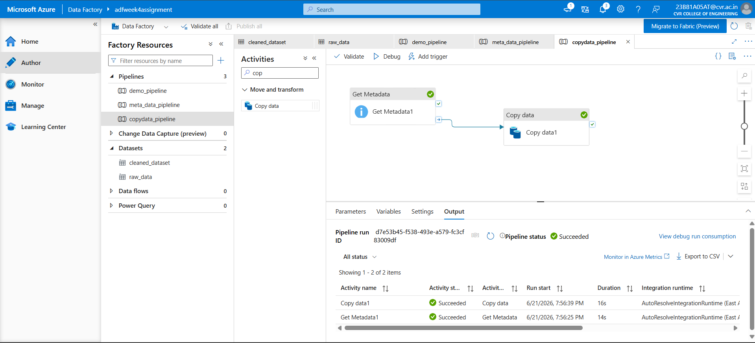

3.Add ForEach activity (optional if multiple files) :

ForEach Activity is used to iterate through a collection of items and execute one or more activities repeatedly for each item.
- Select for each activity and configured the parameter to run the multiple files where i selected meta data foreach and copy activity to run this pipe line
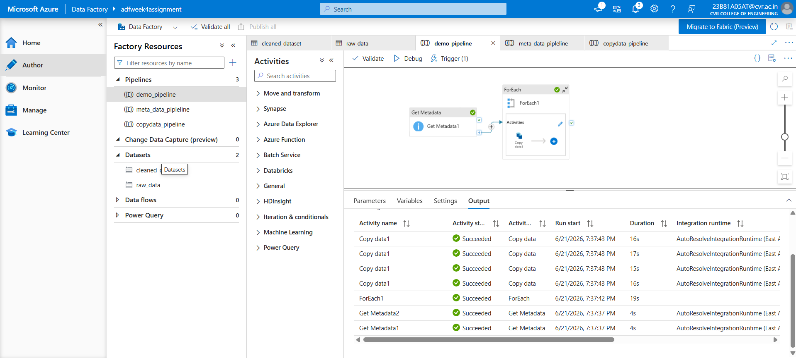

Task 5: Pipeline Execution

1.Run pipeline using Debug/Trigger

To run the pipeline there are two ways we can add a trigger there are three types of trigger used according to the need and we can also run using debug
If the pipeline run without any errors it displays as successed with outputs

Outputs of 3 pipelines when ran:
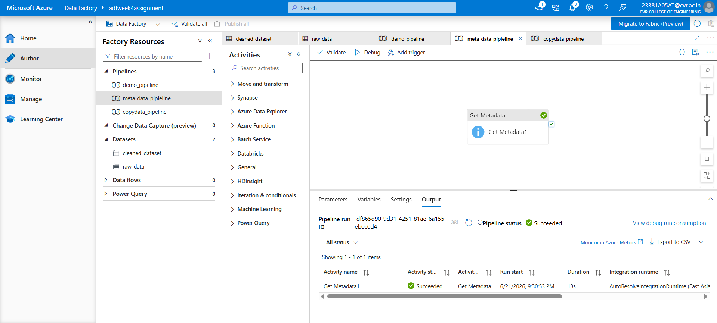
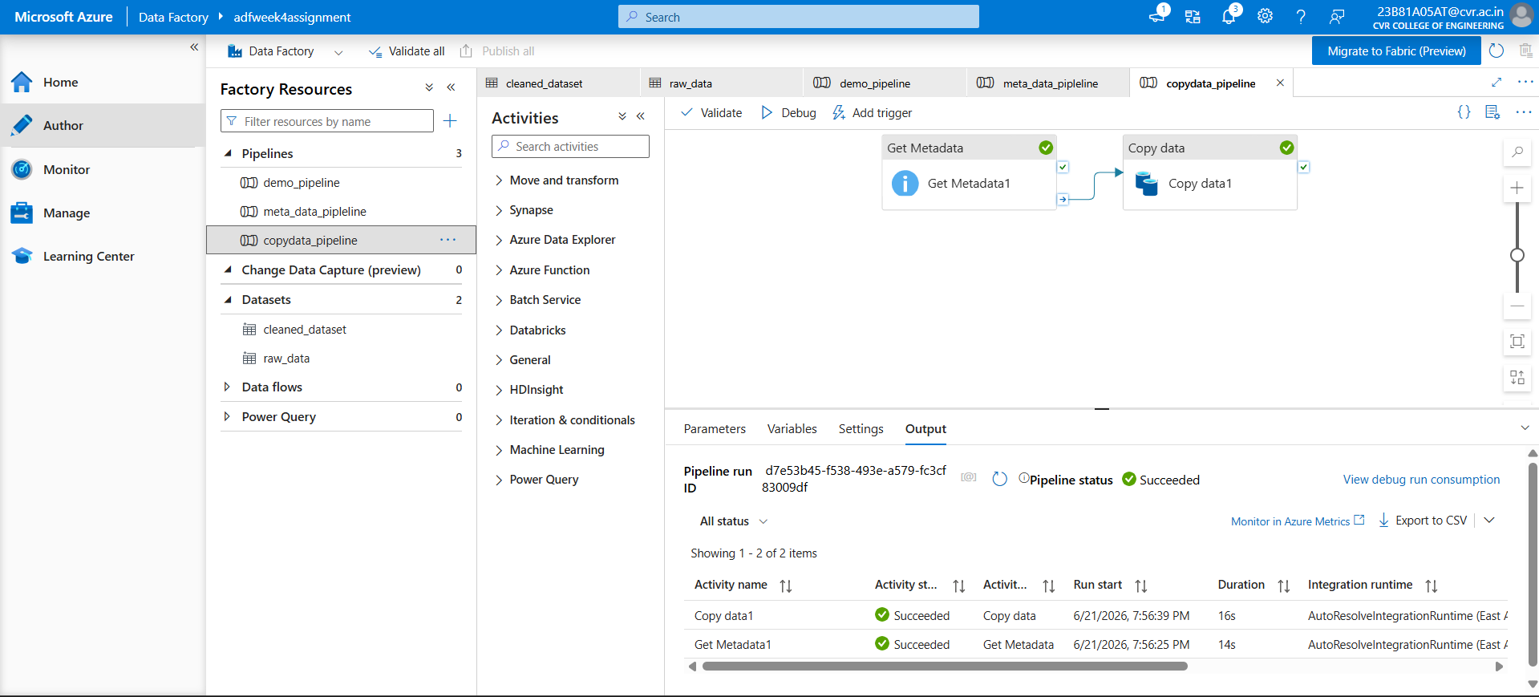
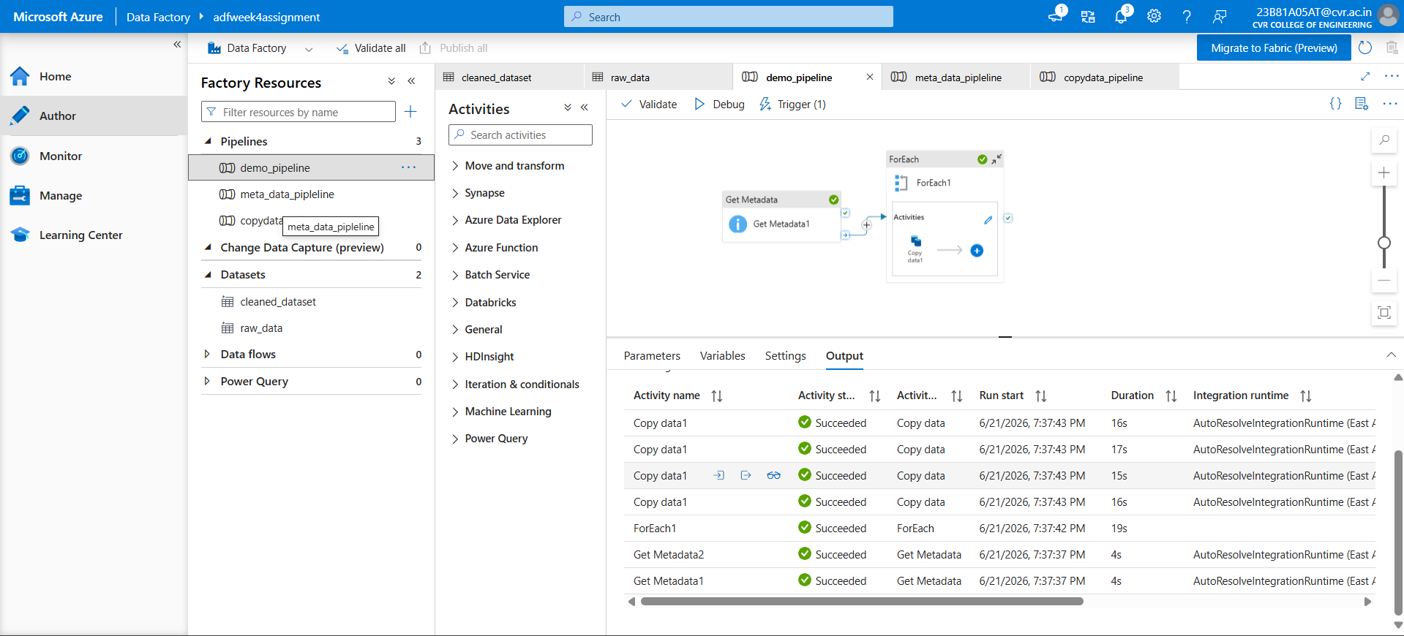
Scheduled trigger:
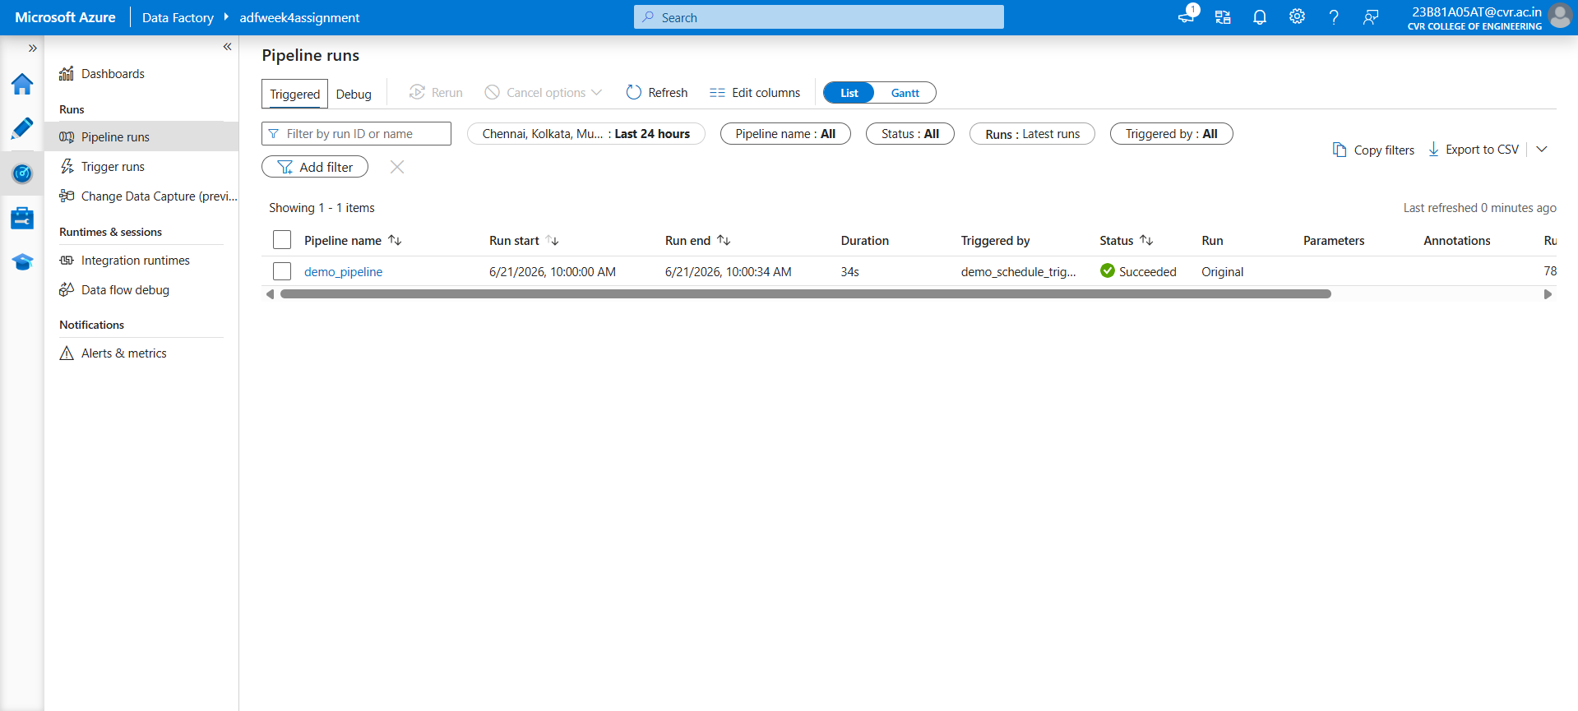
The pipeline ran at 21/6 10:00 am as scheduled before

Debug pipeline runs
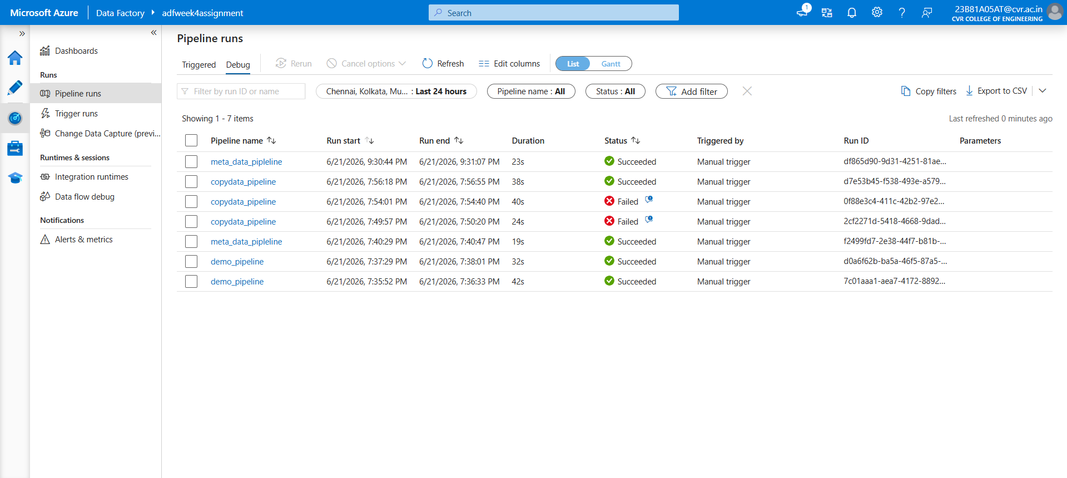
Task 6: IAM Roles
1.Assign roles:
- Reader
- Contributor

IAM (Identity and Access Management) is used in Azure to control who can access resources and what actions they can perform. It helps secure Azure resources by assigning appropriate permissions

The Reader role provides read-only access to Azure resources.
The Contributor role allows users to manage Azure resources.

- To assign the role go to the iam section and click on add role assignment and assign the roles ‘
- But here i have an issue that i cannot assign contributor role due to student account
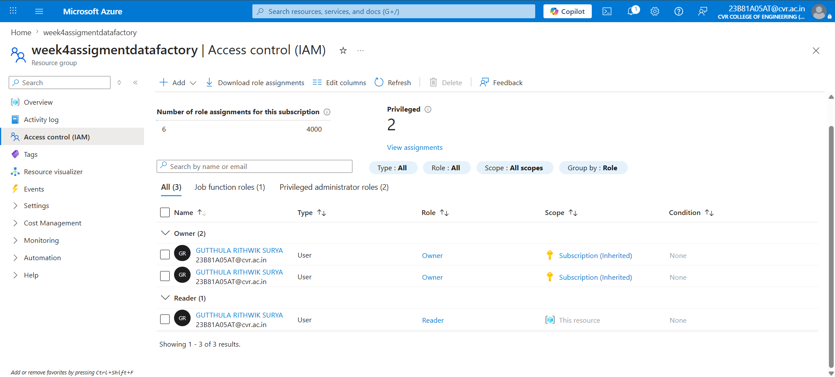

Provide access to ADF for Storage

To provide access to adf for storage we need to assign roles at data storage we can provide two roles as storage blob data contributer and storage blob data reader
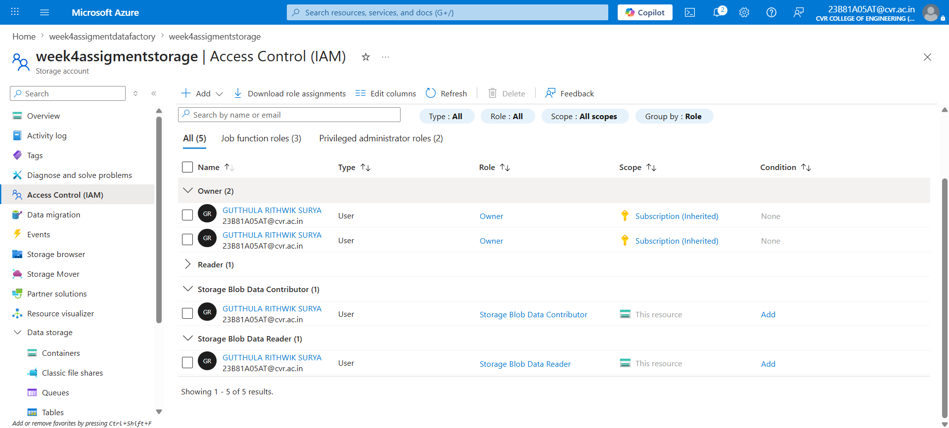

During this assignment, I learned how different Azure services work together to build a complete data pipeline. I created a Resource Group, Storage Account, Blob Container, and Azure Data Factory instance, which helped me understand how resources are organized and managed in Azure. I also learned how to create Linked Services and Datasets to establish connections between Azure Data Factory and Azure Blob Storage.
While building the pipeline, I gained practical experience with Get Metadata, ForEach, and Copy Data activities. The most challenging part for me was configuring the ForEach activity. Initially, I was unable to process multiple files because I did not understand how dataset parameters worked and how values needed to be passed dynamically using expressions such as @item().name. I spent considerable time troubleshooting errors and understanding the relationship between Get Metadata output, ForEach iterations, and dataset parameters. Through this process, I learned how dynamic content is used in Azure Data Factory and how pipelines can be designed to process multiple files automatically.
I also explored Azure IAM and understood the purpose of Reader and Contributor roles in controlling access to resources. Another important lesson was learning how to validate pipelines, monitor executions, identify errors from activity outputs, and debug failures effectively.
Overall, this assignment gave me hands-on experience with Azure cloud services and helped me understand the complete workflow of building, troubleshooting, and executing data pipelines. More than creating the pipeline itself, I learned how to solve configuration issues, work with dynamic parameters, and use Azure Data Factory to automate data movement in a real-world scenario.

