

WEEK 3 - ASSIGNMENT

G . Rithwik Surya
Data Engineering

Query 1 : creating database schema to store tables
create database superstore_data;

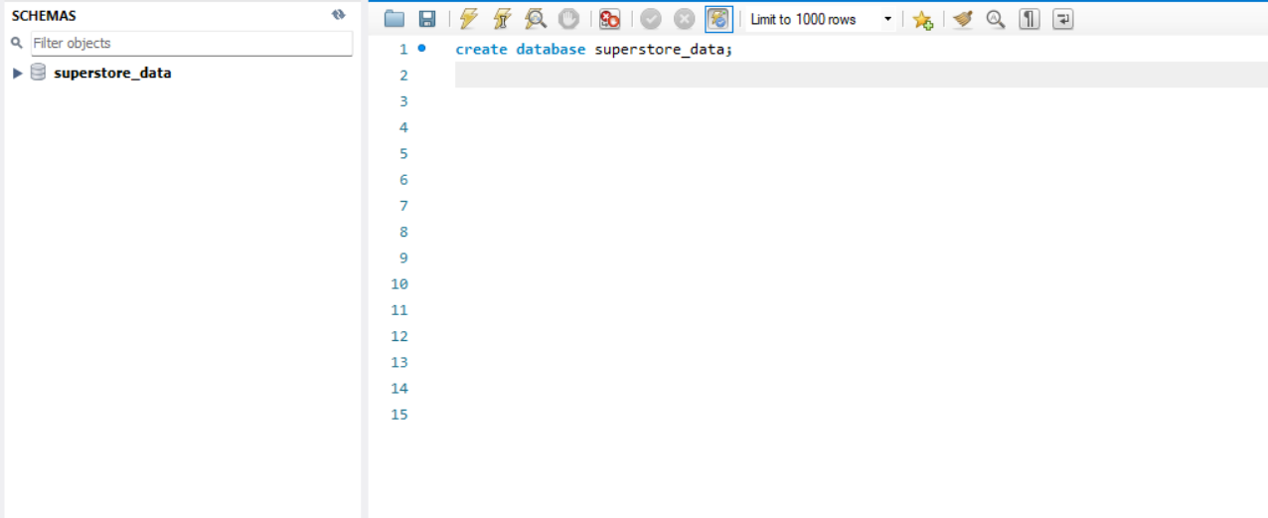

Schema is created

Query 2 :use the superstore_data database
use superstore_data;

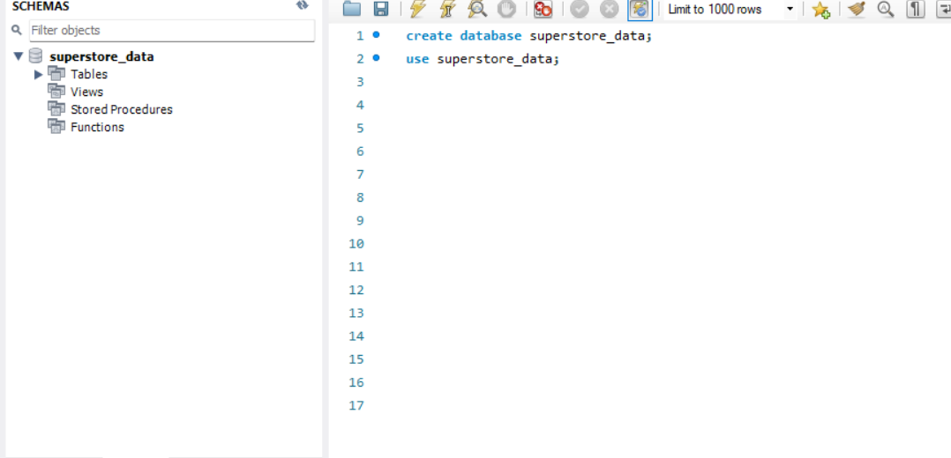

The schema is highlighted such that now we can use the database for adding tables
The superstore_raw table is created and data is imported through table data import wizard in sqlworkbench

Query 3 and 4: verifying the count of records in the table and the type of each column

Describe superstore_raw;
select count(*) from superstore_raw;

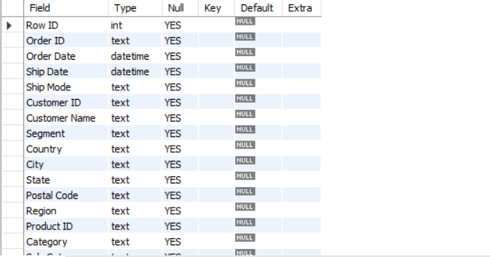

Query 5: creating customers table
create table customers(
customer_id varchar(50) Primary key,
customer_name varchar(100),
segment varchar(50)
)

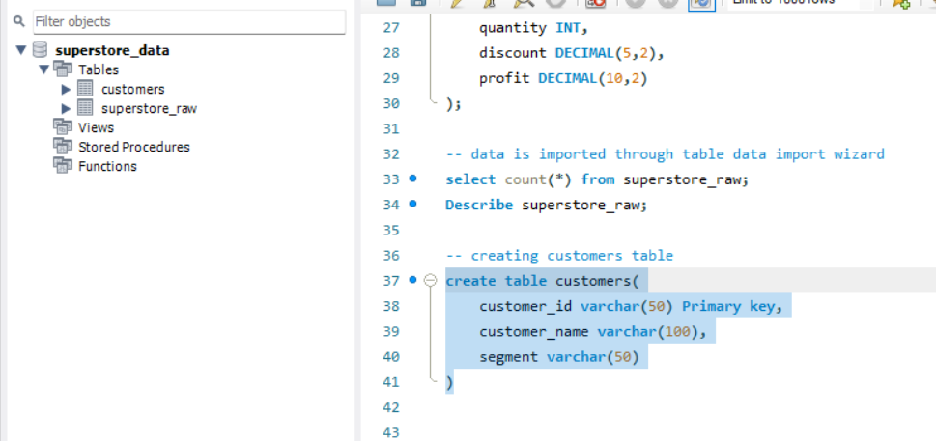

Query 6:inserting distinct records from superstore_raw into the customers table
insert into customers
select distinct
`customer id`,
`customer name`,
segment
from superstore_raw;

select count(*) from customers; // to verify that records are added or not
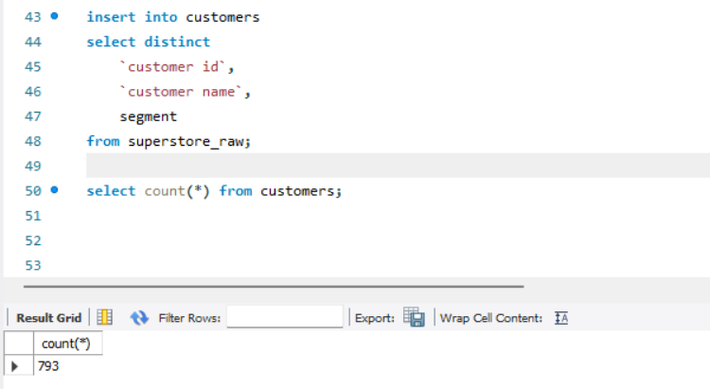
There are 793 records which are distinct for customer id
Query 7: creating products table
create table products (
product_id VARCHAR(50) primary key,
category VARCHAR(50),
sub_category VARCHAR(50),
product_name VARCHAR(255)
);

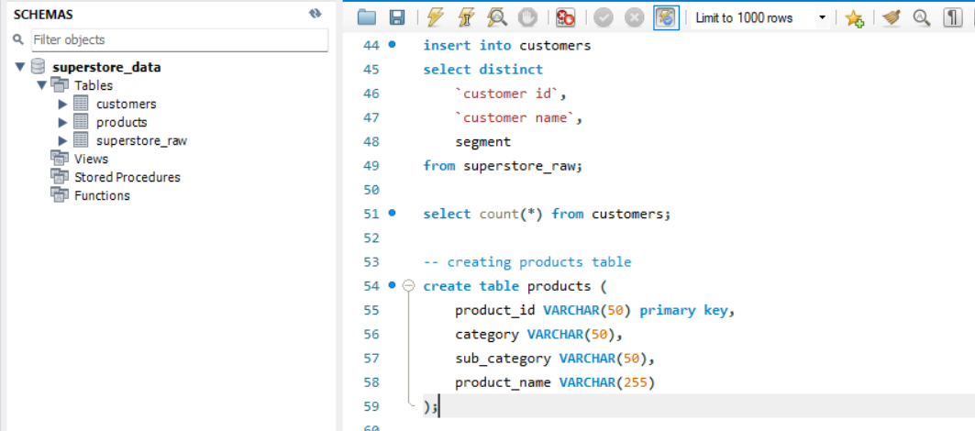

A table as products is created

Query 8: inserting distinct records into products table
insert into products
select distinct
`Product ID`,
Category,
`Sub-Category`,
`Product Name`
from superstore_raw;
select count(*) from products // to verify that records are added or not
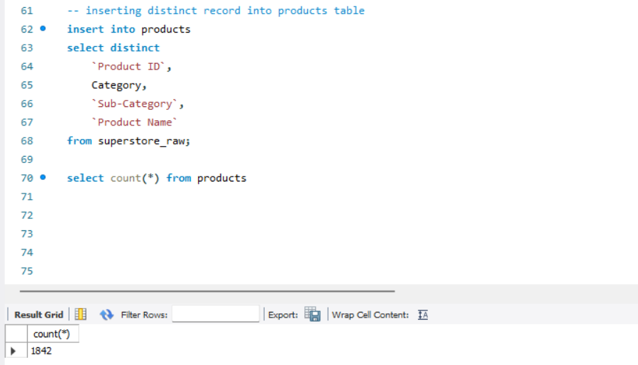

There are 1842 distinct entries for products

Note:There was an issue creating a primary key for the product table as for the assigment there isnt mentioned any importance of primary key so i didnt added any

When i tried to make the product id as a primary key when i inserted data only 1 record was added may be there are much duplicate entries in the product id column

Query 9:creating orders table
create table orders (
row_id INT primary key,
order_id VARCHAR(50),
order_date DATE,
ship_date DATE,
ship_mode VARCHAR(50),

customer_id VARCHAR(50),
product_id VARCHAR(50),

country VARCHAR(50),
city VARCHAR(50),
state VARCHAR(100),
postal_code VARCHAR(20),
region VARCHAR(50),

sales DECIMAL(10,2),
quantity INT,
discount DECIMAL(5,2),
profit DECIMAL(10,2),

foreign key (customer_id)
references customers(customer_id)
);

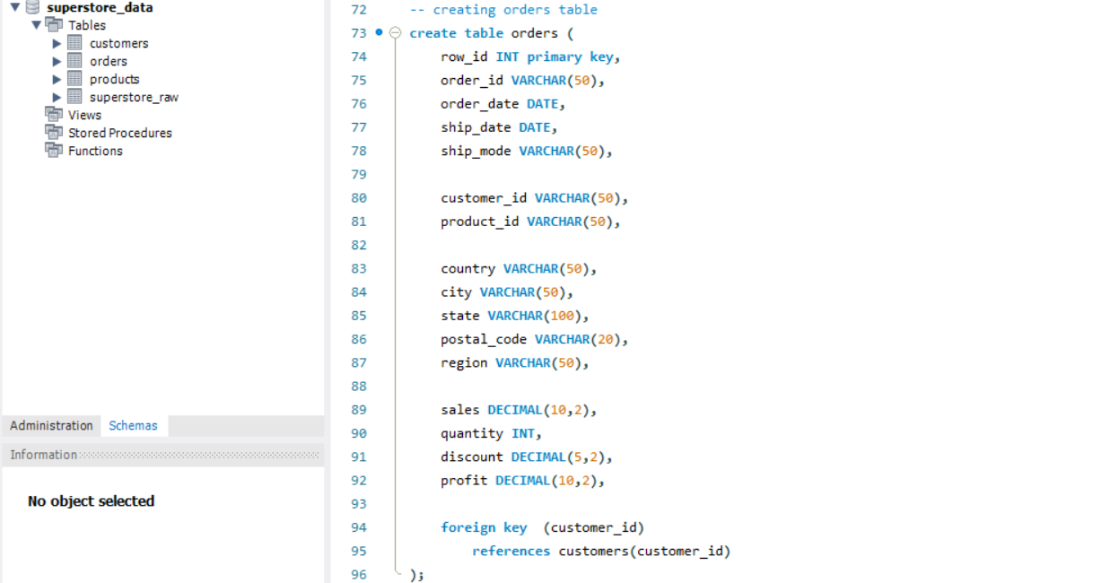
An order table is created

Query 10 : inserting distinct order records into the table
insert into orders
select
`row id`,
`order id`,
`order date`,
`ship date`,
`ship mode`,
`customer id`,
`product id`,
`country`,
`city`,
`state`,
`postal code`,
`region`,
`sales`,
`quantity`,
`discount`,
`profit`
from superstore_raw;

select count(*) from orders

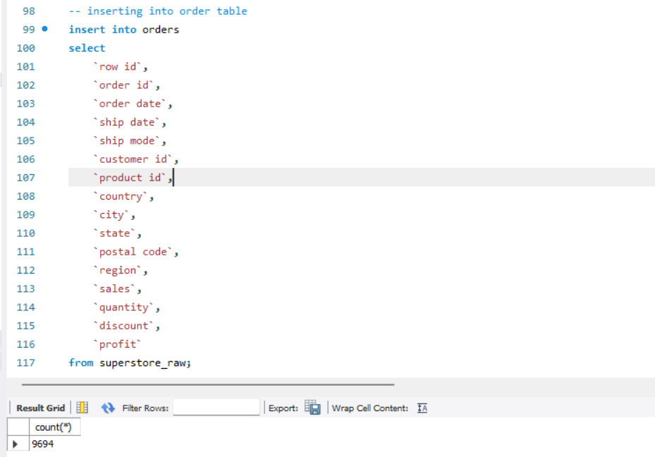
All the records are added in to orders table
Here i didnt used distinct because order ids are always unique and also row ids are unique hence there isnt any need to use distinct
Data quality check

Query 1: to check for duplicates
select customer_id,count(*)
from customers
group by customer_id
having count(*)>1;


There are no duplicates in the customers table

Query 2: checking for null values
select * from orders
where customer_id is null
or product_id is null;

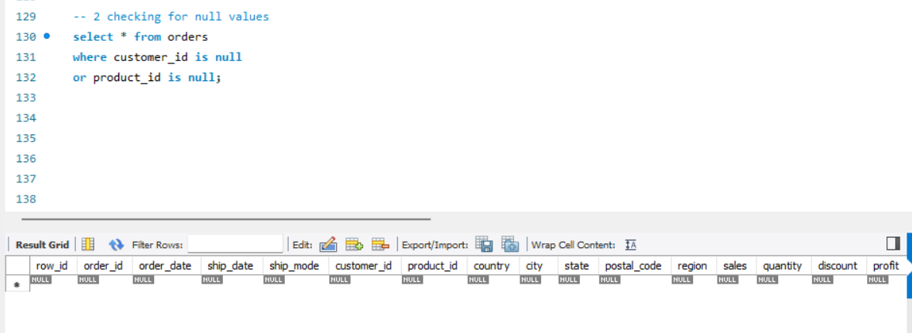
There are no null values

Query 3 : date validation
select * from orders
where ship_date<order_date;
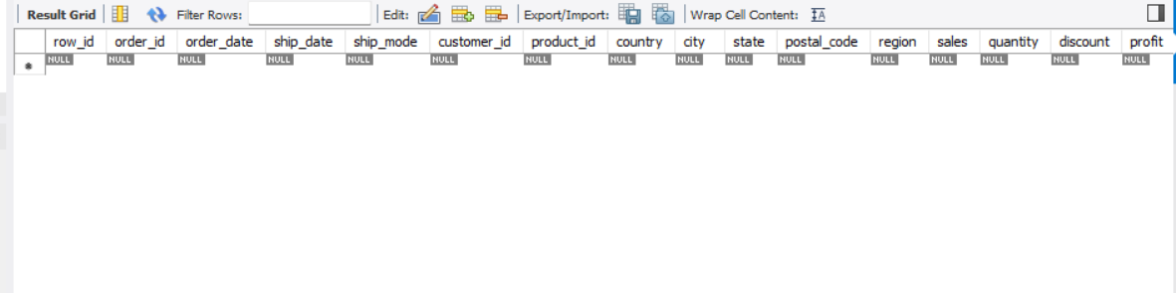

There are no such values where ship_date is before than order_date

Subquery analysis

Query 1 : orders with sales greater than overall average
select * from orders
where sales>
( select avg(sales)
from orders
);
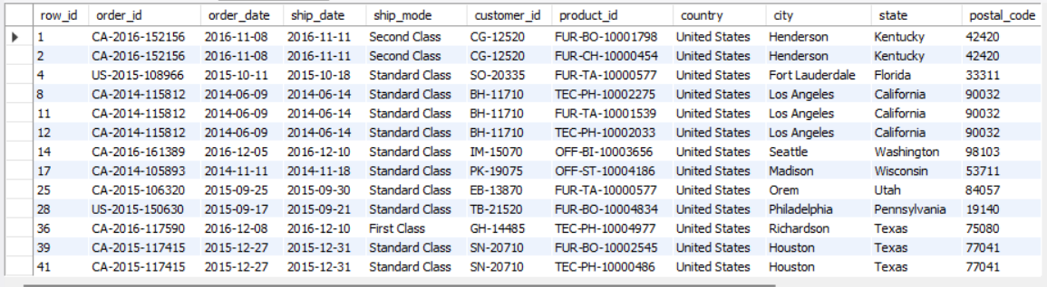
Query 2 :highest value order for every customer

select * from orders o
where sales =
( select max(sales) from orders
where customer_id=o.customer_id
);
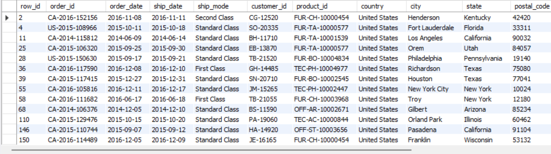

Query 3 :customers above average sales
select customer_id, sum(sales) as total_sales
from orders
group by customer_id
having sum(sales)>
( select avg(customer_sales)
from (
select sum(sales) as customer_sales
from orders
group by customer_id
) t
);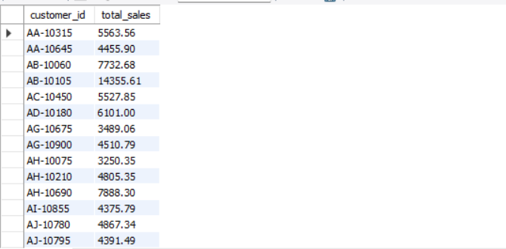

Query 4 : products sold above average quantity
select * from products
where product_id in
(
select product_id from orders
group by product_id
having sum(quantity)>
(
select avg(total_quantity)
from (
select sum(quantity) as total_quantity from orders
group by product_id
)t
)
);


Query 5 :products never ordered
select * from products p
where not exists
( select 1
from orders o
where o.product_id =p.product_id
)

Common table subexpression(CTEs)

Query 1:total sales per customer
with customer_sales as
(
select customer_id, sum(sales) AS total_sales
from orders
group by customer_id
)

select * from customer_sales
order by total_sales desc;

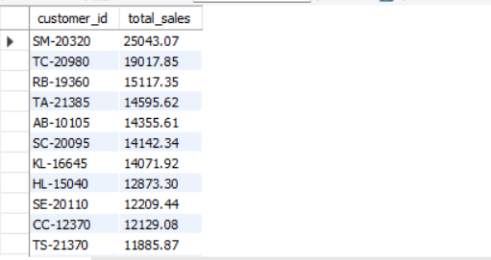

Query 2 : regional sales
with region_sales as
(
select region,sum(sales) as total_sales
from orders
group by region
)
select * from region_sales
order by total_sales desc;

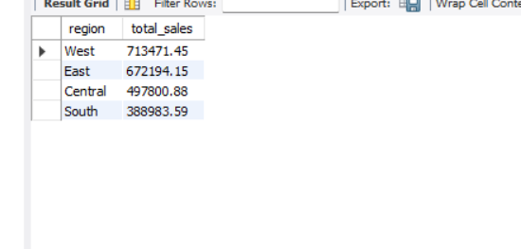

Query 3 : total profit per person
with customer_profit as
(
select customer_id,sum(profit) as total_profit
from orders
group by customer_id
)
select * from customer_profit
order by total_profit desc;
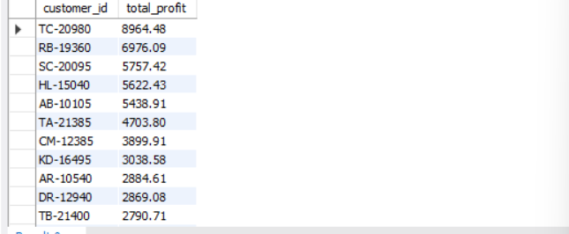

Query 4 : monthly sales trend
with monthly_sales as (
select
year(order_date) as year,month(order_date) as month,
sum(sales) as total_sales
from orders
group by
year(order_date),month(order_date)
)
select * from monthly_sales
order by year,month;
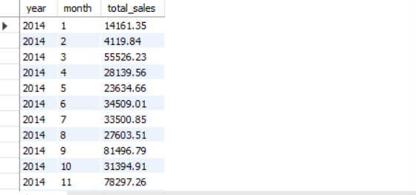
Query 5 : customer with above average revenue
with customer_sales as
(
select customer_id,sum(sales) as total_sales
from orders
group by customer_id
)
select * from customer_sales
where total_sales>
(
select avg(total_sales)
from customer_sales
)
order by total_sales desc;

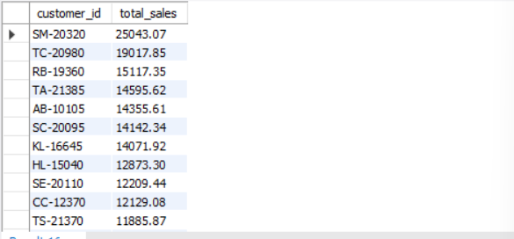

Query 6 :total orders per customer
with customer_orders as
(
select customer_id, count(distinct order_id) as order_count
from orders
group by customer_id
)
select * from customer_orders
order by order_count desc;

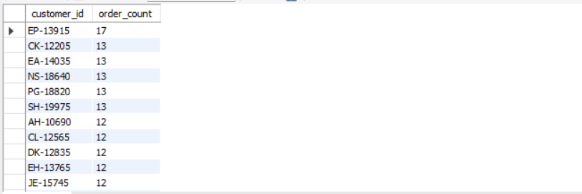

Query 7 :average order value per customer
with avg_order as
(
select customer_id, avg(sales) as avg_order_value
from orders
group by customer_id
)
select * from avg_order
order by avg_order_value desc;
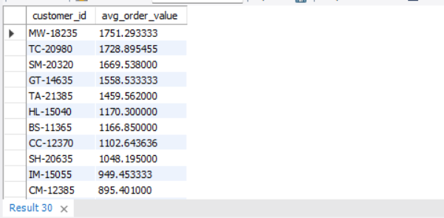

Window functions

Query 1 :row_number()- rank customers by sales
select customer_id,sum(sales) as total_sales,
row_number() over (
order by sum(sales) desc
)as sales_rank
from orders
group by customer_id;

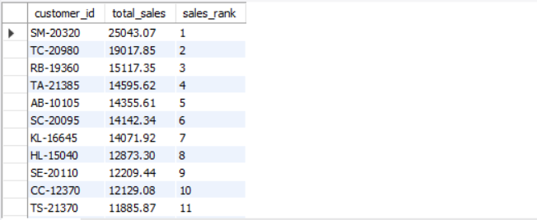

Query 2 : RANK() - Customer Ranking who have equal sales
select customer_id,sum(sales) as total_sales,
rank() over (
order by sum(sales) desc
) as sales_rank
from orders
group by customer_id;
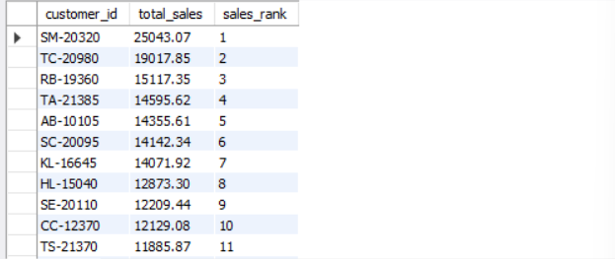

Query 3 :dense_rank()
select customer_id,sum(sales) as total_sales,
dense_rank() over (
order by sum(sales) desc
) as sales_rank
from orders
group by customer_id;

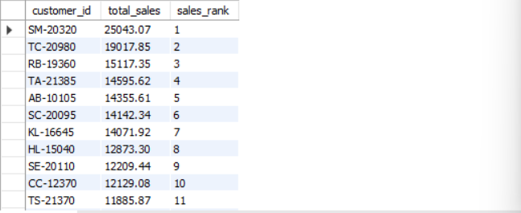

Query 4 : running total sales
Select customer_id,order_id,sales,
sum(sales)
Over (partition by
customer_id
Order by order_date) run_total
From orders;

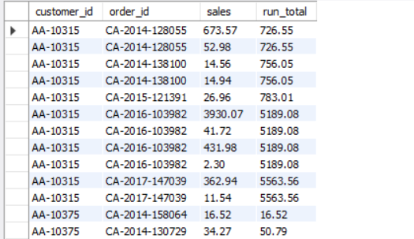

Query 5 :Calculate difference from previous order
select customer_id,order_id,sales,
sales -
lag(sales) over(
partition by customer_id
order by order_date
) as sales_diff
from orders;
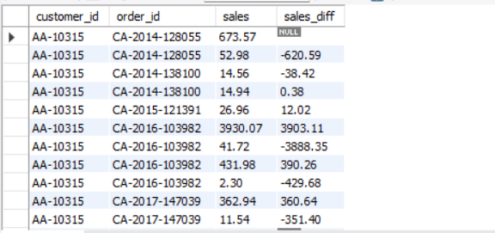

JOIN + CTE + Window Functions

Query 1 :customer sales ranking

with customer_sales as (
select c.customer_id,c.customer_name,
sum(o.sales) as total_sales
from customers c
join orders o
on c.customer_id = o.customer_id
group by
c.customer_id,c.customer_name
)
select customer_id,customer_name,total_sales,
dense_rank() over (
order by total_sales desc
) as customer_rank
from customer_sales;
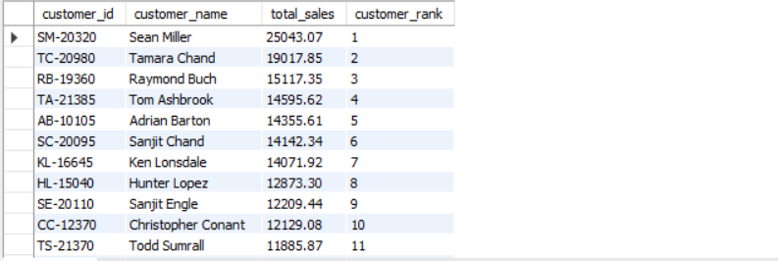

Query 2 : Customer Sales and Profit Ranking
with customer_metrics as (
Select c.customer_id,c.customer_name,
sum(o.sales) as total_sales,
sum(o.profit) as total_profit
from customers c
join orders o
on c.customer_id = o.customer_id
group by
c.customer_id,c.customer_name
)
select *,
rank() over (
order by total_sales desc
) as sales_rank,
rank() over (
order by total_profit desc
) as profit_rank
from customer_metrics;

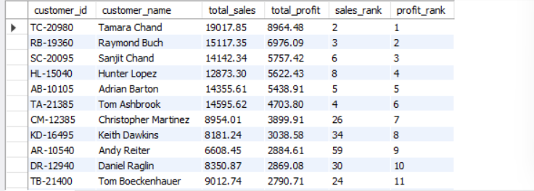

Query 3 :top product in every category
with product_sales as (
select
p.category,p.product_name,
sum(o.sales) as total_sales
from products p
join orders o
on p.product_id = o.product_id
group by
p.category,p.product_name
)
select *,
dense_rank() over (
partition by category
order by total_sales desc
) as category_rank
from product_sales;
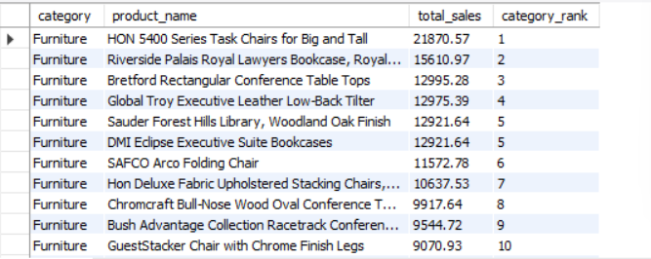

Business Queries

Query 1: Rank States by Total Profit
with state_profit as (
select state,
sum(profit) as total_profit
from orders
group by state
)

select *,
dense_rank() over(
order by total_profit desc
) as profit_rank
from state_profit;
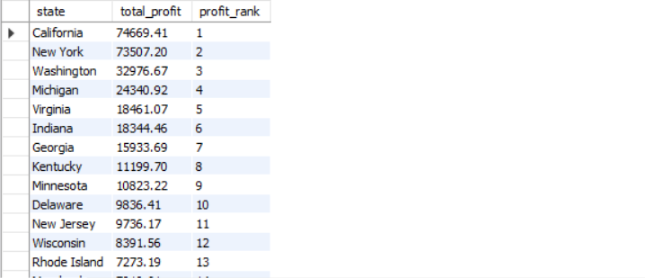
Query 2 :Customer's First and Latest Order
select
c.customer_name,
min(o.order_date) as first_order,
max(o.order_date) as latest_order
from customers c
join orders o
on c.customer_id = o.customer_id
group by c.customer_name;
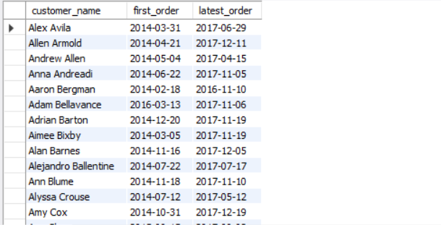

Query 3 :products that generate loss
with product_profit as (
select p.product_name,
sum(o.profit) as total_profit
from orders o
join products p
on o.product_id = p.product_id
group by p.product_name
)
select *
from product_profit
where total_profit < 0
order by total_profit;

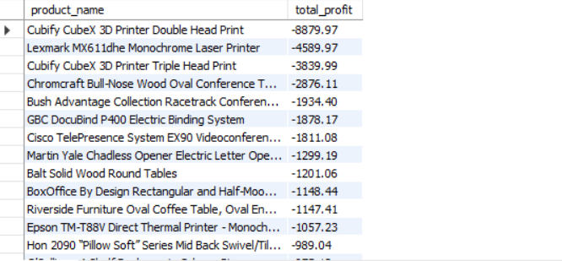

Query 4 :daily sales trends
with daily_sales as (
select order_date,
sum(sales) as total_sales
from orders
group by order_date
)
select * from daily_sales
order by order_date;
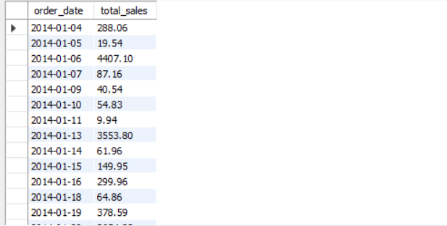

Query 5 :profit by category
select
p.category,
sum(o.profit) as total_profit
from products p
join orders o
on p.product_id = o.product_id
group by p.category;

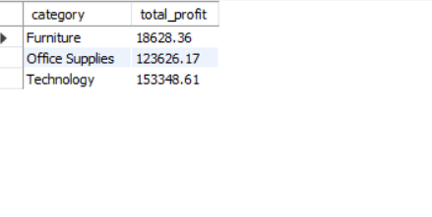
Query 6 : no of orders per customer
select c.customer_name,
count(*) as total_orders
from customers c
join orders o
on c.customer_id = o.customer_id
group by c.customer_name
order by total_orders desc;
