

WEEK 3 - ASSIGNMENT

G . Rithwik Surya
Data Engineering

Query 1 : creating database schema to store tables
create database superstore_data;

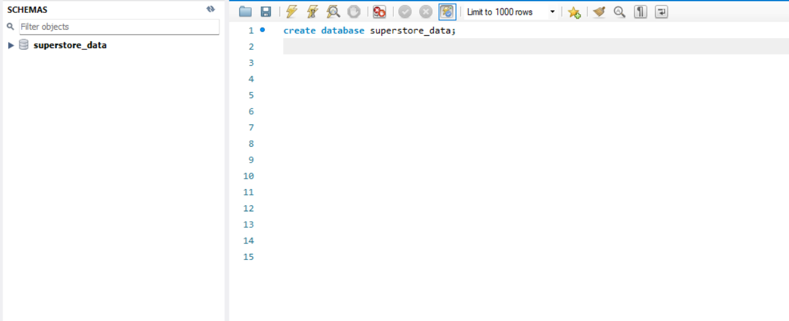

Schema is created

Query 2 :use the superstore_data database
use superstore_data;

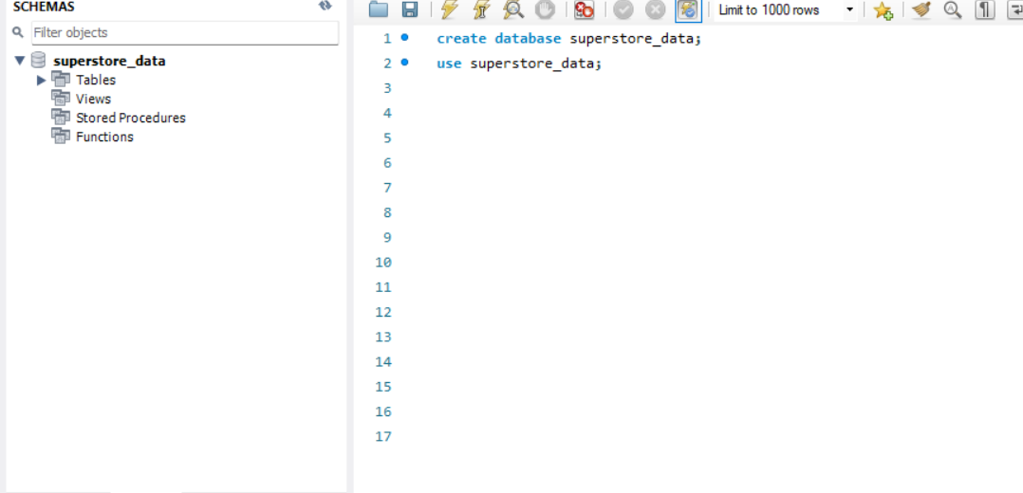

The schema is highlighted such that now we can use the database for adding tables
The superstore_raw table is created and data is imported through table data import wizard in sqlworkbench

Query 3 and 4: verifying the count of records in the table and the type of each column

Describe superstore_raw;
select count(*) from superstore_raw;

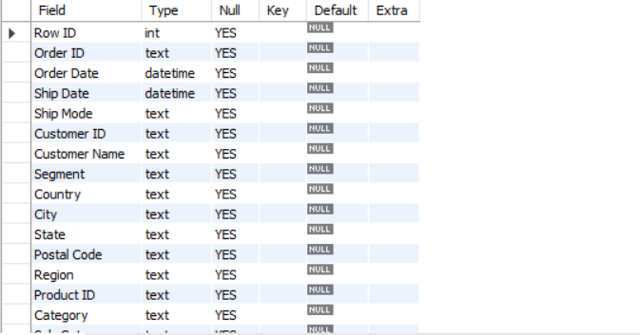
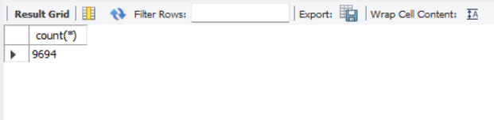
Query 5: creating customers table
create table customers(
customer_id varchar(50) Primary key,
customer_name varchar(100),
segment varchar(50)
)

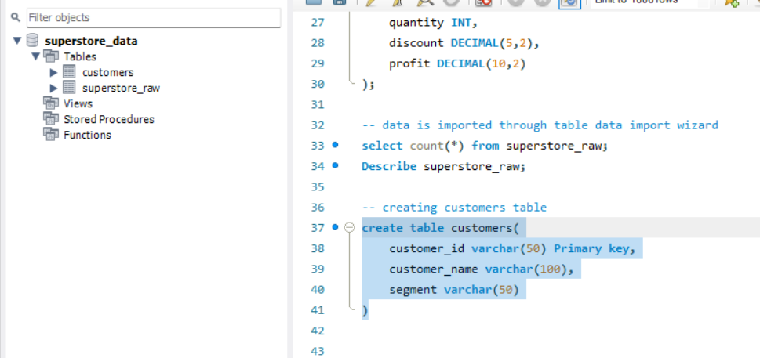

Query 6:inserting distinct records from superstore_raw into the customers table
insert into customers
select distinct
`customer id`,
`customer name`,
segment
from superstore_raw;

select count(*) from customers; // to verify that records are added or not
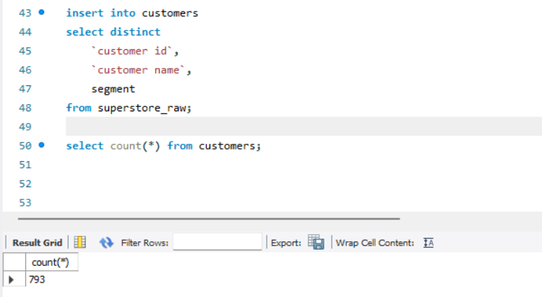
There are 793 records which are distinct for customer id
Query 7: creating products table
create table products (
product_id VARCHAR(50) primary key,
category VARCHAR(50),
sub_category VARCHAR(50),
product_name VARCHAR(255)
);

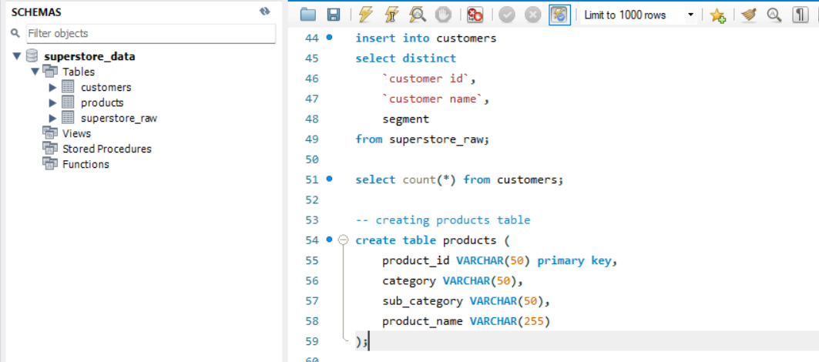

A table as products is created

Query 8: inserting distinct records into products table
insert into products
select distinct
`Product ID`,
Category,
`Sub-Category`,
`Product Name`
from superstore_raw;
select count(*) from products // to verify that records are added or not
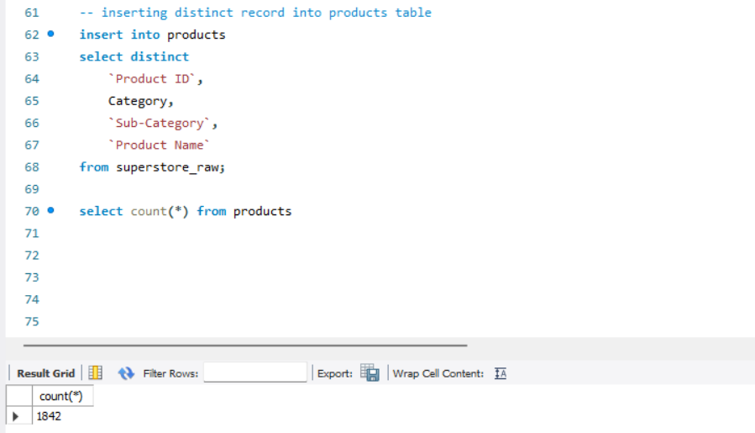

There are 1842 distinct entries for products

Note:There was an issue creating a primary key for the product table as for the assigment there isnt mentioned any importance of primary key so i didnt added any

When i tried to make the product id as a primary key when i inserted data only 1 record was added may be there are much duplicate entries in the product id column

Query 9:creating orders table
create table orders (
row_id INT primary key,
order_id VARCHAR(50),
order_date DATE,
ship_date DATE,
ship_mode VARCHAR(50),

customer_id VARCHAR(50),
product_id VARCHAR(50),

country VARCHAR(50),
city VARCHAR(50),
state VARCHAR(100),
postal_code VARCHAR(20),
region VARCHAR(50),

sales DECIMAL(10,2),
quantity INT,
discount DECIMAL(5,2),
profit DECIMAL(10,2),

foreign key (customer_id)
references customers(customer_id)
);

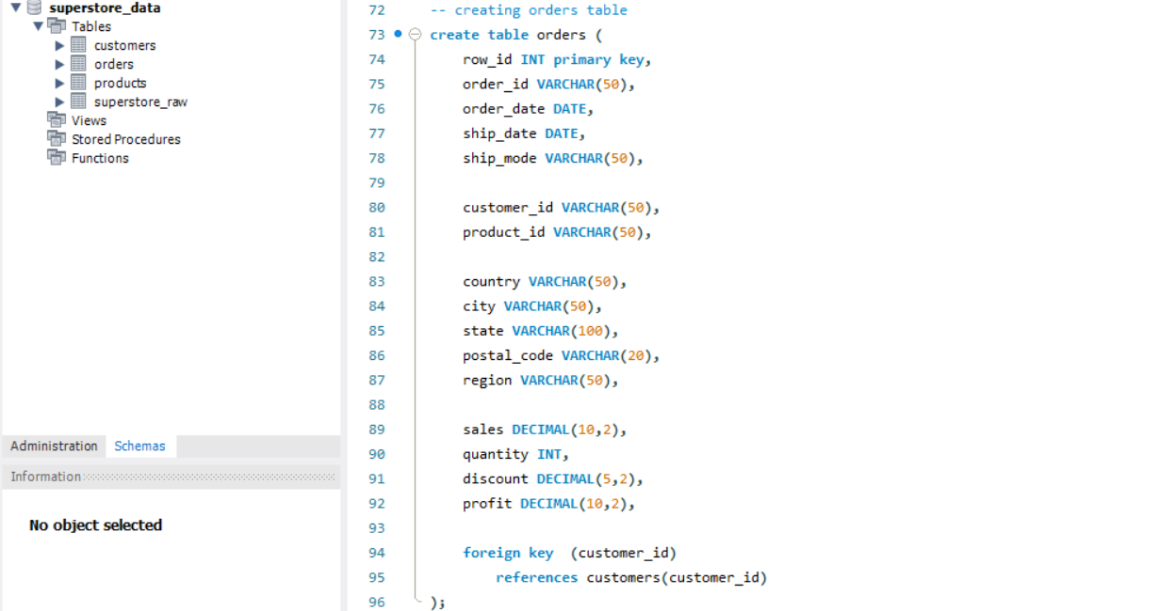
An order table is created

Query 10 : inserting distinct order records into the table
insert into orders
select
`row id`,
`order id`,
`order date`,
`ship date`,
`ship mode`,
`customer id`,
`product id`,
`country`,
`city`,
`state`,
`postal code`,
`region`,
`sales`,
`quantity`,
`discount`,
`profit`
from superstore_raw;

select count(*) from orders

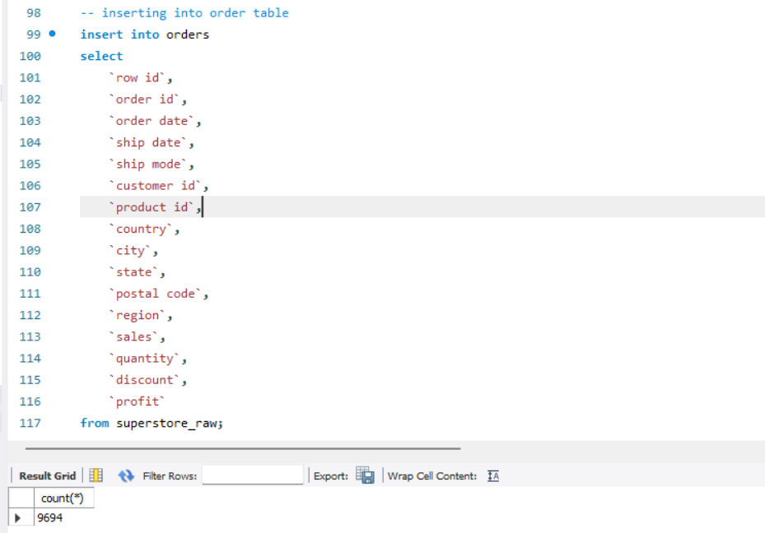
All the records are added in to orders table
Here i didnt used distinct because order ids are always unique and also row ids are unique hence there isnt any need to use distinct

Step -2 Perform Required Queries

Query 1 : Orders where sales are greater than average sales
select * from orders
where sales >
( select avg(sales)
from orders
);
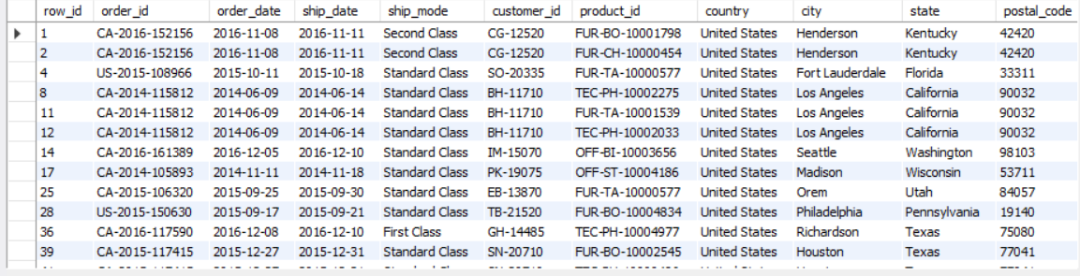

Query 2 :Highest sales order for each customer
select * from orders o
where sales =
( select max(sales) from orders
where customer_id = o.customer_id
);
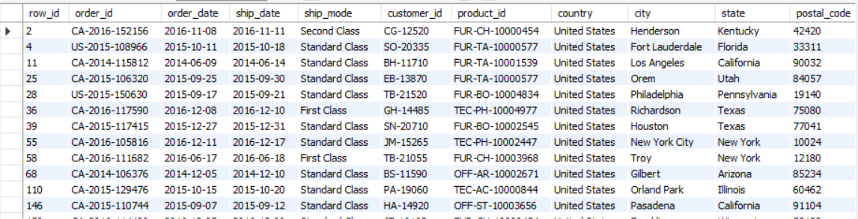
Query 3 :Total sales for each customer (CTE)
with customer_sales as
(select customer_id,sum(sales) as total_sales
from orders
group by customer_id
)
select * from customer_sales;

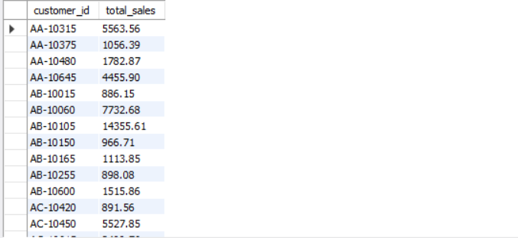
Query 4 :Customers whose total sales are above average
with customer_sales as
( select customer_id, sum(sales) as total_sales
from orders
group by customer_id
)select * from customer_sales
where total_sales >
(select avg(total_sales)
from customer_sales
);

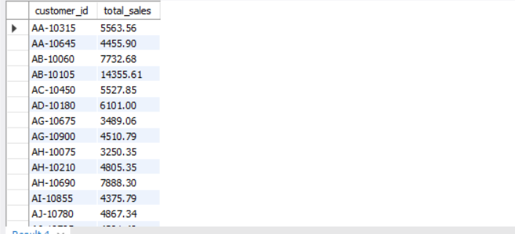
Query 5 : Rank customers based on total sales
with customer_sales as
(select customer_id, sum(sales) as total_sales
from orders
group by customer_id
)
select customer_id,total_sales,
rank() over(
order by total_sales desc
) as sales_rank
from customer_sales;
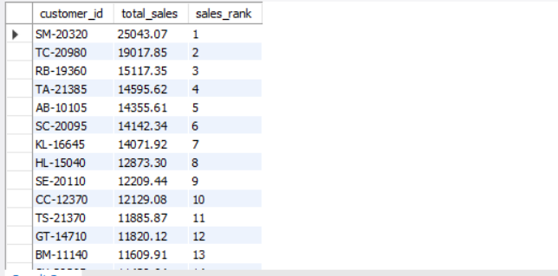
Query 6 :Row numbers for each order within a customer
select customer_id,order_id,sales,
row_number() over(
partition by customer_id
order by sales desc
) as row_num
from orders;

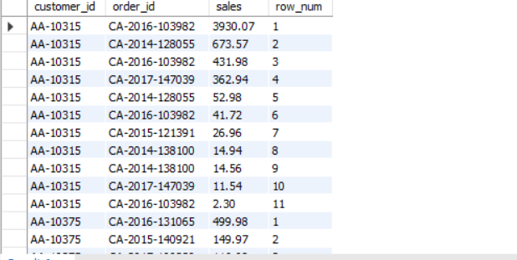
Query 7 : Top 3 customers based on total sales
with customer_sales as
(select customer_id,sum(sales) as total_sales
from orders
group by customer_id
),
ranked_customers as
( select *,
rank() over(
order by total_sales desc
) as sales_rank
from customer_sales
)
select * from ranked_customers
where sales_rank <= 3;
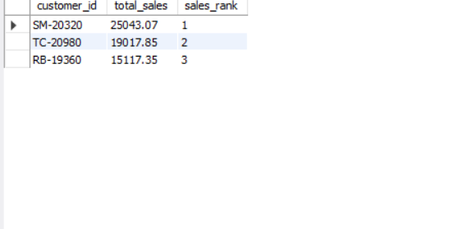

Final Combined Query
Show:
- Customer Name
- Total Sales
- Rank

with customer_sales as
( select customer_id,sum(sales) as total_sales
from orders
group by customer_id
)
select c.customer_name,cs.total_sales,
rank() over(
order by cs.total_sales desc
) as sales_rank
from customer_sales cs
join customers c
on cs.customer_id = c.customer_id;
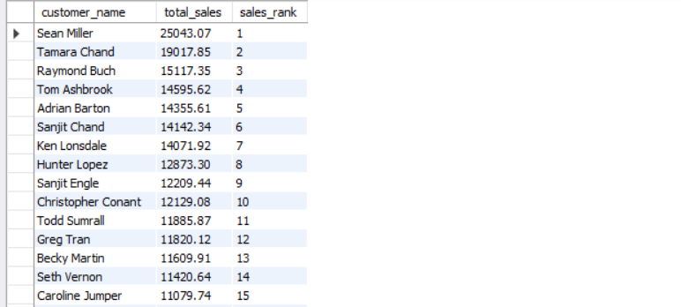

Mini project insights

1 Who are the top 5 customers?
select * from (
select customer_id,sum(sales) as total_sales
from orders
group by customer_id
) t
order by total_sales desc
limit 5;

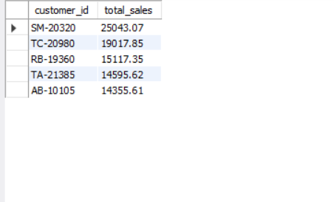

2 Who are the bottom 5 customers?
select * from (
select customer_id,sum(sales) as total_sales
from orders
group by customer_id
) t
order by total_sales
limit 5;

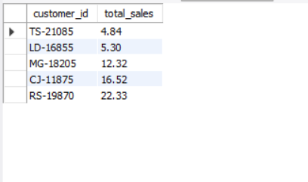

3 Which customers made only one order?
select customer_id,
count(distinct order_id) as order_count
from orders
group by customer_id
having count(distinct order_id) = 1;

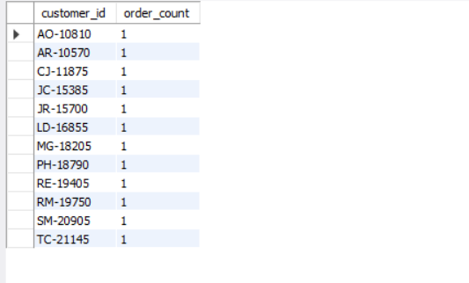

4 Which customers have above-average sales?
with customer_sales as (
select customer_id,sum(sales) as total_sales
from orders
group by customer_id
)
select * from customer_sales
where total_sales > (
select avg(total_sales)
from customer_sales
);
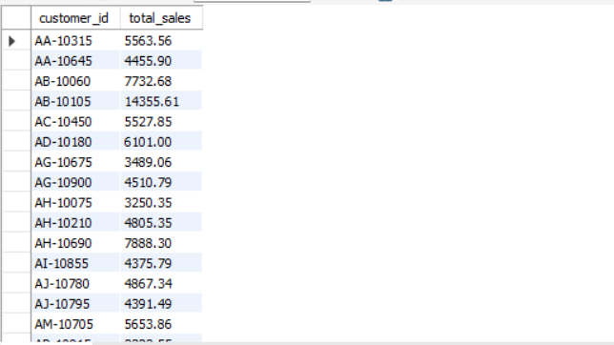

5 What is the highest order value per customer?
select customer_id,
max(sales) as highest_order_value
from orders
group by customer_id
order by highest_order_value desc;

