

Celebal Summer Internship 2026
Week 2 Task: E-Commerce Sales Database

Name- G Rithwik Surya
CVR College Of Engineering
Course -Data Engineering

SQL Sales Data Analysis using superstore Dataset

Steps: 1.Load dataset into a SQL database.
I loaded the CSV file into MySQL using the Table Data Import Wizard in MySQL Workbench. A database called `sales_analysis` was created and the data was imported into a table named `storedata`. The table has 21 columns including order details (`order id`, `order date`, `ship date`, `ship mode`), customer information (`customer id`, `customer name`, `segment`), location data (`city`, `state`, `region`), and product/transaction details (`category`, `sub-category`, `sales`, `quantity`, `discount`, `profit`).

Query 1 : Creating database
create database sales_analysis;
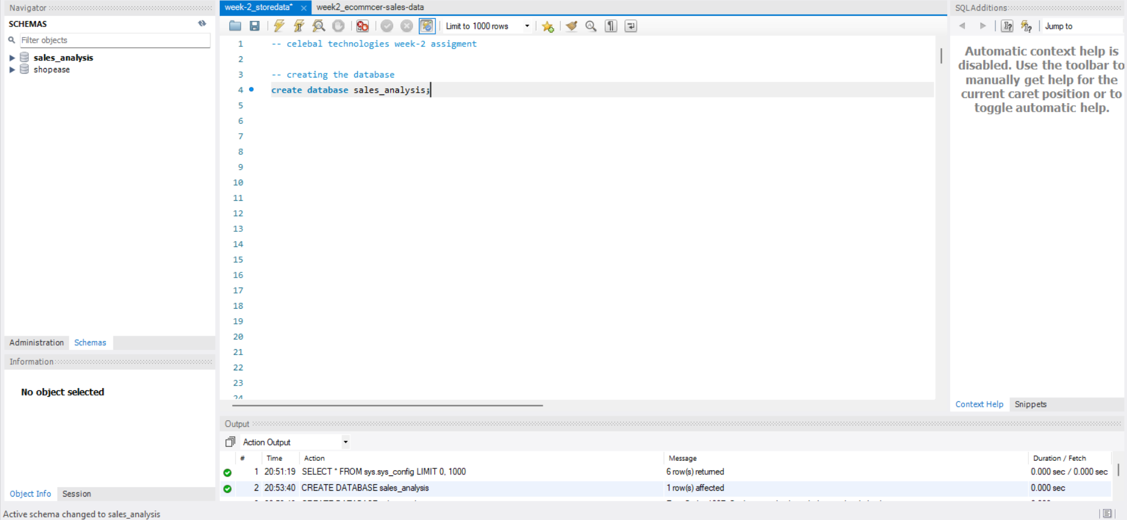

Query 2 : defining the table schema

create table if not exists storedata (
`row id` int,
`order id` varchar(20),
`order date` varchar(20),
`ship date` varchar(20),
`ship mode` varchar(20),
`customer id` varchar(10),
`customer name` varchar(50),
segment varchar(20),
country varchar(30),
city varchar(40),
state varchar(30),
`postal code` int,
region varchar(10),
`product id` varchar(20),
category varchar(20),
`sub-category` varchar(20),
`product name` varchar(200),
sales decimal(10,4),
quantity int,
discount decimal(4,2),
profit decimal(10,4)
);

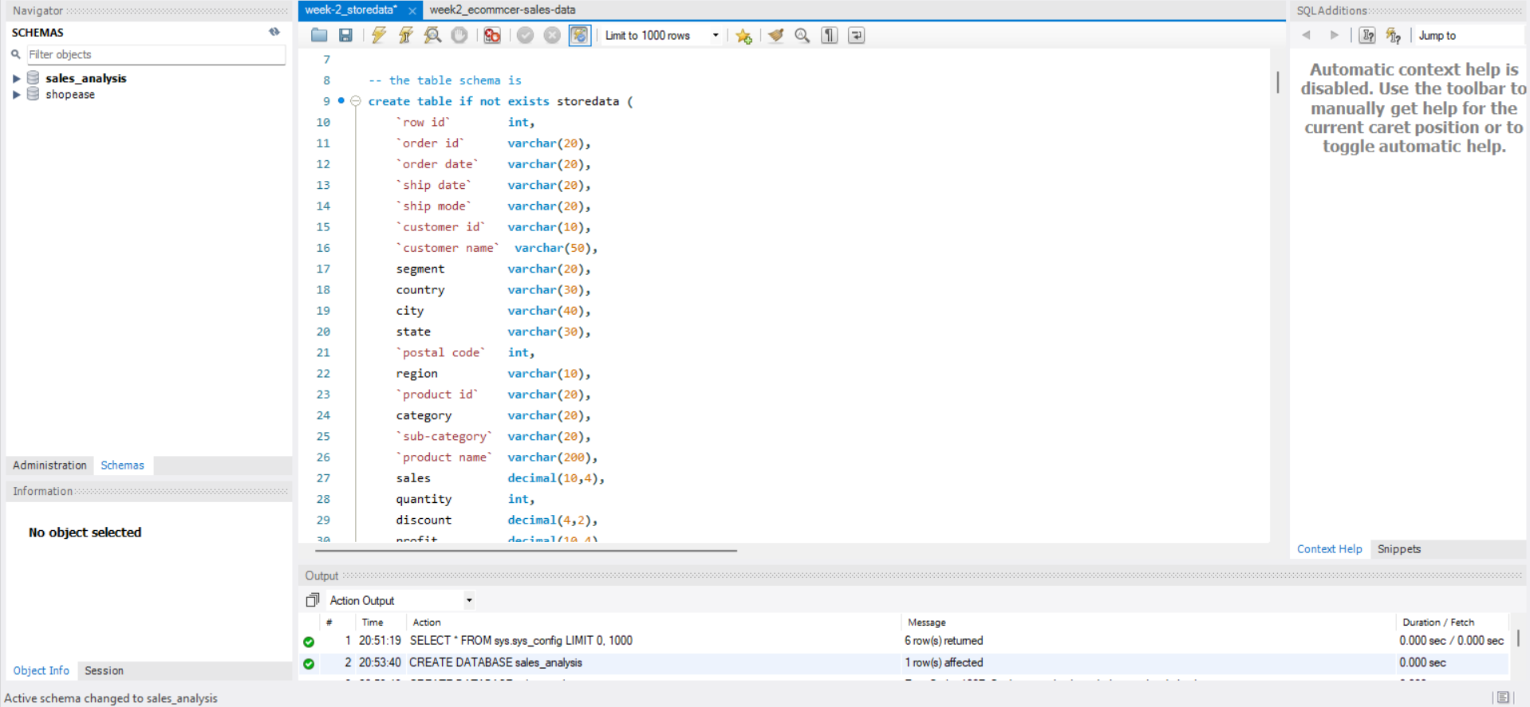

Query 3 : Use Database

Use sales_analysis
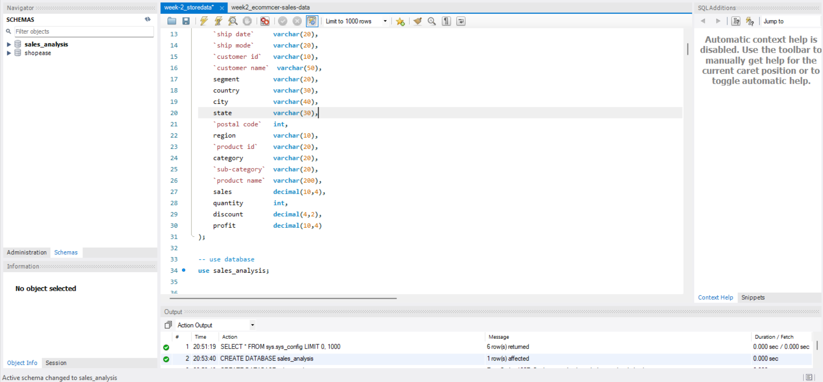

Query 4: schema of the database

Describe storedata

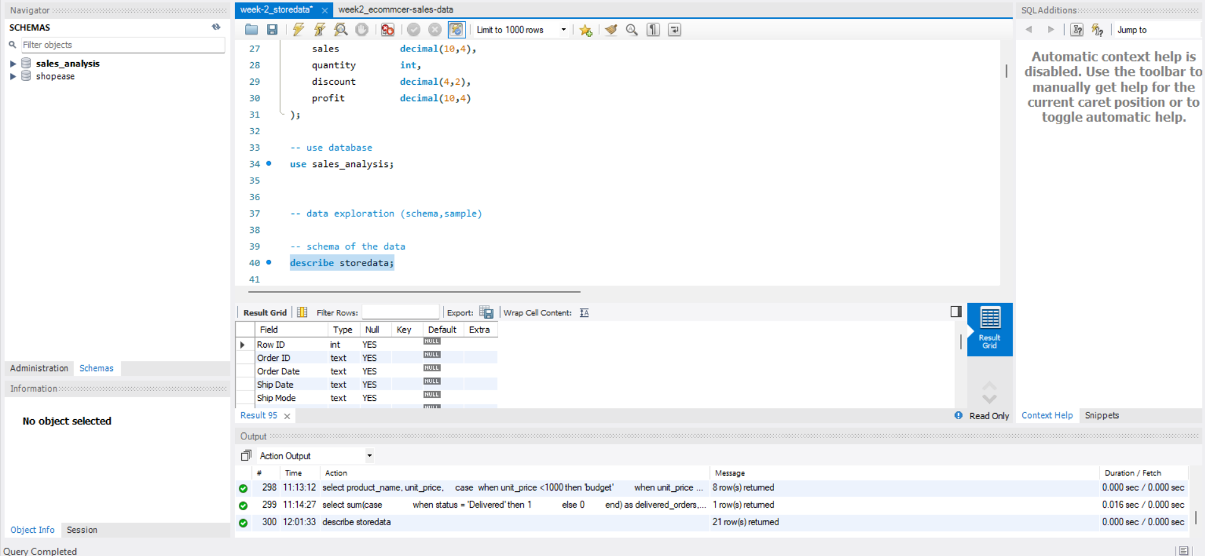

Query 5: display sample data from storedata

select * from storedata limit 10;

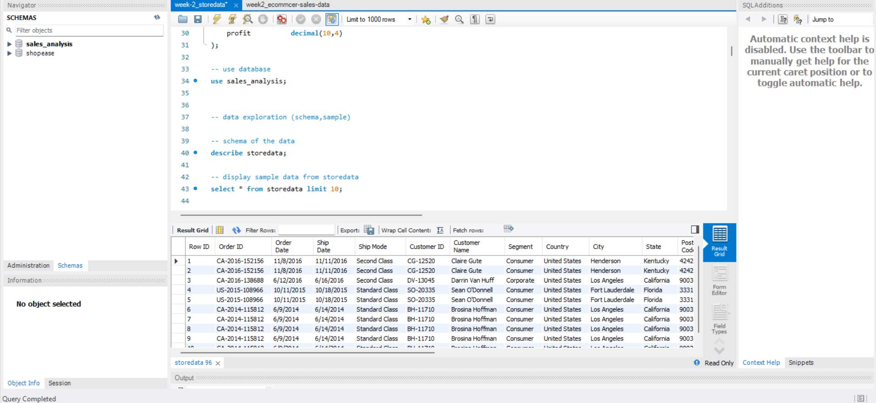

Query 6: total records

select count(*) as total_records from storedata;

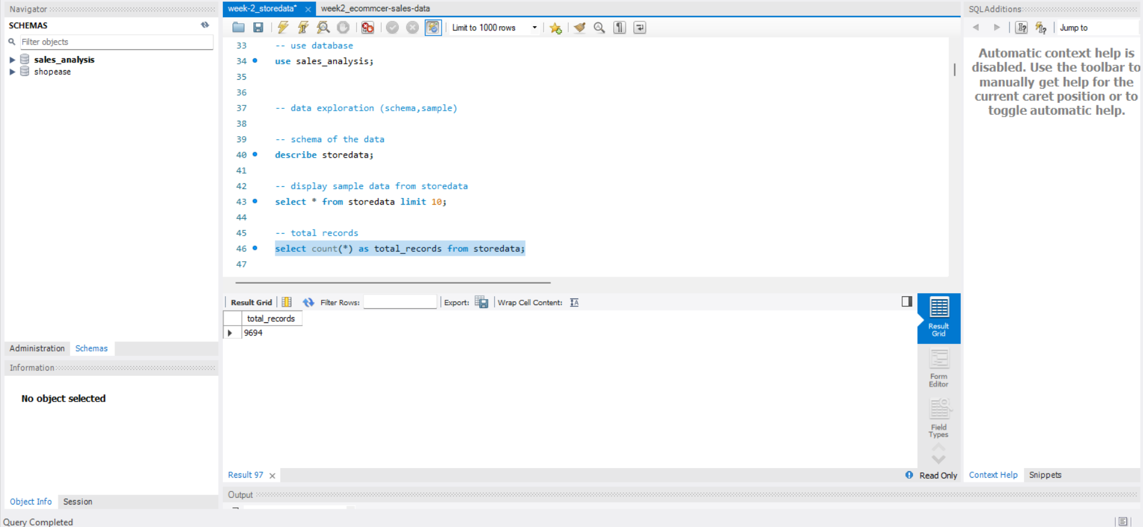

Query 7 : distinct value analysis

distinct customer ids
select count(distinct `customer id`) as customers from storedata;
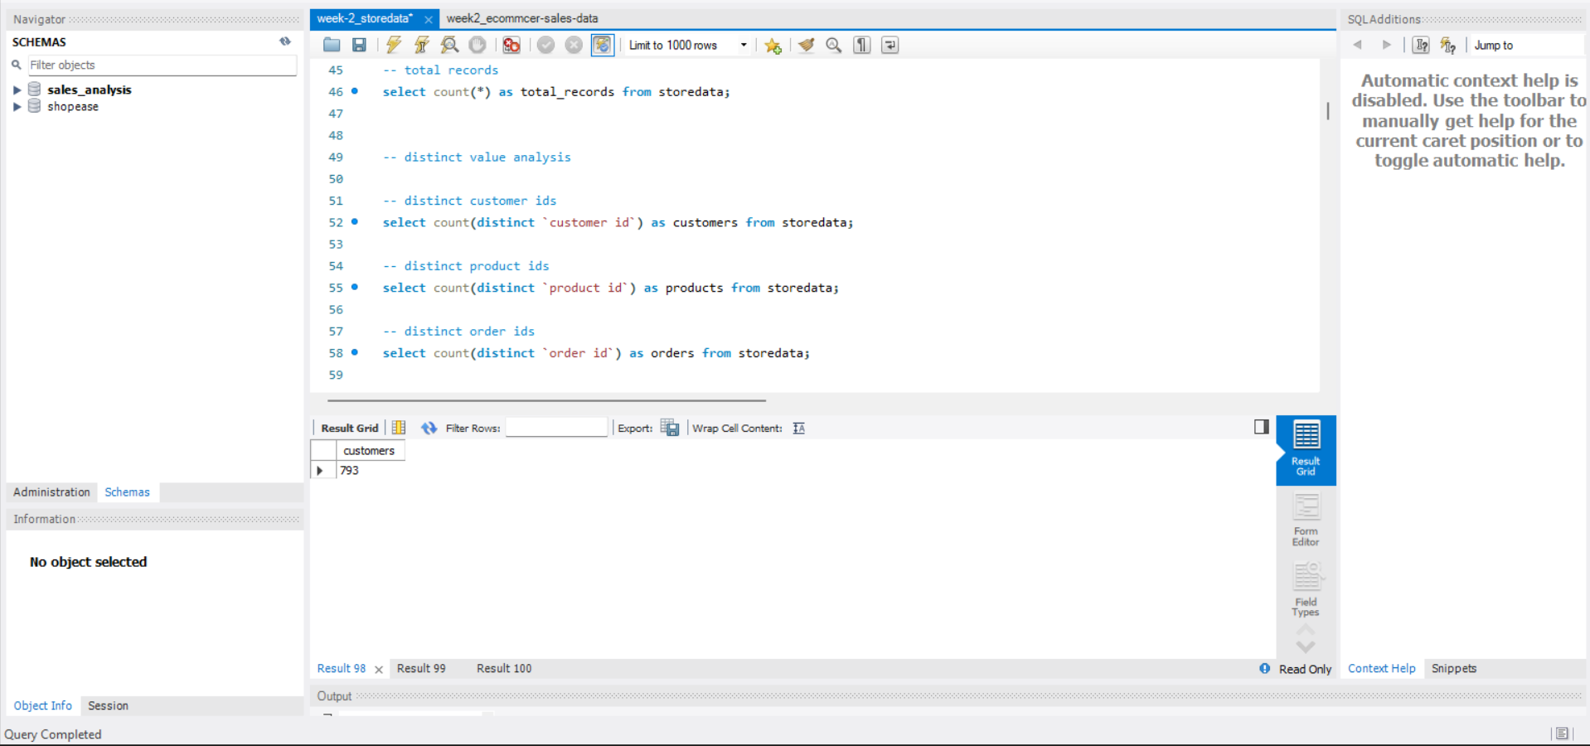

distinct product ids
select count(distinct `product id`) as products from storedata;
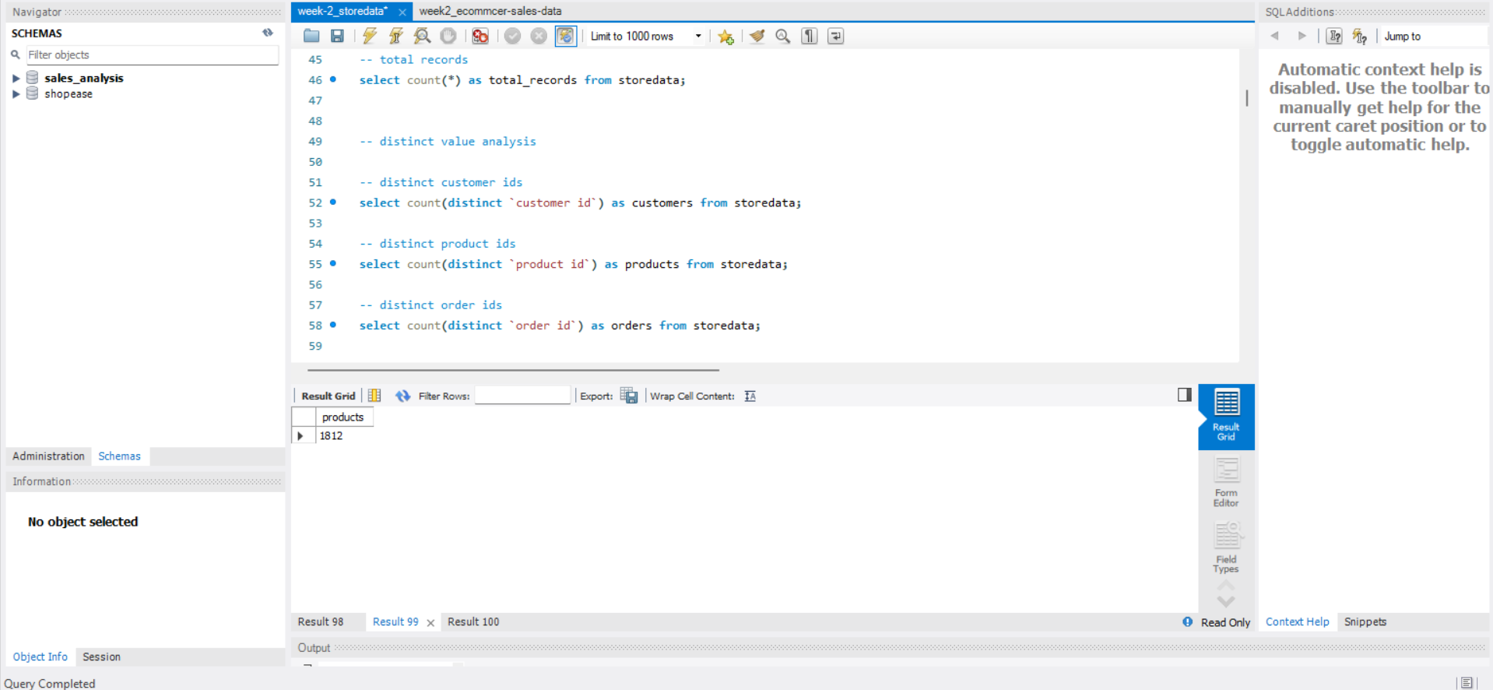
distinct order ids
select count(distinct `order id`) as orders from storedata;

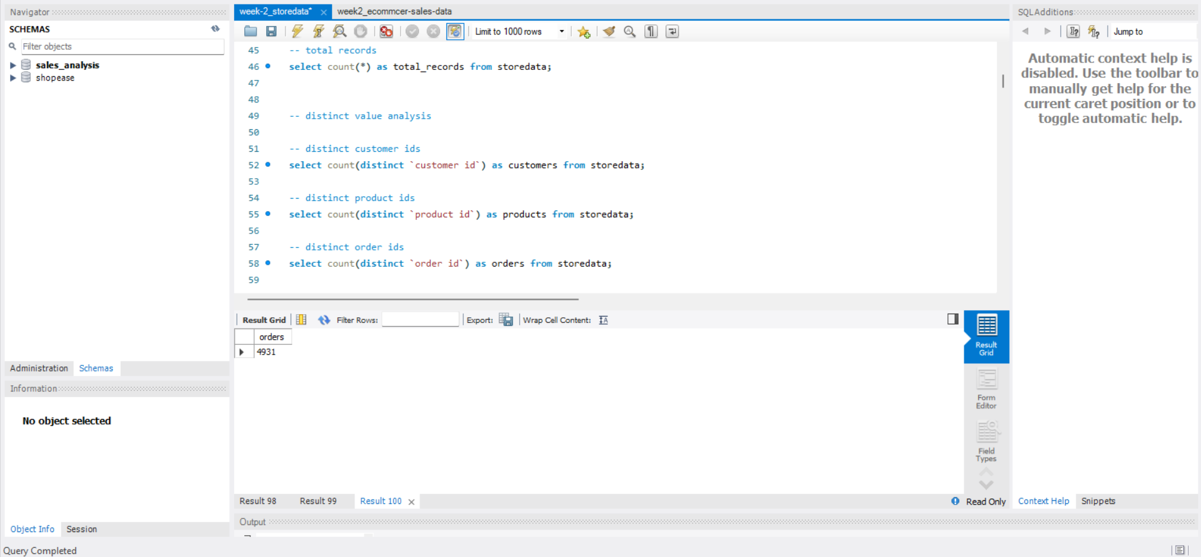

Query 8: unique values per each column

select
count(distinct region) region_cnt,
count(distinct category) category_cnt,
count(distinct `sub-category`) subcategory_cnt,
count(distinct segment) segment_cnt
from storedata;

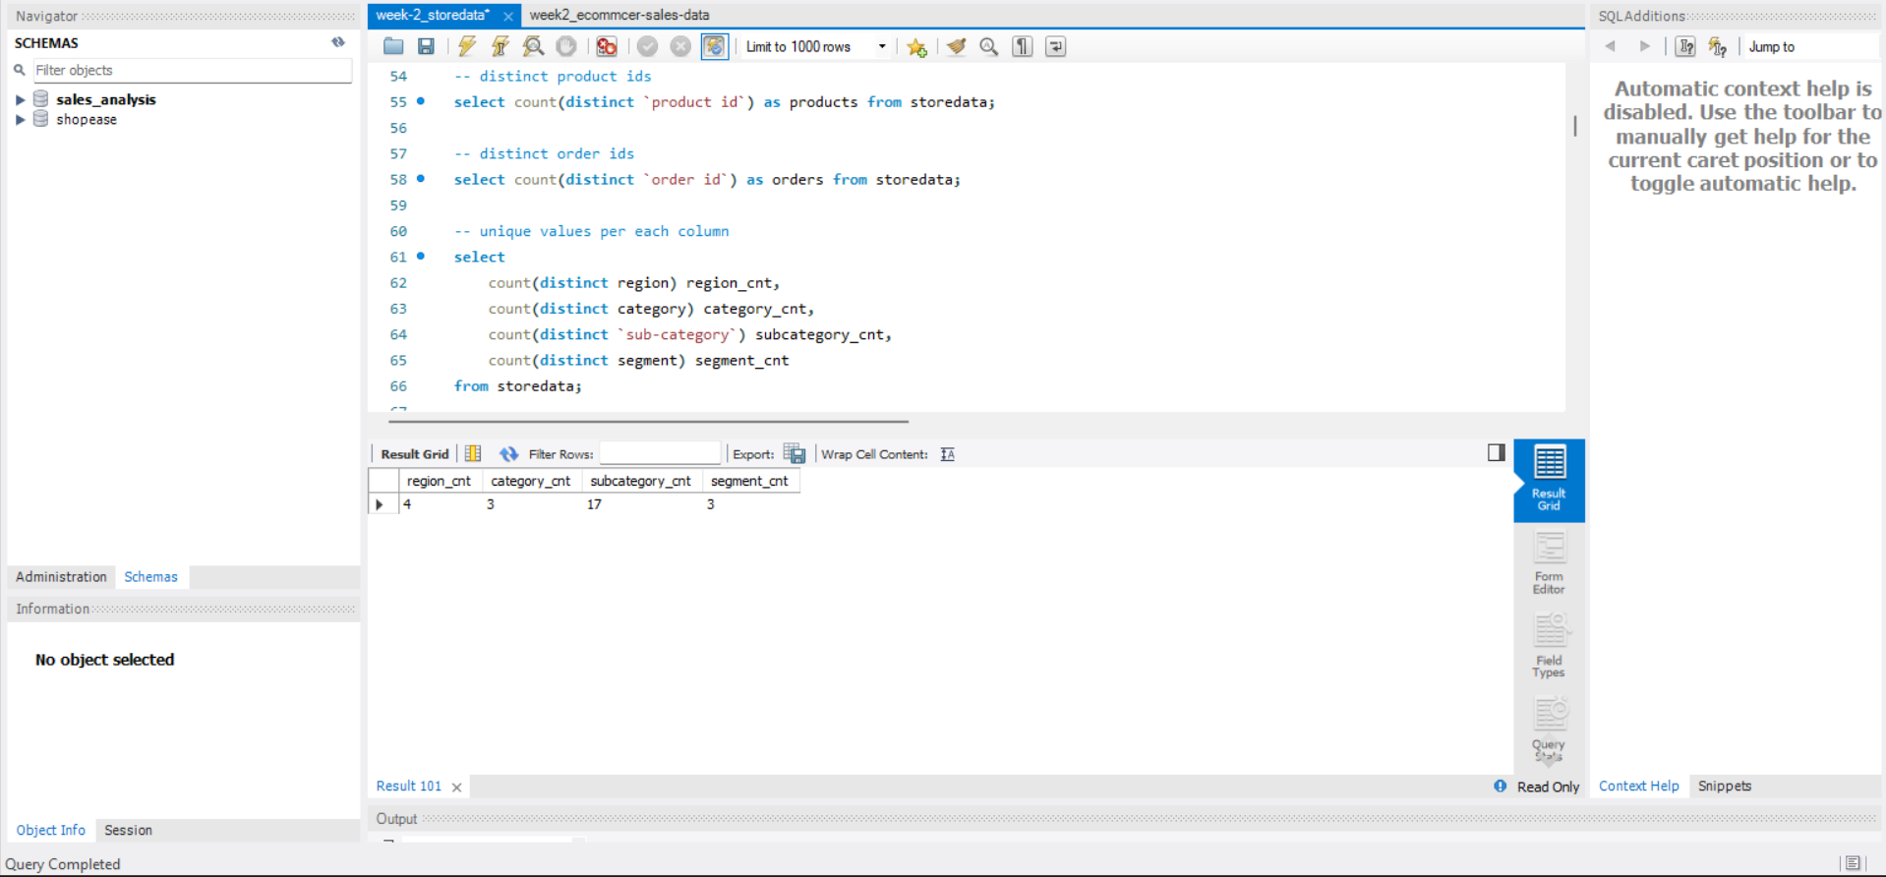

Query 9: check regions
select distinct region from storedata;

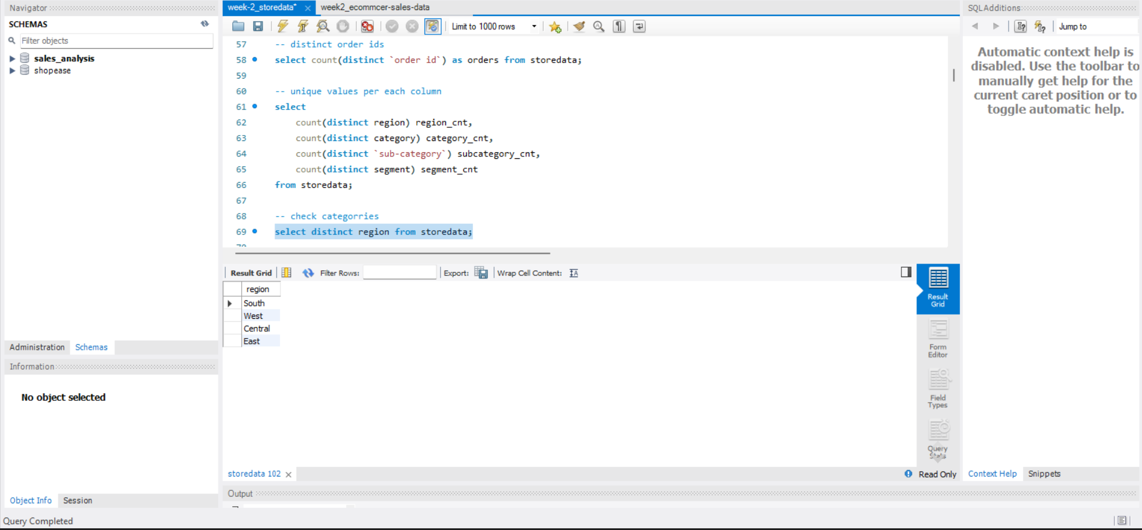

Query 10: check categories
select distinct category from storedata;

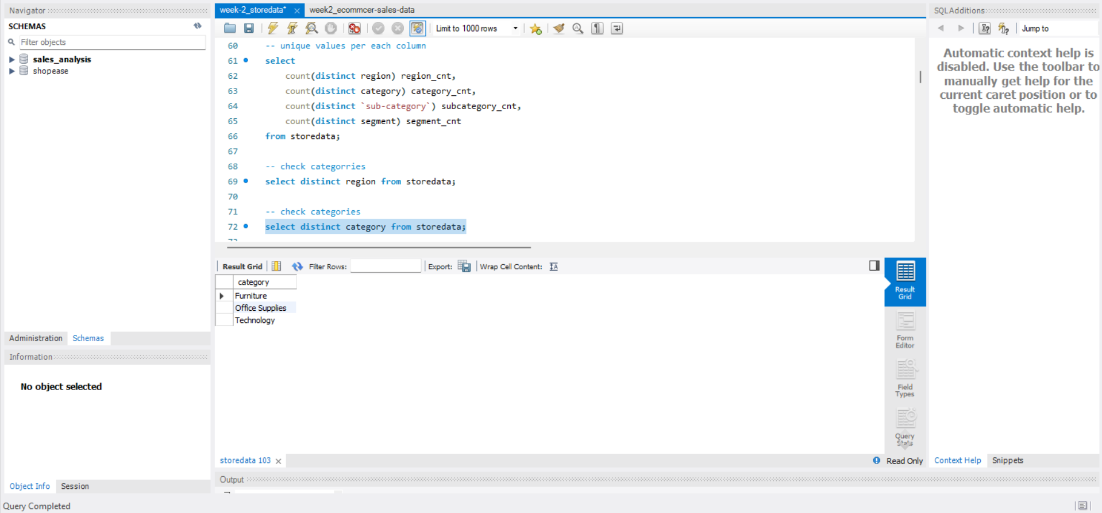

Query 11: check sub-categories
select distinct `sub-category` from storedata;

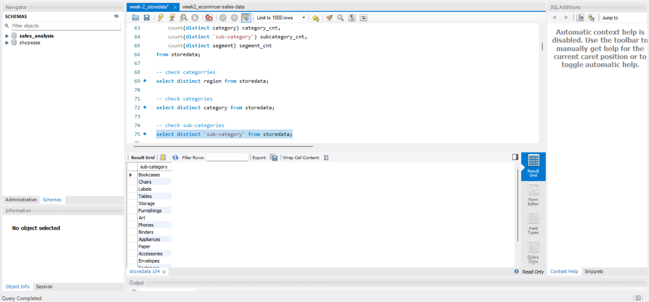

Query 12 :check segment
select distinct segment from storedata;

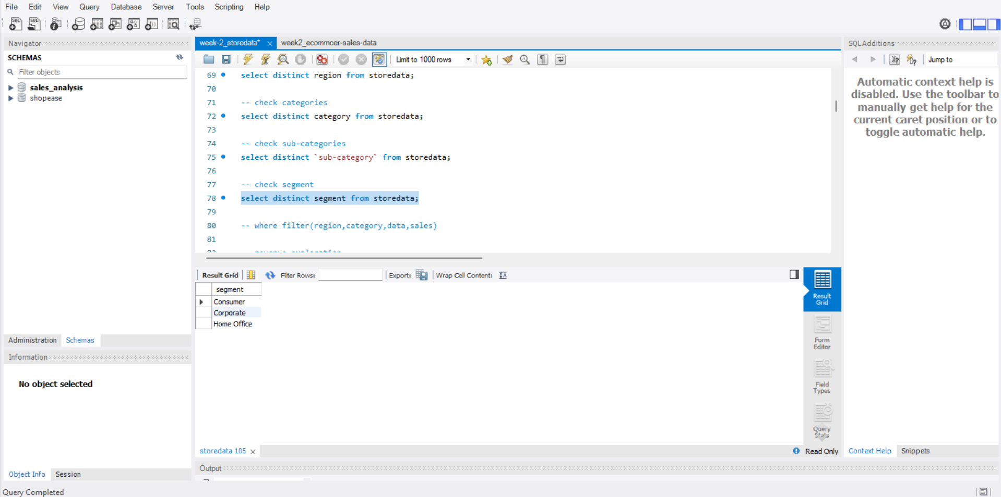

Apply Where Filters
Revenue exploration

Query 13:high revenue orders
select * from storedata where sales > 500;
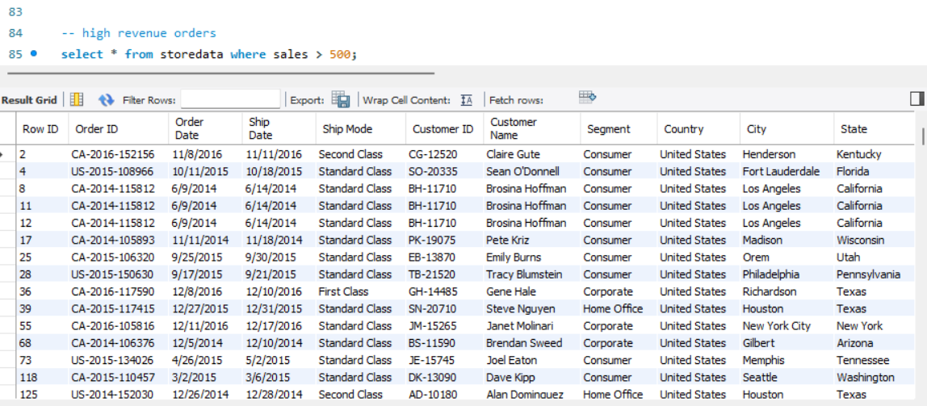

Query 14 :very high revenue orders
select * from storedata where sales > 1000;
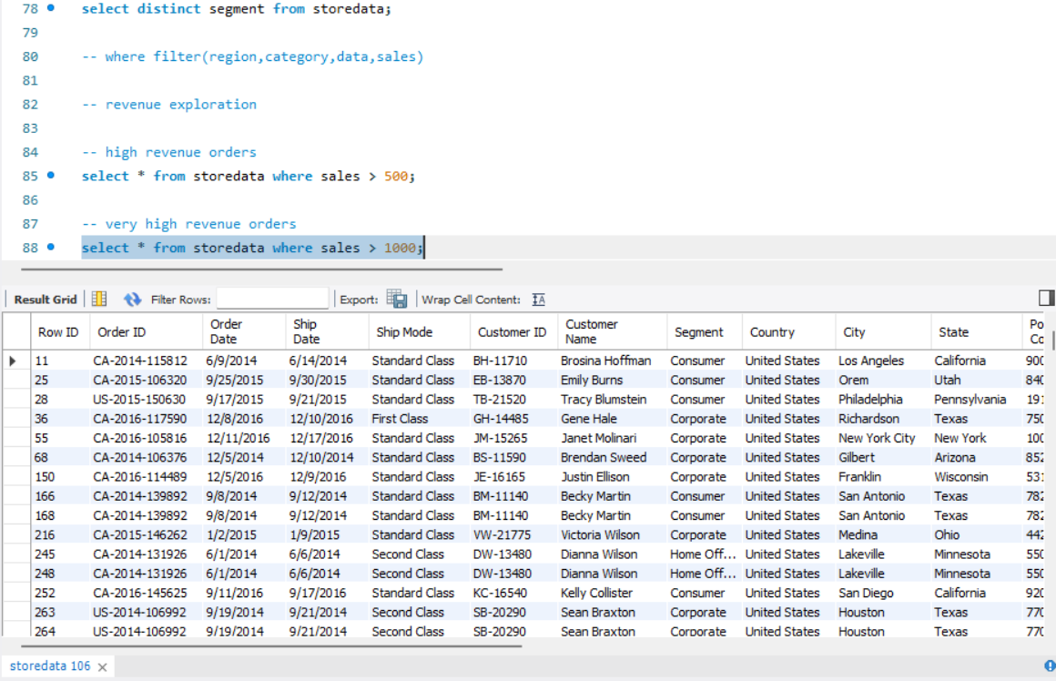

Query 15: low revenue orders
select * from storedata where sales < 50;
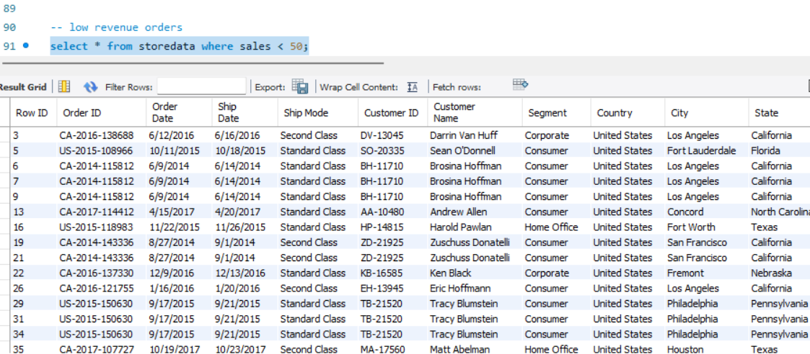

profitability exploration

Query 16: loss making orders
select * from storedata where profit < 0;
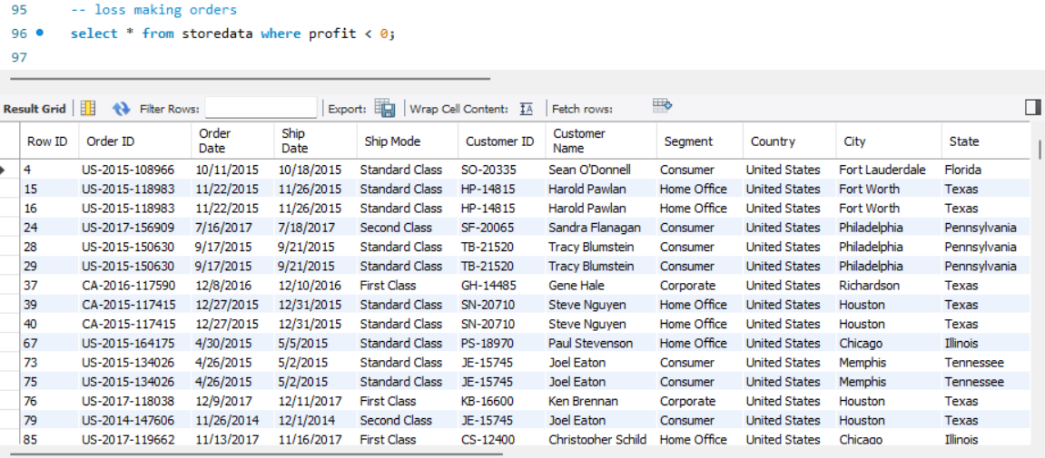

Query 17: high profit orders
select * from storedata where profit > 1000;
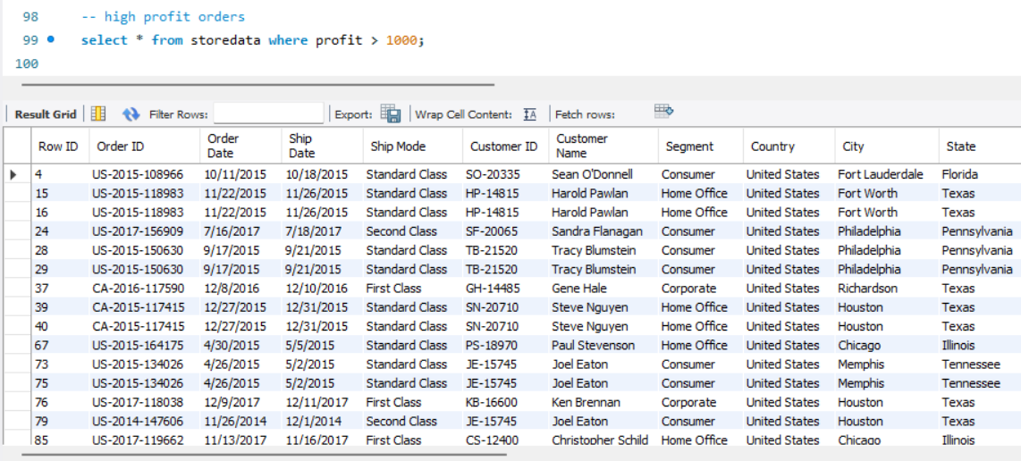

Query 18:break-even orders
select * from storedata where profit = 0;
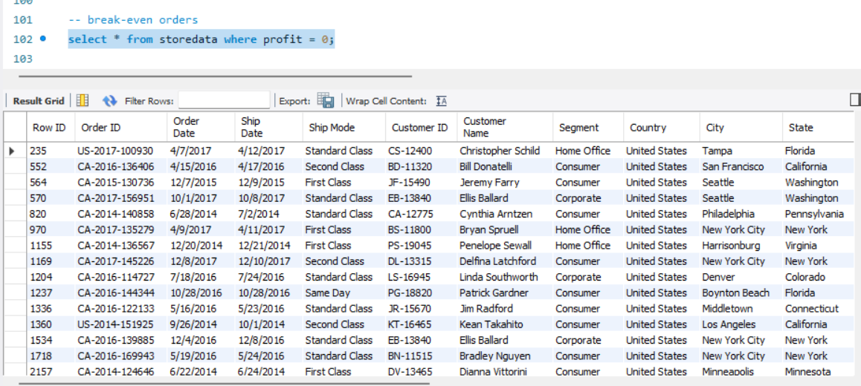

discount analysis

Query 19:no discount orders
select * from storedata where discount = 0;
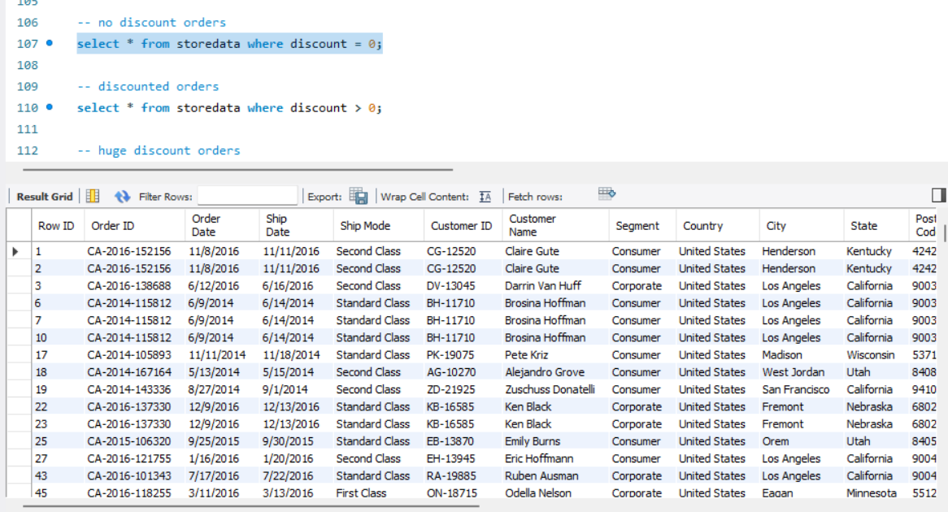

Query 20:discounted orders
select * from storedata where discount > 0;
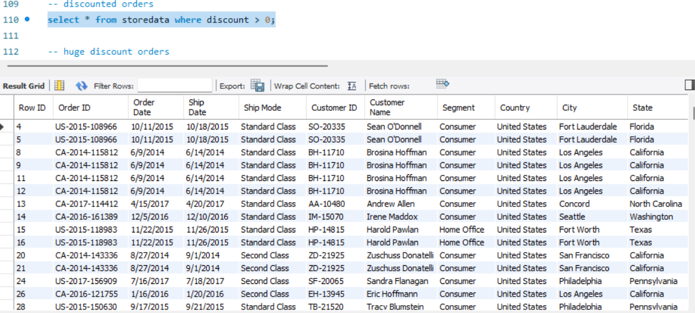
Query 21:heavy discount and loss
select * from storedata where discount > 0 and profit < 0;
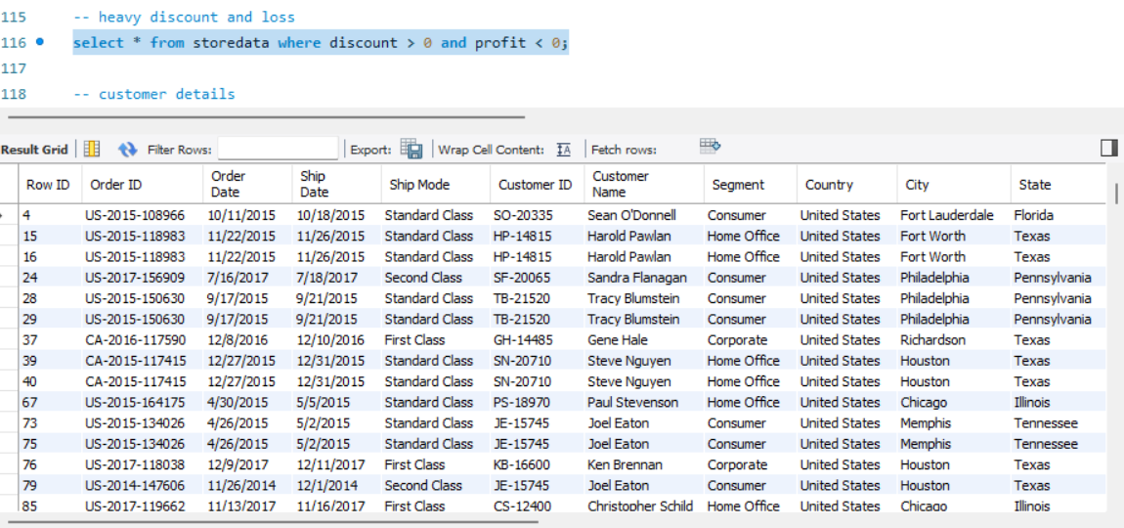

Customer details

Query 22: consumer segment
select * from storedata where segment = 'Consumer';

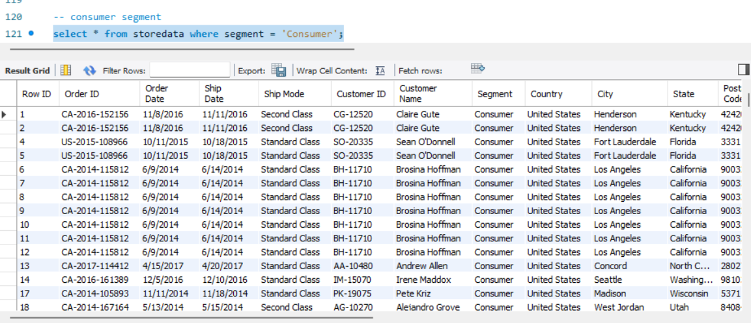

Query 23:corporate segment
select * from storedata where segment = 'Corporate';
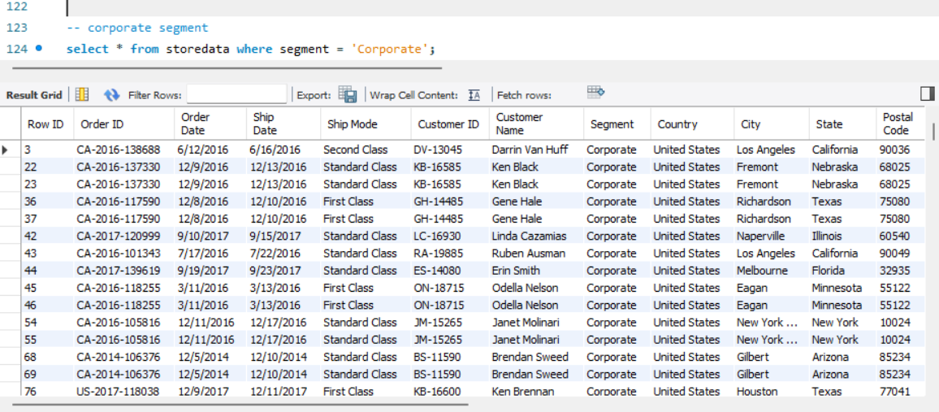
Query 24 :Home office segment
select * from storedata where segment = 'Home Office';
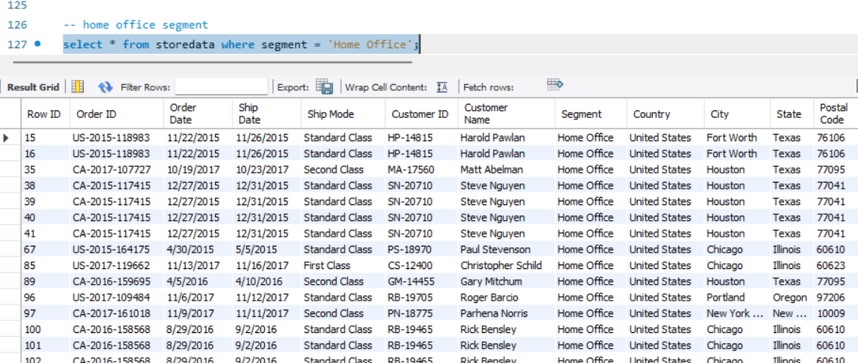

regional filter

Query 25:west region
select * from storedata where region = 'West';
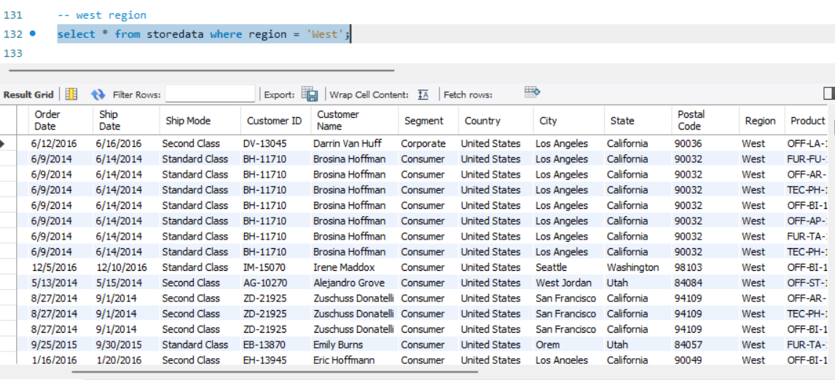
Query 26:west and south region
select * from storedata where region in ('West','South');
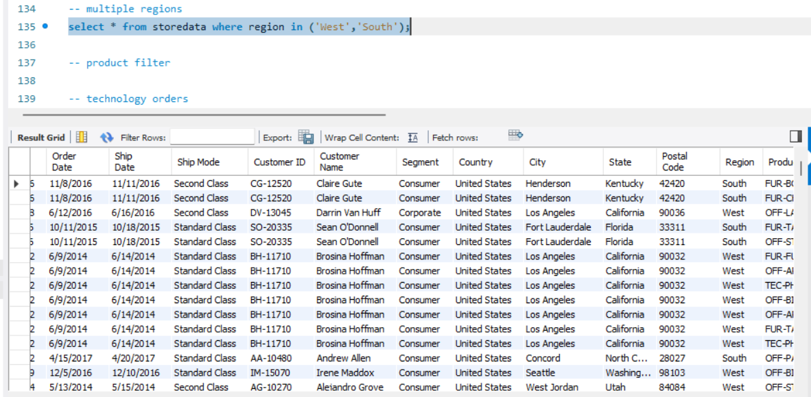

product filter

Query 27: technology orders
select * from storedata where category = 'Technology';

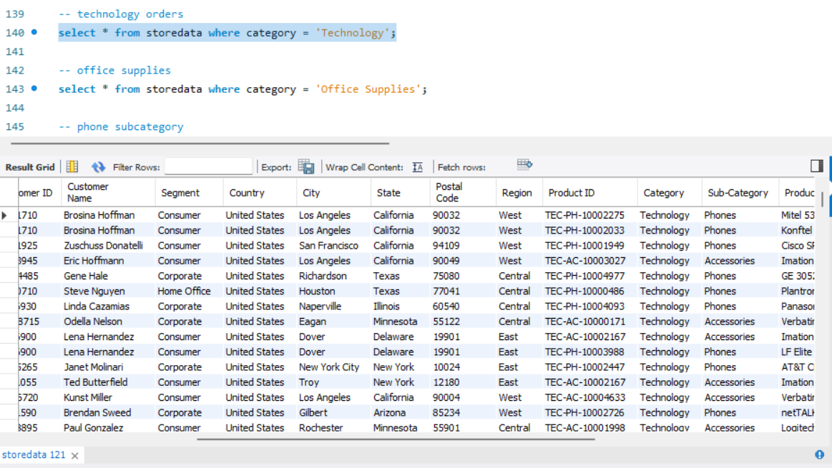

Query 27:office supplies
select * from storedata where category = 'Office Supplies';
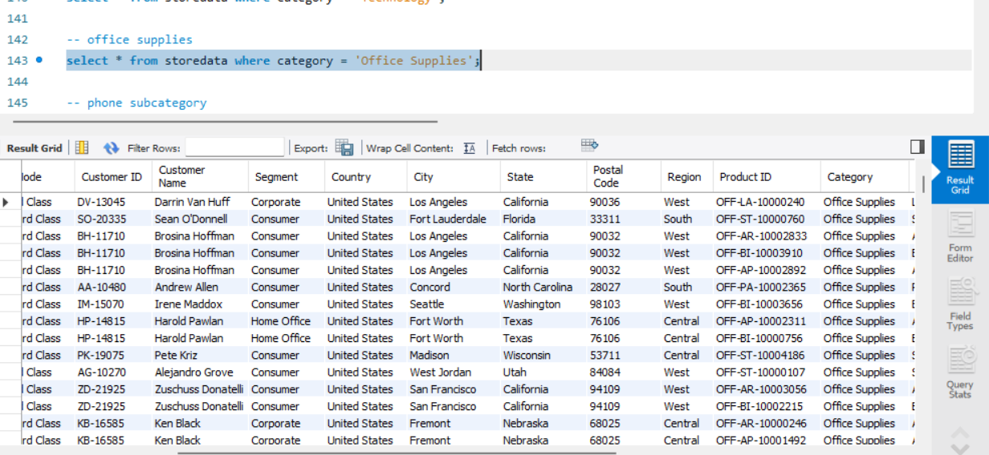

Query 28:phone subcategory
select * from storedata where `sub-category` = 'Phones';
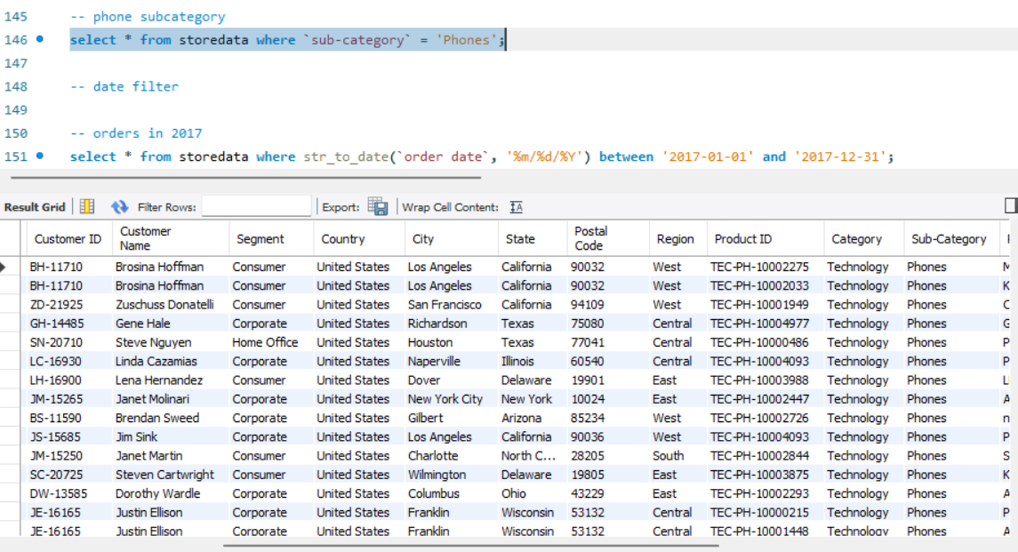
date filter
Query 29: orders in 2017
select * from storedata where str_to_date(`order date`, '%m/%d/%Y') between '2017-01-01' and '2017-12-31';
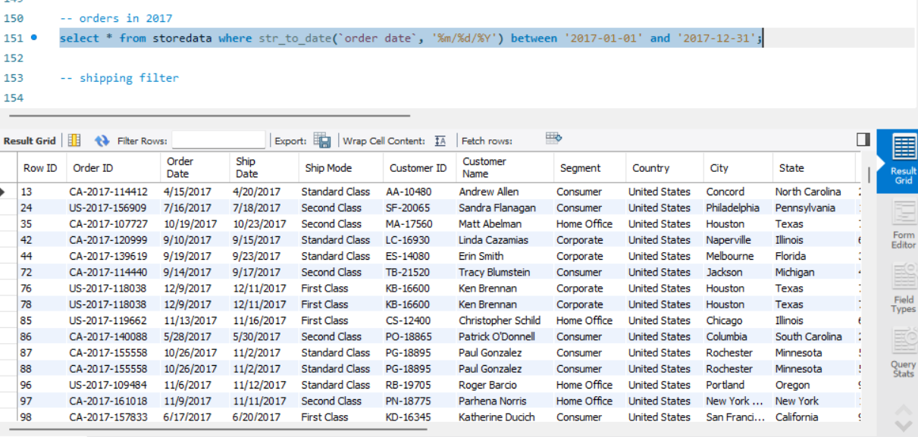

Shipping filter

Query 30:same day delivary
select * from storedata where `ship mode` = 'Same Day';
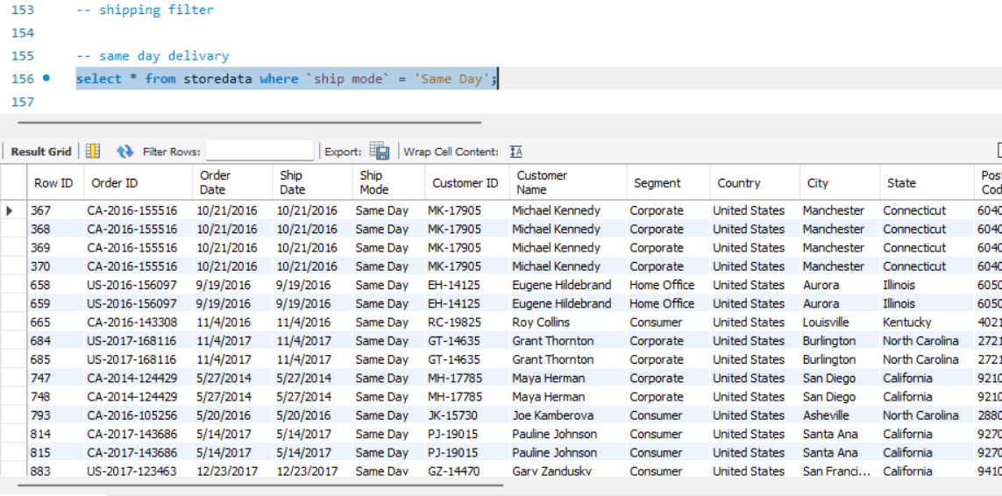

Query 31:standard class
select * from storedata where `ship mode` = 'Standard Class';
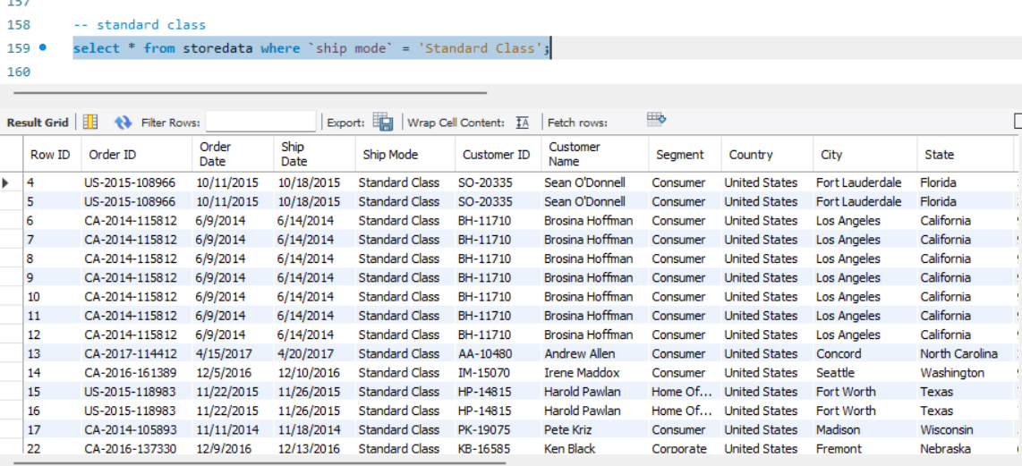

group by aggregations

Query 32:total sales by region
select region, round(sum(sales), 2) as total_sales
from storedata group by region
order by total_sales desc;

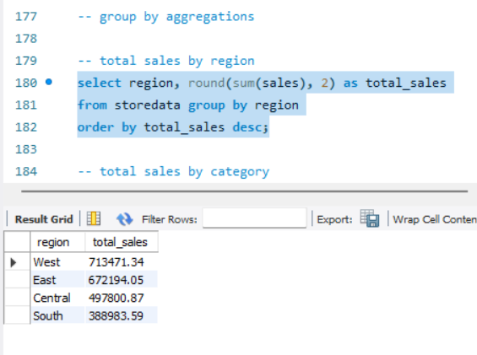
Query 33:total sales by category
select category, round(sum(sales), 2) as total_sales
from storedata group by category
order by total_sales desc;
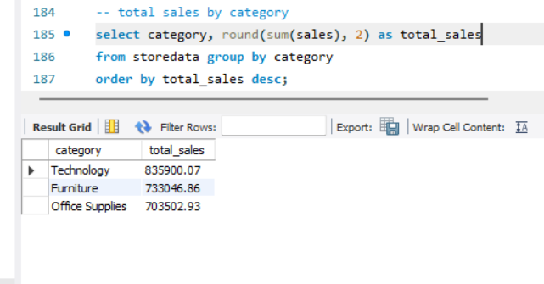

Query 34:total sales by sub category
select `sub-category`, round(sum(sales), 2) as total_sales
from storedata group by `sub-category`
order by total_sales desc;
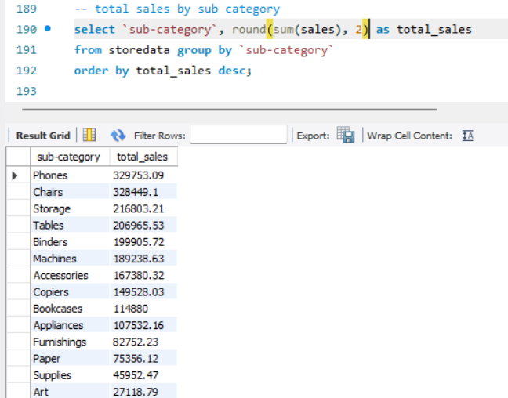
Query 35:total quantity by region
select region, sum(quantity) as total_quantity
from storedata group by region
order by total_quantity desc;
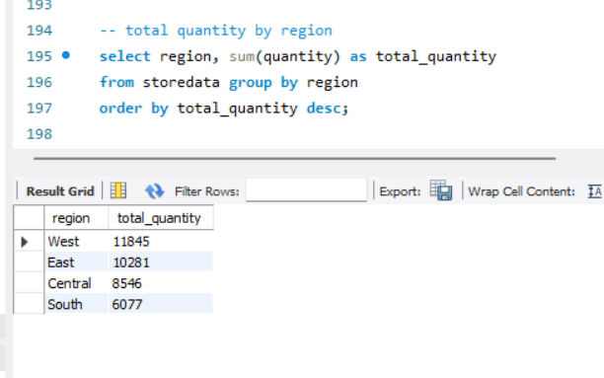

Query 36: average sales by category
select category, round(avg(sales), 2) as avg_sales
from storedata group by category
order by avg_sales desc;
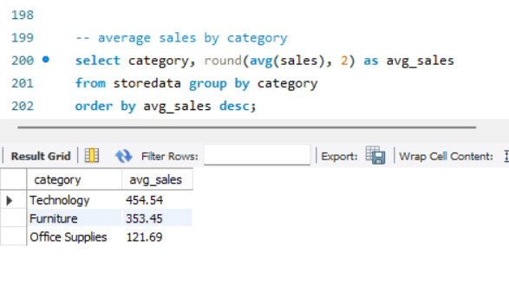

Query 37: average profit by category
select category, round(avg(profit), 2) as avg_profit
from storedata group by category
order by avg_profit desc;
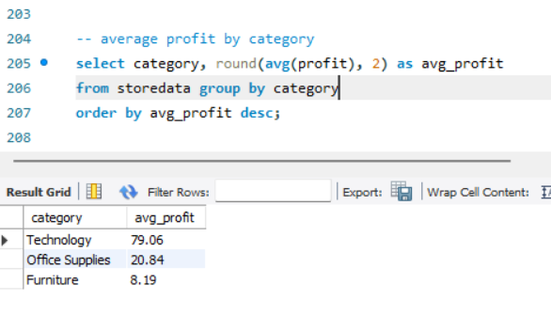
Query 38: sales by customer segment
select segment, round(sum(sales), 2) as total_sales
from storedata
group by segment
order by total_sales desc;
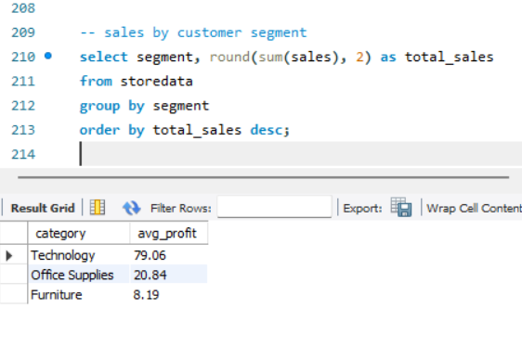

Query 39:min and max sales by category
select category, max(sales) as max_sales, min(sales) as min_sales
from storedata
group by category;
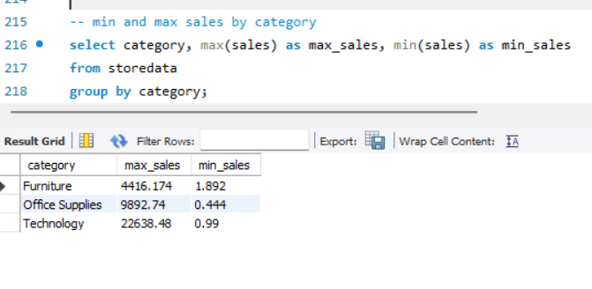
Query 40:total sales,quantity and profit by category
select category,
round(sum(sales), 2) as total_sales,
sum(quantity) as total_quantity,
round(sum(profit), 2) as total_profit
from storedata
group by category
order by total_sales desc;

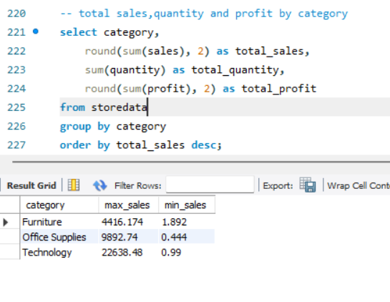
Query 41:total sales and profit by region
select region,
round(sum(sales), 2) as total_sales,
round(sum(profit), 2) as total_profit
from storedata
group by region
order by total_sales desc;
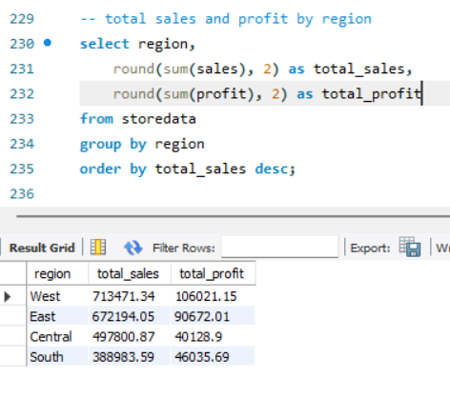
5 sort and and limit

Query 42:top 10 highest sales transactions
select * from storedata
order by sales desc
limit 10;
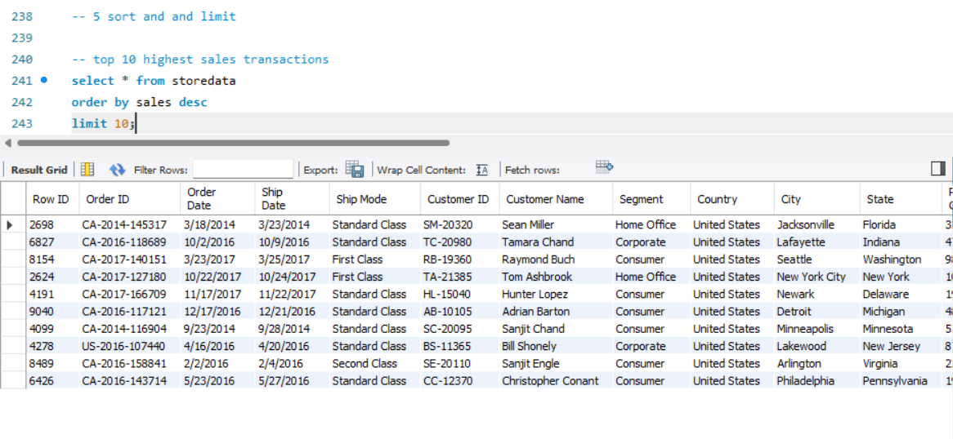
Query 43: top 10 highest profit transactions
select * from storedata
order by profit desc
limit 10;
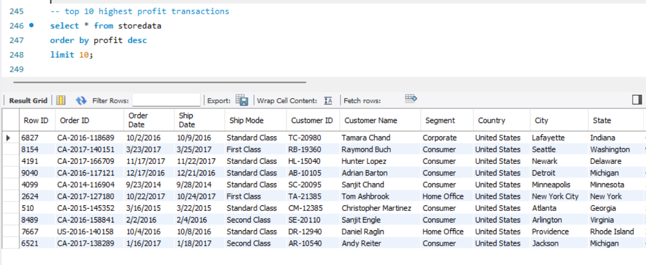

Query 44:top 10 loss transactions
select * from storedata
order by profit asc
limit 10;
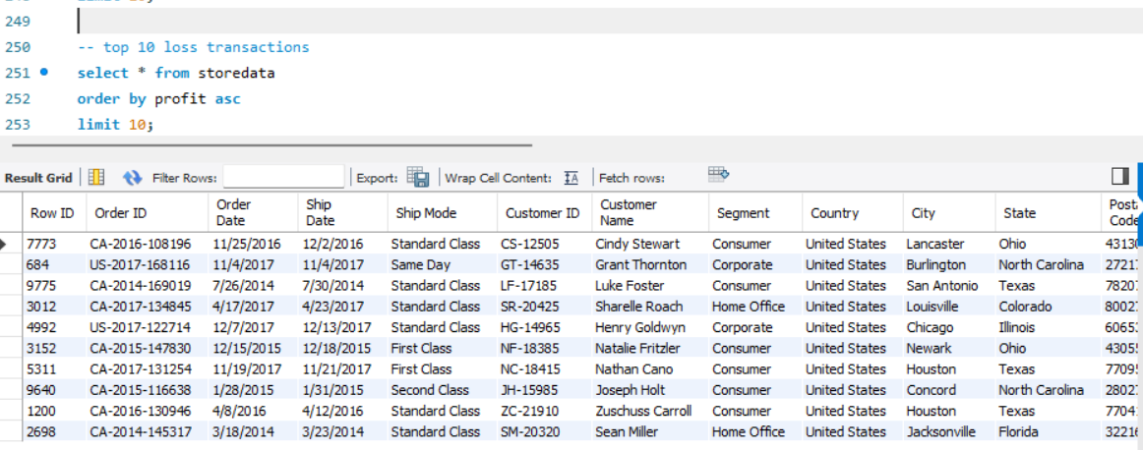
Query 45: top 10 products by sales
select `product name`,
round(sum(sales), 2) as total_sales
from storedata
group by `product name`
order by total_sales desc
limit 10;

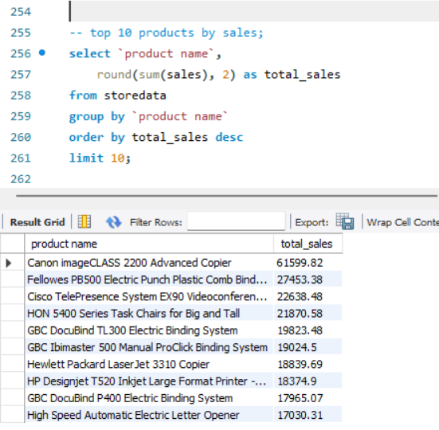

Query 46 : top 10 orders by profit
select
`order id`,
round(sum(profit), 2) as total_profit
from storedata
group by `order id`
order by total_profit desc
limit 10;
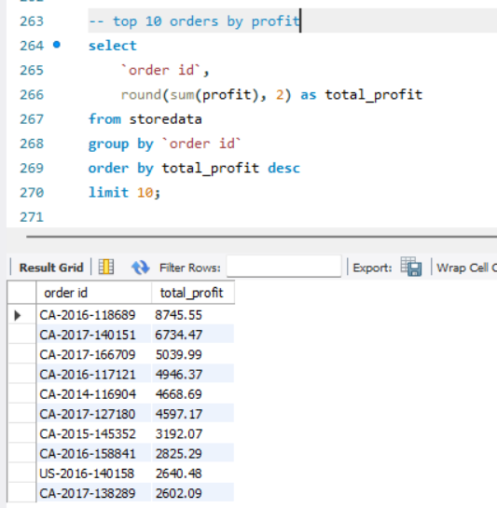

Query 47: top 10 most loss-making orders
select
`order id`,
round(sum(profit), 2) as total_profit
from storedata
group by `order id`
order by total_profit asc
limit 10;
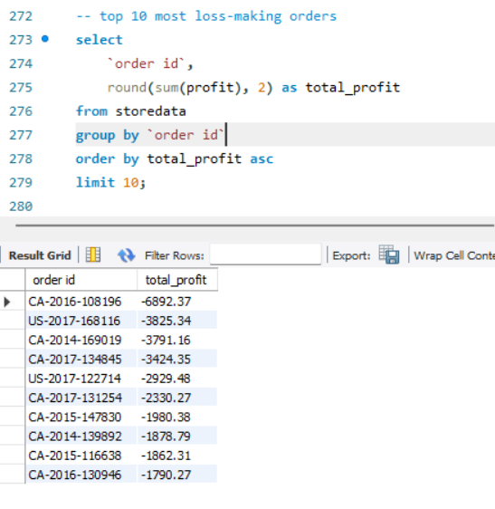

Query 48 :top 10 states per sales
select state,
sum(sales) as total_sales
from storedata
group by state
order by total_sales desc
limit 10;
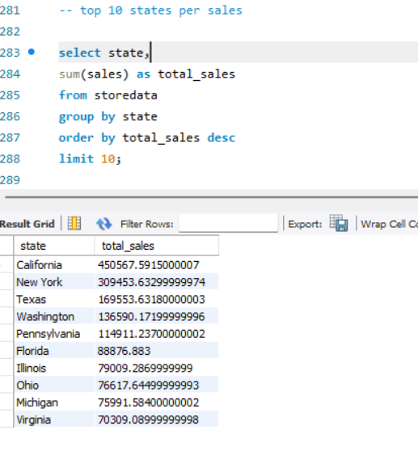
Query 49: top 10 customers per sales
select `customer name`,
round(sum(sales), 2) as total_sales
from storedata
group by `customer name`
order by total_sales desc
limit 10;
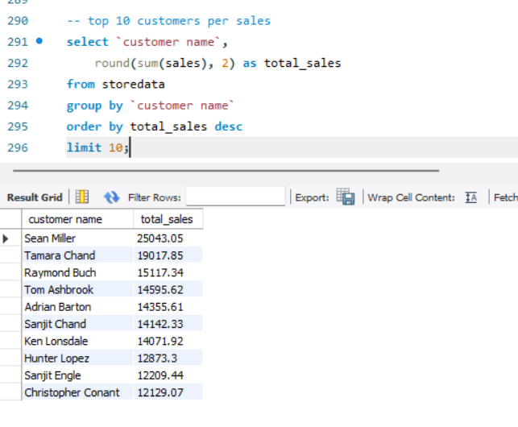

Query 50 : top 10 customers by profit
select `customer name`,
round(sum(profit), 2) as total_profit
from storedata
group by `customer name`
order by total_profit desc
limit 10;

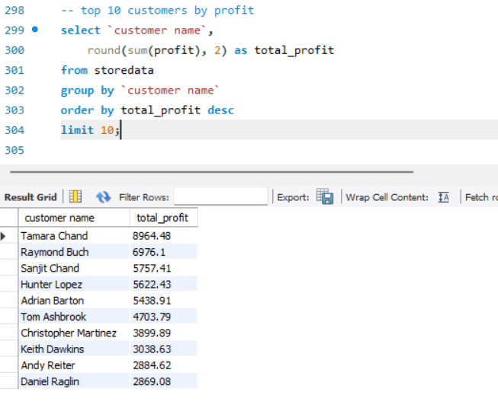
Query 51 : top 10 states by profit
select state,
round(sum(profit), 2) as total_profit
from storedata
group by state
order by total_profit desc
limit 10;
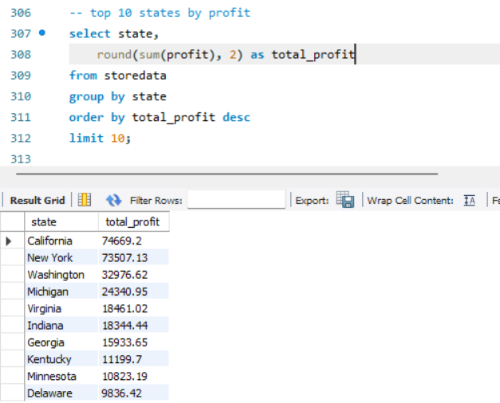

Query 52 : top 10 cities by sales
select
city,
round(sum(sales), 2) as total_sales
from storedata
group by city
order by total_sales desc
limit 10;
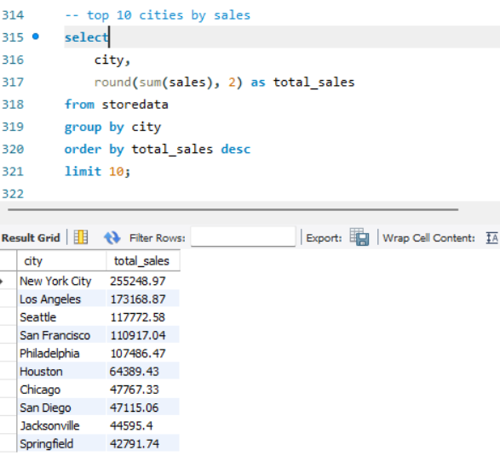
Query 53 : top 10 customers by number of orders
select
`customer name`,
count(distinct `order id`) as total_orders
from storedata
group by `customer name`
order by total_orders desc
limit 10;
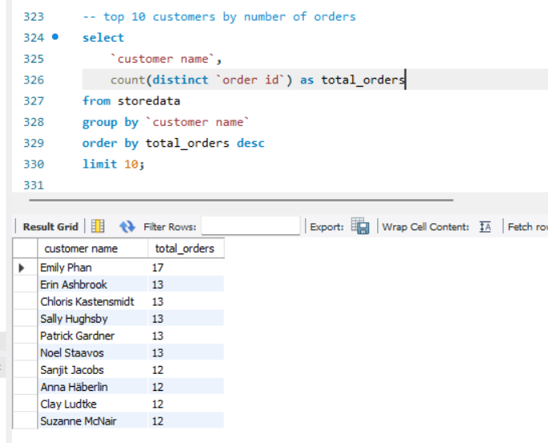

Query 54 : most profitable region
select region,
sum(profit) as total_profit
from storedata
group by region
order by total_profit desc;
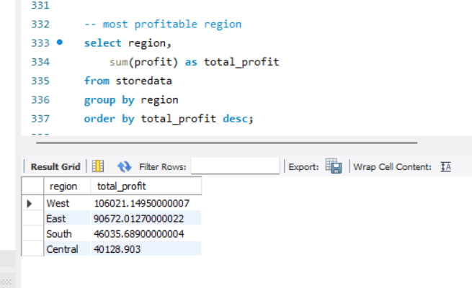
Query 55 : most profitable category
select category,
sum(profit) as total_profit
from storedata
group by category
order by total_profit desc;

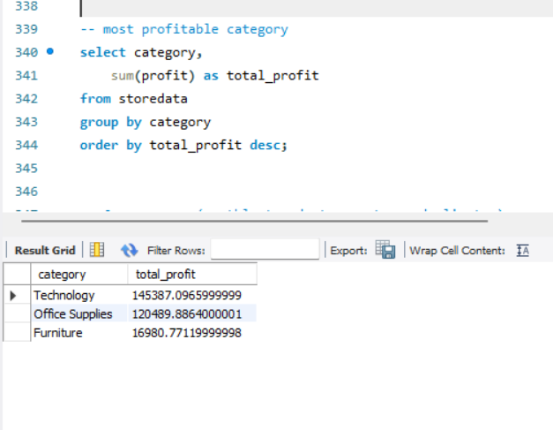

6 use cases (monthly trends,top customer,duplicates)

Query 56 :monthly sales trend
select
date_format(str_to_date(`order date`, '%m/%d/%Y'),
'%Y-%m'
) as month,
round(sum(sales), 2) as total_sales
from storedata
group by month
order by month;
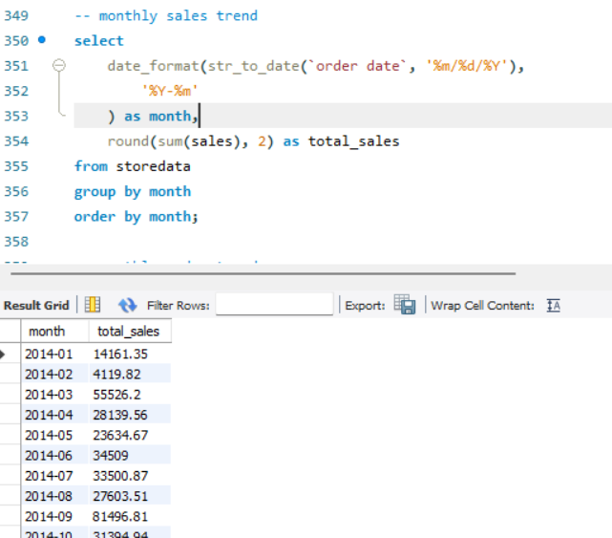
Query 57 : monthly order trends
select
date_format(str_to_date(`order date`, '%m/%d/%Y'),
'%Y-%m'
) as month,
count(distinct `order id`) as total_orders
from storedata
group by month
order by month;

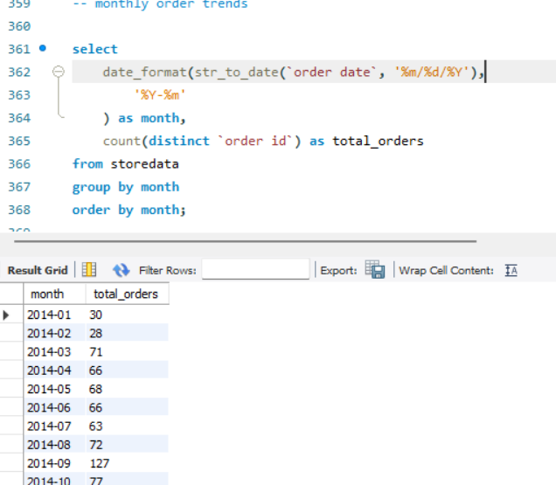
Query 58 : monthly profit trend
select
date_format(str_to_date(`order date`, '%m/%d/%Y'),
'%Y-%m'
) as month,
round(sum(profit), 2) as total_profit
from storedata
group by month
order by month;
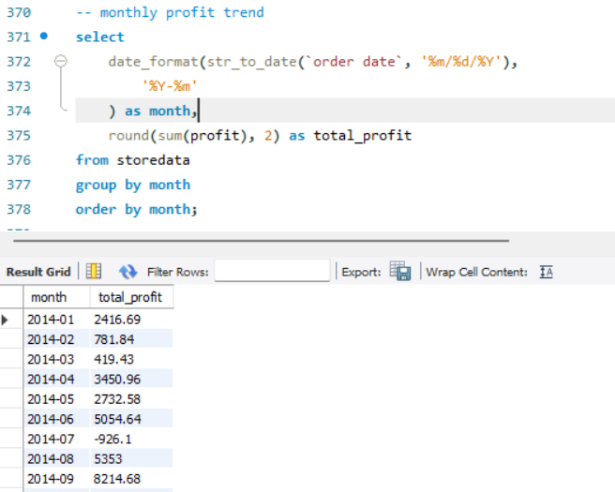

Query 59 : top 10 customers by sales
select `customer name`,
round(sum(sales), 2) as total_sales
from storedata
group by `customer name`
order by total_sales desc
limit 10;

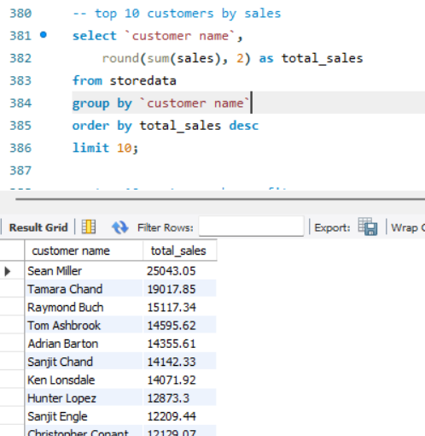

Query 60 : top 10 customers by profit
select `customer name`,
round(sum(profit), 2) as total_profit
from storedata
group by `customer name`
order by total_profit desc
limit 10;
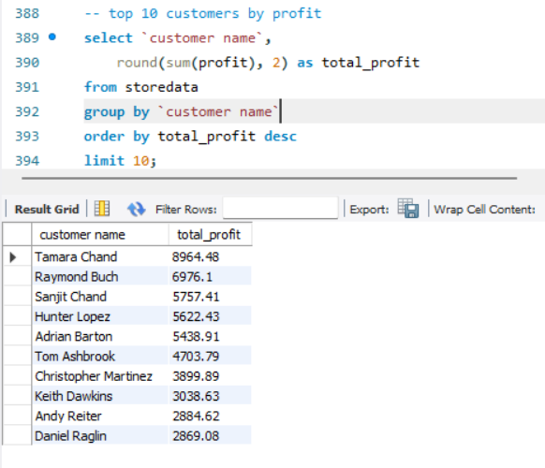

Query 61 : top 10 customers by orders
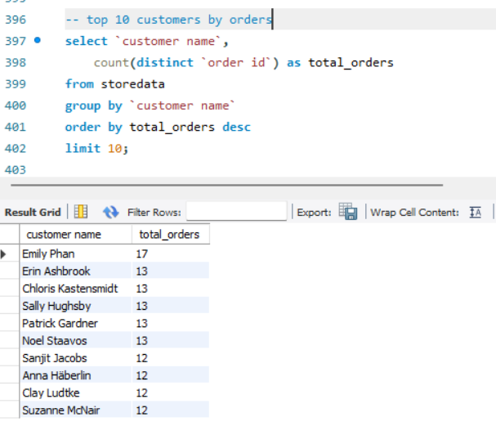

Query 62 : duplicate order check
select
`order id`,
count(*) as duplicate_count
from storedata
group by `order id`
having count(*) > 1
order by duplicate_count desc;
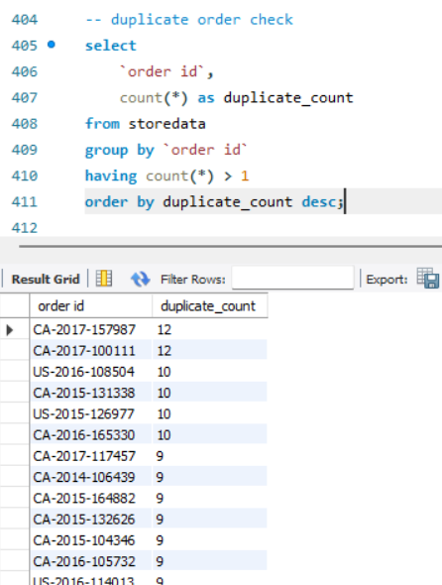

Query 63 : duplicates in customer product and order
select
`order id`,
`customer id`,
`product id`,
count(*) as duplicate_count
from storedata
group by
`order id`,
`customer id`,
`product id`
having count(*) > 1;
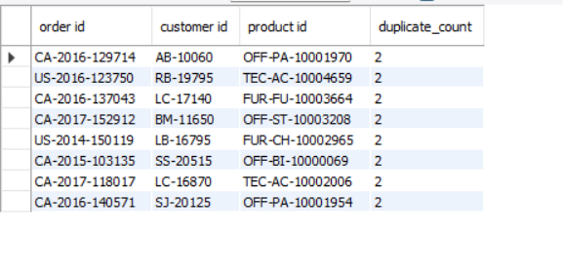
7 validate results(row count,data quality)

Query 64 : total row count
select count(*) as total_rows
from storedata;
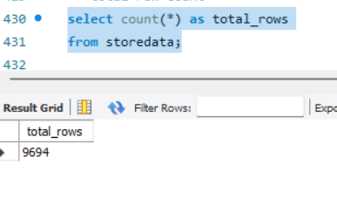
Query 65 : null customer ids
select count(*) as null_customer_id
from storedata
where `customer id` is null;
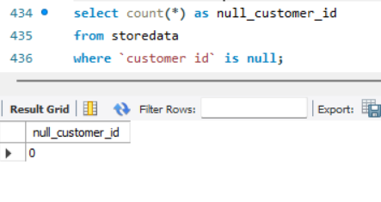
Query 66 : null order ids
select count(*) as null_order_id
from storedata
where `order id` is null;
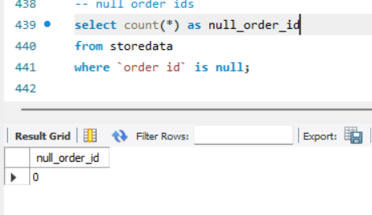

Query 67 : null product ids
select count(*) as null_product_id
from storedata
where `product id` is null;
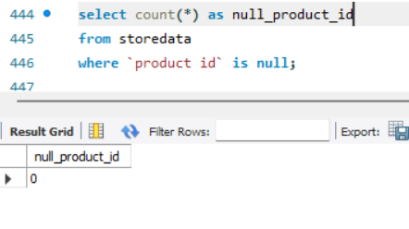
Query 68 : null sales values
select count(*) as null_sales
from storedata
where sales is null;
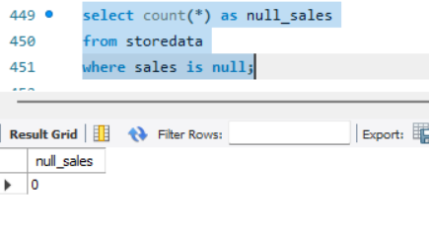
Query 69 : null profit values
select count(*) as null_profit
from storedata
where profit is null;
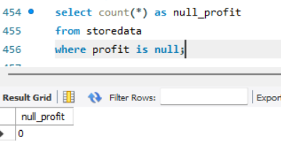

Query 70 : null quantity values
select count(*) as null_quantity
from storedata
where quantity is null;
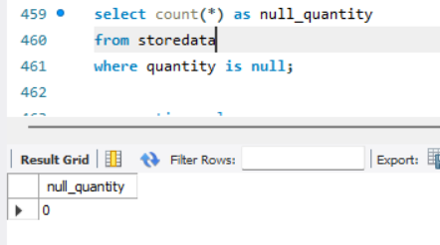
Query 71 : negative sales
select * from storedata
where sales < 0;
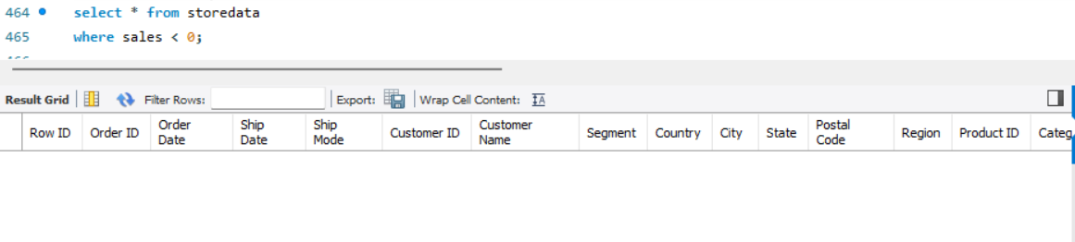
Query 72 : invalid discounts
select * from storedata
where discount < 0 or discount > 1;
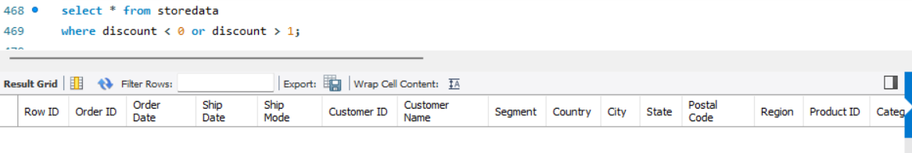
Query 73 : null regions
select count(*) as null_regions
from storedata
where region is null;
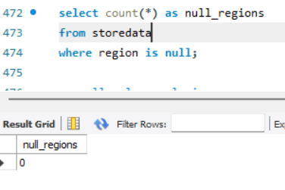
Query 74 : null value analysis
select
count(*) as total_records,
count(sales) as sales_records,
count(*) - count(sales) as missing_sales,
count(profit) as profit_records,
count(*) - count(profit) as missing_profit,
count(`customer name`) as customer_records,
count(*) - count(`customer name`) as missing_customers
from storedata;

