**CSE316: Microprocessors and Microcontrollers Sessional**

Project: Low Cost Food Heater

Submitted by

Mainuddin Russel (1405032)

Provakar Mondal (1405034)

**Contents:**

● Introduction  
● Hardware Requirements  
● Software Requirements  
● Flowchart  
● Block Diagram  
● Circuit Diagram  
● Description of Modules & Used Libraries  
 LM35 Temperature Sensor

SG90 Servo Motor   
 16x2 Alphanumeric LCD Display

LED

● Problems Faced

● Acknowledgements

**Introduction**

The aim of our project is to heat foods at low cost. It can be said food oven too. In our project, the food will be kept in a container. A LM35 temperature will be also kept in the container to measure the temperature inside the container. We have used a 200 W AC bulb to heat the food to a sustain temperature. The reading of the temperature of the LM35 sensor is showed in a 16*2 LCD Display. Our target is to light off the ac bulb in the container when the temperature inside it will rise to sustain temperature. To control this we have divided the line of the bulb in two ports. Normally the two ports are connectionless. A SG90 servo motor has been used as switch to control the connection of this two ports. Under sustain temperature, the servo will touch the ports, fills the connection and so the bulb will be lighting. At sustain temperature, the servo will rotate, incomplete the connection and as a result the bulb will be light off.

(Watch our project video) Russel, the bracked line will be video link

**Hardware Requirements:**

1. Atmega32 microcontroller
2. USB ISP 2.0 AVR Programmer
3. LM35 Temperature Sensor
4. SG90 Servo Motor
5. Led
6. 16x2 Alphanumeric LCD Display
7. Resistors

**Software Requirements:**

1. Atmel Studio 6.2 (to compile .c code and build .hex file)
2. progisp 1.72 (to load .hex file to microcontroller)
3. Proteus 8 Professional (to design circuit)

Flowchart:

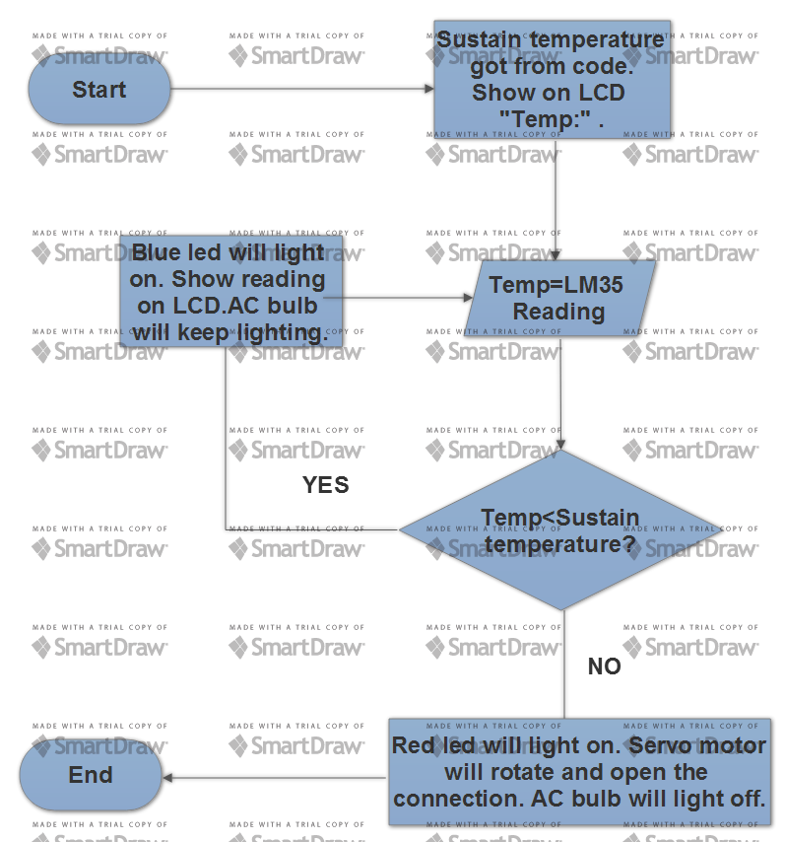

Russel ,you have a lot of work here, to remove the watermark. I tried. Sorry bro.

**Block Diagram**

Showing input and output

16x2 LCD Alphanumeric Display

Atmega32

LM35 Temperature Sensor Reading

SG90 Servo Motor

LEDs

**Circuit Diagram**

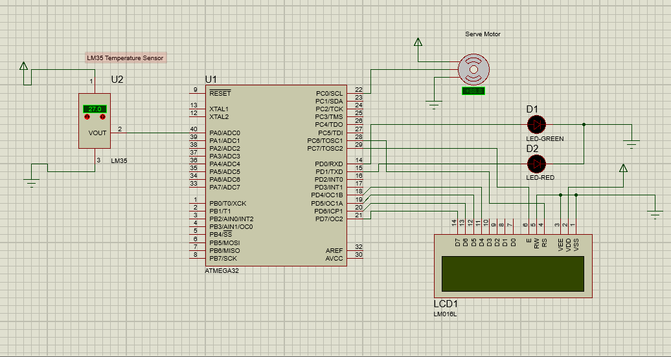

Actual Circuit

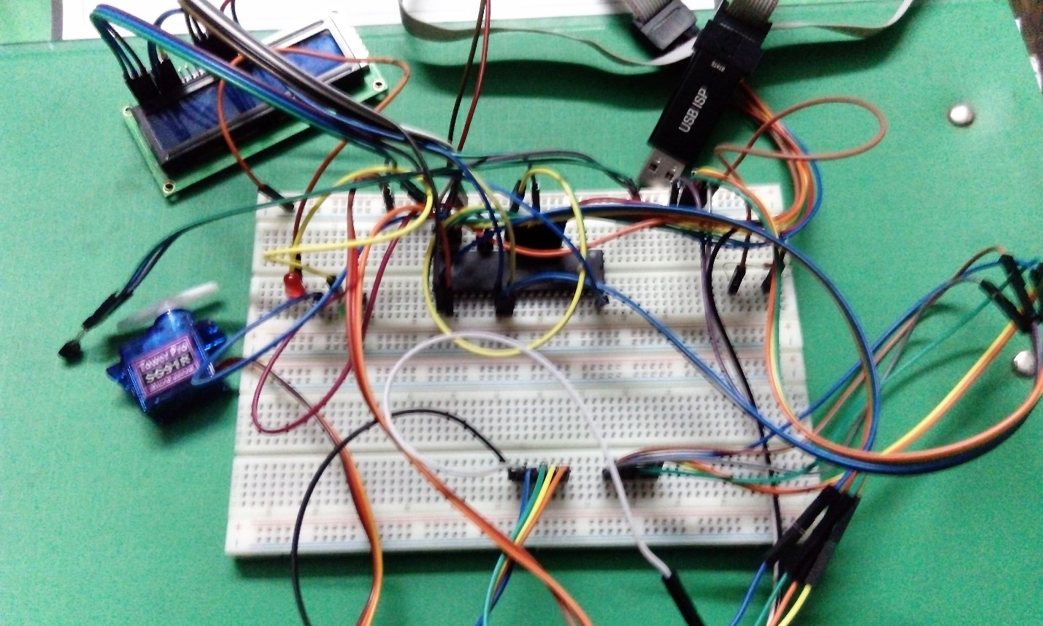

**Description of Modules**

1. LM35 Temperature Sensor

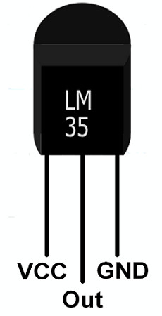

1. SG90 Servo Motor

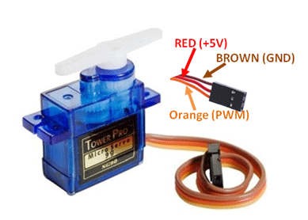

1. 16x2 LCD Alphanumeric Display

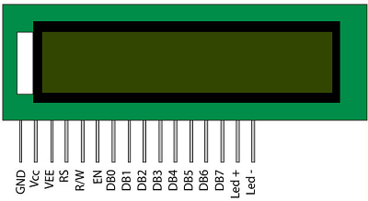

The LCD has 16 connector pins. Connections are:  
● LCD 1 ​ *(GND)*​to GND  
● LCD 2 ​ *(VCC)*​to 5V  
● LCD 3 ​ *(VEE)*​to GND  
● LCD 4 ​ *(RS)*​to PC6 (Pin 28 on Atmega32)  
● LCD 5 ​ *(R/-W)*​to GND  
● LCD 6 ​ *(Enable)*​to PC7 (Pin 29 on Atmega32)  
● LCD 7, 8, 9, 10 are ​ *not connected*● LCD 11 ​ *(DB4)*​to PD4 (Pin 18 on Atmega32)  
● LCD 12 ​ *(DB5)*​to PD5 (Pin 19 on Atmega32)  
● LCD 13 ​ *(DB6)*​to PD6 (Pin 20 on Atmega32)  
● LCD 14 ​ *(DB7)*​to PD7 (Pin 21 on Atmega32)  
● LCD 15 (to VCC) and LCD 16 (to GND) are for background light

1. LEDs

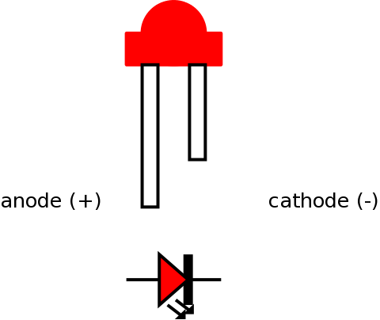

**Used Library**

We have used a .h library file. It is lcd.h file. It has been used to operate 16x2 LCD Alphanumeric Display.

(lcd.h) Russel this bracket will be a link to lcd.h file.you will upload the file to drive and give the link here.

**Problems we faced**

1. The LM35 sensor was not working properly. It was a damaged one. After changing the sensor, it worked.
2. We made mistake in LCD Display connections. After correction of the connections it’s brightness was huge that the text could not be read properly. Then we used a 10k ohm resistance to led- connection. It performed well then.
3. The SG90 servo motor also misbehaved at first. It’s rotation couldn’t be controlled. It was the mistake in our code. When we corrected the code, it’s rotation was as we desired.

**Acknowledgements**

The following sites helped us a lot for our project

1. <https://circuitdigest.com>
2. <https://electrosome.com>
3. <http://www.avrfreaks.net>
4. <http://extremeelectronics.co.in>

Russel make these link

Thank you