Colloids

* type of mixture containing dispersed particles 1-1000nm in diameter
* one substance is evenly distributed in another

Classification:

|  |  |  |
| --- | --- | --- |
| **Type** | **Dispersed substance & medium** | **Examples** |
| Sol | Solid in a liquid | Ruby glass, paints |
| Emulsion | Liquid in a liquid | Milk (solid): Cheese, pearl |
| Foam | Gas trapped in liquid/solid | Whipped cream, soap suds |
| Aerosol | Liquid/solid dispersed in gas | Smoke, mist |

Hydrocolloid: when water is the dispersion medium ex. Jello

Tyndall Effect: in solution, light passes through clearly // in colloidal solutions, light is scattered/reflected in all directions

DNA-grafted particles:

# Nanoscale

Oligonucleotides attached to gold nanoparticles through a thiol functional group (most common)

|  |  |  |
| --- | --- | --- |
| **Noble Metals** | **Oxides** | **Semi-Conductors** |
| Au | FexOy | CdSe |
| Ag | SiO2 | CdS |
| Pd | TiO2 | PdS |

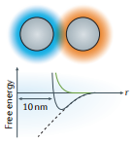Length of DNA ≈ size of particle

* wide potential minimum
* overall hydrodynamic radius of a DNA NP dictates the packing and assembly behavior of the system
* Melting temperature (Tm) of NP aggregates depend on the size of the NPs
* DNA NP superlattices are very compressible, capable of transforming between different structures ex. an isotropic transformation can result in up to 80% volume reduction

Steric stabilization: by adding a *lyophobic* material to a colloid provides a protective “shield” and prevents particles from approaching close enough to join // *synthetic polymers* can be used for this purpose

|  |  |
| --- | --- |
| **Particles** | Polystyrene  Polymethyl methacrylate  Silica  Silica-methacrylate hybrid  Titania  TPM |

# Microscale:

Oligonucleotides attached to polymer / silica particles

* ligand-receptor binding
* physical grafting
* covalent attachment (SPAAC)

Synthesis reactions:

* *Avidin-biotin*: strongest non-covalent interaction
* *Water-soluble carbodiimide / covalent bonding*: strongest interaction, includes amide linkage between carboxylate group and amine group, or azide-alkyne interactions (SPAAC)
* *PEG modification, swelling/deswelling*: polymer-based colloids only, triblock polymers connect DNA to the colloid
* *Solid colloids with surface-mobile linkers*: utilizes small unilamella vesicles (SUVs) to integrate hydrophobically modified linkers // this method and swelling/deswelling results in small, 2D crystalline structures

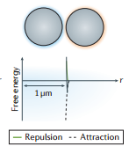Length of DNA ≈ 1% particle size

* often “hit or stick” binding, must attain *smooth surfaces* or *high density of surface-functional anchors* so equilibrium structures (minimize free energy) can be formed
* “hit and stick” binding results in kinetically trapped amorphous aggregates
* thin coating of DNA means a greater sensitivity to particle roughness and inhomogeneity
* *smooth surfaces* allow for homogenous interaction potential
* DNA shorter than particle diameter, and dsDNA never crystallized, but ssDNA always created crystals

DNA bridges: *how particles attract one another*

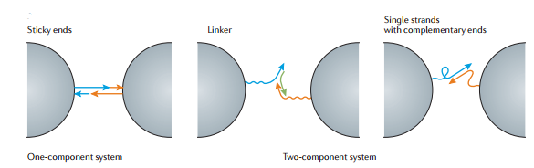

(Allows for more flexibility)

DNA hybridization:

* stability achieved through base-pairing, but more importantly through base stacking
  + Base stacking: a hydrophobic, electrostatic interaction
    - partly inter-strand, partly intra-strand
    - these interactions increase with increased salt concentrations
* hybridization becomes thermodynamically favorable at lower temperatures
* Tm of particles grafted with complementary strands can be higher or lower than Tm of DNA strands in solution
* Nearest neighbor predictions of hybridization of free energy
  + controls strength and Tm of each DNA bridge
  + Observed trend (@ 37°C):
    - G-C > C-G > G-G > G-A ≈ G-T ≈ C-A > C-T > A-A > A-T > T-A
  + DNA stability depends on percentage of G-C bonds: G-C base pairs have the greatest stability (3 H bonds)
    - increasing G-C content raises the Tm at which complementary strands dissociate
    - influenced by neighboring base pairs ex.) A-T surrounded by G-C = stability
* An INCREASE in base pairs = INCREASE in Tm

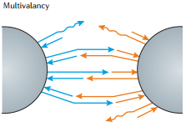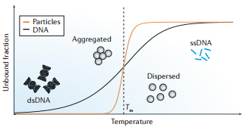

Crystallization zone

* Melting transition from aggregated to dispersed state of the colloidal particles is steeper because of multivalency
  + Multivalency: the ability to form >1 DNA bridge at a time
* curves shift to LOWER temperatures as *linker density* decreases, but shifts to HIGHER temperatures as *molecular mass* decreases
  + larger molecular mass keeps particles further apart, and reduces the number of links
* punbridged(r) = (1 – p) N
  + p: probability
  + N: total number of bridges that can form
  + because of multivalency, N is much greater than 1 // this means that the attraction between particles varies from negligible to irreversible in just a few °C

Attaining Equilibrium:

* conduct at the correct temperature, usually a few °C below the Tm // a non-equilibrium state is attained when procedures are conducted at temperatures well below Tm of the particles
* decrease van der Waals forces by increasing salt concentration
* create an assembly where particles aggregate with a high number of strands that bind together weakly
* minimize free energy: F = Utotal effective potential – TSentropy
  + F can be minimized by maximizing the number of attractive pair interactions between particles

Buffer solutions with different *ionic strengths*

|  |  |  |
| --- | --- | --- |
| NaCl concentration | Interparticle spacing | Reasoning |
| LOW | LARGE spacing | Particle-particle repulsion strong |
| MED (0.05 – 0.7M) | Small spacing increases, ex. ~1.7nm change for a 24-mer linked NP | |
| HIGH | Particles assemble closely | Cations screen the negative charge of DNA  Mask repulsion between 2 negatively charged phosphodiester backbones |

* linear relationship between Tm and salt concentration, decreases van der Waals forces
* a higher NaCl concentration = faster aggregation and often higher grafting density, but also lowers the stabilization against aggregation
  + stepwise addition of salt and DNA may prevent this

Type of Crystals

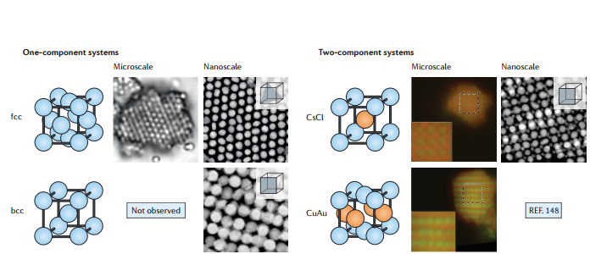

* Assembly structures maximize the total number of hybridized DNA interconnects between particles
* Binding group mobility = less dramatic dissociation transition
  + attained by anchoring DNA to a lipid-coated particle surface
  + bridges gap between hard nano/microparticles with covalently coupled immobile binding groups & soft “floppy” objects with mobile binding groups
* Crystal structures determined by: particle size, stoichiometry, sticky-end sequences
  + thickness depends on: initial particle concentration, particle size, particle density

Crystal characterization

Crystals follow the rule for equilibrium crystals (complementary contact model), meaning that contact between spheres with complementary strands is maximized

F = U – TS

U is minimized when there are a maximum number of attractive pair interactions

EXCEPTIONS:

1. long-ranged interactions: U is no longer proportional to the number of nearest-neighbor pairs

2. large entropic contribution (TS) ex. “soft” vibrational modes

*Cesium-chloride (CsCl)*

* 2 interpenetrating simple cubic lattices
* if particles weren’t distinguished, the assembly would have the *bcc* structure
  + *bcc structure*: favored if next-nearest-neighbor interactions are possible

*Copper-Gold (CuAu)*

* each particle has 8 neighbors of the opposite type
* if particles weren’t distinguished, the assembly would have the fcc structure

CuAu favored over CsCl for all but the weakest A-A, B-B attraction strengths

If A-A, B-B strengths are great enough CuAu will form because of greater interacting pairs of particles

References

Alivisatos, A. Paul, et al. "Organization of'nanocrystal molecules' using DNA." *Nature* 382.6592 (1996): 609-611.

Boal, Andrew K., et al. "Self-assembly of nanoparticles into structured spherical and network aggregates." *Nature* 404.6779 (2000): 746-748.

Connolly, S., and D. Fitzmaurice. "Programmed assembly of gold nanocrystals in aqueous solution." *Advanced Materials* 11.14 (1999): 1202-1205.

Daniel, Marie-Christine, and Didier Astruc. "Gold nanoparticles: assembly, supramolecular chemistry, quantum-size-related properties, and applications toward biology, catalysis, and nanotechnology." *Chemical reviews* 104.1 (2004): 293-346.

Demers, Linette M., et al. "A fluorescence-based method for determining the surface coverage and hybridization efficiency of thiol-capped oligonucleotides bound to gold thin films and nanoparticles." *Analytical chemistry* 72.22 (2000): 5535-5541.

Di Michele, Lorenzo, and Erika Eiser. "Developments in understanding and controlling self assembly of DNA-functionalized colloids." *Physical Chemistry Chemical Physics* 15.9 (2013): 3115-3129.

Fong, Brian, and Paul S. Russo. "Organophilic colloidal particles with a synthetic polypeptide coating." *Langmuir* 15.13 (1999): 4421-4426.

Grzelczak, Marek, et al. "Directed self-assembly of nanoparticles." *ACS nano* 4.7 (2010): 3591-3605.

Kim, Anthony J., Paul L. Biancaniello, and John C. Crocker. "Engineering DNA-mediated colloidal crystallization." *Langmuir* 22.5 (2006): 1991-2001.

Kim, Anthony J., Vinothan N. Manoharan, and John C. Crocker. "Swelling-based method for preparing stable, functionalized polymer colloids." *Journal of the American Chemical Society* 127.6 (2005): 1592-1593.

Kim, Eun-Young, et al. "A real-time PCR-based method for determining the surface coverage of thiol-capped oligonucleotides bound onto gold nanoparticles." *Nucleic acids research* 34.7 (2006): e54-e54.

Leunissen, Mirjam E., et al. "Towards self-replicating materials of DNA-functionalized colloids." *Soft Matter* 5.12 (2009): 2422-2430.

Lin, Cheng‐An J., et al. "Design of an amphiphilic polymer for nanoparticle coating and functionalization." *Small* 4.3 (2008): 334-341.

Macfarlane, Robert J., et al. "Nucleic Acid‐Modified Nanostructures as Programmable Atom Equivalents: Forging a New “Table of Elements”."*Angewandte Chemie International Edition* 52.22 (2013): 5688-5698.

Mirkin, Chad A., et al. "A DNA-based method for rationally assembling nanoparticles into macroscopic materials." *Nature* 382.6592 (1996): 607-609.

Mitchell, Gregory P., Chad A. Mirkin, and Robert L. Letsinger. "Programmed assembly of DNA functionalized quantum dots." *Journal of the American Chemical Society* 121.35 (1999): 8122-8123.

Park, So-Jung, et al. "The structural characterization of oligonucleotide-modified gold nanoparticle networks formed by DNA hybridization." *The Journal of Physical Chemistry B* 108.33 (2004): 12375-12380.

Rogers, W. Benjamin, William M. Shih, and Vinothan N. Manoharan. "Using DNA to program the self-assembly of colloidal nanoparticles and microparticles." *Nature Reviews Materials* 1 (2016): 16008.

Sandström, Pär, Mila Boncheva, and Björn Åkerman. "Nonspecific and thiol-specific binding of DNA to gold nanoparticles." *Langmuir* 19.18 (2003): 7537-7543.

SantaLucia, John, Hatim T. Allawi, and P. Ananda Seneviratne. "Improved nearest-neighbor parameters for predicting DNA duplex stability."*Biochemistry* 35.11 (1996): 3555-3562.

Storhoff, James J., et al. "One-pot colorimetric differentiation of polynucleotides with single base imperfections using gold nanoparticle probes." *Journal of the American Chemical Society* 120.9 (1998): 1959-1964.

Theodorakis, Panagiotis E., et al. "Self-assembly of DNA-functionalized colloids." *arXiv preprint arXiv:1503.05384* (2015).

Valignat, Marie-Pierre, et al. "Reversible self-assembly and directed assembly of DNA-linked micrometer-sized colloids." *Proceedings of the National Academy of Sciences of the United States of America* 102.12 (2005): 4225-4229.

van der Meulen, Stef AJ, and Mirjam E. Leunissen. "Solid colloids with surface-mobile DNA linkers." *Journal of the American Chemical Society*135.40 (2013): 15129-15134.

Wang, Yu, et al. "Crystallization of DNA-coated colloids." *Nature communications* 6 (2015).

Wang, Yufeng, et al. "Synthetic strategies toward DNA-coated colloids that crystallize." *Journal of the American Chemical Society* 137.33 (2015): 10760-10766.

Zhang, Chuan, et al. "A general approach to DNA-programmable atom equivalents." *Nature materials* 12.8 (2013): 741-746.

Zhang, Yugang, et al. "A general strategy for the DNA-mediated self-assembly of functional nanoparticles into heterogeneous systems." *Nature nanotechnology* 8.11 (2013): 865-872.