pd2-Taiko Report 資訊108 蘇俐文 F74046014

UML class diagram:
Game | Player | Taiko
+scene*: QGraphicsScene
+player*: Player
+score*: Score
+time*: Time
<<constructor>>+Game()  +gameOver()  +restart() | <<constructor>>+Player()  +keyPressEvent(QKeyEvent*)  +delay()  +timerstart()  Slot:  +spawn()  +timego() | <<constructor>>+Taiko  Slot:  +move()
Taiko2 | Hit | Hit2
<<constructor>>+Taiko2  Slot:  +move() | <<constructor>>+Hit  Slot:  +check() | <<constructor>>+Hit2  Slot:  +check()
Score | Time
+score: integer | +time: integer
<<constructor>>+Score()  +increase()  +getScore():integer  +restart() | <<constructor>>+Time()  +getTime(): integer  +decrease()  +restart()

Screen Shot:
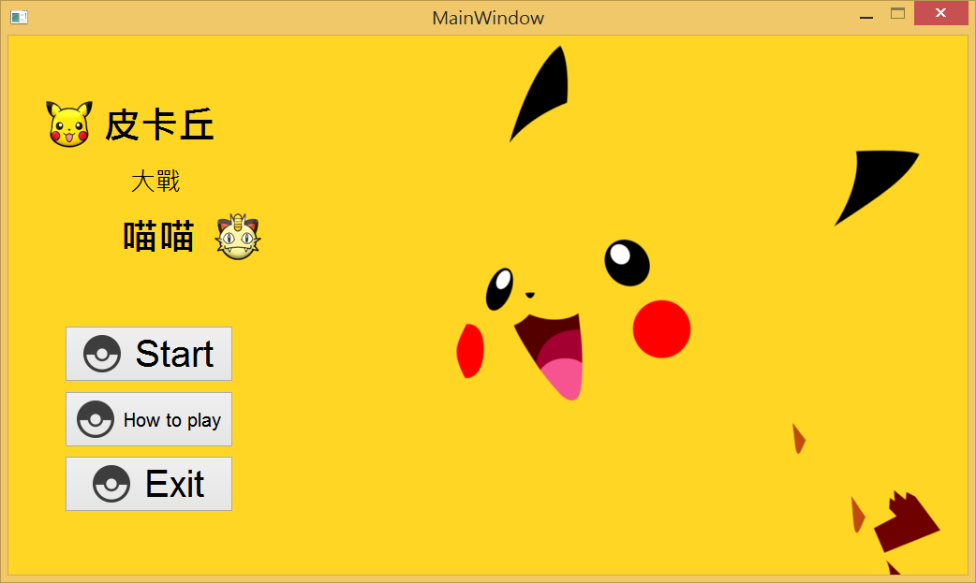
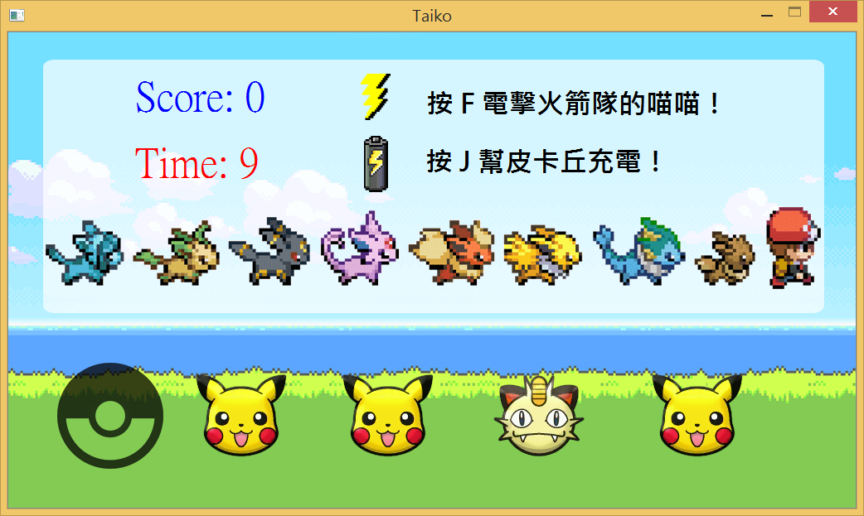
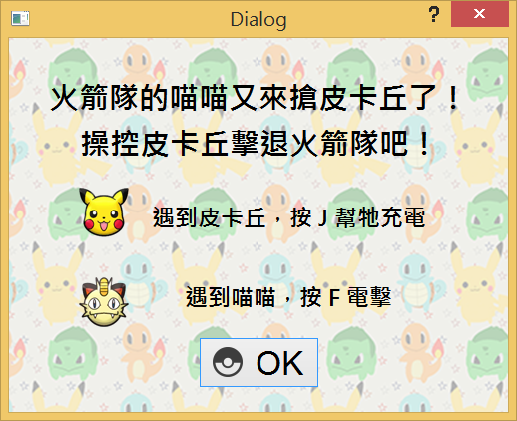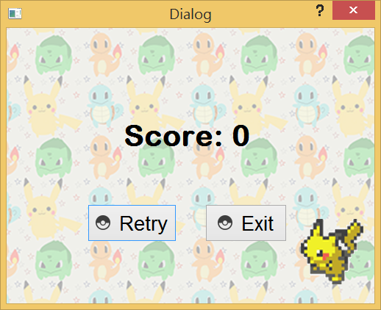
How to play:
按J消除皮卡丘，按F消除喵喵，挑戰時間共三十秒。

Program architecture:
main
mainwindow
how
game
result
exit(0)
Exit
How to play
Start
If time = 0
OK
Retry
Exit
exit(0)

