

Assignment 1: Project Scope and Plan
Team 9 · CAM_DS_401_P126 Employer Project
Employer Partner: Bank of England · Firms in scope: HSBC and Barclays
Team: Susana Venda, Tasneem Ahmad, Qianyi Sun, Debanjan Mukhopadhyay, Rafael Navas, Bupathi Muthukumar, Aidan Cameron
Submitted 14 September 2026 · Word count, sections 1–4: 1027 · Appendices excluded
Contents
1. Background and problem statement 3
2. Team roles and ways of working 3
3. Project scope and plan 5
4. Approach and work plan 6
Appendix A: Project roadmap 7
Appendix B: Work plan and measurable milestones 8
Appendix C: Risk register 9
// Taz Reminder (delete this part before submitting!)
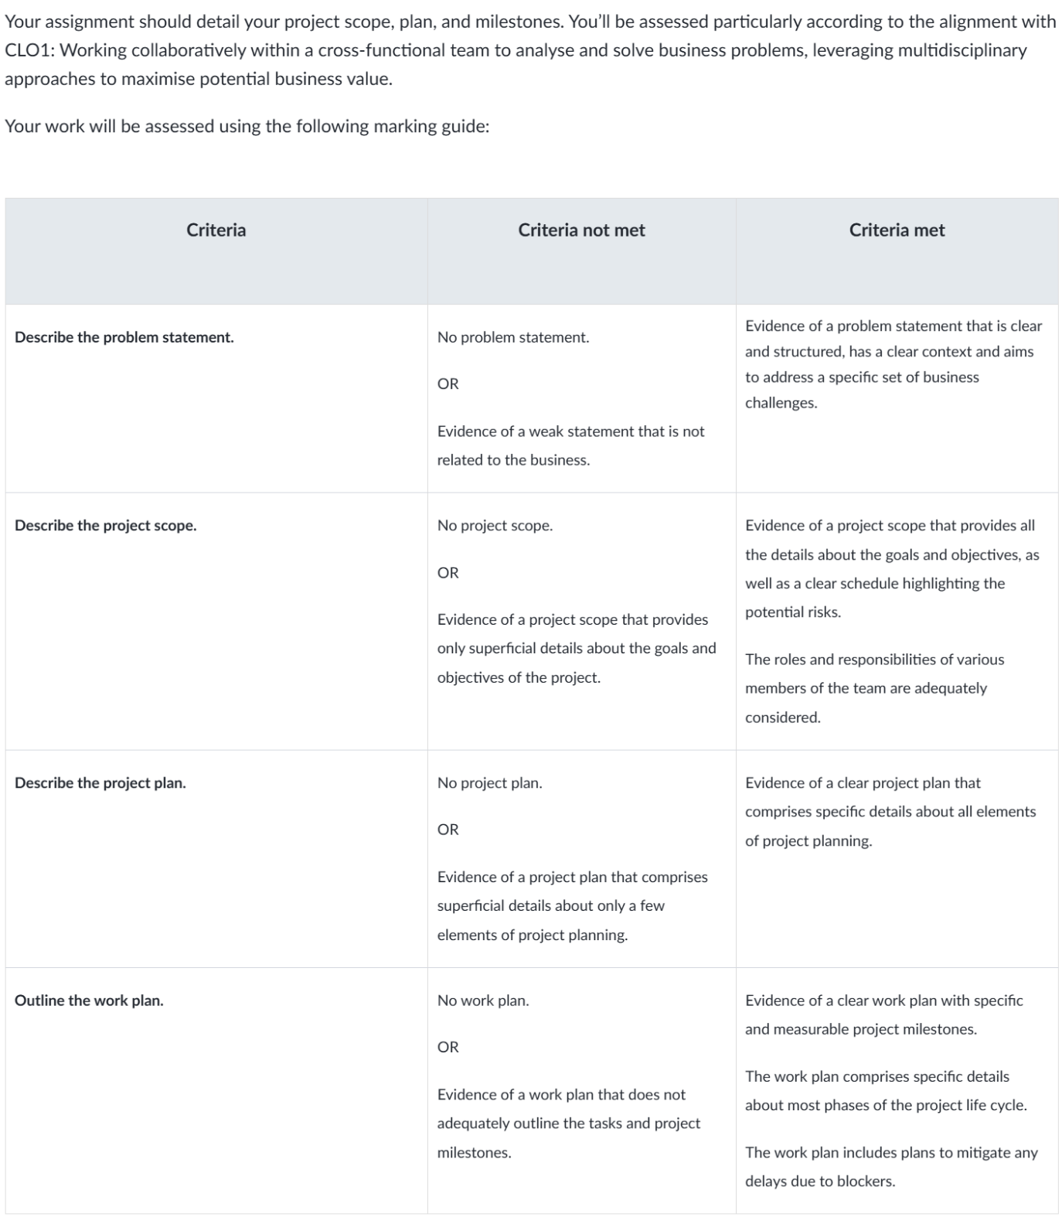

1. Background and problem statement
The Prudential Regulation Authority (PRA) supervises around 1,500 financial firms, drawing primarily on structured regulatory returns submitted through the Bank of England's (BoE) electronic reporting pipeline and validated against thousands of defined data points. Quarterly results announcements sit outside that pipeline. They are unstructured, they combine a curated management presentation with an unscripted analyst question-and-answer (Q&A) session, and interpreting them demands both financial and technical expertise. Because they are expensive to read at scale, whatever supervisory signal they contain is not systematically used. Our problem is therefore not whether earnings calls can be summarised, but whether they carry information that the reported figures do not.
Problem Statement:
Our overarching problem statement is therefore “Can NLP and generative AI extract topic-level, sentiment-level and summary-level signals, from globally systemically important banks’ [G-SIB(s)] earnings call transcripts, reveal insights that the PRA can use for early risk assessment?”.
Our team’s specific problem statement, adopted to close the PRA’s problem gap is:
“Do quarterly earnings announcements and analyst Q&A carry a leading signal about a firm's prudential condition that reported financial metrics alone don't capture?”

We will test three questions for two peer G-SIB; HSBC and Barclays:
- Do the topics analysts raise, and the sentiment attached to them, shift measurably across successive quarters?
- Does management's answering behaviour (e.g. directness, whether a requested metric is supplied, whether the answer stays on topic or instead shows avoidance) change in ways that map onto prudential risk categories?
- Do two peers diverge on the same topic in the same quarter?
Success is a reproducible method and an evidenced answer, including a well-supported negative one, rather than a risk assessment of either firm.

2. Team roles and ways of working
Our team of seven is organised around the five components of the analytical pipeline, with pairs on the two components where a failure would stall everything downstream

Role | Owner | Responsibility | Drawing on Strengths | Involved (in addition to Owner)
Coordinator | Tasneem (Taz) Ahmad | Leads delivery, cadence, agendas, minutes, keeping the roadmap current; milestone tracking, and contact with our tutor and our BoE volunteer. | Given their experience of delivery management & team coordination | -
Topic modelling lead | Debanjan Mukhopadhyay | Leading the topic modeling element of the pipeline using BERTopic to group documents into clusters to discover hidden themes. | Building on prior applied experience | -
Sentiment lead | Qianyi (Alfred) Sun | Leading the NLP element of the pipeline using FinBERT to score/ classify the data by sentiment. | Building on prior sentiment-vs-market educational experience | -
Data pipeline & Integration lead | Susana Venda | Code base setup, technical lead & technical coordination, sourcing raw data from in-scope banks, and preprocessing transcripts. | Building on their strong technical leadership skills, and studied knowledge of data science techniques & principles | Rafael
Summarisation lead | Rafael Navas Gascón | LLM summarisation pipeline will likely be a pivotal part of our analysis, as the finding summaries we hope to generate will need to be grouped in a manner that makes sense [e.g. split into meaningful units such as speaker turns/ Q&A pairs, enriched with labels for units (such as topic, speaker type, date, numbers of mentions), and grouped (such as credit-quality questions, risk questions, every mention of a particular metric)]. | Building on their strong engineering & data categorization experience, comfort with messy text and structural thinking, as well as their patience. | Bupathi
Business & regulatory research | Aidan Cameron | Conducts market research (e.g. Porter’s Five Forces), and builds the prudential risk taxonomy from public material and interprets what each measured signal would mean to a supervisor. | Given their financial & banking experience making them an invaluable SME and supervisory & domain analyst
Editor / QA | Tasneem (Taz) Ahmad | Owns synthesis, validation and communication: assembling results, tracing every finding back to its evidence, and producing the report and presentation. | Given their strong consultancy skills, prior Quality Assurance and Business Analyst experience
Table 1: Group 9’s roles and responsibilities breakdown
Work is distributed by component rather than pooled. Each component produces named files against a data schema agreed at the outset, so members work in parallel rather than waiting on one another, and no work is held only in a personal notebook.
We meet twice weekly (the 2nd checkpoint being an optional drop-in), with a group chat for day-to-day coordination and a single shared document for all writing. The team spans multiple time zones (UK, Central Europe and Eastern Time); meetings are scheduled within the overlap, and anyone unable to attend receives minutes, recording and contributes asynchronously beforehand. Responses expected within 24 hours on weekdays and review of a teammate's draft within 48 hours.

3. Project scope and plan
Scope. The project covers two globally systemically important banks, HSBC and Barclays, across 10 quarters of publicly available earnings-call transcripts and results statements. Within that corpus we separate the management presentation from the analyst question-and-answer session, attribute speaker turns, extract numeric claims, measure topic and sentiment, map topics to prudential risk categories, and produce a comparable state summary for each bank-quarter. Excluded are non-public regulatory data, audio and webcast processing, macroeconomic forecasting, historical stress-scenario modelling, agentic external search, live streaming analysis and model distillation. We also exclude any conclusion about either firm's actual prudential condition: the deliverable is a method and the evidence it produces, not a supervisory judgement.
Objectives.
- O1: a reproducible evidence pipeline producing a provenance-preserving record of every speaker turn and question-and-answer pair across both banks, by 19 September.
- O2: a validated set of conversational and behavioural signals per question-and-answer pair, by 30 September.
- O3: every observed topic mapped to a prudential risk category and dual-coded, by 2 October.
- O4: evidenced comparative findings, recommendations and stated limitations, delivered as a report and a fifteen-minute presentation, by 12 October.
Life cycle.
1. Initiation is complete: brief received, employer launch session attended, team formed and charter signed.
2. Planning concludes with this document and fixes three decisions that are expensive to reverse, namely the two banks, the evidence schema and the exclusion list.
3 Execution runs in four weekly increments from 14 September to 10 October, each ending in a testable artefact rather than a status report.
4. Monitoring and control is a weekly checkpoint against the milestone table in Appendix B together with a review of the risk register in Appendix C; a milestone is either met on its date or explicitly re-planned.
5. Closure covers the final presentation, the handover of our code and individual reflection.
Rationale. Three planning decisions carry most of the weight. Two banks rather than a broad survey, because depth is what makes quarter-on-quarter comparison possible and a strong insight from two firms outweighs thin coverage of many. The analyst question-and-answer session as primary data with the presentation as context, because presentation sentiment is structurally biased towards framing results favourably. And artefacts passed between stages as files, which lets five people work in parallel and leaves a pipeline that can be re-run when the next quarter is published.

4. Approach and work plan
Our approach lets each model earn its place. We begin with a deterministic baseline, a keyword taxonomy derived from the prudential risk categories, so that a result exists independently of any model. We then evaluate pre-trained models against that baseline: a topic model over analyst questions, and a finance-domain sentiment model applied separately to questions and to answers. Rather than fine-tuning from scratch, which six weeks does not allow, we evaluate first and adapt only where measured performance justifies it; any adaptation will be lightweight and documented. Integration is through files, each stage writing a defined artefact that the next stage consumes, which is what makes the pipeline re-runnable.
Evaluation is explicit. We validate a stratified sample of at least sixty question-and-answer pairs against human labels and report agreement rates rather than asserting accuracy.
Each phase is scheduled at approximately one week (with two days of buffer held before each submission):
- evidence extraction to 19 September
- signal measurement to 30 September
- supervisory mapping to 2 October
- comparison and validation to 8 October
Key milestones, the test that determines whether each has been met, and the fallback if one is blocked are set out in Appendix B.

Appendix A: Project roadmap
The roadmap below was produced for practical activity 1.1.5 and provides the high-level view of the project; the granular work plan is in Appendix B.
[ Insert screen capture of the project roadmap here ]

Appendix B: Work plan and measurable milestones
Each milestone states the test by which it is judged complete, and the action taken if it is blocked.
ID | Date | Milestone and its test | Owner | If blocked
M1 | Tue 16 Sep | Corpus acquired and verified. Manifest lists 20 documents (2 banks × 10 quarters) with zero missing quarters and a recorded source and publication date for each. | Evidence pair | Missing quarter: reduce to eight quarters per bank, log the decision, proceed the same day.
M2 | Fri 19 Sep | Evidence table built. Turns and question-answer pairs extracted for every document; at least 95% of turns attributed to a named speaker and speaker type; every row carries bank, quarter, date, section and provenance. | Evidence pair | Layout variance between banks: build a parser per bank; two days of buffer held in week 3.
M3 | Tue 23 Sep | Numeric claims extracted, each with value, unit and time horizon; precision of at least 0.8 measured on a 50-row manual audit. | Evidence pair | Below threshold: restrict to a defined metric list rather than open extraction.
M4 | Fri 26 Sep | Topics and sentiment assigned. Every question-answer pair carries a topic label and separate question and answer sentiment; at least 70% agreement with human labels on a 60-pair stratified sample. | Signals pair | Unstable clusters: fall back to the seeded keyword taxonomy. Decision point fixed on this date.
M5 | Mon 28 Sep | Assignment 2 submitted: deck as PDF plus a recording of 15 minutes ±10%. | Synthesis | Dry run held 26 September so re-recording remains possible.
M6 | Wed 30 Sep | Behavioural signals computed. Answer directness, metric-request coverage and topic-substitution rate calculated per pair and aggregated per bank-quarter. | Signals pair | Reduce to directness and metric coverage; substitution rate is the droppable measure.
M7 | Fri 2 Oct | Supervisory mapping complete. Every observed topic mapped to one of eight prudential categories, dual-coded by two members with disagreements resolved and recorded. | Domain analyst | Runs in parallel from week 3 and therefore never sits on the critical path.
M8 | Tue 6 Oct | Snapshots and comparisons produced. One state summary per bank-quarter plus all three comparison views, rendered with axes and sample sizes labelled. | Synthesis | Drop the peer comparison first; the other two carry the argument alone.
M9 | Thu 8 Oct | Findings validated. Every headline finding traced to at least three evidence records by identifier; limitations section written and agreed by the team. | Synthesis | A finding that cannot be traced is cut rather than softened.
M10 | Sat 10 Oct | Report and presentation complete. Report at 1,500 words ±10%, deck timed at 15 minutes ±10% in a full dry run, code runnable end to end from the artefact files. | Synthesis | Two days of buffer to the deadline by design.
— | Mon 12 Oct | Assignment 3 submitted: report, code, deck and live presentation to the Bank of England. | Project lead | —

Appendix C: Risk register
Risks are reviewed at the weekly checkpoint described in section 3.
ID | Risk | Mitigation | Owner
R1 | A bank does not publish a usable question-and-answer transcript for some quarters, or changes its document layout mid-series. | Verify the full series before any parsing work begins (M1). Build a parser per bank rather than one generic parser. If a quarter is missing, reduce to eight quarters per bank and record the decision. | Evidence pair
R2 | The topic model produces unstable or uninterpretable clusters, stalling everything downstream. | Fall back to a seeded keyword taxonomy derived from the prudential categories, which guarantees an interpretable result. The decision point is fixed at 26 September so the fallback still leaves time. | Signals pair
R3 | The sentiment model misreads hedged, heavily reviewed management language, producing confident but incorrect signals. | Human-validate a stratified sample of at least sixty pairs, report agreement rates, and state the limitation rather than concealing it. | Signals pair
R4 | Divergence between the two banks reflects different business models rather than different risk. | Compare each bank against its own history first and treat cross-bank differences as questions to investigate rather than findings. State the confound explicitly in the report. | Domain analyst
R5 | Scope creep towards forecasting, scenario modelling or agentic components. | The exclusion list is fixed at this assignment. Any addition requires a written decision from the whole team and must displace something already in scope. | Project lead
R6 | A component owner becomes unavailable at a critical point. | The two critical components are owned by pairs. The three single-owner roles each have a named backup, and all work lives in shared files rather than personal notebooks. | Project lead
R7 | Compute or environment limits interrupt long model runs. | Cache intermediate artefacts as files after every stage so a failed run resumes rather than restarts. Full-corpus runs are scheduled off the critical path. | Evidence pair

