TECHNICAL REPORT
Assignment 1: Project Scope and Plan
Employer project with the Bank of England (Group 9). Defines the overarching research question, bank scope, team operating model, milestone plan, and NLP approach for extracting prudential signal from G-SIB earnings announcements and analyst Q&A.
Cambridge Data Science Career Accelerator · Susana Venda (Topic modelling lead) · Group 9 · 2026
Banks: HSBC · Barclays Milestones: A1–A4 GitHub project with 26 dated issues Methods: BERTopic · FinBERT+LDSA · LLM summarisation

Executive Summary
Not counted toward the 1,000-word limit — front matter only, per the brief's word-count convention.
BUSINESS CONTEXT
The Bank of England's Prudential Regulation Authority needs earlier warning of prudential stress than structured regulatory returns alone provide. The BoE brief leaves bank count, topics, metrics, and success criteria open; Group 9 closes that gap with one explicit research question.
SCOPE
HSBC and Barclays, analysed via BERTopic, FinBERT+LDSA sentiment, and metric-grouped LLM summarisation, evaluated against three self-defined baselines.
RECOMMENDATION
Execute against the GitHub roadmap with named owners per issue and weekly monitoring checkpoints, treating the deliverable as a repeatable pipeline rather than a one-off read.

1. Background, Context and Problem Statement
The Bank of England's Prudential Regulation Authority (PRA) supervises around 1,500 firms. Its most accessible data is structured — regulatory returns, financial statements. Its least accessible is unstructured: quarterly earnings calls and the analyst Q&A that follows them, hard to use because they are text and video, not tables, and because they require financial domain knowledge to interpret correctly. The Bank's brief leaves bank count, topics, metrics and success criteria open.
Problem statement: can NLP and generative AI extract topic-level, sentiment-level and summary-level signal from G-SIB earnings call transcripts that the PRA can use for early risk assessment? Group 9's overarching question, adopted to close that gap: do quarterly earnings announcements and analyst Q&A carry a leading signal about a firm's prudential condition that reported financial metrics alone don't capture?
Scope is locked to HSBC and Barclays — UK-incorporated, under full PRA oversight, with complete public Q&A transcripts across enough quarters to work with. US banks and Santander are excluded on regulatory-regime and comparability grounds; a third, US-based bank for geopolitical comparison remains a live, undecided WhatsApp discussion. In scope: BERTopic clustering of Q&A themes, FinBERT combined with LDSA sentiment per theme, summarisation grouped by metric, and refined topic modelling on the clusters that matter. Out of scope: video/webcast processing, fine-tuning models from scratch, and peer benchmarking beyond the two named banks, kept as a stretch goal only.
Item | Decision
Banks | HSBC and Barclays — UK-incorporated, full PRA oversight, complete public Q&A transcripts.
Excluded | US banks and Santander — different regulatory regimes, less comparable data.
Open question | Third, US-based bank for geopolitical comparison — undecided, live in group chat.
In scope | BERTopic clustering; FinBERT+LDSA sentiment; summarisation by metric; refined topic modelling.
Out of scope | Video/webcast processing; fine-tuning from scratch; peer benchmarking beyond HSBC/Barclays (stretch).
Table 1. Scope decisions agreed at kick-off.
Observations: This targets the Bank's own stated interest directly — early warning signals not visible in structured reporting alone — and its mission of monetary and financial stability.

2. Team Roles and Ways of Working
Seven of us: Aidan, Alfred, Bupathi, Debanjan, Rafael, Susana Venda, Taz — one above the programme's suggested four to six, workable only if every person owns something named. Roles are assigned by strength rather than by default, with two confirmed by prior experience: Alfred leads sentiment analysis, drawing on earlier work combining FinBERT with LDSA to correlate Federal Reserve FOMC sentiment with market movement across five asset classes; Susana Venda leads topic modelling, building on prior applied BERTopic experience. Taz coordinates cadence, agendas, minutes and the roadmap — a role that rotates if needed rather than sitting with one person by default. Data/pipeline, summarisation, business and regulatory research, and editor/QA ownership remain pending, to be confirmed at kick-off alongside each member's Belbin behavioural profile.
Backgrounds span experienced developers and delivery leads moving into data science, plus one member with directly relevant applied NLP experience. Work is coordinated through WhatsApp for day-to-day contact, video calls for decisions, Google Drive for files, GitHub for code and task tracking, and Miro for the roadmap; email is kept for tutor contact only. The team commits to two calls a week plus async updates, a 24-hour response norm on weekdays, and meeting times in the overlap of UK, CET and US time zones.
Decisions follow a fixed path: a WhatsApp poll first, then a 5–10 minute timebox, then the component owner decides, escalating to the full team only if scope or deadline is affected. Feedback lands at each milestone rather than the day before a deadline, using a Situation–Behaviour–Impact structure. Contribution means one named owner and date per deliverable on the shared GitHub board, not pooled work, and shortfalls move through a direct SBI conversation, then the full team, then the Cambridge success team if still unresolved.
Role | Owner | Belbin | Responsibility
Coordinator | Taz | Coordinator/Implementer | Cadence, agendas, minutes, keeping the roadmap current; rotates if needed.
Sentiment lead | Alfred | Specialist/Plant/Shaper | FinBERT combined with LDSA, building on prior sentiment-vs-market work.
Topic modelling lead | Susana Venda | — | BERTopic, building on prior applied experience.
Data/pipeline | Pending | — | Sourcing and preprocessing transcripts.
Summarisation lead | Pending | — | LLM summarisation pipeline.
Business & regulatory research | Pending | — | BoE/PRA context, Porter's Five Forces.
Editor / QA | Pending | — | Shared document, word count, PDF export, submission.
Table 2. Role allocation and Belbin behavioural mapping.

Working agreement | Detail
Channels | WhatsApp (day-to-day) · video calls (decisions) · Google Drive (files) · GitHub (code, Alfred) · Miro (roadmap) · email (tutor contact).
Cadence | Two calls a week plus async updates; 24-hour response norm on weekdays; UK/CET/US time zones — meetings sit in the overlap.
Decisions | WhatsApp poll → 5–10 min timebox → component owner decides → full team if scope/deadline is affected.
Feedback | At each milestone, not the day before a deadline; Situation–Behaviour–Impact structure.
Contribution | One named owner and date per deliverable, on a shared board — not pooled work.
Escalation | Direct SBI conversation → full team → Cambridge success team.
Table 3. PREACH working agreements.

3. Project Plan
The plan runs against five life-cycle phases, tracked against fixed calendar dates rather than week numbers, and against a live GitHub project with four milestones and twenty-six dated issues rather than in side conversations.
Initiation (7 September) is a single 90-minute kick-off: banks and business questions agreed, the PREACH charter walked through, roles and section ownership assigned, and every action logged with an owner and a date before the call ends.
Planning (8–14 September) is the sequence that produces this document itself: the project roadmap is built and posted with a 3CQ peer reply (8–9 September); Porter's Five Forces market analysis is run and posted (9–10 September); all four core sections are drafted by their named owners in one shared document (11 September); one editor consolidates the draft to a single voice and cuts it to 1,000 words (12 September); the whole team reviews the result against the marking guide, and the file is exported to PDF (13 September); the designated member submits by midday on 14 September, ahead of the 17:00 deadline.
Execution (15 September–12 October) covers the two technical assignments: data collection, topic modelling and sentiment analysis feed the Assignment 2 preliminary pitch (28 September); summarisation and full evaluation feed the Assignment 3 final report (12 October). Monitoring and control runs throughout rather than as a discrete phase — weekly checkpoints against the GitHub roadmap, blockers flagged the day they are identified. Closure (13–19 October) covers a team retrospective and each member's individual reflection, due 19 October.
The most consequential risk inherited from the Bank is that no success criterion or baseline was ever defined. The team resolves this itself, three ways: temporal comparison of the same firm across quarters, peer comparison between HSBC and Barclays in the same quarter, and a structured-versus-unstructured comparison between reported metrics and the tone of the narrative discussing them. Divergence on any of the three is treated as a genuine finding, so a null result is a valid, reportable outcome rather than a failed analysis.
Phase | Dates | Key activities | Milestone
Initiation | 7 Sep | Kick-off: bank(s) and questions agreed, PREACH charter walked through, roles assigned, actions logged. | Kick-off complete
Planning | 8–14 Sep | Roadmap (8–9), Porter's Five Forces (9–10), sections drafted (11), consolidated to 1,000 words (12), reviewed against marking guide (13). | A1 submitted by midday, 14 Sep
Execution | 15 Sep–12 Oct | Solution development (topic modelling, sentiment) to preliminary pitch; summarisation and evaluation to final report. | A2: 28 Sep · A3: 12 Oct
Monitoring & control | Ongoing | Weekly checkpoints against the GitHub roadmap; blockers flagged same-day. | —
Closure | 13–19 Oct | Team retrospective; individual reflections. | A4: 19 Oct
Table 4. Project life-cycle phases mapped to fixed dates.

Risk | Mitigation
No BoE-defined success criterion or baseline. | Resolved by the team: temporal, peer, and structured-vs-unstructured baselines. A null result is a valid finding, not a failure.
Transcript availability unverified for both banks. | Checked before scope is finalised, not after.
One member's jury service from 14 Sep. | Named ownership means their absence doesn't block a single-owner task.
Uneven early engagement (two members missed the first sync). | Named ownership plus the escalation path in Section 2.
Table 5. Risk register and mitigation.

4. Approach
The technical pipeline runs in four sequenced stages. BERTopic clusters themes directly from analyst Q&A, with topics left data-driven rather than fixed in advance, decided only after initial feature engineering on the actual transcripts. FinBERT, combined with LDSA, scores sentiment per topic cluster. An LLM pipeline then summarises findings grouped by financial metric rather than by raw transcript order. Finally, topic modelling is repeated on whichever clusters turn out to matter, trading initial breadth for later focus.
Evaluation runs against the three baselines described above, not a single accuracy figure: a sample of topic and sentiment labels is hand-validated rather than trusted on the metric alone, and FinBERT's known weakness on hedged, heavily lawyered bank language is reported explicitly. A measurable milestone reads "BERTopic clustering run across eight quarters of Q&A transcripts for both banks" rather than the unmeasurable "complete the analysis."
Tooling is VS Code with the Jupyter plugin, run locally rather than on Colab, to avoid the session timeouts a six-week timeline cannot absorb. Code is version-controlled on GitHub; the narrative report lives in one shared Google Doc, mirrored in the repository. The intended deliverable is a repeatable pipeline rather than a one-off read: the final report states what re-running it next quarter would cost, and what a PRA supervisor would see under both a positive and a null result.
Stage | Method | Output
1. Topic modelling | BERTopic on analyst Q&A, themes data-driven after initial feature engineering. | Theme clusters
2. Sentiment | FinBERT combined with LDSA, per topic cluster. | Sentiment per theme
3. Summarisation | LLM pipeline, grouped by metric. | Metric-level summaries
4. Refinement | Repeat topic modelling on the clusters that matter. | Focused theme set
Table 6. Four-stage analytical pipeline.

Appendix: Project Roadmap
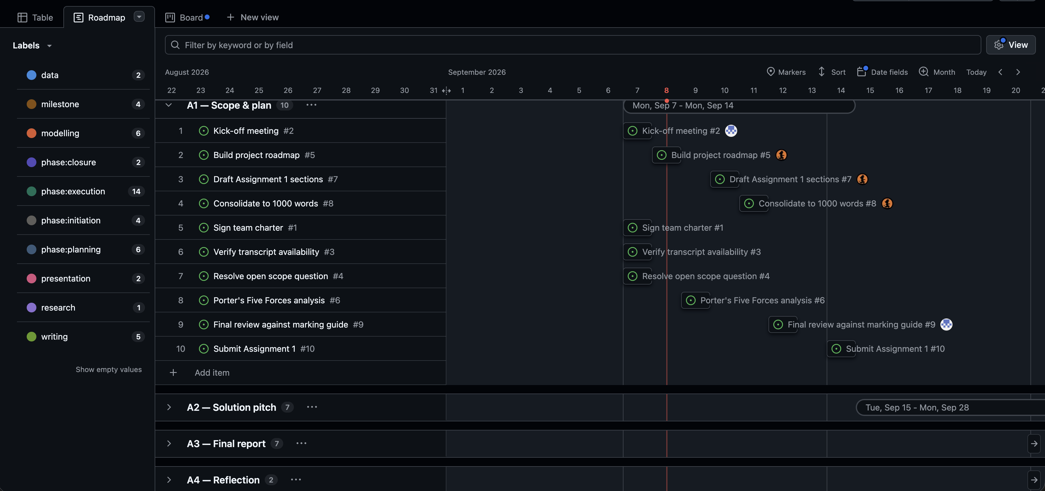
Figure 1. Live GitHub Projects Roadmap view — issues, labels and milestones map directly onto Table 4's five phases and fixed dates.
Links — Roadmap: https://github.com/users/susanavenda/projects/3/views/2 · Milestones: https://github.com/susanavenda/boe-earnings-insights/milestones · Issues: https://github.com/susanavenda/boe-earnings-insights/issues

Word count: 1,075 words (prose across Sections 1–4, excluding tables, captions and the executive summary, per the brief).

