HOSPITAL BED DEMAND FORECASTING
Using Data and Artificial Intelligence to Plan Ahead

Prepared for Hospital Leadership & Operations Stakeholders
Summary Report — Non-Technical Briefing

Executive Summary
Hospitals need to know, ahead of time, how many beds will be needed so that staff, equipment and space can be planned properly. This project built and tested a system that predicts future bed demand using historical hospital data — admissions, discharges, emergency arrivals, surgery schedules and staffing levels.
We tested five different forecasting approaches, ranging from traditional statistical methods to modern artificial intelligence (AI). The best-performing models predicted daily bed demand to within roughly 5–6 beds of the actual figure — a very high level of accuracy for operational planning.
Our recommendation is to move forward with an AI method called XGBoost, paired with a tool that explains why each forecast was made. This gives hospital planners both strong accuracy and clear, trustworthy reasoning behind every prediction, delivered through an easy-to-use dashboard.

The Challenge
Hospitals across the country are under growing pressure. Bed capacity is limited, and it is often difficult to know in advance how many patients will need a bed on a given day. This creates real operational risks:
- Beds, staff and equipment can be under- or over-allocated
- Overcrowding increases risk for patients and staff
- Reactive (rather than proactive) planning is costly and stressful for teams
A reliable forecast of future bed demand allows hospital leaders to plan staffing rotas, prepare capacity, and respond to pressure points before they become critical.

Our Approach
We brought together several hospital data sources into a single, clean dataset covering bed occupancy, patient admissions and discharges, emergency department arrivals, planned surgeries, and staffing levels. From this data, we built indicators that help predict future demand, such as:
- Recent demand trends (e.g. how busy the last day, week, and month have been)
- Calendar effects (day of week, holidays, seasons)
- Operational pressure indicators (how full the hospital currently is, staffing levels relative to plan)
We then trained several forecasting models on this data — from a well-established statistical method through to advanced AI techniques — and compared how accurately each one predicted actual bed demand.

What the Data Told Us
Before building the forecasts, we examined the underlying patterns in hospital demand. Two patterns stood out clearly and were used to strengthen every model:

A Predictable Daily Rhythm
Bed demand activity consistently peaks around midnight and the early hours of the morning, and eases through the afternoon, repeating in a steady daily cycle. Recognising this rhythm helps the models anticipate the busiest hours rather than react to them.
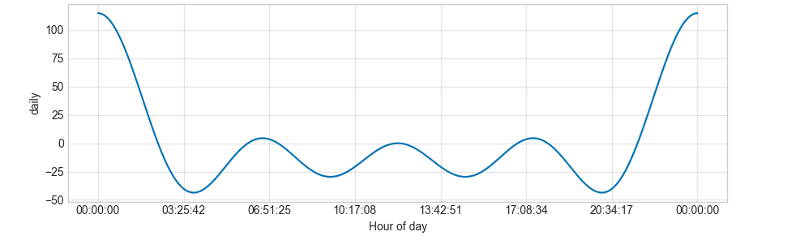
Figure 1 — Typical pattern of hospital activity across the hours of the day.

Seasonal Swings Across the Year
Demand also follows a seasonal pattern, running noticeably higher in the winter and early spring months and easing off over the summer. Building this seasonality into the forecast means staffing and capacity plans can be adjusted well ahead of the busiest periods of the year.
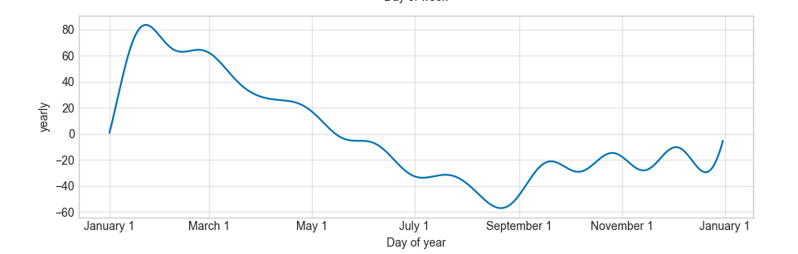
Figure 2 — Seasonal pattern of hospital demand across the calendar year (higher in winter/early spring, lower in summer).

An Upward Underlying Trend
Beyond the daily and seasonal patterns, overall bed demand is trending gradually upward over time. This reinforces the case for proactive capacity planning rather than relying on historical averages alone.
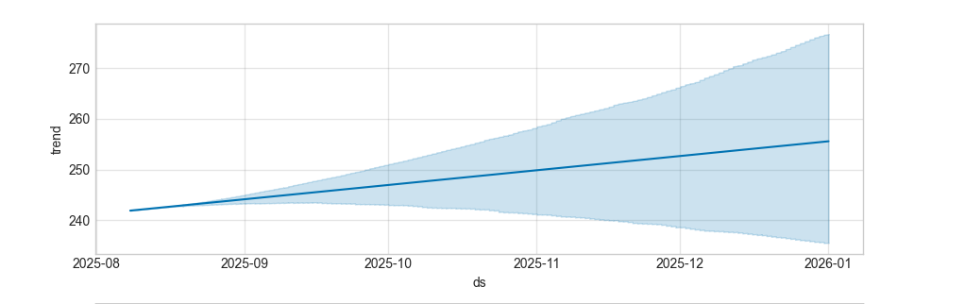
Figure 3 — Underlying demand trend over the analysis period, with shaded range showing forecast uncertainty.

Comparing the Forecasting Methods
We tested five forecasting approaches and measured how close each one's predictions came to what happened. The table below summarises the results in plain terms — 'typical error' means how many beds, on average, each method's forecast was off by on a given day.
Forecasting Method | Accuracy Rating | Typical Error | Recommended Use
Deep Learning (LSTM) | Excellent | ~5 beds/day | Highest precision; best where accuracy matters most
XGBoost (Recommended) | Excellent | ~6 beds/day | Best all-round choice — near-top accuracy, easy to explain and maintain
CatBoost | Very Good | ~8 beds/day | Strong alternative, similar profile to XGBoost
Random Forest | Good | ~13 beds/day | Reliable but noticeably less precise
Traditional Statistical Model | Fair | ~74 beds/day | Useful as a baseline comparison only

Two methods — a deep learning approach called LSTM and an AI method called XGBoost — clearly outperformed the rest, each predicting demand to within roughly five to six beds on average. The traditional statistical model, while easy to interpret, was far less accurate and is best used only as a baseline for comparison.

Seeing the Difference: Baseline Forecast vs. Actual Demand
The chart below shows the traditional statistical model's forecast (orange) plotted against real bed demand (blue) over five months. It tracks the overall daily rhythm, but regularly overshoots or undershoots the actual figure — visual confirmation of the much larger typical error reported for this method in the table above.
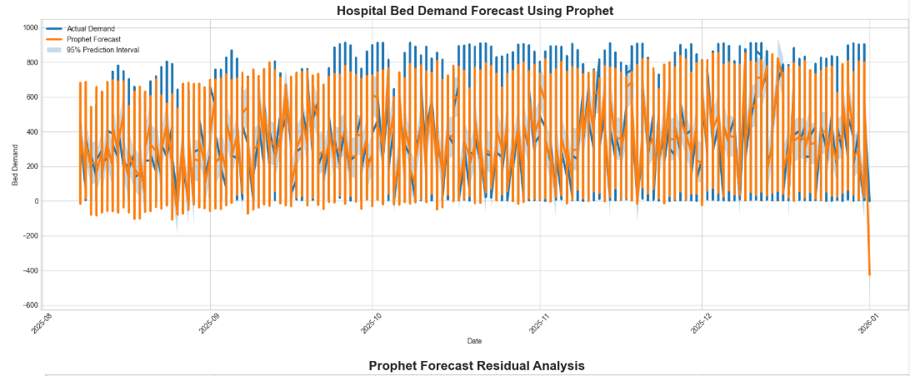
Figure 4 — Baseline statistical forecast (orange) compared against actual hospital bed demand (blue), including the model's prediction range (shaded).
This is exactly the gap the AI-based methods close: XGBoost and the deep learning model track the same daily rhythm far more tightly, which is what drives their much lower typical error.

Our Recommendation
We recommend deploying XGBoost as the primary forecasting engine, for three reasons:
- Accuracy: performance is nearly identical to the most accurate deep learning model
- Transparency: it can be paired with an explainability tool that shows exactly which factors are driving each forecast (e.g. "demand is expected to rise due to high recent occupancy and increased emergency arrivals")
- Practicality: it is simpler to maintain and integrate into a live dashboard than the deep learning alternative
This combination gives hospital leaders both a highly accurate forecast and a clear, human-readable explanation behind every prediction — critical for building trust in an AI-driven planning tool.

How This Will Be Used
The forecasting model will be delivered through an interactive dashboard, giving hospital planners direct access to:
- Forecasted bed demand for upcoming days and weeks
- Live occupancy and admission/discharge trends
- Early-warning indicators when capacity risk is rising
- Filters to explore forecasts by ward, time period, or scenario

Business Impact
Adopting this forecasting system is expected to support:
- More efficient allocation of beds and staff ahead of demand spikes
- Improved staffing and rota planning, reducing last-minute pressure
- Reduced risk of overcrowding and its knock-on effects on patient care
- Smoother patient flow through the hospital, from admission to discharge

Next Steps
- Finalise integration of the forecasting model into the live dashboard
- Pilot the system with operational teams and gather feedback
- Establish a routine review cycle to monitor and retrain the model as new data arrives

