Exploratory Data Analysis (EDA) Summary Report
The EDA was conducted to understand stock price behavior, volume dynamics, and technical indicator patterns in relation to trend classification (Uptrend, Downtrend, Sideways).
Trend analysis shows that stock prices exhibit clear regime behavior rather than random movement.
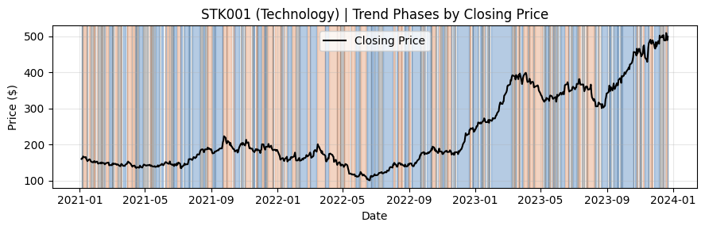
As illustrated in the price trend chart for the Technology stock (STK001), sustained uptrend and downtrend phases are visually distinct, with sideways regimes appearing during consolidation periods. This confirms that the trend labels used for modeling are structurally meaningful and observable in real price behavior.
Volume–price interaction analysis indicates that trading volume plays a critical amplifying role in price movement.
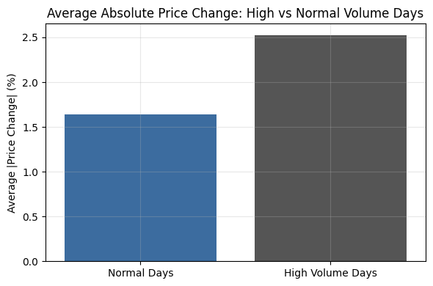
High-volume periods are associated with larger absolute price changes, while low-volume periods correspond to more muted price behavior. This supports the inclusion of volume-based features, such as volume ratios and rolling volume averages, as important explanatory variables in trend prediction.
Feature relationship analysis
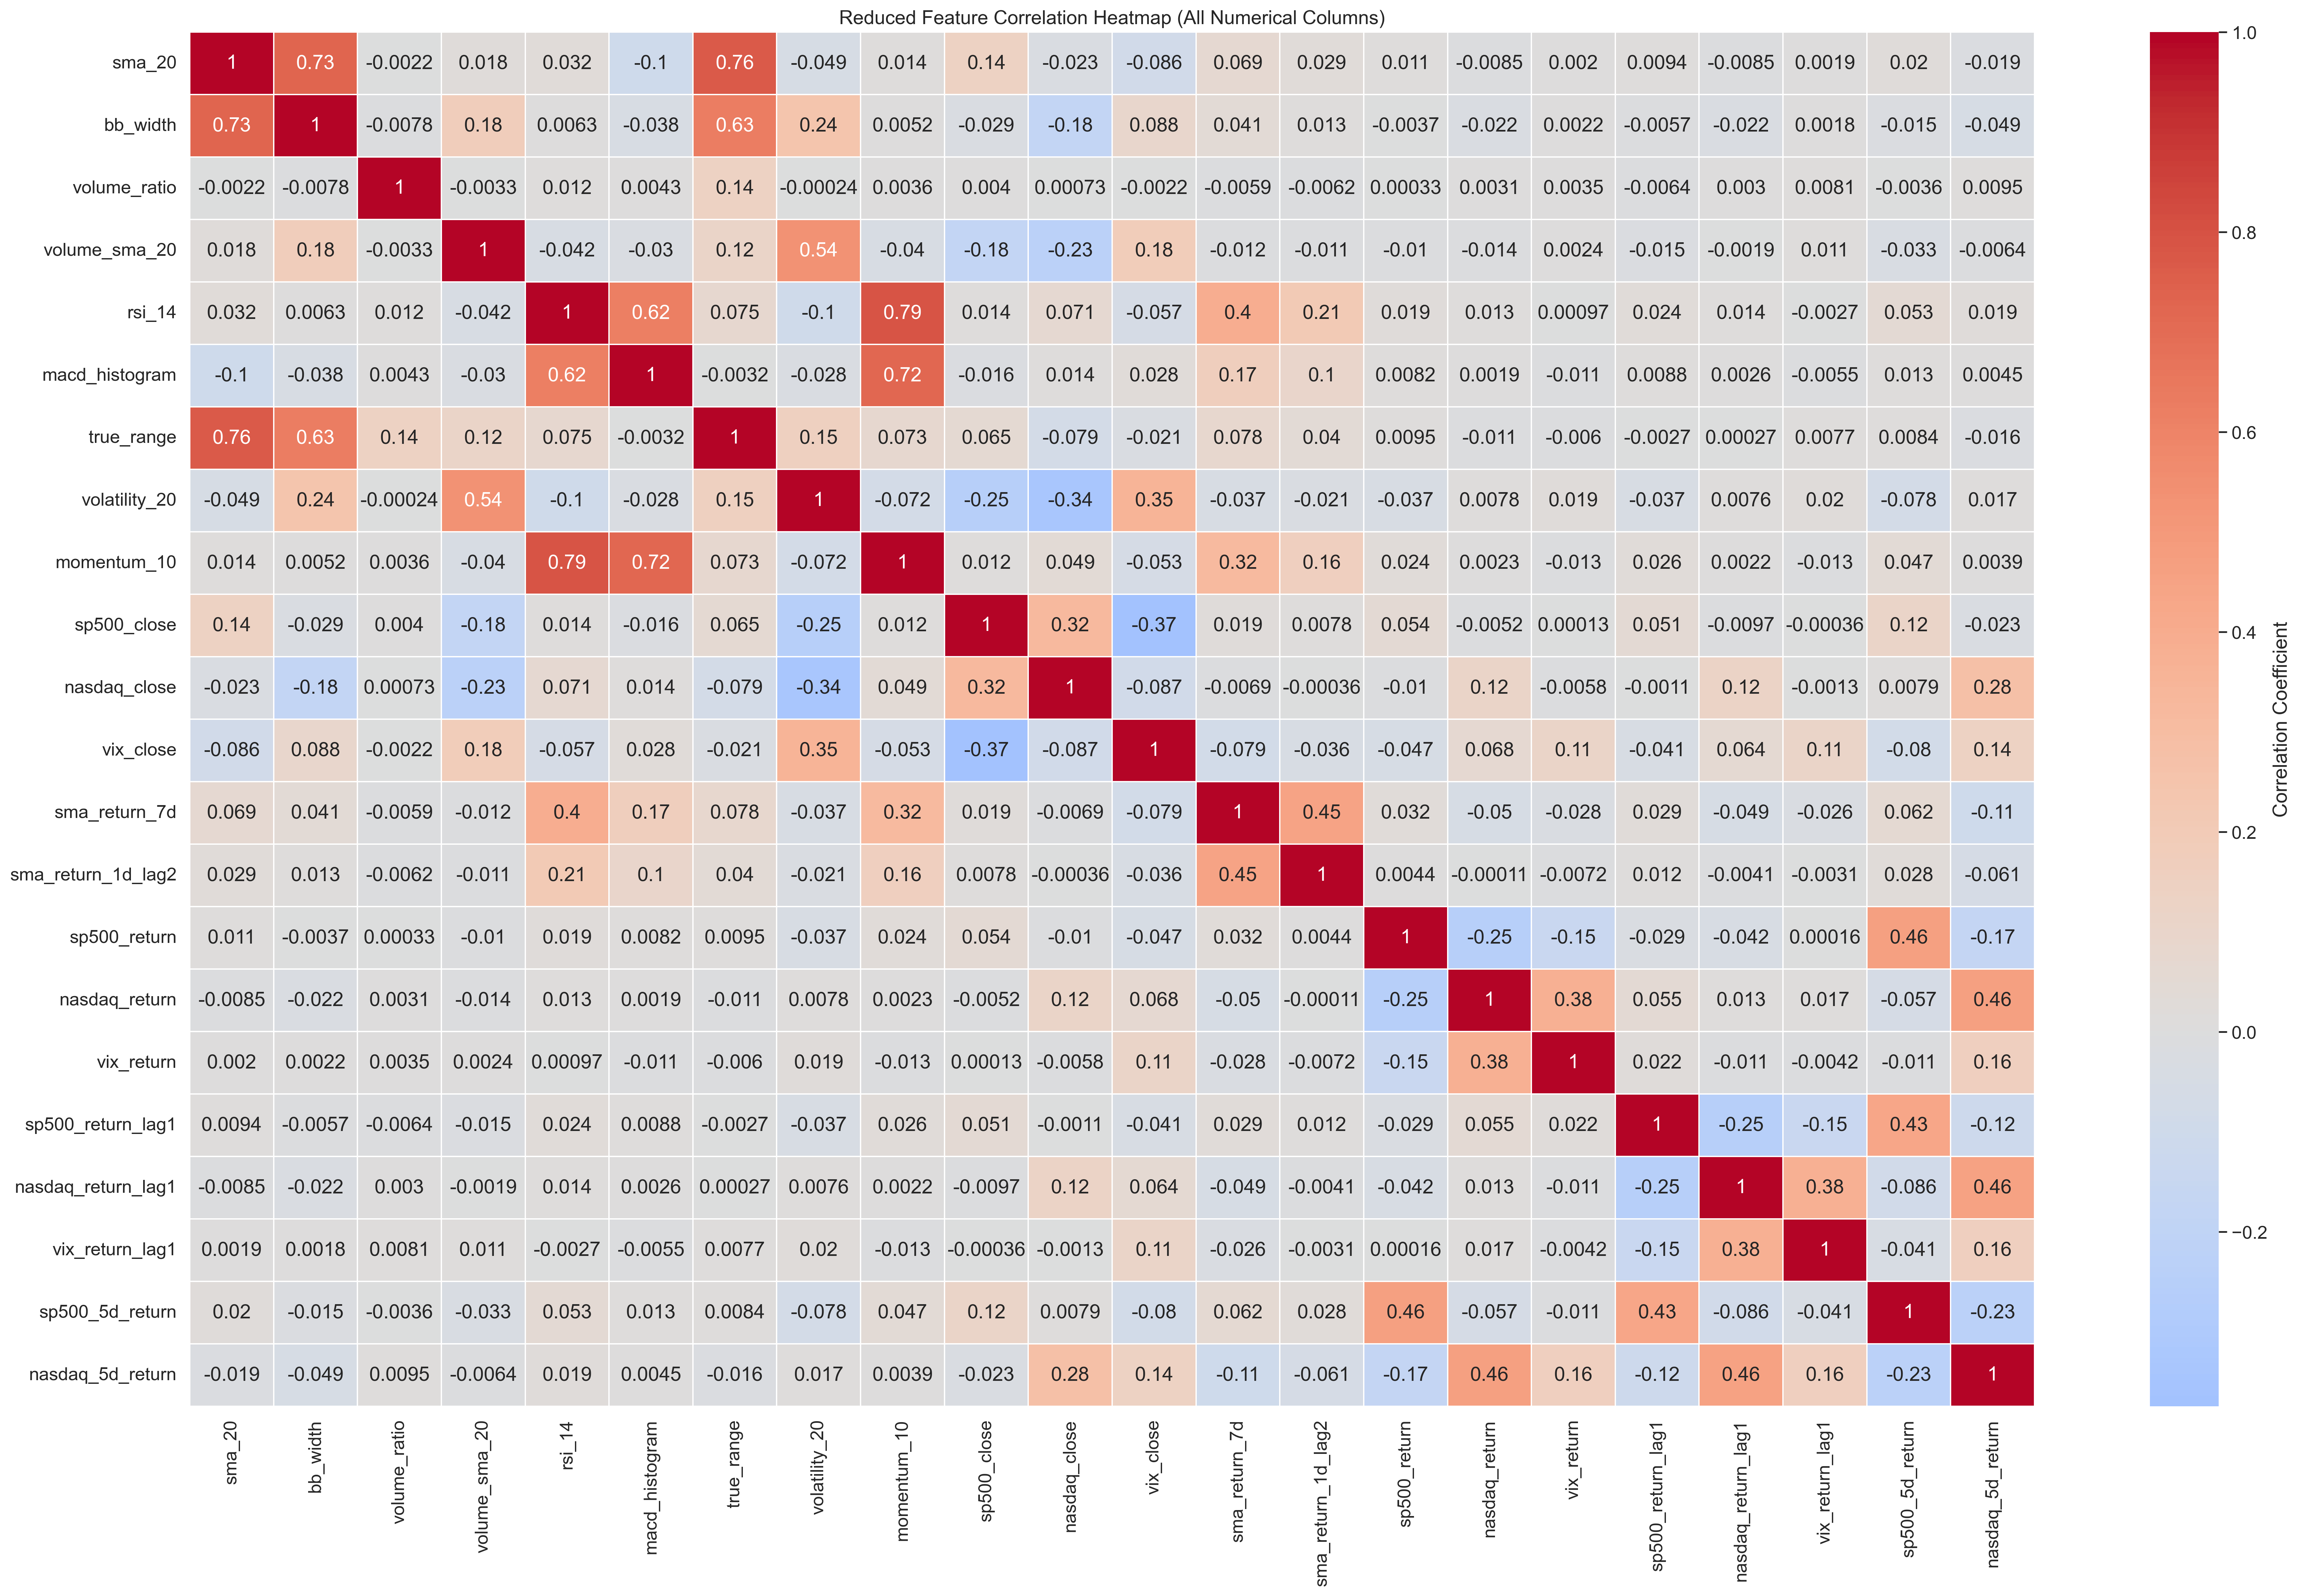
shows that, after feature engineering and selection, the retained indicators exhibit low to moderate correlations. This confirms that multicollinearity was effectively controlled prior to modeling, ensuring that each feature contributes distinct information.
Overall, the EDA shows that stock trend behavior is driven by a combination of price structure, volatility, volume activity, and momentum signals.
- Price structure is captured through moving-average behavior (e.g., sma_20) and short-term returns, which reflect directional bias and trend persistence.
- Volatility dynamics, measured by indicators such as volatility_20, bb_width, and true_range, show that periods of higher uncertainty are associated with larger price movements and regime shifts.
- Volume dynamics, including volume_sma_20 and volume_ratio, indicate that abnormal trading activity often coincides with stronger directional moves.
- Momentum and oscillator indicators (e.g., rsi_14, macd_histogram) further differentiate trending markets from sideways conditions.
Together, these patterns provide a strong empirical basis for framing the problem as a multi-class supervised classification task (Downtrend, Sideways, Uptrend) and justify the feature set used in subsequent modeling.

