**No1**

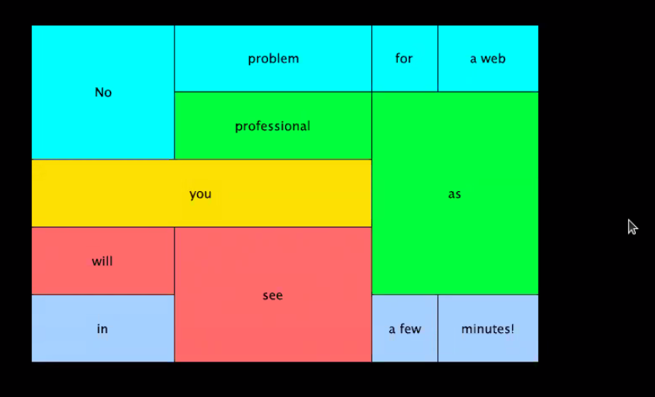

**No2**

**Sample Online Shop**

shop (folder)

- images

- all photo

- pages

-items.html

- item type minimum 15

-name

-price

-add to card

-about.html

-contact.html

-form

-map

- index.html

