Salutone

by Susan Korgen, May 2021

This is my plan for a full-stack software application of my own concept, design, planning, and coding.

# Concept

Salutone is a clinical application for healthcare management and delivery. It is a multiplayer game in which groups of behavioral and emotional health clients learn and apply interpersonal skills, under clinical supervision, with the goal of qualifying to provide mutual support for self-care during the hours between weekly group sessions.

Salutone simulates online healthcare sessions, care coordination, event notification, and cohort management of patients who conduct remote group therapy sessions by blogging. It first simulates, then later demonstrates integration with open-source AI libraries to assess and alert participants regarding emotional tone.

Clients in a group may be unable to regulate expressions of outgoing tone or recognize reactions to incoming tone productively. Neutral prompts from the AI within the multiplayer game permits the clinician in that environment to retain focus on the deeper private needs of each client in a group, without expending energy deciding when or whether to speak if one client needs a reminder, when this may disrupt the group. In time, a group may earn sufficient skill to be trusted to use the application in off hours to mutually support each other in self-care.

In the workplace, Salutone has potential as an interpersonal training ring for bettering group dynamics on a team.

A real Salutone could benefit people. I hope that I (with others) may investigate further on a not-for-profit basis.

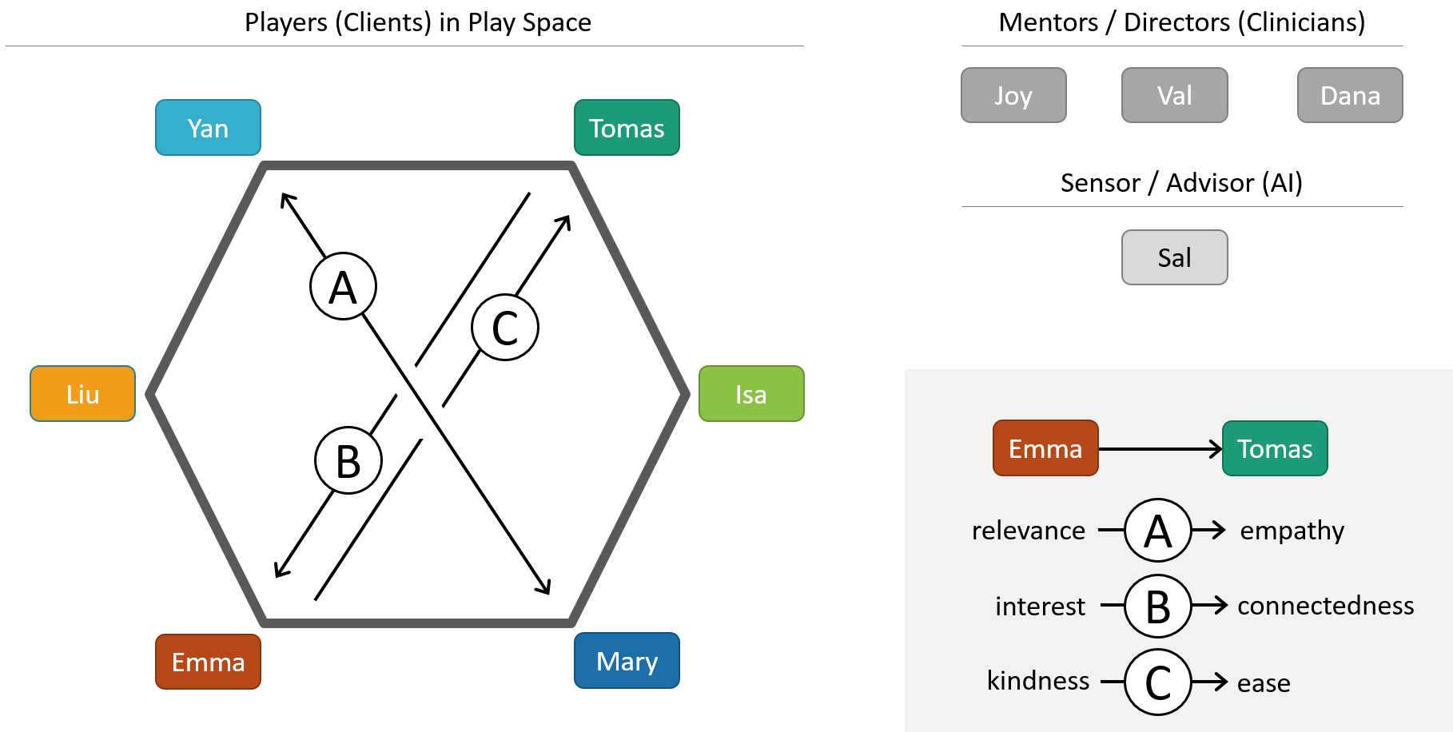

# Benefits

* Training and reinforcement for positive and constructive group dynamics in any context.
* AI ratings on specific emotional and interpersonal metrics are displayed to Mentors during group play.
* AI may pause the game at moments of tension and prompt players to consider interpersonal tone.
* Group leaders stay focused on training and therapeutic goals, keeping more clinical content in mind.
* Trained and committed players from established groups may support each other in therapeutic goals between weekly supervised sessions, by entering the game and conducting a session with the AI monitor.

# Rules

* The game assumes that groups of committed players can learn skills to help each other with their goals.
* Players are members of a committed therapy group, with its own rules, led by a board-certified clinician.
* The clinician leading the group judges independently of the game how well the group is progressing.
* Players have seen and have committed to understand and develop skill with the metrics of the game.
* The goal is not to change people, but to improve the positive quality of their interpersonal interactions.
* The game is a no-fault environment. Everyone is learning. Group events are not caused by one person.
* Every event is an opportunity to learn. The metrics themselves may be flawed. The group may discuss.
* The game is a training sandbox, each game new. No source data contributed by players is kept or stored.

# Demo Script

The Salutone demo software will simulate the following activity to illustrate concepts:

* The player blog posts will be an image with brief text. Other players will comment, with varying tone.
* Each player has a set of similar images unique to them, so their personas are clear during the demo.
* The AI monitor (at first entirely simulated and scripted) will monitor and report on tone and mood.
* Each patient will have a condition and a care plan for simulated care providers to consider and share.
* A fictional therapeutic model, plausible but not researched, determines all metrics for AI monitoring.

# Personas

Monitor

* **Sal** (an AI bot which silently collects session tone history, and prompts occasionally regarding tone)

Mentors

* **Joy** (Group Therapist, Group Leader, may delegate privileges to Val and send limited reports to Dana)
* **Val** (Therapist in Training, attends Group regularly as Associate Leader with limited privileges)
* **Dana** (Individual Therapist of a Player, does not attend Group, may receive reports from Joy)

Players

* **Tomas, Isa, Mary, Emma, Liu, Yan** (Demo players are anonymous)

# Portfolio

Salutone begins as a professional example in my online portfolio. My plan is to build these items over time.

Documents in the portfolio will reflect planning tasks as follows:

* Goals,
* benefits,
* user personas,
* use cases,
* code stack,
* subject matter experts,
* test and acceptance plan,
* wireframes,
* data model, and
* REST API specification.

Based on this plan, software in the portfolio will demonstrate these full-stack features:

* Python, JavaScript, React, and node.js.
* Healthcare interoperability via FHIR resources, via a REST API.
* A back end for storing administration data and an anonymized AI monitor tone history.
* Individual data provided by patients (images or chat) is destroyed immediately after the session.
* A clinician can study patterns in group tone history, only from sessions the clinician attended.

# Therapeutic and Cognitive Model