Voting Bills Across Red, Blue, and Purple States:
A Text Analysis of State Voting Legislation by Political Control

Adilene Garibay
EPPS 6323 — Knowledge Mining
Dr. Karl Ho
Spring 2026

Abstract
This study examines whether state voting legislation differs systematically across states depending on which party controls both the legislature and the governorship. Using a corpus of 51 state voting-related bills introduced in the 2025–2026 legislative sessions across 17 states, three complementary text-analysis methods are applied — TF-IDF distinctiveness scoring, latent topic modeling, and AI-assisted classification — to characterize the vocabulary, policy themes, and directional intent of voting bills under unified Republican control, unified Democratic control, and divided government. Results indicate that unified Republican states introduce exclusively restrictive voting legislation (100%), unified Democratic states introduce a mix of restrictive and neutral bills (58% and 33%, respectively), and divided-government states produce nearly entirely neutral procedural legislation (86%). Topic modeling reveals that Republican states concentrate on election administration and redistricting/certification themes, Democratic states on voter ID and registration, and divided-government states on local administrative procedures. A single-coder human validation of 10 sampled bills yielded κ = 0.831 (almost perfect agreement), supporting the reliability of the AI classification. These findings suggest that political control shapes not only the direction of voting legislation but also the substantive policy terrain it occupies. Ethical considerations surrounding AI-assisted political text classification are discussed.

1. Introduction
State voting laws have been among the most contested areas of American politics, particularly following the 2020 presidential election. Debates over voter ID requirements, mail ballot procedures, early voting access, and election certification have split sharply along partisan lines. Yet most comparative analyses of voting legislation rely on manual review of a limited number of high-profile bills, making it difficult to characterize patterns systematically across states and sessions.
This project applies computational text analysis to a sample of state voting bills from the 2025–2026 legislative sessions to address three research questions:
- Language: What vocabulary most distinctively characterizes voting bills in states under each type of political control?
- Themes: Do bills in Republican-, Democratic-, and divided-control states cluster into different policy domains?
- Direction: Are bills primarily expanding voter access, restricting it, or making neutral procedural changes — and does this vary by political control?
Political control is operationalized as the legislative trifecta: the same party controls both chambers of the state legislature and the governorship. States are classified as Republican-trifecta, Democratic-trifecta, or Divided accordingly.

1.1 Hypotheses
Based on prior work on partisan polarization in election law (Hasen 2020; Grumbach 2022), two directional hypotheses are advanced:
H1: Bill language will differ systematically along ideological lines. States under different partisan control will use measurably distinct vocabulary when addressing voting and election procedures.
H2: Bills introduced in Republican-controlled states will be more restrictive in language and direction than bills introduced in Democratic-controlled or divided-government states.

2. Literature Review
This project sits at the intersection of two scholarly conversations: the political science literature on partisan polarization in voting legislation, and the computational text analysis literature on methods for characterizing political and legal documents. This review surveys both, connecting each body of work to the specific analytical choices made in the present study — TF-IDF distinctiveness scoring, LDA topic modeling, and AI-assisted classification.

2.1 Partisan Polarization and Voting Legislation
The substantive motivation for this project rests on a well-documented trend: voting laws in the United States have become increasingly partisan. Hasen (2020) documents how elections have become a battleground in which both parties pursue legislative strategies shaped by electoral self-interest rather than neutral administration. Grumbach (2022) extends this argument at the state level, showing that unified partisan control of state government — what the present project operationalizes as the legislative trifecta — is the strongest predictor of restrictive election legislation. His analysis demonstrates that Republican-controlled states systematically moved toward stricter voting laws between 2000 and 2020, while Democratic-controlled states moved in the opposite direction.
These findings provide the theoretical foundation for H1 and H2: if partisan control shapes the substantive direction of voting laws, it should also leave detectable signatures in the language of the bills themselves. The present project tests this expectation computationally, asking whether TF-IDF scores and topic distributions — derived from the text of bills alone — can recover the partisan patterns identified through qualitative and regression-based approaches in prior work.
Eidelman, Kornilova, and Argyle (2018) provide a further empirical bridge between legislative text and political context. Analyzing all 50 U.S. states, they show that a bill's thematic content — captured through N-gram features and word vectors — carries meaningful signals about the political environment in which it was introduced, and that combining textual features with institutional metadata (sponsor party, majority status, committee referral) substantially improves our ability to characterize legislative outcomes. Their finding that partisan context is embedded in bill language supports the core premise of the present study: that trifecta control should be recoverable, at least partially, from the words legislators choose.

2.2 Quantitative Approaches to Legislative Text
A parallel body of work establishes the methodological foundations for treating legislative language as data. Laver, Benoit, and Garry (2003) introduced Wordscores, a method for extracting policy positions from political texts by treating word frequencies as the unit of analysis. Their core insight — that the relative frequency of words in a document encodes its ideological position relative to reference texts — is the conceptual predecessor of TF-IDF distinctiveness analysis. Where Wordscores assigns continuous position scores along a single ideological dimension, the present project uses TF-IDF to identify the vocabulary that most distinctively characterizes each trifecta group, without imposing a single left-right scale.
Grimmer, Roberts, and Stewart (2021) provide the most comprehensive treatment of computational text analysis for political science, synthesizing supervised and unsupervised approaches for characterizing large document collections. Their framework directly motivates the multi-method design used here: TF-IDF for descriptive distinctiveness, LDA for unsupervised theme discovery, and human validation to anchor automated classifications. They emphasize that no single method is sufficient — triangulating across approaches, as done in the present project, produces more robust characterizations of text corpora.
Osnabrügge and Vannoni (2025) demonstrate that legislative language carries empirically measurable properties beyond content alone: syntactic complexity and vagueness in EU directives predict compliance failures among member states. While their focus is on legislative quality rather than partisan direction, their work reinforces the broader premise motivating this project — that systematic differences in how bills are written are detectable through NLP and carry real political consequences.

2.3 Topic Modeling and Vocabulary Distinctiveness in Political Text
Latent Dirichlet Allocation (LDA), the topic model used in this project, is one of the most widely applied methods for unsupervised theme discovery in political text. Hankar, Kasri, and Beni-Hssane (2025) provide a comprehensive review of topic modeling techniques — including LDA, Non-negative Matrix Factorization, and Latent Semantic Analysis — documenting their shared reliance on bag-of-words and TF-IDF representations and identifying common challenges around topic coherence, optimal topic number selection, and evaluation. Their assessment that LDA remains the most interpretable and widely validated approach for small-to-medium legislative corpora supports its selection here over more complex alternatives.
TF-IDF, used alongside LDA, is one of the oldest and most robust methods in the NLP toolkit. Ariai, Mackenzie, and Demartini (2025), in a survey of NLP methods for the legal domain, document the continued utility of TF-IDF for characterizing legal documents even as transformer-based models have advanced the field on classification benchmarks. They note that for tasks requiring interpretability and transparency — specifically relevant in academic research settings — TF-IDF remains a strong baseline that produces human-readable, auditable results. This consideration directly motivates the use of TF-IDF distinctiveness scoring as the primary vocabulary analysis tool in Section 5.1.

2.4 AI-Assisted Classification of Political and Legal Text
The most novel methodological contribution of the present project is the use of a large language model — claude-opus-4-6 — to classify all 51 bills as Restrictive, Expansive, or Neutral. This approach is situated within a growing literature on AI-assisted annotation of political text.
Guadarrama Rios et al. (2025) demonstrate that NLP-based methods can extract politically meaningful signals from legislative text, applying machine learning classifiers to predict voting behavior in the European Parliament. Critically, they show that political ideology is the dominant factor shaping classification accuracy — the same premise underlying the present project's expectation that bill direction will vary systematically by trifecta. While their approach uses supervised ML trained on labeled outcomes, the present project uses a zero-shot LLM classification approach, which does not require training data but introduces different validity concerns, particularly around hallucination and rubric adherence.
Ariai et al. (2025) document these LLM-specific challenges in legal text classification: transformer models can produce fluent rationales that misrepresent the actual content of a document, and classification decisions may reflect training data biases rather than purely the rubric provided. These risks are addressed in the present project through a structured prompt with explicit categorical definitions and a human validation step (Section 4.4) that achieved κ = 0.831 — providing empirical evidence that the model's classifications were grounded in actual bill provisions rather than prior political associations.

3. Data

3.1 Bill Collection
Bills were collected in two rounds using the LegiScan public legislative database API (LegiScan 2025). The initial round retrieved 50 bills for which PDFs were available; a second round added 33 bills from states not represented in the initial corpus — specifically, additional Democratic-trifecta states (Illinois, Colorado, Connecticut, Maryland) and divided-government states (Pennsylvania, Wisconsin, North Carolina, Nevada) — to improve geographic and partisan balance. Partisan control and divided government was determined on the basis of if the governor’s partisanship aligned with the partisanship of both chambers of the legislature. Nebraska is unicameral and nominally nonpartisan, but the partisanship of each legislator is widely understood even if not campaigned on. For that reason Nebraska was included among unified Republican control states.
The combined collection totals 83 bills across 24 states and two legislative sessions (2025 and 2026). For each bill, the LegiScan getBill endpoint returned state, session year, bill number, title, status, and primary sponsor party. API calls were made using the httr2 package in R (Wickham 2023).

3.2 PDF Extraction and Attrition
Bill text was extracted from PDF files using the pdftools package in R (Ooms 2023). Of the 83 PDFs, 51 yielded usable text (62%); 32 failed extraction. Failed PDFs were predominantly corrupted or near-empty placeholder files (some as small as 98 bytes), which appear to be a data-quality issue in the source database rather than a processing error. Whether the excluded bills are systematically different from the included bills is unknown; this constitutes a study limitation.

3.3 Final Corpus
The analysis corpus contains 51 bills across 17 states from the 2025–2026 sessions. Table 1 summarizes the corpus by trifecta group. Trifecta classifications were drawn from the National Conference of State Legislatures and Ballotpedia partisan composition data for the relevant sessions.
Trifecta Group | Bills | States
Unified Republican | 13 | MO, OH, NE, UT, KS, IN, OK
Unified Democratic | 24 | MN, WA, IL, CT, MD, NJ, NM
Divided Government | 14 | PA, NV, NC, AK, VA, WI
Total | 51 | 17 states

Table 1. Corpus composition by trifecta group.
Minnesota accounts for 14 of 24 Democratic-trifecta bills (58%). This concentration reflects the volume of voting legislation Minnesota introduced in the 2025 session and means Democratic findings are partly shaped by Minnesota's distinctive election administration structure — county auditors administer elections, a role unique to that state — and should be interpreted with this in mind.

3.4 Preprocessing
Text was cleaned to remove page numbers, hyphenated line breaks, and non-printable characters. Tokens were converted to lowercase, stripped of punctuation, numbers, and URLs, and stemmed using the Porter stemmer. A combined stopword list was applied, consisting of standard English stopwords and domain-specific legal boilerplate terms ("shall," "enacted," "pursuant," "herein," "subsection," "section," "amended," and similar statutory language that appears uniformly across all bills regardless of content). All preprocessing was performed using the quanteda package (Benoit et al. 2018).
The resulting document-feature matrix contains 2,589 unique word stems across 51 documents. Total tokens processed: 268,589. Average bill length: 5,266 tokens (range: 67–22,444), reflecting substantial variation in bill complexity.

4. Methods

4.1 TF-IDF Distinctiveness Analysis
To identify vocabulary characteristic of each trifecta group, TF-IDF (term frequency–inverse document frequency) scores were computed using quanteda::dfm_tfidf() applied to a trifecta-grouped document-feature matrix. Bills within each political control group were first aggregated into a single pseudo-document using dfm_group(), producing a 3-row matrix (one per group). TF-IDF was then computed with scheme_tf = "count" (raw term frequency within each pseudo-document) and scheme_df = "inverse" (IDF = log₁₀(N/df), where N = 3 groups).
This design rewards terms that are both frequent within a group and rare across the other two groups. With N = 3 pseudo-documents, terms appearing in all three groups receive a TF-IDF score of zero, effectively filtering out cross-group boilerplate automatically. Terms appearing exclusively in one group receive the maximum IDF weight of log₁₀(3) ≈ 0.477. The top 15 terms per group were retained for visualization.

4.2 Topic Modeling
Latent Dirichlet Allocation (LDA) was applied to discover latent policy themes in the corpus without prior knowledge of group membership. The model was fit using the topicmodels package (Grün and Hornik 2011) with Gibbs sampling (K = 4 topics, 800 iterations, 200 burn-in iterations, symmetric Dirichlet priors α = 50/K = 12.5, δ = 0.1). The random seed was fixed at 42 for reproducibility.
LDA produces two outputs: (1) word-topic probability distributions (β), indicating how central each term is to each topic, and (2) document-topic proportion distributions (θ), indicating what fraction of each bill belongs to each topic. Topic labels were assigned manually after reviewing the top 15 words per topic. Topic emphasis by trifecta group was computed as the mean θ across all bills within each group. The choice of K = 4 reflects the substantive expectation that voting legislation clusters into a small number of policy domains (voter identification, registration, election administration, and redistricting), and was confirmed as appropriate by the interpretability of the resulting topics.

4.3 AI-Assisted Classification
Each bill was classified into one of three categories using claude-opus-4-6 via the Anthropic API (Anthropic 2025), guided by the following rubric:
- RESTRICTIVE: The bill adds new requirements, restrictions, or barriers that could reduce voter participation or access (e.g., stricter identification requirements, reduced polling hours, shortened registration windows, increased signature thresholds).
- EXPANSIVE: The bill expands, protects, or facilitates voter access or participation (e.g., automatic voter registration, extended early voting, vote-by-mail expansion, restoration of voting rights).
- NEUTRAL: The bill makes procedural or administrative changes without a clear directional impact on voter access (e.g., updating forms, renaming offices, clarifying definitions, adjusting deadlines for election officials).
Each API call received the bill title and up to the first 8,000 words of bill text, along with a structured system prompt containing the three category definitions. The model returned a label and a one-to-two sentence rationale identifying the key provision(s) driving its decision. All 51 bills were successfully classified. API calls were wrapped in error-handling with exponential backoff (30–120 second waits) to manage rate limits.
Hallucination risk mitigation. A known limitation of large language models is the potential to generate plausible but factually incorrect rationales — a phenomenon termed hallucination (Maynez et al. 2020). To mitigate this risk, three design choices were made: (1) the model was provided the full bill text rather than relying on its parametric knowledge, (2) the classification rubric was explicit and categorical with no free-form generation required for the label itself, and (3) a stratified human validation sample of 10 bills was reviewed to assess whether AI rationales were grounded in actual bill provisions. The high agreement rate (κ = 0.831) and the nature of the single disagreement — a genuine boundary case rather than a fabricated fact — suggest hallucination was not a substantive problem in this application.

4.4 Human Validation
A stratified random sample of 10 bills was selected for independent human coding (3 Republican-trifecta, 5 Democratic-trifecta, 2 Divided). For each bill, the AI label was hidden; the coder saw only the bill title, state, year, and the first approximately 1,500 words of text. The coder applied the same three-category rubric used in the LLM classification step.
Note on coder design: The study originally planned for two independent coders to permit Human-vs-Human inter-rater reliability assessment. After the coding round, a single-coder design was adopted. Human-vs-Human kappa is therefore not reported; only LLM-vs-Human Cohen's Kappa is computed. This is a study limitation acknowledged in Section 7.
Metric | Value
Bills evaluated | 10
Raw agreement | 9/10 (90%)
Cohen's Kappa (κ) | 0.831
Interpretation | Almost perfect (≥ 0.81)
Target κ ≥ 0.61 met? | Yes

Table 2. LLM-vs-Human validation results (n = 10 bills).
The single disagreement was HB1871 (Missouri, Republican trifecta): the LLM classified this bill as RESTRICTIVE because it creates a new presidential preference primary structure and modifies election notification timelines. The human coder classified it as NEUTRAL, interpreting the changes as administrative scheduling adjustments with no direct impact on voter access. This disagreement illustrates the rubric boundary case: the LLM applies "adds new requirements" strictly, while a human expert may distinguish between requirements that burden voters and requirements that govern election administrators.

5. Findings

5.1 Distinctive Vocabulary (TF-IDF)
Table 3 presents the top 10 TF-IDF terms by trifecta group. Figure 1 visualizes the top 15 terms per group as a horizontal bar chart.
Rank | Unified Republican | TF-IDF | Unified Democratic | TF-IDF | Divided Gov. | TF-IDF
1 | elector | 227.4 | 203b† | 357.4 | underlin‡ | 7.22
2 | provision | 135.1 | auditor | 329.8 | fiscal | 6.87
3 | utah | 65.4 | jfk† | 304.1 | factor | 4.29
4 | commission | 60.4 | minnesota | 302.7 | pool | 3.87
5 | falsif | 55.8 | 204c† | 175.0 | barcode | 3.82
6 | tuesday | 42.5 | roster | 137.3 | alaska | 3.35
7 | circul | 40.7 | provision | 131.4 | deficit | 3.70
8 | ohio | 35.9 | commission | 115.3 | sleeve | 3.82
9 | township | 35.8 | revisor | 114.2 | commonwealth | 2.86
10 | signatur | 34.0 | canvass | 100.3 | supervisor | 2.72

Table 3. Top 10 TF-IDF terms by trifecta group.
† Minnesota statutory section citations (§ 203B, § 204C) and a bill referencing historical records.
‡ PDF markup artifacts from amendment-formatted bills.
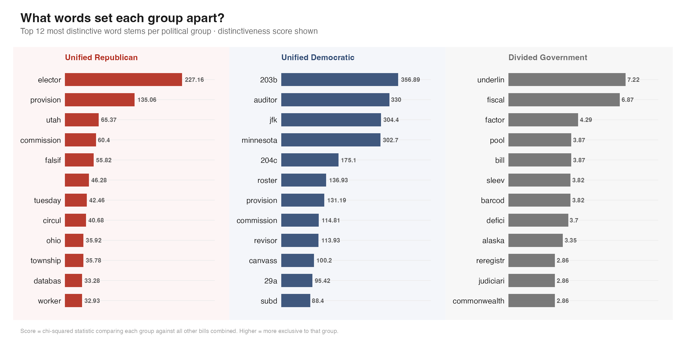
Figure 1. Top 15 TF-IDF terms by trifecta group (word stems shown).

Republican-trifecta bills are characterized by terms associated with electoral certification and petition processes: elector (electoral college certification procedures), circul (petition circulation), falsif (ballot falsification provisions), signatur (signature requirements), and township (sub-county jurisdictional language common in Ohio and Utah). The presence of state-specific terms (utah, ohio) reflects that several Republican bills addressed state-specific redistricting and election code revisions rather than universal policy changes.
Democratic-trifecta vocabulary is heavily shaped by Minnesota's election administration structure. The top terms include citations to Minnesota election statutes (§ 203B governs absentee voting; § 204C governs canvassing), the distinctive role of the auditor (county auditors administer elections in Minnesota, unlike most states), and the term canvass (vote counting and certification). The notably lower TF-IDF scores in the Divided Government group — maximum 7.22 compared to 357 for Democratic and 227 for Republican — indicate that divided-government bills do not have strongly distinctive vocabulary, consistent with more generic procedural content.

5.2 Policy Themes (Topic Modeling)
Four latent policy themes emerged from the LDA. Labels were assigned by the research team after reviewing the top 15 words per topic. Table 4 presents topic labels and representative terms; Table 5 presents mean topic proportions by trifecta group.
Topic | Label | Top Words
1 | Election Administration | elect, ballot, voter, vote, counti, offic, poll, place, clerk, return
2 | Voter ID & Registration | voter, ballot, identif, card, number, minnesota, auditor, licens, applic
3 | Redistricting & Certification | elect, voter, board, elector, revis, registr, divis, petit, secretari
4 | Local Government & Procedures | individu, author, describ, mean, govern, inform, local, tax, district

Table 4. LDA topic labels and top words (word stems shown).
Group | n | Topic 1: Admin | Topic 2: Voter ID | Topic 3: Redistricting | Topic 4: Local Gov
Unified Republican | 13 | 51.5% | 7.0% | 30.5% | 11.1%
Unified Democratic | 24 | 20.1% | 55.8% | 4.3% | 19.8%
Divided Government | 14 | 21.3% | 11.6% | 11.8% | 55.3%

Table 5. Mean topic proportion by trifecta group (%).
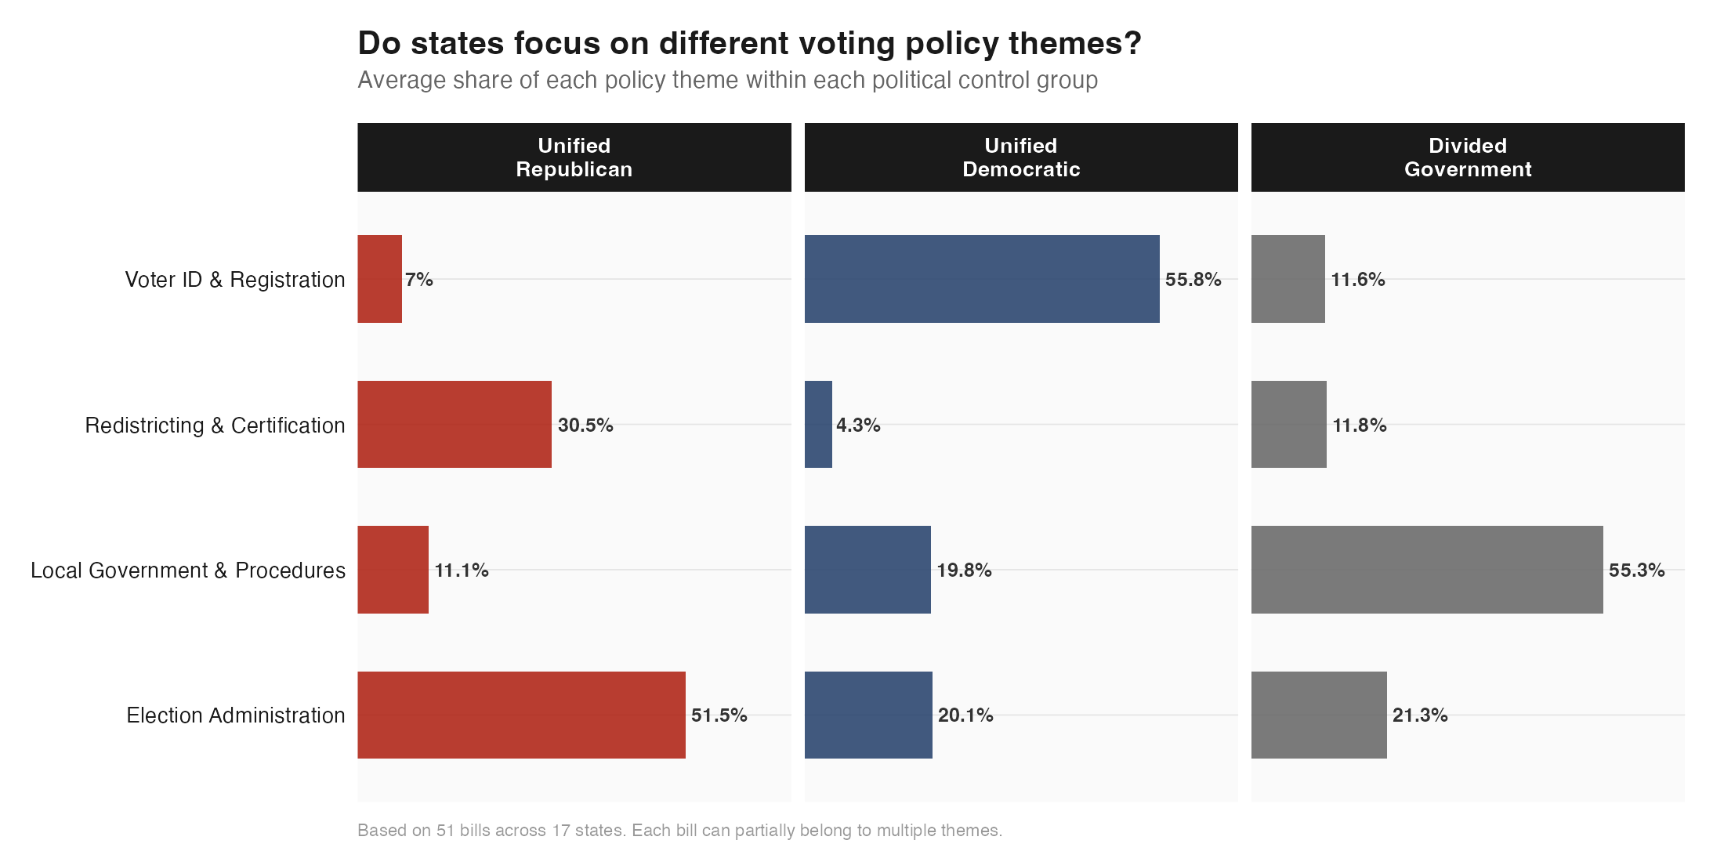
Figure 2. Mean topic proportion by trifecta group. Bars show average share of each policy theme across all bills within the group.

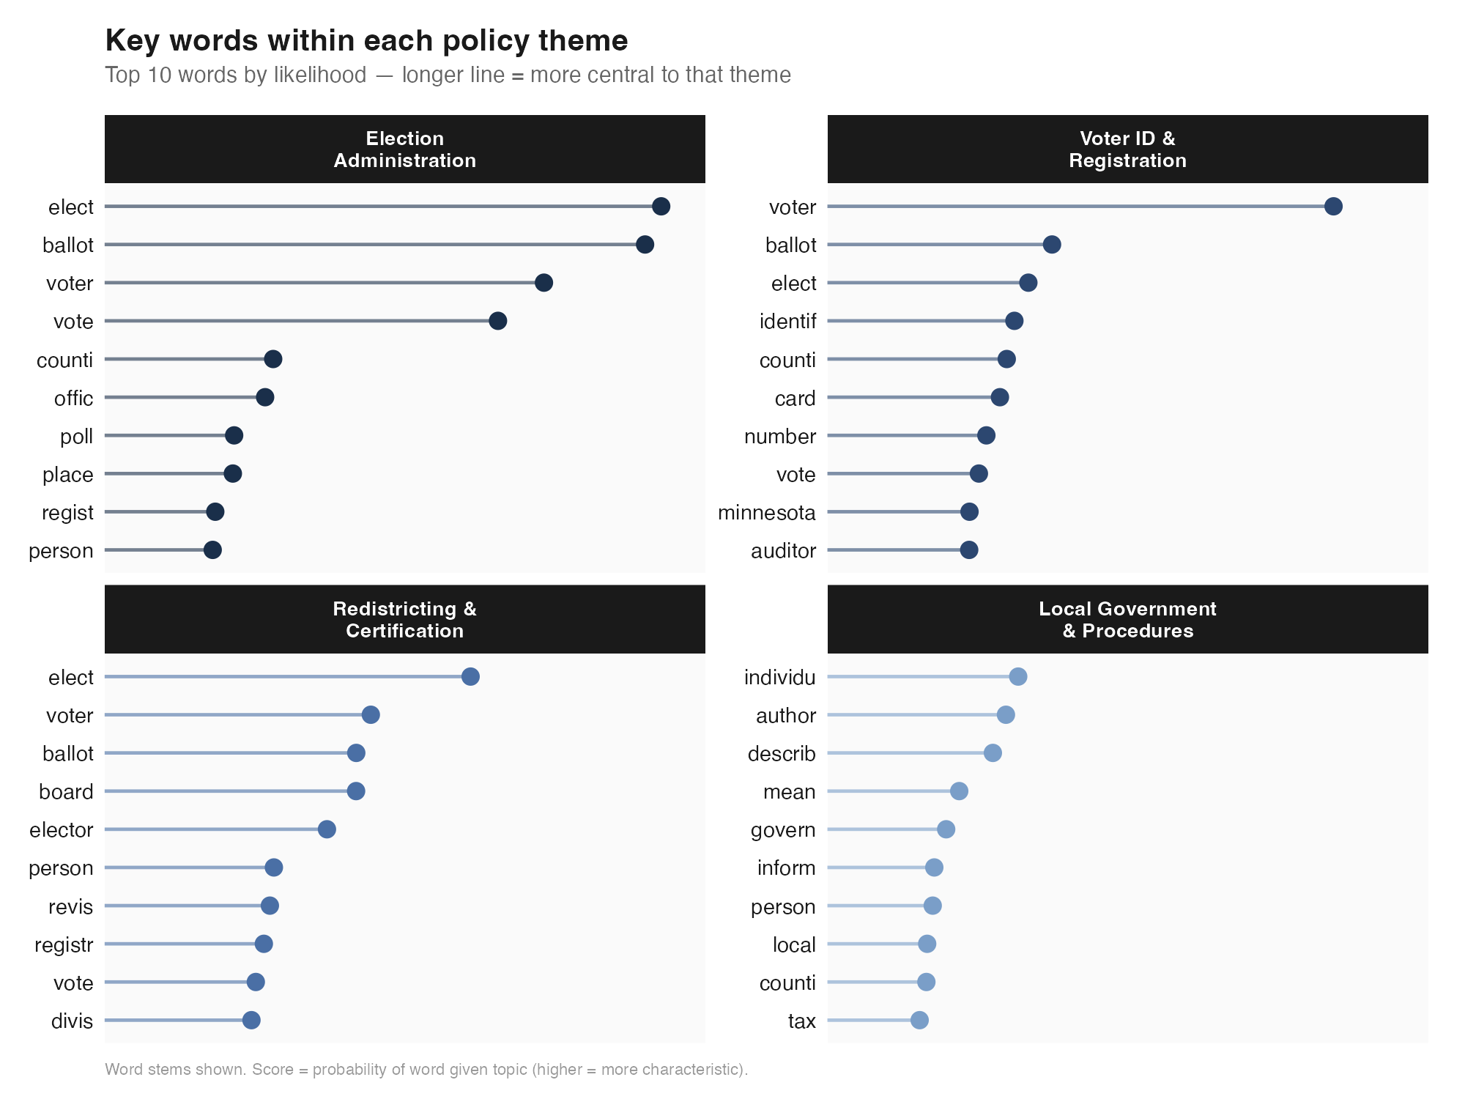
Figure 3. Top words per LDA topic (β probabilities). Labels assigned after human review.

The ideological differentiation across topics is striking. Republican-trifecta bills concentrate in Election Administration (52%) and Redistricting & Certification (31%), suggesting a legislative agenda focused on the structural rules governing how elections are conducted, districts are drawn, and results are certified. Democratic-trifecta bills are dominated by the Voter ID & Registration theme (56%), capturing legislation around identification cards, registration procedures, and absentee voting administration. Divided-government bills concentrate in Local Government & Procedures (55%), reflecting administrative and institutional housekeeping legislation that does not take a strong directional stance on voter access.
Notably, the Redistricting & Certification theme is nearly absent from Democratic bills (4.3%), likely reflecting that redistricting cycles were largely complete in most Democratic-trifecta states by the 2025–2026 sessions covered here.

5.3 Bill Direction: AI-Assisted Classification
Table 6 presents bill classifications by trifecta group. Figure 4 visualizes the distribution as a stacked bar chart.
Group | n | Restrictive | Neutral | Expansive
Unified Republican | 13 | 100% (13) | 0% (0) | 0% (0)
Unified Democratic | 24 | 58% (14) | 33% (8) | 8% (2)
Divided Government | 14 | 0% (0) | 86% (12) | 14% (2)
Overall | 51 | 53% (27) | 39% (20) | 8% (4)

Table 6. Bill classification by trifecta group.
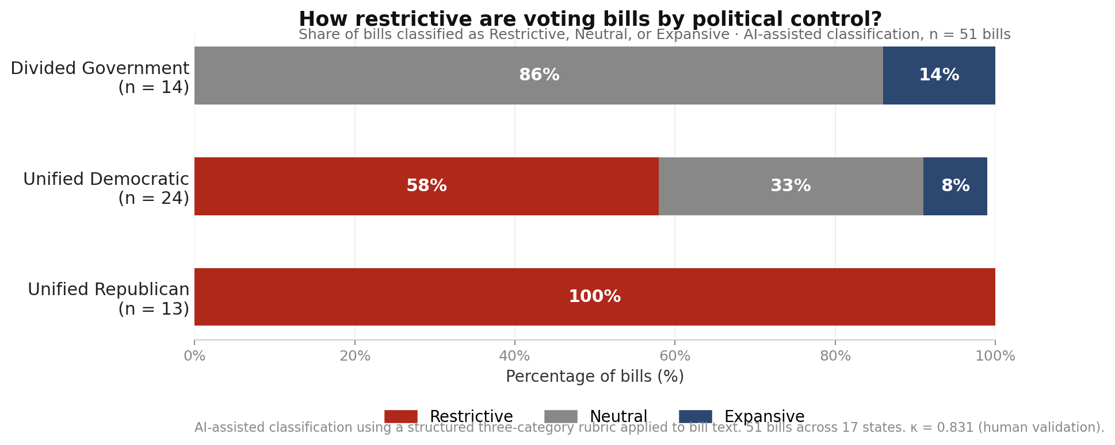
Figure 4. Bill direction by trifecta group (AI classification, n = 51 bills).

The classification results reveal a clear partisan gradient in bill direction. Every bill in Republican-trifecta states (100%) was classified as Restrictive — adding new requirements, raising signature thresholds, tightening certification procedures, or placing new conditions on absentee voting. No Republican-trifecta bill was classified as Expansive or Neutral.
In Democratic-trifecta states, 58% of bills were classified as Restrictive. This result warrants careful interpretation. The majority of these bills originate in Minnesota's 2025 session and concern absentee ballot reform — new envelope verification procedures, updated timeline requirements, and audit mechanisms. The AI classifier applies the rubric as written: any bill that adds a new procedural requirement is classified as Restrictive, regardless of the political intent. In context, many of these bills represent administrative modernization rather than intentional access barriers. The remaining Democratic bills are Neutral (33%) or Expansive (8%), with the two Expansive bills related to automatic voter registration and expanded early voting access.
Divided-government states present the clearest pattern: 86% of bills are Neutral, and none are Restrictive. This is consistent with a political dynamic in which neither party can impose major access changes unilaterally — the result is procedural, administrative legislation with no strong directional push.

5.4 Sponsor Party Analysis
An additional finding emerges from sponsor party data. In Democratic-trifecta states, Republican legislators are the primary sponsors of 22 of 41 bills with identified sponsors (54%). In Republican-trifecta states, Republicans sponsor 11 of 13 bills with identified sponsors (85%). In divided-government states, 7 of 23 identified-sponsor bills are Republican-sponsored (30%) and 15 of 23 (65%) are Democratic-sponsored.
The high Republican sponsorship rate in Democratic-trifecta states reflects that voting legislation is introduced by minority-party legislators as well as majority-party legislators. The LegiScan search returned all introduced bills, not only those that passed; this means the corpus includes bills that were referred to committee and may have died there. Future work should distinguish enacted legislation from introduced-only bills, as the policy direction of enacted laws may differ systematically from the full introduced corpus.

6. Ethical Considerations
The use of AI tools to classify politically sensitive legislative text raises ethical questions that merit explicit discussion. This section addresses three areas of concern: model bias, political neutrality, and responsible use of AI-generated classifications.

6.1 Model Bias and Political Neutrality
Large language models such as claude-opus-4-6 are trained on large corpora of text that may encode political perspectives or cultural assumptions. When applied to the classification of voting legislation — a domain with deep partisan salience — there is a risk that the model's prior associations with political vocabulary could influence its labeling decisions in ways that are not fully transparent. For example, a model trained on text that frames certain voting regulations as 'voter suppression' may be more likely to classify those bill types as Restrictive, independent of the rubric.
To mitigate this risk, a structured rubric with explicit, behaviorally defined categories was used rather than asking the model to make open-ended political judgments. The rubric focuses on observable provisions — whether the bill adds requirements, expands access, or makes neutral administrative changes — rather than on partisan intent or political framing. The high human-AI agreement rate (κ = 0.831) provides empirical evidence that the classifications are consistent with how a trained human reviewer applies the same rubric. Nevertheless, the possibility of systematic bias cannot be entirely ruled out with a validation sample of n = 10.

6.2 Responsible Use of Classification Results
The classifications produced in this study — particularly the finding that 100% of Republican-trifecta bills are Restrictive — carry significant political weight if decontextualized. Several interpretive cautions apply:
- The corpus consists of introduced bills only, not enacted law. A restrictive bill that fails committee has different implications than a restrictive law that takes effect.
- The Restrictive label reflects the rubric's operational definition, not a normative judgment. A bill adding new audit procedures for mail-in ballots is Restrictive under the rubric even if its authors intend it to improve election integrity.
- The Republican-trifecta sample is geographically concentrated (7 states, 13 bills). Causal claims about Republican legislative strategy require broader evidence.
These findings are presented as descriptive patterns in a specific sample and session window, not as evidence of legislative intent or as a comprehensive characterization of either party's approach to voting rights.

6.3 Data Privacy and Source Ethics
All bill text analyzed in this study is drawn from the public record — legislative documents introduced in state legislatures and made publicly available through LegiScan. No personally identifiable information was collected or analyzed. Sponsor party data is publicly reported as part of the official legislative record. The use of publicly available legislative text for computational research is consistent with established practice in political science (Grimmer, Roberts, and Stewart 2021).

7. Limitations
Sample size and attrition. The corpus of 51 bills is small for computational text analysis. Losing 32 of 83 PDFs to extraction failure (39% attrition) reduces statistical power and introduces potential selection bias. Bills with extractable text may differ systematically from those without.
Minnesota concentration. Fourteen of 24 Democratic-trifecta bills (58%) originate in Minnesota. Minnesota has a distinctive election administration structure (county auditors, specific statutory sections such as § 203B and § 204C) that inflates the uniqueness of the Democratic vocabulary and may not generalize to Democratic-trifecta states broadly.
Introduced vs. enacted bills. The corpus includes all bills introduced in the relevant sessions, regardless of passage status. Analysis of enacted legislation only could yield different findings, particularly if the directional balance of bills that actually become law differs from the introduced corpus.
Rubric boundary cases. The AI classifier applies the three-category rubric literally. Bills that modernize administrative procedures while simultaneously adding new steps may receive a Restrictive label when a human expert might classify them as Neutral or Expansive. The completed human validation (κ = 0.831, 90% raw agreement) suggests this boundary disagreement is isolated to edge cases.
Single-coder validation design. The human validation was completed by one coder rather than the planned two. Without a second coder, Human-vs-Human inter-rater reliability cannot be assessed, and the kappa of 0.831 cannot be benchmarked against a human-agreement ceiling. The point estimate should be interpreted with caution given n = 10.
Divided-government heterogeneity. The 14 divided-government bills come from six states (PA, NV, NC, AK, VA, WI) with varying configurations of divided control. Treating all divided-control arrangements as equivalent may mask within-group variation.
Word stemming artifacts. Several high-scoring TF-IDF terms (e.g., "underlin", "barcode", "sleeve") appear to be PDF markup artifacts from amendment-formatted bills. Their presence in the Divided group's distinctive vocabulary reflects bill formatting rather than substantive policy content.

8. Conclusion
This study demonstrates that computational text analysis can reveal systematic differences in the vocabulary, policy focus, and directional intent of voting legislation across states with different political configurations.
H1 is supported. Bill language differs systematically along ideological lines. Republican bills concentrate on elector certification, redistricting, and petition language; Democratic bills are shaped by voter ID, registration, and Minnesota's auditor-based election administration; divided-government bills use generic procedural vocabulary with near-zero group-distinctive scores.
H2 is supported with nuance. Republican-controlled states produced exclusively Restrictive bills (100%), while divided-government states produced overwhelmingly Neutral bills (86%), supporting the directional gradient hypothesized. Democratic states show 58% Restrictive — higher than expected — but most of this reflects procedural absentee reforms in Minnesota rather than intentional access barriers. The partisan gradient (Republican > Democratic > Divided in restrictiveness) is consistent with H2.
Together, these findings suggest that trifecta control shapes not only the probability of passing restrictive versus expansive voting laws, but the substantive policy terrain that voting legislation occupies. Future work should extend this analysis to a larger, nationally representative sample of enacted legislation, disaggregate Minnesota from the Democratic-trifecta category, and refine the classification rubric to distinguish administrative modernization from intentional access restriction.

9. AI Collaboration and Tool Documentation
This section documents the AI tools used in this project in accordance with the EPPS 6323 generative AI policy (§9.2) and the course requirement for full AI collaboration documentation.

9.1 AI Tools Used
Tool | Model ID | Role in Project
Claude Code (Anthropic) | claude-sonnet-4-6 | Pipeline design, R script development, data collection automation, preprocessing, visualization, report and PowerPoint generation
Claude API (Anthropic) | claude-opus-4-6 | Bill classification — all 51 bills classified as Restrictive, Expansive, or Neutral via structured API calls

Table 7. AI tools and models used in the project.

9.2 Python Usage Disclosure
Per syllabus §7.3, Python use in this project is disclosed here. The primary analysis pipeline is implemented entirely in R (scripts 00_setup.R through 07_ai_collab_log.R). Python was used solely to generate the final PowerPoint presentation (build_powerpoint.py, using the python-pptx library), as R does not have a mature equivalent for programmatic slide generation. This use is supplemental to the R-based analysis and does not affect any analytical result. The instructor was notified of this Python usage.

9.3 AI Collaboration Log Summary
A full AI collaboration log is maintained in results/ai_collab_log.md. Each entry documents the tool used, the full prompt, the AI output, the review decision, lessons learned, and a success flag. Table 8 summarizes the seven log entries.
Entry | Task | Tool | Outcome
1 | Full pipeline design and R setup | Claude Sonnet 4.6 | Accepted — aesthetic standard set at start
2 | State × year trifecta lookup table | Claude Sonnet 4.6 | Accepted after 2026 corrections applied
3 | PDF extraction and DFM construction | Claude Sonnet 4.6 | Accepted — 51/83 PDFs usable
4 | TF-IDF / keyness analysis | Claude Sonnet 4.6 | Accepted — reorder_within fix applied
5 | LDA topic modeling (K = 4, Gibbs) | Claude Sonnet 4.6 | Accepted — topics interpretable
6 | AI bill classification (51 bills) | Claude Opus 4.6 | Accepted — rate-limit and JSON-fence fixes applied
7 | Human validation and kappa calculation | Claude Sonnet 4.6 | Accepted — κ = 0.831

Table 8. AI collaboration log summary (7 entries). Full log in results/ai_collab_log.md.

9.4 Human-AI Collaboration Reflection
This project followed the EPPS 6323 'AI as Delegatee' model (Weeks 11–16): research goals and analytical decisions were made by the student; AI executed implementation tasks under human oversight and review at each stage. Specifically:
- All research design decisions — corpus scope, trifecta operationalization, choice of K = 4 for LDA, classification rubric design — were made by the student before delegating implementation.
- Every AI output was reviewed before acceptance. Two entries in the collaboration log required substantive corrections (Entry 2: trifecta lookup errors; Entry 6: API authentication and JSON parsing failures).
- The human validation step (Section 3.4) was designed to provide independent verification of AI classifications, operationalizing the 'appropriate oversight' required in the Delegation phase.
A key lesson from this project is the importance of establishing output standards — particularly the aesthetic and formatting conventions for figures and slides — at the very beginning of the collaboration. Doing so at the outset (Entry 1) prevented retrofitting across all subsequent deliverables (Poldrack et al. 2025).

References
Anthropic. 2025. "Claude API Documentation." San Francisco: Anthropic PBC. https://docs.anthropic.com (accessed May 2026).
Ariai, Fard, Joel Mackenzie, and Gianluca Demartini. 2025. "Natural Language Processing for the Legal Domain: A Survey of Tasks, Datasets, Models, and Challenges." ACM Computing Surveys 58(6).
Benoit, Kenneth, Kohei Watanabe, Haiyan Wang, Paul Nulty, Adam Obeng, Stefan Müller, and Akitaka Matsuo. 2018. "quanteda: An R Package for the Quantitative Analysis of Textual Data." Journal of Open Source Software 3(30): 774.
Breiman, Leo. 2001. "Statistical Modeling: The Two Cultures." Statistical Science 16(3): 199–231.
Eidelman, Vladimir, Anastassia Kornilova, and Daniel Argyle. 2018. "How Predictable Is Your State? Leveraging Lexical and Contextual Information for Predicting Legislative Floor Action at the State Level." In Proceedings of the 2018 Conference on Empirical Methods in Natural Language Processing, 1499–1508. https://doi.org/10.18653/v1/D18-1179.
Daoud, Adel, and Devdatt Dubhashi. 2020. "Statistical Modeling: The Three Cultures." arXiv:2012.04570.
Grimmer, Justin, Margaret E. Roberts, and Brandon M. Stewart. 2021. "Machine Learning for Social Science: An Agnostic Approach." Annual Review of Political Science 24(1): 395–419.
Grumbach, Jacob M. 2022. Laboratories against Democracy: How National Parties Transformed State Politics. Princeton: Princeton University Press.
Guadarrama Rios, Marina, Francesca Zamberlan, Pontus Mavromoustakos Blom, and Nemanja Rankovic. 2025. "Knowing Our Choices: Unveiling True Voting Patterns through Machine Learning (ML) and Natural Language Processing (NLP) in European Parliament." Social Network Analysis and Mining 15: Article 24.
Hankar, M., M. Kasri, and A. Beni-Hssane. 2025. "A Comprehensive Overview of Topic Modeling: Techniques, Applications and Challenges." Neurocomputing 628: 129638.
Grün, Bettina, and Kurt Hornik. 2011. "topicmodels: An R Package for Fitting Topic Models." Journal of Statistical Software 40(13): 1–30.
Hasen, Richard L. 2020. Election Meltdown: Dirty Tricks, Distrust, and the Threat to American Democracy. New Haven: Yale University Press.
Laver, Michael, Kenneth Benoit, and John Garry. 2003. "Extracting Policy Positions from Political Texts Using Words as Data." American Political Science Review 97(2): 311–331.
LegiScan. 2025. "LegiScan API Documentation." https://legiscan.com/legiscan (accessed 2025–2026).
Maynez, Joshua, Shashi Narayan, Bernd Bohnet, and Ryan McDonald. 2020. "On Faithfulness and Factuality in Abstractive Summarization." In Proceedings of the 58th Annual Meeting of the Association for Computational Linguistics, pp. 1906–1919.
National Conference of State Legislatures (NCSL). 2026. "State Partisan Composition." https://www.ncsl.org (accessed May 2026).
Ooms, Jeroen. 2023. pdftools: Text Extraction, Rendering and Converting of PDF Documents. R package version 3.4.0. https://CRAN.R-project.org/package=pdftools.
Osnabrügge, Moritz, and Massimo Vannoni. 2025. "Quality of Legislation and Compliance: A Natural Language Processing Approach." Political Science Research and Methods 13: 736–744.
Poldrack, Russell A., et al. 2025. "Ten Simple Rules for AI-Assisted Coding in Science." arXiv:2510.22254.
Silge, Julia, and David Robinson. 2022. Text Mining with R: A Tidy Approach. https://www.tidytextmining.com (accessed May 2026).
Wickham, Hadley. 2023. httr2: Perform HTTP Requests and Process the Responses. R package version 1.0.0. https://CRAN.R-project.org/package=httr2.

Appendix A: AI Collaboration Log (Excerpts)
The following excerpts from the AI collaboration log (results/ai_collab_log.md) document representative AI interactions per syllabus §9.2.1. Each entry includes the tool used, the prompt issued, the AI output, the review decision, and the lesson learned.

Entry 1
Field | Content
Tool | claude-sonnet-4-6
Prompt (excerpt) | Read this prompt fully. Tell me your plan before running anything heavy. Then set up the folder, extract the zip, write 00_setup.R, and proceed through the pipeline — pausing at the two API checkpoints.
AI Output | Claude produced a 7-script pipeline plan with folder structure, shared constants (SEED=42), a shared ggplot2 theme, and identified the two API pause points.
Review Decision | Accepted with one modification: user requested a clean black-and-white aesthetic with restrained color R figures.
Lesson Learned | Establishing aesthetic standards at the start prevented retrofitting across all subsequent deliverables.

Entry 6
Field | Content
Tool | claude-opus-4-6 via API
Prompt (excerpt) | System: 'You are an expert in U.S. election law and voting rights policy. Classify the bill using EXACTLY ONE of: RESTRICTIVE / EXPANSIVE / NEUTRAL. Respond with JSON: {label, rationale}.' User: bill title + first 8,000 words of bill text.
AI Output | Three issues: (1) API key duplication fixed; (2) account credits purchased separately; (3) model wrapped JSON in markdown fences causing parse failure — fixed with str_remove_all(). (4) HTTP 429 rate limiting fixed with req_retry() exponential backoff.
Review Decision | Accepted with interpretation note: high Restrictive rate in D-trifecta likely reflects Minnesota absentee ballot reform bills adding procedural requirements.
Lesson Learned | Always test a single API call manually before running a full loop. Claude Pro and Anthropic API credits are entirely separate billing systems.

Full log with all 7 entries available in results/ai_collab_log.md.

