5 AI generated images accompanied by a short description

CatNapAttack is your newest must-buy toy for your furry kitty friend! These cute and fuzzy “monsters” (plush cat toys) contain real catnip which will affect your cat while it stays inside the monster. No more worries of catnip covered carpets! Now your cat can get their “nip” as they attack and play with their new monster friend.

PRODUCT LOGO

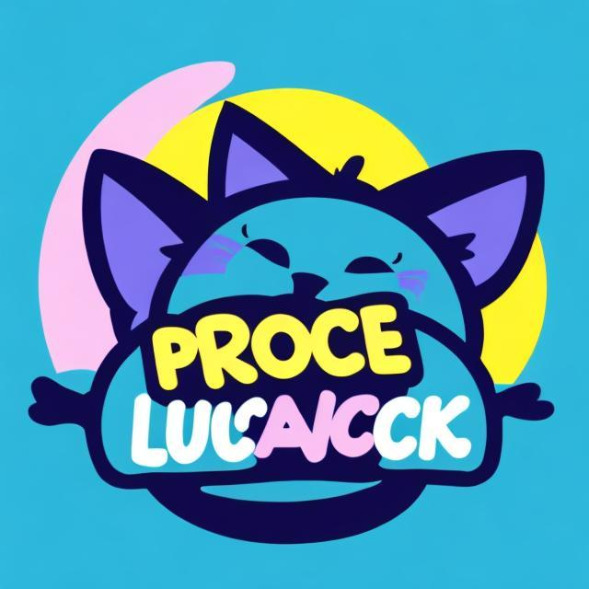

“Logo for a product called ‘CatNapAttack’, blue cat silhouette over product title, bright colors, pop out display”

Using openart.ai

PRODUCT RENDER

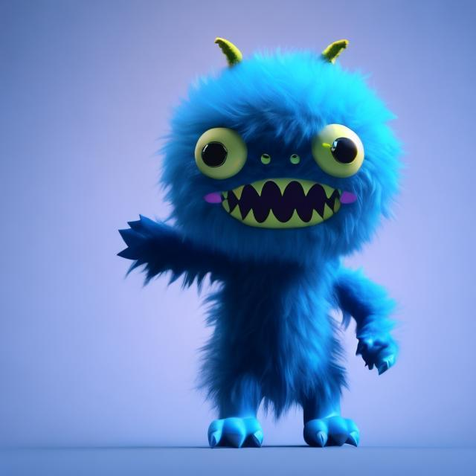

“3-d product render of blue fuzzy monster, 3d render”

Using openart.ai

PRODUCT PROMO (influencers)

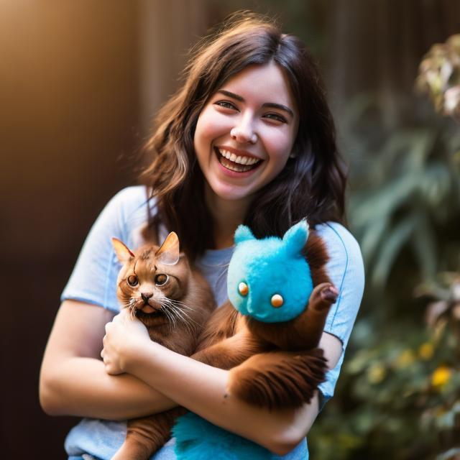

Realistic photo of a young woman, smiling, holding a cat which has a blue fuzzy monster toy in its paws, realistic photo, natural lighting

Using openart.ai

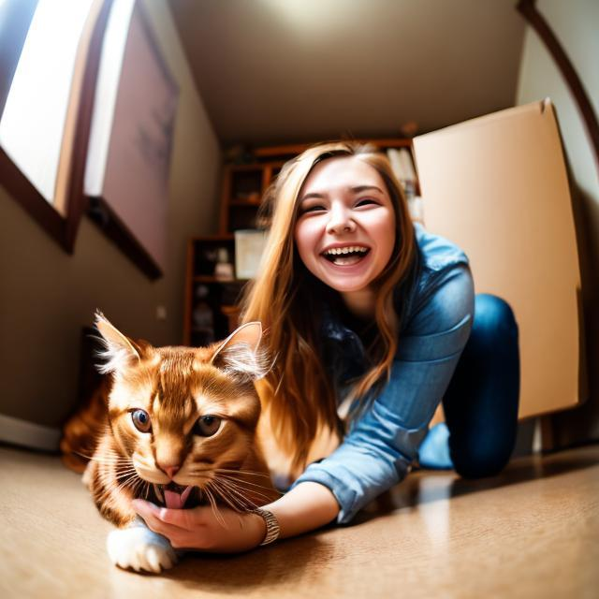

Realistic photo from fisheye lens perspective, young woman smiling and holding a brown cat, 'CatNapAttack' product box is sitting on the floor in the background, dim lighting, realistic photo album

Using openart.ai

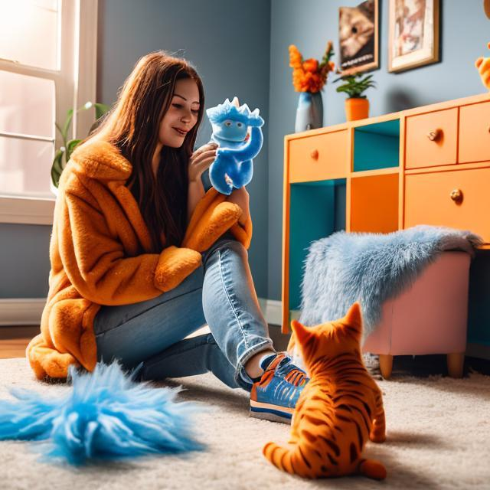

Realistic photo of a young woman sitting on the floor with an orange cat who is playing with a blue fuzzy monster toy and there is a bright colored product box placed on the floor, indoor setting, natural lighting, realistic photo, product placement, sponsored

Using openart.ai

PRODUCT PROMO (product and testers)

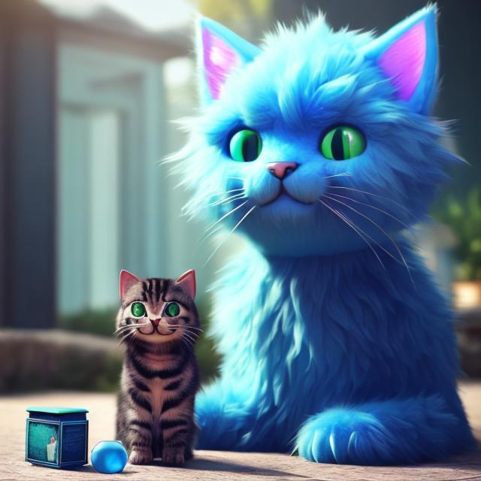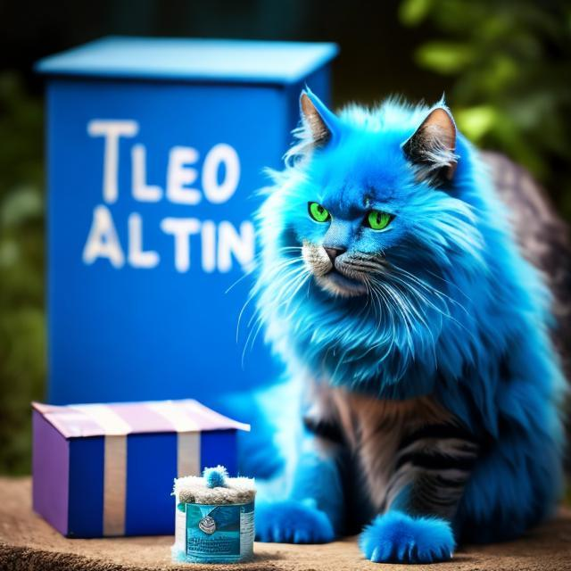

Realistic photo of a cat sitting next to a blue box with the words "CatNapAttack", beside it is a blue fuzzy monster toy and a vial of green substance catnip, realistic photo, natural lighting, outdoor setting

Using openart.ai

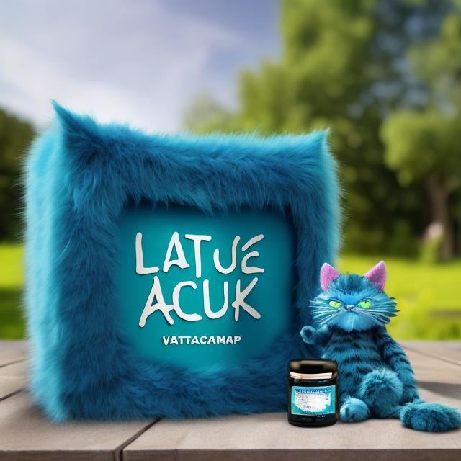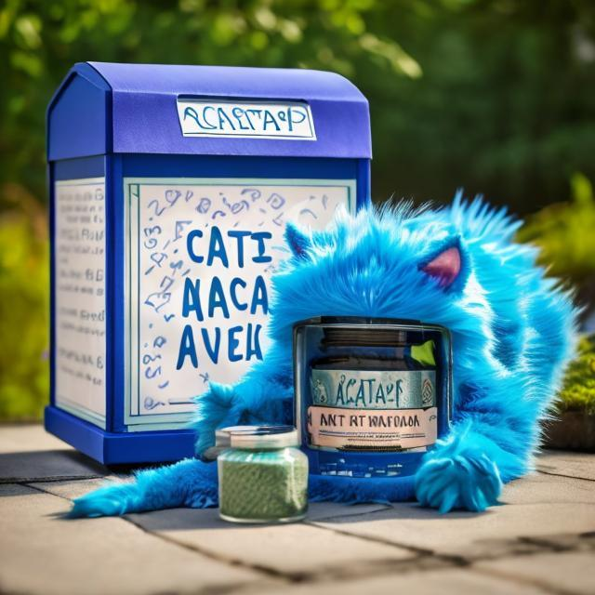

Realistic photo of a large blue box with the words "Cat Nap Attack", beside it is a blue fuzzy monster toy and a vial of green substance catnip, realistic photo, natural lighting, outdoor setting

Using openart.ai