PRSQL-1 IMDB Project

Screenshots of Queries and Output/Results:

- Can you get all data about movies?
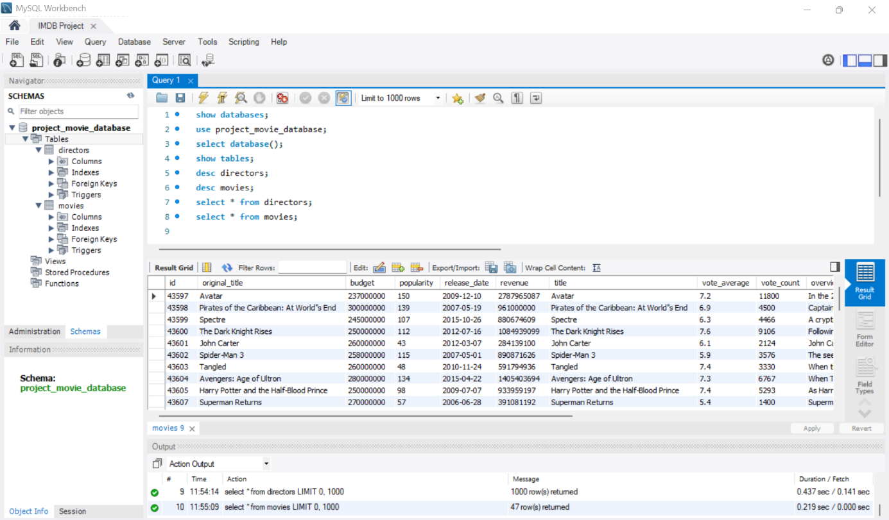

- How do you get all data about directors?

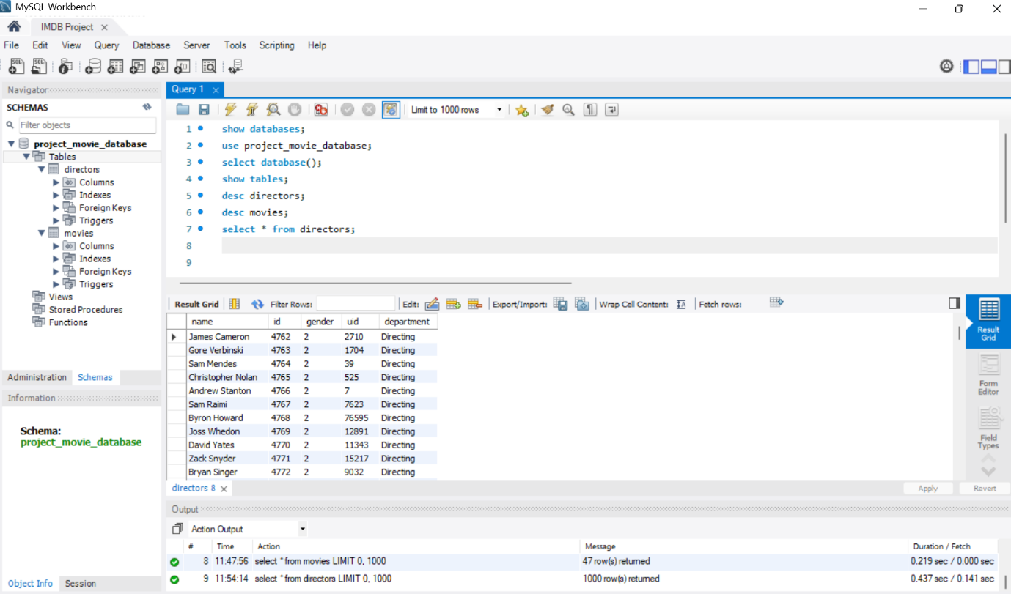

- Check how many movies are present in IMDB.

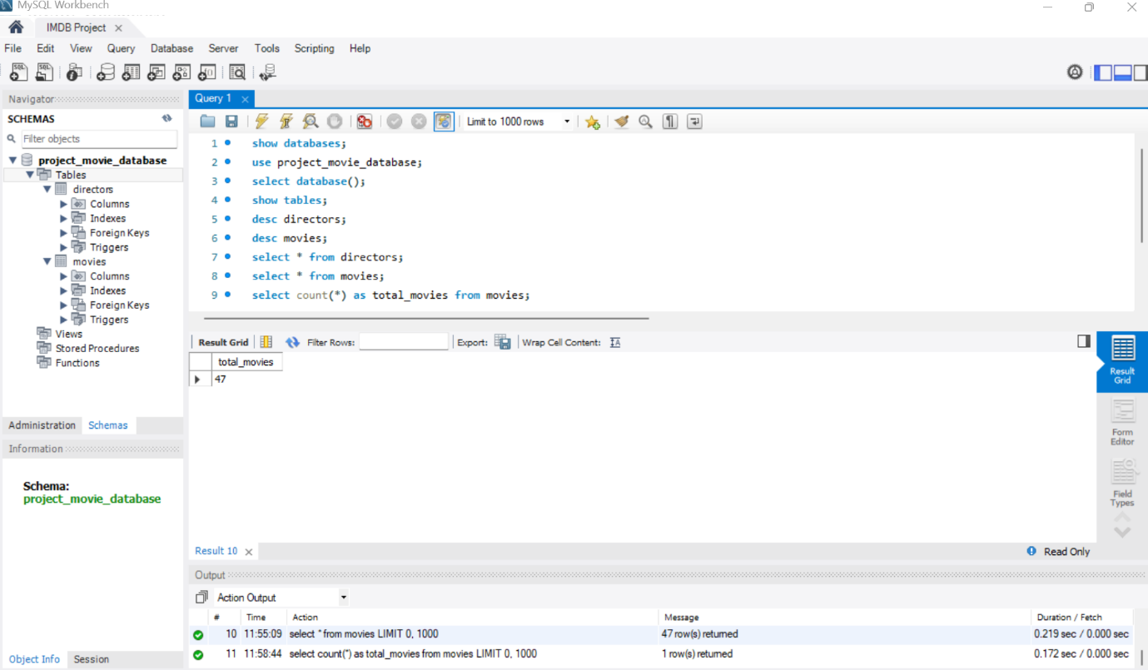

- Find these 3 directors: James Cameron ; Luc Besson ; John Woo

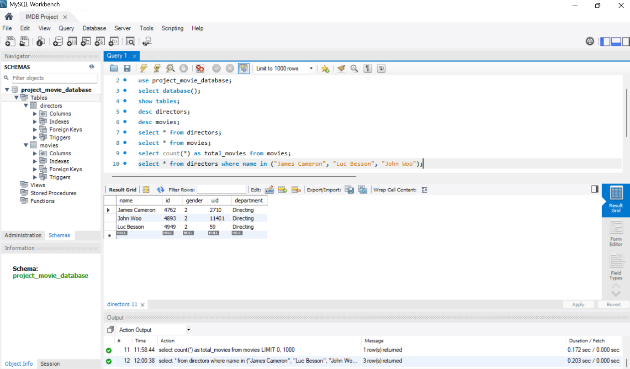

- Find all directors with name starting with S.

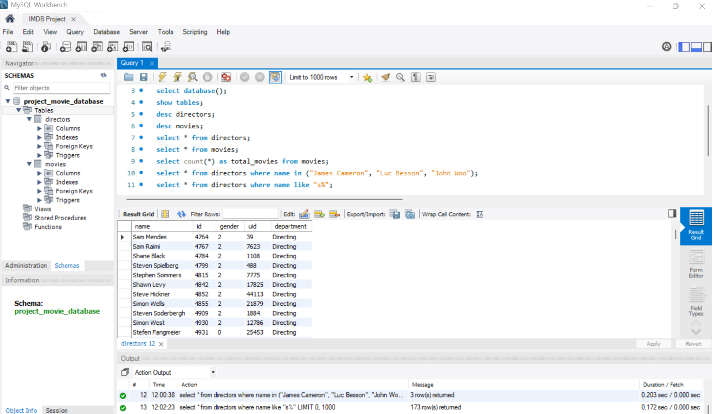

- Count female directors.

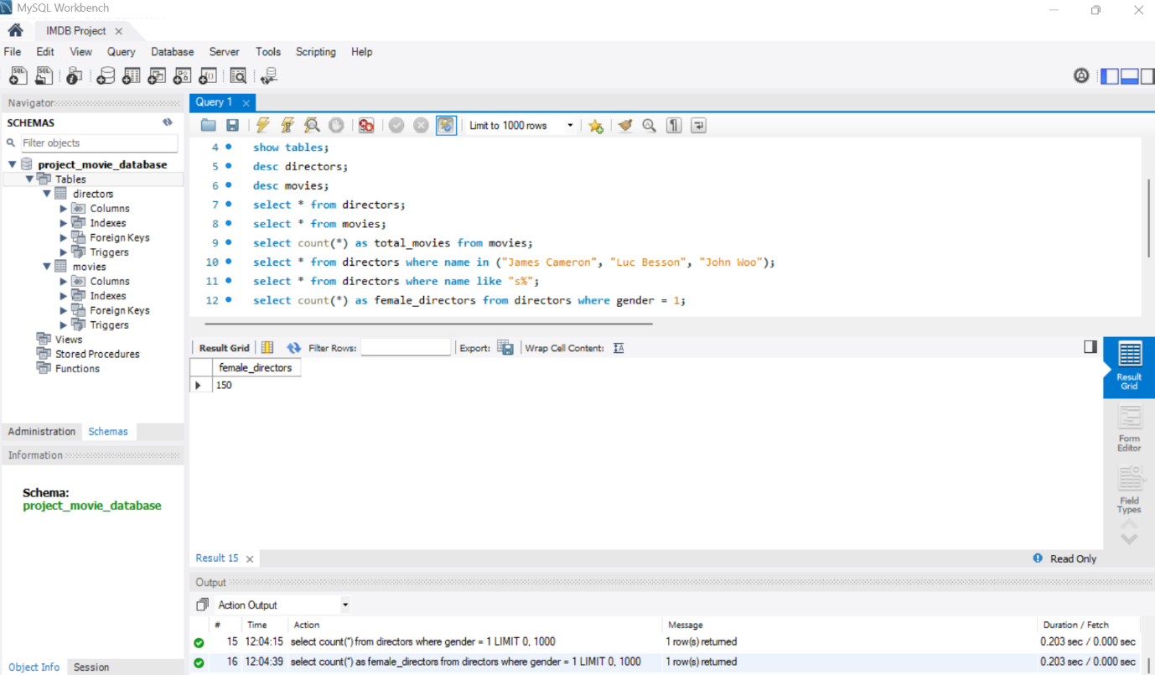

- Find the name of the 10th first women directors?

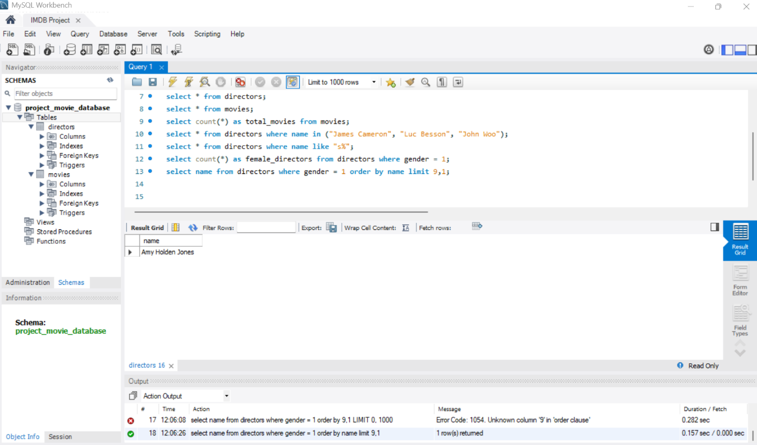

- What are the 3 most popular movies?

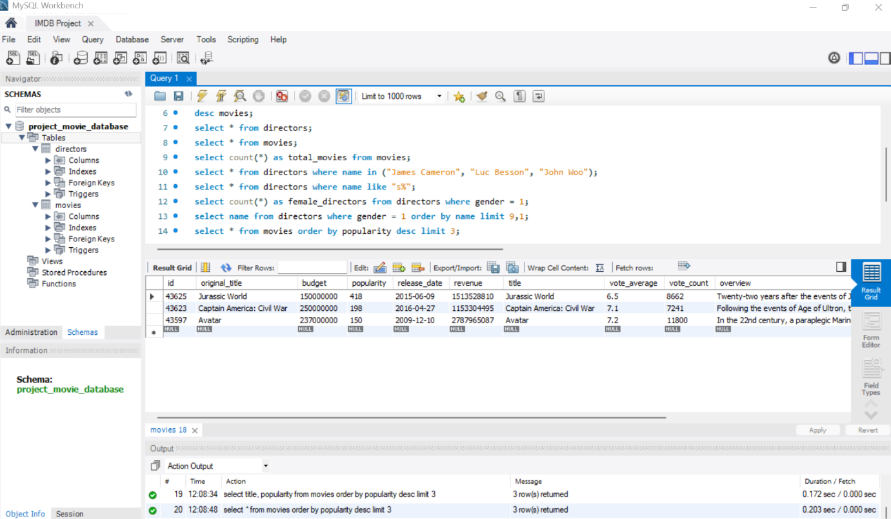

- What are the 3 most bankable movies?

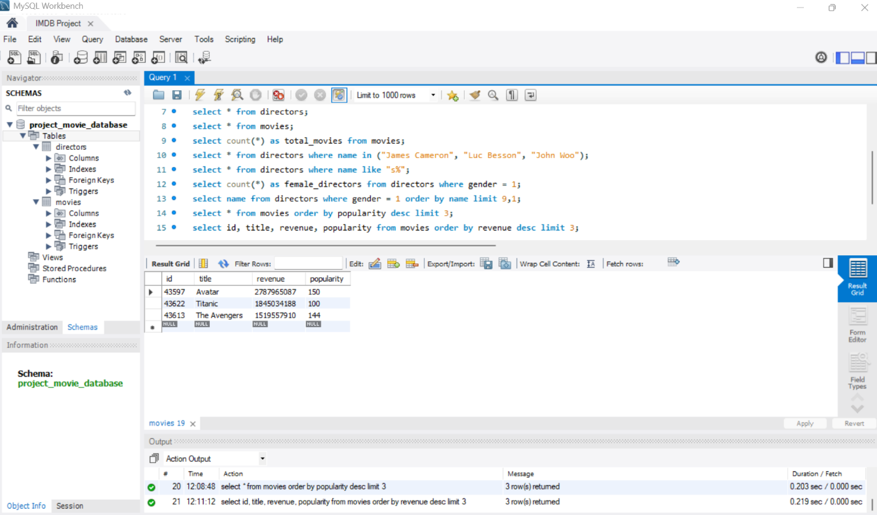

- What is the most awarded average vote since the January 1st, 2000?

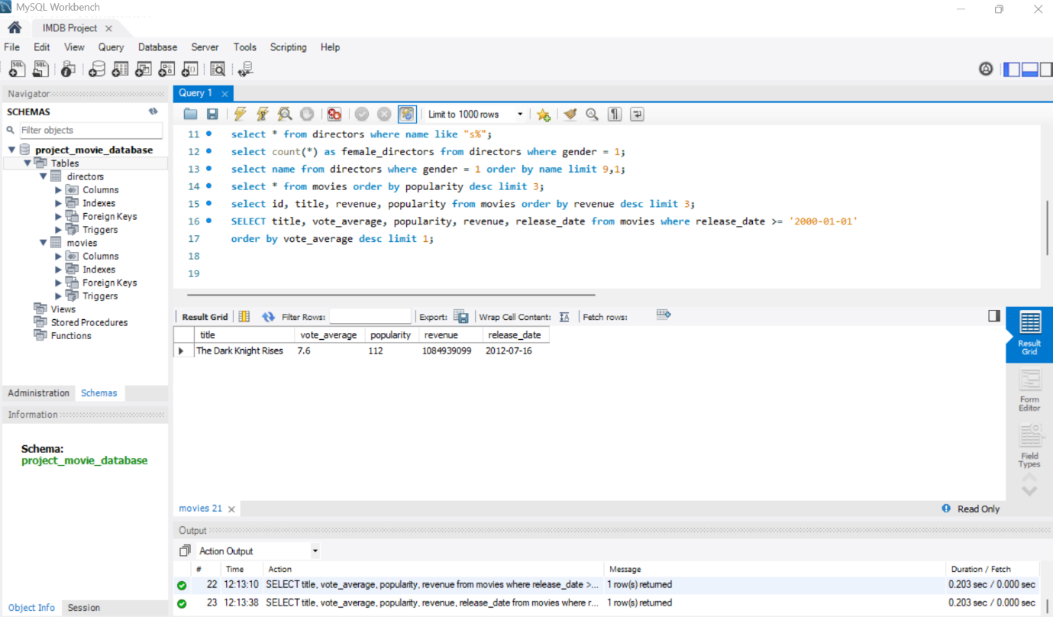

- Which movie(s) were directed by Brenda Chapman?

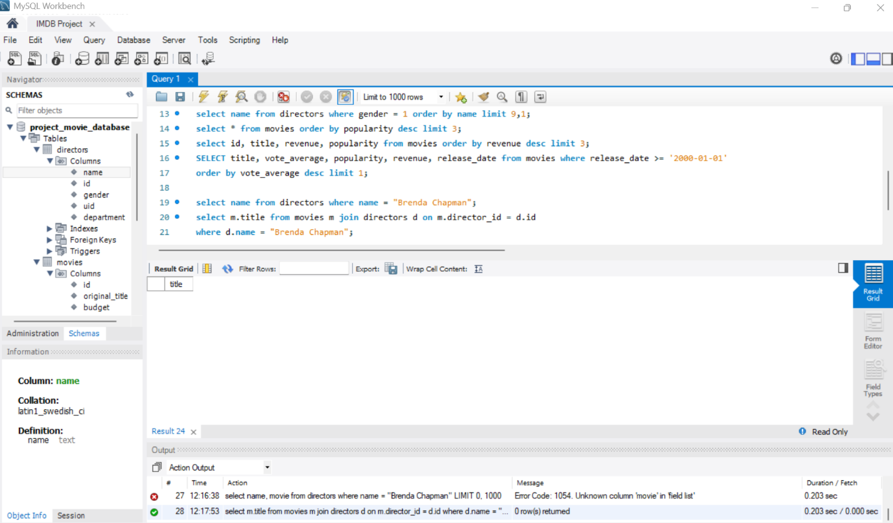

- Which director made the most movies?

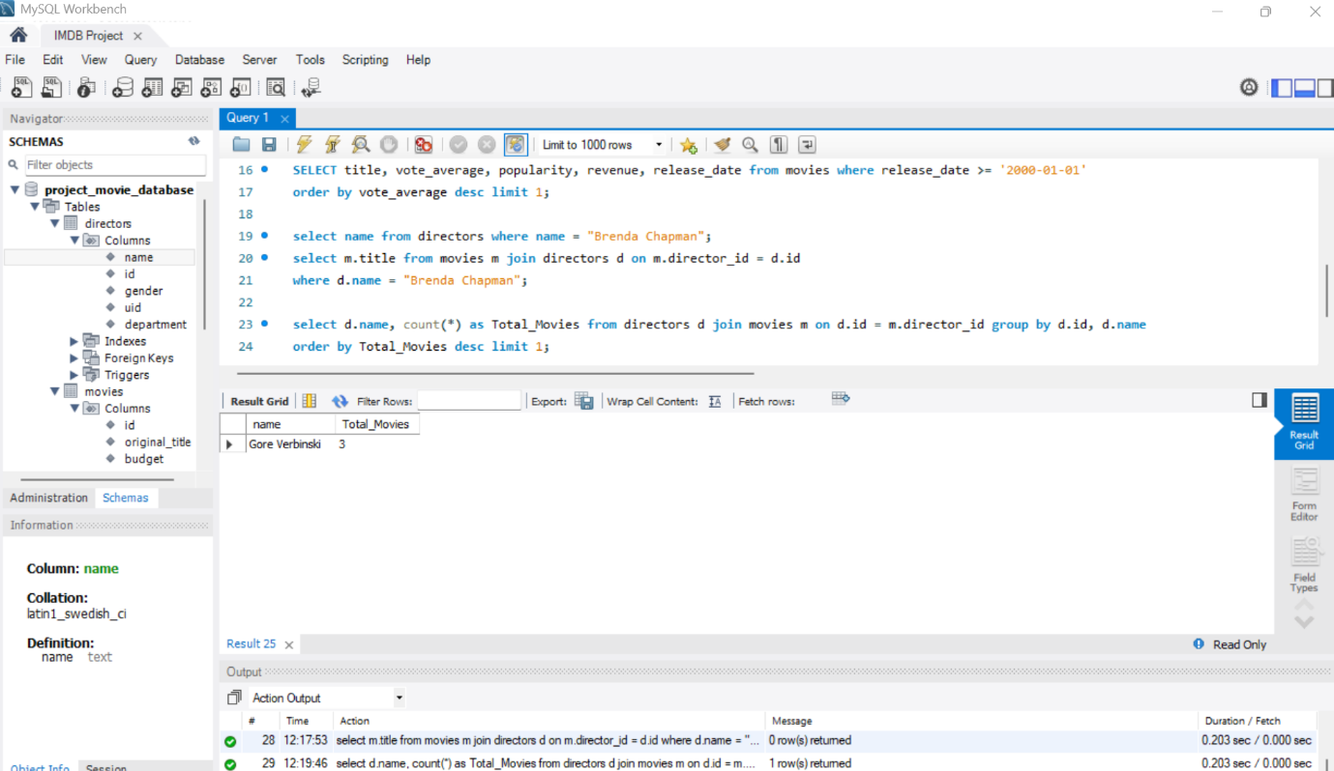

- Which director is the most bankable?

