2016

Yulin Peng

TecDocPro

12/16/2016

Getting Started with Option Trading



*TechDocPro*

*Copyright* © 2016 TechDocPro. All rights reserved.

The information contained herein is proprietary to TechDocPro.

No part or parts of this document may be reproduced or disclosed to

Others except as specifically permitted by TechDocPro.

Created: December 2016

TechDocPro

7740 Alderbridge Way

Richmond, BC

V6X 3L6

For more information,

call: 1-604-367-2228

visit website: www.techdocpro.com

Table of Contents

Introduction 1

What is this tutorial about? 1

Why do I write this tutorial? 1

What Are Options? 2

Example of an option in an everyday situation 2

Calls and Puts 3

Calls 3

Puts 3

Participants in the Option Market 3

Holders 3

Writers 4

Terminologies 5

Strike Price 5

Expiration date 5

Exercising an option 5

Premium 5

In the money 5

Out the money 6

At the money 6

Intrinsic value 7

Extrinsic value 7

Volatility 8

Implied volatility 9

Time value 9

Trade Example 10

A trade example 10

Exiting an option position 11

Understanding Trading Charts 13

Option price reporting table 13

Parameters 14

Column 1 – OpSym 14

Column 2 - Bid 14

Column 3 - Ask 14

Column 4 – Extrinsic 14

Column 5 – Implied Volatility 14

Column 10 – Volume 15

Column 11 - Open interest 15

Risk measures 16

Column 6 - Delta 16

Column 7 - Gamma 16

Column 8 - Vega 17

Column 9 - Theta 17

Trading Strategies 18

Covered call 18

How it works 18

An example 18

When to use it 19

Married Put 19

How it works 19

An example 19

When to use it 20

Short Vertical Spread 20

How it works 20

An example 21

When to use this strategy 22

Start Trading 23

Good luck with your option trading! 23

# Introduction

### What is this tutorial about?

Welcome to **Getting Started with Option Trading**.

This is a tutorial about option trading for beginners. It includes concepts and terminologies and provides a one-stop solution for getting started with option trading.

The following tutorial will help you save time and avoid the frustration of looking for information in many different places.

The tutorial is not for advanced option traders. To learn more complicated option-trading strategies, you will need to read advanced materials or take higher-level option trading courses.

### Why do I write this tutorial?

I started learning option trading about half a year ago.

After investing in the stock market for many years, I started looking for a way to make profit while being able to hedge against the risk of losing a huge amount of money due a sudden plunge of the stock market.

I have been learning basic concepts, terminologies, and trading strategies from online articles and YouTube videos. It is a time-consuming and painful learning experience to gather information from too many different sources. Sometimes I needed to read many articles to fully understand one terminology, because most of the articles were either too difficult to understand, or incomplete in their information.

To help other beginners avoid my painful experience, I decided to write this tutorial. In this tutorial, I will explain all fundamental concepts and terminologies from the beginner’s point of view. I hope you can benefit from this tutorial and start option trading right away.

# What Are Options?

An **option** is a contract that gives the buyer the right, but not the obligation, to buy or sell an underlying asset at a specific price on or before a certain date.

An option is a security, just like a stock or a bond. It is also a binding contract with strictly defined terms and properties.

An option is a contract that deals with an underlying asset. In the following example, the house is the underlying asset. In the option market, the underlying asset is a stock or an index.

## Example of an option in an everyday situation

To help you understand what an option is, here is a simple example.

Mary is selling a house. Peter would love to buy Mary’s house, but Peter won’t have the money for another three months. Peter negotiates with Mary and agrees to a deal that gives Peter the option to buy the house in three months for $300,000. Peter pays Mary $3,000 for this option.

Peter has bought a **call option** by paying a $3,000 premium. The strike price is $300,000 and the expiration date is three months from now. Within the three months, if Peter buys the house, he will pay $300,000 to get the house, but will not get the $3,000 premium back.

If Peter doesn’t buy this house and walks away, Mary will keep the $3,000 premium.

The key to this example is that as a **call option**, the buyer **has the right** to buy but **doesn’t have the** **obligation** to buy. The seller has to sell only if the buyer decides to buy. No matter whether the buyer decides to buy or not, the seller will **always collect the premium**.

After Mary and Peter sign the deal, there are three possible situations:

* The price of the house rises to $400,000. Peter will be very happy to buy the house valued at $400,000 at a price of $300,000. Peter makes money from the price increase of the house. His profit will be **$400,000**- $**300,000** - $**3,000** = $**97,000**.
* The market goes down, and the price of the house drops to $200,000. Peter can walk away with the loss of the $3,000 premium.
* The house price is unchanged. Peter can buy the house for $300,000, or not buy the house and lose only the $3,000 premium.

This example shows the exact mechanism of a call option. After buying a call option, you have the right (or control of underlying asset) to buy the underlying asset (a house in this example), but not an obligation to do so. You can do nothing and let the option become worthless at the expiration date, losing your investment which is the premium you paid for the option. The seller of the call option always collects the premium no matter whether you execute the option or not.

## Calls and Puts

### Calls

A **call** option gives the buyer the right to buy an asset at a certain price within a specific period of time, but the buyer **doesn’t** have to buy. It gives the seller the obligation to sell an asset at a certain price within a specific period of time if the buyer wants to buy.

Buyers of calls hope that the stock will increase substantially before the option expires, and the sellers of calls collect a premium no matter which direction the asset goes in.

### Puts

A **put** gives the buyer the right to sell an asset at a certain price within a specific period of time, but the buyer doesn’t have to sell. The seller of a put has to buy if the buyer wants to sell the asset at a certain price within a specific period of time.

Buyers of puts expect that the stock price will go down substantially before the option expires. The sellers of puts collect premiums no matter whether the asset’s price goes up or down. When the stock price drops dramatically, the seller will lose money, and the buyer will hedge against the risk of losing money.

## Participants in the Option Market

In the options market, people who are expecting the stock price to rise are said that to have a long position; people who are expecting the stock price to drop are said to have a short position.

Participants in the option market are divided into two types:

### Holders

People who buy call options are called holders, and are said to **have long positions.**

People who buy put options are called holders, and are said to have **short positions.**

### Writers

People who sell call options are called writers, and are said to have **short positions**.

People who sell put options care called writers, and are said to have **long positions**.

# Terminologies

This chapter will introduce basic terminologies. You will need to understand these terminologies before you start option trading.

## Strike Price

The price at which an underlying stock can be purchased or sold is called the **strike price**. For a call option the stock price must go above the strike price for the holder to make a profit by exercising the option. For a put option the stock price must go below the strike price for the holder to make a profit by exercising the option.

In the example from the last chapter, $300,000 is the strike price of the $3,000 option buying the house.

## Expiration date

**Expiration date** is the end date of the period of time when the option is effective. Upon reaching this date, all options are worthless. Just like when you buy car insurance, there is an expiration date. The holder of calls or puts can only exercise the option before or on the expiration date.

In the example in chapter 1, the expiration date is the date which falls three months after Peter pays $3,000 to Mary.

## Exercising an option

When the holder of a call option or a put option buys the underlying asset, it is said that the **option is exercised**. In the option market, most options are not exercised.

## Premium

**Premium** is the money collected by the seller of calls and puts. When the call or put is sold to the buyer, the seller sells the call or put options for a certain amount of money.

Any option is sold for a certain amount of premium. The premium for an option depends on whether it is “in the money,” or “out the money,” or “at the money.” The premium also depends on some other factors explained henceforth.

## In the money

When the stock’s market price is higher than the strike price in a call option, or lower than the strike price in a put option, we call this situation **in the money**.

When the option is in the money, the option is worth exercising. If the holder exercises the option, the holder will profit from the trade.

## Out the money

When the stock’s market price is lower than the strike price in a call option, or higher than the strike price in a put option, we call this situation **out the money**.

When the option is out the money, it means the option is not worth exercising, because you will lose money.

## At the money

**At the money** is a situation in which the strike price is the same as the market price of the underlying security. When the option is at the money, both call and put are at the money.

The premium is more expensive for an option that is in the money than for an option that is out the money or at the money. A price movement is required for an option that is out the money and at the money to become valuable (in the money).

The following figures show in the money, out the money, and at the money of call options (figure 1) and put options (figure 2).

**Figure 1. For a call option**

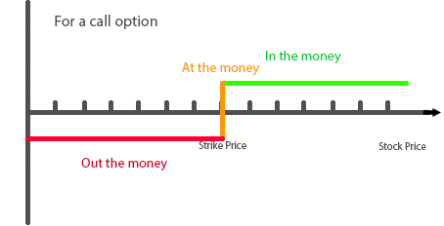

**Figure 2. For a put option**

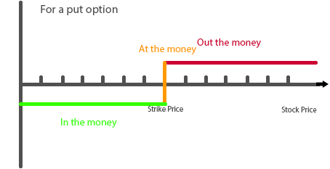

## Intrinsic value

The **intrinsic value** for a call option is the market price of the stock minus the strike price. The intrinsic value is the profit made by the buyer if he/she exercises the option right now, not including additional fees (without calculating premium cost). The actual profit should be the intrinsic value minus the premium paid for the option.

**For example, if you buy a call option with a strike price of 10 and the market value is $12, then the intrinsic value is $12 - $10 = $2.**

The intrinsic value for a put option is the strike price minus the market price. The intrinsic value is the profit made by the buyer if the buyer exercises the option right now without calculating premium cost. The actual profit should be the intrinsic value minus the premium paid for the option.

**For example, if the strike price is $8 and the market price is $5, the intrinsic value is $8 - $5 = $3**.

Options only have an intrinsic value when they are in the money. Intrinsic value is what the option is worth if it expires right now.

## Extrinsic value

The **extrinsic value** is everything that is not intrinsic value of an option’s total value.

**The value of an option = intrinsic value + extrinsic value**

**Total option premium – intrinsic value = extrinsic value**

**If you buy an option at the premium of $3, and the intrinsic value of the option is $2:**

**The extrinsic value: $3 – $2 = $1**

Investors pay more than an option’s current exercise value (intrinsic value) because there is value in the ability to hold a contract over time. The amount of time left until expiration and the volatility of the underlying asset directly impact the price of an option, thus impacting the extrinsic value.

## Volatility

**Volatility** is the amplitude of the stock price. When the price for one stock changes dramatically, this stock has high volatility (see figure 4). When the price for one stock changes only within a very small range, this stock has low volatility (see figure 5).

**Figure 4. Stock with high volatility**

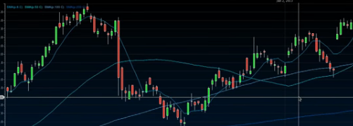

**Figure 5. Stock with low volatility**

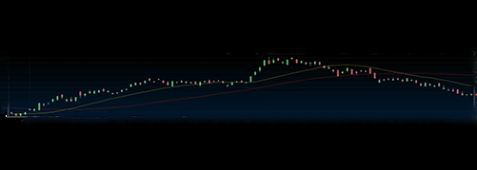

For simple option trading, only the stock that has high volatility is worth buying.

## Implied volatility

**Implied volatility** is the most significant factor to affect the time value of an option. Implied volatility represents the expected volatility of a stock over the life of the option. Implied volatility is directly influenced by the supply and demand of the underlying options and by the market’s expectation of the share price’s direction.

Implied volatility will rise as the demand for an option increases. Options that have high levels of implied volatility will result in high-priced option premiums. Figure 4 shows that the time value of an option falls to zero with the passage of time.

## Time value

Each option has a **time value**. The time value of an option is always decaying. When the time is closer to the expiration date, the time value of an option is close to zero.

Time value (days to expiration) is one factor of extrinsic value for an option.

**Figure 4. Time value of an option**

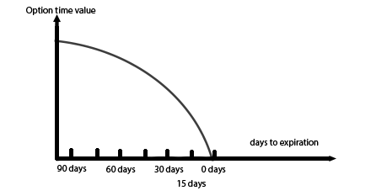

# Trade Example

After having learned basic concepts and terminologies of option trading, you can look at a practical example to understand how options work in a real situation.

## A trade example

On March 1st, the stock price of ABC is $67 and the premium (cost) is $2.75 for a May $70 call, which indicates that the expiration date is the third Friday of May and the strike price is $70. The total price of the contract is $2.75 x 100 = $275.

Note: In a real situation, you will pay commission when buying or selling options. To simplify the calculation in this example, we will ignore the cost of commissions.

The minimum unit for option trading is 100 shares, so the price for one option of 100 shares is $2.75 x 100 ($275). The strike price is $70, which means you have the right to buy the underlying stock (ABC) at the price of $70 before or at the third Friday of May.

There are three possible situations:

* Within two months (before or at the third Friday of May) the stock price moves above $70. You will make money by paying only $70 to get a stock which is actually worth more than $70. You will make money from this contract.
* Within two months (before or at the third Friday of May) the stock price rises but is still less than $70. You will not exercise the contract, because you don’t want to buy the stock at a price higher than the market price. The key point is that you have **the right to buy, but you don’t have the obligation**, so you just don’t buy. Even though you have the right to buy, you don’t need to use it when you don’t benefit.
* Within two months (before or at the third Friday of May) the stock price drops and the price is less than $67. Of course, you will not buy the stock because you will not benefit.

When the stock price is $67, it's less than the $70 strike price, so the option is worthless. But don't forget that you've paid $275 for the option, so you will lose this amount of money.

Three weeks after the option purchase date the stock price is $78. The options contract has increased along with the stock price and is now worth $8.25 x 100 = $825. Subtracting what you paid for the contract, your profit is ($8.25 - $2.75) x 100 = $550. You almost doubled your money in just three weeks. You could sell your option, which is called **closing your position**, and take your profits. You can also keep the option if you think the stock price will continue to rise

By the expiration date, the price has dropped to $62. Because this is less than the $70 strike price and there is no time left, the option contract is worthless. You now lose your original investment of $275.

The following table demonstrates the stock price, option price, contract value, and paper gain/loss during the period that the option is effective.

**Table 1. Values of the Option During Effective Period of Time**

|  |  |  |  |
| --- | --- | --- | --- |
| **Date** | **March 1** | **March 21** | **Expiry Date** |
| **Stock Price** | $67 | $78 | $62 |
| **Option Price** | $2.75 | $8.25 | worthless |
| **Contract Value** | $275 | $825 | $0 |
| **Paper Gain/Loss** | $0 | $550 | -$275 |

The range of the price change for the length of this contract from high to low was $825, and the highest value of the contract would have been double the premium paid for this contract.

## Exiting an option position

You open an option position by buying or selling, and they are called “buy to open” or “sell to open.”

There are three ways to exit an option position:

* **Close the option** by selling the option at a higher price.
* **Exercise the option** by buying the underlying stock in a call option, or selling the underlying stock in a put option.
* Let the option **expire** on expiration day. The option will be worthless at expiry.

In this example, you exit an option in the following three ways:

**Close the option**

Selling out the **option** when the market price of the stock goes above the strike price. In this example, you could sell the option at the price of $8.25 to make profit by selling the option.

**Exercise the option**

Buying the stock when the market price of the stock goes above the strike price in a call option. After exercising the option, you can sell the stock to market to make profit, or hold the stock to wait for it to go up continuously, if you think it will keep going up.

**Let the option expire**

Hold the option until the expiration date and leave the option worthless. You will do this when the market price of the stock is under the strike price within two months of the period of the contract.

In reality, the majority of options are not actually exercised. The majority of option traders choose to take the profits by trading out their options.

# Understanding Trading Charts

In previous chapters we talked about theories and examples. In this chapter we are going to look at the real operating interface of the option-trading platform. Because nowadays all options are trading through online venues, you must understand the numbers on the screen to trade your options.

## Option price reporting table

Table 2 is an option-trading screen of an online trading platform. Even though not every broker’s software interface is exactly the same, they look similar because the parameters for option trading are the same.

**Table2. Option-Price Table**



The table includes 12 columns. The following sections explain each column.

## Parameters

In this section, we explain all parameters except column 6 to 9. The row in **green** is current market price of the stock (**$126.33**). Let us look at the row circled in **red**.

### Column 1 – OpSym

This column has the underlying stock symbol, the contract month and year, the strike price, and the option type.

The first line in the first column means that the underlying stock of this option is IBM. The contract will expire in March 2010. It is a **call** **option**, and the strike price is $125.

### Column 2 - Bid

The **bid price** is the latest and highest price offered by a buyer who want to buy the option in column 1 of the same line. If you enter a market order to sell the March 2010, $125 call, you would sell it at the bid price of $3.40.

### Column 3 - Ask

The **ask price** is the latest and lowest price offered by a seller who wants to sell the option on the first column at the same line. If you enter a market order to buy the March 2010, $125 call, you would buy it at the ask price of $3.50.

### Column 4 – Extrinsic

Any option value consists of two parts: the **intrinsic** value and **extrinsic** value.

**Premium = intrinsic value + extrinsic value**

The balance by the premium of the option subtracting intrinsic is the extrinsic value. For example, the intrinsic value is $126.33 – $125 = $1.33.

**The extrinsic value = premium – intrinsic value = $3.40 – $1.33 = $2.07.**

$2.07 is the bid extrinsic value for the call option of IBM MAR10 125 C.

### Column 5 – Implied Volatility

**Implied volatility** (IV) represents the expected volatility of a stock over the life of the option. IV is directly influenced by the supply and demand of the underlying options and by the market’s expectation of the share price’s direction. Options that have high levels of implied volatility will result in high-priced option premiums. IV is a significant factor affecting the premium of an option.

The value is calculated by an option-pricing model. Because this tutorial is for beginners, we will not explain how this value is calculated. We only need to understand the following points to use it to help us in our option trading:

* IV is influenced by the supply and demand of the underlying options and the market’s expectation of the share price’s direction. The low IV implied less demand for the option, and the high IV means more demand for the option.
* When we look at the IV of an option, we compare it with the history value of the IV of this option.
* It is time to sell when the IV is high, and it is time to buy when IV is low.

### Column 10 – Volume

**Volume** indicates how many contracts of a particular option were traded in a given period. The option with strike price that is closer to the stock price has a high volume.

Typically options with large volume will have relatively tighter bid/ask spreads, because more people want to buy or sell these options.

### Column 11 - Open interest

This is the total number of contracts of a particular option that have been opened but have not yet been closed on the given day.

When a new buyer and seller enter the market, the open interest will change. If an option holder has 5 option contracts and sells the 5 option contracts to an option buyer, the open interest will not change because the total number of options does not change.

If an option holder exercises the option, the open interest will change.

The open interest is a measure of the money flow into a futures or options market. An increase in open interest usually indicates a bullish market.

## Risk measures

In this section we will explain four risk measures of options. They are **Delta, Gamma, Theta, and Vega.**

**Table 3. Risk Measures**

|  |  |
| --- | --- |
| Vega | Measures the impact of a change in volatility |
| Theta | Measures the impact of a change in time remaining |
| Delta | Measures the impact of a change in the price of underlying |
| Gamma | Measures the rate of change of delta |

### Column 6 - Delta

**Delta** is the ratio of change in the price of option compared to the change in the price of the underlying asset. If a stock option has a delta value of 0.5, this means that if the underlying stock increases in price by $1, the option will rise by $0.50.

The formula to calculate the delta is:

**Delta = change in option price/change in price of the underlying asset.**

If you buy an “at the money” call or put, it will have a delta of approximately 0.5, meaning that if the underlying stock price moves 1 point, the option price will change by 0.5 points (all other things remaining the same).

If the price moves up, the call will increase by 0.5 points and the put will decrease by 0.5 points. For options at the money, delta is 0.5.

Looking at column 6 in table 2, you can see that four of the out-of-the-money options have delta values close to 0, and deep in-the-money options have deltas that are close to 1. You can also see how the delta changes when the option (strike price) changes from in-the-money to out-of-the-money.

### Column 7 - Gamma

**Gamma** measures the rate of change of delta.

**Delta is not a constant.** When the underlying moves, the delta value on any option will change. The gamma of an option reflects the change in the delta in response to a one-point movement of the underlying stock price. Gamma is presented as a percentage.

When trading options with delta and gamma, two options with equal value of deltas may not be equal in outcome. The delta with the higher gamma will have a higher risk because given an unfavorable move of the underlying, the delta with the higher gamma will exhibit a larger adverse change.

Gamma is largest for options that are at the money. When gamma is too big the traders face more risk and hold potential for large gains.

### Column 8 - Vega

**Vega** represents the amount that an option contract’s price changes in reaction to a 1% change in the implied volatility of the underlying. It indicates the option’s sensitivity to changes in the volatility of the underlying.

Look at column 8 in table 2. For the March 2010 $125 call in the red rectangle, if implied volatility rose one point – from 19.04 to 20.04% - the price of this option would gain $0.141. This indicates why it is preferable to buy options when implied volatility is low. And to sell options when implied volatility is high. Because you pay relatively less time premium and a subsequent rise in IV will result in a higher price of the option.

### Column 9 - Theta

**Theta** is a measure of the rate of time premium decay. It is always negative. As soon as you own an option, the amount of time value remaining on the option decreases.

Owners of these wasting assets expect that the underlying stock will make a move quick enough to put a profit on the option before the expiration date. In other words, if delta beats theta, the trade can be closed profitably.

Looking at column 7 in table 2, you can find the theta for each option is negative.

One can buy the options with a later expiration date to get more time to let the underlying stock’s price change. The premium will be higher, because the premium includes more time value. The options that expire sooner have a higher theta.

# Trading Strategies

In the former chapters, we explained basic knowledge and terminologies with regard to option trading. In this chapter we will introduce three basic trading strategies. Two of the strategies consist of only one option trade accompanied by purchased underlying. The third example consists of two option trades in one transaction, so you can both make profit and hedge against the risk with a small amount of portfolio.

## Covered call

Covered call is a simple option-trade strategy that only includes one trade. Let us look at how this strategy works.

### How it works

When you own a stock, or buy a stock, you sell a call option against the same amount of your asset (your stock).

For each 100 shares of stock you own, you can sell a call option against those shares.

You need to select a stock that will hold steady or move up.

After you sell the call option, here are possible situations:

* The stock price remains the same or drops; the buyer will not exercise the contract. You will profit from the premium you have collected from selling your call option.
* The stock price goes up and is higher than the strike price; the buyer will exercise the contract. You will lose your stock, but you still make profit from the premium you collected when selling the call option. Your loss will be the stock’s price minus the strike price, but you are not really losing anything.

### An example

For example, the stock price is $85 when you buy in. You can sell a call contract of strike price $90 within one week at the option price of $3 per share. By selling this call option you will receive a $300 premium for this call option.

When one week has elapsed or during the one week, if the stock price is under $90, the buyer will not buy the stock, not exercising the contract. You will profit from the premium of $300 you have collected by selling the call option.

If the stock price goes over $95, the buyer normally will exercise the option to buy the stock. You still collect $300 of premium as your profit. What you have lost is just the chance to earn ($95 - $90) * 100 = $1,000. But you didn’t actually lose.

### When to use it

When you think one stock will keep steady or only move up slightly.

## Married Put

This is another simple strategy including only one trade. It explains how an option protects you from unexpected and dramatic change in the stock price.

### How it works

When you buy a stock, you purchase a put option against the same amount.

Here are possible situations:

* When the price of the stock goes up during the option’s effective period, you don’t want to and don’t have to sell your stock.
* When the price of the stock goes down dramatically below the strike price, you can sell your stock at the strike price. You lose the premium you paid for the put option and a certain amount of your investment. When the market goes down dramatically, this strategy can protect your investment by limiting your loss to an expectable small amount.

### An example

For example, you purchase the ABC stock at the price of $95. You think that it will go up. But for safety’s sake, you buy a put option with strike price of $90 and expiration date of one week, which means you have the right to sell it before or on the expiration date at the strike price of $90.

During the period of time until the option expires, here are possible situations:

* The price goes up or remains the same. You don’t have the obligation to sell the stock at the strike price. Your loss is just your premium. This is just like when you buy car insurance. Even though your car isn’t involved in an accident, you can’t get your car insurance back.
* If the price of the stock goes down to $80, you have the right to sell your stock at the strike price of $90. This way, you limited your loss. **Your loss is ($95 - $90) * 100 = $500 plus your premium, not ($95 – $80) * 100 = $1,500 plus premium.**

### When to use it

When you buy a stock that you think will go up, but you want to protect your investment against an unexpected and dramatic plunge of the stock price.

## Short Vertical Spread

From the first two examples we have learned that we can sell a call option to collect time premium and buy a put option to protect our investment against a dramatic drop of the stock price. Now we will learn to use two option trades together. The vertical spread trading strategy is a more complicated trading strategy which includes two trades in one transaction.

### How it works

Short vertical spread is the most basic spread. It is the building block of many spread trading strategies.

Using this strategy, you sell a call option (short option) and buy a call option (long option) at different strike prices with the same expiration date, in which the short option has a strike price higher than current stock price and lower than the long option’ s strike price.

Here are the possible situations:

1. If the stock price keeps under both short option’s strike price and long option’s strike price. The buyer of the short option won’t exercise the short option, and you don’t need to exercise the long option either. Your profit will be the balance by premium you collect from short option subtract the premium you paid for the long option. Normally the short option’s premium is more expensive than the long option, because the strike price of the short option is closer to current stock price than the long option’s strike price. The lower the strike price of a call option, the more valuable it is (the more premium it will cost). Because lower price call allows the owner to purchase stock at a lower price.
2. If the stock price goes up and is above both short option and long option’s strike price, both you and the buyer will exercise the long and short call options. Your loss will be the balance by short contract’s loss subtracting the long contract’s gain and difference between two premiums for your short and long option. Your loss is limited.
3. If the stock price goes up between the strike price of short option and the strike price of long option. Your profit will be between your gain in situation 1 and loss in situation 2.

### An example

Let us look at a practical example to understand this trading strategy. For example, the price of the stock ABC is currently $67. You can sell a call option (short option) with strike price of $70 at the price of $3. At the same time you can buy a call option (long option) with strike price of $75 at the price of $1.20. Both call options have the same expiration date.

Here are three possible scenarios:

1. The stock price keeps under the strike price of $70. Both call options will be out the money and be worthless. Under this situation, your profit will be the $3 * 100 – $1.20 * 100 = $180.
2. The stock’s price goes up to $90, above the higher strike price of the call option.

* **Your loss from the short option: ($90 – $70) * 100 = $2,000**
* **Your gain from the long option: ($90 - $75) * 100 = $1,500**
* **Your total loss: $2,000 – $1,500 = $500**

**Considering the premium gain: $300 – $120 = $180**

**Your loss is: $500 – $180 = $320**

1. The stock’s price goes between the lower strike price and the higher strike price. Your profit (loss) will be in between (+) $180 and (-) $320.

The important thing is that no matter how high the stock price will go, your loss will not be more than $320.

Figure 5 shows clearly how the profit or loss changes along with the change of the stock price.

**Figure 5. Short vertical spread**

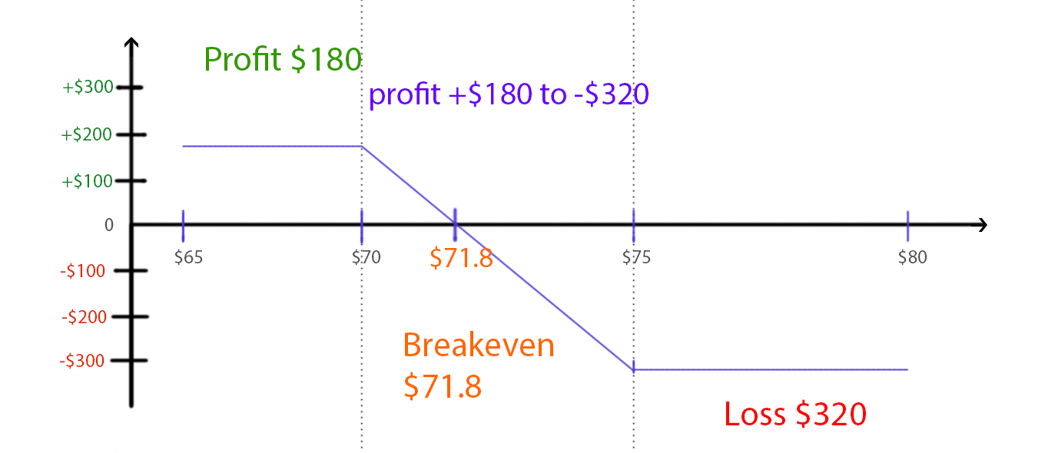

For this trade, the max profit is $180 (entry price), and the max loss is $320 (width of strikes – entry price). When the stock price is between the strike prices, the profit is $180 - (X – $70) * 100, and X<$75.

**When $71.8 <X < $75 the, the profit is negative.**

**When $70 < X <= $71.8, the profit is positive. It means that you earn money.**

**$71.8 is the break-even point.**

### When to use this strategy

When you expected that one stock’s price will change within a range of a lower price and a higher price. You use the lower price as your short option’s strike price, and use the higher price as your long option’s strike price. In this strategy, you make profit from the balance of premium collected from the short option and the premium paid for the long option.

# Start Trading

You now understand the fundamentals of option trading.

To practice your trading skills, you need to open an account in an investment organization. You need to make sure that the investment account has permission for option trading. Most option-trading accounts have a practice account, so you can exercise option trading with this account first.

Start with smaller amounts. If you still don’t understand some concepts or terminologies, you will come to understand through trading.

After some trading exercises, read this tutorial again. You should have a deeper understanding of the theories and parameters.

## Good luck with your option trading!

For further information, consult online resources. Here are some useful links:

<http://www.smbtraining.com/overview/options-trading-101>

<http://www.1option.com/index.php?/ask_me/>

<http://www.investopedia.com/university/options/>

<https://www.virtualbrokers.com/en-us/compare-brokers?gclid=CKOFkv-f_9ACFUlNfgodmV0GEQ>