HOME HERO™ ASSET #4

The Invisible Backpack
What kids carry that we cannot see.
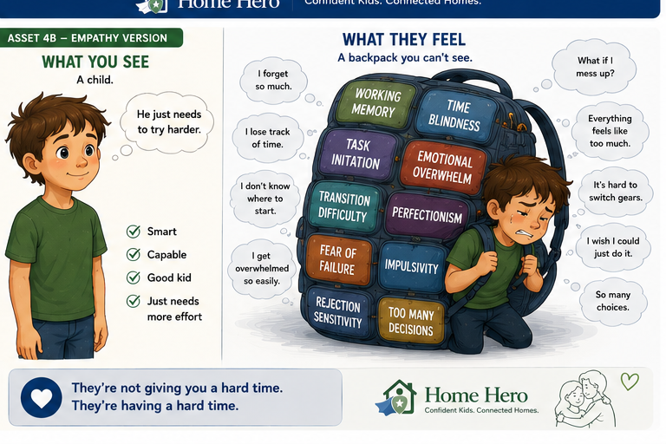

Resource Library Summary
Many children carry invisible executive function and emotional challenges that adults cannot see. Understanding the load changes how we respond.

Website Article
When parents look at a child, they often see what everyone else sees: a child who is bright, capable, and old enough to know what to do.
What they cannot always see is what that child may be carrying.
For many children with ADHD, executive function challenges, anxiety, or emotional sensitivity, everyday responsibilities can come with an invisible backpack. That backpack may be filled with working memory challenges, time blindness, difficulty starting, emotional overwhelm, fear of failure, transition difficulty, impulsivity, rejection sensitivity, perfectionism, and too many decisions at once.
From the outside, the child may look like they are ignoring directions, avoiding responsibility, or refusing to try. Inside, the child may be working hard just to manage the weight of the task before they even begin.
This is one reason parents and children can get stuck in the same frustrating loop.
A parent sees a child who forgot again.
The child feels like they failed again.
A parent sees a child who has not started.
The child feels frozen because the first step is not clear.
A parent sees a child who is distracted.
The child feels pulled in too many directions at once.
The goal of Home Hero is not to excuse behavior or remove responsibility. The goal is to help families understand what is making responsibility harder, then build support that helps children succeed.
When we understand the backpack, our response changes.
Instead of saying, "You just need to try harder," we can ask, "What part feels hard right now?"
Instead of saying, "Why did you forget again?" we can ask, "What would help you remember next time?"
Instead of assuming defiance, we can look for the hidden load.
Children do not need adults to carry the backpack for them forever. They need adults to notice that the backpack exists, help make the load visible, and teach skills that make it easier to manage over time.
That is how confidence grows.
Not from shame. Not from pressure. Not from constant correction.
Confidence grows when children experience success with the right amount of structure and support.
The invisible backpack reminds us that children are not giving us a hard time. Often, they are having a hard time.
When families can see that clearly, connection becomes possible again.

