HOME HERO™ ASSET #4

The Invisible Backpack
60-second app version
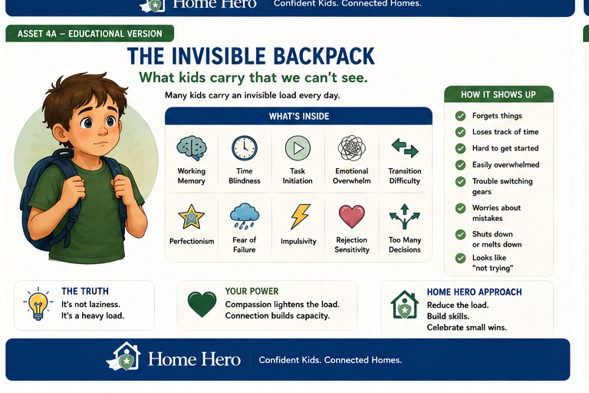

App Version
You see a child.
They may feel a backpack full of challenges you cannot see.
Inside the backpack might be:
- Working memory
- Time blindness
- Task initiation
- Emotional overwhelm
- Fear of failure
- Too many decisions
When a child struggles, ask:
"What might be in their backpack today?"
Try this instead of "try harder":
"What part feels hard right now?"
Small support can lighten a heavy load.

