HOME HERO™ ASSET #4

The Invisible Backpack
Infographic copy
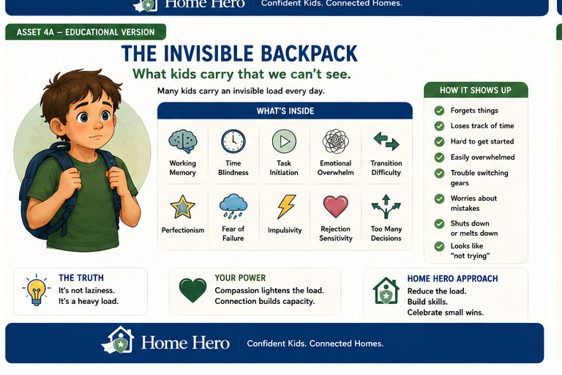

Infographic Copy
Headline: The Invisible Backpack
Subhead: What kids carry that we cannot see.
What You See:
- Does not listen
- Forgets things
- Avoids tasks
- Gets distracted
- Has an attitude
What They May Feel:
- Working memory overload
- Time blindness
- Task initiation difficulty
- Emotional overwhelm
- Transition difficulty
- Fear of failure
- Perfectionism
- Rejection sensitivity
- Too many decisions
The Truth:
It is not laziness. It is a heavy load.
Home Hero Approach:
Reduce the load. Build skills. Celebrate small wins.
Footer:
They're not giving you a hard time. They're having a hard time.
Home Hero™ | Confident Kids. Connected Homes.

