**Sheet: 2014 | Output**

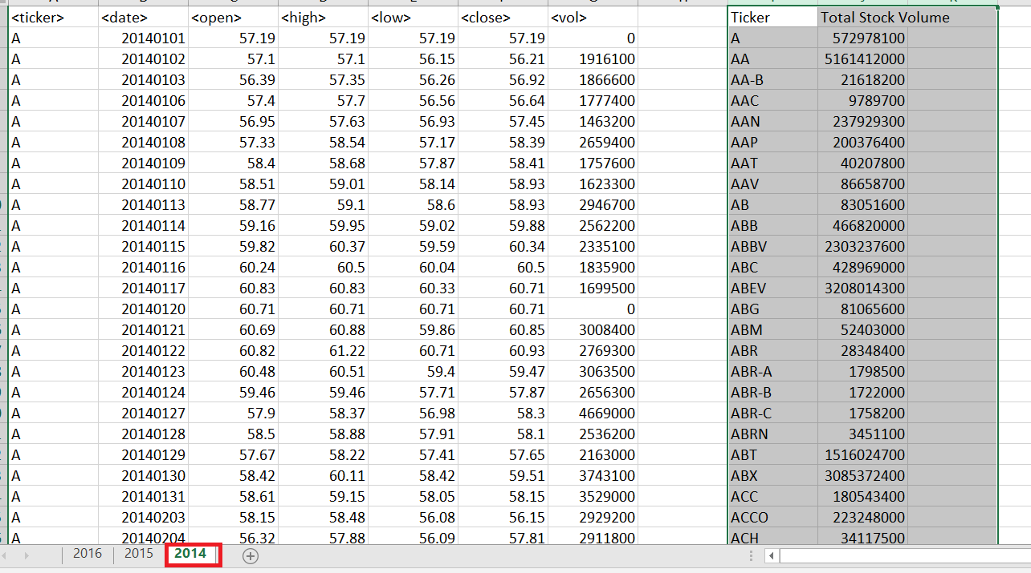

**Sheet: 2015 | Output**

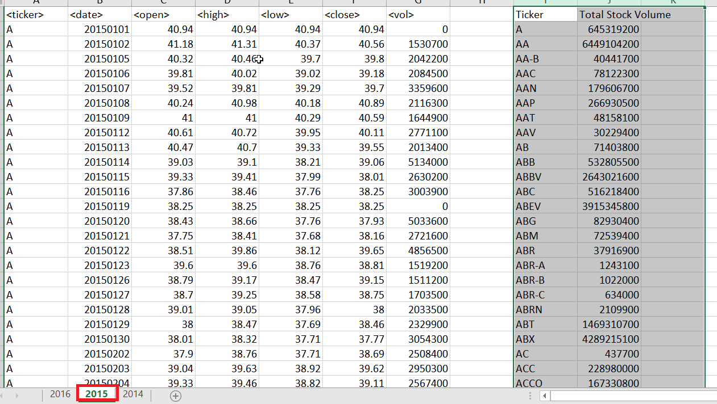

**Sheet: 2015 | Output**

