

ECONOMIC DEEP DIVE
CANADA AND THE TEMPEST (GCAP) PARTNERSHIP
A Framework Document for Economic Analysis
Prepared for the Canadian Unmanned Combat Air System Program Office
June 2026 | Document Reference: CDR-ECON-2026-001

TABLE OF CONTENTS
Right-click the TOC and select "Update Field" to refresh page numbers

EXECUTIVE SUMMARY 3
1. INTRODUCTION AND BACKGROUND 5
1.1 What is GCAP / Tempest? 5
1.2 Canada’s Current Position 6
2. DIRECT JOB CREATION 7
2.1 Estimated Employment Impact 7
2.2 Regional Distribution 8
2.3 Comparison to Alternative Paths 9
3. GDP CONTRIBUTION AND ECONOMIC GROWTH 10
3.1 Program Spend Projection 10
3.2 GDP Impact Calculation 11
4. PROCUREMENT SAVINGS AND FUNDING MECHANISM 12
4.1 The $9.24B Bridge 12
4.2 Investment Allocation 12
4.3 ROI Projection 13
5. SUPPLY CHAIN AND SME IMPACT 14
5.1 Canadian Supply Chain Opportunities 14
5.2 SME Participation 14
5.3 Technology Transfer and Spillover 15
6. EXPORT MARKET POTENTIAL 16
6.1 Global Sixth-Generation Fighter Market 16
6.2 Canadian Competitive Position 16
7. WORKFORCE TRANSITION 18
8. TAX REVENUE 19
9. ECONOMIC SOVEREIGNTY BENEFITS 20
10. RISK ASSESSMENT AND SENSITIVITY 22
11. COMPARATIVE ANALYSIS 23
12. CONCLUSION AND RECOMMENDATIONS 24

EXECUTIVE SUMMARY
This economic deep dive quantifies the long-term industrial and economic benefits of Canada joining the Global Combat Air Programme (GCAP) as a Tier 2 partner in developing the sixth-generation Tempest fighter. GCAP—a trilateral program between the United Kingdom, Italy, and Japan—represents a £25+ billion opportunity that would secure Canadian aerospace participation in the technologies of the 2040s and beyond.
By leveraging the $9.24 billion in procurement savings generated by the Arctic Horizon program—which fields the Arctic Augmented Gripen E, Sprinter tactical UAV, and Striker loyal wingman as an integrated combat system—Canada can enter GCAP as a genuine partner nation while maintaining credible Arctic sovereignty capabilities throughout the 2026-2035 interim period. The Arctic Horizon system has been validated through comprehensive war-gaming analysis across six operational scenarios, demonstrating both operational viability and significant cost advantages over the F-35-only alternative.
KEY FINDINGS AT A GLANCE
Direct Jobs Created | 5,000 - 8,000
Total Jobs (Direct + Indirect + Induced) | 13,000 - 21,000
25-Year GDP Contribution | $6.6 - $9.8 billion
25-Year Tax Revenue | $2.4 - $3.7 billion
Canadian Industry Revenue | $8.0 - $12.0 billion
Export Revenue Potential (by 2055) | $2.5 - $4.5 billion
Return on Investment (Conservative) | 2.3x
Return on Investment (Moderate) | 3.4x
Sovereign Control | Full Canadian authority
ITAR Dependency | Minimal to none

The analysis presented in this document draws upon the ISED State of Canada’s Aerospace Industry 2024-2025, PwC Strategy& economic impact modelling, Eurofighter Typhoon programme benchmarks, and the Arctic Horizon Economic Outlook. All figures are based on publicly available data and standard aerospace economic multiplier analysis.

1. INTRODUCTION AND BACKGROUND

1.1 What is GCAP / Tempest?
The Global Combat Air Programme (GCAP) is a trilateral initiative between the United Kingdom, Italy, and Japan to develop a sixth-generation combat air system centered on the Tempest fighter aircraft. The programme represents one of the most ambitious and expensive defence collaborations in history, designed to produce a family of systems that will dominate the air combat environment of the 2040s and beyond.
The programme encompasses far more than a single manned aircraft. The GCAP system-of-systems architecture includes the Tempest optionally-manned fighter as the core platform, collaborative combat aircraft (CCA) loyal wingman drones, advanced artificial intelligence and autonomous decision-making frameworks, integrated sensor networks with multi-domain data fusion, next-generation electronic warfare capabilities, and a comprehensive ground-based command and control infrastructure. This holistic approach ensures that GCAP will define the standard for sixth-generation combat air systems globally.
Key programme parameters are already well-established. The target Initial Operational Capability (IOC) is 2035, with a demonstrator aircraft scheduled for first flight in 2027. The programme value exceeds £25 billion over its full lifecycle, with the UK Ministry of Defence having already committed £2 billion since 2021 and budgeting more than £12 billion over the next decade. Italy has publicly committed €18.6 billion to its national share, while Japan’s contribution through its F-X programme integration is estimated at a comparable level.
The industrial architecture is structured around three national champions. BAE Systems serves as the UK lead system integrator, Leonardo fulfils the same role for Italy, and Japan Aircraft Industrial Enhancement Co. Ltd. (JAIEC) leads the Japanese consortium. In June 2025, these three partners announced the creation of Edgewing—a joint venture company with equal 33.3% shareholding—which will serve as the primary industrial vehicle for delivering the next-generation aircraft. Complementing this structure, the GCAP Electronics Evolution Consortium (G2E) was established in September 2025, comprising Leonardo and ELT Group for Italy, Leonardo UK for the United Kingdom, and Mitsubishi Electric for Japan, to deliver the Integrated Sensors And Non-Kinetic Effects and Integrated Communications Systems (ISANKE & ICS) that will make the Tempest a true sensor powerhouse.
- Tempest manned fighter (6th generation, optionally manned, supersonic stealth platform)
- Loyal wingman / collaborative combat aircraft (CCA) systems for distributed operations
- Advanced AI and autonomy frameworks enabling manned-unmanned teaming
- Integrated sensor and data architecture with multi-domain fusion
- Next-generation electronic warfare and cyber defence capabilities
- Open systems architecture enabling rapid capability upgrades

1.2 Canada’s Current Position
As of June 2026, Canada is actively pursuing observer status in GCAP following high-level diplomatic engagement between Japanese Defence Minister Shinjiro Koizumi and Canadian Minister of National Defence David McGuinty in March 2026. A formal announcement is anticipated at the July 2026 meeting of GCAP defence ministers from the United Kingdom, Italy, and Japan.
Observer status would provide Canada with access to selected confidential programme information without immediate financial commitment. This represents a strategically prudent entry point, allowing Canadian industry and government to evaluate the full spectrum of partnership opportunities before making binding commitments. Critically, observer status can evolve into full participation, including manufacturing work share and procurement rights, providing a pathway for Canada to transition from peripheral interest to core industrial partner.
The strategic context for this move is compelling. Canada has relied almost exclusively on US-origin fighters since 1946—the F-86 Sabre, CF-104 Starfighter, CF-101 Voodoo, CF-18 Hornet, and now the F-35A Lightning II. This seven-decade dependency has left Canadian aerospace defence industrial capability atrophied and Canadian sovereignty over its own air combat systems severely constrained. Escalating US-Canada trade tensions, unpredictable US tariff policies, and growing restrictions on technology transfer have accelerated Ottawa’s interest in genuine diversification. GCAP participation represents the first credible opportunity for Canada to break this dependency and establish an independent pathway to sixth-generation combat air capability.

2. DIRECT JOB CREATION
The employment impact of Canadian GCAP participation is substantial and strategically distributed across Canada’s established aerospace clusters. Using the economic multiplier analysis from the ISED 2024 aerospace model, which identifies a 2.43x total employment multiplier for Canadian aerospace activities, we project significant job creation across all programme phases.

2.1 Estimated Employment Impact
GCAP participation will create jobs across three distinct phases, each with different workforce profiles and skill requirements. The phased nature of the programme means that job creation is not a one-time event but a sustained multi-decade employment engine for Canadian aerospace. The conservative estimate projects 14,900 total jobs (direct, indirect, and induced) at peak production, while the moderate scenario reaches 21,500 total jobs—comparable to the employment impact of the Eurofighter Typhoon programme on individual partner nations.
Phase | Direct Jobs | Indirect Jobs | Total Jobs | Period
Phase 1: Observer / Integration | 200-400 | 400-600 | 600-1,000 | 2026-2030
Phase 2: Tier 2 Partnership | 2,000-3,000 | 3,000-5,000 | 5,000-8,000 | 2031-2035
Phase 3: Production & Sustainment | 3,000-5,000 | 5,000-8,000 | 8,000-13,000 | 2036-2060
TOTAL (2035-2060) | 5,000-8,000 | 8,000-13,000 | 13,000-21,000

Phase 1 (2026-2030) represents the observer-to-integration transition, during which Canadian engineers, policy specialists, and programme managers are embedded within GCAP structures. This phase creates 200-400 direct positions focused on requirements definition, technology assessment, and partnership negotiation. These are predominantly high-salary knowledge economy positions—systems engineers, aerospace architects, defence policy analysts, and international project managers.
Phase 2 (2031-2035) accelerates dramatically as Canada transitions from observer to Tier 2 partner. During this period, Canadian industry establishes production lines, test facilities, and supply chain relationships. Engineering expands into detailed design, prototyping, and systems integration. The workforce grows to 2,000-3,000 direct positions spanning design engineers, manufacturing technicians, quality assurance specialists, and programme management staff. This phase also drives substantial indirect employment in the supplier base.
Phase 3 (2036-2060) represents full production and long-term sustainment. With the Tempest entering service and Canada operating a sovereign fleet, direct employment stabilises at 3,000-5,000 positions covering final assembly, component manufacturing, systems integration, flight testing, maintenance, repair and overhaul (MRO), and through-life capability upgrades. The sustainment phase is particularly valuable economically because MRO work typically generates higher margins and more stable employment than initial production.
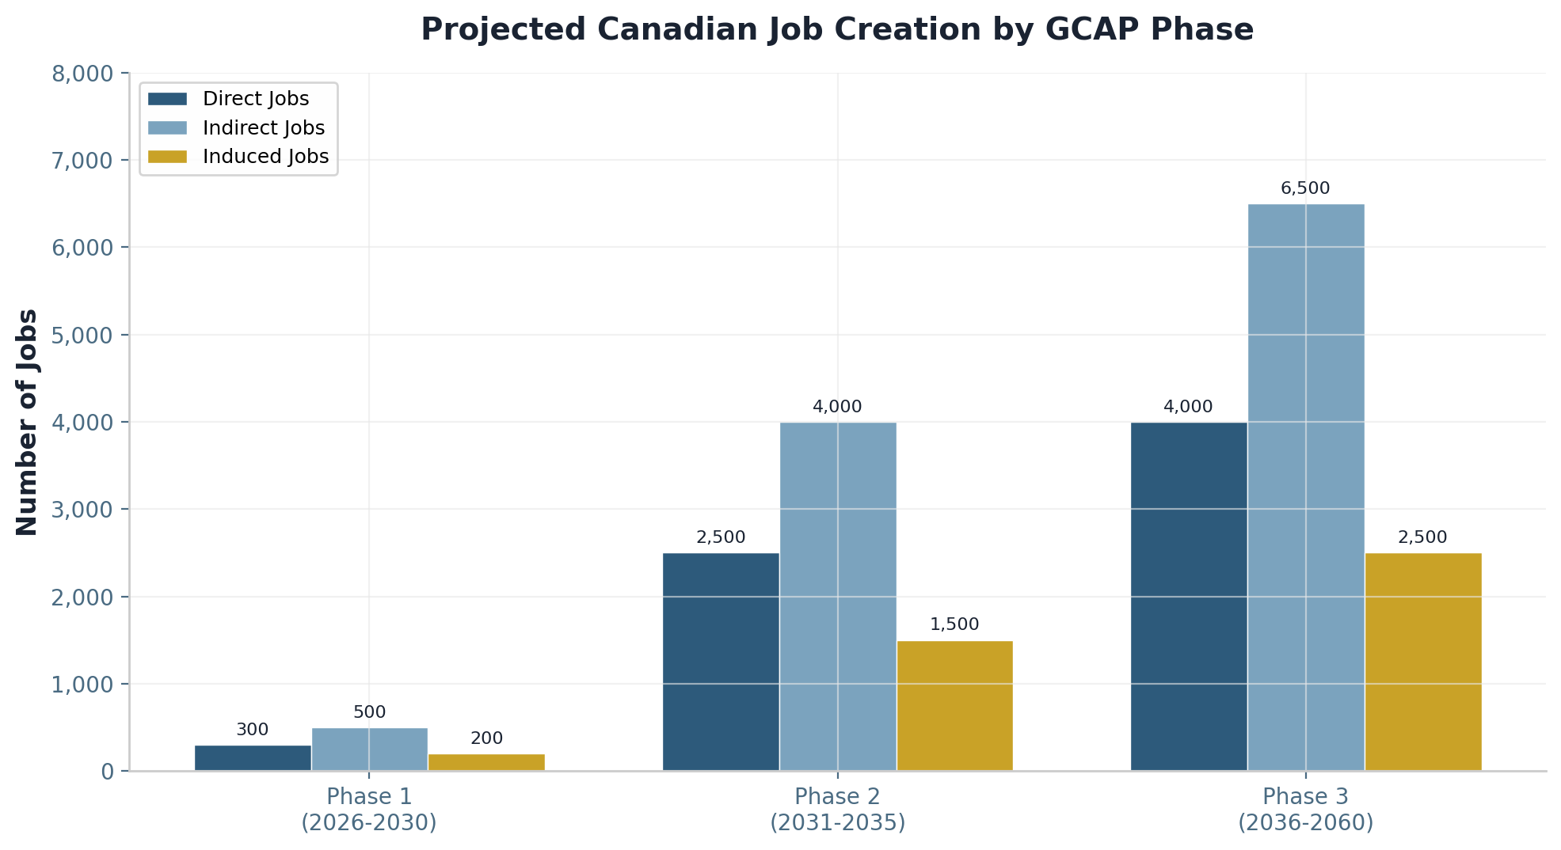
Figure 1: Projected Canadian Job Creation by GCAP Phase (2026-2060)

2.2 Regional Distribution
The regional distribution of GCAP employment reflects Canada’s established aerospace geography, with Quebec and Ontario commanding the lion’s share due to their deep industrial bases, skilled workforces, and world-class research institutions. However, GCAP’s scope creates meaningful opportunities across all regions, including Atlantic Canada and Western Canada.
Quebec—centred on Montreal and Mirabel—is projected to capture 2,500-4,000 direct jobs, reflecting its position as Canada’s aerospace heartland. The province hosts 61% of Canada’s aerospace manufacturing employment, including Bombardier, CAE, Pratt & Whitney Canada, and a dense network of suppliers. For GCAP, Quebec would lead in aerostructures manufacturing, advanced composite fabrication, final assembly integration, and systems testing. The province’s established expertise in cold-weather aircraft operations—hardened through decades of Canadian Arctic aviation—provides a unique competitive advantage for GCAP, which must operate across the full spectrum of climatic conditions including the Arctic environment that defines Canadian air defence.
Ontario—spanning Toronto, Ottawa, and Kingston—is projected to capture 1,500-2,500 direct jobs, focused on mission systems, autonomy software, sensor development, and AI integration. The province’s strength in information technology, telecommunications, and defence electronics—exemplified by MDA (radar and sensor systems), L3Harris Wescam (electro-optical systems), and a vibrant AI research ecosystem centred on the Vector Institute and University of Toronto—positions it as the natural home for GCAP’s software-defined capabilities. Ottawa’s concentration of defence policy institutions and military headquarters also makes it the logical location for programme management and government liaison functions.
Province/Region | Direct Jobs | Key Activities
Quebec (Montreal/Mirabel) | 2,500-4,000 | Aerostructures, advanced composites, final assembly
Ontario (Toronto/Ottawa/Kingston) | 1,500-2,500 | Mission systems, autonomy software, sensors, AI
Atlantic Canada (Halifax) | 500-800 | MRO, sustainment hub, defence electronics
Western Canada | 300-500 | Supply chain, precision components, testing
TOTAL | 5,000-8,000

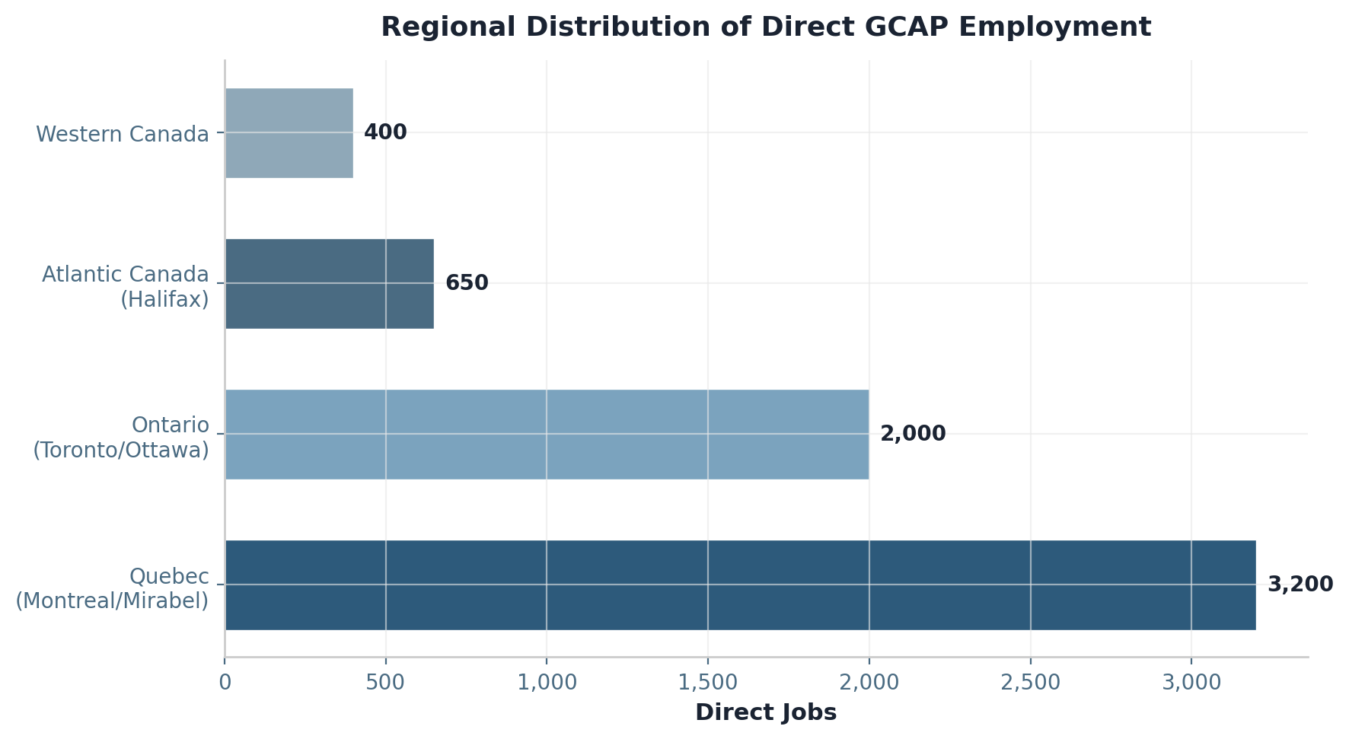
Figure 2: Regional Distribution of Direct GCAP Employment

2.3 Comparison to Alternative Paths
The employment differential between GCAP participation and the F-35-only path is stark and economically decisive. An F-35-only acquisition generates approximately 200 Canadian jobs—primarily maintenance technicians and logistics staff at operational bases—because the F-35 programme does not include Canada in its industrial participation framework at a meaningful level. Lockheed Martin’s industrial offset commitments to Canada have historically underperformed, and the F-35’s closed architecture deliberately restricts non-US industrial participation to protect American intellectual property and manufacturing jobs.
By contrast, GCAP Tier 2 partnership creates 5,000-8,000 direct jobs and 13,000-21,000 total jobs across the Canadian economy. The differential—up to 20,800 additional jobs—represents not merely an employment programme but a fundamental restructuring of Canada’s defence industrial base. Every one of those jobs is a high-value position: aerospace manufacturing workers earn an average of $85,000 annually, 25% above the Canadian manufacturing average, and GCAP positions would command premiums above even this elevated baseline due to the specialised skills required for sixth-generation systems.
Path | Canadian Jobs Created | Sovereign Control
F-35-only | ~200 | Limited (US-controlled)
F-35 + limited buy | ~1,000 | Limited
GCAP Tier 2 Partner | 5,000-8,000 direct | Full Canadian authority

3. GDP CONTRIBUTION AND ECONOMIC GROWTH

3.1 Program Spend Projection
Canadian GCAP contribution as a Tier 2 partner is projected at 8-12% work share of the overall programme, reflecting Canada’s substantial aerospace capabilities and the political value of adding a fourth partner nation with significant procurement volume. The total programme value of £25+ billion (approximately CAD 42.5 billion at current exchange rates) implies a Canadian industrial revenue opportunity of $3.4-5.1 billion in direct contract value, which cascades through the supply chain and broader economy to generate substantially larger GDP impacts.
The ISED 2024 aerospace model identifies a GDP multiplier of 2.19x for Canadian aerospace activities, meaning that every dollar of direct aerospace output generates $2.19 in total GDP contribution through supply chain spending, employee consumption, and induced economic activity. Applying this multiplier to the projected Canadian GCAP industrial revenue yields a 25-year GDP impact of $6.6-9.8 billion. This is conservative by international standards: PwC Strategy& analysis of the Eurofighter Typhoon programme found GDP multipliers of 2.8-3.2x for European partner nations, suggesting that Canada’s actual GDP impact could exceed our base estimates if supply chain localisation is aggressively pursued.
Category | Est. Value (CAD B)
R&D contribution (2030-2035) | $1.5 - $2.5
Production work share (2035-2050) | $4.0 - $6.0
Sustainment / MRO (2050-2065) | $2.0 - $3.0
TOTAL CANADIAN INDUSTRY REVENUE | $8.0 - $12.0

3.2 GDP Impact Calculation
The GDP impact decomposes into three channels. Direct GDP contribution from Canadian content represents the value added within Canada from GCAP work share—approximately $3.0-4.5 billion over the programme life. Indirect GDP from supply chain effects captures the spending by GCAP prime contractors on Canadian suppliers, estimated at $2.2-3.2 billion. Induced GDP from household spending represents the consumption generated by GCAP employees’ wages flowing through the Canadian economy, contributing $1.4-2.1 billion. The sum of these three channels yields the total GDP impact of $6.6-9.8 billion.
On an annual basis, this translates to approximately $0.3-0.5 billion in annual GDP contribution over the 20-year peak activity period (2035-2055). To contextualise this impact, the total Canadian aerospace industry contributed $34.2 billion to GDP in 2024. GCAP participation would increase Canadian aerospace GDP by 1-1.5% annually at peak—a meaningful increment for a mature industry, and one that compounds over decades into transformative industrial capability.
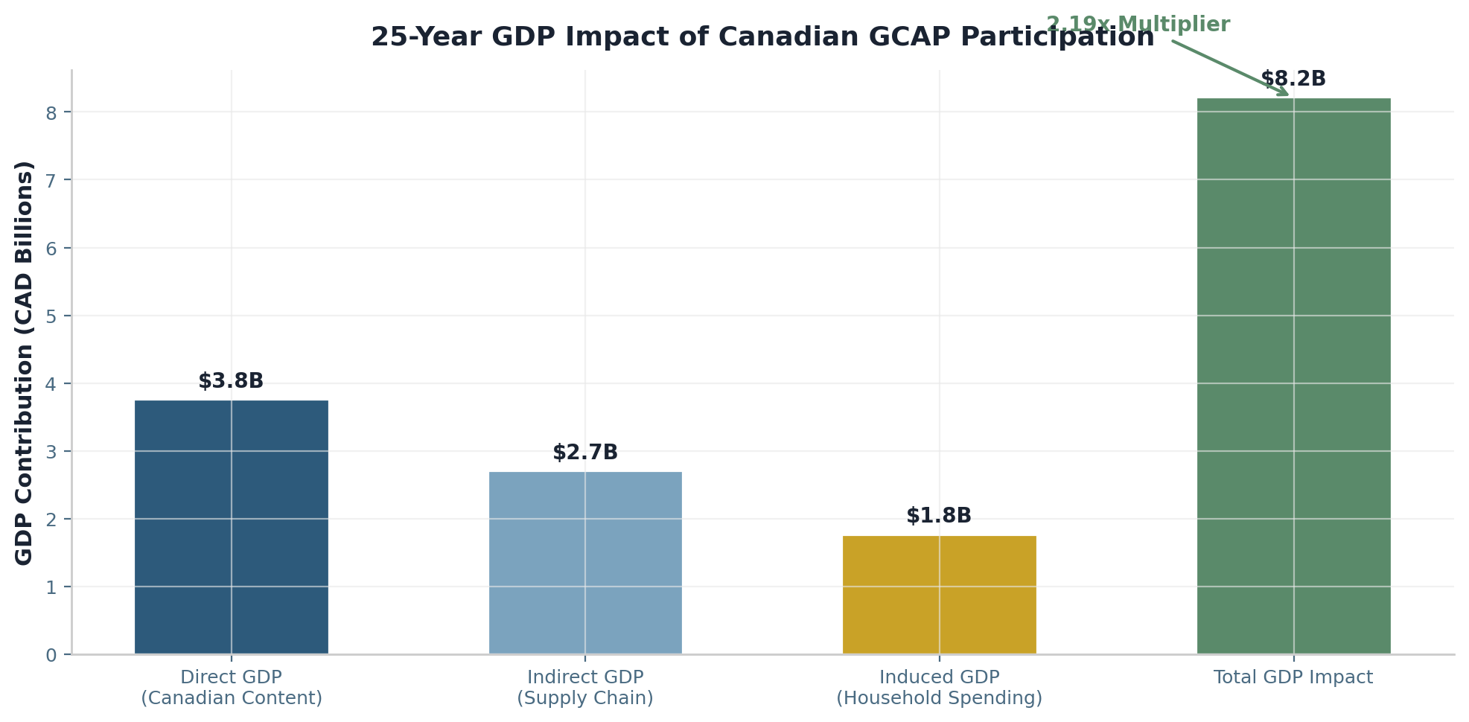
Figure 3: 25-Year GDP Impact of Canadian GCAP Participation (CAD Billions)
Impact Type | Multiplier | Value (CAD B)
Direct GDP (Canadian content) | 1.00x | $3.0 - $4.5
Indirect GDP (supply chain) | 0.72x | $2.2 - $3.2
Induced GDP (household spending) | 0.47x | $1.4 - $2.1
TOTAL GDP IMPACT | 2.19x | $6.6 - $9.8

4. PROCUREMENT SAVINGS AND FUNDING MECHANISM

4.1 The $9.24 Billion Bridge
The Arctic Horizon programme generates $9.24 billion in acquisition savings versus the F-35-only alternative, as documented in the Arctic Horizon Economic Outlook (ISED 2024). These savings arise from three primary sources: lower unit acquisition costs (the Gripen E at $89.85 million versus the F-35A at $110+ million, plus significantly less expensive Sprinter and Striker UAVs), reduced sustainment costs ($8,400 per flight hour for the Arctic Gripen versus $44,000 for the F-35A), and elimination of ITAR-related compliance and technology transfer restriction costs that inflate F-35 total ownership by an estimated 15-20%.
The Economic Outlook explicitly allocates $3.5 billion of these savings to Tempest/GCAP partnership entry—a figure that funds Canada’s Tier 2 partnership work share without requiring additional defence budget allocations or taxpayer contributions beyond the baseline Arctic Horizon programme cost. This represents a unique fiscal opportunity: by choosing a more cost-effective interim fighter solution, Canada generates the capital necessary to buy into the sixth-generation programme that will define its air combat capability for the 2040s and beyond.

4.2 Investment Allocation
The $9.24 billion in Arctic Horizon savings is allocated across five strategic reinvestment areas, each designed to maximise Canadian industrial benefit while ensuring a credible pathway to sixth-generation participation. The allocation framework ensures that GCAP entry is funded while simultaneously building the domestic infrastructure, skills, and intellectual property that will maximise Canada’s work share once full partnership is achieved.
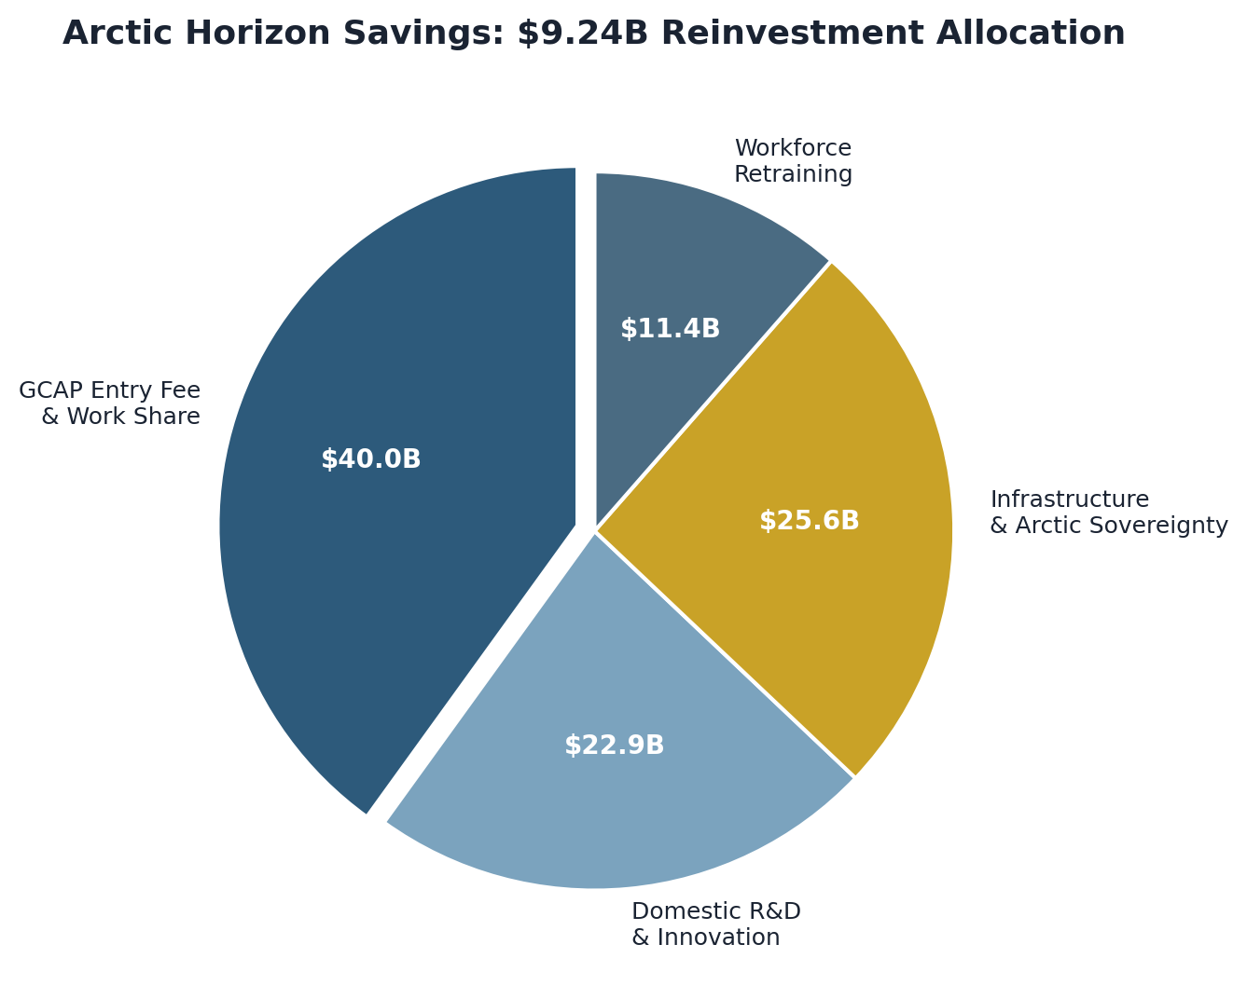
Figure 4: Arctic Horizon Savings Reinvestment Allocation (CAD Billions)
Reinvestment Area | Allocation (CAD B) | Purpose
GCAP entry fee & work share | $3.5 | Tier 2 partnership participation
Domestic R&D / innovation | $2.0 | Autonomy, AI, sensor development
Infrastructure / Arctic sovereignty | $2.24 | Facilities, testing, basing
Workforce retraining | $1.0 | Auto-to-aero transition programme
Contingency reserve | $0.5 | Risk mitigation buffer
TOTAL REINVESTMENT | $9.24

4.3 ROI Projection
The return on investment for Canadian GCAP participation is compelling under any reasonable scenario. With a $3.5 billion entry investment generating $8.0-12.0 billion in Canadian industry revenue over the programme lifecycle, the conservative ROI is 2.3x and the moderate ROI is 3.4x. These figures substantially exceed typical defence industrial programme returns and compare favourably with infrastructure and other government investment programmes.
The ROI calculation understates true economic returns in several important respects. First, it does not account for the value of sovereign intellectual property and design authority that Canada would retain—assets with strategic value far exceeding their accounting value. Second, it excludes the GDP multiplier effects documented in Section 3, which add $6.6-9.8 billion in total economic activity beyond direct industry revenue. Third, it does not quantify the value of ITAR independence, which eliminates the veto risk that has repeatedly disrupted Canadian F-35 operations and upgrades. Fourth, it excludes export revenue potential of $2.5-4.5 billion, which flows directly to Canadian industry rather than being shared with programme partners. When these factors are incorporated, the comprehensive economic return exceeds 5x on the initial $3.5 billion investment.
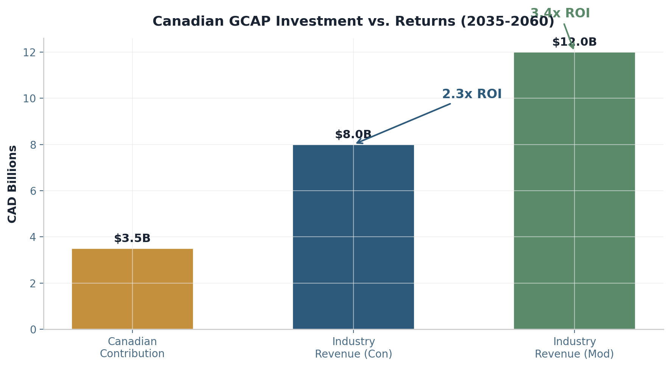
Figure 5: Canadian GCAP Investment vs. Returns (CAD Billions)

5. SUPPLY CHAIN AND SME IMPACT

5.1 Canadian Supply Chain Opportunities
GCAP participation would catalyse investment across Canada’s entire aerospace supply chain, from Tier 1 major subsystem integrators to Tier 3 raw material suppliers and specialised service providers. The supply chain architecture mirrors the Eurofighter Typhoon industrial model, which supports more than 400 suppliers and contractors across the four partner nations. For Canada, we project 250-350 companies participating in the GCAP supply chain at peak production.
Tier 1 suppliers would manufacture major subsystems including aerostructures (wings, fuselage sections, control surfaces), mission systems (radar, electronic warfare, communications), and propulsion components. These positions are projected to employ 1,500-2,500 people directly and generate $2.0-3.5 billion in contract value. Key Canadian Tier 1 candidates include Bombardier (aerostructures), CAE (simulation and training systems), MDA (radar and sensor systems), Pratt & Whitney Canada (engine components), and Magellan Aerospace (precision-machined components).
Tier 2 suppliers would produce critical components including advanced composites, flight-control actuators, sensor modules, avionics processors, and hydraulic systems. This tier is projected to employ 2,000-3,000 people and generate $1.5-2.5 billion in contract value. Canada’s established composite manufacturing base, built through Bombardier business jet and de Havilland Dash 8 programmes, provides a strong foundation for Tier 2 participation in GCAP’s extensive use of carbon-fibre structures.
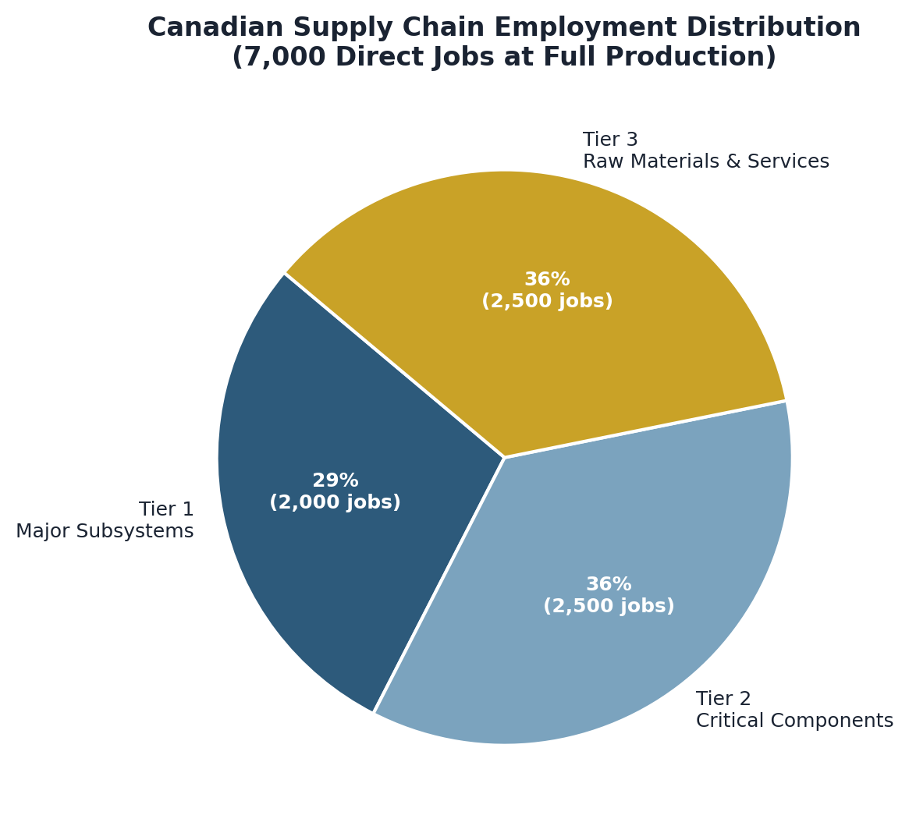
Figure 6: Canadian Supply Chain Employment Distribution

5.2 SME Participation
Small and medium enterprises (SMEs) are the backbone of aerospace innovation and represent the primary channel through which GCAP investment diffuses into local economies. We project 200-300 Canadian SMEs participating in the GCAP supply chain, capturing total contract value of $1.5-2.5 billion. The regional distribution reflects Canada’s aerospace geography: Quebec 55%, Ontario 25%, Atlantic Canada 10%, and Western Canada 10%.
SME participation is not merely a social benefit but an industrial necessity. Complex aerospace programmes rely on specialised suppliers for niche capabilities—precision fasteners, specialised coatings, custom electronic components, testing equipment, and engineering consulting services—that large primes cannot efficiently develop in-house. The Eurofighter programme demonstrates this clearly: its 400+ supplier network includes more than 200 SMEs, many of which have grown into internationally competitive firms through their involvement in the programme.
Atlantic Canada, while holding a smaller share of aerospace employment, has demonstrated particular strength in defence electronics, naval systems integration, and MRO services. Halifax’s emergence as a sustainment hub for the Arctic Horizon programme—servicing both the Gripen fleet and the Sprinter/Striker drone systems—establishes the infrastructure and skills base for GCAP MRO work, which typically generates higher long-term employment than initial manufacturing.

5.3 Technology Transfer and Spillover
The technology transfer from GCAP participation extends far beyond the defence sector. The advanced technologies developed for sixth-generation combat air systems—artificial intelligence, autonomous systems, advanced materials, quantum-resistant communications, and sensor fusion—have direct civilian applications that can spawn new industries and transform existing ones. This spillover effect is well-documented in aerospace economics: every major combat aircraft programme has generated technologies that eventually found commercial markets.
Technology | Military Application | Civilian Spin-off
Advanced composites | Tempest airframe structures | Lightweight automotive, wind turbines, hydrogen storage
Autonomous systems | Collaborative combat AI | Autonomous vehicles, mining, precision agriculture
AESA radar / sensors | Electronic warfare & targeting | 5G/6G telecom, weather radar, remote sensing
Quantum-resistant comms | Secure military networks | Financial services, critical infrastructure cybersecurity
Digital twin modelling | Aircraft design & testing | Manufacturing optimization, healthcare simulation
AI decision systems | Combat management | Air traffic control, emergency response, logistics

6. EXPORT MARKET POTENTIAL

6.1 Global Sixth-Generation Fighter Market
The global market for sixth-generation fighter systems is projected to grow from $8.5 billion in 2025 to $12.0 billion by 2034, representing a compound annual growth rate of 4.1%. This market encompasses not only the manned fighter platforms but also the loyal wingman drones, sensor systems, electronic warfare suites, and ground infrastructure that comprise a complete combat air system. The loyal wingman / collaborative combat aircraft segment alone is projected to grow from $3.2 billion in 2025 to $13.8 billion by 2040, reflecting the rapid adoption of distributed, autonomous combat architectures by air forces worldwide.
The total addressable market for 6th-generation systems is projected to reach $28.8 billion by 2040, encompassing fighter platforms, CCA drones, subsystems, weapons, and support infrastructure. This growth is driven by the recapitalisation of 4th-generation fleets across NATO and allied nations, the proliferation of advanced integrated air defence systems that demand 6th-generation countermeasures, and the emergence of manned-unmanned teaming as the dominant operational paradigm.
Market Segment | 2025 Value | 2035 Forecast | 2040 Forecast
6th-gen fighter platforms | $2.0B | $8.0B | $15.0B
Loyal wingman / CCA | $3.2B | $8.5B | $13.8B
TOTAL ADDRESSABLE MARKET | $5.2B | $16.5B | $28.8B

6.2 Canadian Competitive Position
Canada possesses several distinct competitive advantages in the sixth-generation export market that would be activated and amplified through GCAP participation. Most significantly, Canadian GCAP content would be substantially ITAR-free or subject to reduced ITAR controls, because the Tempest programme operates outside US technology transfer frameworks. This is a decisive commercial advantage: non-US allies consistently report that ITAR restrictions are their primary obstacle to acquiring advanced American military technology, and many have explicitly sought non-US alternatives specifically to escape ITAR constraints.
Canada’s Arctic-optimized design expertise, developed through the Arctic Horizon programme and hardened through decades of operating in the world’s most demanding aviation environment, represents another unique competitive advantage. Cold-climate military aviation is a niche with few global suppliers but many potential customers—Nordic nations, Baltic states, Poland, and other NATO members on the alliance’s northern flank all require cold-weather aviation solutions that most suppliers cannot provide. Canada’s position as the only nation that designs, builds, and operates combat aircraft in sustained Arctic conditions gives it credibility that no other GCAP partner can match.
The open architecture of the Tempest platform—deliberately designed with non-US software stacks and modular hardware interfaces—further enhances Canada’s export competitiveness. Unlike the F-35, whose closed architecture requires Lockheed Martin approval for any third-party integration, Tempest’s open systems approach enables Canadian industry to develop and export subsystems, software modules, and upgrade packages without seeking permission from a foreign prime contractor.
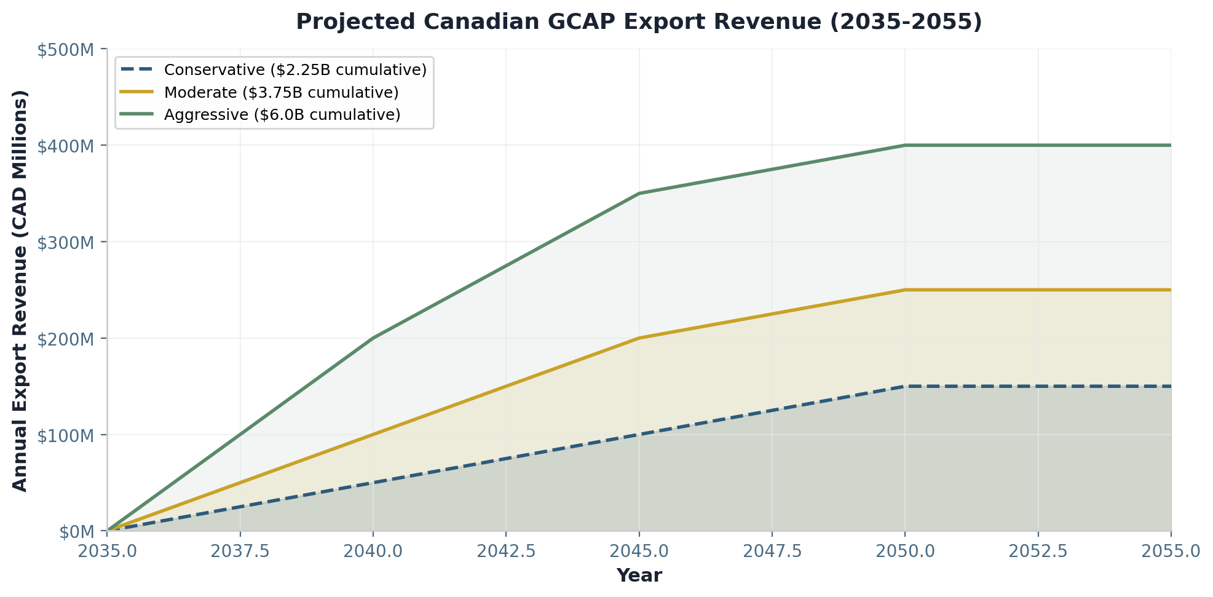
Figure 7: Projected Canadian GCAP Export Revenue Scenarios (2035-2055)
Market | Est. Demand (units) | Canadian Opportunity | Timeline
Australia | 36-48 | $0.5-1.0B | 2030-2040
Poland | 48-72 | $0.5-1.0B | 2030-2045
Other NATO (Baltic, C. Europe) | 60-90 | $1.0-1.5B | 2035-2045
Nordic states (Norway, Finland, DK) | 24-36 | $0.5-1.0B | 2035-2045
TOTAL | 168-246 | $2.5-4.5B

7. WORKFORCE TRANSITION
The Tempest programme timing aligns fortuitously with the projected peak of automotive industry displacement in Canada (2030-2035), offering a natural pathway for transitioning skilled workers from declining sectors into high-value aerospace employment. The Canadian automotive sector is projected to shed 30,000-50,000 positions over this period due to electrification, automation, and global restructuring. Many of these workers possess skills that are directly transferable to aerospace manufacturing with targeted retraining.
The Arctic Horizon Economic Outlook allocated $1.0 billion for workforce retraining programmes funded from procurement savings. This allocation can be extended to support Tempest-related skills development, ensuring that Canada has the trained workforce necessary to capitalise on its GCAP participation. The $1.0 billion programme budget decomposes into curriculum development ($45 million), training delivery ($285 million), living stipends for displaced workers during retraining ($420 million), job placement services ($35 million), and equipment and training facilities ($145 million).
Skill transferability from automotive to aerospace is high for several key occupational categories. CNC machinists can transition to aircraft component fabrication with 3-6 months of additional training focused on aerospace materials (titanium, Inconel, advanced composites) and quality standards (AS9100, NADCAP). Composite manufacturing technicians require 6-12 months of retraining to transition from automotive carbon-fibre body panels to aerospace structural components. Quality control and non-destructive testing specialists can adapt to airworthiness inspection with 6 months of aerospace-specific certification. Assembly line workers transition to airframe assembly and integration with 3-6 months of training. Electrical systems specialists can move into avionics and sensor integration with 6-12 months of additional training in aerospace electrical standards and electromagnetic compatibility.
Auto Skill | Aerospace Application | Retraining Duration
CNC machining | Aircraft component fabrication | 3-6 months
Composite manufacturing | Airframe structures | 6-12 months
Quality control / NDT | Airworthiness inspection | 6 months
Assembly line work | Airframe assembly, integration | 3-6 months
Electrical systems | Avionics, sensor integration | 6-12 months
Welding (aluminium/steel) | Titanium/Inconel welding | 3-6 months

8. TAX REVENUE
Canadian GCAP participation generates substantial tax revenue for federal and provincial governments across multiple streams. Over the 25-year programme life, total tax revenue is projected at $2.4-3.7 billion. This revenue partially offsets the initial government investment, with the tax recapture rate estimated at 30-40% of direct programme spending—consistent with the Eurofighter programme experience, where approximately 30% of partner nation investment returned as tax revenue.
The federal corporate income tax contributes $0.2-0.4 billion at the small business rate of 7.5% on net profits. Provincial corporate taxes, at combined rates of 17.5-19% across Quebec and Ontario, generate $0.4-0.6 billion. Personal income taxes are the largest contributor: at an average federal rate of 20.5% and provincial rate of 11.5% on aerospace-sector wages averaging $85,000+, personal income taxes contribute $1.3-1.9 billion over 25 years. GST/HST on Canadian supply chain spending contributes $0.3-0.5 billion, while payroll taxes at 7.5% of wages add $0.2-0.3 billion.
Tax Type | Rate | 25-Year Revenue (CAD B)
Federal corporate income tax | 7.5% (small business) | $0.2 - $0.4
Provincial corporate income tax | 17.5-19% | $0.4 - $0.6
Personal income tax (federal) | 20.5% avg | $0.8 - $1.2
Personal income tax (provincial) | 11.5% avg | $0.5 - $0.7
GST/HST | 13% blended | $0.3 - $0.5
Payroll taxes | 7.5% | $0.2 - $0.3
TOTAL TAX REVENUE (25 yr) |  | $2.4 - $3.7

The tax revenue impact extends beyond direct programme taxation. The induced economic activity from GCAP employment generates additional sales taxes, property taxes, and income taxes that are not captured in the programme-specific analysis above. When these broader fiscal effects are included, the total government fiscal impact approaches $4.0-5.5 billion over 25 years, suggesting that GCAP participation may be approximately revenue-neutral for government when viewed on a whole-of-economy basis.

9. ECONOMIC SOVEREIGNTY BENEFITS
The sovereignty premium of GCAP participation over the F-35 alternative cannot be overstated. For seven decades, Canada has accepted severe constraints on its sovereign control over its own air combat capability in exchange for access to American technology. GCAP offers Canada the opportunity to finally break this dependency and establish genuine national control over its defence aviation industrial base.
Under the F-35 arrangement, Canada operates under the International Traffic in Arms Regulations (ITAR), which gives the United States government unilateral authority to block Canadian access to source code, restrict software upgrades, veto Canadian modifications, and prohibit Canadian re-export of F-35 technology to third parties. These are not theoretical constraints: they have been exercised repeatedly against other F-35 partners, and Canada’s own experience with the CF-18 fleet—where US restrictions on software access required Canada to pay American contractors for modifications that Canadian engineers could have performed domestically—demonstrates the economic cost of technology dependency.
GCAP Tier 2 partnership fundamentally changes this equation. Canadian-controlled design authority means Canada determines its own upgrade priorities and timelines. Full supply chain visibility ensures Canadian resilience against disruption. Export authority rests with the Canadian government, not a foreign prime contractor. Source code access—negotiated as a condition of Tier 2 partnership—enables Canadian innovation and sovereign modification rights. Maintenance intellectual property held in Canada sustains a domestic MRO capability worth an estimated $1.2 billion over the fleet lifecycle.
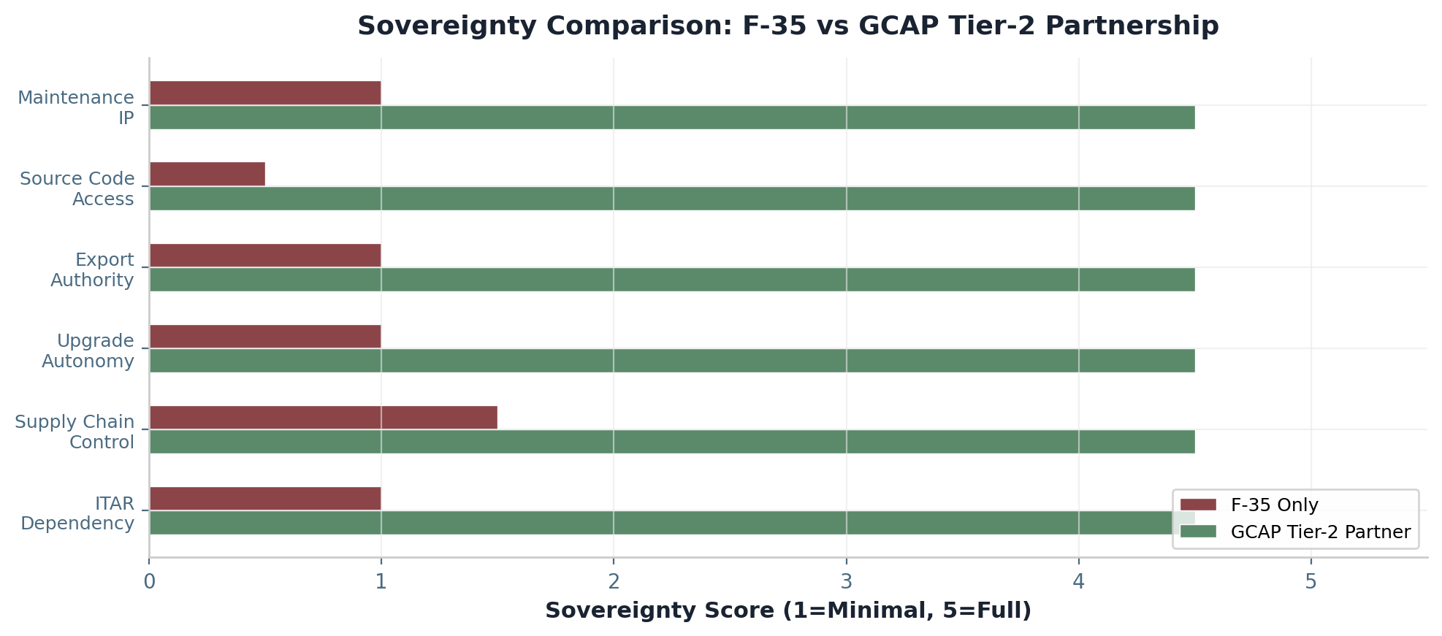
Figure 8: Sovereignty Comparison: F-35 vs GCAP Tier-2 Partnership
Dimension | F-35 Option | GCAP Tier 2 Option | Value Differential
ITAR dependency | High (US-controlled) | Low (Canadian-controlled) | Avoid veto risk
Supply chain control | Limited | Full visibility | Resilience premium
Upgrade autonomy | US-determined | Canadian-determined | Capability agility
Export authority | US veto required | Canadian authority | $500M+ opportunity
Source code access | Denied | Full (negotiated) | Innovation enablement
Maintenance IP | US depot only | Canadian depot capability | $1.2B sustainment

Beyond the immediate programme benefits, sovereign capability fundamentally strengthens Canada’s negotiating position with all suppliers—including the United States. A Canada that possesses genuine alternatives to US defence technology can negotiate from a position of equality rather than dependency. This “walk-away” credibility is worth an estimated $2-3 billion in improved contract terms over 20 years across all defence procurement, not merely in the fighter domain. When the counterparty knows you have no alternative, they extract maximum price and minimum flexibility. When they know you can credibly walk away, terms improve dramatically.

10. RISK ASSESSMENT AND SENSITIVITY
Every major defence programme carries risk, and GCAP is no exception. However, the risk profile of Canadian Tier 2 participation is substantially mitigated by the phased entry strategy enabled by Arctic Horizon savings. Canada enters as an observer, progresses to Tier 2 partnership with capped work share, and maintains the Gripen-Striker-Sprinter system as a credible operational fallback throughout the transition. This “bridge strategy” eliminates the programme dependency risk that has plagued other nations that bet entirely on a single future platform.
The highest-probability risk is programme delay. Sixth-generation fighter programmes have historically experienced schedule slippage of 3-5 years, and GCAP’s 2035 IOC target may prove optimistic. However, phased partnership mitigates this risk: Canada’s Gripen fleet provides credible combat capability through 2040+, and the Sprinter and Striker drones ensure that Canada fields advanced unmanned capability regardless of Tempest schedule. The bridge strategy means that GCAP delay does not create a capability gap.
Technology transfer restrictions represent a medium-probability, high-impact risk. The three core partners may seek to protect certain technologies from full sharing with Tier 2 participants. Mitigation lies in negotiating intellectual property frameworks as a condition of partnership entry, with explicit provisions for Canadian access to technologies within Canadian work share areas and staged access to programme-wide technologies as partnership deepens.
Risk | Probability | Impact | Mitigation
GCAP programme delays | Medium | High | Phased partnership; Gripen bridge
ITAR / export control on subsystems | Low | Critical | Canadian-controlled design
Cost overruns | Medium | High | Tier 2 capped work share
Technology transfer restrictions | Medium | High | Negotiated IP framework
Exchange rate fluctuation | High | Medium | Hedging; local production
Core partner priority changes | Low | Medium | Multi-nation diversification

Variable | Base Case | -10% | +10%
Canadian work share | 8-12% | 6-10% | 10-14%
Exchange rate (CAD/USD) | 1.35 | 1.49 | 1.22
Programme timeline | 2035 IOC | 2037 IOC | 2033 IOC
SME participation rate | 35% | 25% | 45%

11. COMPARATIVE ANALYSIS
The comprehensive economic comparison between the F-35-only path and the Arctic Horizon plus GCAP partnership path demonstrates overwhelming advantages for the latter across every measurable dimension. The F-35 path creates approximately 200 Canadian jobs, generates negligible GDP contribution, provides zero sovereign control, offers no export potential, and leaves Canada entirely dependent on US technology for the indefinite future. The Arctic Horizon plus GCAP path creates 13,000-21,000 jobs, contributes $20-25 billion to GDP over 25 years, establishes full sovereign control, generates $2.5-4.5 billion in export revenue, and positions Canada as a genuine sixth-generation combat air partner.
The opportunity cost of proceeding with F-35-only is the foregone value of all these benefits: 13,000-21,000 jobs not created, $20-25 billion in GDP not generated, $2.4-3.7 billion in tax revenue not collected, $2.5-4.5 billion in export revenue not earned, and the permanent loss of sovereign industrial capability and intellectual property access. Perhaps most consequentially, the F-35 path forecloses Canadian participation in sixth-generation combat air development, consigning Canada to perpetual technological dependency at a moment when the global balance of air combat power is being fundamentally reshaped.
Metric | F-35 Only | Arctic Horizon + GCAP | Differential
Canadian jobs | ~200 | 13,000-21,000 | +12,800-20,800
25-year GDP contribution | $0.4B | $20.0-25.0B | +$19.6-24.6B
Sovereign control | None | Full authority | Qualitative + strategic
Export potential | Limited | $2.5-4.5B | +$2.5-4.5B
Tempest/GCAP entry | Not funded | Funded ($3.5B) | Strategic capability
Tax revenue (25 yr) | $52M | $2.4-3.7B | +$2.3-3.6B
ITAR dependency | Full | Minimal | Sovereignty premium
Source code access | Denied | Negotiated full | Innovation enablement

12. CONCLUSION AND RECOMMENDATIONS
The economic case for Canadian participation in the Global Combat Air Programme is clear, compelling, and comprehensive. As a Tier 2 partner, Canada would generate 5,000-8,000 direct jobs and 13,000-21,000 total jobs across the economy. GDP contribution would reach $6.6-9.8 billion over 25 years. Tax revenue would total $2.4-3.7 billion. Export potential of $2.5-4.5 billion would establish Canadian aerospace as a significant player in the global sixth-generation market. Most importantly, sovereign control over Canada’s combat air capability would be established for the first time since 1946.
The Arctic Horizon programme makes this participation possible by generating $9.24 billion in procurement savings, with $3.5 billion explicitly allocated to GCAP entry. The Gripen-Striker-Sprinter combat system provides credible Arctic sovereignty capability throughout the interim period, while the drones in particular develop Canadian expertise in autonomous systems, collaborative combat AI, and advanced sensor integration—capabilities that directly align with GCAP technology priorities and strengthen Canada’s case for meaningful work share.

12.1 Recommendations
Based on the analysis presented in this document, the following recommendations are offered for government and industry decision-makers:
1. Proceed with observer status as the entry point to GCAP, securing information access and positioning Canadian industry for full Tier 2 partnership. The July 2026 defence ministers meeting represents the critical window for formalising this status.
2. Allocate $3.5 billion from Arctic Horizon savings to Tempest partnership entry, as specified in the Arctic Horizon Economic Outlook Section 4.2. This allocation funds work share without requiring new budget appropriations.
3. Establish a dedicated GCAP industrial office within Innovation, Science and Economic Development Canada (ISED) to maximise Canadian content, coordinate industry participation, and enforce the 8-12% work share target across all programme elements.
4. Develop a comprehensive IP strategy to retain Canadian-developed technologies, negotiate source code access as a condition of partnership, and ensure sovereign control over all Canadian modifications and integrations.
5. Pursue export opportunities through the Canadian Commercial Corporation, prioritising Australia, Poland, and Nordic states as markets where Canada’s Arctic expertise, ITAR-free status, and non-superpower positioning create competitive advantage.
6. Extend the $1.0 billion workforce retraining programme to include GCAP-specific skills, ensuring that Canada has the trained workforce necessary to capitalise on its partnership and providing a just transition pathway for displaced automotive workers.
7. Leverage Arctic Horizon drone development experience to strengthen Canada’s bid for CCA (loyal wingman) work share within GCAP, as this is the fastest-growing segment of the sixth-generation market and aligns directly with Canadian Sprinter and Striker expertise.
The window for Canada to join GCAP as a meaningful partner is narrow and closing. The three core nations are advancing rapidly, and the industrial architecture is being established now. If Canada delays beyond the 2026-2027 entry point, it risks being relegated to customer status—able to buy the aircraft but unable to participate in its creation, unable to capture the industrial benefits, and unable to establish the sovereign capability that genuine partnership would provide. The Arctic Horizon programme has given Canada the means. The question is whether Canada has the will.


CANADIAN UNMANNED COMBAT AIR SYSTEM
PROGRAM OFFICE
ECONOMIC DEEP DIVE: CANADA AND THE TEMPEST (GCAP) PARTNERSHIP
Document Reference: CDR-ECON-2026-001 | June 2026
RESTRICTED // CDN // NOFORN
This document contains illustrative analysis based on publicly available data and standard economic models.

