UNCONTROLLED CONCEPT BASELINE - NOT FOR FLIGHT RELEASE

The Optimal Sprinter Technical Specifications v6.1
Conceptual CDR 70-80% engineering baseline
Version 6.1 | 2026-09-06
A clean engineering baseline for a Mach 1.6 Opening Doors Sprinter.
Prepared from project documents, public technical sources, and explicit engineering closure logic.
Contents

Document basis and use 3
Executive baseline summary 4
1. Role, doctrine, and design drivers 5
1.1 Falcon benchmark and scale boundary 6
1.2 Design drivers and selected trades 7
2. Requirements hierarchy 8
2.1 Top-level requirements and closure status 9
2.2 Controlled geometry 10
2.3 Mass properties and center of gravity 11
2.4 Internal arrangement and volumes 12
3. Aerodynamic architecture 13
3.1 Drag polar and lift characteristics 14
3.2 Mach 1.60 performance closure 15
3.3 Stability, control, and handling 16
4. Propulsion selection 17
4.1 Installed propulsion budget 18
4.2 Inlet and duct system 19
4.3 Exhaust and infrared integration 20
5. Mission design and reference sortie 21
5.1 Fuel closure 22
5.2 Field performance and flight envelope 23
6. Structures and materials 24
6.1 Loads, life, and structural margins 25
6.2 Circular materials strategy 26
6.3 Material qualification and boundaries 27
6.4 Manufacturing and assembly flow 28
7. Thermal management 29
7.1 Fuel system 30
7.2 Electrical power architecture 31
8. Flight controls 32
8.1 Autonomy and human command 33
8.2 Datalinks and navigation 34
9. Signature management 35
9.1 Infrared, visual, acoustic, and vulnerability 36
10. Mission systems 37
10.1 Payload bay design 38
10.2 Payload modules and store envelope 39
11. Reliability and safety 40
11.1 Maintainability and Arctic operation 41
12. Gripen and Striker integration 42
12.1 Fleet employment and sortie generation 43
13. Verification approach 44
13.1 Verification matrix 45
13.2 Pending validation register 46
13.3 Technical risks and closure path 47
14. Controlled baseline specification 48
14.1 Interface specification 49
14.2 Acceptance criteria 50
15. Annex A: calculation basis 51
16. Annex B: source basis and data limits 52
17. Annex C: acronyms and abbreviations 53
18. Annex D: compliance and design record 54

Document basis and use
This document establishes a clean Sprinter v6.1 point design for engineering discussion and verification planning. It uses the mature Rev 2.x architecture as the point of departure, anchors the propulsion basis on public Safran M88 data, excludes export-controlled US articles from the aircraft supply chain, and integrates the Opening Doors doctrine without carrying forward historical narrative material.
The baseline uses public data, project documents, and transparent engineering estimates. It is not a flight release, procurement specification, weapons-clearance document, or certified radar-signature statement. Values marked PENDING VALIDATION require the stated test, OEM data release, or qualification action before use in a binding design decision.
The design rule is simple: closure first, cost second, growth third. A feature remains only when it supports the intended Sprinter role and closes at the stated maturity. Items that resist closure enter the pending-validation list instead of receiving unsupported certainty.
Baseline identity: a recoverable, single-M88, Mach 1.6 door-opening aircraft optimized for rapid penetration support rather than persistence or all-aspect survivability.
- Design maturity target: CDR 70-80%, with subsystem decks still dependent on OEM and test data.
- Design role: frontal-aspect low-observable, high-speed, attritable collaborative combat aircraft.
- Human authority: Gripen E retains target assignment and weapons-release authority.

Executive baseline summary
Sprinter v6.1 closes around a 3,800 kg maximum takeoff mass, 2,530 kg operating empty mass, 250 kg internal payload, and 990 kg usable fuel. A 20.0 m² cropped-delta wing and one afterburning Safran M88-2 engine provide the required Mach 1.60 dash for five minutes at 40,000-45,000 ft, with the reference 45,000 ft dash closing on dry power. The 3.05 m internal bay closes the in-service IRIS-T short-range air-to-air missile as the validated self-defense fit. The public M88-2 rating is 50/75 kN, dry/augmented, and 897 kg dry mass.
The point design accepts the real 897 kg M88 with an installed propulsion group of 1,090 kg. This drives the larger empty mass, yet preserves a useful 26.1% usable fuel fraction and a 2.01 static thrust-to-weight ratio at maximum takeoff mass. The resulting aircraft keeps the Falcon-inspired sprint philosophy while accepting the larger scale needed for an ITAR-free propulsion system, a 250 kg payload, an IRIS-T-length bay, and runway operation.
Most major balances close analytically: mass, wing loading, installed thrust margin, fuel mission, electrical load, dash thermal load, rejected-takeoff brake energy, field length, and internal-store envelope. The principal open items are the OEM installed-engine deck, inlet CFD and wind-tunnel data, radar-signature measurement, store-separation testing, flight-control law validation, and lot-level qualification for recycled feedstocks.
Parameter | Baseline | Closure basis
Maximum takeoff mass | 3,800 kg | Mass budget and reserve
Operating empty mass | 2,530 kg | Bottom-up group budget
Usable fuel / retained fuel | 990 kg / 30 kg | Mission and tank volume
Internal payload | 250 kg | Bay, rack, and CG envelope
Bay / air-to-air fit | 3.05 m / 1 × IRIS-T | Store envelope closure
Dash condition | Mach 1.60, 5 min, 40-45 kft | Drag and analytic engine deck
Wing / span / length | 20.0 m² / 7.90 m / 11.5 m | Geometry closure
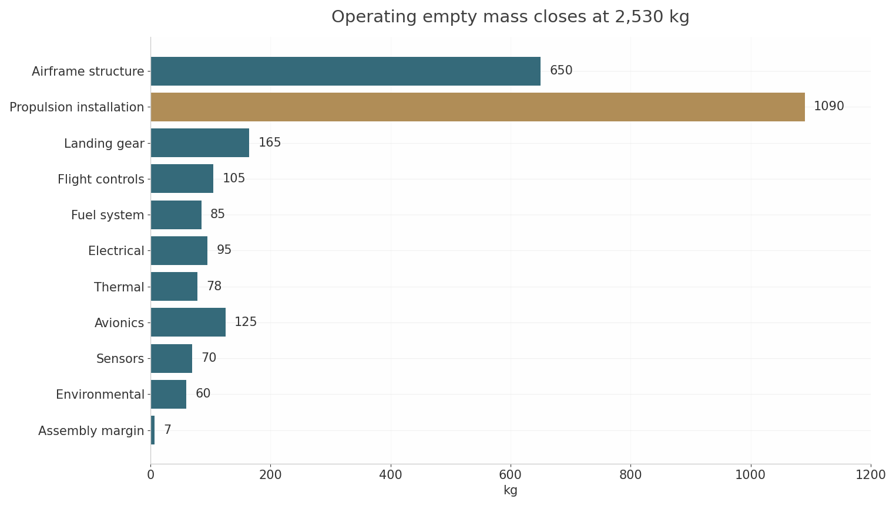
Figure 1. Operating empty mass budget.

1. Role, doctrine, and design drivers
Sprinter is the fast, expendable-tolerant element of the Opening Doors concept. Its task is to force defensive systems to radiate, maneuver, allocate interceptors, and expend missiles at a time and place chosen by the Gripen-led package. It does not replace Striker. It creates the tactical opening that Striker then exploits with more persistent precision strike and electronic-warfare effects.
The operational sequence begins with Gripen-led suppression and electronic preparation. Sprinters then enter on divergent axes at high speed, present credible frontal targets, collect emitter data, and create engagement geometry that the defense cannot ignore. Striker follows through the corridor, delivers heavier effects, and covers egress. Gripen E retains command authority and conducts heavier follow-on attacks.
This role drives a specific set of engineering choices: high dash speed, frontal signature discipline, enough fuel for a meaningful penetration leg, a modular internal bay sized around the in-service IRIS-T, an ITAR-free supply chain anchored in Canadian and non-US NATO suppliers, strong electrical power for EW payloads, high-sortie maintainability, and production simplicity. Persistence, rear-sector signature perfection, heavy air-to-air armament, and exquisite all-weather sensing receive lower priority.
Design intent: Sprinter opens the corridor; Striker exploits it; Gripen commands and delivers heavier effects.
- Primary missions: emitter triggering, ESM mapping, cooperative geolocation, decoy presentation, stand-in jamming, high-speed ISR snapshot, and limited SEAD/DEAD effects.
- Secondary missions: counter-cruise-missile barrier support, short-range air-to-air self-defense with internal IRIS-T, post-strike reconnaissance, communications relay, and withdrawal screening.
- Excluded missions: autonomous weapons release, long-endurance loiter, all-aspect stealth penetration, and internal carriage of weapons longer than 3.05 m.

1.1 Falcon benchmark and scale boundary
The Canadian Falcon provides the mission philosophy, not the dimensions. Its public specification lists Mach 1.6, 10 km maximum altitude, 50 kg payload, and 450 kg maximum takeoff mass, with containerized launch and parachute recovery. Those values describe a sub-scale target and attritable multirole UAV. Sprinter needs roughly five times the payload, a runway-independent-but-runway-capable support model, higher altitude, and enough fuel for a 500 nm class sortie.
A direct scale-up of Falcon fails because propulsion, inlet pressure recovery, structural volume, landing loads, thermal mass, and mission-system power do not scale linearly. Sprinter therefore retains Falcon’s sprint-and-attritability logic while adopting a mature low-bypass afterburning turbofan and a more robust airframe.
Ghost Bat provides the manufacturing and collaborative-aircraft analogue for Striker, not for Sprinter. Boeing’s public roadmap now lists 12,000 lb maximum takeoff weight, more than 4,500 lb useful load, a 25% larger wing, BLOS communications, and internal AMRAAM or SDB carriage. Sprinter deliberately remains smaller, faster, cheaper, and less persistent.
Benchmark | Useful lesson | Boundary for Sprinter
Falcon | Mach 1.6 sprint, attritable design logic, modular payload | 450 kg scale and 50 kg payload do not meet mission needs
MQ-28 | Composite manufacturing, modular nose, collaborative control | High subsonic class and larger payload class fit Striker better
Rev 2.x Sprinter | 18 m² class geometry, 250 kg bay, fixed DSI concept | Engine mass and installed deck required correction
Striker | M88 commonality and doctrine fit | Striker optimizes persistence and all-aspect survivability

1.2 Design drivers and selected trades
The highest-leverage trade is propulsion sovereignty. The rejected F125 alternative closed thrust but carried full US export-control exposure on the single engine. The Safran M88-2 closes thrust with a published 50/75 kN dry/augmented rating, 897 kg mass, 65 kg/s airflow, and a deep in-service record on the Rafale across French and export operators. The aircraft therefore grows by about 350 kg rather than carrying supply-chain veto risk on its single engine.
The second trade is signature versus persistence. Sprinter controls frontal RF signature, infrared contrast, and emissions during the opening phase. It accepts a conventional rear quadrant and a finite dash rather than paying for the deeper structure, cooling, and material burden of all-aspect survivability.
The third trade is payload flexibility versus store length. The 3.05 m bay supports SmartGlider Light-class compact glide weapons, one internal IRIS-T short-range air-to-air missile, EW pallets, and compact decoy modules. AMRAAM-class length still does not close; the baseline assigns long-range air-to-air weapons to Gripen or Striker. IRIS-T closes the air-to-air requirement with a mature, in-service weapon that already flies on Gripen E: 2.936 m length, 127 mm diameter, approximately 25 km range, and Mach 3 speed.
- Selected: single non-US NATO engine, fixed DSI inlets, frontal LO, internal bay, runway operation, modular EW, recoverable airframe.
- Rejected: high-bypass business-jet engine, twin-engine installation, ITAR-controlled propulsion, persistent loiter optimization, all-aspect LO requirement, and 3.60 m AMRAAM-length internal bay.
- Growth path: engine-pool commonality with Striker, optional SATCOM, alternate store ejector, and higher-rate thermoplastic secondary structure.

2. Requirements hierarchy
The requirements hierarchy separates mission needs, vehicle performance, subsystem functions, and validation evidence. A requirement closes only when the arithmetic, vendor data, interface budget, and environmental envelope align. Analysis remains labeled analysis; vendor data remain vendor data; test data remain test data.
Threshold values define the minimum useful Sprinter. Objective values define the preferred growth point. No threshold depends on an unproven radar cross-section value, classified engine deck, unavailable weapon, or an unqualified recycled material lot.
The resulting hierarchy is intentionally narrower than earlier concept papers. It prioritizes the door-opening sortie and allows Striker to carry the heavier strike and persistence burden.
 | Requirement discipline: an item that does not close moves to the pending-validation list without destabilizing the point design.
Level |  | Requirement set | Decision authority
Mission |  | Opening Doors sortie, corridor creation, coordinated egress | Operational sponsor
Vehicle |  | Mach 1.60 dash, 250 kg payload, 3,800 kg MTOW, runway operation | Chief engineer
Subsystem |  | M88 installation, DSI inlet, 45 kVA power, 42 kW heat rejection | Subsystem leads
Component |  | Qualified materials, actuators, racks, doors, antennas, connectors | Design owners
Evidence |  | Calculation, analysis, analogue, vendor datum, ground test, flight test | Verification lead

2.1 Top-level requirements and closure status
The table below is the controlling requirement summary for v6.1. Closure status uses the strongest evidence currently available. PENDING VALIDATION identifies a credible but not yet proven item; it does not mark the entire baseline as infeasible.
The most important closure is Mach 1.60. With a 20.0 m² wing, 3,450 kg representative dash mass, and M88 augmented thrust, analytic installed thrust exceeds drag by more than 100% at the 40,000 ft worst-case dash point, and analytic dry thrust alone exceeds drag at 45,000 ft. The margin remains subject to inlet pressure recovery and OEM deck confirmation.
Requirement | Threshold | Objective | Basis | Status
Dash speed | Mach 1.60 for 5 min | Mach 1.65 for 5 min | Aero and engine analysis | CLOSED, deck pending
Dash altitude | 40,000 ft | 45,000 ft | ISA and inlet model | CLOSED, CFD pending
Payload | 250 kg internal | 300 kg growth module | Mass, bay, CG | CLOSED
Air-to-air self-defense | 1 × IRIS-T internal | IRIS-T Block 2 growth fit | Bay, mass, CG | CLOSED, separation pending
Propulsion sovereignty | Non-US NATO engine, ITAR-free | Canadian supplier content growth | Public vendor data | CLOSED, export pending
Reference mission | 250 nm radius, 5 min dash | 525 nm ground track | Fuel closure | CLOSED
Field length | 1,000 m ISA+20 | 750 m ISA | Analytical | CLOSED, test pending
Signature | Frontal shaping discipline | Measured frontal reduction | Shaping only | PENDING VALIDATION
Recycled content | 15% of OEW | 18% at rate production | Material article budget | PENDING LOT DATA
Human command | Gripen authorization for release | Multi-ship cooperative tasking | Doctrine and interface | CLOSED

2.2 Controlled geometry
The geometry balances supersonic wave drag, low-speed field performance, internal volume, and manufacturing simplicity. The 52° leading-edge sweep gives a Mach-normal component of 0.985 at Mach 1.60, keeping the leading edge at the intended high-speed regime. A 5.0% root thickness and 4.2% tip thickness provide more credible fuel, spar, and actuator volume than an ultra-thin concept wing.
The 20.0 m² wing holds maximum-takeoff wing loading to 190 kg/m². This remains close to the mature Rev 2.x value while accommodating the actual M88 installation. The cropped-delta planform avoids the weight and signature burden of separate horizontal tails.
Geometry item | Value | Design note
Length | 11.5 m | Includes nose probe allowance
Wing span | 7.90 m | No folding mechanism
Height | 1.65 m | Gear extended, static attitude
Wing reference area | 20.0 m² | Cropped delta
Aspect ratio | 3.12 | Supersonic low-AR class
Leading-edge sweep | 52° | Mach-normal closure at Mach 1.60
Taper ratio | 0.24 | Tip volume for RCS edge control
Root / tip thickness | 5.0% / 4.2% | Integral fuel and actuator volume
Mean aerodynamic chord | 2.85 m | CG reference
Control surfaces | 4 elevons, 2 rudders, 2 drag panels | Tailless control allocation
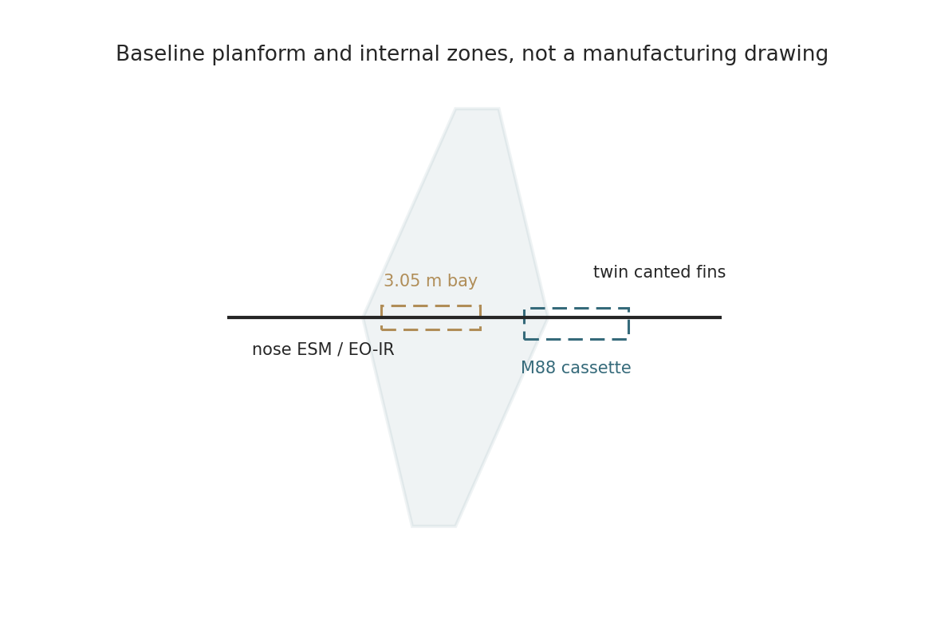
Figure 2. Planform and internal arrangement.

2.3 Mass properties and center of gravity
The operating-empty budget is 2,530 kg. The M88-2 engine accounts for 897 kg of that total, with the remainder of the propulsion group covering larger inlets and ducts, mounts, nozzle adaptation, drains, fire seals, and cooling provisions. The 1,090 kg installed propulsion figure is deliberately conservative relative to the bare engine. The longer engine cassette and enlarged inlet system add structure beyond the earlier bay stretch.
Maximum takeoff mass closes at 3,800 kg with 250 kg payload, 990 kg usable fuel, and 30 kg retained fuel. A 100 kg growth zone remains available to 3,900 kg for a heavier EW pallet, extra cooling, or a limited structural change, subject to landing-gear and brake checks.
Mass group | kg | Share of OEW
Airframe structure | 650 | 25.7%
Propulsion installation | 1,090 | 43.1%
Landing gear | 165 | 6.5%
Flight controls | 105 | 4.2%
Fuel system | 85 | 3.4%
Electrical system | 95 | 3.8%
Thermal management | 78 | 3.1%
Avionics and mission core | 125 | 4.9%
Sensors and apertures | 70 | 2.8%
Environmental and misc. | 60 | 2.4%
Assembly margin | 7 | 0.3%
Operating empty mass | 2,530 | 100%
- Empty CG target: 42.0% MAC, forward limit 38.5%, aft limit 45.5%.
- MTOW CG range: 39.0-45.0% MAC, with fuel sequencing inside ±0.4% MAC.
- Store-release CG shift: less than 0.6% MAC for any single 130 kg station.
- Design growth reserve: 100 kg, allocated before structural or propulsion changes.

2.4 Internal arrangement and volumes
The internal layout uses a long nose avionics bay, a 3.05 m lower centerline mission bay, integral wing tanks, and a removable aft engine cassette. Side DSI inlets feed S-ducts around the mission bay. Fuel sits close to the CG and sequences from forward and aft groups to protect trim during the dash.
The engine cassette splits at the aft fuselage transport joint. Removal uses four primary mounts, self-sealing fuel and pneumatic connections, two electrical connectors, one FADEC harness, and an alignment cradle. Target removal time is 90 minutes with a three-person crew after access-panel removal.
The bay envelope is 3.05 m × 0.52 m × 0.46 m, or 0.73 m³. Two stations each carry 130 kg. Power, cooling, data, and release wiring terminate at a single modular interface plate. The bay door remains closed during the Mach 1.60 dash and opens only below Mach 0.90.
Zone | Primary contents | Access approach
Nose | ESM front end, EO-IR window, flight computers, GNSS/INS | Two upper panels
Forward fuselage | Forward fuel bladder, mission computer, power conversion | Left/right cheek panels
Center fuselage | 3.05 m payload bay, main landing gear, inlet ducts | Lower doors and side panels
Wing | Integral fuel, elevon actuators, ESM antennas | Lower removable panels
Aft fuselage | M88 engine, thermal loop, generator, nozzle adapter | Engine cassette and upper doors
Empennage | Canted fins, rudders, RF-transparent tips | Fin root access panels

3. Aerodynamic architecture
The aerodynamic concept is a cropped delta with aligned leading edges, fixed DSI inlets, a faceted forebody, and canted twin fins. The planform prioritizes low wave drag and a clean frontal sector while retaining a practical approach speed. Area ruling controls the cross-section growth around the inlets, bay, and engine cassette.
The wing uses a modified supersonic biconvex-root and supercritical-tip section family. Root t/c is 5.0%; tip t/c is 4.2%. Leading-edge radius remains small but manufacturable. A replaceable radar-absorbing leading-edge strip protects the highest-signature edge without forcing the entire skin into a fragile coating system.
The drag build-up uses a zero-lift drag estimate plus lift-induced drag. Values below are CDR-stage estimates, not wind-tunnel data. They remain adequate for point-design closure because the M88 thrust margin is large and the fuel budget includes reserve.
Mach | CD0 estimate | K estimate | Use
0.85 | 0.0180 | 0.180 | Ingress and egress
1.05 | 0.0310 | 0.200 | Transonic acceleration
1.30 | 0.0290 | 0.190 | Supersonic climb
1.55 | 0.0275 | 0.185 | Dash entry
1.60 | 0.0278 | 0.185 | Design dash
1.65 | 0.0286 | 0.185 | Maximum level objective

3.1 Drag polar and lift characteristics
At 35,000 ft and Mach 0.82, the cruise drag estimate is 4.1-4.6 kN across the representative 3,150-3,450 kg mass band. At 40,000 ft and Mach 1.60, drag rises to approximately 19.0 kN at 3,450 kg. At 45,000 ft, drag falls to approximately 15.1 kN. These values use q = 0.7pM², L = W, and D = qS(CD0 + KCL²).
The estimated subsonic cruise L/D is 6.5-7.5, low by transport-aircraft standards but credible for a low-aspect-ratio supersonic delta. Sprinter accepts this because its mission uses a short dash and does not optimize for long loiter. Ferry range closes through fuel fraction rather than through high cruise efficiency.
Low-speed closure uses CLmax 1.15 with elevons and boundary-layer control from the fixed DSI. At 3,800 kg, estimated sea-level stall speed is 101 kt. Approach speed is 124-128 kt depending on store state and crosswind additive.
- Cruise drag: 4.4 kN at Mach 0.82, 35,000 ft, 3,350 kg.
- Dash drag: 19.0 kN at Mach 1.60, 40,000 ft, 3,450 kg.
- Dash drag: 15.1 kN at Mach 1.60, 45,000 ft, 3,450 kg.
- Maximum usable lift coefficient: 1.15 approach, 0.62 buffet-free maneuver cruise.
- Wave-drag increment: included in the Mach 1.05-1.65 CD0 table.
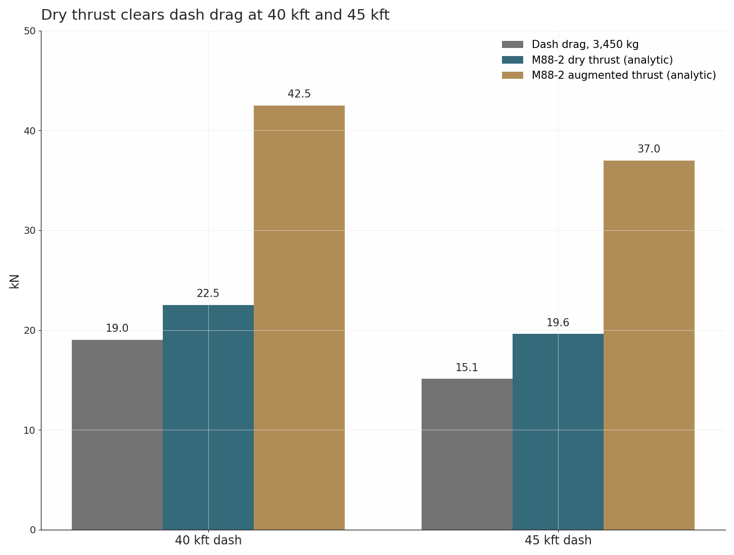
Figure 3. Analytic drag and installed thrust closure.

3.2 Mach 1.60 performance closure
The Mach 1.60 requirement closes at both 40,000 and 45,000 ft with exceptional margin. The conservative point is 40,000 ft: estimated drag is 19.0 kN and the analytic installed augmented thrust is 42.5 kN, giving a 124% thrust margin. At 45,000 ft, estimated drag is 15.1 kN and analytic augmented thrust is 37.0 kN, giving a 145% margin. Analytic dry thrust of 22.5 kN at 40,000 ft and 19.6 kN at 45,000 ft also exceeds drag at both points, so the reference dash runs dry at 45,000 ft and with minimal augmentation at 40,000 ft. Predominantly dry operation cuts afterburner plume signature and dash fuel.
The analytic deck scales the public 75 kN sea-level static augmented rating and the 50 kN dry rating by total-pressure ratio, inlet recovery, installation losses, and a conservative nozzle factor. It is not an OEM deck. The margin is large enough to absorb a 20% engine-deck error, a 10% drag error, and a 10% inlet-recovery shortfall at the design point.
Acceleration from Mach 0.82 to Mach 1.55 uses approximately 100 seconds and 70 kg fuel in the reference profile. The five-minute Mach 1.60 dash uses approximately 150 kg fuel in the dry-to-minimal-augmentation profile. The combined acceleration and dash allocation is 220 kg, including transient afterburner lighting and throttle variation.
Closure item | 40,000 ft | 45,000 ft | Margin
Mach 1.60 drag at 3,450 kg | 19.0 kN | 15.1 kN | Analytical
Analytic installed thrust | 42.5 kN | 37.0 kN | OEM deck pending
Excess thrust | 23.5 kN | 21.9 kN | 124% / 145%
Five-minute distance | 76 nm | 76 nm | Speed basis
Dash fuel | 150 kg | 145 kg | Fuel model
Requirement verdict | CLOSED | CLOSED | CFD and OEM validation remain

3.3 Stability, control, and handling
The tailless delta uses four elevons, two canted fins with rudders, and two upper-surface drag panels. Primary pitch and roll control comes from elevon allocation. Yaw stability comes from the canted fins; yaw trim and crosswind decrab use the rudders and differential drag panels. The control mixer protects against single-surface saturation.
Static margin is 4-6% MAC in cruise and 2-4% MAC at the aft CG limit. The flight-control laws provide artificial stability, pitch-rate command, roll-rate command, angle-of-attack limiting, Mach limiting, structural load limiting, and automatic recovery modes. A simple mechanical backup is not fitted; redundancy comes from triplex computation, dual power buses, and independent actuator electronics.
Estimated Dutch-roll damping exceeds 0.35 at approach and 0.25 at high-altitude cruise with the control laws active. Lateral departure resistance at 18° angle of attack remains PENDING CFD. High-speed aeroelastic margins receive dedicated FEA and ground-vibration testing before envelope expansion.
Control function | Mechanization | Redundancy
Pitch | Inboard elevons, symmetric | Two actuators, triplex command
Roll | Outboard elevons, differential | Two actuators, triplex command
Yaw | Twin rudders plus drag panels | Independent buses
High-speed trim | Fuel sequencing and elevon trim | Autotrim authority limited
Approach | Direct lift and drag-panel schedule | Automatic go-around mode
Failure case | Single actuator failure | Remaining surfaces reallocate

4. Propulsion selection
The selected propulsion class is one afterburning Safran M88-2 low-bypass turbofan. Public data list 50/75 kN dry/augmented thrust, 897 kg dry mass, 3.54 m length, and 65 kg/s airflow. The engine powers the Rafale across French and export fleets with more than one million accumulated flight hours, and Safran lists a fully modular design with a one-hour engine removal and reinstallation capability. These public values anchor the mass and sea-level thrust basis.
The Eurojet EJ200 lists 60/90 kN and about 1,000 kg in current consortium material. Its extra thrust exceeds the mission need, and its 4.0 m length forces more fuselage growth than the M88; it remains the documented fallback class. Business-jet high-bypass engines fail the supersonic drag and inlet-pressure requirement, and any US-controlled engine fails the sovereignty requirement. The M88 is therefore the only closing public-data choice.
The engine is treated as an OEM-furnished article with a program-modified accessory gearbox, inlet-control schedule, health-monitoring interface, and nozzle-edge treatment. French export authorization, the installed deck, and Canadian support arrangements remain PENDING OEM VALIDATION. Safran maintains an established Canadian industrial footprint in landing systems, electrical systems, and engine support, and that footprint anchors the in-country support model. The point design does not depend on a speculative M88 T-REX or clean-sheet derivative.
Propulsion decision: accept the real 897 kg M88 and grow the aircraft to close, eliminating US export-control exposure rather than retaining a lighter engine that carries supply-chain veto risk.

4.1 Installed propulsion budget
The installed propulsion group is 1,090 kg. The bare engine contributes 897 kg. Larger inlets and S-ducts contribute 70 kg, engine mounts and fire barriers 38 kg, nozzle adaptation and edge treatment 28 kg, accessory gearbox adaptation 22 kg, and drains, cooling, and sensors 35 kg. This budget includes local structure but excludes starter-generator mass carried in the electrical group.
Static thrust-to-weight ratio is 2.01 at 3,800 kg and 2.84 at typical landing mass. The engine operates in dry power for ingress, egress, and the 45,000 ft reference dash. The afterburner is reserved for takeoff, transonic acceleration, the 40,000 ft dash point, emergency climb, and go-around.
Engine life exceeds airframe life. Safran public data describe a modular, on-condition maintenance architecture with a one-hour removal and reinstallation capability across a fleet with long export service. Sprinter uses a pooled-engine support model: engines remain program assets, while airframes carry a 1,000-hour design life. This approach materially reduces the impact of losing an airframe.
Installed item | kg | Closure note
M88-2 bare engine | 897 | Vendor public datum
DSI inlets and S-ducts | 70 | Geometry estimate
Mounts, fire seals, barriers | 38 | Analogue
Nozzle adaptation | 28 | OEM integration pending
Accessory gearbox adaptation | 22 | OEM integration pending
Drains, cooling, sensors | 35 | Analogue
Installed propulsion total | 1,090 | Closed budget

4.2 Inlet and duct system
Twin fixed-geometry DSI inlets sit on the forward fuselage shoulders. Each inlet has 0.260 m² capture area, sized for an estimated 60-68 kg/s total engine airflow at the dash. A fixed compression bump, cowl lip, and boundary-layer spill path remove the need for a variable ramp or heavy bleed system.
Each S-duct is 1.45 m long and uses two curvature changes to hide direct fan line-of-sight. Maximum local centerline slope is 24°. Target total-pressure recovery is 0.88 at Mach 1.60 and 0.95 at subsonic cruise. Distortion target is less than 6% at the engine face across the normal maneuver envelope.
Low-speed excess air passes through automatic spill doors. High-angle and crosswind behavior receives CFD, wind-tunnel, and ground-engine testing before high-speed taxi. The fixed DSI approach reduces part count and radar reflectors compared with a variable inlet, but it remains a PENDING VALIDATION item until pressure-recovery and distortion data exist.
Parameter | Design value | Evidence need
Capture area per inlet | 0.260 m² | CFD and engine airflow
Duct length | 1.45 m | Aeroacoustic and distortion CFD
Maximum local duct slope | 24° | Flow-separation CFD
Recovery at Mach 1.60 | ≥0.88 target | Wind tunnel
Distortion at engine face | ≤6% target | Ground engine test
Low-speed spill | Two automatic doors per side | Loads and flight test

4.3 Exhaust and infrared integration
The baseline retains the OEM variable-area convergent-divergent nozzle rather than imposing a bespoke two-dimensional nozzle. This protects engine certification, afterburner operability, and supportability. A serrated outer lip, cooled centerbody, and local edge-aligned fairing reduce rear-sector spikes without pretending that the rear quadrant is low observable.
Infrared control relies on bypass-air mixing, upper-surface shielding from ground observers, controlled afterburner use, and strict dash-time limits. The exhaust remains the dominant rear-sector signature source. Sprinter accepts this because its survivability model depends on frontal aspect, speed, emitter confusion, and Striker EW cover rather than post-pass stealth.
No thrust vectoring is fitted. Nozzle actuation links to FADEC through the OEM interface. Any change to nozzle area schedule, temperature limits, or flameholder life requires OEM approval. This integration item remains PENDING OEM VALIDATION even though the architectural choice closes.
- Nozzle type: OEM variable-area convergent-divergent unit with program edge treatment.
- Thrust reverser: not fitted; landing roll uses brakes, drag panels, and runway length.
- Nozzle cooling: bypass-air film plus radiation-tolerant local shields.
- Rear-sector policy: shape and shield the installation, but assign post-pass protection to speed and escort EW.
- Engine cassette: nozzle adapter remains with the aircraft; core engine removal uses a standardized quick-disconnect plane.

5. Mission design and reference sortie
The reference Opening Doors sortie uses a 220 nm ingress, a 76 nm five-minute dash, a 20 nm effects segment, and a 190 nm egress. Ground track totals about 507 nm before routing margins. Mission time is approximately 84 minutes, including takeoff, climb, approach, and employment time.
The sortie begins after Gripen-led suppression has already degraded the defended sector. Sprinter then enters on an assigned axis, climbs to the dash corridor, accelerates, closes the bay, and performs the high-speed penetration. During the dash, it records emitters, transmits bearing lines, presents a credible target, and triggers defensive reactions. Effects begin after deceleration or during a preplanned high-speed jamming window.
The aircraft does not loiter over the defended area. After completing the assigned effect, it turns onto the egress axis, rejoins the cooperative picture, and lands with a 180 kg reserve. A second Sprinter on a divergent axis provides cross-bearing geometry and forces the defense to divide attention.
- Ingress: Mach 0.80-0.84 at 35,000 ft, emissions controlled.
- Dash: Mach 1.55-1.60 at 40,000-45,000 ft for five minutes.
- Effects: ESM, decoy, EW, ISR snapshot, or limited store release.
- Egress: Mach 0.78-0.82 at 35,000 ft under Striker EW cover.
- Reserve: 180 kg usable fuel at planned landing.
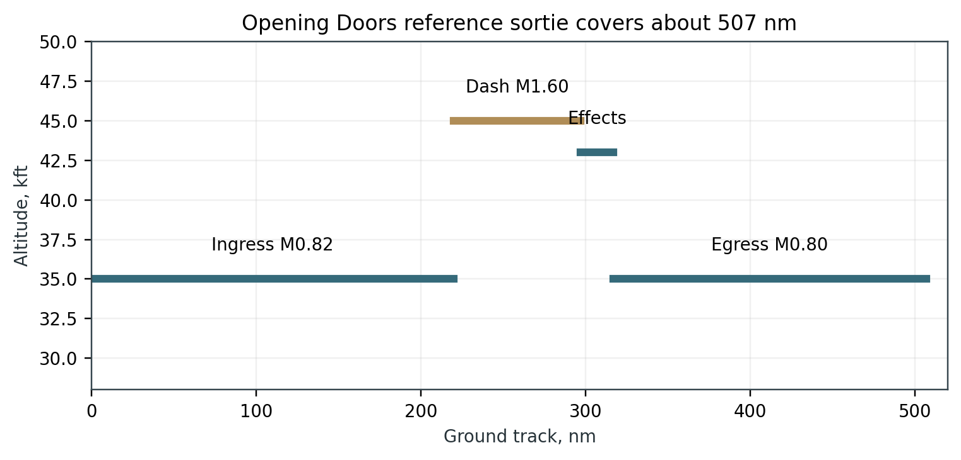
Figure 4. Reference Opening Doors sortie profile.

5.1 Fuel closure
Usable fuel is 990 kg. The planned mission burn is 810 kg, leaving 180 kg reserve. Retained and trapped fuel is 30 kg, giving 1,020 kg total fuel. At 0.81 kg/L, total tank volume is approximately 1,259 L; the installed tank system provides 1,260 L usable geometric capacity plus expansion space.
The dash fuel estimate uses the dry-to-minimal-augmentation profile of the M88, representative installed thrust of 19-23 kN, and a five-minute duration. Acceleration adds 70 kg. The result remains below the 220 kg combined allocation for acceleration and dash.
Ferry performance with no payload is approximately 1,050 nm and 2.4 hours with standard reserve. This is adequate for deployment and range repositioning. It is not a design driver; Sprinter trades persistence for sprint performance.
Phase | Fuel kg | Time / distance | Closure note
Start and taxi | 35 | 12 min | Ground allowance
Takeoff and climb | 145 | 10 min | Dry power plus brief augmentation
Ingress | 175 | 220 nm | Mach 0.82, 35 kft
Acceleration | 70 | 100 s | M0.82 to M1.55
Dash | 150 | 5 min / 76 nm | M1.60
Employment and turn | 45 | 8 min | Bay or EW activity
Egress | 160 | 190 nm | Mach 0.80
Approach and landing | 30 | 10 min | Standard pattern
Reserve | 180 | 20 min class | Planned landing reserve
Usable total | 990 | 84 min reference | Closed
Retained | 30 | Not usable | System allowance
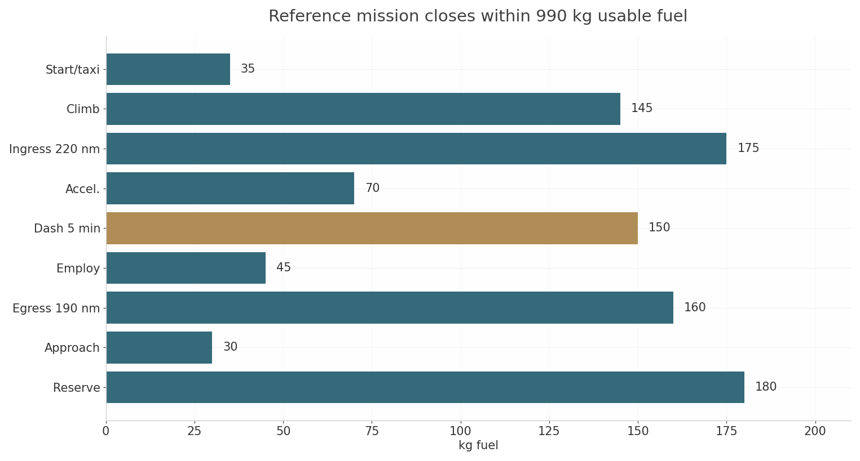
Figure 5. Reference mission fuel budget.

5.2 Field performance and flight envelope
Takeoff distance is approximately 620 m at sea level ISA, 3,800 kg, dry runway, and military-plus-augmented takeoff technique. At ISA+20 and 1,500 m pressure altitude, estimated ground roll rises to 800-850 m. The 1,000 m threshold closes with margin, aided by the M88 thrust margin and 190 kg/m² wing loading.
Landing distance is 890-990 m at 2,695 kg landing mass, 126 kt approach speed, anti-skid brakes, drag panels, and no reverse thrust. Rejected takeoff at 120 kt and 3,800 kg produces 7.2 MJ kinetic energy. The brake system is sized for 12 MJ, leaving 66% energy margin before tire, runway, and fuse-plug limits.
The normal envelope is Mach 0.25-1.60, sea level to 45,000 ft. Maximum operating Mach is 1.65; never-exceed Mach is 1.70. Limit load is +6.0g / -2.5g at maneuvering weight, with flight-control envelope protection. High-speed bay operation is prohibited; the bay opens below Mach 0.90.
Performance item | Baseline | Limit / note
Takeoff ground roll, ISA SL | 620 m | 3,800 kg, dry runway
Takeoff ground roll, hot/high | 850 m | ISA+20, 1,500 m
Approach speed | 124-128 kt | Store state dependent
Landing distance | 890-990 m | 2,695 kg, anti-skid
Maximum operating Mach | 1.65 | Five-minute high-speed limit
Never-exceed Mach | 1.70 | Dive and structural limit
Normal ceiling | 45,000 ft | Dash corridor
Ferry ceiling | 47,000 ft | Lightweight, dry power
Limit load | +6.0g / -2.5g | Maneuvering weight
RTO brake capacity | 12 MJ | 7.2 MJ required at 120 kt

6. Structures and materials
The airframe uses a hybrid structure: BMI carbon-composite wing skins and spars, Al-Li primary frames, secondary 7xxx aluminum articles, titanium fittings, steel landing-gear elements, and thermoplastic or recycled-carbon-fiber non-primary panels. The architecture supports inspection, repair, material segregation, and eventual recovery. The landing gear sources from a Canadian supplier with complete fighter landing-gear design authority, matching the existing Gripen E supply relationship. Canadian aerostructure suppliers in the Magellan class provide composite panels, machined detail parts, and castings.
The wing centerbox is a two-spar, multi-rib torsion box integral with the center fuselage. Fuel tank walls use sealed composite skins with titanium fuel-zone fittings. The mission bay uses four primary frames and two removable lower doors. The engine cassette attaches to a titanium aft ring and two fail-safe side links.
The structural concept favors conservative gauges and replaceable sacrificial edges over minimum-weight complexity. This adds mass in selected areas but eases production, improves battle-damage tolerance, and supports high sortie rates.
- Primary wing and centerbody: qualified BMI carbon laminate with titanium hardpoints.
- Bay frames and racks: Al-Li 2099 or 2195 with certified recycled-content secondary brackets.
- Secondary panels: CF/PEKK or CF/PPS where temperature and signature permit.
- Fairings and access covers: recycled-carbon-fiber nonwoven veil over qualified structural substrate.
- Hot-zone attachments: Ti-6Al-4V or qualified superalloy, with recycled content only after lot data.

6.1 Loads, life, and structural margins
Limit maneuver load is +6.0g / -2.5g at maneuvering weight. Ultimate load uses a 1.50 factor. The design gust and taxi cases use military runway roughness and 20 ft/s vertical gust at design cruise speed. The dash case combines Mach 1.60, 3.5g wind-up turn, full bay, and 80% fuel.
Design life is 1,000 flight hours, 500 landings, 250 afterburner dash events, and 10 calendar years. Damage-tolerance inspection intervals begin at 100 hours for the wing box, bay frames, gear trunnions, and engine mounts. Fail-safe design uses dual load paths at the wing root, engine ring, and main gear.
Preliminary margin policy requires at least 0.10 ultimate margin on primary structure, 0.15 on fittings, and 0.20 on bonded joints before flight test. Flutter margin target is 15% above the never-exceed dynamic pressure. These values remain PENDING FEA, ground-vibration testing, and flight-flutter clearance.
Case | Design value | Closure evidence
Symmetric maneuver | +6.0g limit | Preliminary loads model
Negative maneuver | -2.5g limit | Preliminary loads model
Dash pull-up | 3.5g at Mach 1.60 | Aeroelastic check pending
Landing sink | 3.0 m/s at MTOW | Gear drop test pending
RTO | 120 kt at MTOW | Brake energy closed
Design life | 1,000 h / 500 landings | Fatigue test pending
Flutter margin | 15% above VNE dynamic pressure | GVT and flight test pending

6.2 Circular materials strategy
Recycled content is inserted only where qualification, traceability, temperature, signature, and structural function close. Airbus reports closed-loop aluminum work, 460 tonnes of titanium scrap collected from French sites by 2025-01, and a first ingot containing end-of-life titanium from a pylon in 2025-06; EcoTitanium is described as capable of up to 75% recycled titanium ingots.
A recycled 7075 aerospace-sheet study found that deep purification brought recycled melt cleanliness and resulting performance close to primary sheet, with no significant differences reported under the study conditions. QinetiQ and AMS have flown a structural hinge made from recycled titanium powder, reporting 97% material efficiency and 93.5% lower CO₂e relative to the stated conventional baseline.
Sprinter uses this evidence cautiously. First-article recycled content totals about 402 kg, or 15.9% of operating empty mass. Rate-production target is 20% after material lots, allowables, and supplier capacity stabilize. The expanded recycled share aligns with the sovereignty policy: feedstocks source from Canadian and European closed-loop suppliers. Primary wing skins, engine rotating parts, hot-section components, and signature-critical outer skins remain outside the recycled-content substitution path.
Article | Eligible mass | Recycled target | Qualification gate
Al racks and brackets | 230 kg | 160 kg | Certified closed-loop 7075 lot
Ti AM fittings | 150 kg | 120 kg | Powder chemistry and fatigue lot
Steel pins and bolts | 90 kg | 60 kg | VAR remelt traceability
RCF fairings | 90 kg | 40 kg | Coupon, FST, impact, RF checks
Copper harness | 28 kg | 14 kg | Conductivity and insulation lot
Battery materials | 42 kg | 8 kg | Cell supplier declaration
Total | 630 kg | 402 kg | 15.9% of OEW
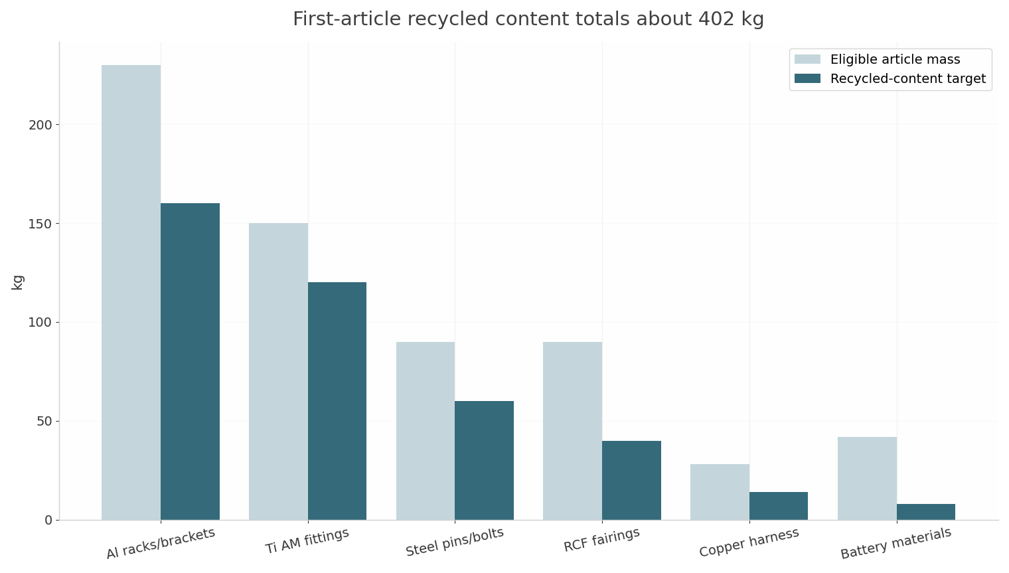
Figure 6. Recycled-content article budget.
- Recoverable or reusable mass: at least 62% of OEW, including engine cassette, metals, batteries, and thermoplastic panels.
- Production scrap: segregated by alloy family and tracked through the digital material passport.

6.3 Material qualification and boundaries
Each recycled feedstock receives a material passport covering source alloy, melt lot, contamination control, chemistry, mechanical allowables, fatigue spectrum, thermal exposure, surface treatment, and repair history. No article enters flight hardware on a generic recycled-content claim.
Secondary aluminum articles use certified closed-loop scrap with known alloy family. The preferred first application is avionics racks, non-primary brackets, ground-support tooling, bay liners, and removable equipment trays. Primary fittings receive recycled content only after A-basis or B-basis allowables match the selected design case.
Recycled titanium enters through additive-manufactured brackets, equipment supports, thermal shields, and semi-structural fittings. Critical engine-adjacent fittings retain virgin aerospace lot material until high-temperature fatigue, fracture, and oxidation data close. Recycled carbon fiber remains limited to non-primary fairings, liners, access-panel inner plies, and sacrificial panels. Thermoplastic composite panels use CF/PEKK or CF/PPS where service temperature remains below the qualified limit.
- Approved first uses: racks, trays, brackets, liners, removable fairings, tooling, and ground-support equipment.
- Conditional uses: bay bulkhead brackets, landing-gear secondary braces, and thermal shields.
- Excluded first-article uses: primary wing skins, main spars, rotating engine parts, hot-section parts, and signature-critical outer mold line.
- Design-for-recovery: separable fasteners, material-marked panels, minimized co-cured mixed-material joints, and engine cassette removal.

6.4 Manufacturing and assembly flow
The production flow uses six major modules: nose, forward fuselage, centerbody and bay, left wing, right wing, and aft engine cassette. Determinant assembly locates modules through machined datum features rather than large monolithic jigs. Final mate occurs at two fuselage splices and two wing-root splice planes.
Primary BMI wing skins use automated fiber placement and autoclave or qualified out-of-autoclave cure. Secondary CF/PEKK panels use stamp forming and induction or ultrasonic welding where joint data close. Metallic brackets use machining or additive manufacturing with full lot traceability. Recycled carbon-fiber veils enter through compression-molded panels and nonwoven surface layers.
The build target is 1,800 assembly labor hours per aircraft at unit 24 and 1,250 hours at unit 72. First-pass yield target is 92%. Recycled feedstock benefits are lower scrap disposal, material recovery value, shorter machining loops, and resilient supply.
Flow step | Target | Production lever
Wing skin layup | 2 tools, 5 days | AFP and reusable edge strips
Centerbody cure | 1 tool, 3 days | Integral fuel-zone design
Metallic bracket production | 60% near-net | AM and reduced machining
Secondary panel forming | 24 h cycle | Thermoplastic stamp forming
Final mate | 5 days | Determinant assembly
Engine cassette install | 8 h | Quick-disconnect plane
Acceptance test | 3 days | Automated BIT and leak checks

7. Thermal management
The thermal system combines fuel heat sink, a PAO liquid loop, cold plates, ram-air assist at subsonic speed, and controlled electrical load shedding. Peak heat rejection is 42 kW for 300 seconds during the dash with a high-power EW payload. The resulting energy load is 12.6 MJ.
Fuel provides the primary transient sink. Approximately 220 kg of fuel passes through the thermal loop during the combined acceleration and dash. With a 2.1 kJ/kg·K heat capacity and a 25 K allowed rise, fuel absorbs about 11.6 MJ. The PAO loop and structural thermal mass add approximately 2.9 MJ, producing 14.5 MJ capacity against 12.6 MJ demand.
Bulk fuel temperature remains below 60°C and heat-exchanger wall temperature remains below 120°C. The system does not use expendable water or cryogenic cooling. At Mach 1.60 and 45,000 ft, recovery temperature is approximately 43°C, within BMI composite, titanium, and qualified aluminum limits with margin.
Thermal item | Design value | Status
Peak heat load | 42 kW for 300 s | Closed by sink budget
Peak heat energy | 12.6 MJ | Calculated
Fuel heat sink | 11.6 MJ | Calculated
PAO and structure sink | 2.9 MJ | Calculated
Total capacity | 14.5 MJ | 15% margin
Bulk fuel limit | 60°C | Controlled input
Loop architecture | Dual pumps, two zones | Ground test pending

7.1 Fuel system
The fuel system stores 1,020 kg total JP-8 or equivalent aviation turbine fuel. Wing integral tanks hold 800 L and fuselage bladder tanks hold 460 L. Total geometric capacity is 1,260 L, matching the 1,259 L calculated from 1,020 kg at 0.81 kg/L before expansion-space adjustment.
Three boost pumps feed a single engine manifold. Crossfeed valves isolate a failed tank group. The forward fuselage bladder empties first, followed by aft wing groups, then the center wing group. This sequence holds CG within ±0.4% MAC and keeps the heaviest remaining fuel near the structural center.
Tank protection uses reticulated foam, ullage nitrogen-enriched-air inerting, self-sealing lower panels, and isolated dry bays around hot ducts. Single-point pressure refueling completes in 12 minutes. Gravity defueling through the same manifold supports engine removal and depot inspection.
Tank group | Volume | Fuel mass | Sequence
Left/right wing integral | 800 L | 648 kg | Middle and final
Forward fuselage bladder | 260 L | 211 kg | First
Aft fuselage bladder | 200 L | 162 kg | Second
Total geometric | 1,260 L | 1,020 kg nominal | Includes retained allowance
Usable | 1,222 L | 990 kg | Mission usable
Retained/trapped | 38 L | 30 kg | Not credited

7.2 Electrical power architecture
A 45 kVA brushless starter-generator mounts to the engine accessory gearbox and feeds a 270 V dc primary bus through active rectification. At 0.85 power factor, real power is 38.2 kW. The normal dash load budget totals 38.2 kW, including 12 kW payload power and 3.5 kW conversion losses.
Two LiFePO₄ batteries provide 5.4 kWh nameplate energy and 4.32 kWh usable energy at 80% depth of discharge. Essential load is 7.5 kW after load shedding, giving approximately 35 minutes of flight-critical endurance. The batteries are split into physically separated forward and aft compartments.
The accessory-gearbox power extraction, starter torque, generator cooling, and FADEC electrical interfaces require OEM confirmation. This is PENDING OEM VALIDATION, but the aircraft-side bus, load table, battery reserve, and wiring architecture close at CDR level.
Load group | kW | Mode
Flight-critical loads | 7.2 | Continuous
Mission avionics and comms | 5.5 | Continuous
Mission payload | 12.0 | Dash continuous
Thermal pumps and valves | 5.0 | Dash continuous
Actuator average | 2.5 | Maneuver average
Environmental and probes | 1.5 | Continuous
Battery charging and hotel | 1.0 | Normal
Conversion and distribution losses | 3.5 | Normal
Total | 38.2 | Matches generator real power
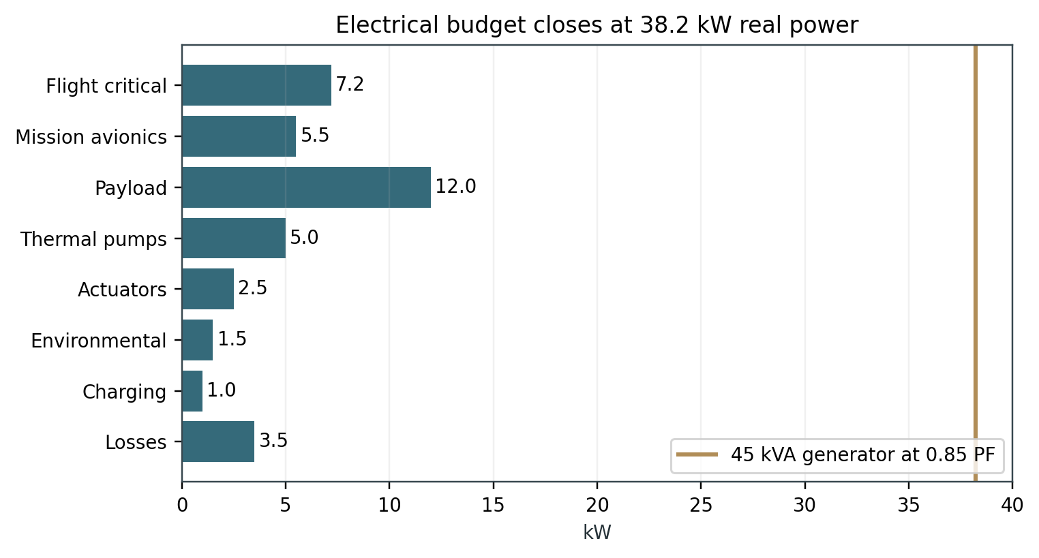
Figure 7. Electrical load closure.

8. Flight controls
The flight-control system uses triplex digital flight-control computers, dual 270 V dc power lanes, dissimilar inertial sensors, and electrohydrostatic actuators for primary surfaces. No central hydraulic system is fitted. Each actuator contains local electronics, a brushless motor pump, and position feedback.
The control laws provide rate command, attitude hold, navigation coupling, automatic dash hold, load relief, buffet protection, stall protection, overspeed protection, and automatic return-to-base. The aft-CG case uses reduced roll-rate authority and gain scheduling by Mach, dynamic pressure, fuel state, and bay configuration.
Flight termination uses an independent power supply, guarded command path, and destruct-or-land logic selected by range rules. Loss of link triggers a preplanned hold, return, or controlled termination depending on phase, terrain, fuel, and authorization state.
Element | Architecture | Design target
Flight-control computers | Triplex, dissimilar lanes | 1e-6 class catastrophic system fault target
Primary actuators | Six EHA units | Single-failure tolerant
Rudder actuators | Two EHA units | Independent buses
Air data | Two pitot-static plus flush synthetic air data | Voting and reasonableness checks
Inertial reference | Two tactical-grade FOG IMUs | GNSS-denied continuity
Flight termination | Independent receiver and battery | Range-specific logic
Ground maintenance | Built-in test and health recording | 15 min post-flight download

8.1 Autonomy and human command
The autonomy stack separates safety-of-flight control, mission execution, cooperative behavior, and weapons authorization. The vehicle manages route, formation, sensor pointing, dash timing, emissions, and recovery. Gripen E retains target assignment, weapons-release consent, and abort authority.
Mission autonomy uses behavior nodes rather than unconstrained generative planning. Nodes include ingress formation, picture anchor, track relay, geolocation solve, dash entry, bay sequence, release authorization, EW cover, egress formation, and return to base. Each node carries entry conditions, exit conditions, timing limits, link-loss behavior, and human override.
No autonomous kinetic release occurs. Store arming proceeds only after a valid Gripen authorization message, positive geofence check, target-track quality check, bay-door status check, and separation-envelope check. Any disagreement between authorization, geofence, or store state triggers hold and return logic.
- Human command: Gripen E tactical aircrew remains the release authority.
- Vehicle autonomy: route, formation, dash, sensor, EW, and recovery execution.
- Safety logic: geofence, link-loss, collision-avoidance, store-safing, and flight termination.
- Cyber policy: signed mission loads, hardware root of trust, partitioned mission network, and no maintenance-port path to flight-control lanes.
- Data policy: onboard recording continues during link loss; cooperative tracks carry confidence and time quality.

8.2 Datalinks and navigation
Primary communications use a directional Ku-band link to Gripen E, Striker, or a relay aircraft. A lower-rate UHF/L-band backup provides command and health data. A 60 GHz short-range intra-flight link supports close formation and high-rate picture exchange when geometry permits. SATCOM is an optional nose module rather than a baseline fit.
Navigation uses dual GNSS receivers with controlled-reception antennas, two FOG inertial units, synthetic air data, terrain-aided corrections when mapping data are available, and cooperative ranging from the package. GNSS-denied performance target is better than 2 nm position error over a 10-minute dash and effects segment, with exact drift pending vendor selection and flight test.
Cooperative geolocation uses time-synchronized bearing lines from two Sprinters or a Sprinter-Striker pair. The baseline does not claim a single-ship precision emitter fix. Two-ship geometry, calibrated antenna phase centers, and common time provide the operational solution.
Function | Baseline | Fallback
Primary C2 | Directional Ku-band | UHF/L-band narrowband
High-rate local mesh | 60 GHz intra-flight | Ku-band reduced rate
Navigation | Dual GNSS/INS | INS plus terrain/cooperative ranging
Time | GNSS-disciplined clock | Holdover oscillator
Emitter geolocation | Two-ship ESM bearings | Gripen/Striker triangulation
Link loss | Hold, return, or terminate | Mission-specific preplan

9. Signature management
Sprinter manages frontal RF signature through planform alignment, DSI inlets, S-duct fan blockage, faceted forebody edges, serrated bay doors, flush apertures, internal stores, and controlled antenna emissions. The priority sector is ±60° about the nose in X-band and Ku-band threat channels.
No exact radar cross-section value is claimed. Public sources do not provide a defensible certified value for this concept, and the user-provided project documents identify exact RCS as unavailable. The design closes shaping rules, materials boundaries, gap controls, and test requirements instead.
The rear quadrant receives limited treatment. The conventional variable nozzle, canted fins, and hot exhaust prevent a credible all-aspect claim. This is an intentional role trade: Sprinter survives the opening phase through speed, frontal signature, EW, numerical pressure, and Striker cover.
- Frontal controls: 52° edge family, DSI, S-ducts, flush EO/IR window, internal bay, and edge-aligned access panels.
- Materials: replaceable RAM leading-edge strips, conductive gap seals, treated inlet lips, and controlled fastener spacing.
- Emissions: directional links, receive-heavy modes, power management, and mission-dependent EW transmit windows.
- Verification: coupon, panel, inlet, full-scale pole, and flight-test measurement sequence.
- Claim boundary: no certified RCS number enters the baseline until measured data exist.

9.1 Infrared, visual, acoustic, and vulnerability
Infrared management uses bypass-air mixing, engine bay cooling, upper-surface nozzle shielding, low-smoke fuel scheduling, and dash-time discipline. The afterburner plume remains detectable; the objective is reduced pre-dash and post-dash contrast rather than invisibility during maximum augmentation.
Visual and acoustic control use a low-contrast gray-blue finish, anti-glint canopy-free nose treatment, serrated panel lines, and high-altitude operating profiles. Contrail policy uses altitude and humidity routing when the mission permits. No expensive active visual camouflage is fitted.
Vulnerability reduction relies on separated fuel tanks, foam and inerting, redundant flight-control lanes, separated power buses, fire detection, and sacrificial lower panels. The aircraft remains attritable: the design accepts loss under concentrated fire but seeks to make each loss operationally costly for the defender.
Signature / vulnerability item | Design control | Residual risk
Infrared | Mixing, shielding, dash-time limit | Afterburner plume remains visible
Visual | Low-contrast finish and altitude routing | Contrails under humid conditions
Acoustic | High altitude and short augmentation | Transonic boom near defended area
Fuel fire | Foam, inerting, isolated dry bays | Ground test pending
Single actuator hit | Control reallocation | Flight test pending
Datalink attack | Directional link, authentication, link-loss logic | Cyber test pending

10. Mission systems
The baseline mission suite favors passive sensing and modular effects over a permanent radar. Six conformal ESM antennas cover the forward and side sectors from 2-18 GHz. A flush EO/IR window supports short-range snapshot imagery, terminal scene capture, and battle-damage assessment.
The mission computer provides 40 TOPS-class edge processing, 16 TB encrypted storage, time synchronization, and open mission-system interfaces. A software-defined EW payload occupies the bay and uses aircraft power and cooling through the modular interface plate.
The aircraft carries no permanent large AESA radar. An optional compact X-band aperture occupies the nose module for specialized variants. This preserves frontal shaping, power, and cooling margins. Sprinter’s primary sensing value comes from passive geolocation and cooperative tracks rather than single-ship radar surveillance.
- Baseline ESM: 2-18 GHz, six conformal arrays, time-synchronized bearing output.
- EO/IR: flush mid-wave infrared and visible camera, snapshot mode, retractable cover.
- Mission computer: open architecture, 40 TOPS class, 16 TB recorder, hardware root of trust.
- EW interface: 12 kW continuous, 18 kW short-duration, 15 kW cooling, dual fiber and Ethernet.
- Optional aperture: compact X-band module, PENDING CFD, power, and signature validation.

10.1 Payload bay design
The internal bay is 3.05 m long, 0.52 m wide, and 0.46 m high. Usable volume is 0.73 m³. Two stations each support 130 kg, with a total bay limit of 250 kg after rack and cable mass. The doors open below Mach 0.90 and below 260 kt equivalent airspeed.
Each station carries a 14-inch NATO-style suspension pattern where practical, a release connector, fiber data, Ethernet, 28 V dc, and 270 V dc. Cooling uses a cold-plate interface at the station rather than a bay-wide air loop. The bay floor is sacrificial and replaceable after release testing. The AAM-1 fit suspends one IRIS-T across both stations on a dual ejector, with the wing plane horizontal inside the 0.52 m bay width and 114 mm longitudinal clearance in the 3.05 m bay.
The bay structure uses two titanium end frames, two Al-Li intermediate frames, composite doors, and removable liners. Recycled-content aluminum and recycled-carbon-fiber parts enter the liner, rack adapters, and non-primary brackets first.
Bay parameter | Value | Closure note
Internal length | 3.05 m | Store envelope closed
Internal width | 0.52 m | Door and duct integration
Internal height | 0.46 m | Bay frames and doors
Usable volume | 0.73 m³ | Geometry
Payload mass | 250 kg | Mass and CG closed
Station rating | 2 × 130 kg | Rack analysis pending
AAM fit | 1 × IRIS-T on dual ejector | Fit closed, separation pending
Power | 12 kW continuous / 18 kW peak | Electrical budget closed
Cooling | 15 kW continuous | Thermal budget closed
Door opening limit | Mach 0.90 / 260 kt EAS | Loads test pending

10.2 Payload modules and store envelope
The module set covers the intended role. EW and ESM modules have priority. Kinetic options fit the 3.05 m envelope and preserve the low-observable closed-bay dash. The air-to-air option is the in-service IRIS-T, already integrated on Gripen E, which gives Sprinter a validated self-defense weapon without dependence on any developmental interceptor. The strike option is the European MBDA SmartGlider Light, 2.0 m long and 120 kg class.
AMRAAM and full-length decoys do not close in the baseline bay; their length exceeds the 3.05 m envelope. Gripen carries long-range air-to-air weapons; Striker receives the larger internal-strike role; Sprinter carries one IRIS-T, compact effects, and door-opening payloads.
Store separation remains PENDING VALIDATION. Captive carry closes by geometry, mass, and CG. Release does not close until CFD, wind-tunnel, ground-ejection, and flight-release testing establish safe trajectories.
Module | Mass | Function | Status
ESM-1 | 120 kg | Enhanced emitter mapping and precision timing | Closed interface
EW-1 | 190 kg | DRFM noise/deception jamming, 2-18 GHz | Integration pending
DEC-1 | 90 kg | Active/passive RF augmentation and towed-element provision | Integration pending
ISR-1 | 140 kg | EO/IR snapshot, recorder, target-area scene capture | Closed interface
KIN-1 | 120-240 kg | One to two SmartGlider Light-class compact glide weapons | Separation pending
AAM-1 | 90 kg | One IRIS-T short-range air-to-air missile | Fit closed, separation pending
REL-1 | 150 kg | High-rate relay and crosslink node | Closed interface
Fuel/Cooling growth | 120 kg | Extended EW thermal endurance | Bay trade study

11. Reliability and safety
The reliability model uses a 1,000-hour airframe life, pooled M88 engines, line-replaceable mission modules, and automated built-in test. Target mission reliability is 0.97 for a planned sortie after engine start. Target catastrophic aircraft-system failure rate is 1e-6 per flight hour class, with final allocation dependent on safety assessment.
Single-engine risk is accepted for the attritable mission class, but flight-critical electrical and flight-control functions remain redundant. Battery endurance covers diversion, approach, and landing after generator loss. Flight termination and link-loss behavior protect populated areas and controlled ranges.
The engine’s public support history reduces technical risk. Safran describes the M88 as fully modular, dual-channel FADEC controlled, and proven across more than one million Rafale fleet flight hours in French and export service. The M88 supports on-condition maintenance and a one-hour engine removal and reinstallation cycle.
Reliability item | Target | Verification
Mission reliability | 0.97 after engine start | FMECA and reliability growth
Airframe life | 1,000 h / 500 landings | Fatigue test
Dash events | 250 full-augmentation events | Engine and thermal tracking
Catastrophic system fault | 1e-6 per flight hour class | Safety assessment
Engine removal | 90 min | Maintainability demo
Post-flight data download | 15 min | Ground demonstration
Turnaround | 35 min excluding payload change | Line demonstration

11.1 Maintainability and Arctic operation
The maintenance concept uses line-replaceable units, color-coded connectors, self-aligning racks, built-in test, and a 15-minute post-flight health download. The mission module swaps in 20 minutes using a two-person crew and a standardized lift. Engine cassette removal takes 90 minutes after panels and drains are prepared.
Arctic operation starts at -40°C after cold soak with battery conditioning, heated pitot and air-data probes, fuel-system water management, and preheated avionics racks. Deicing uses approved fluid on the wing and DSI lips before takeoff. In-flight icing clearance remains limited to light conditions pending testing.
Snow and slush operation uses nose-gear spray deflectors, sealed lower connectors, and corrosion-resistant coatings. Tire and brake limits receive winter runway friction correction. The aircraft does not use parachute recovery as the baseline; runway recovery protects turnaround time and payload reuse.
Task | Target time | Crew
Mission module swap | 20 min | 2
Refuel | 12 min | 1 plus supervisor
Post-flight download | 15 min | 1
Engine cassette removal | 90 min | 3
Tire replacement | 25 min | 2
EO/IR window replacement | 30 min | 2
Full turnaround | 35 min excluding payload | 4

12. Gripen and Striker integration
Sprinter integrates with Gripen E through a mission-planning station, directional C2 link, cooperative track manager, authorization protocol, and shared debrief system. Gripen assigns axes, timing, target classes, emissions policy, and release consent. Sprinter returns bearing lines, confidence, imagery snapshots, and health state.
Striker receives the corridor picture and follows after Sprinter has triggered or mapped residual defenses. Striker’s larger payload, more persistent profile, and all-aspect survivability fit exploitation. Sprinter’s role ends when the corridor, emitter map, deception effect, or limited kinetic effect creates the opening.
The preferred local package is two Sprinters, one Striker, and one Gripen E. A larger package uses four Sprinters, two Strikers, and two Gripen E aircraft. The 2:1 Sprinter-to-Striker ratio provides divergent axes, cross-bearing geolocation, and reserve capacity without overloading the human command node.
Platform | Opening Doors role | Design implication
Gripen E | Command, suppression, target assignment, heavy follow-on strike | Human authority and high-quality sensors
Sprinter | High-speed trigger, map, decoy, EW, IRIS-T self-defense | Mach 1.60, frontal LO, 250 kg bay with internal IRIS-T
Striker | Corridor exploitation, precision strike, EW cover | Larger payload, persistence, all-aspect LO
Ground/relay | Launch, recovery, mission planning, BLOS relay | Mission station and data repository

12.1 Fleet employment and sortie generation
Surge planning uses 1.5 sorties per aircraft per day for a limited period. Sustainable operations use 0.8-1.0 sortie per aircraft per day.
Attrition planning uses replenishment rather than deliberate sacrifice. Under disciplined SEAD-first employment, the planning loss range is 2-3% per high-end sortie, with sensitivity to EW survival and simultaneous fighter/SAM saturation. Older high-loss concepts are not used for planning.
The support set includes one engine pool at 15% spare ratio, two mission-module sets per three aircraft, one mobile mission-planning cell per six aircraft, and one deployable maintenance kit per four aircraft. Recycled-material stocks are treated as qualified feedstock lots, not generic scrap bins.
Fleet metric | Planning value | Note
Surge rate | 1.5 sorties/aircraft/day | Limited duration
Sustainable rate | 0.8-1.0 sorties/aircraft/day | 30-day planning
Planning loss range | 2-3% per high-end sortie | Discipline dependent
Engine spares | 15% of installed engines | Pooled asset
Mission modules | 2 sets per 3 aircraft | Role dependent

13. Verification approach
Verification proceeds from analysis to component test, subsystem test, full-scale ground test, and flight test. Each requirement carries a method and evidence owner. A CLOSED label means the point-design arithmetic closes at CDR level, not that flight qualification is complete.
The first physical gates are inlet CFD, structural FEA, material coupon qualification, thermal-loop brass-board testing, electrical-load emulation, bay-door rig testing, and engine-gearbox OEM data. The first flight program then expands low-speed handling, high-speed envelope, inlet compatibility, thermal performance, signature, and store separation.
A digital thread links requirement, geometry, mass, load case, material lot, supplier batch, test article, and flight result. The material passport shares the same identifier structure so recycled content remains auditable from source melt through end-of-life recovery.
- Analysis gates: aero, mass, propulsion, thermal, electrical, brake energy, field length, and mission fuel.
- Ground gates: proof load, fatigue spectrum, inlet/engine compatibility, thermal loop, electrical integration, EMI/EMC, brake energy, bay ejection.
- Flight gates: envelope expansion, handling, dash, thermal soak, datalink, cooperative geolocation, signature, store separation, Arctic operation.
- Data gates: no certification claim from analysis alone; no RCS claim from shaping alone; no recycled-content claim without lot records.

13.1 Verification matrix
The matrix identifies the minimum evidence needed before the point design advances beyond CDR 80%. Items marked CLOSED remain subject to normal test confirmation. Items marked PENDING VALIDATION require the listed action before a binding production decision.
Requirement | Method | Current evidence | Next gate
Mass and CG | Calculation | Bottom-up 2,530 kg OEW | Weighing and CG test
Mach 1.60 dash | Analysis and vendor anchor | M88 SLS rating and dry-dash margin | OEM deck plus wind tunnel
Inlet recovery | CFD and ground test | 0.88 recovery target | Subscale then engine test
Structure | FEA and test | Load cases defined | Proof, fatigue, GVT
Thermal | Calculation | 14.5 MJ sink versus 12.6 MJ load | Loop brass board
Electrical | Calculation | 38.2 kW load equals capacity | Generator rig
Brakes | Calculation | 12 MJ capacity versus 6.6 MJ need | Dynamometer test
Mission fuel | Calculation | 990 kg usable, 135 kg reserve | Flight profile test
Bay geometry | CAD and mass | 3.05 m envelope closes | Store fit and separation
Frontal signature | Shaping rules | No exact RCS claim | Pole and flight measurement
Recycled materials | Article budget | 329 kg first-article target | Lot qualification
Human command | Interface design | Authorization states defined | Cyber and operational test

13.2 Pending validation register
Pending validation items are credible design features that lack the final evidence needed for production commitment. They remain bounded and do not invalidate the closed point design. Each item has an owner, a test path, and a fallback.
The largest items are propulsion-specific: M88 French export authorization, installed deck, accessory-gearbox power extraction, inlet compatibility, and nozzle adaptation. The fallback is the Eurojet EJ200 in the same thrust class, with fuselage length and MTOW rechecked before contract commitment.
Material items remain deliberately conservative. Recycled content accepts a lower percentage without changing outer mold line, mass, or performance. The mission does not depend on recycled feedstock; the sustainability target uses qualified supply once available.
Item | Why pending | Closure action | Fallback
M88 supply and export authorization | French export release not yet established for the program | OEM quotation and export agreement | Eurojet EJ200, fuselage recheck
Installed engine deck | SLS rating does not define Mach/altitude installation | OEM deck and inlet model | Throttle/drag re-balance
45 kVA gearbox extraction | Accessory pad capability not public | OEM gearbox and thermal review | Lower payload power or added RAT
Inlet recovery/distortion | Fixed DSI data not yet measured | CFD, wind tunnel, engine ground test | Larger capture area or revised bump
Frontal RCS | No measured value exists | Pole, chamber, and flight test | Retain shaping-only claim
Store separation | No CFD or release test | Captive, tunnel, ground, flight sequence | EW-only bay
Recycled 7075 primary use | Allowables not program-specific | Lot testing and allowables | Secondary articles only
Recycled Ti fatigue | Powder lot history not complete | AM allowables and fatigue | Virgin Ti fittings
Arctic icing envelope | No icing tunnel or flight data | Icing tunnel and flight test | No-icing operational limit

13.3 Technical risks and closure path
The highest technical risk is inlet-engine compatibility at Mach 1.60. A fixed DSI inlet has strong precedent, but the specific capture area, duct curvature, spill schedule, and M88 distortion tolerance require matched test data. The closure path uses CFD, subscale tunnel testing, full-scale inlet testing, and ground-engine runs before flight.
The second risk is thermal management with a high-power EW payload. The calculated sink closes for five minutes, but hot-day taxi, repeated dashes, and descent with low fuel flow reduce margin. The closure path adds a thermal brass board, payload power caps, and an optional bay fuel/cooling module.
- Risk 1: inlet distortion. Mitigation: conservative capture area, spill doors, matched CFD, early engine rig.
- Risk 2: engine supply. Mitigation: OEM and export agreement, pooled engines, EJ200 alternate.
- Risk 3: recycled-material allowables. Mitigation: secondary-first insertion and full lot passports.
- Risk 4: store separation. Mitigation: compact stores, subsonic release envelope, instrumented test sequence.
- Risk 5: signature overclaim. Mitigation: no numerical claim until pole and flight measurement.

14. Controlled baseline specification
The controlled baseline below is the v6.1 point-design contract. Changes require mass, aerodynamic, propulsion, thermal, electrical, and verification impact review. Values are engineering targets unless explicitly identified as public vendor data.
Category | Controlled value | Tolerance / limit
Length / span / height | 11.5 m / 7.90 m / 1.65 m | ±0.05 m
Wing area / aspect ratio | 20.0 m² / 3.12 | Controlled geometry
MTOW / growth ceiling | 3,800 kg / 3,900 kg | Brake and gear check above ceiling
OEW | 2,530 kg | ±3% at CDR
Usable / retained fuel | 990 kg / 30 kg | Tank calibration
Internal payload | 250 kg | 2 × 130 kg stations
Dash | Mach 1.60, 5 min, 40-45 kft | MMO 1.65, VNE 1.70
Propulsion | M88-2, 50/75 kN, 897 kg | ITAR-free supply chain
Reference mission | 250 nm radius, 507 nm ground track | 135 kg reserve
Bay | 3.05 × 0.52 × 0.46 m | Open below Mach 0.90
Power | 45 kVA, 38.2 kW real | PF 0.85
Thermal | 42 kW for 300 s | 14.5 MJ sink
Structure | +6.0g / -2.5g, 1,000 h | 500 landings
Recycled content | 15.9% first article | 20% rate target

14.1 Interface specification
The interface set is intentionally small and repeatable. Mechanical, electrical, data, thermal, and authorization interfaces use the same patterns across mission modules. A module receives no direct flight-control access and no unsupervised engine-control access.
The Gripen interface carries tasking, tracks, bearing lines, health, imagery, authorization, abort, and timing. The Striker interface carries corridor state, emitter confidence, EW plan, and deconfliction. The ground interface carries mission load, health download, material passport, and maintenance actions.
The bay interface provides 270 V dc at 12 kW continuous, 18 kW for 60 seconds, 28 V dc at 2 kW, dual 10 GbE-class fiber paths, precision time, discrete safety lines, release consent, and a 15 kW cold-plate loop. Connector locations and pin maps remain controlled configuration items.
Interface | Baseline | Control rule
Gripen C2 | Directional Ku plus narrowband backup | Gripen retains release authority
Striker cooperative | Corridor state and EW plan | Time-synced common track
Mission module power | 270 V dc, 12 kW continuous | 18 kW peak for 60 s
Mission module data | Dual fiber Ethernet plus time | No flight-control access
Mission module cooling | 15 kW cold plate | Payload temperature telemetry
Store release | Dual-governed consent and discrete chain | No autonomous kinetic release
Maintenance | Diagnostic port and 15 min download | Signed access and audit log
Material passport | Lot, article, repair, recovery record | Required for recycled content

14.2 Acceptance criteria
Acceptance testing begins with weighing, CG measurement, fuel-capacity calibration, electrical-load verification, thermal-loop verification, brake dynamometer correlation, structural proof, and mission-module interface checks. Every aircraft receives a production acceptance flight before delivery.
Performance acceptance uses calibrated airspeed, GPS/inertial truth, fuel-flow measurement, engine-health recording, and telemetry. The production dash acceptance point is Mach 1.55 for two minutes; full Mach 1.60 for five minutes remains a type-certification envelope test rather than a routine production requirement.
Material acceptance uses the digital passport, supplier lot certificate, chemistry result, mechanical allowables reference, article serialization, and recovery-route record. Recycled content receives the same acceptance threshold as virgin material; a lower standard is not permitted.
Acceptance item | Criterion | Stage
Empty mass | Within ±3% of 2,530 kg target | Production
CG | Within 39.0-45.0% MAC loaded envelope | Production
Fuel capacity | 990 kg usable, 30 kg retained | First article and calibration sample
Electrical | 38.2 kW normal load, 35 min battery reserve | First article
Thermal | 42 kW for 300 s at ground rig condition | First article
Brakes | 12 MJ dynamometer capacity | Qualification
Production dash | Mach 1.55 for 2 min | Production flight
Full dash | Mach 1.60 for 5 min | Type envelope
Mission module | Power, cooling, data, safety discretes | Each module
Material passport | Complete lot-to-article chain | Each aircraft

15. Annex A: calculation basis
ISA properties use standard tropospheric and lower-stratospheric relations. Dynamic pressure uses q = 0.7pM². Lift uses L = W. Drag uses D = qS(CD0 + KCL²). These equations support point-design closure only; final performance requires measured aerodynamic and engine data.
At 40,000 ft and Mach 1.60, p is approximately 18.75 kPa and q is approximately 33.61 kPa. At S = 20.0 m² and W = 3,450 kg, CL is approximately 0.050. With CD0 0.0278 and K 0.185, drag is approximately 19.0 kN. At 45,000 ft, drag is approximately 15.1 kN.
Brake energy uses KE = 0.5mV². At 3,800 kg and 120 kt, kinetic energy is approximately 7.2 MJ. The 12 MJ brake capacity provides 66% margin before operational derating. Thermal dash energy uses 42 kW × 300 s = 12,600 kJ. Electrical real power uses 45 kVA × 0.85 = 38.25 kW.
Calculation | Input | Result
Wing loading | 3,800 kg / 20.0 m² | 190 kg/m²
Dash drag, 40 kft | q 33.61 kPa, S 20 m², CD about 0.0283 | 19.0 kN
Dash drag, 45 kft | q 26.43 kPa, S 20 m², CD about 0.0286 | 15.1 kN
Mach-normal component | 1.60 × cos 52° | 0.985
Dash distance | Mach 1.60, 300 s | About 76 nm
RTO energy | 0.5 × 3,800 kg × (61.7 m/s)² | 7.2 MJ
Battery endurance | 4.32 kWh / 7.5 kW | 34.6 min
Thermal energy | 42 kW × 300 s | 12.6 MJ
Generator real power | 45 kVA × 0.85 | 38.25 kW
Fuel volume | 1,020 kg / 0.81 kg/L | 1,259 L

16. Annex B: source basis and data limits
Public sources anchor the benchmark and supplier-visible values. Falcon public data provide Mach 1.6, 10 km altitude, 50 kg payload, and 450 kg MTOW. Safran and Eurojet public data provide the M88 and EJ200 thrust and mass anchors, and public program material documents the M88 Rafale service record. Boeing public data provide the current MQ-28 roadmap and collaborative-aircraft context.
Circularity sources support feasibility boundaries, not blanket qualification. Airbus reports titanium and aluminum closed-loop work, including a first end-of-life titanium ingot and up to 75% recycled titanium potential through EcoTitanium. The 7075 study reports comparable performance under a controlled deep-purification process. QinetiQ reports a flight demonstration of recycled titanium additive hardware. Recycled carbon-fiber sidewall work demonstrates secondary-structure use and a 22% panel weight reduction in that demonstrator.
Public data do not provide Sprinter radar cross-section, M88 installed Mach/altitude thrust, accessory-pad power extraction, classified EW performance, store-separation clearance, or program-specific recycled-material allowables. Those items remain pending validation by design.
- Project basis: origin.txt, sprinter & striker.txt, Sprinter_Rev_2.pdf, Opening Doors doctrine passages, Falcon reference material, and Striker role-separation material.
- Public engineering basis: supplier pages, Boeing roadmap material, academic recycled-material literature, and current circularity demonstrations.
- Primary limitation: this is a conceptual engineering baseline, not an OEM-approved aircraft design.
- Traceability rule: every public figure in this document is attached to a source note; every derived figure is identified as calculation, analysis, analogue, or pending validation.

17. Annex C: acronyms and abbreviations
The following abbreviations support the baseline. Terms are defined for engineering use and do not imply qualification or procurement status.
Term | Definition | Term | Definition
AESA | Active electronically scanned array | AFP | Automated fiber placement
AM | Additive manufacturing | BIT | Built-in test
BLOS | Beyond line of sight | BMI | Bismaleimide resin
CDR | Critical design review | CFD | Computational fluid dynamics
CG | Center of gravity | CRPA | Controlled reception pattern antenna
DRFM | Digital radio-frequency memory | EAS | Equivalent airspeed
EHA | Electrohydrostatic actuator | EMC | Electromagnetic compatibility
EO/IR | Electro-optical / infrared | ESM | Electronic support measures
EW | Electronic warfare | FADEC | Full-authority digital engine control
FEA | Finite element analysis | FST | Fire, smoke, and toxicity
GNSS | Global navigation satellite system | GVT | Ground vibration test
INS | Inertial navigation system | ISA | International Standard Atmosphere
LO | Low observable | LRU | Line-replaceable unit
MAC | Mean aerodynamic chord | MTOW | Maximum takeoff weight
OEW | Operating empty weight | PAO | Polyalphaolefin coolant
RCS | Radar cross section | RTO | Rejected takeoff
SDB | Small Diameter Bomb | SLS | Sea-level static
AAM | Air-to-air missile | LOAL | Lock-on after launch
ITAR | International Traffic in Arms Regulations | SFC | Specific fuel consumption

18. Annex D: compliance and design record
The document uses a clean-baseline structure. It contains no historical correction register and no audit trail of earlier revisions. The design record consists of the controlled parameter table, calculation basis, source basis, verification matrix, and pending-validation register.
The document avoids floating background objects and uses a native table of contents, headers, footers, stable-width tables, and embedded charts. No exact classified performance value is asserted. No recycled-content claim exceeds the stated article and lot-qualification boundary.
Configuration authority begins with the controlled values in Section 14. A proposed change enters through mass, aero, propulsion, thermal, electrical, signature, and verification impact review before adoption. The pending-validation register is the only approved location for unresolved items.
End of controlled baseline.
- Baseline name: The Optimal Sprinter Technical Specifications v6.1.
- Version date: 2026-09-06.
- Design maturity: conceptual CDR 70-80%.
- Intended use: engineering alignment, verification planning, and doctrine-to-aircraft traceability.
- Release boundary: not for flight release, weapons employment, procurement commitment, or operational planning.

Safran Aircraft Engines, M88 public product page, accessed 2026-09-06, https://www.safran-group.com/products-services/m88-proven-performance-and-reliability.
UVAD, Falcon Supersonic UAV public specification page, accessed 2026-09-02, https://uvad.ca/falconsupersonicuav/.
Boeing, MQ-28 Ghost Bat public product page and 2026-06 roadmap release, accessed 2026-09-02, https://www.boeing.com/defense/autonomous-and-unmanned-systems/mq-28-ghost-bat and https://boeing.mediaroom.com/news-releases-statements?item=131675.
Safran Aircraft Engines, M88 public product page, accessed 2026-09-06, https://www.safran-group.com/products-services/m88-proven-performance-and-reliability.
Rolls-Royce / EUROJET, EJ200 public product page, accessed 2026-09-06, https://www.rolls-royce.com/products-and-services/defence/aerospace/combat-jets/ej200.aspx.
Saab, IRIS-T public product page, accessed 2026-09-05, https://www.saab.com/products/iris-t.
Diehl Defence, IRIS-T integration on fighter aircraft platforms public release, accessed 2026-09-05, https://new.diehl.com/defence/en/press-media/news/diehl-defence-enhances-integration-capabilities-of-iris-t-missile-into-fighter-aircraft-platforms.
Safran Aircraft Engines, M88 public product page, accessed 2026-09-06, https://www.safran-group.com/products-services/m88-proven-performance-and-reliability.
M88-2 public specification data (from Safran Aircraft Engines data), accessed 2026-09-06, https://en.wikipedia.org/wiki/Snecma_M88.
Rolls-Royce / EUROJET, EJ200 public product page, accessed 2026-09-06, https://www.rolls-royce.com/products-and-services/defence/aerospace/combat-jets/ej200.aspx.
Safran, Canada country page (landing systems, electrical, and support footprint), accessed 2026-09-06, https://www.safran-group.com/countries/canada.
Safran Aircraft Engines, M88 public product page, accessed 2026-09-06, https://www.safran-group.com/products-services/m88-proven-performance-and-reliability.
Héroux-Devtek, Contract with Saab AB to manufacture complete landing gear systems for the Gripen E fighter aircraft, 2016-12-14, https://investors.herouxdevtek.com/2016-12-14-HEROUX-DEVTEK-ANNOUNCES-CONTRACT-WITH-SAAB-AB-TO-MANUFACTURE-COMPLETE-LANDING-GEAR-SYSTEMS-FOR-THE-GRIPEN-E-FIGHTER-AIRCRAFT.
Magellan Aerospace public company and capability overview, accessed 2026-09-06, https://magellan.aero.
Airbus, Increasing titanium and aluminium circularity, 2025-07-10, https://www.airbus.com/en/newsroom/stories/2025-07-waste-not-want-not-increasing-titanium-and-aluminium-circularity.
S. Du et al., Sustainable recycling of aluminum scraps to recycled aerospace-grade 7075 aluminum alloy sheets, Sustainable Materials and Technologies, 2024, https://www.sciencedirect.com/science/article/abs/pii/S221499372400280X.
QinetiQ, UK pioneers 3D printing of aircraft parts using recycled titanium, accessed 2026-09-02, https://www.qinetiq.com/en/news/uk-pioneers-3d-printing-of-aircraft-parts-using-recycled-titanium.
Saab, IRIS-T public product page, accessed 2026-09-05, https://www.saab.com/products/iris-t.
MBDA, SmartGlider Light public product information, accessed 2026-09-06, https://www.airforce-technology.com/projects/smartglider-light-air-launched-guided-weapon/.
Safran Aircraft Engines, M88 public product page, accessed 2026-09-06, https://www.safran-group.com/products-services/m88-proven-performance-and-reliability.
Safran Aircraft Engines, M88 public product page, accessed 2026-09-06, https://www.safran-group.com/products-services/m88-proven-performance-and-reliability.
UVAD, Falcon Supersonic UAV public specification page, accessed 2026-09-02, https://uvad.ca/falconsupersonicuav/.
Safran Aircraft Engines, M88 public product page, accessed 2026-09-06, https://www.safran-group.com/products-services/m88-proven-performance-and-reliability.
Rolls-Royce / EUROJET, EJ200 public product page, accessed 2026-09-06, https://www.rolls-royce.com/products-and-services/defence/aerospace/combat-jets/ej200.aspx.
M88-2 public specification data (from Safran Aircraft Engines data), accessed 2026-09-06, https://en.wikipedia.org/wiki/Snecma_M88.
Boeing, MQ-28 Ghost Bat public product page and 2026-06 roadmap release, accessed 2026-09-02, https://www.boeing.com/defense/autonomous-and-unmanned-systems/mq-28-ghost-bat and https://boeing.mediaroom.com/news-releases-statements?item=131675.
Airbus, Increasing titanium and aluminium circularity, 2025-07-10, https://www.airbus.com/en/newsroom/stories/2025-07-waste-not-want-not-increasing-titanium-and-aluminium-circularity.
S. Du et al., Sustainable recycling of aluminum scraps to recycled aerospace-grade 7075 aluminum alloy sheets, Sustainable Materials and Technologies, 2024, https://www.sciencedirect.com/science/article/abs/pii/S221499372400280X.
QinetiQ, UK pioneers 3D printing of aircraft parts using recycled titanium, accessed 2026-09-02, https://www.qinetiq.com/en/news/uk-pioneers-3d-printing-of-aircraft-parts-using-recycled-titanium.
CompositesWorld, Recycled carbon fiber proves its potential for aircraft interiors, 2016-01-29, https://www.compositesworld.com/articles/recycled-carbon-fiber-proves-its-potential-for-aircraft-interiors.

