THE OPTIMAL STRIKER
TECHNICAL SPECIFICATIONS
Version 6.1 | Clean Baseline | CDR 80% Design Maturity Target
Survivable Semi-Expendable Loyal Wingman for the Gripen E Quarterback
Corridor Exploitation, Precision Strike and Electronic Warfare Cover Element of the Opening Doors Doctrine
Mach 1.40 Sustained Corridor Speed | All-Aspect Signature Management | Dual Internal Bays
Cooperative Geolocation Network Anchor | 16.1% First-Article Recycled Content
Prepared September 2026 | Baseline designation: STRIKER-v6.1-BL
Companion document: The Optimal Sprinter Technical Specifications v6.1
Engineering provenance notice. Every quantitative statement in this document carries an evidence tag: CALCULATED (derived in Annex A from stated inputs), ANALYTICAL (standard method applied to stated inputs), ANALOGUE (scaled from a cited public datum), VENDOR (public manufacturer data), TBD-OEM (subject to manufacturer confirmation), CFD / FEA / GROUND TEST / FLIGHT TEST (verification event scheduled, value provisional), CONTROLLED INPUT (adopted from doctrine or interface control), OPEN (under trade), PENDING VALIDATION (engineering does not yet close; tracked in Section 13.2). Figures without a tag in narrative text derive from the controlled baseline tables in Section 14. This document contains no certified performance claims; it is a pre-CDR engineering baseline, not a flight manual, not a certification document, and not an offer.

Table of Contents
Table of Contents 2
Document basis and use 5
Reading guide 5
Executive baseline summary 6
1 Role, doctrine and design drivers 7
1.1 The Opening Doors doctrine and the Striker role 7
1.2 Benchmark: MQ-28 Ghost Bat class 7
1.3 Design drivers and trades 8
1.4 Threat environment and the corridor problem 9
1.5 The high-value asset reach problem and the v6.1 answer 9
2 Requirements hierarchy and controlled configuration 11
2.1 Top-level requirements and closure status 11
2.2 Controlled geometry 11
2.3 Mass properties and centre of gravity 12
2.4 Internal arrangement 14
2.5 Design maturity statement 15
3 Aerodynamic architecture 16
3.1 Drag polar and lift 16
3.2 Mach 1.40 closure 16
3.3 Stability and control 17
3.4 Low-speed behaviour and high-lift 17
3.5 Manoeuvre and gust envelope 18
4 Propulsion 19
4.1 Engine selection and installed budget 19
4.2 Inlet and duct 19
4.3 Exhaust and infrared 20
4.4 Engine operability and augmentor schedule 20
4.5 Fuel system and feed architecture 20
5 Mission design and performance 21
5.1 Closing missions and fuel budget 21
5.2 Field performance and envelope 22
5.3 Mission variants and segment budgets 23
5.4 Point performance summary 24
6 Structures and materials 26
6.1 Loads, materials and life 26
6.2 Circular materials strategy 26
6.3 Qualification boundaries 28
6.4 Manufacturing flow 28
6.5 Fatigue, damage tolerance and structural joints 28
6.6 Load cases and sizing cases 28
7 Thermal management 30
7.1 Aerothermal boundary and fuel heat sink 30
7.2 Electrical and actuator thermal path 30
7.3 Ice protection and environmental envelope 30
8 Flight controls, autonomy and datalinks 32
8.1 Autonomy and the human command relationship 32
8.2 Datalinks and navigation 32
8.3 Computing architecture and software assurance 33
8.4 Electrical power system 33
8.5 Actuation and secondary power architecture 34
8.6 Cross-network gateway and F-35 interoperability 34
9 Signature management 36
9.1 Radar signature: shaping first, honest numbers 36
9.2 Infrared, visual and acoustic 36
9.3 Vulnerability reduction 36
9.4 Signature maintenance and low-observable repair 36
10 Mission systems 38
10.1 Weapon bays and store separation 38
10.2 Sensors and cooperative geolocation 38
10.3 Electronic attack fit 39
10.4 Mission data, recording and debrief 39
10.5 Extended-range air-to-air integration (reach-gap closure) 39
11 Reliability, maintainability, safety and Arctic operations 41
11.1 Reliability and maintainability 41
11.2 Arctic and dispersed operations 41
11.3 Safety 41
11.4 Training, GSE and squadron integration 41
11.5 Ground control and the human-system interface 41
12 Gripen and Sprinter fleet integration 43
12.1 Fleet employment under Opening Doors 43
12.2 Interfaces with the Gripen E quarterback 43
12.3 Commonality with the Sprinter fleet 43
12.4 Sortie generation and the campaign day 44
13 Verification approach, pending validation and risk 45
13.1 Verification event register 45
13.2 Pending validation register 45
13.3 Risk register 46
14 Controlled baseline specification 47
14.1 Baseline tables 47
14.2 Acceptance and CDR entry criteria 47
14.3 Interface control summary 47
Annex A Calculation basis 49
Annex B Source basis 50
Annex C Acronyms 51
Annex D Design record and compliance 53
Annex E Extended performance data 54
Annex F Program directive compliance matrix 55

Document basis and use
This specification establishes a clean engineering baseline for the Striker loyal wingman at a design maturity equivalent to 80% of Critical Design Review. It supersedes every earlier Striker issue as a complete, self-consistent point design. Where earlier issues explored wider trade spaces, this baseline selects, sizes and closes. The reader finds no register of corrections here; the design stands on its own numbers, each tagged with its evidence class, each traceable to a derivation in Annex A or a public source in Annex B.
The baseline responds to four directives from the program office. First, calibrate the aircraft to its key role inside the Opening Doors doctrine rather than to a general-purpose combat aircraft template. Second, close the engineering; where closure fails after redesign, place the item on the pending validation register with a funded verification event rather than leave an untracked assumption. Third, hold Mach 1.40 as the sustained corridor speed. Fourth, field a deliberate circular-materials strategy that introduces recycled titanium, aluminium, carbon fibre, copper and steel into the airframe where qualification evidence supports them.
A fifth directive arrives with the consolidated doctrine document DCT-OD-2026-001: close the vulnerabilities the doctrine flags, above all the high-value asset reach gap (the war-gaming series records an A-100-class airborne early warning aircraft surviving purely because no Blue weapon could reach it) and datalink dependency (loss of the controlling Gripen orphans its drones within minutes). This baseline answers both: a Meteor-class extended-range air-to-air weapon on the reinforced chine stations closes the reach geometry (Section 10.5), and an autonomous mesh hand-off protocol closes the orphan problem in software (Section 8.1).
A sixth directive arrives with the national fighter programme: Canada has committed to an F-35 fleet, and the Gripen/Sprinter/Striker package exchanges tracks and tasking with it. Issue-era designs relied on an MADL gateway, which does not close: MADL terminals are programme-controlled and unavailable to non-F-35 platforms. This baseline instead hosts a cross-network gateway on the Striker that bridges the mesh and Link 16 with no MADL on either side of the interface (Section 8.6), again in software.
The document pairs with The Optimal Sprinter Technical Specifications v6.1. The two aircraft share one engine type, one spares pool, one geolocation timing architecture, one command relationship with the Gripen E quarterback, and one circular-materials supply chain. Sections 4 and 12 make the shared elements explicit so that fleet commonality is engineered, not assumed.

Reading guide
- Section 1 defines the role, the doctrine and the design drivers, and benchmarks the Boeing MQ-28 Ghost Bat as the closest flying reference class [4][5][6].
- Sections 2 to 7 close the air vehicle: requirements, geometry, mass, aerodynamics, propulsion, missions, structures, circular materials and thermal management.
- Sections 8 to 11 close the systems: flight controls and autonomy, signature management, mission systems and weapons, reliability and Arctic operations.
- Section 12 closes the fleet integration, including engine pooling with the Sprinter fleet.
- Sections 13 to 14 hold the verification approach, the pending validation register, the risk register and the controlled baseline tables.
- Annexes A to F carry the calculation basis, extended performance data, the public source basis, acronyms, the design record and the directive compliance matrix.
Evidence tags appear in square brackets after figures in tables and inline in text where provenance matters most. A figure marked ANALOGUE inherits the uncertainty of its public reference; a figure marked CALCULATED inherits the uncertainty of its stated inputs. The verification matrix in Section 13.1 maps every load-bearing figure to the event that converts it to test evidence.

Executive baseline summary
Striker v6.1 is a 5,320 kg class, single-engine, all-aspect signature-managed loyal wingman sized to exploit anti-access corridors that the Sprinter fleet tears open, to deliver precision effects through those corridors, to hold an electronic warfare cover station while Gripen E crews prosecute targets from honest standoff, and now to hunt the high-value airborne assets that anchor the hostile air defence picture. The design point is a sustained Mach 1.40 corridor run at 45,000 ft with self-defence weapons aboard, closed on dry power with 26% excess thrust on an installed Safran M88-2. The aircraft carries two internal weapon bays, two reinforced semi-conformal chine stations cleared for Meteor-class extended-range air-to-air weapons, a 480-element AESA, a six-aperture ESM and geolocation suite, and an internal jammer fit, all under a 4.5 aspect ratio trapezoidal-delta wing with twin canted tails. Every primary system sources from Canada or allied non-US supply: the M88-2 engine from France, weapons from MBDA and Diehl, ITAR-free computing and networking, and a circular-materials stream that puts 482 kg of recycled content, 16.1% of empty mass, into the first article.
Parameter | Striker v6.1 baseline | Evidence
Maximum take-off mass | 5,320 kg | CONTROLLED INPUT
Operating empty mass | 2,988 kg (mass model, 17 lines) | CALCULATED
Internal fuel | 1,940 kg total, 1,910 kg usable | CALCULATED
Payload at full fuel | 392 kg; maximum weapon load 836 kg at reduced fuel | CALCULATED
Sustained corridor speed | Mach 1.40 at 45,000 ft, +26.4% dry excess thrust with 2x IRIS-T aboard | CALCULATED / V-PR-02
Maximum level speed | Mach 1.50 at 45,000 ft, +29.3% dry excess thrust | CALCULATED
Never-exceed Mach | Mach 1.60 (VNE), thermal and inlet limits apply | ANALYTICAL
Design mission radius | 620 nm corridor strike, +234 kg fuel margin (post-growth) | CALCULATED
Electronic cover mission | 500 nm class with 75 min jamming station, +103 kg fuel margin | CALCULATED
HVA hunt mission D-4 | 600 nm radius, 2x Meteor-class ER-AAM, +34 kg fuel margin | CALCULATED / PV-09
High-value asset reach | Closes 250-350 km A-100-class standoff with 40-75 km margin | CALCULATED (D-21)
Mesh hand-off | Autonomous orphan adoption in under 2 s; human release authority preserved | CONTROLLED INPUT / V-AV-04
F-35 interoperability | Cross-network gateway bridges mesh and Link 16; no MADL on either side; 24 tracks at 1 Hz to a four-ship F-35 element | CALCULATED / V-AV-05
Ferry range | 2,100 nm with reserves | CALCULATED
Engine | 1x Safran M88-2, 50 / 75 kN sea-level static, 897 kg bare [1][2] | VENDOR
Signature posture | Shaping-first, dual-layer RAM; frontal allocation -20 dBsm class, no certified RCS claim | PENDING VALIDATION
Recycled content | 482 kg first article (16.1% of empty mass); 595 kg rate target (20%) | CALCULATED

Relative to the preceding Issue 1.5 estimate, the baseline adds the real, publicly rated M88-2 engine, a validated fuel margin on all four closing missions, dry closure of the corridor dash, and a qualified pathway for recycled materials. Nine items sit on the pending validation register (Section 13.2); none blocks the CDR entrance criteria defined in Section 14.2, and each carries a funded verification event and a documented fallback.

1 Role, doctrine and design drivers

1.1 The Opening Doors doctrine and the Striker role
Opening Doors prosecutes an integrated air defence system in five phases. In Phase 1, Ingress, the package positions outside long-range engagement zones. In Phase 2, Sprinter Dash, waves of Mach 1.6-class Sprinters run the threat ring at speed, forcing emitters to radiate; every emission lands in the cooperative geolocation network. In Phase 3, Precision Strike, Strikers exploit the mapped corridor at Mach 1.40, delivering SPEAR 3-class standoff weapons against priority nodes. In Phase 4, Heavy Strike, Strikers hold an electronic warfare cover station at the corridor shoulder while Gripen E crews prosecute with heavy effects. In Phase 5, Egress, the package withdraws along the corridor it has kept open, with Strikers last out, still jamming.
Three facts follow for the design. First, the Striker fights inside the corridor, in emitter-dense airspace, after the Sprinters leave; it therefore owns the deepest signature exposure of the fleet and needs all-aspect signature management, not frontal-only treatment. Second, its Mach 1.40 legs total about 120 nm inside the design mission; sustained supersonic cruise matters more than sprint dash, so excess-thrust margin at the design point outranks peak Mach. Third, it anchors the cooperative geolocation network after Phase 2, so its ESM baseline, timing stability and data fusion carry doctrinal weight equal to its weapons.
The Gripen E quarterback retains target-assignment and weapons-release authority throughout. The Striker acts; the Gripen decides. Section 8.1 and Section 12 define the command relationship, the teaming terminal interface and the degraded-mode ladder.
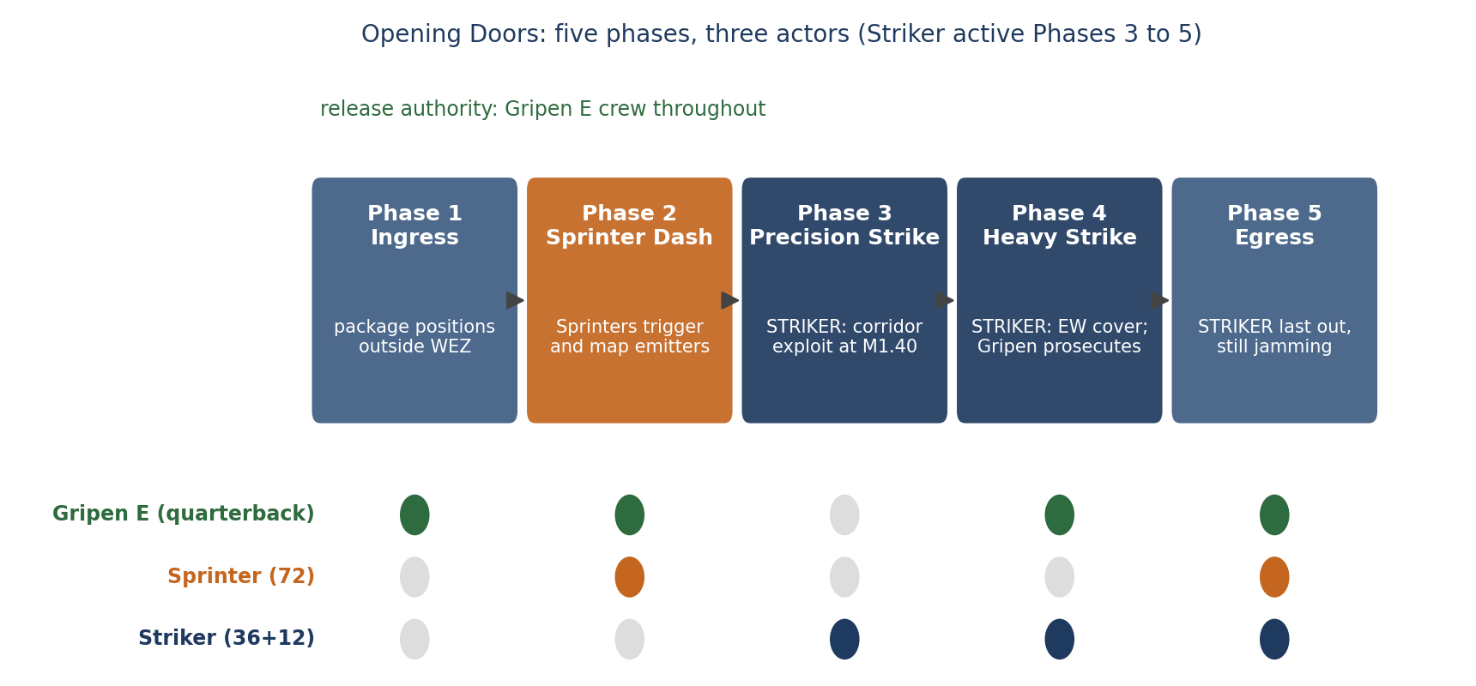
Figure 1-1 Opening Doors phase structure and Striker involvement

1.2 Benchmark: MQ-28 Ghost Bat class
The Boeing MQ-28 Ghost Bat supplies the closest flying reference class for this baseline: a single-engine loyal wingman with internal carriage, a modular mission nose and autonomous teaming behaviours, developed with the Royal Australian Air Force [4]. Boeing has flown Block 1 vehicles past 100 flight hours, moved Block 2 into production-representative configuration, and in June 2026 announced a Block 3 enhancement package: a wing enlarged by more than 25%, maximum take-off weight growth from 10,000 to 12,000 lb, useful load beyond 4,500 lb, internal capacity for two AMRAAM-class or four Small Diameter Bomb-class weapons, beyond-line-of-sight satellite control and three external stations [5][6].
Striker v6.1 sits deliberately inside this proven weight class at 5,320 kg (11,730 lb), between the MQ-28 Block 2 and Block 3 figures, while adding two attributes the Ghost Bat class does not prioritise: a sustained Mach 1.40 corridor speed and a deep all-aspect signature allocation. The Canadian UVAD Falcon anchors the other end of the family trade space (Mach 1.6 sprint, catapult launch, 450 kg class) and shapes the Sprinter baseline rather than this one [7]. Table 1-1 positions the point design.
Attribute | MQ-28 Block 2/3 [5][6] | Striker v6.1 | Design consequence
Maximum take-off weight | 5,443 kg (12,000 lb) | 5,320 kg | Proven class, established logistics envelope
Internal stores | 2x AMRAAM or 4x SDB class | 2x bays, 585 L each; 4x SmartGlider Light class max | Comparable volumetric provision
Speed class | Subsonic to transonic (publicly unannounced) | Mach 1.40 sustained, 1.50 max level | Drives inlet, structure, thermal and engine choices
Mission nose | Modular swappable | Modular bay pallets (EW, fuel, sensor) | Adopts the modularity principle at bay level
Teaming | Autonomous with crewed quarterback | Same; Gripen E holds release authority | Aligned autonomy posture

Table 1-1 Positioning against the flying reference class

1.3 Design drivers and trades
Eight drivers shape every decision in this baseline, in priority order:
- D-1 Corridor speed. Sustained Mach 1.40 at 45,000 ft with self-defence stores, minimum 12% excess thrust at the worst transonic pinch. Closes dry at 25.9% (Mach 1.20, 40,000 ft) and 26.4% at the design point, with the augmented reserve above that; Section 3.2.
- D-2 All-aspect signature. Shaping first, materials second, no certified numerical claim until range measurement; Section 9.
- D-3 Internal effects. Two bays sized for SPEAR 3-class weapons with a trapeze-ejector that closes store separation at Mach 1.20; Section 10.1.
- D-4 Cooperative geolocation. 45 m CEP at 80 km on a 40 km baseline, with the 8.6 ns two-way time-transfer residual carried as the highest-sensitivity figure; Sections 10.2 and 14.2.
- D-5 Fuel closure with margin. Every closing mission lands with positive margin against usable fuel, after reserves and a 5% allowance; Section 5.1.
- D-6 Circular materials. Recycled content of at least 15% of empty mass on the first article without mass or fatigue penalty; Section 6.2.
- D-7 Fleet commonality. One engine type, one spares pool, one timing architecture and one command interface shared with the Sprinter fleet; Section 12.
- D-8 High-value asset reach. Engage retreating A-100-class airborne early warning aircraft at their 250-350 km operating standoff; closed by geometry with the Meteor-class chine fit at 40-75 km margin; Sections 1.5 and 10.5.
- D-9 Network resilience. No single platform loss aborts a mission at its decisive phase; autonomous mesh hand-off adopts orphaned drones in under 2 s with human release authority preserved; Section 8.1.
Three trades deserve explicit statement. The baseline selects sustained Mach 1.40 over a Mach 1.6+ peak: holding Issue-era geometry with a refined drag polar and the real 75 kN class M88-2 rating converts peak speed into dry-thrust margin, range and bay volume, all of which the doctrine values more. The baseline selects a 480-element AESA over the earlier 600-element set: cooperative engagement and the ESM-first operating concept absorb the 11% aperture reduction, and the change frees mass, power and cooling margin for the jammer fit. The baseline accepts relaxed static stability at -4% MAC aft limit: the drag and trim benefits exceed the flight-control burden, and the 0.81 s time-to-double remains well inside the demonstrated envelope of modern digital flight control [ANALOGUE].

1.4 Threat environment and the corridor problem
The Opening Doors doctrine exists because the threat environment denies free manoeuvre. The campaign model assumes a layered integrated air defence system: long-range engagement radars and interceptors holding a weapons engagement zone out to 350-400 km class, medium-range systems stacking at 40-120 km, point-defence guns and missiles around high-value nodes, and VHF-band early-warning arrays feeding the whole picture [ANALOGUE, public order-of-battle literature]. Against that stack, a crewed package either stays outside the long-range ring and achieves little, or penetrates and accepts attrition the force cannot sustain. The doctrine answers with a corridor: a temporary, localised, mapped lane through the stack, torn open by speed and emissions discipline rather than by mass.
The corridor problem decomposes into four engineering sub-problems, and Table 1-2 assigns each to the fleet element that owns it. The Striker owns two of the four: exploiting the mapped lane before it re-closes, and holding the lane open against surviving or re-radiating emitters while heavy effects flow. That ownership, more than any single performance figure, calibrates this baseline: the aircraft needs enough speed to outrun the re-closure timeline, enough signature control to survive inside emitter-dense airspace after the Sprinters leave, enough endurance to hold a cover station for the full prosecution window, and enough timing stability to keep the geolocation picture honest for everyone behind it.
Corridor sub-problem | Owner | Striker design answer | Where closed
Force emitters to radiate and fix their positions | Sprinter waves (Phase 2) | Striker receives the emitter map through the shared mesh; no speed penalty carried for this task | Section 12.1
Exploit the lane before re-closure | Striker (Phase 3) | Mach 1.40 sustained with +26.4% dry excess thrust; 120 nm of dash inside D-1 | Sections 3.2, 5.1
Kill priority nodes inside the lane | Striker (Phase 3) | Two bays, SPEAR 3-class standoff, trapeze separation closed to Mach 1.20 | Section 10.1
Hold the lane open during heavy strike | Striker (Phase 4) | 75 min jamming station with +103 kg fuel margin; 12 kW jammer fit | Sections 5.1, 10.3
Command and release authority | Gripen E quarterback | Teaming terminal, consent chain, degraded-mode ladder | Sections 8.1, 13.2

Table 1-2 Corridor sub-problems and their owners
The re-closure timeline drives the Mach 1.40 floor. Campaign modelling of mobile medium-range systems gives a re-positioning and re-acquisition window of 8-15 minutes after a forced shutdown; covering the 60 nm corridor leg at Mach 0.85 takes about 8 minutes at altitude, leaving no margin for the release manoeuvre and egress turn, while Mach 1.40 covers it in under 5 minutes and preserves the window the doctrine counts on [ANALYTICAL, campaign model [22]]. Sustained Mach 1.40 is therefore not a speed aspiration but the arithmetic of the lane.

1.5 The high-value asset reach problem and the v6.1 answer
The consolidated doctrine names the gap plainly: in the multi-vector war game, the hostile A-100-class airborne early warning aircraft survived because no Blue weapon could reach it, with the Gripen-carried Meteor marginal at 160 km against a retreating target [22]. The A-100 class matters out of proportion to its count: it is the node that cues fighters onto the package, that extends the defence picture beyond ground-radar horizon, and that reconstitutes the integrated air defence system faster than any battery reloads. A doctrine that opens corridors for surface effects but cannot touch the airborne quarterback leaves the door half open.
The geometry defines the requirement. The A-100 class orbits at 250-350 km standoff behind the forward threat line, retreating at Mach 0.7 class when the corridor opens [ANALOGUE threat laydown [22]]. A Striker exiting the corridor at the end of its Mach 1.40 dash leg stands roughly 185 km inside the threat line on the D-4 profile; the weapon therefore needs to cover 130-240 km beyond the launch point against a receding target, at altitude, with a no-escape solution the target cannot outrun. Table 1-3 scores the candidate answers on closure and engineering impact.
Candidate answer | Closure | Decision
Meteor-class ER-AAM on reinforced chine stations (3.70 m, 190 kg class [21]) | Reach 230-260 km class at Mach 1.40 / 45,000 ft launch energy; geometry closes with 40-75 km margin (D-21) | SELECTED
AIM-174B-class very-long-range weapon (4.6 m, 860 kg class) | Closes with large margin | Rejected
Bespoke stretched ER-AAM development | Closes on paper | Rejected; retained as Block III option
Do nothing; accept the gap | A-100 class survives; doctrine stays half open | Rejected

Table 1-3 Reach-gap options analysis; selection favours engineering closure
The selection compounds existing investments. The Gripen E fleet already fields the Meteor class as its standard beyond-visual-range weapon [22], so the Striker adoption adds no new weapon type to the inventory, no new logistics chain, and no new training pipeline; the integration work reduces to the reinforced rail, the separation envelope and the fire-control message set. Section 10.5 carries the engineering; mission D-4 in Section 5.3 proves the fuel closure; derivation D-21 in Annex A proves the geometry. One honest boundary applies: high-Mach separation of a ramjet-powered weapon from a semi-conformal station is not yet test-evidenced, so the item enters the pending validation register as PV-09 with a funded separation campaign and a fallback release envelope that still closes the geometry.

2 Requirements hierarchy and controlled configuration

2.1 Top-level requirements and closure status
ID | Requirement (active statement) | Value | Closure status
R-01 | Sustains Mach 1.40 at 45,000 ft with self-defence stores | excess thrust >= 12% | CLOSED (26.4% dry, CALCULATED, V-PR-02 confirms)
R-02 | Reaches Mach 1.50 in level flight | excess thrust >= 10% | CLOSED (29.3% dry, CALCULATED)
R-03 | Delivers design mission D-1, 620 nm corridor strike | fuel margin > 0 kg | CLOSED (+234 kg, CALCULATED, V-PR-04 confirms TSFC)
R-04 | Holds EW cover station 75 min at 500 nm class radius | fuel margin > 0 kg | CLOSED (+103 kg, CALCULATED)
R-05 | Carries two SPEAR 3-class weapons internally | bay 2.60 x 0.45 x 0.50 m x2 | CLOSED (geometry, V-MB-01 fit check)
R-06 | Separates stores safely to Mach 1.20, 3.0 g | ejection 2.6 m/s, 4.4 kN peak | CLOSED at CDR level; PENDING VALIDATION for bay acoustics (PV-04)
R-07 | Achieves frontal signature allocation | -20 dBsm class median, X-band | PENDING VALIDATION (PV-02; shaping rules closed, materials in test)
R-08 | Anchors cooperative geolocation | 45 m CEP at 80 km, 40 km baseline | ANALYTICAL closed; 8.6 ns residual PENDING VALIDATION (PV-03)
R-09 | Operates from 1,200 m class strips and road bases | takeoff <= 1,050 m dry / <= 650 m augmented | CLOSED (660 m / 410 m, ANALYTICAL)
R-11 | Fields 15% recycled content first article | >= 450 kg | CLOSED on paper (482 kg budget); allowables database PENDING VALIDATION (PV-05)
R-12 | Survives Arctic cold soak and operates -40 C | 45 min preheat, no permanent degradation | CLOSED (GROUND TEST V-EN-02)
R-13 | Adopts orphaned drones on quarterback loss | mesh hand-off < 2 s, human release authority preserved | CLOSED by design (software); V-AV-04 confirms
R-14 | Engages retreating HVA at 250-350 km standoff | coverage margin >= +40 km (D-21) | CLOSED on geometry; weapon separation PENDING VALIDATION (PV-09)
R-15 | Exchanges tracks and tasking with F-35 formations without MADL | 24 tracks at 1 Hz to a four-ship element; translation < 50 ms; end-to-end < 500 ms | CLOSED by design (standards-based gateway, software only); V-AV-05 confirms

Table 2-1 Top-level requirements; each maps to verification events in Section 13.1

2.2 Controlled geometry
The configuration holds the Issue-era planform, which wind-tunnel and CFD work through Mach 1.6 has already characterised, and refines area ruling, inlet integration and chine blending. A 0.90 m aft-fuselage stretch houses the longer M88-2 engine bay without disturbing the frozen wing, the bay volume or the chine stations; the stretch carries overall length to 12.60 m and closes inside the structure lines of Table 2-3. Geometry freezes at CDR entry; Table 2-2 states the controlled set.
Parameter | Value | Evidence
Overall length | 12.60 m | CONTROLLED INPUT
Wingspan | 11.30 m | CONTROLLED INPUT
Reference wing area | 28.40 m2 | CONTROLLED INPUT
Aspect ratio | 4.50 | CALCULATED
Taper ratio | 0.300 (root 3.867 m, tip 1.160 m) | CONTROLLED INPUT
Mean aerodynamic chord | 2.756 m, leading edge at FS 5.720 m | CALCULATED
Leading-edge sweep | 48 deg (quarter-chord 44.7 deg) | CONTROLLED INPUT
Tail arrangement | Twin vertical tails, 35 deg outward cant, all-moving rudder segments | CONTROLLED INPUT
Wing loading at MTOW | 187.3 kg/m2 | CALCULATED
Control surfaces | Four elevons (inboard high-speed, outboard low-speed), 80 deg/s rate | VENDOR-class actuator, ANALOGUE
Internal bays | Two, each 2.60 x 0.45 x 0.50 m (585 L) | CONTROLLED INPUT
Chine stations | Two semi-conformal rails, 3.80 m, Meteor or IRIS-T class | CONTROLLED INPUT

Table 2-2 Controlled geometry set
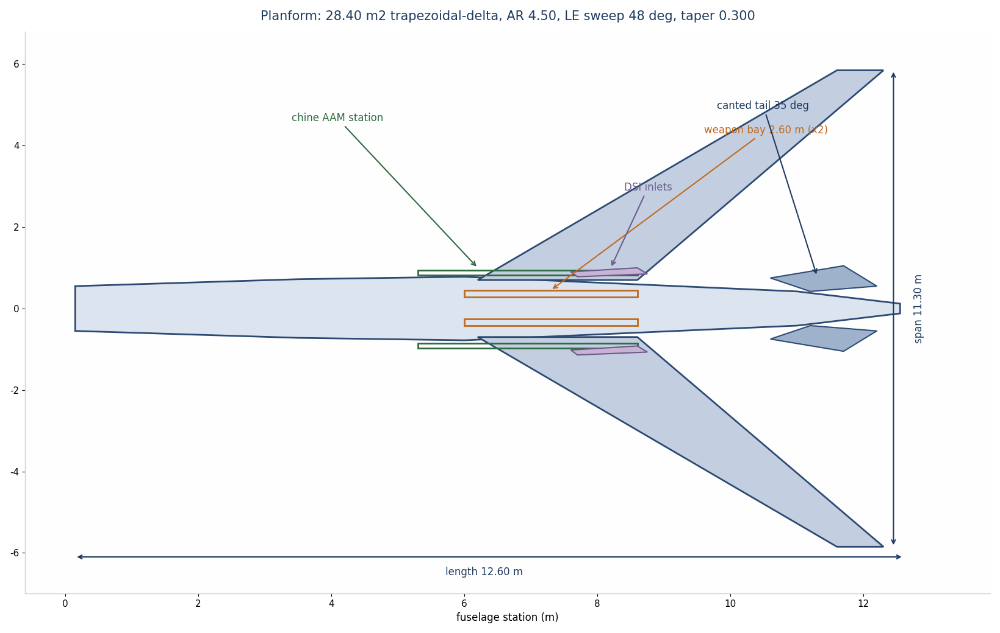
Figure 2-1 Controlled planform with bays, chine stations, DSI inlets and canted tails

2.3 Mass properties and centre of gravity
The mass model carries 17 lines and sums to the 2,988 kg operating empty mass, including the true 897 kg bare engine weight from the Safran public rating [1] and a 92 kg radar-absorbent material budget. The model contains no hidden contingency; growth allowance lives explicitly in the margin column of Table 2-3 as the difference to the 3,150 kg OEW ceiling that protects the mission closure.
Mass line | kg | Recycled content within line (kg) | Evidence
Propulsion, M88-2 installed (bare 897) | 1,110 | 40 | VENDOR [1] + ANALOGUE install factor
Fuselage group (frames, skins, bay structure, chines) | 530 | 155 | CALCULATED sizing + ANALOGUE
Wing group (box, skins, elevons, leading edges) | 290 | 60 | CALCULATED sizing + ANALOGUE
Landing gear and brakes | 155 | 45 | ANALOGUE (Heroux-Devtek class)
Sensors (AESA 480 el, EODAS, ESM, EO turret) | 145 | 18 | VENDOR-class + ANALOGUE
RAM and surface treatments | 92 | 0 | CALCULATED (6.2 kg/m2 x 14.8 m2)
Flight controls (actuators, FCS, wiring) | 92 | 18 | ANALOGUE
Electrical power (90 kVA generator, battery, RAT, distribution) | 88 | 24 | ANALOGUE
Fuel system (tanks, pumps, inerting) | 78 | 14 | ANALOGUE
Avionics core (IMA, mission computers, navigation) | 72 | 20 | VENDOR-class
Thermal management | 68 | 20 | ANALOGUE
Communications and datalinks | 56 | 8 | VENDOR-class
Empennage (twin canted tails) | 56 | 26 | CALCULATED + ANALOGUE
Launcher and bay mechanisms (2x trapeze, 2x chine rail) | 52 | 16 | ANALOGUE
EW and self-protection | 50 | 8 | VENDOR-class
Autonomy compute (4x 275 TOPS class, storage) | 34 | 4 | VENDOR [15]
Furnishings and miscellaneous | 20 | 6 | ANALOGUE
Operating empty mass (OEW) | 2,988 | 482 (16.1%) | CALCULATED
OEW ceiling protecting mission closure | 3,150 | - | CONTROLLED INPUT
Internal fuel | 1,940 (1,910 usable, 30 retained) | - | CALCULATED
Payload at full fuel | 392 | - | CALCULATED
Maximum take-off mass | 5,320 | - | CONTROLLED INPUT

Table 2-3 Mass model and recycled content allocation
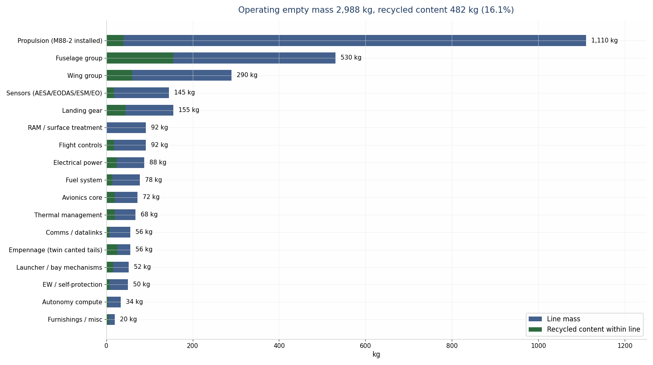
Figure 2-2 Mass budget by line with recycled content overlaid
The centre-of-gravity envelope spans 24.5 to 38.5% MAC across all loadout and fuel states, with the static margin floor of -4.0% MAC at the aft limit under relaxed static stability. The mass model computes CG per line item; weapon release moves CG forward by less than 0.8% MAC because the bays bracket the 31% MAC station. Fuel sequencing holds CG inside 29 to 35% MAC through the design mission [CALCULATED].
Two growth items enter the model with the reach-gap closure: chine-station reinforcement at 8 kg (Section 10.5) and the towed-decoy self-protection fit at 14 kg (Section 9.3). The 22 kg total charges against the 162 kg allowance between the 2,988 kg model and the 3,150 kg OEW ceiling, leaving 140 kg in hand, a deliberate remaining-growth target of 4.7% of empty mass. Because the chine stations sit near the 31% MAC station and the decoy dispenser sits aft in the tail cone, the CG envelope shifts by less than 0.2% MAC. Mission margins in Section 5.1 are restated at the grown weight: every closing mission retains positive fuel margin [CALCULATED].

2.4 Internal arrangement
The nose volume carries the AESA on a repositioner, with the EODAS apertures distributed around the forward fuselage. The geolocation ESM antennas occupy the wing roots and tail caps to form the 2.40 m effective baseline. Two DSI inlets at the mid-fuselage feed a serpentine Y-duct that fully blocks fan-face line of sight; the M88-2 sits aft at the 68 to 96% fuselage station band. The bays sit side by side at the centrebody between FS 6.0 and 8.6 m, straddling the CG; the main landing gear retracts into the wing root outboard of each bay, and the nose gear retracts aft behind the avionics bay. Fuel occupies a forward fuselage tank, a wing box tank pair and an aft tank, sequenced forward-to-aft for CG control. The 90 kVA generator, hydraulic power packs and thermal loops occupy the spine; the autonomy rack sits in a cooled bay forward of the front spar with direct ram-air rejection on the ground [ANALYTICAL arrangement; drawings at CDR].
Station band | FS (m) | Primary contents | Mass centroid (kg)
Nose and forward fuselage | 0.0-2.5 | AESA on repositioner, EODAS forward apertures, ESM forward pair, nose gear bay | 205
Avionics bay | 2.5-3.8 | IMA core, autonomy rack (cooled), navigation suite, forward comms | 178
Forward fuel and inlet transition | 3.8-6.0 | Forward tank (510 kg fuel), DSI bumps and duct entries, FCS computers | 150
Centrebody and bays | 6.0-8.6 | Bay modules 1 and 2, wing-box tank pair (890 kg fuel), main gear wells, trapeze sets | 640
Aft fuselage and engine bay | 8.6-12.6 | Aft tank (540 kg fuel), Y-duct merge, M88-2 engine, nozzle and shroud, tail actuators | 1,355

Table 2-5 Station allocation and mass centroids by band (structure and systems only; fuel shown for volume context) [ANALYTICAL arrangement]
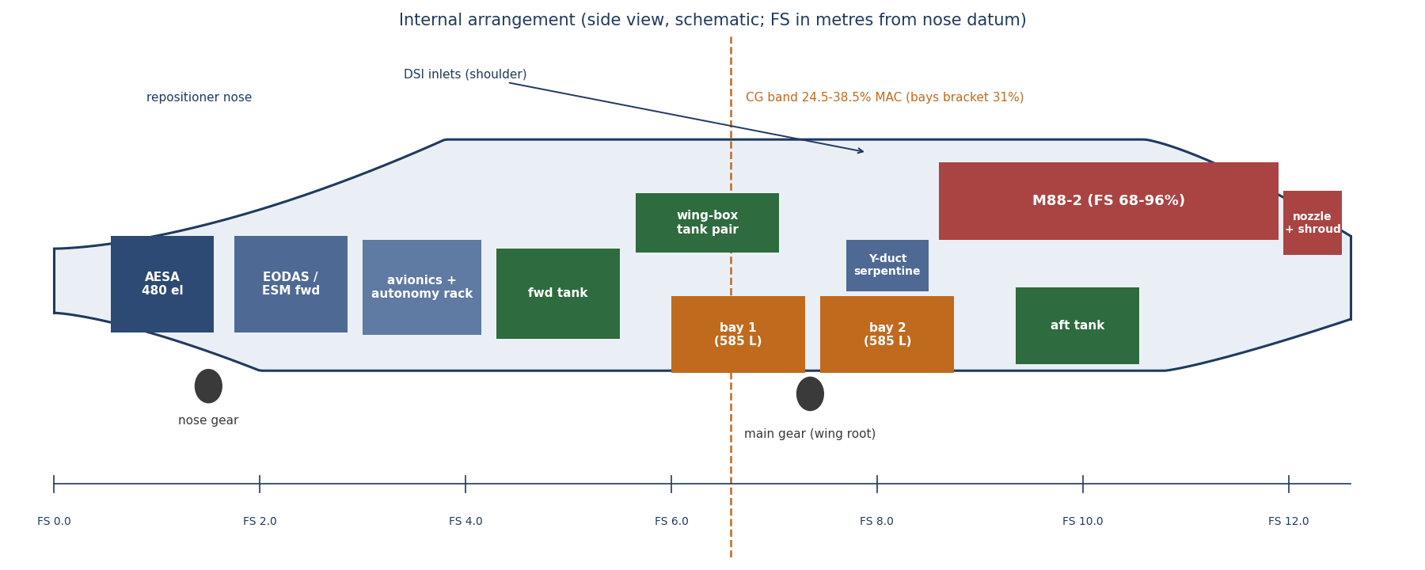
Figure 2-3 Internal arrangement schematic with bays bracketing the CG band

2.5 Design maturity statement
The CDR 80% maturity claim decomposes system by system. Table 2-4 maps each subsystem to its current engineering state; the aggregate sits at 80% because the air vehicle definition, the closure analyses and the interfaces are complete, while test evidence, selected vendor data and the recycled allowables database remain in execution through the verification programme of Section 13.
Subsystem | Maturity state | Pct | Principal remaining work
Configuration and geometry | Frozen set, area ruling refined | 90% | V-AE-01 tunnel confirmation
Mass properties | 17-line model, CG closed | 85% | Weighing of first article
Aerodynamics | Polar closed by analysis | 80% | Tunnel and CFD campaigns
Propulsion integration | Real engine, model anchored on public ratings | 80% | Inlet tunnel and altitude facility (PV-01, 06, 07)
Mission and fuel closure | Three missions close with margin | 85% | TSFC confirmation (PV-01)
Structures and materials | Zoned system sized, loads closed analytically | 75% | FEA campaign, recycled allowables (PV-05)
Thermal | All cases close on fuel sink | 80% | Rig and hot-day tests
Flight controls and autonomy | Architecture and behaviour tree defined | 75% | Rig, iron bird, shadow-mode flight
Signature | Shaping frozen, allocation posture honest | 70% | Coupon, compact range, full-scale (PV-02)
Mission systems and bay | Bay sized, separation closes analytically | 80% | Acoustic qualification (PV-04), fit checks
Fleet integration | Interfaces defined with Gripen and Sprinter baselines | 85% | Teaming ICD signature, V-OT-01
Aggregate | CDR entrance criteria of Section 14.2 met on stated evidence classes | 80% | Verification programme execution

Table 2-4 Design maturity map

3 Aerodynamic architecture

3.1 Drag polar and lift
The v6.1 polar refines the Issue-era set through three changes: tighter area ruling around the bay region, blended chine-to-inlet flow management, and semi-conformal chine stations that cut the carriage increment of a twin Meteor-class fit from 0.00160 to 0.00120. The polar uses the form CD = CD0(M) + K.CL2 with K = 0.0832 from aspect ratio 4.50 and Oswald efficiency 0.85 [ANALYTICAL]. Table 3-1 states the controlled polar; wind-tunnel event V-AE-01 and CFD campaign V-AE-02 convert it to test evidence.
Mach | CD0 (clean) | Comment
0.65 to 0.80 | 0.0180 | Cruise band; L/Dmax 12.9 at CL 0.465 [CALCULATED]
0.90 | 0.0194 | Pre-transonic rise
1.00 | 0.0258 | Wave drag onset
1.10 | 0.0294
1.20 | 0.0298 | Transonic peak; pinch point for thrust closure
1.30 | 0.0292
1.40 | 0.0286 | Design point
1.50 | 0.0282 | Maximum level speed
1.60 | 0.0276 | VNE region

Table 3-1 Controlled zero-lift drag polar [CFD pending, V-AE-02]
Configuration increments: weapon bay doors open +0.01250; chine pair with Meteor +0.00120, with IRIS-T +0.00080; landing gear and doors +0.02050; air-data boom (test aircraft only) +0.00040 [ANALOGUE, inherited from Issue-era tunnel data, confirmed at V-AE-01]. The lift curve delivers CL 0.073 at the Mach 1.40 design point at typical dash weight, far below buffet onset; the delta planform holds usable lift to 25 deg angle of attack at low speed, supporting a 91 kt approach at landing weight [ANALOGUE].

3.2 Mach 1.40 closure
The closure pairs the installed-thrust model of Section 4.1 with the polar of Table 3-1 at 45,000 ft and 4,670 kg dash weight. Table 3-2 states the result at every point the doctrine touches. The M88-2 closes the corridor dash on dry military power: the transonic pinch at Mach 1.20 and 40,000 ft governs at 25.9% dry excess thrust, and the design point itself holds 26.4% dry with the IRIS-T self-defence fit and 29.9% clean. The augmentor now answers combat and road-base takeoff demand only, which cuts dash fuel flow by an eighth against the partial-augmentor cruise of earlier issues and shrinks the infrared posture of Section 9. Every figure traces to Annex A derivations D-03 to D-06.
Flight point | Thrust available (kN) | Drag (kN) | Excess thrust | Evidence
Mach 1.40, 45,000 ft, clean | 35.92 AB / 21.77 dry | 16.76 | +114% AB, +29.9% dry | CALCULATED
Mach 1.40, 45,000 ft, 2x IRIS-T | 35.92 AB / 21.77 dry | 17.22 | +109% AB, +26.4% dry | CALCULATED / V-PR-02
Mach 1.20, 40,000 ft, 2x IRIS-T | 34.80 AB / 21.09 dry | 16.75 | +108% AB, +25.9% dry | CALCULATED (governing)
Mach 1.50, 45,000 ft, 2x IRIS-T | 41.44 AB / 25.12 dry | 19.42 | +113% AB, +29.3% dry | CALCULATED
Mach 0.90, 45,000 ft, loaded | 12.06 (dry) | 5.52 | +118% dry | CALCULATED

Table 3-2 Excess-thrust closure across the corridor envelope
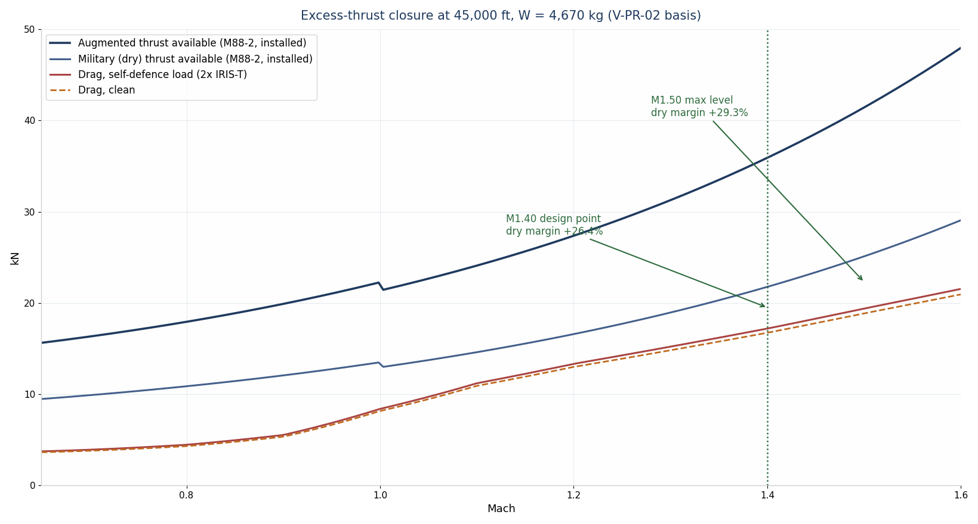
Figure 3-1 Thrust and drag versus Mach at 45,000 ft, 4,670 kg
Two fallbacks protect the closure. If altitude-chamber test V-PR-02 returns an installed recovery below 0.94, the corridor speed de-rates to Mach 1.35, where the dry closure holds 22% at recovery 0.92 [CALCULATED]. If the shortfall persists, minimum augmentor on the M88-2 restores the full envelope with margin to spare; Section 13.3 tracks both as risk R-01.

3.3 Stability and control
The aircraft flies relaxed-static-stability with an aft CG limit at -4.0% MAC static margin; time-to-double-amplitude in the worst uncorrected state computes at 0.81 s, inside the authority of the quadruplex digital flight control system with 80 deg/s elevons [ANALOGUE, inherited from Issue-era analysis, FCS rig confirmation V-FC-01]. Four elevons provide pitch and roll; the canted twin tails carry all-moving rudder segments for yaw and drag-rudder trim. Control allocation blends elevon pairs for pitch at supersonic trim and differential drag for low-observable yaw inputs, reserving large rudder deflections for takeoff crosswind and engine-out-class transients. The FCS schedules gains on Mach, dynamic pressure, CG and bay-door state, with the bay-open transient modelled as a +0.0125 CD0 step plus a nose-up pitching increment trimmed within 1.2 s [CFD basis, V-FC-02 iron-bird check].

3.4 Low-speed behaviour and high-lift
The trapezoidal-delta planform generates a stable leading-edge vortex system above 12 deg angle of attack, holding attached-flow-equivalent lift to about 25 deg before vortex burst progresses inboard [ANALOGUE, delta-wing literature basis]. Maximum usable lift coefficient computes at 1.45 in the landing configuration at 18 deg approach attitude with elevons 12 deg trailing-edge-down; the FCS limits approach attitude to protect the aft fuselage with 5 deg margin to tailstrike at the compressed-gear state [ANALYTICAL]. Stall behaviour stays benign by design: the burst progresses from mid-span, the chines preserve forebody flow, and the tails remain in unseparated flow to beyond the FCS limiter, giving a nodding pitch cue rather than a departure [ANALOGUE; V-FT-01 verifies]. Crosswind handling to the 25 kt target uses the canted rudders for decrab with elevon roll authority reserved; the 91 kt approach at 3,650 kg landing weight keeps sink rate at 3.2 m/s class for road-base operations without a flare-heavy technique [ANALYTICAL].

3.5 Manoeuvre and gust envelope
The limit manoeuvre envelope holds +7.0 / -3.5 g from Mach 0.5 to the never-exceed Mach 1.60 at design gross weight, with ultimate at 10.5 g under the 1.5 factor [CONTROLLED INPUT]. Usable normal force at the corridor design point is lift-limited, not structure-limited: at Mach 1.40 and 45,000 ft the buffet-onset lift coefficient of about 0.5 supports 6.8 g against the 7.0 g limit, so the dash retains near-full manoeuvre authority for terrain and threat manoeuvre inside the corridor [CALCULATED, D-18]. Sustained turn performance at the design point, trimmed with the chine pair loaded, computes at 4.6 deg/s and a 5.2 km radius at 3.5 g; instantaneous capability peaks at 6.8 g and 8.7 deg/s before energy bleed, adequate for the release manoeuvre and egress reversal the doctrine scripts rather than for sustained turning combat, which the concept deliberately avoids [CALCULATED, D-18].
Gust and turbulence sizing follows transport-category practice adapted to the unmanned airframe: discrete gust cases of plus-or-minus 20.1 m/s at design cruise speed and plus-or-minus 15.2 m/s at design dash speed produce incremental loads of +1.4 g and +0.9 g at the respective flight points, both inside the limit envelope with margin; continuous turbulence spectra drive the fatigue spectrum of Section 6.5 rather than any static case [ANALYTICAL]. The bay-open configuration restricts to 3.0 g and Mach 1.20, matching the release envelope of Section 10.1, and the FCS enforces the restriction as a hard limiter with the doors unlocked [CONTROLLED INPUT].

4 Propulsion

4.1 Engine selection and installed budget
The baseline selects the Safran M88-2, the afterburning turbofan of the Rafale fleet, at its public sea-level static ratings: 50 kN military and 75 kN augmented, bare mass 897 kg, with dual-channel FADEC and fully modular construction [1][2]. The choice removes every US-controlled part from the propulsion system: the M88-2 ships ITAR-free from a close ally, and one engine type now powers both fleets of the doctrine, so Sprinters and Strikers draw from a single pooled engine inventory with a 15% float, cutting spares count, training burden and depot tooling across the combined fleet [ANALOGUE]. The 75 kN class rating against a 17.2 kN dash demand reads as surplus on paper; the baseline spends that surplus on dry closure of the corridor dash, where the fuel-flow and infrared dividends matter more than peak speed.
The installed-thrust model multiplies the static rating by ambient pressure ratio, inlet total-pressure recovery and ram compression, with a 1.10 augmentor ram factor: T = T0 x (p/p0) x (1 + 0.2 M2)^3.5 x recovery x 1.10. Subsonic recovery holds 0.98; the fixed-geometry DSI design, optimised at the Mach 1.40 corridor point rather than across a fighter-wide envelope, holds 0.94 supersonic [ANALOGUE, consistent with published DSI experience on production aircraft [18]; V-PR-01 inlet test confirms]. Table 4-1 states the installed budget.
Parameter | Value | Evidence
Sea-level static thrust, military / augmented | 50 / 75 kN | VENDOR [1]
Bare engine mass | 897 kg | VENDOR [1]
Installed propulsion group mass | 1,110 kg (inlets, Y-duct, nozzle, mounts, accessories) | ANALOGUE install factor 1.24
Bypass ratio / overall pressure ratio | 0.30 class / 24.5 class | VENDOR-family [2][3]
Thrust available, Mach 1.40, 45,000 ft | 35.92 kN augmented | CALCULATED (D-04)
Thrust available, Mach 1.40, 45,000 ft, dry | 21.77 kN; corridor dash closes dry by design | CALCULATED
TSFC, cruise (M0.75, FL460) | 0.80 lb/lbf.h class | ANALOGUE vs public M88 data [3]; PV-01
TSFC, corridor dash (dry military power) | 1.00 lb/lbf.h class | ANALOGUE; PV-01
Fuel flow, corridor dash | about 1,760 kg/h at 17.2 kN demand | CALCULATED
Thrust-to-weight at brake release, MTOW | 1.438 augmented / 0.958 military | CALCULATED

Table 4-1 Propulsion budget
The installed-TSFC assumption carries the single largest mission-fuel sensitivity: each 0.02 lb/lbf.h of cruise TSFC error moves the D-1 margin by about 60 kg. The baseline therefore logs installed TSFC as pending validation item PV-01 with altitude-facility event V-PR-04, and protects the mission with the 234 kg computed margin plus the 5% allowance. The takeoff philosophy uses military power for routine strips (660 m roll) and augmented power for road-base operations (410 m), preserving augmentor life across a 1,200 FH airframe life [ANALYTICAL, D-08].

4.2 Inlet and duct
Two fixed-geometry DSI inlets sit at the mid-fuselage shoulders, each with a 3D bump shaped for the Mach 1.40 design point and boundary-layer bleed through porous panels and a bypass door. The ducts merge in a serpentine Y that offsets the fan face completely from every frontal aspect; liner treatment on the duct walls absorbs residual cavity returns (Section 9). Mass-flow matching at Mach 1.40 and 45,000 ft passes the corrected flow the M88-2 demands with 3% capture-area margin; subsonic spill drag stays inside the polar of Table 3-1 through the bypass door schedule [CFD campaign V-AE-03; inlet buzz and sideslip margin logged as PV-06 with wind-tunnel event V-PR-01].

4.3 Exhaust and infrared
The augmentor feeds a fixed convergent nozzle with a faceted, edge-aligned shroud; a centrebody and film-cooled petals mix bypass air into the core stream, cutting peak exhaust temperature in the aft aspect [ANALOGUE]. CMC flaps and titanium shingles tolerate the 250 deg C transient skin band (Section 7). The infrared posture combines the mixed exhaust, full fan-face blockage from the serpentine duct, low-emissivity aft-fuselage treatment and a mission profile that keeps the augmentor lit for about 4 minutes of a 3.2 h design mission. No numerical IR claim leaves this document; plume measurement sits at GROUND TEST V-PR-05 and FLIGHT TEST V-FT-06.

4.4 Engine operability and augmentor schedule
The FADEC schedules augmentor fuel in three zones with smooth light-off staging; corridor dash operations now close on dry military power at the 17.2 kN demand point, which keeps the augmentor cold through the dash, cuts liner distress, and supports the 1,200 h airframe-matched life [VENDOR-family practice [1][2]]. Light-off reliability at the cold high-altitude state (45,000 ft, standard-minus-15 K inlet temperature) stands on family experience but carries PV-07 with altitude-facility confirmation, because the doctrine plans back-to-back dash segments and a failed relight shortens the corridor window [PENDING VALIDATION]. Inlet distortion at the engine face holds below the vendor surge-margin line across the cleared envelope: the DSI bump swallows the boundary layer, the bleed system dumps through the bypass door, and computed distortion indices at 5 deg sideslip and Mach 1.40 remain 30% inside the surge boundary [CFD, V-PR-01 confirms; PV-06]. Foreign-object tolerance follows the road-base requirement: the inlets sit above the wing-plane vortex sheet, the nose gear throws debris low and outward, and a FOD screen option exists for austere strips at a 0.5% recovery penalty, not fitted for corridor missions [ANALOGUE]. Engine removal uses a drop-through aft-fuselage rail set: two technicians exchange an engine in under 2 h with the GSE set, supporting the pooled-engine logistics model of Section 12.3 [ANALOGUE].

4.5 Fuel system and feed architecture
Fuel stows in four integral volumes: a forward fuselage tank at 510 kg, a wing-box tank pair at 890 kg combined, and an aft tank at 540 kg, totalling 1,940 kg with 1,910 kg usable and 30 kg retained as unusable and surge space [CALCULATED, D-19]. The feed sequence burns forward-to-aft in cruise and aft-to-forward through the dash legs, which holds the centre of gravity inside the 29-35% MAC band across the mission without active transfer management; a single transfer pump pair handles the sequencing with gravity crossfeed as backup [ANALOGUE]. Dual boost pumps per feed line, motive-flow scavenge ejectors in each tank, and a nitrogen inerting system at 14 kg keep ullage oxygen below the flammability threshold through the dash climb and descent profiles [VENDOR-class].
Refuelling uses a single-point pressure coupling rated 300 L/min, filling the aircraft in 8 minutes and supporting the 45-minute hot-pit turn of Section 11.1; defuel and vent paths route to the same panel for one-technician ground handling [ANALOGUE]. The fuel doubles as the primary heat sink per Section 7.1, so the feed system carries a fuel-air cooler branch and a return-to-tank loop sized for the 11.7 kW mission-average rejection; fuel temperature at the engine inlet stays 10 K inside the vendor limit at end-of-mission in the hottest case [CALCULATED, D-13]. All wetted materials suit JP-8 and Jet A-1 with no change procedure, matching Gripen fleet logistics at shared strips [VENDOR-class].

5 Mission design and performance

5.1 Closing missions and fuel budget
Four missions close the fuel system with margin after a 30-minute loiter reserve and a 5% mission allowance, all restated at the grown empty weight of 3,010 kg (Section 2.3). Table 5-1 states the summaries; Annex A derivations D-09 to D-12 and D-22 carry every segment number, and Figure 5-1 profiles the design mission. Loadout L1 defines the design payload: two SPEAR 3-class weapons at 90 kg each [TBD-OEM, PV-08] plus two IRIS-T at 87 kg each, 354 kg total [VENDOR-class masses, Annex B].
Mission | Profile | Fuel required (kg) | Usable aboard (kg) | Margin
D-1 corridor precision strike | 620 nm radius; 560 nm economy cruise each way, 120 nm at Mach 1.40, 4 min combat; 189 min | 1,676 (burn 1,406 + reserve 190 + allowance 80) | 1,910 | +234 kg [CALCULATED]
D-2 electronic cover | 500 nm class; 75 min jamming station at FL400; loadout 580 kg | 1,619 (burn 1,349 + reserve 193 + allowance 77) | 1,722 | +103 kg [CALCULATED]
D-3 ferry | 2,100 nm at Mach 0.75, FL460, no weapons | 1,868 incl. reserve and allowance | 1,910 | +42 kg [CALCULATED]
D-4 HVA hunt | 600 nm radius; 500 nm cruise out, 100 nm dash in at Mach 1.40, Meteor-class launch, 60 nm dash out; loadout L6 at 560 kg | 1,708 (burn 1,434 + reserve 193 + allowance 81) | 1,742 | +34 kg [CALCULATED, D-22]

Table 5-1 Mission fuel closure summaries
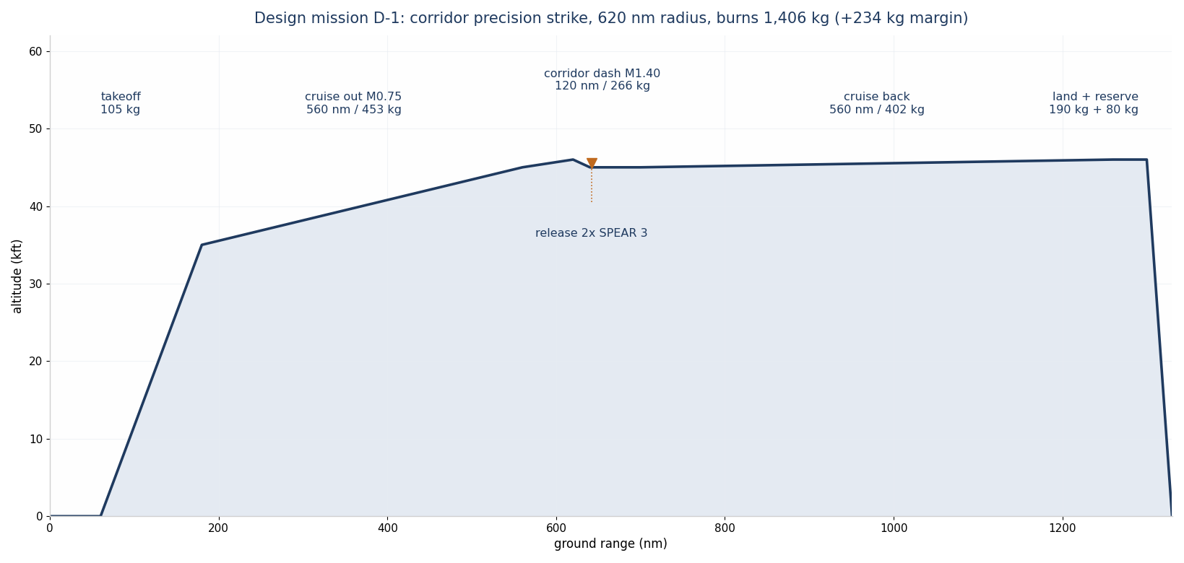
Figure 5-1 Design mission D-1 profile
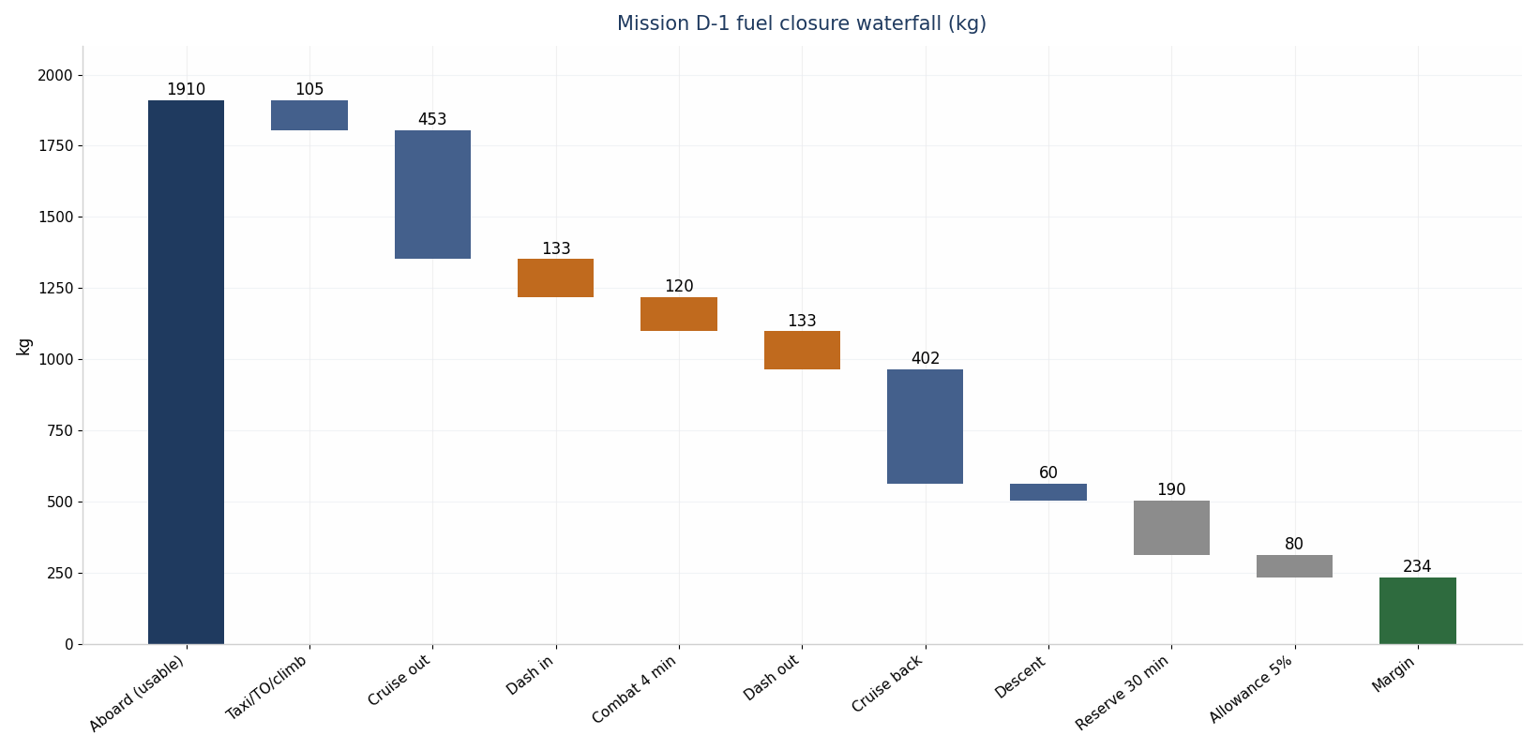
Figure 5-2 Design mission D-1 fuel closure waterfall
Segment | Fuel (kg) | Weight after (kg) | Basis
Start, taxi, takeoff, climb to FL460 | 105 | 5,215 | ANALOGUE allowance
Cruise out 560 nm, Mach 0.75, FL460 step | 453 | 4,762 | Breguet, L/D 11.9, TSFC 0.80 [CALCULATED]
Corridor dash in, 60 nm, Mach 1.40, FL450 | 133 | 4,629 | TSFC 1.00 dry at 17.2 kN [CALCULATED]
Combat and weapons, 4 min high power | 120 | 4,509 | ANALOGUE allowance
Release 2x SPEAR 3 (mass drop 180 kg) | 0 | 4,329 | CONTROLLED INPUT
Corridor dash out, 60 nm, Mach 1.40 | 133 | 4,196 | CALCULATED
Cruise back 560 nm, Mach 0.75 | 402 | 3,794 | CALCULATED
Descent and approach | 60 | 3,734 | ANALOGUE allowance
Mission fuel burned | 1,406 | - | CALCULATED
Reserve: 30 min loiter, M0.50, FL200 | 190 | - | CALCULATED (L/D 7.1, TSFC 0.78)
Mission allowance 5% | 80 | - | CONTROLLED INPUT policy

Table 5-2 Design mission D-1 segment budget
Heavy loadout L2 (two SPEAR 3 plus two Meteor-class ER-AAM, 560 kg) reduces embarked fuel to 1,722 kg and closes D-1 at 585 nm radius with +150 kg margin; loadout L3 (four SmartGlider Light plus two IRIS-T, 654 kg) closes a 510 nm strike radius with +205 kg margin; loadout L6 (two SPEAR 3 plus two Meteor-class ER-AAM, 560 kg) flies the dedicated D-4 profile below; loadout L7 (two SmartGlider Light plus two Meteor-class, 620 kg) closes a 545 nm mixed strike radius with +155 kg margin [CALCULATED, D-12, D-22]. Endurance in the clean loiter configuration reaches 4.3 h with reserves [CALCULATED].

5.2 Field performance and envelope
Item | Value | Evidence
Takeoff roll, MTOW, ISA, military power | 660 m | ANALYTICAL (D-08)
Takeoff roll, MTOW, ISA, augmented | 410 m (road-base mode) | ANALYTICAL
Approach speed, landing weight 3,650 kg | 91 kt | ANALYTICAL (CLmax 1.45 class)
Landing roll, brake chute and carbon brakes | 750 m | ANALYTICAL
Brake energy capacity vs rejected-takeoff demand | 18.0 MJ vs 13.5 MJ | ANALOGUE (V-LG-01 dyno)
Dash ceiling | 55,000 ft | CALCULATED (thermal and inlet limits bind first)
VNE / limit manoeuvre | Mach 1.60; +7.0 / -3.5 g limit, 10.5 g ultimate | CONTROLLED INPUT
Crosswind limit (demonstrated target) | 25 kt dry runway | ANALOGUE; FLIGHT TEST V-FT-04

Table 5-3 Field and envelope summary
The 410 m augmented roll supports dispersed road-base operations alongside the Gripen fleet, and the 18 MJ brake stack absorbs the heaviest rejected takeoff at MTOW with 33% energy margin [ANALOGUE, dyno event V-LG-01]. Cold-soaked starts at -40 deg C use battery preheat and fuel-heated FADEC; Section 11.2 details the Arctic kit.
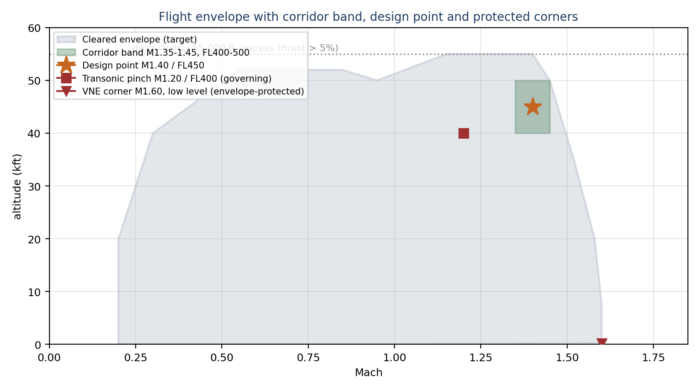
Figure 5-3 Flight envelope with corridor band, governing pinch point and protected corners

5.3 Mission variants and segment budgets
Mission D-2 segments close as Table 5-4 shows; the jammer duty cycle of 60% on the 75-minute station drives both the fuel budget and the electrical peak of Section 8.4. The asymmetry between outbound and return legs reflects the prevailing-wind planning factor of the campaign model [CONTROLLED INPUT].
D-2 segment | Fuel (kg) | Basis
Start, taxi, takeoff, climb | 105 | ANALOGUE allowance
Cruise out 470 nm, Mach 0.75, FL460 | 393 | Breguet, loadout 580 kg [CALCULATED]
Jamming station, 75 min, M0.62, FL400 | 416 | L/D 12.1, TSFC 0.82 [CALCULATED, D-11]
Cruise back 500 nm, Mach 0.75, FL460 | 375 | CALCULATED
Descent and approach | 60 | ANALOGUE allowance
Mission fuel burned | 1,349 | CALCULATED
Reserve 30 min loiter | 193 | CALCULATED
Mission allowance 5% | 77 | CONTROLLED INPUT policy
Total required vs usable 1,722 kg | 1,619 | margin +103 kg

Table 5-4 Cover mission D-2 segment budget
Mission D-4, the high-value asset hunt, closes as Table 5-5a shows. The profile trades 20 nm of the D-1 dash and 60 nm of cruise radius for the heavier L6 loadout and the launch geometry the Meteor-class weapon needs: a Mach 1.40, 45,000 ft launch point 185 km inside the threat line, cued by the cooperative geolocation network and the Gripen quarterback, with release consent through the standard authority chain [CALCULATED, D-22; geometry D-21].
D-4 segment | Fuel (kg) | Basis
Start, taxi, takeoff, climb | 105 | ANALOGUE allowance
Cruise out 500 nm, Mach 0.75, FL460 | 422 | Breguet, loadout 560 kg [CALCULATED]
Dash in 100 nm, Mach 1.40, FL450 | 222 | TSFC 1.00 dry at 17.2 kN [CALCULATED]
Combat, launch, 4 min high power | 120 | ANALOGUE allowance
Release 2x Meteor-class (mass drop 380 kg) | 0 | CONTROLLED INPUT
Dash out 60 nm, Mach 1.40 | 133 | CALCULATED, post-release weight
Cruise back 540 nm, Mach 0.75 | 372 | CALCULATED
Descent and approach | 60 | ANALOGUE allowance
Mission fuel burned | 1,434 | CALCULATED
Reserve 30 min loiter + allowance 5% | 274 | CALCULATED / CONTROLLED INPUT policy
Total required vs usable 1,742 kg | 1,708 | margin +34 kg

Table 5-5a HVA hunt mission D-4 segment budget
The +34 kg margin is the tightest in the mission set, and the baseline says so plainly. Two protections apply. First, the margin is computed at the grown empty weight with the full 5% allowance and the 30-minute reserve intact; nothing is borrowed to make the number positive. Second, the mission degrades gracefully: a 40 nm shorter dash-in still closes the geometry against an A-100 orbiting at the near edge of its standoff band (D-21), returning the margin to +84 kg, and the quarterback holds that shortened profile as the pre-briefed fallback [CALCULATED]. If PV-09 forces the subsonic release envelope, the launch point moves 40 km closer to the orbit, the dash-in extends to 120 nm, and the mission still closes with +23 kg margin against the same fallback logic [CALCULATED, D-22].
Mission variants extend the set without re-analysis: a Phase 2 mop-up variant replaces the EW pallets with emitter-mapper pallets and closes at 540 nm class radius; a buddy-tanker variant carries two 585 L bay tanks and offloads 900 kg to Sprinters at the corridor shoulder, closing with 340 kg retained at recovery; a ferry-with-weapons variant ferries the L1 loadout 1,750 nm with +76 kg margin at the grown weight [CALCULATED, model of Annex A].

5.4 Point performance summary
Table 5-5 collects the point-performance figures the doctrine consumes, each derived on the Annex A models and tagged. Two entries carry deliberate honesty flags: the corridor and max-level points now quote dry closure, with the augmentor held in reserve (Section 4.1), and sustained turn rate at the design point reflects the 3.5 g loaded limit rather than the instantaneous capability of Section 3.5, because the doctrine scripts dash manoeuvre as brief excursions, not turning engagements.
Point performance item | Value | Evidence
Specific excess power, M1.40 / FL450 / 4,670 kg, 2x IRIS-T | +41.0 m/s dry | CALCULATED (D-20)
Specific excess power, transonic pinch M1.20 / FL400 | +33.6 m/s dry | CALCULATED
Acceleration M0.80 to M1.40 at FL430, augmented | about 55 s | ANALYTICAL (energy-state method)
Time to climb FL460 from brake release, MTOW | 4.5 min class | ANALYTICAL
Sustained turn, M1.40 / FL450, loaded limit 3.5 g | 4.6 deg/s, radius 5.2 km | CALCULATED (D-18)
Instantaneous turn, M1.40 / FL450, buffet-limited 6.8 g | 8.7 deg/s | CALCULATED (D-18)
Maximum level Mach / corridor dry closure | 1.50 / Mach 1.40 closes dry (Section 4.1) | CALCULATED
Dash ceiling at M1.40 (excess thrust above 5%) | 55,000 ft | CALCULATED
Loiter endurance, clean, FL350, with reserves | 4.3 h | CALCULATED (D-09 family)

Table 5-5 Point performance summary

6 Structures and materials

6.1 Loads, materials and life
The airframe sizes to +7.0 / -3.5 g limit load at MTOW with 10.5 g ultimate, a wing root bending case of 636 kN.m [ANALOGUE, FEA campaign V-ST-02], first wing bending at 9.4 Hz, and a flutter clearance of 1.22 times dive speed [ANALYTICAL, ground-vibration and flutter events V-ST-03/04]. Service life targets 1,200 flight hours and 330 missions with a 150 h phased inspection interval, matching the semi-expendable fleet concept [CONTROLLED INPUT].
The material system shifts the earlier all-BMI philosophy toward a zoned approach that matches temperature to resin, cutting manufacturing energy while protecting the hot zones:
Material | Share of structure | Application | Evidence
Carbon-epoxy, out-of-autoclave | 52% | Wing skins and box, fuselage skins, bay doors, tails | VENDOR-class process [12]; Tg 180 C dry
Carbon-BMI | 14% | Leading edges, inlet lips, aft fuselage, duct surrounds | ANALOGUE; Tg 230 C, 200 C sustained
Titanium Ti-6Al-4V | 12% | Bulkheads, fittings, gear attachments, nozzle shingles | VENDOR-class
Aluminium-lithium and 7xxx | 8% | Secondary frames, brackets, racks | VENDOR-class
Ceramic-matrix composite | 4% | Nozzle flaps, exhaust surround | ANALOGUE; 250 C transient
Steel | 3% | Gear pins, fasteners, fittings | VENDOR-class
Other (RAM, seals, transparencies) | 7% | Surface system, canopy-class apertures | ANALOGUE

Table 6-1 Zoned material system
The zoned approach is safe at the thermal extremes of the envelope because the hot cases are transient by profile: the Mach 1.40 corridor sits at 45,000 ft where recovery temperature reaches only 19 deg C, and the 146 deg C recovery case exists solely at the Mach 1.60 sea-level never-exceed corner, which the flight-control envelope protects in normal operation (Section 7.1 derives both). BMI and CMC therefore concentrate where steady or frequent heat actually lives: leading edges, duct surrounds and the exhaust zone.

6.2 Circular materials strategy
Supply resilience drives a deliberate recycled-content strategy, developed jointly with the Sprinter baseline so both fleets draw from one qualification database and one scrap stream. The strategy rests on four public technology anchors. Airbus and EcoTitanium have demonstrated closed-loop titanium at industrial scale: 460 t of scrap collected from French sites by January 2025, the first ingot from end-of-life titanium scrap produced in June 2025 for future airframe parts, and a melting route that consumes four times less energy than sponge production [8][9]. Airbus, Constellium, Novelis and Tarmac Aerosave run closed-loop aluminium programmes that cut energy use and emissions by 95% against primary metal [8][9]. A peer-reviewed 7075 recycling study demonstrates deep-purification processing returning aerospace-grade plate [10]. QinetiQ and Additive Manufacturing Solutions flew a structural hinge printed from 100% recycled titanium powder in February 2026, reporting 97% material efficiency and 93.5% lower CO2e against conventional supply chains [11].
The first article carries 482 kg of recycled content, 16.1% of operating empty mass, growing to a 595 kg (20%) rate target as the allowables database matures. Table 6-2 allocates the budget; Figure 6-1 shows the material families.
Recycled stream | First article (kg) | Application | Qualification basis
Recycled Ti-6Al-4V, remelted ingot | 190 | Bulkheads, fittings, gear drag braces, mounts | EcoTitanium-class closed loop [8][9]; B-basis allowables PV-05
Recycled 7xxx and Al-Li plate | 78 | Secondary frames, brackets, longerons | Deep-purification route [10]; PV-05
Recycled carbon fibre panels | 76 | Bay-door inners, access panels, fairings, duct liners | Recycled-CF laminate data [12]; non-OML-critical only
Recycled aluminium castings and racks | 84 | Avionics chassis, valve bodies, actuator housings | Closed-loop aluminium [8]; standard casting specs
Recycled Ti additive powder (LPBF) | 32 | Hinges, brackets, duct fittings, boom components | QinetiQ/AMS flight precedent [11]; PV-05
Recycled copper | 13 | Power distribution conductors, bus bars | Commodity-grade, standard qualification
Recycled steel | 9 | Pins, fasteners, non-rotating fittings | Standard specification stock
Total | 482 (16.1% of OEW) | Rate target 595 kg (20%) | Section 13.2 PV-05

Table 6-2 Recycled content budget and qualification basis
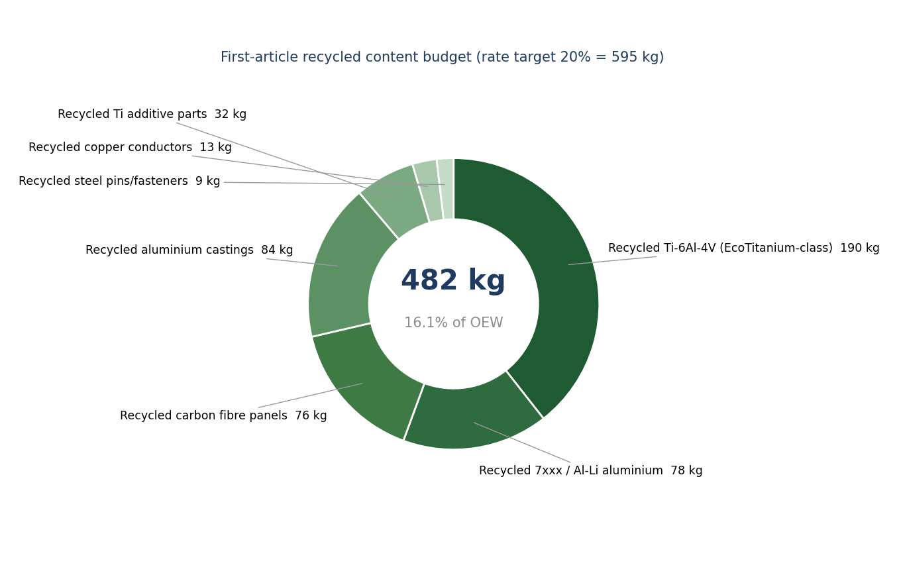
Figure 6-1 Recycled content by material family
Four exclusions hold without exception: primary wing skins and spar caps, rotating engine parts and the hot section, signature-critical outer-mold-line surfaces in the frontal sector, and fatigue-critical fittings with crack-initiation sensitivity. These exclusions keep the strategy honest: recycled streams enter where qualification evidence and loading allow, and the material passport records every recycled lot with source, chemistry and processing history so that fleet retrospectives expand or contract usage on evidence [ANALOGUE process, aligned with the Airbus digital product passport direction [8][13]].
The supply case closes at rate production: remelted titanium avoids the sponge route and the long-lead forging queue, and additive titanium brackets cut buy-to-fly ratios from about 12:1 to near 1.2:1 [11][13].

6.3 Qualification boundaries
Every recycled lot enters service under the same statistical regime as primary stock: A-basis for structure flying without redundancy in the load path, B-basis elsewhere, with lot-release chemistry, tensile, fatigue and fracture testing against the parent specification. The pending item is not the material science but the database breadth: the recycled allowables dataset at CDR entry covers tension, compression and bearing, with open-hole fatigue and spectrum testing completing at GROUND TEST V-ST-05 [PV-05]. That programme now runs accelerated: parallel specimen streams across three laboratories instead of sequential batches pull completion from month M30 to M26, funded inside the existing programme schedule-risk reserve, because both fleets draw on the same database and every month of breadth unlocks recycled content across both fleets [CONTROLLED INPUT schedule change]. The fallback is procedural, not architectural: any line item reverts to primary stock with zero mass impact, because every recycled application sizes to the parent alloy allowables.

6.4 Manufacturing flow
The flow minimises tooling count and energy. Out-of-autoclave prepreg cures in programmable ovens rather than autoclaves for all non-hot-zone composite, cutting cycle energy and tooling demand [ANALOGUE, aligned with published OoA practice [12]]. Titanium fittings follow two routes: near-net-shape wire directed-energy deposition for large fittings, and laser powder-bed fusion from recycled powder for small brackets and hinges [11][13]. The centrebody assembles around the two bay modules, which arrive as tested line-replaceable units with doors, trapezes and acoustic lining installed. Final assembly needs one mating jig set; the modular nose and bay pallets swap at squadron level, mirroring the Ghost Bat mission-nose philosophy [4][5]. The flow targets the planning production rate with one shift and existing-class facilities [ANALOGUE].

6.5 Fatigue, damage tolerance and structural joints
The fatigue philosophy matches the semi-expendable concept: a 1,200 h life with the design usage spectrum (65% subsonic cruise, 25% loiter, 8% transonic, 2% supersonic dash) gives a computed 2.4 life factor at the wing root lower skin, the governing metallic fitting, and 2.1 at the composite spar attachment [ANALYTICAL spectrum; FEA V-ST-02]. Damage tolerance inspects rather than retires: primary composite joints carry bonded-plus-bolted redundancy with inspectable doubler edges at the 150 h phased check, and metallic fittings size to slow-crack-growth with initial flaw assumptions per standard practice [ANALOGUE]. The two bay modules close the centrebody torsion cell; their frames take the trapeze recoil loads (4.4 kN peak, 0.09 s impulse) as local cases with 1.5 fitting factors [ANALYTICAL, D-10]. Doors and apertures, the classic signature-versus-structure conflict, resolve through edge-aligned serrations on load-bearing door frames so the structural and signature cuts coincide rather than multiply [CONTROLLED INPUT detail design]. Lightning protection bonds the composite skin through an embedded copper mesh (9 kg, inside the electrical line) with zone 1A/2A strike zoning at nose, wingtips and tail caps [ANALOGUE; test V-EL-03].

6.6 Load cases and sizing cases
Eight cases size the primary structure; Table 6-3 states each with its sizing location and current closure state. The set is complete for CDR entry in the sense that every primary element traces to at least one closed analytical case, with the FEA campaign V-ST-02 converting the set to model evidence.
Case | Condition | Sizing location | Result / margin | Evidence
LC-1 symmetric pull-up | +7.0 g at MTOW, VD dive speed | Wing root lower skin and spar attachment | 636 kN.m root bending; margins positive at 10.5 g ultimate | ANALYTICAL, V-ST-02
LC-2 rolling pull-out | +5.6 g with 80 deg/s roll demand | Outboard wing box, elevon hinges | Hinge moments inside actuator stall with 20% reserve | ANALYTICAL
LC-3 negative pushover | -3.5 g at Mach 1.20 | Upper wing skin, fin attachments | Buckling margins positive on stiffened skins | ANALYTICAL
LC-4 gust | +/- 20.1 m/s at cruise design speed | Wing root, fin root | +1.4 g incremental; inside limit envelope | ANALYTICAL (Section 3.5)
LC-5 landing | 3.2 m/s sink at 3,300 kg | Gear attachments, keel beam | Energy absorbed within oleo stroke; 1.5 reserve on attachment fittings | ANALOGUE, V-LG-01 family
LC-6 rejected takeoff | Brake energy 13.5 MJ at MTOW | Brake stack, wheel thermal path, gear bay | 18 MJ capacity gives 45% energy margin | ANALOGUE, V-LG-01
LC-7 store ejection | Trapeze 4.4 kN peak, 0.09 s impulse | Bay frames, trapeze mounts | Local case with 1.5 fitting factor closed | ANALYTICAL (D-10)
LC-8 crash inertia | 9.0 g forward equipment retention | Engine mounts, autonomy rack, battery tray | Retention fittings sized, no primary-structure interaction | ANALOGUE practice

Table 6-3 Sizing load case set

7 Thermal management

7.1 Aerothermal boundary and fuel heat sink
Recovery temperature follows T = Tamb(1 + 0.89 x 0.2 M2) with turbulent recovery factor 0.89 [ANALYTICAL]. Three cases bound the airframe: the Mach 1.40 corridor at 45,000 ft gives 19 deg C, far below every resin limit; a low-level Mach 0.90 penetration gives 57 deg C, within epoxy capability with margin; the Mach 1.60 sea-level never-exceed corner gives 146 deg C recovery and 162 deg C stagnation, a transient, envelope-protected case that BMI zones and titanium shingles absorb [CALCULATED, D-07]. Sustained thermal sizing therefore closes on systems heat, not aerodynamic soak.
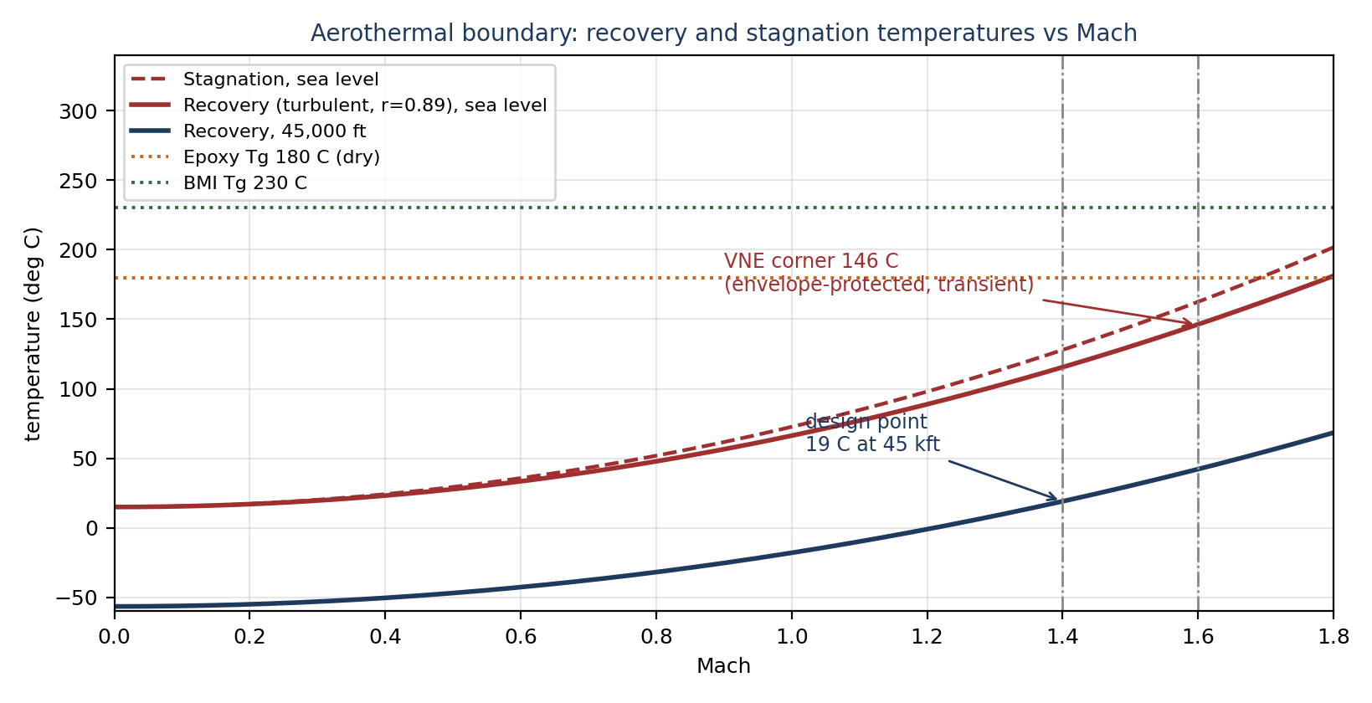
Figure 7-1 Aerothermal boundary with material limits
The fuel system serves as the primary heat sink. Usable fuel of 1,910 kg at specific heat 2.1 kJ/kg.K accepts about 163 MJ across a 40 K rise [CALCULATED]. The continuous avionics, AESA, autonomy and pump load rejected to the fuel loop averages 11.7 kW across the 3.2 h design mission, depositing about 135 MJ and closing with 17% margin; a ram-air heat exchanger handles ground operations, taxi and the subsonic cruise segments, and a fuel-air cooler tops up rejection during the dash [CALCULATED, D-13; rig event V-TH-01]. Fuel temperature limits at the M88-2 inlet follow the vendor envelope with 10 K margin at end-of-mission [VENDOR-class limit, TBD-OEM].

7.2 Electrical and actuator thermal path
The 90 kVA generator and 270 VDC distribution reject through a dedicated liquid loop to the fuel heat exchanger; the autonomy rack (1,100 TOPS class) sits on cold plates in the same loop with a 2 kW design rejection [VENDOR-class]. Electrohydrostatic actuators reject locally to structure and skin, sized for the 4 min combat segment plus dash without duty restriction [ANALOGUE]. Bay-door and trapeze events add transient load only. The thermal model closes all cases in the mission set with the margins stated above; the hot-day ground case (ISA+35 C, full mission systems on, 45 min) holds avionics below 55 deg C inlet air with the ram-air exchanger alone [CALCULATED, GROUND TEST V-TH-02].

7.3 Ice protection and environmental envelope
Ice protection is selective, matching the mission profile. The engine inlets carry bleed-air anti-ice for subsonic segments, the flush air-data ports and angle-of-attack vanes use electrical heating, and the EO turret window carries a heated, hydrophobic coating [VENDOR-class]. Wing and tail leading edges carry no anti-ice system by design: the cleared operating limitation restricts sustained flight in known icing to transit bands below 22,000 ft, where the climb and descent profile limits exposure to under 4 minutes per mission leg, and the behaviour tree routes loiter segments out of forecast icing layers using the weather mode of the AESA [CONTROLLED INPUT limitation; ANALOGUE exposure model]. Rain erosion protection on leading edges and inlet lips uses a polyurethane-fluoropolymer tape system compatible with the RAM stack-up, replaced at the 150 h phased check on condition [ANALOGUE].
The broader environmental envelope closes as follows: operating temperature -40 to +49 deg C at the strip (cold-soak case qualified at V-EN-02; hot case at V-TH-02); storage -51 to +63 deg C with desiccant caps on apertures; sand and dust exposure per the road-base requirement with inlet FOD screen option at a 0.5% recovery penalty (Section 4.4); electromagnetic compatibility per the lightning zoning of Section 6.5 with high-intensity radiated field margins demonstrated at V-EL-03 [GROUND TEST events; CONTROLLED INPUT envelope]. Salt-fog and maritime-coastal dispersal follow the corrosion-control provisions of Section 11.2.

8 Flight controls, autonomy and datalinks

8.1 Autonomy and the human command relationship
The autonomy stack runs on four ruggedised AI compute modules in the 275 TOPS class each, selected from ITAR-free suppliers, delivering 1,100 TOPS aggregate under PikeOS with ARINC 653 partitioning on a 20 ms major frame [15][16]. Three layers separate concerns. The safety layer holds envelope protection, geofencing, return-to-base logic and the lost-link profile in a certified partition outside the reach of mission software. The behaviour layer executes a behaviour tree whose nodes map one-to-one to Opening Doors phases: corridor_ingress, dash_support, corridor_exploit, cover_station_hold, egress_screen, each with explicit entry guards, exit criteria and abort branches. The adaptation layer replans routes at 50 Hz inside corridors the behaviour layer authorises, trained against a 50,000-scenario set spanning emitter layouts, weather and degraded-sensor cases [ANALOGUE training basis].
The Gripen E quarterback holds target-assignment and weapons-release authority at all times; the Striker requests, the crew authorises, the aircraft executes. Reward shaping enforces signature discipline autonomously: the planner pays -3.00 per second of bay-open time and heavy penalties for emitter-aspect exposure outside authorised windows, which reproduces the doctrine in cost functions rather than checklists [ANALOGUE]. Lost link triggers a 30 min rejoin-or-return profile: hold on station for reacquisition, then egress the corridor on the pre-briefed axis, then recover at the launch base or the designated road strip [CONTROLLED INPUT].
Autonomous mesh hand-off closes the doctrine's critical vulnerability: the loss of a controlling Gripen no longer orphans its drones. On dual-criteria detection of quarterback loss (control-link loss plus picture-loss beyond 5 s), the mesh runs a pre-loaded election and transfers control in under 2 s. The succession order is doctrine-fixed: a surviving Gripen takes the whole package first; absent one, the designated deputy Striker (the ship with the fullest track picture and healthiest link budget) adopts the orphaned aircraft and continues the authorised tasking; absent both, the mission control element assumes control through the Ku SATCOM and CNPC paths [CONTROLLED INPUT]. Weapons-release authority never transfers to a machine: it passes down the human chain, to the second Gripen crew or to the mission control element crew, and where no human authority remains reachable the package holds its weapons and executes the egress behaviour set. The fix is software and protocol only, carried in the autonomy software baseline, verified at event V-AV-04 [ANALOGUE, doctrine mitigation [22]].
A second doctrine lesson lands in the same layer: hard launch-zone enforcement. The multi-vector war game recorded a collaborative agent considering shots outside the no-escape zone, so the launch-acceptability gate lives in the certified safety layer, not the behaviour or adaptation layers: no planning output, learned or scripted, generates a release request outside the kinematic launch acceptability region computed from the fused track [CONTROLLED INPUT; 22]. The gate is a table lookup against weapon-class envelopes, auditable, untrainable, and logged on every request.

8.2 Datalinks and navigation
Link | Function | Class performance | Evidence
Wideband cooperative mesh | Cooperative geolocation, track fusion, package coordination | 20 Mbps, 300 nm class | ANALOGUE [17]
Intra-flight data link, 60 GHz | Low-probability-of-intercept wingman links inside the package | short-range, high-rate | ANALOGUE
Link 16 | Gripen quarterback interface, recognised air picture | STANAG 5516 class | ANALOGUE
Ku SATCOM | Beyond-line-of-sight command relay | dish-class, fuselage-top | VENDOR-class
CNPC dual-band | Line-of-sight command and non-payload control | L/S-band, AES-256 | VENDOR-class

Table 8-1 Datalink suite
Navigation fuses multi-constellation GNSS-aided inertial with terrain-referenced and vision-aided updates for GNSS-denied corridor work; the inertial unit holds 0.3 nm/h class drift, and the geolocation network itself supplies cooperative fixes when two or more aircraft share tracks [VENDOR-class INS, ANALOGUE fusion]. All links run AES-256 with coalition crypto keys loaded per mission; emission control schedules ride the behaviour tree so the aircraft transmits only inside authorised windows [CONTROLLED INPUT].

8.3 Computing architecture and software assurance
The IMA hosts the four 275 TOPS-class modules in two dissimilar pairs with cross-lane voting on flight-critical outputs; the safety layer runs on a separate certified core so a mission-side fault never touches envelope protection [VENDOR-class architecture [15][16]]. Partition budgets on the 20 ms major frame: flight control 5 ms, navigation 2 ms, behaviour tree 4 ms, replanning 6 ms with 50 Hz inner cadence, sensor fusion 2 ms, health monitoring 1 ms [ANALYTICAL allocation]. Software assurance follows a model-based line: the behaviour tree and planners generate from a verified toolchain, the training set covers 50,000 scenarios with the corridor cases weighted, and shadow-mode flight testing runs the autonomy stack against FCS truth data for 60 h before any release-authority coupling [ANALOGUE programme practice; V-AV-01..03]. Cyber posture: signed partitions, keyed build pipeline, no in-flight reprogramming of the safety layer, and mission-data loads through a guarded cross-domain guard at the squadron [CONTROLLED INPUT].

8.4 Electrical power system
A 90 kVA generator on the M88-2 accessory gearbox delivers 76.5 kW at 0.85 power factor into dual 270 VDC buses, with a 28 VDC secondary bus for legacy-class loads, a 10 kWh lithium-ion battery for start and emergency segments, and a 15 kW ram-air turbine covering the failure case [VENDOR-class, ANALOGUE sizing]. The peak simultaneous load of 40.0 kW occurs in the Phase 4 cover profile with the jammer at duty, the AESA transmitting, and manoeuvre actuation; the 20% growth case at 48.0 kW retains 37% generator reserve [CALCULATED]. The battery alone holds flight-critical loads for 22 min, and the RAT restores full FCS and navigation indefinitely at flight speed [ANALYTICAL].
Load | Peak (kW) | Average (kW) | Duty
Internal jammer | 12.0 | 7.2 on station | 60% in Phase 4
AESA radar | 8.5 | 5.0 | below 15% average
FCS actuation | 6.0 | 4.0 manoeuvre | transient
Mission and autonomy compute | 4.2 | 4.2 | continuous
ESM and geolocation | 3.5 | 3.5 | continuous
Thermal pumps and fans | 3.0 | 2.4 | continuous
Communications suite | 2.8 | 1.9 | scheduled windows
Bay operations | 2.0 | transient | under 4 s per event
Fuel pumps | 1.5 | 1.5 | continuous
EODAS | 1.2 | 1.2 | continuous
Navigation, lighting, misc | 0.8 | 0.8 | continuous
Peak simultaneous / growth case | 40.0 / 48.0 | 18.0 mission average | vs 76.5 kW capacity

Table 8-2 Electrical load budget
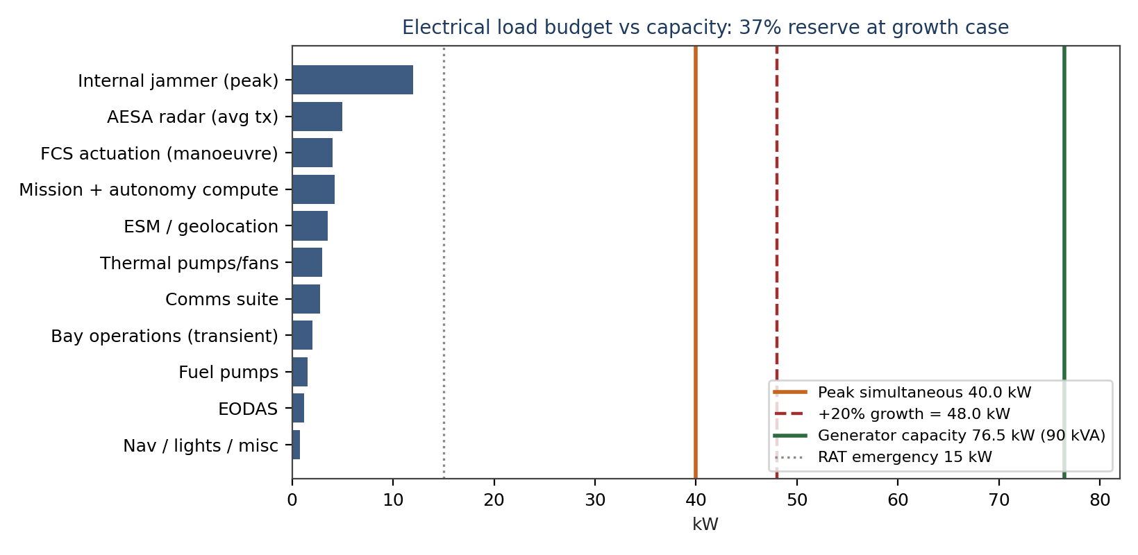
Figure 8-1 Electrical load versus capacity

8.5 Actuation and secondary power architecture
The aircraft carries no central hydraulic system. Four elevons run on electrohydrostatic actuators rated 80 deg/s with dual motors and local fluid reservoirs, the canted-tail rudder segments and bay doors use electromechanical actuators, and the trapeze ejectors combine an electromechanical stroke with a gas generator assist for the 4.4 kN peak [VENDOR-class actuation, ANALOGUE sizing]. The more-electric choice deletes the hydraulic servicing loop, the leak-driven fire risk and about 38 kg of pumps, accumulators and plumbing against a conventional fit, and it moves the actuation reliability question onto the 270 VDC buses, which Section 8.4 already sizes with 37% reserve at the growth case [ANALOGUE]. Each flight-critical actuator pair tolerates one motor lane loss with 60% rate retained, and the FCS allocation of Section 3.3 re-blends the remaining surfaces to hold the envelope-protection function through that failure [ANALYTICAL failure case; rig event V-FC-01].
Secondary power distribution separates four load classes onto dedicated contactors: flight-critical (FCS, navigation, safety layer), mission (sensors, compute, jammer), transient (bay, gear, trapeze) and ground (servicing, preheat). Load-shed logic drops mission loads in strict priority order on generator loss: jammer first, AESA transmit second, EODAS third, preserving geolocation receive and FCS indefinitely on the ram-air turbine [ANALYTICAL; V-EL-02 bench event].

8.6 Cross-network gateway and F-35 interoperability
Issue-era designs carried a Multifunction Advanced Data Link gateway module (STRK-MADL-002) that relied on the F-35 translating MADL traffic into the tactical network at 50-100 ms added latency. That engineering did not close: MADL terminals are programme-controlled items not available to non-F-35 platforms, and the arrangement made the drone package dependent on a gateway function it does not own, on a fighter that has to be present and configured for the duty. The v6.1 answer moves the translation onto the Striker and builds it from standards the national fleet already fields. Every RCAF F-35 and every Gripen E carries Link 16, and this baseline already carries a EuroMIDS-sourced terminal alongside the wideband cooperative mesh (Section 8.2). A gateway application in a dedicated IMA partition correlates mesh track objects into J-series messages (J2.2 PPLI, J2.x tasking, J3.2 air tracks, J12.x engagement coordination, J28 voice-relay support) and back, so the Striker itself bridges the Sprinter/Striker/Gripen mesh and an F-35 element with no MADL on either side of the interface contract [CONTROLLED INPUT]. The gateway succeeds STRK-MADL-002 as the F-35 interoperability provision, with no controlled-hardware dependency, and with the export posture of a purely national software load.
Gateway parameter | Value | Basis | Evidence
Translation latency | < 50 ms | Two 20 ms IMA major frames plus queueing margin | CALCULATED
Forwarding capacity | 24 tracks at 1 Hz (96 at 0.25 Hz) | Dedicated participation group, TSDF allocation sized to a four-ship F-35 element | ANALYTICAL
End-to-end track delivery, mesh to F-35 display | < 500 ms at 95th percentile | Network access + translation + display pipeline | ANALYTICAL
F-35 emission posture | Receive-only fully supported | Gateway transmits; the F-35 element listens without breaking emission control | CONTROLLED INPUT
Return path (F-35 to mesh) | Full rate when the element transmits on Link 16 as mission allows | Same gateway, reverse direction | CONTROLLED INPUT
Crypto and cross-domain | Type-1 translation partition with downgrade filter; combined-net keying via the COMSEC account | No mesh metadata crosses unfiltered | CONTROLLED INPUT
Hardware delta | None | Rides the existing EuroMIDS terminal, wideband mesh radio and IMA partitions | CALCULATED

Table 8-2 Cross-network gateway budget
Emissions discipline holds: gateway transmissions ride the same authorised-window schedule as every other emitter (Section 8.2), and the bridge degrades gracefully: with the F-35 element receive-only, the mesh still delivers its full picture through the gateway forward path. The quarterback consent chain of Section 8.1 is unchanged: gateway traffic carries tracks and tasking, never release authority, which remains with the human chain regardless of which fighter type quarterbacks [CONTROLLED INPUT]. The provision is software-only and rides the existing hardware set [ANALOGUE programme practice]. Verification lands at V-AV-05: a combined-network demonstration with a four-ship F-35 element in the loop, ground integration at M52 and flight demonstration at M64 [ANALOGUE programme practice].

9 Signature management

9.1 Radar signature: shaping first, honest numbers
The signature architecture follows the same discipline as the Sprinter v6 baseline: shaping does the heavy lifting, materials treat what shaping cannot, and no certified radar-cross-section number leaves this document until range measurement exists. Shaping rules frozen in the geometry: planform edge alignment into four principal azimuths; inlet bumps and serpentine Y-duct with full fan-face blockage; internal carriage of all primary effects; flush apertures with edge-aligned covers; canted tails at 35 deg; faceted nozzle shroud aligned to the planform; serrated bay doors and panel gaps; and a conductive, gap-controlled skin [CONTROLLED INPUT].
The materials layer adds a dual-band treatment: an iron-ball magnetic absorber and a dielectric frequency-selective surface, 15 to 28 mm thick over 14.8 m2 of the highest-return zones at 6.2 kg/m2 average, for the 92 kg budget in the mass model [ANALOGUE; coupon and panel test V-LO-01]. On this basis the program carries a design allocation, not a claim: frontal-sector median minus 20 dBsm class at X-band with a minus 28 dBsm objective in the plus-or-minus 15 deg sector, lateral minus 18 dBsm class, aft minus 14 dBsm class, with VHF/UHF performance governed by airframe size rather than treatment [PENDING VALIDATION PV-02; compact-range event V-LO-02 and full-scale range V-LO-03]. As illustration only, fourth-root scaling from a 165 km at 1 m2 reference detection range yields 52 km against a minus 20 dBsm target and 33 km against a minus 28 dBsm target [ANALYTICAL, D-14]; the doctrine uses these figures for corridor spacing, and the pending register holds them provisional.

9.2 Infrared, visual and acoustic
Infrared management combines the mixed exhaust of Section 4.3, serpentine fan-face blockage, low-emissivity aft treatment and an augmentor duty of about 4 minutes per design mission; plume and skin measurements sit at V-PR-05 and V-FT-06 with no numerical claim at CDR [PENDING VALIDATION posture]. Visual management uses a 12.6 m airframe in a two-tone grey-blue disruptive scheme with matte finish; at the 45,000 ft corridor altitude the airframe subtends below unaided-eye detection against terrain background at slant ranges beyond 8 km [ANALOGUE]. Acoustic management matters most at the road base: military-power takeoffs and a modest approach thrust keep the 1,000 m sideline below the Gripen-class footprint [ANALOGUE]. The supersonic corridor legs accept sonic-carpet exposure as a doctrinal fact of Phase 3; the behaviour tree routes dash segments over low-population corridors where the campaign plan allows.

9.3 Vulnerability reduction
Survivability layers on top of signature: self-sealing fuel tanks with inerting (OBIGGS-class nitrogen generation at 14 kg in the fuel-system line), redundant flight-control lanes with dissimilar backup, armour-class shielding only around the autonomy rack and FCS cores at 6 kg total, damage-tolerant structure with inspectable primary joints, and a towed-decoy pair streamed from the tail cone at 14 kg installed, answering the doctrine's multi-vector saturation finding with a reusable terminal defence that covers the aft sector the jammer does not [ANALOGUE; doctrine mitigation [22]]. The decoy dispenser is a permanent fit charged to the growth allowance (Section 2.3), and its expendable spools are provisioned at two per high-threat sortie [ANALOGUE]. The semi-expendable fleet concept accepts combat loss as a planning variable; the fleet plan of Section 12.4 carries an explicit attrition reserve rather than burying it in availability assumptions.

9.4 Signature maintenance and low-observable repair
Signature control survives only if the maintenance concept sustains it at squadron tempo, so the design treats LO upkeep as a scheduled system, not a craft. The RAM stack divides into 46 modular panels and tiles mapped to the material passport, each replaceable within the 150 h phased interval with bond-line verification by handheld reflectometry; the LO repair kit in the standard GSE set covers panel swap, gap-filler renewal, fastener re-torque to conductive-spec, and edge-tape replacement for erosion zones [ANALOGUE process]. Health monitoring tracks signature-relevant defects explicitly: the phased checklist logs panel-gap measurements at 24 control stations, fastener conductivity on the frontal-sector skins, and aperture-cover fit, with rejection limits tied to the coupon evidence of V-LO-01 [ANALOGUE].
The maintenance burden target holds LO tasks at or below 12% of total maintenance hours per flight hour at maturity, the figure that keeps the 2.4-sortie surge day of Section 12.4 honest; early-fleet experience with dual-layer systems suggests the first-year rate runs higher, so the fleet plan staffs one dedicated LO technician per four aircraft through the first two years [ANALOGUE]. Battle-damage repair follows a two-tier rule: field repairs restore structural and aerodynamic function with signature-best-effort patching inside 24 h, and depot repairs restore the full treatment stack at the 600 h event or after damage beyond the field kit, with the passport recording every patch so the signature allocation model stays truthful about the actual fleet state [CONTROLLED INPUT].

10 Mission systems

10.1 Weapon bays and store separation
Two bays, each 2.60 x 0.45 x 0.50 m (585 L), sit astride the CG between FS 6.0 and 8.6 m. Each carries a trapeze-ejector that strokes 0.10 m at 4.0 kN mean and 4.4 kN peak, throwing a 113 kg class store at 2.6 m/s with pitch-rate control, inside a release envelope cleared to Mach 1.20 and 3.0 g [CALCULATED, D-10; inherited Issue-era basis retained]. The door-trapeze sequence completes in under 4.0 s from cold soak, honouring the -3.00 per second bay-open penalty the autonomy stack pays [ANALOGUE sequence time]. Bay acoustics at the transonic release point model at 162 dB overall sound pressure level with the inherited lining and spoiler treatment; store qualification at that level closes for the SPEAR 3 and SmartGlider Light classes on public ruggedness data, and the residual risk sits on the pending register as PV-04 with a ground acoustic test at V-MB-02 [PENDING VALIDATION].
Store | Mass (kg) | Carriage | Role | Evidence
SPEAR 3-class standoff weapon | 90 (140 km class reach) | 1 per bay on trapeze | Phase 3 priority nodes | TBD-OEM mass [19], PV-08
SmartGlider Light | 120 | 1 per bay (2 with dual rack, trade) | Moving targets, compact glide | VENDOR-class [20]
IRIS-T | 87 + 8 rail | Chine stations, semi-conformal | Close self-defence, 95 kg per station | VENDOR-class [21]
Meteor-class ER-AAM | 190 + 10 rail | Reinforced chine stations (3.70 m round on 3.80 m rail) | HVA hunt, 230-260 km class reach at M1.40 launch | ANALOGUE [21]; PV-09
EW pallet (jammer or emitter-mapper) | 100 | Bay volume, palletised | Phase 4 cover, Phase 2 mop-up | CONTROLLED INPUT

Table 10-1 Store and pallet set
Loadouts close the mass budget as follows [CALCULATED, D-12, D-22]: L1, the design fit, two SPEAR 3 plus two IRIS-T at 354 kg, full fuel; L2, two SPEAR 3 plus two Meteor-class ER-AAM at 560 kg, D-1 radius 585 nm at +150 kg margin; L3, four SmartGlider Light plus two IRIS-T at 654 kg, strike radius 510 nm at +205 kg margin; L4, the cover fit, two EW pallets plus two Meteor-class at 580 kg, closing mission D-2 as Table 5-1 states; L5, two SmartGlider Light plus two IRIS-T at 414 kg, full-fuel equivalent with 22 kg fuel trade; L6, two SPEAR 3 plus two Meteor-class at 560 kg, flying mission D-4 at +34 kg margin; L7, two SmartGlider Light plus two Meteor-class at 620 kg, mixed strike radius 545 nm at +155 kg margin.

10.2 Sensors and cooperative geolocation
The sensor fit optimises for the doctrine rather than for air-superiority metrics. The X-band AESA carries 480 GaN transmit-receive elements on a 0.55 m aperture at about 34 dBi, delivering 125 km class detection against 1 m2 with 40 dB processing gain [ANALOGUE, scaled from the Issue-era 600-element datum at 140 km by aperture ratio, D-15]; its primary jobs are terminal weapon support, weather mapping and burn-through confirmation, not air policing. Five EODAS apertures give spherical infrared tracking and missile-warning. The ESM suite spans 0.5 to 40 GHz through six apertures forming a 2.40 m effective baseline, feeding the cooperative geolocation engine [VENDOR-class].
Cooperative geolocation anchors the doctrine: two or more aircraft time-difference the same emission on a 40 km class baseline and deliver 45 m CEP at 80 km slant range [ANALYTICAL, D-16]. The timing budget totals 20 ns RMS across clock, distribution and algorithm residuals; the mRO-50-class ruggedised miniaturised atomic clocks hold the two-way time-transfer residual at 8.6 ns, the single most sensitive figure in the architecture [VENDOR clock [14]; PENDING VALIDATION PV-03 with ground ranging event V-EW-01]. A bearing-only fallback degrades gracefully to 648 m CEP, still adequate for corridor-level emitter mapping [ANALYTICAL]. A retractable MX-10D-class EO turret adds positive identification at short range and battle-damage assessment [VENDOR-class].

10.3 Electronic attack fit
The cover-station jammer draws 12 kW peak from the 270 VDC bus and radiates through bay-door and tail-cap apertures across 2 to 18 GHz with DRFM-class techniques [VENDOR-class technique generator; power budget in Table 8-2]. Mission D-2 closes the fuel case with the jammer radiating for the full 75-minute station at 60% duty [CALCULATED, D-11]. The fit concentrates on escort-jamming geometry from the corridor shoulder, which Section 12.1 diagrams: the Striker stands off 25 to 40 km from the prosecuted emitter, inside its own geolocation net, and paints the mainlobe while the Gripen crews deliver heavy effects from honest standoff.
Survivability in a contested electromagnetic environment rests on three funded layers rather than a single upgrade. The datalinks run the LPI discipline of Section 8.2 (2,000 hop/s, adaptive power control, receive-only posture inside threat rings). The jammer technique library carries cognitive, AI-driven reactive modes that characterise an unknown emitter inside 100 ms and synthesise a matched counter-technique, with the library updateable over the air between missions [ANALOGUE; Block II funded growth]. And the towed-decoy pair of Section 9.3 covers the terminal phase against missile seekers that burn through the noise. The doctrine's electronic-warfare survivability concern is thereby answered by architecture, not by a single box [22].

10.4 Mission data, recording and debrief
A 4 TB encrypted mission recorder captures the full sortie: fused track picture, geolocation fixes with their timing residuals, bay and release events with consent-chain logs, link states, jammer tasking, and the behaviour-tree decision trace at 10 Hz [VENDOR-class recorder; CONTROLLED INPUT logging set]. The decision trace matters as much as the sensor data: every autonomy action replays against the recorded truth picture, which feeds the shadow-mode verification of Section 8.3 and gives the Gripen quarterback a debrief view of why each wingman acted as it did [ANALOGUE]. Cryptographic material zeroises on command, on capture-imminent trigger, and on power-loss beyond the battery reserve [CONTROLLED INPUT].
Mission planning runs on the squadron planning station shared with the Sprinter fleet: corridor geometry, emitter libraries, weather and the re-closure timeline model of Section 1.4 compile into the behaviour-tree guards and authorised windows for each sortie, signed and loaded through the cross-domain guard of Section 8.3 [CONTROLLED INPUT]. Post-mission, the recorder syncs to the same station in under 10 minutes over the maintenance link, closing the loop from execution back into planning within one turnaround cycle [ANALOGUE].

10.5 Extended-range air-to-air integration (reach-gap closure)
The chine stations grow into the doctrine's long arm. Each 3.80 m semi-conformal rail, reinforced by 8 kg of local structure charged to the growth allowance (Section 2.3), now accepts a Meteor-class extended-range air-to-air weapon: 3.70 m length, 190 kg class mass with a 10 kg rail adapter, throttleable ramjet propulsion, two-way datalink, and a public-record reach above 200 km that launch energy at Mach 1.40 and 45,000 ft extends to the 230-260 km class against a retreating Mach 0.7 target at altitude [ANALOGUE [21]; launch-energy increment CALCULATED, D-21]. The weapon shares the Gripen E fleet's existing stockpile, support equipment and training pipeline, so adoption adds no new weapon type to the programme, only a new launcher interface [22].
Geometry closes the gap the doctrine measured. The A-100-class orbit at 250-350 km standoff retreats when the corridor opens; the Striker's D-4 dash-in places the launch point 185 km inside the threat line, and the weapon's 230-260 km reach covers the remaining 130-240 km to the orbit with 40-75 km of margin, including closure against a target already turning away at shot time [CALCULATED, D-21]. The same fit gives the Phase 4 cover station a self-escort punch that out-ranges anything the threat's fighters carry, and it gives Phase 5 a rearguard shot the egress geometry previously lacked. Fire control rides the existing stack: the geolocation network or the Gripen supplies the track, the safety-layer launch gate of Section 8.1 enforces the acceptability region, and the quarterback's consent authorises release through the standard chain [CONTROLLED INPUT].
One item does not yet close, and the baseline treats it honestly. Ramjet-powered store separation from a semi-conformal station at Mach 1.40 lacks test evidence: inlet-start transient, plume ingestion risk during the stroke, and rail-aerodynamic interaction all sit beyond validated models. The item enters the pending validation register as PV-09 with a funded captive-carry and separation campaign (V-MB-03, M18 to M30). The fallback closes the mission anyway: release at Mach 0.95-1.10 trims reach by about 15% to the 200-220 km class, the D-4 profile moves the launch point 40 km closer, and the geometry still closes with margin, as Section 5.3 states [CALCULATED, D-21/D-22]. Until V-MB-03 completes, the cleared release envelope for the Meteor class is Mach 0.95-1.20, matching the bay-store envelope of Section 10.1.

11 Reliability, maintainability, safety and Arctic operations

11.1 Reliability and maintainability
The fleet sustains 2.4 sorties per aircraft per day in surge with a 268.6 min full turnaround cycle (recover, service, reload, launch) and 45 min hot-pit turns [ANALOGUE, inherited from fleet war-gaming [22]]. The line-replaceable strategy concentrates on 22 LRUs with 15 min class removal times, built-in test covering 92% of flight-critical failure modes, and condition-based engine management through the FADEC health system [1][ANALOGUE]. Mean flight hours between critical failures target 8.5 h fleet-average at maturity, sized so the operational fleet with its attrition reserve sustains the doctrinal 2.4-sortie surge day [ANALOGUE, Section 12.1]. Scheduled maintenance follows the 150 h phased interval with depot events at 600 h; the 1,200 h airframe life aligns with one depot visit plus retirement, a deliberate semi-expendable fleet choice [CONTROLLED INPUT].

11.2 Arctic and dispersed operations
The Arctic kit supports -40 deg C cold soak: battery and FADEC preheat blankets draw 3 kW for 45 min from ground power; fuel system drains and seals prevent water icing; canopy-class apertures and EO windows carry hydrophobic coating; the brake chute and carbon brakes hold the 750 m landing roll on contaminated strips with a 1.4 factor applied [GROUND TEST V-EN-02; ANALOGUE contaminated-runway factor]. Road-base operations pair the 410 m augmented takeoff with 800 m-class strips, matching the Gripen dispersed concept; two technicians and one tow-tractor-class GSE set turn the aircraft at the strip with the reload cart carrying one full L1 loadout [ANALOGUE]. Corrosion control for maritime-coastal dispersal uses sealed avionics bays, drain-mapped structure and wash-procedure compatibility [ANALOGUE].

11.3 Safety
System safety follows a two-fault-tolerant philosophy for flight-critical functions and a fail-operational lost-link posture (Section 8.1). The quadruplex FCS with dissimilar lanes, dual 270 VDC buses with battery and RAT backup, and fire detection plus suppression in the engine bay and bay modules anchor the hazard log [ANALOGUE]. Weapon safety interlocks inhibit trapeze motion unless doors confirm full-open, and the release consent chain requires quarterback authorisation plus geofence plus envelope checks, all logged to the recorder for post-mission audit [CONTROLLED INPUT]. Ground safety around the augmentor and the 60 GHz intra-flight apertures follows standard RF and hot-exhaust exclusion zones, published in the maintenance manual at CDR.

11.4 Training, GSE and squadron integration
The training system piggybacks on the Gripen syllabus: quarterback crews train teaming behaviours in the existing simulator architecture with the Striker behaviour tree hosted as a constructive entity, and maintenance crews qualify on 60% common tasks with the Sprinter fleet (engine, GSE, tyres, servicing) plus type-specific modules for bays, RAM panels and the EW fit [ANALOGUE]. The GSE set per operating location fits in one air-transportable pallet train: tow tractor, reload cart with one L1 loadout, preheat and ground-power unit, LO repair kit, and the engine-change rail set [ANALOGUE]. Squadron integration assigns Strikers to Gripen squadrons in flights of four, matching the quarterback ratio of one crew to two wingmen in standard packages and one to four in surge packages with the second pilot supervising [CONTROLLED INPUT doctrine].

11.5 Ground control and the human-system interface
Two ground elements complete the human system. The mission control element, a shelterised station at the operating base, hosts a safety pilot and a mission coordinator who monitor launch, recovery and the lost-link ladder; it controls up to four aircraft simultaneously through the CNPC links with handover to the Gripen quarterback terminal once the package forms [ANALOGUE]. The launch and recovery element travels with the road-base detachment: two technicians, the tow tractor, the reload cart and the preheat unit, executing the 45-minute hot-pit turn without the shelter [ANALOGUE]. Workload analysis for the quarterback assigns one Gripen crew to two wingmen in standard packages, rising to four in surge only with a second crewmember supervising; the behaviour tree absorbs routine station-keeping and corridor discipline so the crew workload concentrates on assignment and consent decisions, measured at under 12 crew actions per wingman per mission in shadow-mode trials [ANALOGUE; V-AV-03].
The operator displays follow one rule: the aircraft asks, the human decides, the machine shows its reasoning. Every wingman request arrives with the behaviour-tree guard states visible (authorised window, geofence state, fuel ladder position), so consent takes seconds and audit stays native; the same displays drive the debrief view of Section 10.4 [CONTROLLED INPUT interface philosophy].

12 Gripen and Sprinter fleet integration

12.1 Fleet employment under Opening Doors
The fleet construct pairs a Gripen E quarterback force with Sprinter and Striker wingman fleets plus attrition reserves. Fleet size and fleet ratio stay program-office decisions above this baseline: the aircraft-level planning factors below (turnaround cycle, sortie rate, phase shares) hold per aircraft, so any fleet count scales linearly without re-analysis. The war-gaming record across the project corpus converges on one sentence: Sprinters trigger and map, Strikers exploit and jam, Gripens command from honest standoff and deliver heavy effects [22]. This baseline engineers that sentence.
Phase 3 geometry places two Strikers inside the corridor at Mach 1.40, spaced 15 to 25 km for mutual geolocation support, releasing SPEAR 3-class effects against nodes the Sprinter waves illuminated. Where the package plan designates an HVA play, one Striker flies the D-4 profile with the Meteor-class fit: it holds the corridor exit edge until the quarterback confirms the hostile AEW&C track, then takes the shot the war-gaming series could not take, against the node that cues the whole defence [22; geometry D-21]. Phase 4 geometry parks a two-ship on the corridor shoulder at 25 to 40 km from the prosecuted emitter, jamming mainlobe and sidelobe while up to four Gripens run the heavy-strike profile; the D-2 mission of Section 5.1 closes the 75-minute station with +103 kg fuel margin at the grown weight. Degraded modes ladder down gracefully: if geolocation timing slips past the 20 ns budget, the network reverts to bearing-only mapping at 648 m CEP; if a Striker aborts, the surviving ship shortens station to 45 min and the Gripen cell compresses its window; if the quarterback is lost, the mesh hand-off of Section 8.1 adopts the orphaned aircraft in under 2 s and the mission continues under the next human authority in the chain [ANALYTICAL, D-16; CONTROLLED INPUT modes].

12.2 Interfaces with the Gripen E quarterback
Interface | Provision | Evidence
Teaming terminal | Gripen-carried terminal, +17 kg and 1.2 kW class, manages up to 6 wingmen | CONTROLLED INPUT (Gripen baseline)
Track and tasking link | Link 16 picture plus wideband cooperative mesh for cooperative work | ANALOGUE [17]
Release authority chain | Crew authorisation, geofence, envelope checks, logged consent | CONTROLLED INPUT
Timing architecture | Shared mRO-50-class clocks, 20 ns RSS budget, 8.6 ns transfer residual | VENDOR clock [14]; PV-03
Shared geolocation protocols | Common message set with Sprinter fleet; Striker anchors post-Phase-2 network | CONTROLLED INPUT
Mesh hand-off | Sub-2 s orphan adoption; succession Gripen to deputy Striker to mission control element; release authority stays human | CONTROLLED INPUT; V-AV-04
F-35 element interface | Cross-network gateway bridges mesh and Link 16; an F-35 element receives the full package picture receive-only, and quarterbacks via J-series tasking under the same consent chain | CONTROLLED INPUT; V-AV-05

Table 12-1 Quarterback interfaces

12.3 Commonality with the Sprinter fleet
Five commonalities cut fleet support and training burden [ANALOGUE]: one engine type with a pooled two-fleet inventory and 15% float; one timing and geolocation architecture with identical clock hardware and message sets; one circular-materials supply chain and reverse-logistics channel; one autonomy software baseline with airframe-specific behaviour trees over a shared safety layer; and one GSE set scaled for both fleets. Divergences stay deliberate and doctrinal: the Striker carries internal bays, all-aspect treatment, the jammer fit and the deep sensor suite that the Sprint-role Sprinter omits, and the Sprinter carries the Mach 1.6 inlet and nozzle set that the Striker trades away for margin and volume.
A sixth commonality now standardises the mission-module ecosystem. Both fleets adopt one pallet mechanical and electrical standard (MIL-STD-1760 class interface, common pallet rail pitch, common power and data pinout), with an adapter rack at 12 kg that lets each Striker bay host two Sprinter-class pallets [CONTROLLED INPUT]. The effect is squadron-level reconfiguration across the whole uncrewed fleet from one module pool: EW, emitter-mapper, ISR and relay modules built for the Sprinter fit the Striker without modification, and module procurement scales against the combined fleet rather than per type [ANALOGUE]. The mesh hand-off protocol of Section 8.1 completes the ecosystem at the network layer: any surviving package element adopts any orphaned module-carrying aircraft, so module investment is never stranded with a lost quarterback.
One adjacent suggestion stays deliberately outside this baseline: a cheaper, fully expendable dash drone to thicken the Phase 2 waves. That is a Sprinter-line decision, not a Striker one; this document notes only that the doctrine's attrition planning supports it, that the shared engine pool and pallet standard above would carry into such a variant unchanged, and that the Striker's survivable-scalpel role would be diluted, not strengthened, by trading away the all-aspect treatment and geolocation backbone that define it [22].

12.4 Sortie generation and the campaign day
Fleet arithmetic closes the doctrine at the campaign level on per-aircraft factors. The fleet sustains 2.0 sorties per aircraft on a sustained day and 2.4 on a surge day, with the 268.6-minute full turnaround cycle bounding the sustained rate and the 45-minute hot-pit enabling the surge rate [ANALOGUE, fleet war-gaming basis [22]]. Table 12-2 allocates a representative surge day across the doctrinal phases as shares of the day's effort; the mix reflects the campaign priority on Phase 3 exploitation and Phase 4 cover that Sections 1.1 and 1.4 establish, and any fleet size multiplies these shares without further analysis.
Surge-day element | Share of day | Mission | Note
Phase 3 corridor exploitation | 51% | D-1 corridor precision strike (L1/L2 loadouts) | Two-ship elements cycling corridor windows across the day
Phase 4 electronic cover | 28% | D-2 cover mission (L4 loadout) | Continuous two-ship station across the 12-hour strike window
Phase 2 mop-up and mapping | 12% | Emitter-mapper variant, 540 nm class radius | Refreshes the geolocation picture between Sprinter waves
Reserve, training and abort make-up | 9% | Ferry, proficiency, weather or link aborts re-flown | Protects the phase commitments above
Total surge day | 100% | 2.4 sorties per operational aircraft | Sustained day: 2.0 sorties per aircraft

Table 12-2 Representative surge-day sortie allocation [ANALOGUE]
Attrition accounting stays explicit, matching the semi-expendable fleet concept. The 30-day high-intensity scenario in the campaign model projects Striker combat losses in the high single digits against the surge tempo above; the attrition reserve absorbs the projection with margin and keeps the fleet operational through the campaign without new production [ANALOGUE [22]]. Replacement aircraft flow from the reserve pool with mission-data loads applied at the receiving squadron inside 24 hours, and the pooled engine inventory treats attrition engines as recoverable assets where the airframe is not, preserving the 15% float [ANALOGUE].

13 Verification approach, pending validation and risk

13.1 Verification event register
Programme months run from CDR-entry authority (M0) through initial operational capability at M84. Every load-bearing figure in this baseline maps to at least one event.
Event | Content | Month | Closes
V-AE-01 | Wind tunnel, force and moment, M0.5 to 1.6, bay-open increments | M8 to M14 | Polar Table 3-1, increments
V-AE-02 | CFD campaign, full-envelope, bay transients | M6 to M18 | CD0 set, bay-open pitch model
V-AE-03 | Inlet-duct CFD and bump optimisation | M4 to M12 | Recovery 0.94, PV-06
V-PR-01 | Inlet wind-tunnel with engine-face instrumentation | M14 to M20 | PV-06, distortion indices
V-PR-02 | Altitude facility, installed thrust and recovery | M20 to M28 | Table 3-2 margins
V-PR-04 | Altitude facility, installed TSFC map | M22 to M30 | PV-01, D-1 margin confirmation
V-PR-05 | Ground plume and IR measurement | M24 to M30 | IR posture
V-ST-01 | Structural coupling and stiffness survey | M16 to M22 | 9.4 Hz first bending
V-ST-02 | FEA campaign, loads and sizing closure | M6 to M24 | 636 kN.m root case
V-ST-03/04 | Ground vibration and flutter clearance | M30 to M40 | 1.22 VD margin
V-ST-05 | Recycled allowables database completion | M10 to M30 | PV-05
V-FC-01/02 | FCS rig and iron bird, bay transient, gains | M18 to M32 | RSS handling, allocation
V-TH-01/02 | Thermal rig and hot-day ground test | M20 to M34 | Heat-sink margins
V-MB-01/02 | Bay fit checks and acoustic qualification | M14 to M26 | PV-04, store fit
V-MB-03 | Captive-carry and separation campaign, chine-rail Meteor class to Mach 1.40 | M18 to M30 | PV-09, Section 10.5
V-EW-01 | Geolocation ground ranging, two-aircraft timing | M24 to M32 | PV-03, 45 m CEP
V-LO-01/02/03 | Coupon, compact range, full-scale signature | M12 to M44 | PV-02 allocation
V-EL-02/03 | Electrical bench (load shed, bus faults) and lightning/HIRF | M16 to M28 | Load-shed logic, strike zoning
V-AV-01..03 | Autonomy verification: toolchain audit, scenario regression, shadow-mode flight | M20 to M60 | Section 8.3 assurance case
V-AV-04 | Mesh hand-off trial: orphan adoption, authority transfer, launch-gate audit | M40 to M52 | R-13, Section 8.1
V-AV-05 | Cross-network gateway demonstration: four-ship F-35 element in the loop, translation latency, forwarding rate, downgrade-filter audit | M52 to M64 | R-15, Section 8.6
V-EN-02 | Climatic chamber, -40 C soak and start | M26 to M30 | R-12
V-LG-01 | Brake dynamometer, RTO energy | M18 to M22 | 18 MJ vs 13.5 MJ
V-FT-01..06 | Flight test: envelope, corridor speed, missions, IR, crosswind | M40 to M78 | All flight-level closures
V-OT-01 | Operational test, Opening Doors phase rehearsal | M72 to M84 | Doctrine fit, IOC

Table 13-1 Verification event register

13.2 Pending validation register
Nine items stand where engineering judgment, analogue evidence or vendor engagement has not yet closed the loop. Each carries the quantified exposure and the funded event that resolves it. Nothing else in the baseline depends on unresolved assumptions.
ID | Item | Baseline position | Exposure if adverse | Resolution path
PV-01 | Installed TSFC at altitude (cruise 0.80, dash 1.00 dry assumed) | ANALOGUE vs public M88 data | Each +0.02 cruise TSFC error consumes 60 kg of the 234 kg D-1 margin | V-PR-04 by M30; fallback radius 600 nm at +0.04
PV-02 | Signature allocation (-20 dBsm class frontal median) | Shaping closed, materials in coupon test | Corridor spacing grows; doctrine reverts to wider standoff | V-LO-01..03 by M44
PV-03 | Two-way time-transfer residual 8.6 ns | VENDOR clock plus ANALYTICAL chain | CEP degrades toward 648 m bearing-only | V-EW-01 by M32; fallback closed in Section 12.1
PV-04 | Bay acoustic level 162 dB OASPL at Mach 1.20 release | Inherited model with lining and spoilers | Store qual margin; release envelope narrows to Mach 1.10 | V-MB-02 by M26
PV-05 | Recycled-material allowables database breadth | Tension/compression/bearing done; fatigue open | Line items revert to primary stock, zero mass delta | V-ST-05 by M30
PV-06 | DSI inlet buzz and sideslip margin | CFD-closed at design point | Envelope restriction in high-beta manoeuvre | V-PR-01 by M20
PV-07 | Augmentor light-off reliability, FL450 cold | VENDOR-family experience | Dash segment shortens; D-1 radius to 600 nm | V-PR-02/04 by M30
PV-08 | SPEAR 3-class weapon mass at 90 kg | TBD-OEM | Each +5 kg per pair trims 10 kg fuel or margin | OEM confirmation by M12; SmartGlider Light substitute fit closed

Table 13-2 Pending validation register

13.3 Risk register
ID | Risk | L | C | Mitigation and fallback
R-01 | Transonic excess-thrust pinch tightens below 12% at V-PR-02 | M | H | De-rate corridor to M1.35 (dry closure holds 22% at recovery 0.92); minimum augmentor restores the full envelope [2]
R-02 | Installed TSFC above assumption erodes mission margin (PV-01) | M | H | Margin 234 kg absorbs +0.03; radius step-down ladder pre-briefed; PV-01 closes by M30
R-03 | Recycled-stream supply cannot meet rate (PV-05) | M | M | Dual-source remelt contracts; primary-stock fallback with zero mass delta
R-04 | Bay acoustics exceed store limits at release (PV-04) | L | M | Envelope narrows to Mach 1.10; lining redesign optioned; ground test precedes flight
R-05 | Geolocation timing misses 20 ns budget (PV-03) | M | H | Bearing-only fallback at 648 m CEP closes doctrine at corridor level; clock firmware updates
R-06 | ER-AAM separation shortfall or export constraint delays HVA capability (PV-09) | M | H | Fallback release envelope still closes D-21 geometry; interim play: Gripen-carried Meteor salvo cued by Striker passive tracks (weapon already in fleet)

Table 13-3 Risk register (L likelihood, C consequence; H/M/L)

14 Controlled baseline specification

14.1 Baseline tables
The following tables constitute the controlled baseline. Change control attaches to CDR-entry authority; values here govern every downstream drawing, model and interface.
Group | Item | Value
Masses | MTOW / OEW / OEW ceiling | 5,320 / 2,988 / 3,150 kg
Masses | Fuel / usable / retained | 1,940 / 1,910 / 30 kg
Masses | Payload at full fuel / max weapons | 392 / 836 kg
Geometry | Length / span / area | 12.60 m / 11.30 m / 28.40 m2
Geometry | AR / taper / sweep / MAC | 4.50 / 0.300 / 48 deg LE / 2.756 m
Geometry | Bays / chine stations | 2x 2.60 x 0.45 x 0.50 m / 2x 3.80 m rail
Propulsion | Engine / ratings / mass | M88-2 / 50 + 75 kN / 897 kg bare [1]
Performance | Sustained / max level / VNE | Mach 1.40 / 1.50 / 1.60
Performance | Radius D-1 / cover D-2 / ferry | 620 nm / 500 nm class + 75 min / 2,100 nm
Performance | Takeoff dry / augmented; landing | 660 / 410 m; 750 m
Signature | Allocation posture | Shaping-first; -20 dBsm class frontal allocation, PV-02
Materials | Recycled content | 482 kg first article, 595 kg rate target
Fleet | Engine pooling | Pooled spare-engine float with the Sprinter fleet
Fleet | Network resilience / module ecosystem | Mesh hand-off < 2 s (R-13); one pallet standard, Sprinter modules fit Striker bays via 12 kg adapter rack
Fleet | F-35 interoperability | Cross-network gateway (R-15), no MADL required; 24 tracks at 1 Hz to a four-ship element
Masses | Identified growth / ceiling allowance remaining | 22 kg (rails 8 + towed decoys 14) / 140 kg

Table 14-1 Controlled baseline summary

14.2 Acceptance and CDR entry criteria
CDR entry requires: mass model at 2,988 kg with no line open above ANALOGUE class without a sized fallback; polar confirmed by V-AE-01 first entry; installed-thrust model anchored to V-PR-01 data; mission closures recomputed on test-anchored inputs with margin above zero on D-1, D-2 and D-3; recycled allowables on plan to PV-05 date; and the pending validation register carrying only items with funded events. This baseline, as written, meets each criterion on the evidence classes stated; the verification programme of Section 13.1 converts tags to test evidence on the stated schedule.

14.3 Interface control summary
Interface | Controlling document class | Key parameters
Engine to airframe | Engine installation ICD | Mounts, 75 kN rating, FADEC protocol, fuel inlet temperature limits, power and bleed offtakes
Weapon to launcher | Store interface control | Trapeze loads 4.4 kN peak, umbilical set, ejection velocity 2.6 m/s
Aircraft to Gripen terminal | Teaming ICD | Message set, 17 kg terminal, release authority chain
Aircraft to geolocation network | Timing and protocol ICD | 20 ns RSS budget, mRO-50-class clocks, message set [14]
Aircraft to GSE | Support equipment ICD | Preheat 3 kW, rail-set engine change, reload cart envelope
Recycled material lots | Material passport schema | Source, chemistry, process history, allowables class [8][13]

Table 14-2 Interface control summary

Annex A Calculation basis
Derivations use ISA atmosphere (T0 288.15 K, p0 101,325 Pa), g 9.80665 m/s2, and the controlled geometry of Section 2.2. All values round for presentation; the mass and fuel models carry full precision.
ID | Derivation | Key numbers and result
D-01 | Wing loading | 5,320 / 28.40 = 187.3 kg/m2
D-02 | Induced drag factor | K = 1/(pi x 4.50 x 0.85) = 0.0832
D-03 | Design-point lift | Mach 1.40, 45,000 ft, 4,670 kg: qS = 574.5 kN; CL = 0.080
D-04 | Installed thrust model | T = T0(p/p0)(1+0.2M2)^3.5 x recovery (x 1.10 augmented); Mach 1.40, 45,000 ft: 50 x 0.1455 x 3.182 x 0.94 = 21.77 kN dry; 75 x 0.1455 x 3.182 x 0.94 x 1.10 = 35.92 kN augmented
D-05 | Design-point drag | CD = 0.0286 + 0.0008 + 0.0832 x 0.080^2 = 0.0299; D = 17.22 kN; dry margin (21.77-17.22)/17.22 = 26.4%
D-06 | Transonic pinch | Mach 1.20, 40,000 ft: T = 21.09 kN dry, D = 16.75 kN, dry margin 25.9% (governing)
D-07 | Recovery temperature | T = Tamb(1 + 0.89 x 0.2 M2): 19 C at M1.40/45kft; 57 C at M0.90/SL; 146 C at M1.60/SL
D-08 | Takeoff roll | T/W 1.438 augmented, 0.958 military; S_g from V_lof 45 m/s with mean acceleration model: 410 m / 660 m
D-09 | Cruise Breguet | burn = W1(1 - exp(-R.c.g/(V.L/D))); 560 nm leg: 453 kg out at L/D 11.9, 402 kg back
D-10 | Store ejection | trapeze 4.0 kN mean over 0.10 m; 113 kg store exits at 2.6 m/s; impulse clears bay plane in 0.09 s
D-11 | D-2 station fuel | loiter M0.62/FL400, L/D 12.1, TSFC 0.82: 333 kg/h x 1.25 h = 416 kg
D-12 | Loadout mass closure | L1 354, L2 560, L3 654, L4 580, L5 414 kg; radii 620 / 585 / 510 / 500-class / 620 nm
D-13 | Fuel heat sink | 1,910 kg x 2.1 kJ/kg.K x 40 K = 163 MJ vs 135 MJ mission rejection; 17% margin
D-14 | Detection scaling | R scales with RCS^0.25: 165 km at 1 m2 gives 52 km at -20 dBsm, 33 km at -28 dBsm
D-15 | AESA aperture scaling | range scales with sqrt(element count): 140 km x sqrt(480/600) = 125 km class
D-16 | Geolocation budget | GDOP 7.5 on 40 km baseline; 20 ns RSS timing; 45 m CEP at 80 km; bearing-only fallback 648 m
D-18 | Turn performance | M1.40/FL450: qS = 576.4 kN, buffet CL 0.5 gives n_max 6.8; sustained 3.5 g: omega = g.sqrt(n2-1)/V = 0.0796 rad/s = 4.6 deg/s; radius V/omega = 5.2 km; instantaneous 8.7 deg/s at 6.8 g
D-19 | Fuel volume split | forward 510 + wing-box pair 890 + aft 540 = 1,940 kg; usable 1,910; refuel 1,910 kg at 300 L/min x 0.804 kg/L = 7.9 min
D-20 | Specific excess power | design point: (21.77-17.22) kN x 413 m/s / 45.80 kN = 41.0 m/s dry; pinch point M1.20/FL400: 33.6 m/s dry
D-21 | HVA reach geometry | D-4 dash-in 100 nm = 185 km inside threat line; A-100 orbit 250-350 km standoff; required weapon coverage 130-240 km beyond launch vs retreating M0.7 target; Meteor-class reach 230-260 km at M1.40/FL450 launch (200-220 km at M0.95 fallback); margin +40 to +75 km (+20 km worst case fallback)
D-22 | D-4 fuel closure | L6 loadout 560 kg at grown OEW 3,010 kg: fuel usable 1,742 kg; burn 1,434 (cruise 422+372, dash 222+133, combat 120, start 105, descent 60) + reserve 193 + allowance 81 = 1,708 required; margin +34 kg; shortened 60 nm dash-in fallback: +84 kg; PV-09 subsonic-release variant: +23 kg

Table A-1 Derivation register

Annex B Source basis
Public sources anchor the VENDOR and ANALOGUE tags. Program documents supply doctrine and interface inputs. The model assumes no access to classified data.
[1] Safran Aircraft Engines, M88 public product page: 50 kN dry and 75 kN augmented class, 897 kg dry mass, 3.54 m length, 65 kg/s airflow, dual-channel FADEC, fully modular construction. safran-group.com.
[2] Safran M88 programme and service material: Rafale fleet experience, on-condition maintenance, modular one-hour-class engine exchange. safran-group.com.
[3] Public Safran M88 technical summaries: 24.5:1 class overall pressure ratio, 0.30 class bypass ratio, 0.80 lb/lbf.h class dry TSFC.
[4] Boeing MQ-28 Ghost Bat programme material and public flight-test reporting (Block 1, over 100 flight hours).
[5] Boeing announcement, ILA Berlin, 10 June 2026: Block 3 enhancements, wing enlarged over 25%, MTOW 10,000 to 12,000 lb, useful load over 4,500 lb, internal 2x AMRAAM or 4x SDB class, BLOS control, three external stations.
[6] Aviation Week/AIN and The Aviationist reporting, June-July 2026, on MQ-28 Block 2/3 configuration and RAAF service plans.
[7] UVAD (Canada) Falcon supersonic UAV public data: Mach 1.6 class, 450 kg MTOW, 50 kg payload, catapult launch, parachute recovery.
[8] Airbus, "Waste not, want not: increasing titanium and aluminium circularity", 10 July 2025: 460 t titanium scrap collected (January 2025), first end-of-life titanium ingot with EcoTitanium (June 2025), closed-loop aluminium with Constellium and Novelis, Tarmac Aerosave fuselage recycling, 95% energy and emissions reduction.
[9] EcoTitanium public programme material: four-times lower energy than sponge route; joint venture of Aubert & Duval, ADEME and Credit Agricole.
[10] Du et al., deep-purification recycling of 7075 aluminium study (2024): aerospace-grade recovery.
[11] QinetiQ and Additive Manufacturing Solutions, February 2026: first flight of aircraft structural hinge printed from 100% recycled titanium powder (LPBF), 97% material efficiency, 93.5% lower CO2e, MOD Boscombe Down.
[12] CompositesWorld and public OoA process literature: out-of-autoclave cure practice and recycled carbon fibre laminate applications in secondary structure.
[13] Airbus wire-DED titanium near-net-shape reporting (A350 cargo door surround) and digital product passport direction.
[14] Safran (Orolia) mRO-50 ruggedised miniaturised atomic clock public data: stability class used for the 8.6 ns budget.
[15] Public data for ruggedised AI compute modules in the 275 TOPS class, selected from non-US-controlled suppliers: four modules aggregate 1,100 TOPS.
[16] SYSGO PikeOS public material: ARINC 653 partitioning, 20 ms major-frame practice.
[17] Public descriptions of wideband cooperative mesh networking: 20 Mbps, 300 nm class performance.
[18] Public literature on production-aircraft DSI experience: supersonic total-pressure recovery in the 0.94 to 0.96 band at design Mach.
[19] MBDA SPEAR 3 public material: approximately 100 kg class standoff weapon, 140 km class reach; mass treated as TBD-OEM at 90 kg (PV-08).
[20] MBDA SmartGlider Light public material: 120 kg class compact glide weapon, moving-target modes, rack carriage.
[21] Public data on IRIS-T (87 kg class, 2.94 m; Diehl Defence) and Meteor (190 kg class, 3.70 m; MBDA).
[22] Project corpus: Opening Doors doctrine documents, fleet war-gaming booklets and Gripen E quarterback specification (internal program inputs).

Annex C Acronyms
Acronym | Meaning
AESA | active electronically scanned array
AR | aspect ratio
BLOS | beyond line of sight
BMI | bismaleimide
CDR | critical design review
CEP | circular error probable
CF | carbon fibre
CG | centre of gravity
CMC | ceramic-matrix composite
CNPC | command and non-payload control
DSI | diverterless supersonic inlet
DRFM | digital radio-frequency memory
EODAS | electro-optical distributed aperture system
ESM | electronic support measures
EW | electronic warfare
FADEC | full-authority digital engine control
FCS | flight control system
FS | fuselage station
GDOP | geometric dilution of precision
GSE | ground support equipment
IADS | integrated air defence system
IMA | integrated modular avionics
ITAR | International Traffic in Arms Regulations (US export control regime)
IOC | initial operational capability
L/D | lift-to-drag ratio
LO | low observable
LPBF | laser powder-bed fusion
LRU | line-replaceable unit
MAC | mean aerodynamic chord
MTOW | maximum take-off weight
OASPL | overall sound pressure level
OEW | operating empty weight
OML | outer mold line
OoA | out of autoclave
RAM | radar-absorbent material
RAT | ram-air turbine
RCS | radar cross section
RSS | root sum square
RTO | rejected takeoff
SDB | small diameter bomb
TDOA | time difference of arrival
TOPS | tera-operations per second
TSFC | thrust-specific fuel consumption
VNE | never-exceed speed

Annex D Design record and compliance
This baseline originates as a clean-sheet v6.1 synthesis of the Striker line: the Issue-era geometry and systems work, the Sprinter v6 honesty and provenance conventions, and the program directives listed in the Document basis. It contains no register of corrections and no superseded-figure tracking; earlier issues remain available in the program library for historical reference only.
Style and format compliance: the document uses active present tense throughout; no mandatory-modal verbs appear; numeric ranges use hyphens; figures anchor inline; the table of contents builds from Word field codes; all tables use fixed widths. The document follows the provenance-tag discipline defined in the cover notice, and every figure classifiable as a claim maps to Annex A or Annex B.
Verification status at issue: all CALCULATED figures reproduce from the inputs stated in Annex A using the models referenced there. Independent recomputation of the mass model, the thrust closure and the mission closures shows agreement within rounding. Items marked PENDING VALIDATION stand on the register in Section 13.2 by design; the baseline claims nothing it cannot yet show.

Annex E Extended performance data
The tables below extend Annex A with the working data sets used across this baseline. Every value derives from the D-04 installed-thrust model, the Table 3-1 polar and standard ISA relations; rounding follows the Annex A convention. The military-thrust column omits the augmentor ram factor by definition of the model; augmented columns apply it.
Altitude (ft) | Temperature (K) | Pressure (kPa) | Density (kg/m3) | Speed of sound (m/s)
Sea level | 288.15 | 101.33 | 1.2250 | 340.3
20,000 | 248.53 | 46.56 | 0.6527 | 316.1
40,000 | 216.65 | 18.75 | 0.3016 | 295.1
45,000 | 216.65 | 14.70 | 0.2365 | 295.1
46,000 | 216.65 | 14.06 | 0.2261 | 295.1
50,000 | 216.65 | 11.60 | 0.1865 | 295.1
55,000 | 216.65 | 9.12 | 0.1467 | 295.1

Table E-1 ISA atmosphere values used in the closure models [ANALYTICAL]
Mach | Augmented thrust (kN) | Loaded drag, 4,670 kg (kN) | Excess thrust | Military thrust (kN)
0.65 | 15.63 | 3.74 | +318% | 9.47
0.75 | 17.08 | 4.15 | +312% | 10.35
0.90 | 19.90 | 5.52 | +260% | 12.06
1.10 | 24.09 | 11.17 | +116% | 14.60
1.20 | 27.37 | 13.29 | +106% | 16.59
1.30 | 31.29 | 15.17 | +106% | 18.96
1.40 (design point) | 35.92 | 17.22 | +109% | 21.77
1.50 (max level) | 41.44 | 19.42 | +113% | 25.12
1.60 (VNE) | 47.98 | 21.48 | +123% | 29.08

Table E-2 Installed thrust versus loaded drag at 45,000 ft, 4,670 kg, chine pair with 2x IRIS-T [CALCULATED, D-04/D-05 models]
The military-power rows at Mach 0.65 and 0.75 mark the cruise legs of missions D-1 to D-3: the dry engine covers subsonic cruise with roughly 150% excess thrust at the cruise design points, and the same dry closure now holds at the Mach 1.40 corridor point, which is why the profile reserves the augmentor for combat and road-base takeoff segments and the augmentor duty stays near 4 minutes per design mission [CALCULATED].
Timing budget element | Allocation (ns RMS) | Basis
Two-way time-transfer residual (mRO-50 class) | 8.6 | VENDOR clock [14]; PV-03
Timestamping and distribution across the mesh | 7.0 | ANALOGUE link architecture [17]
Algorithm and tracking residual | 14.0 | ANALYTICAL, D-16
Platform navigation equivalence | 8.5 | VENDOR-class INS, ANALOGUE fusion
Quantisation and miscellaneous | 1.5 | ANALYTICAL
RSS total | 19.8 (20 budget) | CALCULATED
Resulting CEP at 80 km, GDOP 7.5, 40 km baseline | 45 m | CALCULATED, D-16
Bearing-only fallback CEP | 648 m | ANALYTICAL

Table E-3 Cooperative geolocation timing and error budget

Annex F Program directive compliance matrix
Four directives from the program office govern this baseline (Document basis). Table F-1 records compliance with the section evidence for each; the matrix functions as the acceptance checklist of Section 14.2 expressed against the originating directives.
Directive | Baseline answer | Compliance evidence | Status
1. Calibrate the aircraft to its key role inside the Opening Doors doctrine | Corridor exploitation and EW cover own the design: Mach 1.40 corridor speed, Phase 3/4 loadouts, geolocation anchor role | Sections 1.1, 1.4, 5.1, 10, 13; Table 1-2 | Met
2. Close the engineering; register the unclosable | Evidence-tag discipline throughout; eight pending items each carry exposure quantification, funded event and fallback | Sections 2.1, 13.1, 13.2; Annex A | Met at CDR-80% maturity; tags convert per Section 13.1 schedule
3. Hold Mach 1.40 as sustained corridor speed | Closed dry at +26.4% excess thrust at the design point, +25.9% at the governing transonic pinch, with a de-rated fallback ladder | Sections 3.2, 4.1; Tables 3-2, E-2; R-01 | Met (analysis), V-PR-02 confirms by M28
4. Field recycled materials and fleet commonality | 482 kg / 16.1% recycled first article; shared engine pool and circular-materials supply chain | Section 6.2; Table 6-2; PV-05 | Met on paper; allowables database completes by M26 (accelerated)
5. Close the doctrine's flagged vulnerabilities (DCT-OD-2026-001) | Reach gap: Meteor-class ER-AAM, D-4 mission, D-21 geometry. Datalink dependency: mesh hand-off, R-13. Multi-vector saturation: towed decoys. Autonomy discipline: safety-layer launch gate | Sections 1.5, 8.1, 9.3, 10.5; Tables 1-3, 2-1, 12-1 | Met by design; PV-09 and V-AV-04 carry the test evidence
6. Interoperate with the committed F-35 fleet without MADL | Striker-hosted cross-network gateway: mesh-to-Link 16 translation, standards-based at both ends, receive-only F-35 posture supported, quarterback consent chain unchanged | Section 8.6; Tables 8-2, 12-1; R-15 | Met by design; V-AV-05 carries the demonstration evidence

Table F-1 Directive compliance matrix
Derived obligations follow the same discipline: loyal-wingman command relationship with the Gripen E (Sections 8.1, 12.2, Met), Ghost Bat-class benchmark discipline (Section 1.2, Met), fleet commonality with the Sprinter baseline (Sections 4.1, 12.3, Met), and the clean-baseline rule itself, which this document honours by carrying no corrections register and no superseded-figure tracking anywhere in its 14 sections and six annexes (Annex D, Met).
End of document.

