**組員：杜昉紜(410821204)、朱婉云(410821203)、吳珈瑄(410821310)**

作業說明:

1. Serial Monitor 顯示目前Temperature, Humidity, Moisture, light Meter, status

2. 按下button繼電器作動(答一聲)

3. 當溫度到達28度時， status由(Safety-> Alarm), LED燈亮起

4. 當濕度AO濕度大於400時，status由(Alarm-> Safety)， 繼電器作動

**程式碼：**

|  |
| --- |
| #include "DHTesp.h" #include <Wire.h> #include <BH1750.h> #define soilPin A0  //存儲中間值 int soilValue; //定義土壤濕度 int soilMoisture;  BH1750 lightMeter; int BH1750Check;  DHTesp dht; int buttom = 0; int LED = 0; float currentTemp; float currentHumidity;  const int relayPin = 13 ;  void setup() {  pinMode (2,INPUT);  pinMode (0,INPUT);  pinMode (12,OUTPUT);  pinMode(relayPin, OUTPUT);  dht.setup (2,DHTesp::DHT11);  currentTemp = dht.getTemperature();  currentHumidity = dht.getHumidity();  Serial.begin(115200);  Serial.setTimeout(10);     Wire.begin(4,5);      if (lightMeter.begin()) {     Serial.println(F("BH1750 Test begin"));   }   else {     Serial.println(F("BH1750 Initialization FAILED"));     while (true) //flow trap     {}   } }  void loop() {   String Status;     soilValue = analogRead(soilPin);   Serial.print("soilValue: ");   Serial.println(soilValue);   //把電壓值按照[0,1023]映射到[100,0]   //soilMoisture = map(soilValue,0,1023,100,0);   //每隔一秒輸出一次值   /*delay(1000);   Serial.print("soilMositure: ");   Serial.print(soilMoisture);   Serial.println("%");*/       float lux = lightMeter.readLightLevel();   Serial.print("Light: ");   Serial.print(lux);   Serial.println(" lx");   delay(1000);     if( digitalRead(0) == LOW)  {     buttom = 1;     Status = "Alarm";     digitalWrite(relayPin, LOW);     Serial.println("buttom = 1");  }  else  {     buttom = 0;     Status = "Safety";     digitalWrite(relayPin, HIGH);     Serial.println("buttom = 0");  }  float temperature = dht.getTemperature();  float humidity = dht.getHumidity();  if(temperature != currentTemp || humidity != currentHumidity){   currentTemp = temperature;   currentHumidity = humidity;  }  Serial.print("Temperature :");  Serial.println(currentTemp);  Serial.print("Humidity :");  Serial.println(currentHumidity);  if(currentTemp >= 28)  {   Status = "Alarm";   digitalWrite(12, LOW);  }  else  {   Status = "Safety";   digitalWrite(12, HIGH);  }  if(soilValue > 400)  {   Status = "Safety";   digitalWrite(relayPin, HIGH);  }  Serial.print("Status :");  Serial.println(Status);  delay (2000); } |

**Serial Monitor 截圖**

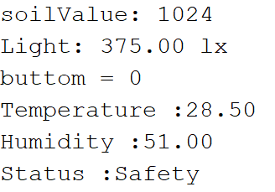

**沒按下button -> 繼電器沒響**

**溫度(Temperature) >= 28 度 -> Status = Alarm**

**濕度(soilValue) > 400 -> Status = Alarm to Safety**

**Status-Result = Safety**

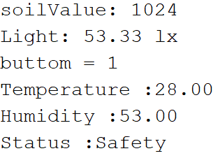

**有按下button -> 繼電器作響**

**溫度(Temperature) >= 28 度 -> Status = Alarm**

**濕度(soilValue) > 400 -> Status = Alarm to Safety**

**Status-Result = Safety**