Mid-Term Homework (2022)

Part1:

1. Write a Java program to read the following XML file (shown in Figure1).

|  |
| --- |
| <?xml version="1.0"?>  <score_data>  <student student_id="A001">  <xml_class>60</xml_class>  <data_structure>70</data_structure>  <algorithm>85</algorithm>  <network>90</network>  </student>  <student student_id="A002">  <xml_class>66</xml_class>  <data_structure>78</data_structure>  <algorithm>62</algorithm>  <network>88</network>  </student>  <student student_id="A003">  <xml_class>89</xml_class>  <data_structure>77</data_structure>  <algorithm>80</algorithm>  <network>50</network>  </student>  </score_data> |

Figure 1: score_data.xml

1. Write data to a database.

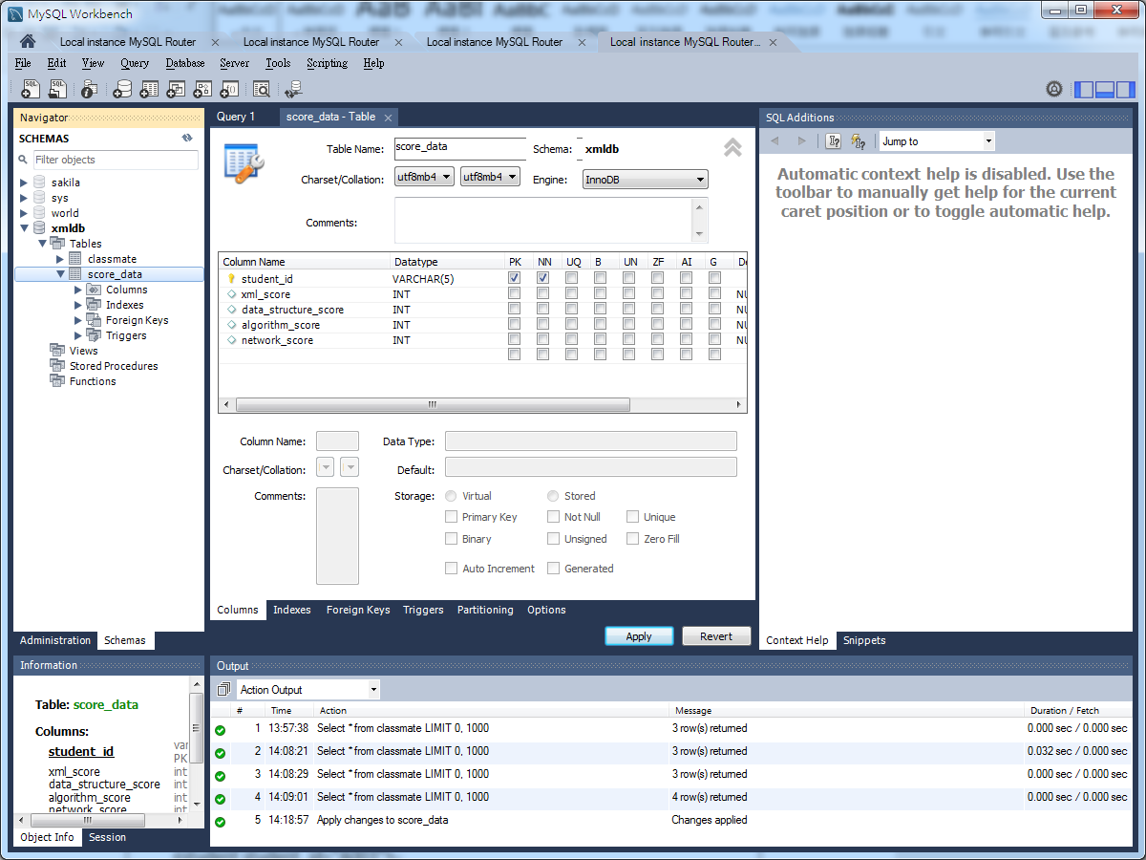

Part2:

1. Write a Java program to read the score of each class from database table.
2. Create a new XML document.
3. Compute GPA, and add gpa attribute in each class element.
4. Write the XML tree into a new file: output.xml (See Figure 2)
5. Upload your two java source files.
6. **Demonstrate your programs in the class.**

|  |
| --- |
| <?xml version="1.0"?>  <score_data>  <student student_id="A001">  <xml_class gpa="2">60</xml_class>  <data_structure gpa="2.7">70</data_structure>  <algorithm gpa="4">85</algorithm>  <network gpa="4.5">90</network>  </student>  <student student_id="A002">  <xml_class gpa="2.3">66</xml_class>  <data_structure gpa="3.3">78</data_structure>  <algorithm gpa="2">62</algorithm>  <network gpa="4">88</network>  </student>  <student student_id="A003">  <xml_class gpa="4">89</xml_class>  <data_structure gpa="3.3">77</data_structure>  <algorithm gpa="3.7">80</algorithm>  <network gpa="1">50</network>  </student>  </score_data> |

Figure 2: output.xml

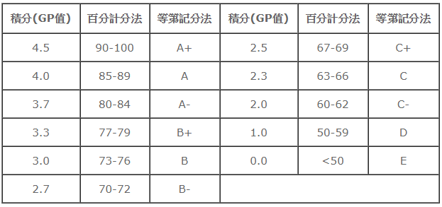

**ANS:**

My Main java source files.  
1. Create database

* JDBCExample.java

2. Create table

* JDBCExample_CreateTable.java

3. Read XML file and Write data to Database

* DomParserDemo.java

4. Write a Java program to read the score of each class from database table.

* JDBCExample_Select.java

5. Create a new XML document.

* CreateXMLFile.java

6. Compute GPA, and add gpa attribute in each class element && Write the XML tree into a new file: output.xml

* CreateXMLFileGPA.java