We have already fixed some errors to run app. The app is running well in iPhone 5 simulator well but with some warnings. The app is not running on the greater than 5 version.

1) In iPhone 5 - 43 warnings

2) Greater than iPhone 5 - 140 warnings & 30 errors.

3) Sliders problems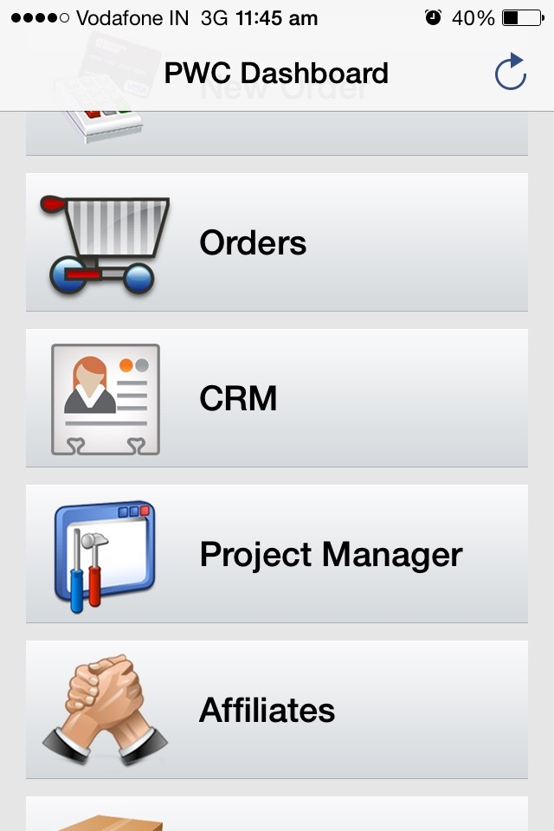

4) Showing this page 2 times after click on the dashboard menu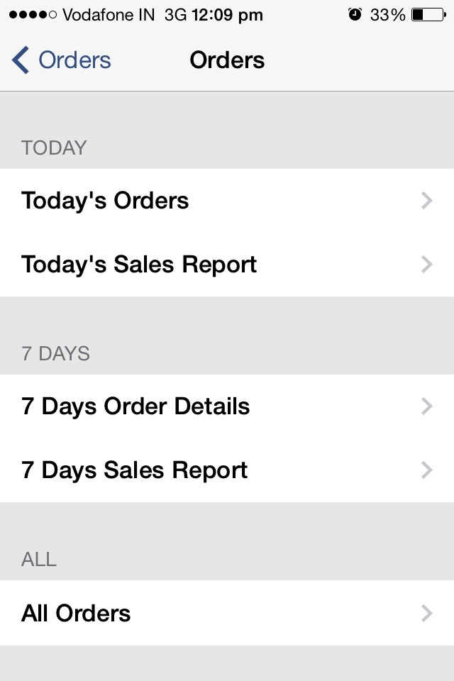

5) Some Text not showing correctly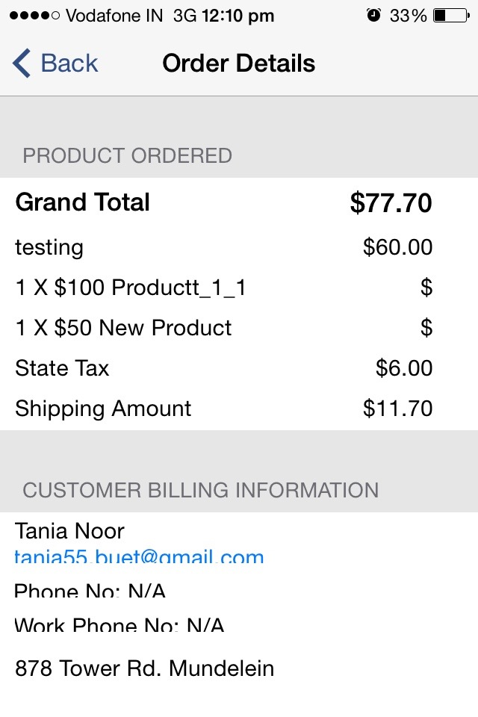

6) New Order menu not showing correctly.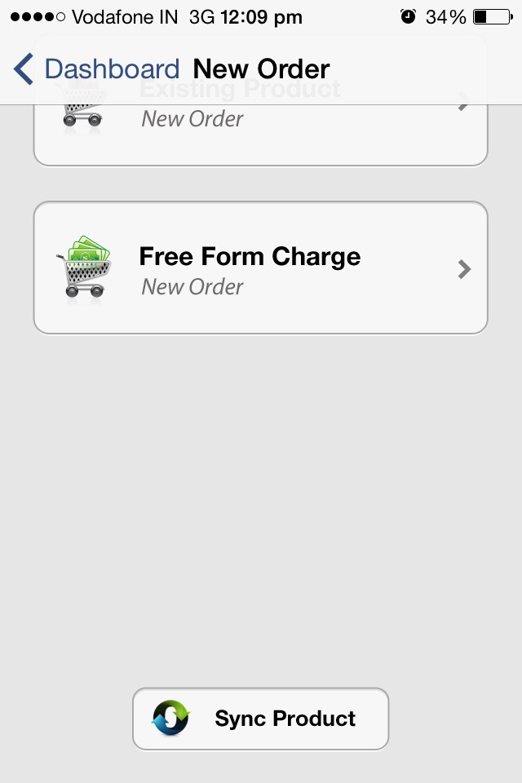

7)Text and close button overlapping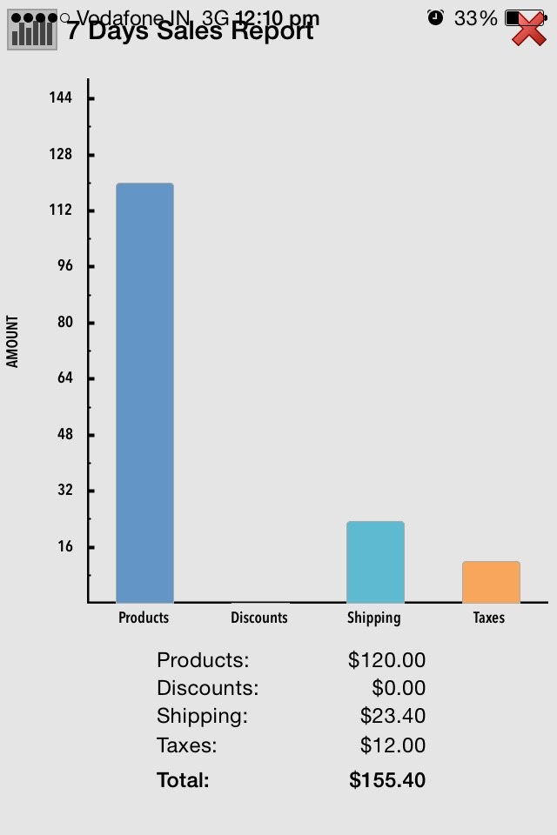

8)Texts are not showing correctly.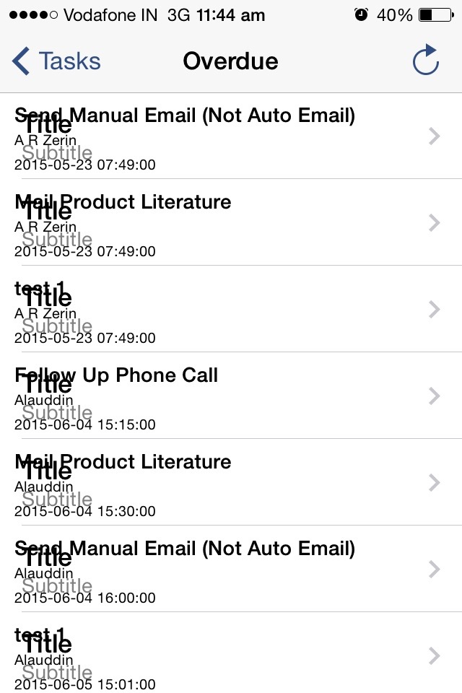

9) Elements missing.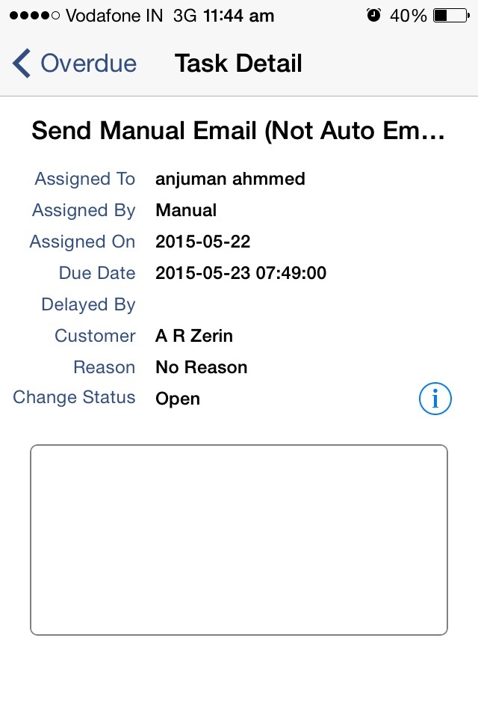

10)Elements missing