**Problem**

Design a network with multiple VLANs to separate broadcast domains and enable inter-VLAN communication using a Layer 3 device.

**Network Design:**

Create a network with at least three VLANs (e.g., VLAN 10 for Sales, VLAN 20 for Marketing, and VLAN 30 for HR).

Assign IP subnets to each VLAN (e.g., 192.168.10.0/24 for VLAN 10, 192.168.20.0/24 for VLAN 20, and 192.168.30.0/24 for VLAN 30).

**Solution**

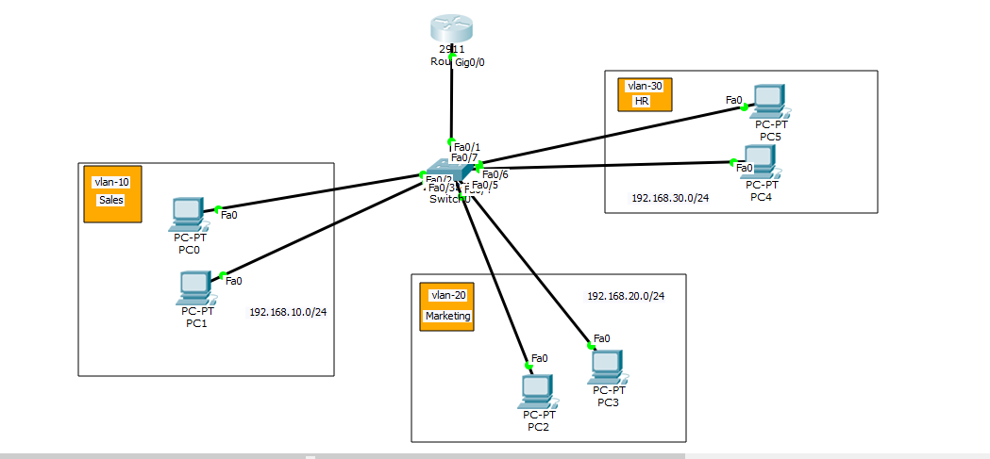**\*** ->Inter-VLAN routing is the process of sending data between different VLANs (Virtual Local Area Networks). VLANs divide broadcast domains on a LAN environment, and hosts in different VLANs can't communicate with each other by default. To enable communication, a router or Layer 3 switch is required to route traffic between VLANs.

**Step-1: Configure the VLAN Number and Name**

Switch(config)#vlan 10

Switch(config-vlan)#name sales

Switch(config-vlan)#vlan 20

Switch(config-vlan)#name marketing

Switch(config-vlan)#vlan 30

Switch(config-vlan)#name hr

**Step-2: Configure Access Mode**

Switch(config)#interface range fastEthernet 0/2-3

Switch(config-if-range)#switchport mode access

Switch(config-if-range)#switchport access vlan 10

Switch(config-if-range)#exit

Switch(config)#interface range fastEthernet 0/4-5

Switch(config-if-range)#switchport mode access

Switch(config-if-range)#switchport access vlan 20

Switch(config-if-range)#exit

Switch(config)#interface range fastEthernet 0/6-7

Switch(config-if-range)#switchport mode access

Switch(config-if-range)#switchport access vlan 30

**Step-3: Configure Trunk Mode**

Switch(config)#int f0/1

Switch(config-if)#switchport mode trunk

**Step-4: Inter-VLAN Configure**

*-> Use the encapsulation dot1q command in subinterface range configuration mode to apply a VLAN ID to the subinterface.

Router(config)#int gigabitEthernet 0/0.10

Router(config-subif)#encapsulation dot1Q 10

Router(config-subif)#ip address 192.168.10.1 255.255.255.0

Router(config-subif)#exit

Router(config)#int gigabitEthernet 0/0.20

Router(config-subif)#encapsulation dot1Q 20

Router(config-subif)#ip address 192.168.20.1 255.255.255.0

Router(config-subif)#exit

Router(config)#int gigabitEthernet 0/0.30

Router(config-subif)#encapsulation dot1Q 30

Router(config-subif)#ip address 192.168.30.1 255.255.255.0

Router(config-subif)#do wr

**Step-5: Configure IP in the PC manually.**

Default Gateway of Sales(VLAN 10) => 192.168.10.1

Default Gateway of Marketing(VLAN 20) => 192.168.20.1

Default Gateway of HR(VLAN 30) => 192.168.30.1