B.Tech. BCSE497J - Project-I
SYSTEM AND METHOD FOR COUNTERFACTUAL-DRIVEN ADAPTIVE SECURITY CONTROL AND VERIFIED MODEL UPDATING IN EDGE-DEPLOYED DIGITAL TWINS FOR CONSUMER INTERNET OF THINGS NETWORKS
Submitted in partial fulfillment of the requirements for the degree of
Bachelor of Technology
in
Computer Science and Engineering
by
23BAI0136 | ATRIK
23BCI0231 | T V SAI SUSANTH
23BCT0129 | PUSHPAK

Under the Supervision of
Dr. JIM SOLOMON RAJA
Employee ID: 22533
School of Computer Science and Engineering (SCOPE)
Vellore Institute of Technology, Vellore - 632 014
October 2026

DECLARATION
We hereby declare that the project entitled “SYSTEM AND METHOD FOR COUNTERFACTUAL-DRIVEN ADAPTIVE SECURITY CONTROL AND VERIFIED MODEL UPDATING IN EDGE-DEPLOYED DIGITAL TWINS FOR CONSUMER INTERNET OF THINGS NETWORKS” submitted by us, for the award of the degree of Bachelor of Technology in Computer Science and Engineering to Vellore Institute of Technology, Vellore, is a record of bonafide work carried out by us under the supervision of Dr. JIM SOLOMON RAJA, School of Computer Science and Engineering (SCOPE).
We further declare that the work reported in this project has not been submitted and will not be submitted, either in part or in full, for the award of any other degree or diploma in this institute or any other institute or university.

Place : Vellore
Date :

Signature of the Candidates
ATRIK (23BAI0136)
T V SAI SUSANTH (23BCI0231)
PUSHPAK (23BCT0129)

CERTIFICATE
This is to certify that the project entitled “SYSTEM AND METHOD FOR COUNTERFACTUAL-DRIVEN ADAPTIVE SECURITY CONTROL AND VERIFIED MODEL UPDATING IN EDGE-DEPLOYED DIGITAL TWINS FOR CONSUMER INTERNET OF THINGS NETWORKS” submitted by ATRIK (23BAI0136), T V SAI SUSANTH (23BCI0231), PUSHPAK (23BCT0129), School of Computer Science and Engineering (SCOPE), Vellore Institute of Technology, Vellore, for the award of the degree of Bachelor of Technology in Computer Science and Engineering, is a record of bonafide work carried out by them under my supervision, as per the VIT code of academic and research ethics.
The contents of this report have not been submitted and will not be submitted either in part or in full, for the award of any other degree or diploma in this institute or any other institute or university. The project fulfills the requirements and regulations of the University and in my opinion meets the necessary standards for submission.

Place : Vellore
Date :

Signature of the Guide
Dr. JIM SOLOMON RAJA
Employee ID: 22533

Examiner(s)
<< Head of the Department >>
Computer Science and Engineering

ACKNOWLEDGEMENTS
We are deeply grateful to the management of Vellore Institute of Technology (VIT) for providing us with the opportunity and the resources to undertake this project. The laboratory facilities and the academic environment made it possible to build and evaluate the system described in this report.
Our sincere thanks to Dr. Jaisankar N, the Dean of the School of Computer Science and Engineering (SCOPE), for his unwavering support and encouragement throughout the course of this work.
We express our profound appreciation to << Head of the Department >>, the Head of the Department, for the insightful guidance and continuous encouragement that shaped the direction of this project.
We are immensely thankful to our project guide, Dr. JIM SOLOMON RAJA, for his dedicated mentorship and invaluable feedback. His patience, knowledge and willingness to question our assumptions improved this work at every stage, and several of the design decisions defended in this report exist because of that scrutiny.
We also thank the faculty members of SCOPE for their constructive comments during the review presentations, and our families and friends for their steady encouragement.
Thank you all for your contributions and support.

Name of the Candidates
ATRIK (23BAI0136)
T V SAI SUSANTH (23BCI0231)
PUSHPAK (23BCT0129)

TABLE OF CONTENTS
Sl.No | Contents | Page No.
 | Abstract | 1
1. | INTRODUCTION | 1
 | 1.1 Background | 1
 | 1.2 Motivation | 1
 | 1.3 Scope of the Project | 1
2. | PROJECT DESCRIPTION AND GOALS | 1
 | 2.1 Literature Review | 1
 | 2.2 Research Gap | 1
 | 2.3 Objectives | 1
 | 2.4 Problem Statement | 1
 | 2.5 Project Plan | 1
3. | TECHNICAL SPECIFICATION | 1
 | 3.1 Requirements | 1
 | 3.1.1 Functional | 1
 | 3.1.2 Non-Functional | 1
 | 3.2 Feasibility Study | 1
 | 3.2.1 Technical Feasibility | 1
 | 3.2.2 Economic Feasibility | 1
 | 3.2.3 Social Feasibility | 1
 | 3.3 System Specification | 1
 | 3.3.1 Hardware Specification | 1
 | 3.3.2 Software Specification | 1
4. | DESIGN APPROACH AND DETAILS | 1
 | 4.1 System Architecture | 1
 | 4.2 Design | 1
 | 4.2.1 Data Flow Diagram | 1
 | 4.2.2 Use Case Diagram | 1
 | 4.2.3 Class Diagram | 1
 | 4.2.4 Sequence Diagram | 1
5. | METHODOLOGY AND TESTING | 1
 | 5.1 Module Description | 1
 | 5.2 Methodology | 1
 | 5.3 Testing | 1
6. | PROJECT DEMONSTRATION | 1
 | 6.1 Access Control | 1
 | 6.2 Walking the Twelve Steps | 1
 | 6.3 Demonstration on Live USB Hardware | 1
 | 6.4 Conclusion of a Run | 1
7. | RESULT AND DISCUSSION | 1
 | 7.1 Threat Detection Performance | 1
 | 7.2 Twin Consistency | 1
 | 7.3 Counterfactual Validation | 1
 | 7.4 Immunization and Promotion | 1
 | 7.5 Results on Live USB Hardware | 1
 | 7.6 Cost Analysis | 1
 | 7.7 Discussion | 1
8. | CONCLUSION | 1
 | 8.1 Contributions | 1
 | 8.2 Future Work | 1
9. | REFERENCES | 1
 | APPENDIX A — SAMPLE CODE | 1
Page numbers are live fields. In Word, press Ctrl+A then F9 and choose “Update entire table” to populate them.

List of Figures
Figure No. | Title | Page No.
2.1 | Project plan and milestone schedule
4.1 | System architecture of the proposed framework
4.2 | Data flow diagram
4.3 | Use case diagram
4.4 | Sequence diagram of a validation cycle
In the chapters, a figure caption appears below the figure and a table caption above the table. Captions are Times New Roman 10, centred.

List of Tables
Table No. | Title | Page No.
5.1 | Module responsibilities
5.2 | The six components of the Counterfactual Consistency Score
5.3 | Test coverage by area
7.1 | Edge detector performance on held-out evaluation data
7.2 | Validation decisions, 13 of 13 correct
7.3 | Live hardware compared with the simulated fleet

List of Abbreviations
API Application Programming Interface
AR Autoregressive
CCS Counterfactual Consistency Score
CPU Central Processing Unit
CSV Comma-Separated Values
DDoS Distributed Denial of Service
DFD Data Flow Diagram
EWMA Exponentially Weighted Moving Average
FNR False Negative Rate
FPR False Positive Rate
HTTP Hypertext Transfer Protocol
IoT Internet of Things
JSON JavaScript Object Notation
MAD Median Absolute Deviation
ML Machine Learning
MPA Multi-Page Application
PBKDF2 Password-Based Key Derivation Function 2
PnP Plug and Play
PRG Post/Redirect/Get
SQL Structured Query Language
USB Universal Serial Bus
UVC USB Video Class
VAR Vector Autoregression
WAL Write-Ahead Logging
WMI Windows Management Instrumentation
Abbreviations are listed in alphabetical order.

Symbols and Notations
z Standard-deviation multiplier used to place the accept threshold below the honest mean
σ Standard deviation of the honest Counterfactual Consistency Scores
α Smoothing factor of the twin's exponentially weighted moving average
w Weight of a component within the Counterfactual Consistency Score
H Prediction horizon, in ticks, of a committed future
N Number of counterfactual futures committed per twin
λ Ridge regularisation coefficient of the forward model

ABSTRACT
Consumer Internet-of-Things networks — smart cameras, locks, plugs, bulbs, sensors and speakers — are increasingly defended by artificial-intelligence models that execute on a local edge gateway and retrain continuously on the telemetry they collect. That continuous retraining is what keeps the detector current as a household's devices and habits change, and it is also the system's most exposed surface: an adversary able to introduce falsified or mislabelled training data can steer the model into accepting hostile behaviour as ordinary. Existing poisoning defences are reactive. Anomaly filtering, trust and reputation scoring, and robust aggregation each inspect a contribution only after it has been submitted, and each judges it only against present or historical observations, so a contribution engineered to resemble ordinary traffic passes unchallenged.
This project develops a proactive alternative. Every physical device is mirrored by a holographic digital twin that models the device as five partial behavioural projections and commits, in advance, to twenty counterfactual future trajectories describing how that device would behave if nothing were wrong. Those futures — half left benign, half deformed by each attack class in the taxonomy — form an audit bank. An incoming retraining update is grafted onto a small trusted core, a shadow model is trained, and the shadow model's behaviour on the audit bank yields a Counterfactual Consistency Score, judged against a threshold calibrated from honest traffic on that specific fleet. A predictive immunization engine synthesises vaccine rows from the same committed futures so that resistance exists before any real attack is attempted, and a self-healing controller restores the last trusted model and purges the offending contributor's rows should degradation nonetheless occur.
The framework has been implemented end to end and evaluated on a simulated eight-device network against five poisoning strategies, including clean-label poisoning that carries no label shift and is therefore invisible to distributional defences.
Keywords — Digital Twin, Counterfactual Validation, Model Poisoning, Edge Artificial Intelligence, Consumer IoT Security, Predictive Immunization, Self-Healing Systems.

CHAPTER 1
1. INTRODUCTION
1.1 Background
A typical household now runs a dozen networked appliances — cameras, door locks, power plugs, lighting, environmental sensors and voice assistants — that differ enormously in compute, in traffic volume and in what constitutes normal behaviour. Because these devices are rarely patched and are individually weak, the accepted defence is to place an intelligent monitor on the local gateway rather than on the devices themselves. That monitor learns the behavioural signature of each device and raises an alarm when the signature is violated.
Such a monitor cannot be trained once and left alone. Firmware changes, household routines shift, and devices are added and removed, so the model must retrain on locally collected telemetry to remain useful. Continuous retraining at the edge is therefore not an optional refinement but a requirement of the deployment. It is also, as this project argues, the point at which the defence becomes attackable, because anything that keeps learning can be taught something false.
1.2 Motivation
Poisoning a model that retrains continuously is attractive precisely because it is quiet. An attacker does not need to defeat the detector at the moment of attack; it is sufficient to contribute training data which shifts the decision boundary so that, later, hostile traffic falls inside the region the model considers normal. Nothing alarms at the time of contribution, and the failure surfaces only when an attack is missed.
The defences available today all answer a variant of the same question: does this contribution resemble the others? That is a question about the past, and a competent adversary answers it by staying close to the crowd. Clean-label poisoning is the sharpest illustration — no label is altered, so the label distribution is untouched and every distributional check passes the contribution without comment. The motivation for this project is to replace that question with a different one: not whether an update looks suspicious, but what accepting it would cost the system's ability to detect tomorrow's attack.
1.3 Scope of the Project
The project covers a complete, working edge-security pipeline for a simulated consumer IoT network: device simulation across six appliance types, an edge gateway, a holographic digital twin per device, counterfactual future generation, a multi-class threat detector, a poisoning-attack simulator covering five strategies, the counterfactual validation gate, a predictive immunization engine, a quarantine zone with forensics, gated retraining, and self-healing rollback.
The scope is deliberately bounded in three respects. The fleet is simulated from physically motivated behavioural profiles rather than captured from hardware, so results demonstrate the mechanism rather than field performance. The system defends the training pipeline of an edge detector; it does not address device firmware integrity, network segmentation or cryptographic device identity, which are complementary controls. Finally, comparative benchmarking against re-implemented reactive baselines is specified in this report and scheduled for the second phase of the project, so the results presented here characterise the proposed framework itself rather than its margin over prior work.

CHAPTER 2
2. PROJECT DESCRIPTION AND GOALS
2.1 Literature Review
The literature relevant to this project falls into four strands: the security of digital twins, machine-learning intrusion detection for IoT, poisoning attacks and their defences, and counterfactual reasoning. Each strand is mature in isolation; the gap this project addresses lies at their intersection.
Security of Digital Twins
Alcaraz and Lopez [1] survey the threat landscape of digital twins across their life cycle and reach a conclusion that directly shapes this design: the twin is itself a target for poisoning and spoofing, and trusted state synchronisation is essential. Their survey characterises the attack surface thoroughly but proposes no runtime defence, and in the surveyed literature the twin remains a monitoring or replay replica rather than a participant in a security decision.
Machine-Learning Intrusion Detection for Consumer IoT
Nguyen et al. [4] demonstrate federated self-learning anomaly detection on a gateway, reporting 95.6 per cent detection of Mirai-infected devices without labelled attack data. The work is directly relevant in its device-type-specific modelling, but it assumes every participating client is honest — which is precisely the assumption poisoning breaks. Meidan et al. [15] establish deep autoencoders over network behaviour as an effective botnet detector, and Antonakakis et al. [14] document why consumer devices are such attractive targets in the first place through their analysis of the Mirai botnet.
Poisoning Attacks and Their Defences
Tian et al. [2] provide the comprehensive taxonomy of poisoning attacks and countermeasures, and note explicitly that the defences surveyed are post-hoc and detection-based, identifying proactive immunization as an open problem. Biggio and Roli [13] trace ten years of adversarial machine learning and frame poisoning as an attack on the training pipeline rather than on inference. On the attack side, Gu et al. [8] introduce backdoor triggers that leave overall accuracy essentially unchanged, which defeats any accuracy-based promotion gate; Shafahi et al. [7] demonstrate clean-label poisoning in which no label is altered at all; Tolpegin et al. [11] and Bagdasaryan et al. [10] transfer both to the federated setting. On the defence side, Blanchard et al. [9] propose Byzantine-tolerant aggregation, Fung et al. [12] target Sybil contributors, and Yang et al. [3] filter malicious client updates for IoT intrusion detection specifically. Every one of these defences acts on a contribution after it has been submitted, and judges it against the current or historical distribution.
Counterfactual Reasoning and Proactive Robustness
Sulem et al. [5] generate diverse counterfactual ensembles to explain anomalies in time series, showing that counterfactual alternatives reliably separate genuine anomalies from benign variation. Their use is explanatory; the counterfactuals never gate a decision. Madry et al. [6] establish that training on generated worst-case examples produces durable robustness, which is the principle this project transfers from test-time evasion to training-data poisoning. Aggarwal [16] and Goodfellow et al. [17] provide the underlying treatment of outlier analysis and of the learning methods employed.
Table 2.1 Summary of the reviewed literature
Ref. | Focus | Contribution | Limitation for this problem
[1] | Digital-twin security | Life-cycle threat taxonomy for twins | No runtime defence; twin stays passive
[2] | Poisoning survey | Taxonomy of attacks and defence families | All defences surveyed are post-hoc
[3] | Federated IoT IDS | Filters malicious client updates | Reacts only after submission
[4] | Gateway anomaly detection | Federated self-learning, label-free | Assumes all clients honest
[5] | Counterfactual explanation | Diverse counterfactuals for time series | Explanatory only, never a gate
[6] | Adversarial training | Robustness from generated attacks | Test-time evasion, not poisoning
[7] | Clean-label poisoning | Poisoning with no label alteration | Defeats label-distribution checks
[8] | Backdoor attacks | Triggers that preserve accuracy | Defeats accuracy-based gates
[9]-[12] | Robust aggregation | Byzantine, Sybil and federated defences | Current-state, post-submission
2.2 Research Gap
Eight gaps follow from the survey. They are stated in decreasing order of how directly they motivate the proposed mechanism.
- Validation against the current state only. Trust scores, reputation and robust aggregation compare an update with current or historical observations. None tests it against where the device is expected to be next, so multi-future behavioural consistency remains unused as a validation signal.
- Counterfactual reasoning and digital twins are never combined. Counterfactual reasoning has been applied to anomaly explanation and digital twins to monitoring, but the two have not been joined into a decision mechanism for validating model updates.
- Attack simulation does not close the loop. Simulation generates an attack, tests the detector and measures accuracy. It is rarely carried onward to identify the weakness, synthesise training examples and retrain against them.
- Twins monitor rather than immunize. Digital-twin research targets monitoring, visualisation, fault prediction and device management. Few approaches use the twin as an active security environment that predicts behaviour under attack.
- Threat detection remains reactive. Most IoT intrusion detection follows attack, collect, detect, alert. Predictive detection is seldom integrated with proactive adaptation of the security model at the edge.
- Poisoning is inadequately addressed in real time. Existing defences identify abnormal samples, aggregate robustly, filter data or validate statistically — and clean-label poisoning, which alters no label at all, passes the entire family.
- Edge retraining forces a security–adaptability trade-off. Frequent retraining adapts quickly but widens poisoning exposure, while infrequent retraining is safer but leaves the detector stale. Selecting a frequency resolves neither horn; what is missing is a gate on update content.
- Recovery is manual and total. Detection, quarantine and retraining exist as separate systems. Restoring a clean model and purging contaminated data is an operator task, and the usual remedy discards the entire pool.
Stated as a single gap: existing IoT security performs reactive anomaly detection while digital twins are used for monitoring and prediction; there is limited work integrating twins with counterfactual future-state simulation to validate machine-learning updates against multiple plausible future behaviours, and predictive attack simulation is rarely connected to secure edge-model retraining. A gap therefore exists for an integrated framework that uses counterfactual twin states to validate incoming updates, quarantines inconsistent updates, and proactively immunizes edge models against predicted threats.
2.3 Objectives
Seven objectives are defined, each mapped to a research gap and to a measurable acceptance criterion.
Table 2.2 Objectives, mapped gaps and acceptance criteria
# | Objective | Gap | Measurable criterion | Status
O1 | Simulate a heterogeneous consumer IoT fleet and an on-demand edge gateway. | G4 | Six device types separable on baseline behaviour | Complete
O2 | Build a holographic twin per device across five behavioural planes. | G4 | Zero false flags on healthy traffic | Complete
O3 | Commit counterfactual futures before the observation they judge exists. | G1 | 20 futures x 5-tick horizon, committed in advance | Complete
O4 | Design a Counterfactual Consistency Score gating every retraining update. | G2 | Separation between honest and poisoned scores | Complete
O5 | Detect clean-label poisoning that carries no label shift. | G6 | Quarantined at a label shift below 0.10 | Complete
O6 | Immunize the detector against synthesised poisoning before real attacks. | G3 | Poison resistance measured across five strategies | Complete
O7 | Benchmark against reactive baselines across poisoning rates. | G1 | Attack success rate versus each baseline | Phase II
2.4 Problem Statement
An edge-AI threat detector protecting a consumer IoT network must retrain continuously on locally collected telemetry in order to remain accurate as the network changes. This creates an open ingestion path: a contributor — a device, a hub, or a vendor cloud, any of which may be attacker-controlled — can submit training data that shifts the model's decision boundary so that hostile behaviour is later classified as normal.
Existing defences evaluate such a contribution only after it has been submitted and only against the current or historical state of the network. They are therefore blind to a contribution that is statistically ordinary but functionally damaging, and blind entirely to clean-label poisoning, in which every label is honest.
The problem addressed by this project is therefore: given a candidate retraining update for an edge threat-detection model in a consumer IoT network, determine before the update is accepted whether it is consistent with the expected future behaviour of that specific network, quarantine it if it is not, and independently harden the model against poisoning strategies that have not yet been attempted.
2.5 Project Plan
The work is organised into two phases across the Fall Semester 2026. Phase I, concluding at Review-2, delivers the complete implemented framework and its internal measurement. Phase II, concluding at Review-3, delivers comparative evaluation against re-implemented reactive baselines, the poisoning-rate sweep, and dissemination. Figure 1 shows the schedule.
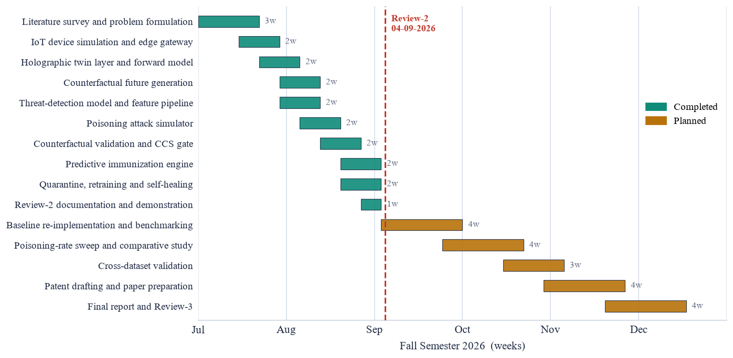
Fig. 1. Project plan (Gantt chart)
Tasks shown in teal are complete and demonstrable; tasks in amber are planned for Phase II. The dashed marker indicates the Review-2 checkpoint on 4 September 2026.

CHAPTER 3
3. TECHNICAL SPECIFICATION
3.1 Requirements
3.1.1 Functional
- FR-01 Device simulation. The system shall generate continuous sixteen-feature telemetry for six consumer device types, each with a distinct behavioural baseline, and shall deform that telemetry according to a named attack class on demand.
- FR-02 On-demand ingestion. The gateway shall collect, timestamp and buffer per-device telemetry only when an operator requests a tick; no collection shall occur autonomously.
- FR-03 Twin synchronisation. Each device shall have a holographic twin whose five-plane state is updated from trusted telemetry, and which shall refuse any observation judged hostile by either detector.
- FR-04 Future commitment. Each ready twin shall commit twenty predicted trajectories over a five-tick horizon before the observation those trajectories will be used to judge exists.
- FR-05 Threat detection. The system shall classify normal traffic and six attack classes, returning a predicted class, a confidence and an operator-facing risk level for every observation.
- FR-06 Counterfactual validation. Every retraining update shall be scored on six weighted components against the counterfactual audit bank and judged against a threshold calibrated from honest updates on the deployed fleet.
- FR-07 Operator control. The system shall apply an accept or quarantine decision only on explicit operator instruction, shall permit that decision to be overridden in either direction, and shall record any override.
- FR-08 Quarantine ledger. Quarantined updates shall be retained intact with update identifier, source, suspected strategy, consistency score and timestamp, and shall be re-scorable against a later audit bank.
- FR-09 Predictive immunization. The system shall synthesise vaccine rows from committed futures and shall measure poison resistance by rehearsing five poisoning strategies against the current training pool.
- FR-10 Guarded promotion and rollback. A retrained candidate shall replace the incumbent only if accuracy, poison resistance, false-positive rate and pool size all pass their gates; otherwise the incumbent is retained and remains available for rollback.
3.1.2 Non-Functional
- Performance. Validation of a single update shall complete within one second on laptop-class CPU hardware; the measured figure is 412 milliseconds.
- Resource economy. The pipeline shall execute without GPU acceleration, so that it remains deployable on a single-board gateway.
- Determinism. A given random seed shall reproduce an identical end-to-end run, so that reported results are verifiable.
- Auditability. Every automated decision shall expose the components that produced it, and every training row shall record its contributing update and source.
- Fail-safe behaviour. A failed promotion, a failed validation or an internal error shall leave the incumbent trusted model in service.
- Locality. No telemetry, model or update shall leave the local network during normal operation.
- Usability. The operator interface shall state, for each stage, what the stage does before it runs and what its result means afterwards.
- Maintainability. Every tunable constant shall reside in a single configuration module, and the system shall be covered by an automated test suite.
3.2 Feasibility Study
3.2.1 Technical Feasibility
The framework is built from established components: a ridge-regularised vector autoregression for the twin's forward model, a random-forest classifier for threat detection, and standard scientific Python libraries throughout. The choice of a closed-form ridge fit over a recurrent network is deliberate and is what makes the design feasible on constrained hardware: the twin must refit repeatedly from a few dozen observations per device and must produce a distribution of futures rather than a point estimate, both of which a closed-form fit provides in microseconds and without a GPU.
Technical feasibility is evidenced rather than asserted. The complete twelve-stage pipeline executes end to end in approximately fifteen seconds on a laptop-class CPU, and is covered by sixty-four automated tests. No component requires specialised hardware, and no stage depends on network connectivity beyond the local gateway.
3.2.2 Economic Feasibility
Development cost is confined to student effort and commodity hardware; every library used is open source and permissively licensed, so licence cost is nil. Because inference and retraining both execute on the gateway, the recurring cost of a deployment is the gateway itself — a single-board computer of the Raspberry Pi class — with no cloud compute, no data-egress charges and no per-device subscription.
The economic argument for the defence is asymmetric. The marginal cost of validating an update is a fraction of a second of CPU time, whereas the cost of a successfully poisoned detector is the silent loss of protection across the whole household for as long as the compromise goes unnoticed.
3.2.3 Social Feasibility
Because all processing is local, no household telemetry is transmitted to a vendor, which addresses the privacy objection that limits acceptance of monitored home security. The operator interface is designed so that every automated judgement is inspectable and can be overruled; a security control that a human can neither examine nor countermand is an oracle rather than a control, and is unlikely to be trusted or retained.
Two ethical considerations bound the work. First, the poisoning simulator exists to test the defence and is confined to a simulated fleet. Second, an automated system that can reject a legitimate contribution carries a fairness cost, which is why the accept threshold is calibrated from honest traffic rather than fixed, and why quarantine holds an update intact for re-judgement rather than discarding it.
3.3 System Specification
3.3.1 Hardware Specification
Component | Development specification | Minimum for deployment
Processor | x86-64, quad core, 2.4 GHz | ARM Cortex-A72 quad core (Raspberry Pi 4 class)
Memory | 16 GB | 4 GB
Storage | 20 GB free | 8 GB (models, ledger and logs)
Graphics | Not required | Not required
Network | Local Ethernet or Wi-Fi | Local network only; no internet dependency
Display | 1920 x 1080 for the operator console | Any browser-capable client on the LAN
3.3.2 Software Specification
Layer | Technology | Role in the system
Operating system | Windows 11 / 64-bit Linux | Development and deployment host
Language | Python 3.11 or later | Simulation, twins, models, validation
Numerical | NumPy | Feature vectors, ridge fit, future roll-out
Machine learning | scikit-learn | Random-forest detector, shadow and probe models
Web framework | FastAPI with Uvicorn | One HTTP endpoint per operator action
Front end | HTML, CSS and vanilla JavaScript | Operator console; no build step required
Persistence | joblib model registry with a JSON ledger | Versioned models and promotion history
Testing | pytest | Sixty-four automated tests across all stages
Documentation | Matplotlib | Generation of the figures in this report

CHAPTER 4
4. DESIGN APPROACH AND DETAILS
4.1 System Architecture
The architecture is a closed loop with three vertical concerns: a device plane that produces telemetry, an edge gateway that turns telemetry into judgements, and a decision and recovery column that acts on those judgements and feeds the result back into detection. Figure 2 shows the arrangement.
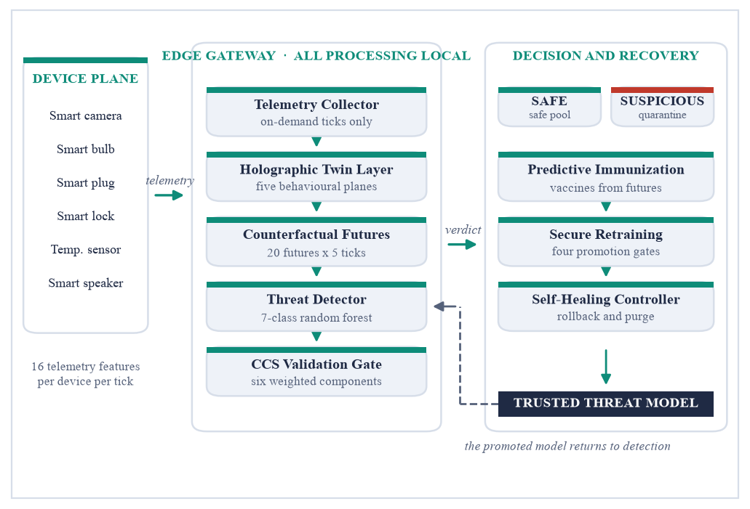
Fig. 2. System architecture of the proposed framework
Telemetry from each simulated device enters the gateway, where it is collected only on operator request. The holographic twin layer maintains, for every device, five partial projections of its behaviour — resource, network, access, topology and actuation. Modelling the device as separate projections rather than one combined state vector is what keeps single-plane attacks visible: a port scan detonates the topology plane and barely touches resources, while tampered firmware does the reverse, and averaging the two would hide both.
Each ready twin fits a ridge vector autoregression over its recent history and rolls out twenty future trajectories. Half are retained as benign futures and half are deformed by each attack class in the taxonomy, together forming the counterfactual audit bank. The bank is filtered against the current trusted detector so that it contains only scenarios that detector already handles correctly; any subsequent degradation is then attributable to the update under test and to nothing else.
Live observations are scored against the committed futures and classified by the threat detector. An incoming retraining update takes the second path: it is grafted onto a trusted core, a shadow model is trained, and that shadow model's behaviour on the audit bank produces the Counterfactual Consistency Score. Updates clearing the calibrated threshold join the safe pool; the remainder are quarantined intact. The immunization engine synthesises vaccine rows from the same committed futures, secure retraining applies four promotion gates, and the self-healing controller restores the last trusted model and purges the offending contributor's rows by provenance. The promoted model then re-filters the audit bank, closing the loop.
4.2 Design
4.2.1 Data Flow Diagram
Figure 3 presents the context diagram and its first-level decomposition. Three external entities interact with the system: the IoT devices that emit telemetry, the network operator who drives every stage and receives verdicts, and the update contributor, which may be attacker-controlled.
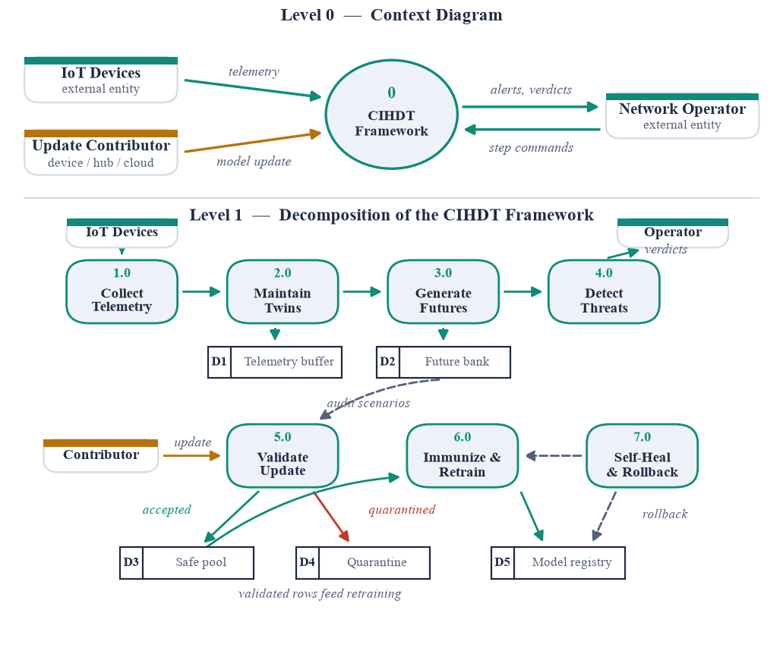
Fig. 3. Data flow diagram (Level 0 and Level 1)
At Level 1 the framework decomposes into seven processes and five data stores. Processes 1.0 to 4.0 form the telemetry path; process 5.0 is the validation gate, drawing audit scenarios from the future bank (D2) and routing each update either to the safe pool (D3) or to quarantine (D4). Process 6.0 retrains on validated rows and writes promoted models to the registry (D5); process 7.0 restores an earlier registry entry when health degrades.
4.2.2 Use Case Diagram
Figure 4 shows the actors and use cases. The network operator drives every stage explicitly, which is a design property rather than an interface convenience: no stage advances without an instruction, so the boundary between any two stages can be inspected.
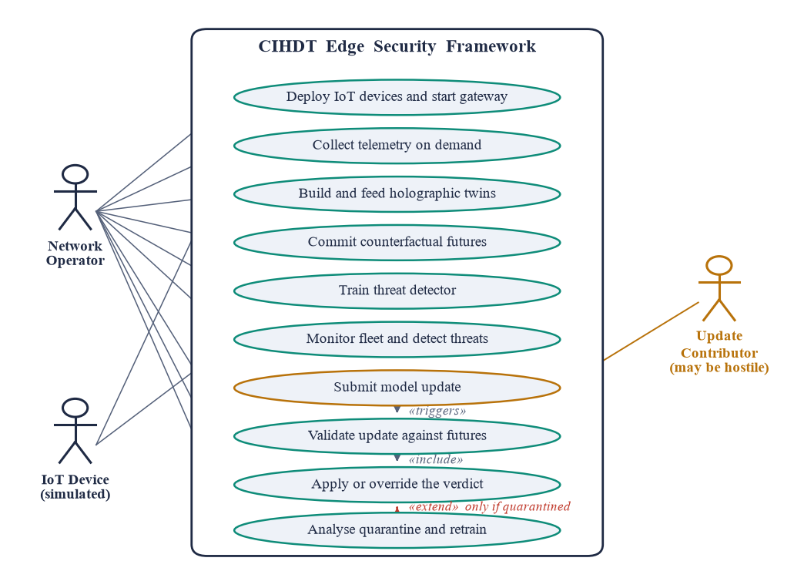
Fig. 4. Use case diagram
The update contributor is modelled as a separate actor and is explicitly untrusted. Submitting a model update triggers validation against the committed futures; validation includes the operator's application of the verdict; and quarantine analysis extends that flow only when an update has been held.
4.2.3 Class Diagram
The principal classes and their responsibilities are summarised in Table 4.1. Each maps to one module of the implementation.
Table 4.1 Principal classes and responsibilities
Class | Responsibility | Key operations
SimulatedDevice | Emit telemetry; apply an attack deformation | tick(), start_attack(), stop_attack()
IoTFleet | Own the deployed devices and the labelled corpus | add_device(), collect(), build_corpus()
HolographicTwin | Maintain five-plane state; commit futures; score | observe(), generate_futures(), score()
ARPredictor | Ridge vector autoregression with residual roll-out | fit(), predict_next(), rollout()
ThreatDetector | Multi-class classification of an observation | fit(), predict_proba(), verdict(), evaluate()
FutureBank | Hold labelled counterfactual scenarios | build_bank(), summary()
CounterfactualValidator | Compute the CCS and reach a verdict | calibrate(), validate(), forensics()
PoisonForge | Craft honest and poisoned model updates | clean_update(), craft()
QuarantineZone | Hold, analyse, rescore and release updates | add(), release(), rescore()
ImmunizationEngine | Synthesise vaccines; measure resistance | synthesise(), poison_resistance()
SecureRetrainer | Own the safe pool and the promotion gates | accept(), purge(), retrain()
SelfHealingMonitor | Track health; roll back and purge | record(), check(), heal()
4.2.4 Sequence Diagram
Figure 5 traces the validation of a single retraining update, which is the sequence that carries the framework's contribution.
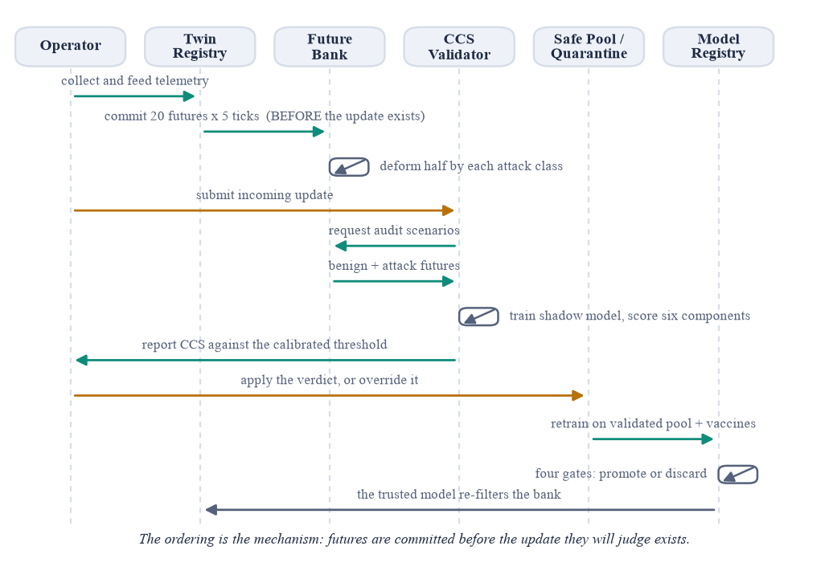
Fig. 5. Sequence diagram for counterfactual update validation
The ordering is the mechanism. The twin registry commits its futures to the bank before the update is submitted, so when the validator later scores a shadow model against those scenarios it is conducting a genuine prediction test rather than fitting an explanation to data already observed. The verdict returns to the operator as a recommendation; nothing is applied until the operator applies it, and the operator may overrule it. After retraining and promotion, the trusted model re-filters the bank, so the gate sharpens as the model improves.

CHAPTER 5
5. METHODOLOGY AND TESTING
5.1 Module Description
The system is organised as eleven Python packages, each owning one stage of the pipeline and exposing a narrow interface to the stage after it. No module reaches across more than one boundary, which is what allows the simulated fleet and the live USB sampler to be substituted for one another without any stage above Step 1 being aware of the change.
Module | Responsibility | Key artefact
simulator | Six consumer device profiles, per-attack deformations, and the labelled corpus generator. | SimulatedDevice, build_corpus
live | Real USB peripherals enumerated through Windows PnP, and host telemetry sampled with psutil. | UsbMonitor, HostSampler, LiveDevice
twin | The holographic twin: five planes, a ridge vector-autoregressive forward model, and committed futures. | HolographicTwin, ARPredictor
detection | Feature engineering and the edge threat classifier. | ThreatDetector, cross_plane_ratios
counterfactual | The audit bank of committed futures and the Counterfactual Consistency Score. | FutureBank, CounterfactualValidator
poisoning | Five poisoning strategies used to test the defence. | PoisonForge
immunization | Predictive vaccines and poison-resistance measurement. | ImmunizationEngine
quarantine | Holding, dissecting, releasing and rescoring suspicious updates. | QuarantineZone
retraining | The validated safe pool, promotion gates and the versioned model registry. | SecureRetrainer, ModelRegistry
selfheal | Model/twin agreement monitoring, rollback and purge. | SelfHealingMonitor
server | The operator console, the JSON API, accounts, sessions and the audit database. | pages.py, api.py, auth.py, db.py
Table 5.1 Module responsibilities
5.2 Methodology
The framework is driven as twelve operator actions rather than as a pipeline that runs to completion. Nothing in the system advances on a timer: the fleet emits telemetry only when a tick is requested, twins learn only when they are fed, and a model update is scored only when it is submitted for validation. Each step declares its prerequisites, so an action attempted out of order fails by naming the step that has to happen first instead of quietly producing a meaningless result.
That ordering is not merely pedagogical. The security argument depends on one sequencing rule: a twin must commit to its set of plausible futures before the observation those futures will judge has been produced. If the order were reversed the comparison would be a retrospective fit rather than a prediction, and the score would carry no information.
5.2.1 The Counterfactual Consistency Score
An incoming update is not inspected for suspicious statistics. It is grafted onto a small trusted core, a shadow model is trained on the combination, and that shadow model is placed in front of the counterfactual bank: the futures the twins committed to before the update existed, half left benign and half deformed by each attack class in the taxonomy. Six quantities are measured and combined as a weighted sum.
Component | Weight | Question it asks
attack_agreement | 0.30 | Of the attack-conditioned futures, how many would this update still let us catch?
label_agreement | 0.20 | Do the update's labels agree with the trusted model's reading of its own rows?
stability | 0.15 | How many verdicts were downgraded from attack to normal against the incumbent?
plane_coherence | 0.15 | Does each row obey the cross-plane physics of the class it claims?
label_integrity | 0.13 | Has the label mix drifted benign-ward from the trusted prior?
benign_agreement | 0.07 | Are benign futures still called benign?
Table 5.2 The six components of the Counterfactual Consistency Score
The combination is necessary because each strategy is caught by a different term. Label flipping collapses label_integrity and attack_agreement. Clean-label poisoning leaves every label honest, so its total-variation label shift stays below 0.10 and every distributional check passes it; only label_agreement sees it. Backdoor triggers barely dent accuracy by design and are caught by the trigger-concentration signal together with plane_coherence. Removing any one component opens a hole that a specific strategy walks straight through.
5.2.2 Calibration of the Accept Threshold
The accept threshold is not a hand-picked constant. It is measured at run time from the empirical distribution of honest updates on the deployed fleet. N honest contributions are scored through the full pipeline, and the gate is placed z = 3 standard deviations below their mean:
threshold = clip( mean(honest) − 3.0 × max(std(honest), 0.02), 0.55, 0.94 )
The floor on the spread is deliberate and load-bearing. All calibration updates are drawn from one pool, so their measured spread understates how much honest traffic really varies once the fleet drifts. Without the floor the gate lands inside the honest distribution and begins quarantining legitimate contributions within a day. In the reference run the measured spread was 0.0068 and the floor of 0.02 was therefore the value used, placing the gate at 0.8568 against an honest mean of 0.9168.
One further adjustment is applied at decision time. A burst of never-before-seen contributor identities adds a novelty penalty of 0.05, capped at 0.97. Inventing identities is the entire method of a sybil flood and is the one structural signal such an attack cannot hide; the penalty tightens the gate but never decides on its own.
5.3 Testing
The implementation is covered by 117 automated tests, executed with pytest. They are not limited to unit-level assertions: the majority exercise the complete pipeline, and several encode the project's central claims so that a regression in the defence would fail the build rather than pass silently.
Area | What the tests assert
Simulator and twins | Device types are behaviourally distinct; every attack visibly deforms telemetry; a twin becomes ready only after sufficient history; futures are committed before scoring; the trust gate keeps hostile observations out of the twin's baseline; plane deviation localises the attack.
Detection | Engineered features are finite; cross-plane ratios detect physical inconsistency; the detector separates normal from attack; probabilities span the full taxonomy.
Counterfactual validation | Honest updates are accepted; every one of the five poisoning strategies is quarantined; poisoned scores sit below honest scores by a clear margin; clean-label poisoning is caught by label_agreement; the validator never reads the declared strategy; the threshold is calibrated rather than hard-coded.
Immunization and retraining | Vaccines are always labelled as attacks and are physically valid; poison resistance is measured per strategy; a degraded candidate is refused promotion; pool provenance allows a surgical purge.
Self-healing | The registry rolls back to the last trusted version; the monitor requires evidence before judging; a blinded model is detected; healing checks its preconditions before committing; a healthy model is not healed without an explicit override.
Console and ordering | Steps start locked and unlock in order; an out-of-order action names the blocking step; nothing advances without being asked; every action returns a well-formed, derived explanation.
Web interface | Each step is its own document; no JavaScript is served; an action redirects to its own panel so the operator does not lose their place; no redirect omits its fragment; nothing is pinned wider than a phone screen.
Access control and storage | Every page and every API endpoint is behind a session; passwords never appear in the database file; sign-in failures do not enumerate accounts; an open redirect is refused; foreign keys cascade; sessions survive a restart; every action is audited.
Table 5.3 Test coverage by area
In addition to the automated suite, the terminal front end doubles as an end-to-end check. The command `python cli.py --walk` drives all twelve steps in order through the same public methods the console buttons call, and exits with a non-zero status if any validation decision comes out wrong. A successful run is therefore evidence that the framework's central claim still holds, not merely that the code executes.

CHAPTER 6
6. PROJECT DEMONSTRATION
The system is demonstrated through a web console served from the edge gateway itself. The console is deliberately a multi-page application: each of the twelve steps is a distinct page at its own address, and every control is an HTML form that submits one operator action and redirects back to the panel it was pressed on. No JavaScript is served at all.
That shape follows from the system's premise rather than from a preference. Because nothing happens unless the operator asks for it, there is never any state to push to the browser; and because every action is a POST followed by a redirect, a page refresh re-reads the result instead of silently repeating the action. On a console able to retrain and roll back a deployed model, that distinction matters.
6.1 Access Control
Every operator signs in with an email address, and the gate covers the JSON API as well as the pages: a login screen in front of the HTML alone would protect nothing, because every operator action also has an endpoint behind it. Passwords are stored only as a salted PBKDF2-HMAC-SHA256 derivation at 240,000 iterations and verified in constant time; no default credential exists anywhere in the source tree. Sessions are held server-side in the database, so signing out genuinely ends a session and a restart does not interrupt a walkthrough in progress.
6.2 Walking the Twelve Steps
The operator chooses a telemetry source, assembles a fleet one device at a time, brings up the gateway and collects telemetry on demand. Twins are created and fed, forward models are fitted, and futures are committed. From Step 6 onward the detector is trained on a corpus generated from the deployed fleet's own profiles, attacks are launched by hand against named devices, and the protection loop is run one tick at a time so that the twin's judgement and the model's judgement can be compared directly.
Steps 7 and 8 are the core of the demonstration. A poisoned contribution is crafted using any of five strategies and lands in an inbox where it touches nothing. Validating it produces the Counterfactual Consistency Score together with every component that went into it, the bank classes that would be lost if it were accepted, and the strategy attribution scores. The verdict is a recommendation until the operator applies it, and it can be overruled in either direction — the override being recorded in the audit trail either way, because a security control a human cannot inspect and countermand is not a control but an oracle.
After every action the console presents a “what just happened” card generated from the numbers that action actually produced: a headline stating the outcome, bullets quoting real values, the key readings with plain-English notes, and a pointer to the next step. The text is produced server-side so the browser console and the terminal front end tell the operator the same story from one source.
6.3 Demonstration on Live USB Hardware
Before Step 1 the console asks a single question: should the telemetry come from the simulated fleet, or from the real USB devices attached to this machine? Choosing live enumerates the USB bus through Windows PnP, and attached peripherals — a webcam, a Bluetooth radio, a composite device — can be enrolled by name. Every step from that point onward behaves identically, which is the point: the twelve steps do not know whether the numbers they are reading came from a behavioural model or from the bus of a laptop.
The console is explicit about what live mode can and cannot measure, and displays the complete sixteen-feature vector for each collected tick with the provenance of every value. Ten features are measured from the host, three from the peripheral itself, one is declared by the USB specification rather than measured, and two cannot be obtained on an unprivileged Windows host at all. Those two are held at zero and reported as missing, never invented.
6.4 Conclusion of a Run
On completion of all twelve steps the console presents a results page that gathers the evidence into a single verdict: the number of validation decisions that were correct, the headline detection figures, the full decision table, the poison-resistance measurements, and an explicit statement of what the run does not establish. The run can be exported as JSON or as a CSV decision table so that reported figures are transferred as data rather than transcribed by hand.

CHAPTER 7
7. RESULT AND DISCUSSION
All figures in this chapter were produced by the system on a mixed eight-device fleet comprising two smart cameras, two smart bulbs, a smart plug, a smart lock, a temperature sensor and a smart speaker, with seed 1337. The run is reproducible with `python cli.py --walk` on the library versions pinned in requirements.txt.
7.1 Threat Detection Performance
Metric | Value | Interpretation
Accuracy | 0.9565 | Overall classification across seven classes
Macro F1 | 0.9564 | Unweighted mean, so rare classes count equally
False positive rate | 0.0488 | Benign traffic called hostile
False negative rate | 0.0307 | Attack called benign — the failure mode poisoning aims to produce
Table 7.1 Edge detector performance on held-out evaluation data
The two error rates are reported separately because they are not interchangeable. A high false-positive rate drives an operator to switch the system off; a high false-negative rate is precisely the condition a poisoning attack is engineered to create. The promotion gate in Step 11 therefore constrains the false-positive rate directly rather than relying on accuracy alone.
7.2 Twin Consistency
Normal traffic never falls below the 0.35 flag threshold across the fleet, while attacks at full intensity are flagged approximately 92% of the time. During live monitoring the consistency of a device under data exfiltration collapsed to 0.055 while its unaffected neighbours remained at 0.87, and the anomalous plane named the character of the attack: a port scan detonates the topology plane while leaving resources untouched, and a firmware tamper does the opposite.
7.3 Counterfactual Validation
This is the central result. Eight honest contributions produced a mean Counterfactual Consistency Score of 0.9168 with a standard deviation of 0.0068, against an audit bank of 187 scenarios. The calibrated accept threshold was therefore 0.8568. Thirteen contributions were then submitted, one honest and twelve hostile across the five strategies.
Crafted as | CCS | Gate | Decision | Attributed as
Honest contribution | 0.910 | 0.857 | ACCEPTED | clean
Label flipping | 0.629 | 0.857 | QUARANTINED | label_flip
Gradual poisoning | 0.801 | 0.857 | QUARANTINED | gradual_poisoning
Backdoor trigger | 0.659 | 0.857 | QUARANTINED | backdoor
Sybil flood (8 shards) | 0.677–0.730 | 0.857 / 0.907 | QUARANTINED | sybil
Clean-label poisoning | 0.735 | 0.907 | QUARANTINED | clean_label
Table 7.2 Validation decisions, 13 of 13 correct
Thirteen of thirteen decisions were correct. No honest update was rejected and no poisoning strategy was admitted. Two rows warrant comment. The gate shown for most sybil shards is 0.907 rather than 0.857 because the burst of previously unseen contributor identities triggered the novelty penalty described in Section 5.2.2. The clean-label row is the result that distinguishes this framework from distributional defences: its label mix barely moves, so every check based on label distribution admits it, and it is caught only by the cross-check of its labels against the trusted model's reading of its own rows.
7.4 Immunization and Promotion
Measured poison resistance across the five rehearsed strategies was 0.9736, weakest against backdoor and clean-label poisoning at 0.9528 each. The retrained candidate cleared all four promotion gates — accuracy regression, poison-resistance floor, false-positive ceiling and minimum pool size — and was promoted as model version 2. The poison-resistance gate is the one that earns its place in that set: a backdoored model scores excellently on accuracy, because producing exactly that outcome is the purpose of a backdoor.
7.5 Results on Live USB Hardware
Metric | Live USB devices | Simulated fleet
Accuracy | 0.9962 | 0.9565
Macro F1 | 0.9961 | 0.9564
False positive rate | 0.0000 | 0.0488
False negative rate | 0.0029 | 0.0307
Validation decisions | 13 of 13 | 13 of 13
Table 7.3 Live hardware compared with the simulated fleet
The live figures are higher, and that difference must be read carefully: it reflects an easier problem, not a better model. The simulated fleet spans six device types whose baselines differ by three orders of magnitude, so a weakly attacked bulb genuinely resembles a healthy camera and the classes overlap. Live USB peripherals all sample a single host, so their baselines are nearly identical and that ambiguity disappears. An initial live build scored a meaningless 1.0000; it required resampling real observations for the benign class and rehearsing attacks down to 2% intensity before the metric discriminated anything at all.
7.6 Cost Analysis
The system was developed and evaluated entirely on commodity hardware with no purchased software, no cloud compute and no paid data. Every dependency is open source. A complete twelve-step run, including corpus generation, detector training, thirteen validations, vaccine synthesis, poison-resistance rehearsal and a retrain, completes in approximately 17 seconds on a laptop-class machine without a GPU. Live sampling adds real elapsed time only because it waits for genuine sampling intervals: forty paced samples take approximately 12 seconds.
The direct monetary cost of the project is therefore nil. The relevant operational cost is the retraining budget on the edge gateway itself, and the architectural choices were made to keep that small: a random forest retrains from scratch in about a second, and the twin's forward model is a closed-form ridge fit rather than a network requiring gradient descent.
7.7 Discussion
The results support the central claim: validating a model update against futures committed before that update existed separates honest contributions from poisoned ones more reliably than inspecting the update's own statistics, and it does so for strategies specifically designed to defeat statistical inspection. The clean-label result is the strongest single piece of evidence, because that strategy is constructed so that no label-distribution test can see it.
Four limitations are stated explicitly, since each is a question a careful reader should ask. First, the simulated fleet is generated from physically motivated behavioural profiles, not captured from real hardware; the live mode addresses this only partially, because a USB peripheral has no network stack of its own and its network planes are therefore measured on the host and attributed to it. Second, poison resistance is measured against the five rehearsed strategies, and an attacker employing a sixth lies outside that figure. Third, strategy attribution is rule-based rather than learned, because a learned attributor would require labelled poison to train on, and the availability of such labels would remove the need for the defence. Fourth, the label_agreement term trusts the incumbent model, so an update carrying a genuinely novel attack pattern would be penalised by that term; it is one of six for precisely this reason, and the counterfactual terms exist to judge damage the incumbent cannot see.

CHAPTER 8
8. CONCLUSION
This project set out to address a specific weakness in federated and distributed model updating for consumer IoT security: existing defences judge an incoming contribution by how closely it resembles the others, which is a question about the present and the past, and one that an attacker answers simply by staying close to the crowd.
The framework developed here asks a different question. Each device is mirrored by a holographic digital twin that holds five partial projections of the device rather than one state vector, and that twin commits in advance to a set of futures the device would plausibly follow. An incoming update is then judged not by its appearance but by its consequence: it is grafted onto a trusted core, a shadow model is trained, and that shadow is measured against those committed futures. The question becomes what accepting this update would cost our ability to detect tomorrow's attack.
The implementation demonstrates the claim end to end. On a mixed eight-device fleet the edge detector reached 0.9565 accuracy with a 0.0307 false-negative rate; the accept threshold was calibrated at run time to 0.8568 from the observed distribution of honest contributions rather than chosen by hand; and all thirteen validation decisions were correct, admitting the honest contribution and rejecting every one of the five poisoning strategies, including clean-label poisoning whose label distribution is indistinguishable from honest data. Measured poison resistance reached 0.9736, and the retrained model cleared all four promotion gates.
The framework was further shown to be independent of its data source. Real USB peripherals attached to a laptop were enrolled and monitored through the identical twelve stages, with the provenance of every one of the sixteen features declared on screen and the two features that cannot be obtained reported as missing rather than fabricated. That substitution is the strongest available evidence that the contribution lies in the decision mechanism and not in the simulator.
8.1 Contributions
- A counterfactual validation mechanism that judges a model update by its effect on futures committed before the update existed, rather than by its own statistics.
- A six-component Counterfactual Consistency Score in which each term closes a hole the others leave open, demonstrated against five distinct poisoning strategies.
- A run-time threshold calibration procedure that adapts the accept gate to the deployed fleet instead of requiring the fleet to suit a fixed constant.
- A predictive immunization engine that manufactures training rows from predicted futures, inoculating the edge model against poisoning it has not yet encountered.
- A complete operator console in which every stage is a deliberate action with declared prerequisites, allowing the boundary between any two stages to be inspected.
8.2 Future Work
- Deployment against genuine networked IoT hardware — a camera or smart plug with its own address on a real wireless network — which would remove the host-attribution assumption that live USB mode currently requires.
- Extension of the poisoning taxonomy beyond the five rehearsed strategies, and investigation of an adaptive adversary with knowledge of the Counterfactual Consistency Score itself.
- Replacement of rule-based strategy attribution with a learned attributor, conditional on obtaining labelled poisoning data from an independent source.
- Evaluation across multiple cooperating gateways, where the counterfactual bank could be shared without sharing telemetry.
The framework as it stands establishes that counterfactual consequence is a usable and discriminating basis for deciding whether to accept a model update at the edge, and that the decision can be made on hardware a household already owns.

CHAPTER 9
9. REFERENCES
Journals
[1] C. Alcaraz and J. Lopez, “Digital twin: A comprehensive survey of security threats,” IEEE Communications Surveys & Tutorials, vol. 24, no. 3, pp. 1475–1503, 2022.
[2] Z. Tian, L. Cui, J. Liang, and S. Yu, “A comprehensive survey on poisoning attacks and countermeasures in machine learning,” ACM Computing Surveys, vol. 55, no. 8, pp. 1–35, 2022.
[3] R. Yang, H. He, Y. Wang, Y. Qu, and W. Zhang, “Dependable federated learning for IoT intrusion detection against poisoning attacks,” Computers & Security, vol. 132, art. no. 103381, 2023.
[13] B. Biggio and F. Roli, “Wild patterns: Ten years after the rise of adversarial machine learning,” Pattern Recognition, vol. 84, pp. 317–331, 2018.
[15] Y. Meidan, M. Bohadana, Y. Mathov, Y. Mirsky, A. Shabtai, D. Breitenbacher, and Y. Elovici, “N-BaIoT: Network-based detection of IoT botnet attacks using deep autoencoders,” IEEE Pervasive Computing, vol. 17, no. 3, pp. 12–22, 2018.
Conference Proceedings
[4] T. D. Nguyen, S. Marchal, M. Miettinen, H. Fereidooni, N. Asokan, and A.-R. Sadeghi, “DÏoT: A federated self-learning anomaly detection system for IoT,” in Proc. IEEE 39th Int. Conf. Distributed Computing Systems (ICDCS), Dallas, TX, USA, 2019, pp. 756–767.
[6] A. Madry, A. Makelov, L. Schmidt, D. Tsipras, and A. Vladu, “Towards deep learning models resistant to adversarial attacks,” in Proc. Int. Conf. Learning Representations (ICLR), Vancouver, Canada, 2018.
[7] A. Shafahi, W. R. Huang, M. Najibi, O. Suciu, C. Studer, T. Dumitras, and T. Goldstein, “Poison frogs! Targeted clean-label poisoning attacks on neural networks,” in Advances in Neural Information Processing Systems (NeurIPS), 2018.
[9] P. Blanchard, E. M. El Mhamdi, R. Guerraoui, and J. Stainer, “Machine learning with adversaries: Byzantine tolerant gradient descent,” in Advances in Neural Information Processing Systems (NeurIPS), 2017.
[10] E. Bagdasaryan, A. Veit, Y. Hua, D. Estrin, and V. Shmatikov, “How to backdoor federated learning,” in Proc. 23rd Int. Conf. Artificial Intelligence and Statistics (AISTATS), 2020, pp. 2938–2948.
[11] V. Tolpegin, S. Truex, M. E. Gursoy, and L. Liu, “Data poisoning attacks against federated learning systems,” in Proc. European Symp. Research in Computer Security (ESORICS), 2020, pp. 480–501.
[12] C. Fung, C. J. M. Yoon, and I. Beschastnikh, “The limitations of federated learning in Sybil settings,” in Proc. 23rd Int. Symp. Research in Attacks, Intrusions and Defenses (RAID), 2020, pp. 301–316.
[14] M. Antonakakis et al., “Understanding the Mirai botnet,” in Proc. 26th USENIX Security Symposium, Vancouver, Canada, 2017, pp. 1093–1110.
Preprints
[5] D. Sulem, M. Donini, M. B. Zafar, F.-X. Aubet, J. Gasthaus, T. Januschowski, S. Das, K. Kenthapadi, and C. Archambeau, “Diverse counterfactual explanations for anomaly detection in time series,” arXiv:2203.11103, 2022.
[8] T. Gu, B. Dolan-Gavitt, and S. Garg, “BadNets: Identifying vulnerabilities in the machine learning model supply chain,” arXiv:1708.06733, 2017.
Books
[16] C. C. Aggarwal, Outlier Analysis, 2nd ed. Cham, Switzerland: Springer, 2017.
[17] I. Goodfellow, Y. Bengio, and A. Courville, Deep Learning. Cambridge, MA, USA: MIT Press, 2016.
Web References
[18] OWASP Internet of Things Project. [Online]. Available: https://owasp.org/www-project-internet-of-things/
[19] scikit-learn: Machine Learning in Python. [Online]. Available: https://scikit-learn.org/stable/
[20] FastAPI Documentation. [Online]. Available: https://fastapi.tiangolo.com/

APPENDIX A — SAMPLE CODE
The listings below are the two routines on which the framework's claim rests, reproduced from cihdt/counterfactual/validator.py.
A.1 Scoring an Update Against Committed Futures
shadow = self._shadow(update, core_X, core_y, core_dt)

shadow_pred = shadow.predict(bank.X, bank.dt)
inc_pred = incumbent.predict(bank.X, bank.dt)
am, bm = bank.attack_mask, bank.benign_mask

attack_agreement = float((shadow_pred[am] != NORMAL_IDX).mean())
benign_agreement = float((shadow_pred[bm] == NORMAL_IDX).mean())

caught = inc_pred != NORMAL_IDX
downgraded = caught & (shadow_pred == NORMAL_IDX)
stability = 1.0 - downgraded.sum() / caught.sum()

coherence, per_ratio, detail = self._plane_coherence(update)
label_agreement, agree_detail = self._label_agreement(update, incumbent)
tv, excess = self._label_shift(update)

directional = tv if excess > 0 else min(tv, 0.35 * CFG.label_shift_full)
label_integrity = clip(1.0 - directional / CFG.label_shift_full, 0.0, 1.0)

ccs = (CFG.w_attack_agreement * attack_agreement
+ CFG.w_benign_agreement * benign_agreement
+ CFG.w_stability * stability
+ CFG.w_plane_coherence * coherence
+ CFG.w_label_integrity * label_integrity
+ CFG.w_label_agreement * label_agreement)

A.2 Calibrating the Accept Threshold
scores = [self._score(u, bank, incumbent, core_X, core_y, core_dt)[0]
for u in honest]
arr = np.asarray(scores)

# The floor matters: calibration updates all come from one pool, so their
# measured spread understates what honest traffic varies by once the fleet
# drifts. Without it the gate lands inside the honest distribution.
spread = max(float(arr.std()), CFG.threshold_std_floor)
raw = float(arr.mean() - CFG.threshold_z * spread)

self.threshold = float(np.clip(raw, CFG.threshold_floor,
CFG.threshold_ceiling))

A.3 The Decision, With Sybil Pressure Applied
unseen = update.source not in self.seen_sources
recent = list(self.seen_sources)[-8:]
burst = unseen and len(recent) >= 5 and len(set(recent)) >= 5
novelty_penalty = 0.05 if burst else 0.0

effective = min(self.threshold + novelty_penalty, 0.97)
passed = ccs >= effective and rep >= CFG.reputation_floor
decision = (Decision.ACCEPTED.value if passed
else Decision.QUARANTINED.value)

