Grocery Delivery Management System
Susan Rogers
INFO-C450 – Systems Design

Overview
The Grocery Delivery Management System is a Java-based application designed to help local grocery stores provide online ordering and delivery services. Many small grocery stores do not have affordable systems that allow customers to browse products, place delivery orders, and track deliveries.
This system solves that problem by offering a simple and efficient platform where customers can search for products, submit grocery orders, and monitor delivery status. Managers can maintain product inventory and assign delivery staff, while delivery staff can update order status during the delivery process.
The system improves efficiency, reduces manual errors, and helps grocery stores expand their services to customers who prefer online ordering.
This final version of the system includes expanded functionality, improved workflow design, and enhanced system documentation developed after the midterm phase.

Demo Link

https://1751071.kaf.kaltura.com/media/Grocery%20Delivery%20Management%20System%20Demo/1_5hynxw51

Project Repository
GitHub Repository:
https://github.com/susaroge-svg/Grocery-Delivery-Management-System

Key Features
User Registration and Login
Users can create accounts and securely log into the system.
Product Browsing and Search
Customers can view available grocery products and search by keyword or category.
Shopping Cart and Order Placement
Customers can add items to their cart and place grocery delivery orders.
Order Tracking
Customers can track the status of their orders as they move through the delivery process.
Product and Inventory Management
Managers can add, update, or remove grocery products and manage inventory levels.
Delivery Assignment
Managers can assign delivery staff to orders and monitor delivery progress.
Delivery Status Updates
Delivery staff update order status so customers receive accurate delivery updates.

System Requirements
To run the system, the following are required:
• Java Development Kit (JDK)
• NetBeans IDE
• Desktop computer running Windows, macOS, or Linux
The system uses Java Swing for the user interface and in-memory data storage using Java ArrayLists, so no external database installation is required.

System Architecture
The system consists of several main components:
• User interface screens for customers, managers, and delivery staff
• Application logic handling product management, order processing, and delivery updates
• An in-memory data storage component that stores products, users, orders, and deliveries
This architecture allows the system to remain lightweight and easy to deploy for small businesses.

Example Screens
(Insert screenshots from your NetBeans program if you have them)
Example screens include:
• Login screen
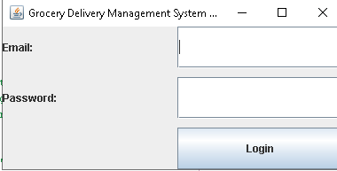
• Product browsing screen
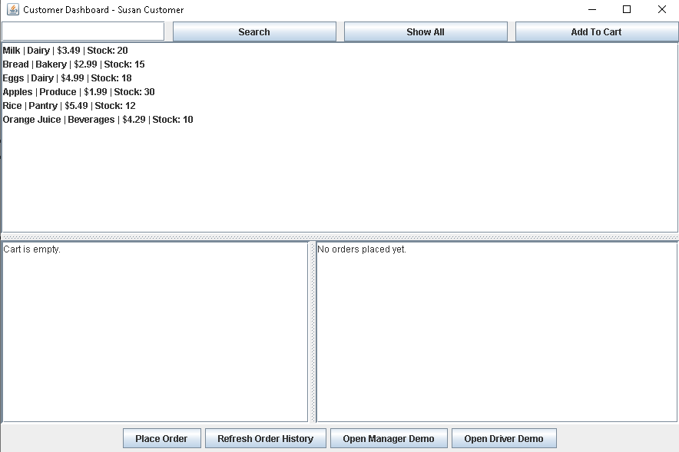

• Shopping cart and order confirmation screen
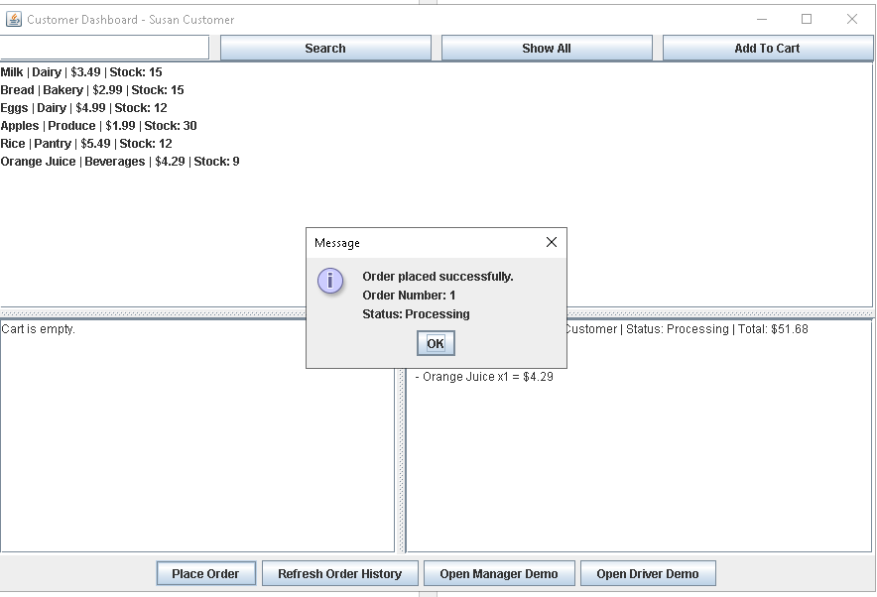
• Manager dashboard for assigning deliveries
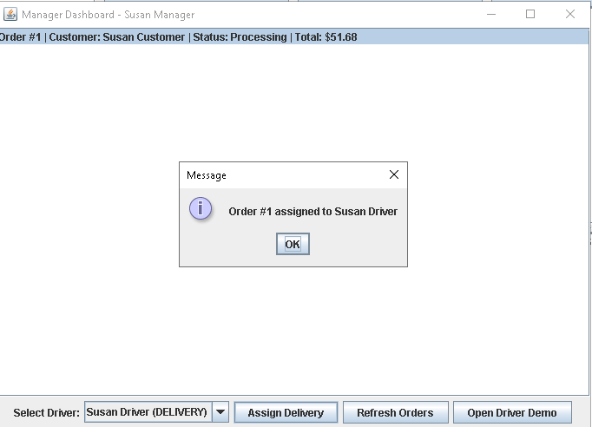
• Delivery status tracking screen
