Exp. No: 3 Determination and plotting of Force of attraction between two electric Charges and two parallel conductors separated by varying distance.

Aim:
To determine and plot the Force of attraction between two electric Charges and two parallel conductors separated by varying distance between them using MATLAB.
Program:
Test case (i) Determination and plotting of force between two electric charges with varying distance
clc;
clear;
q1 = input('Enter the charge q1=');
q2 = input('Enter the charge q2=');
epsilon = 8.854e-12;
k = 1/(4*pi*epsilon);
r = linspace(0.1,10,100);
F = k*q1*q2./(r.^2);
disp('Force at r = 1 m is:');
disp(k*q1*q2/(1^2));
plot(r,F,'LineWidth',2);
xlabel('Distance (m)');
ylabel('Force (N)');
title('Force between two electric charges');

output
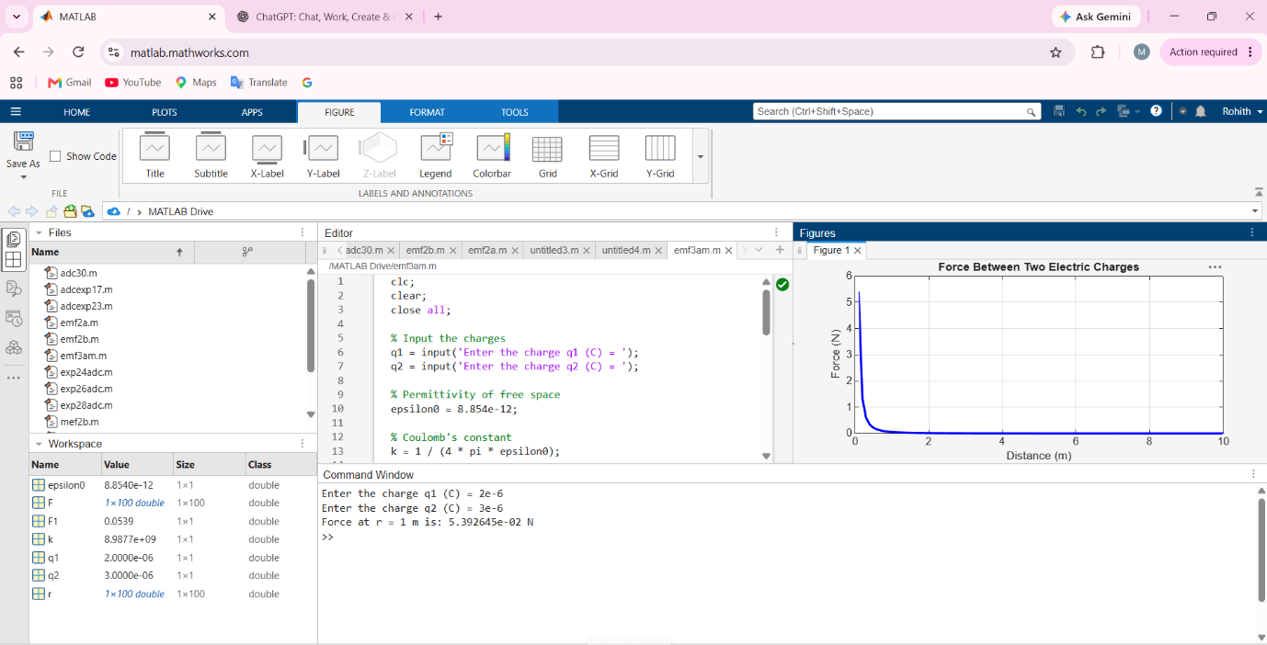

Test case (ii) Determination and plotting of force between two electric charges with different magnitudes
clc;
q1 = 5e-6;
q2 = 2e-6;
epsilon = 8.854e-12;
k = 1/(4*pi*epsilon);
r = linspace(0.5,5,100);
F = k*q1*q2./(r.^2);
plot(r,F,'LineWidth',2);
xlabel('Distance (m)');
ylabel('Force (N)');
title('Force between two charges (different magnitudes)');

OUTPUT
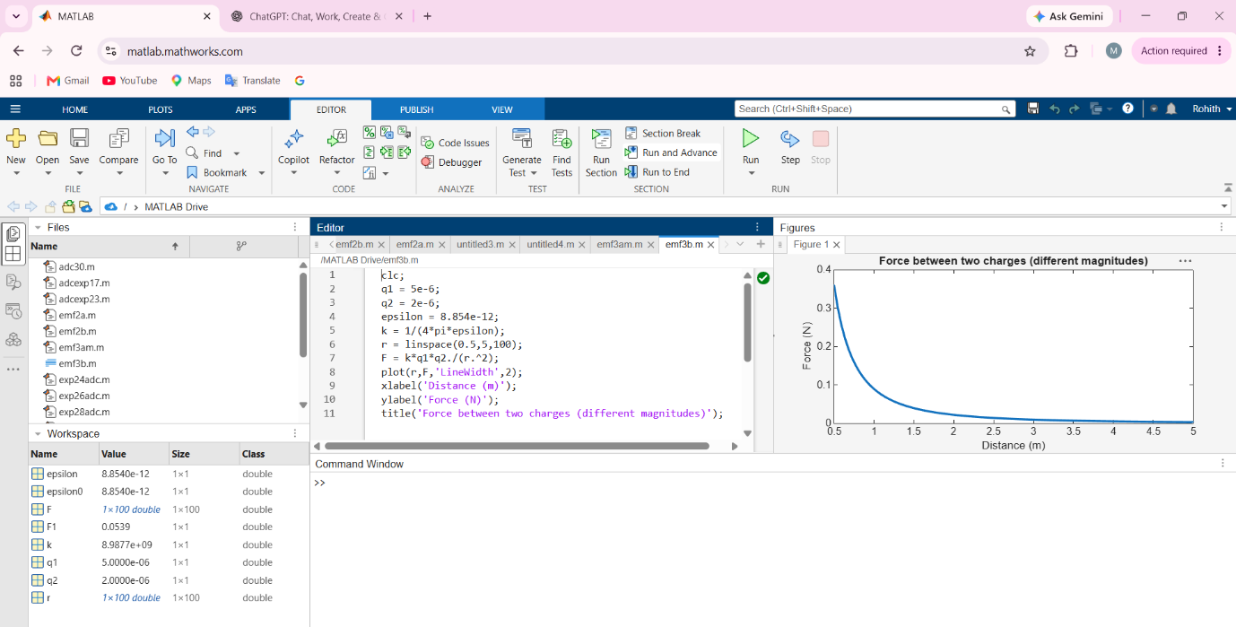

S. No. | Objective | Assessment Criterion | Excellent – 4 | Good – 3 | Satisfactory – 2 | Needs Improvement – 1 | Weighting (%) | Marks given | Marks obtained
1 | Identify physical quantities and force models | Identify physical quantities and force models | Correctly identifies charge/current, separation, medium and force direction for both cases. | Identifie s most quantiti es and models correctl y. | Needs guidance in selecting the correct relation or direction. | Uses incorrect force models or quantities. | 25 | 2.5
2 | Calculate electric and magnetic forces | Calculate electric and magnetic forces | Implements Coulomb-force and parallel-current force calculations correctly with units. | Calculat ions are mostly correct with minor errors. | Some calculations are correct but require assistance. | Force calculations are invalid or absent. | 25 | 2.5
3 | Evaluate force versus separation | Evaluate force versus separation | Correctly varies separation, plots trends and checks theoretical distance dependence. | Trend and plots are correct with minor omissio ns. | Limited sweep or incomplete trend interpretation. | Does not establish a valid relationship. | 30 | 3
4 | Explain and report results | Explain and report results | Explains attraction/repulsi on and reports assumptions, units and conclusions clearly. | Conclus ion is correct with minor docume ntation gaps. | Conclusion is incomplete or partly inaccurate. | Conclusion is missing or incorrect. | 20 | 2
Total |  |  |  |  |  |  | 100 | 10

