**A MINI PROJECT REPORT**

**ON**

**Agricultural Assistant System**

Course Code: ITA504

Course Title: Programming in C# with Visual Studio.Net

*by*

Soumendra Nath Sanyal(13MCA0153)

Sushmita Kumari(13MCA0159)

Under the guidance of

**Prof. Dr Sathiyamoorthy E**

**Assistant Professor (Sr), SITE,**

**VIT University, Vellore.**

**SCHOOL OF INFORMATION TECHNOLOGY AND ENGINEERING**

**VIT UNIVERSTY**

**PROJECT OVERVIEW:**

In this project we implemented a user friendly agricultural assistant system. India is an Agriculture based country. The economy of our country is very largely dependent on agriculture.

The study in the field of agriculture is also a very important part of the Indian education. So we implemented a system where students and farmers can post their queries and answers will be given by professors. It is very important to know about the crop. Certain parameters are very essential related to crop namely (soil type, temperature, location etc.). In our system we have provided all the details about all these parameters. Anyone can check this info and solve their problem. We have included the information regarding different event related to agriculture like (seminar, conference, survey etc.). Students and farmers can get all the details regarding of those events from our website. Agriculture is very much practical oriented process. So it is very much essential to include some practical Implementation. For this reason we have included some audio-visual clippings in our website which will be very useful for the farmers as well as for students.

**Proposed System:**

This project helps the crew who conduct events in villages. In this Project we are providing an interface to the teams to store their data in order to conduct awareness events efficiently. By using **Agriculture Assist** project user can make a schedule for the coming events and can arrange data needed in the events such as data regarding crops, presentation on seasonal crops. Before going to any program in certain village they can be able to cross check the stuff needed in that event at any point of time. So our project is suggested as a web application because so many teams around the India can be able to work on this area .If any villager needs some suggestions and help they will send the query .These queries will be solved by experience professors.

This project has the following features:

* Creating the climate, crops, and topics, files -by the Professor
* Creating the Users, User roles, events -by the administrator.
* View schedule, post query, view reply from the professor --- by the students
* Playing video, audio files
* **MODULES:**
* Admin
* Professor
* Farmer
* Student

**Technical Environment:**

* Microsoft framework 2.0, Visual Studio 2012 IDE
* Data Collection ( Microsoft Excel)
* Video Links (YouTube)

**Some Snapshot:**

1. **Home Page:**

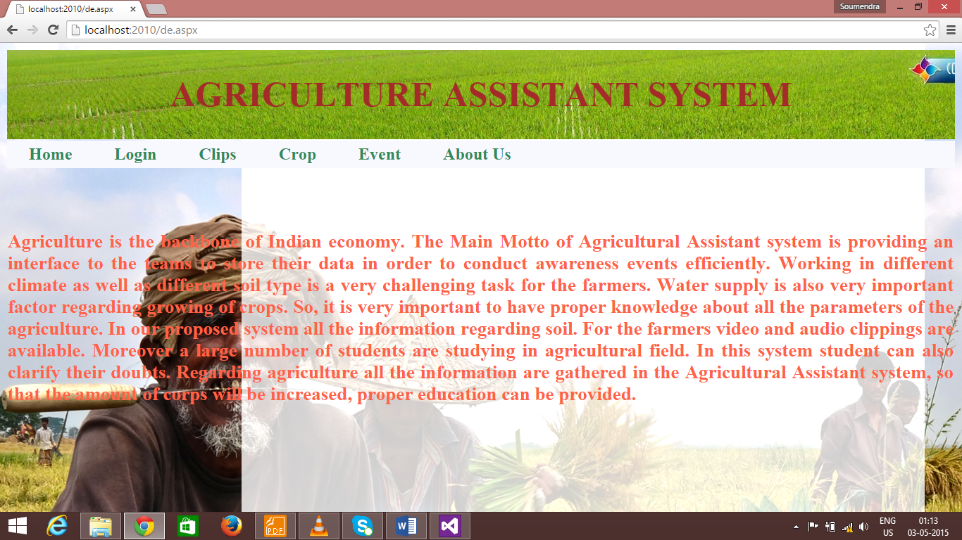

From the home page we can clearly visualize all the modules. We have a small description in this page about the agricultural assistance and why it is required in India. Moreover all the modules like login, clips, crop, and event are there. Anyone can open the website and search the information about crops and events as well as they will not have any problem regarding watching clips that are available in our website. For posting queries related to agriculture user has to make account. After making the account user can post their doubt related to agriculture. Eminent professor will provide answers for those doubts. As well as we have introduced a forum in our website where all the questions that are already asked will be displayed with their answers. It will help a person enrich their knowledge related to the agriculture. From the structure of our website it is easy to understand that it is very user friendly. User can easily search events, crops without having any account in our website. Different event will provide users additional information about the events and some past events are also being added. It is good chance for the user to participate in those events.

1. **Login Page:**

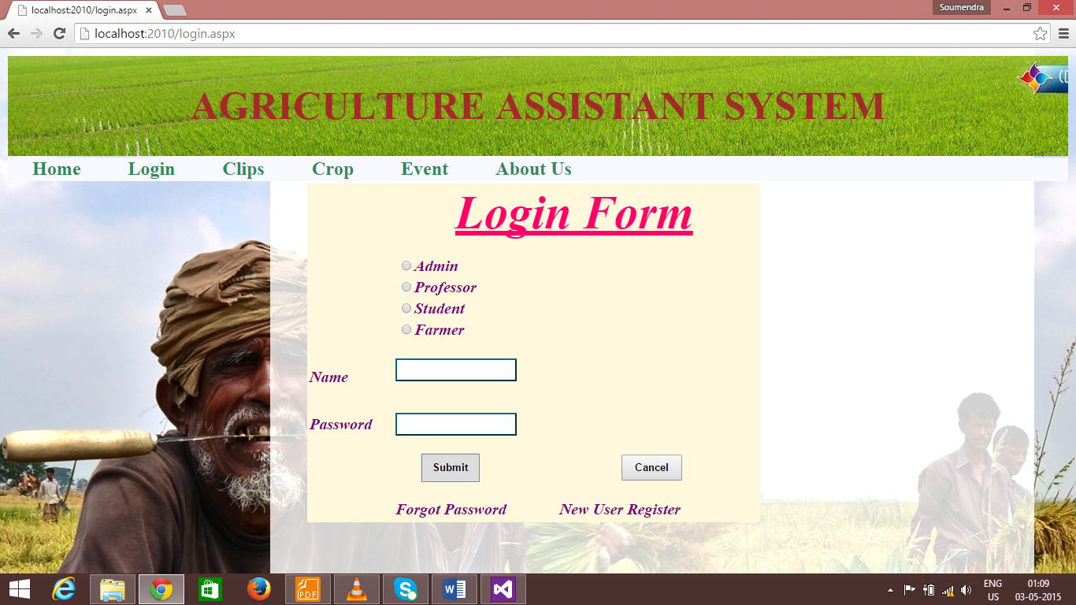

1. **Video Clips Page:**

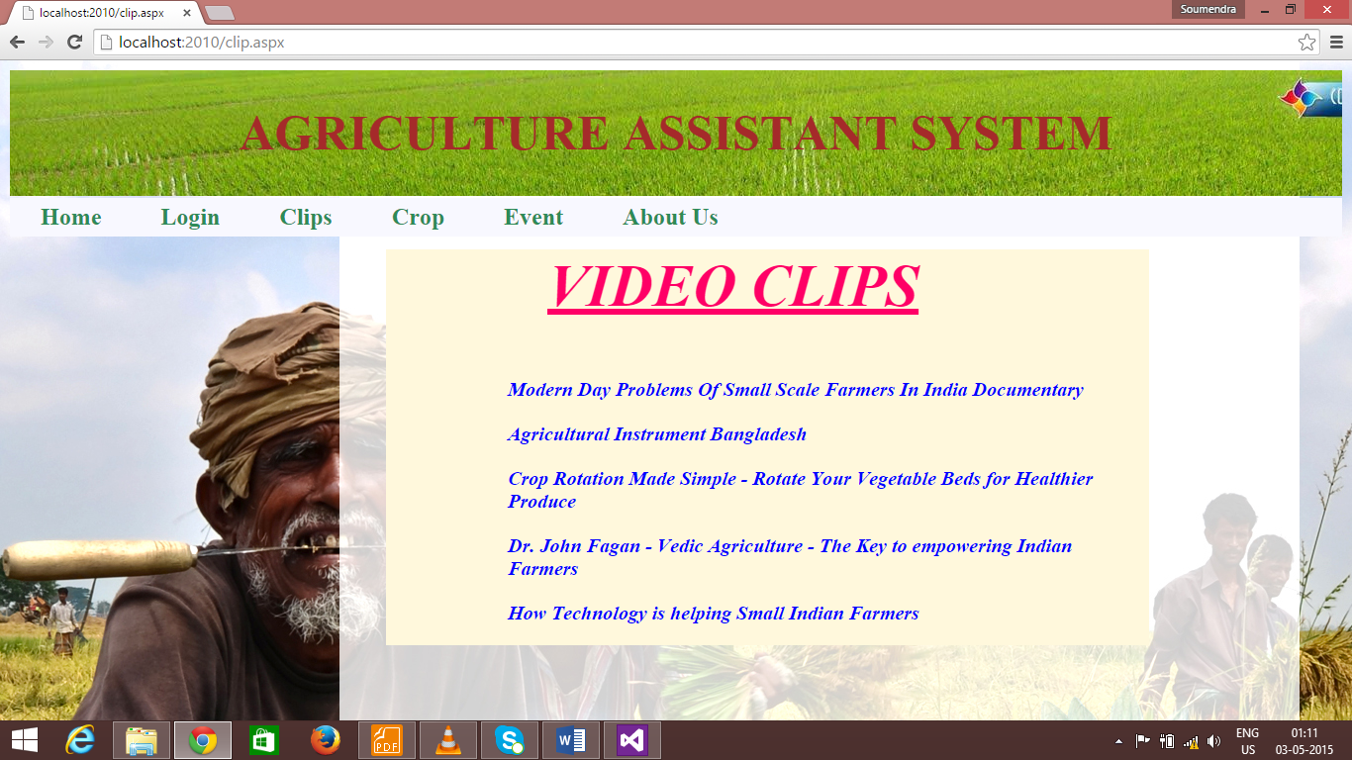

**Conclusion and Future work:** In this project we have tried to implement an informative website on agriculture. Many farmers in India have no idea about recent time research on agriculture, upcoming technologies etc. Students of agriculture also will be beneficial by our website. We have provided some event in our website. There should be description of events that are already happened as well as there will be description for some event which will be going to happen in future. Further we want to make a procedure of make registration for those events. So that farmers or students can participate for those event and they will get more practical knowledge.