Project Report: PolicyMind

1. Description
PolicyMind is an AI-powered assistant we built to help businesses and developers figure out the complicated world of AI laws—especially things like the EU AI Act and India’s DPDP Act. Instead of paying expensive lawyers just to understand if a new AI feature is legal, PolicyMind lets you either chat directly with the regulations to get clear answers, or use our simulator to instantly check your product idea against the law.

2. Problem Statement (PS)
The inspiration for this project came from a massive problem in the tech industry right now: AI is moving way faster than most people can comprehend, and governments are responding with incredibly dense, confusing regulations.
Companies are struggling because:
- • The laws are vague: It takes hours of reading to figure out if your specific use-case is actually banned or just highly regulated.
- • You can't trust normal AI for legal advice: If you ask a standard AI (like ChatGPT) about a law, it might hallucinate and confidently invent a rule that doesn't exist, which is a massive liability.
- • No central tool exists: Compliance officers don't have a good, unified dashboard to upload new laws, track what their employees are asking, and run safety checks before writing code.

3. Proposed Solution
To solve this, we designed PolicyMind with two main engines that work together to keep things safe and accurate:
- • The RAG Chatbot: Instead of letting the AI guess the law, we restrict it. When you ask a question, the system searches through actual PDF documents of the law, pulls out the most relevant paragraphs, and forces the AI to only use that exact text to answer you. We also force it to give checklists and risk scores instead of long, confusing paragraphs.
- • The Risk Simulator: For times when you don't even want to chat, we built a deterministic risk simulator. You just fill out a quick form (what data you use, what sector you're in), and our backend engine runs it against hardcoded legal rules to instantly tell you if your idea is "High Risk" or "Unacceptable".

4. Methodology
We built this as a full-stack web application, focusing heavily on making the AI both smart and reliable.
- • Frontend: We used React.js and Tailwind CSS to make it look clean and modern. We also added Recharts for the admin analytics dashboard and React Flow to create those really cool, interactive knowledge graphs.
- • Backend & Database: The backend is powered by Python and FastAPI. For storing user data, chat histories, and bookmarks, we used PostgreSQL (hosted on Supabase) and connected it using SQLAlchemy.
- • The AI Brain: We used LangChain to handle the heavy lifting of reading PDFs and chopping them into smaller pieces. Those pieces are converted into vectors using a HuggingFace model (all-MiniLM-L6-v2) and saved into a local ChromaDB database.
- • Answering Questions: When a question is asked, we retrieve the best chunks of law using MMR (so we get a diverse set of results). Finally, we send those chunks to Llama 3.2 (via OpenRouter) with a very strict prompt to give us the final, accurate answer.

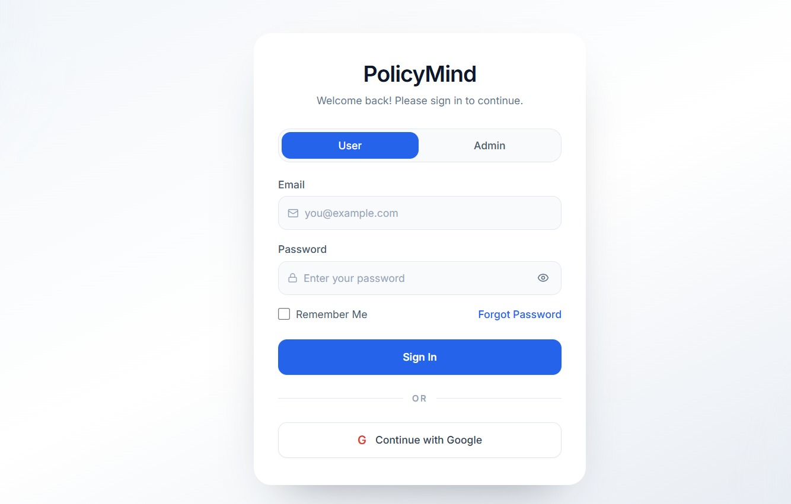

Admin page
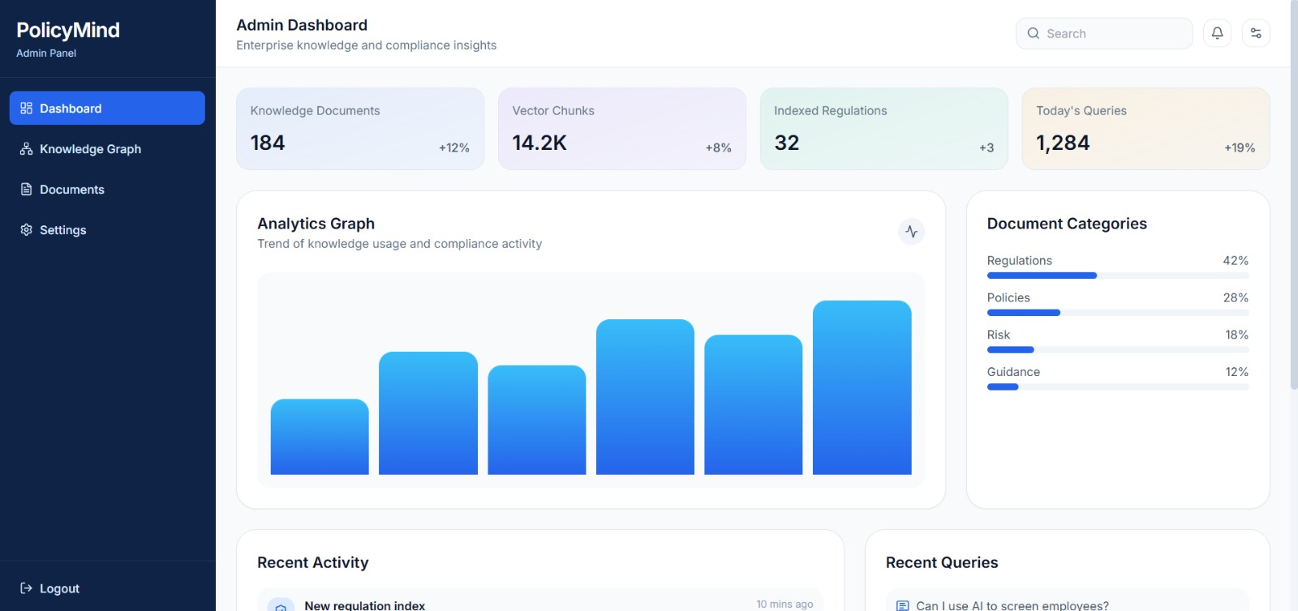

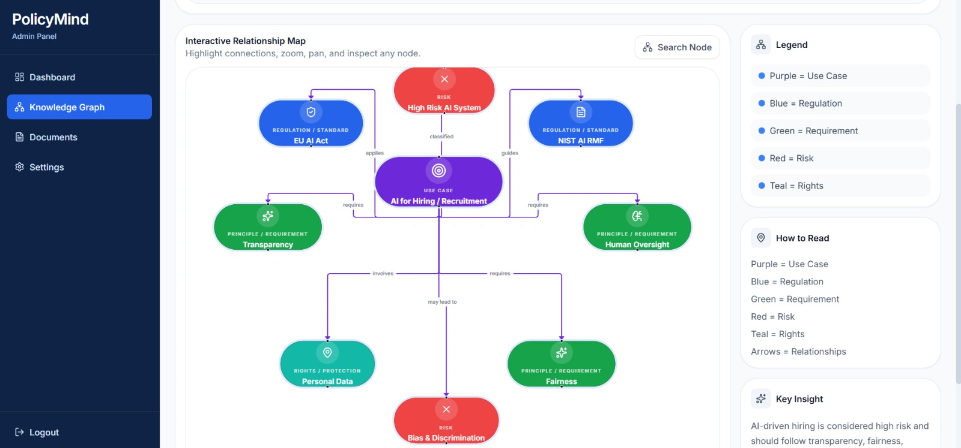

User page:
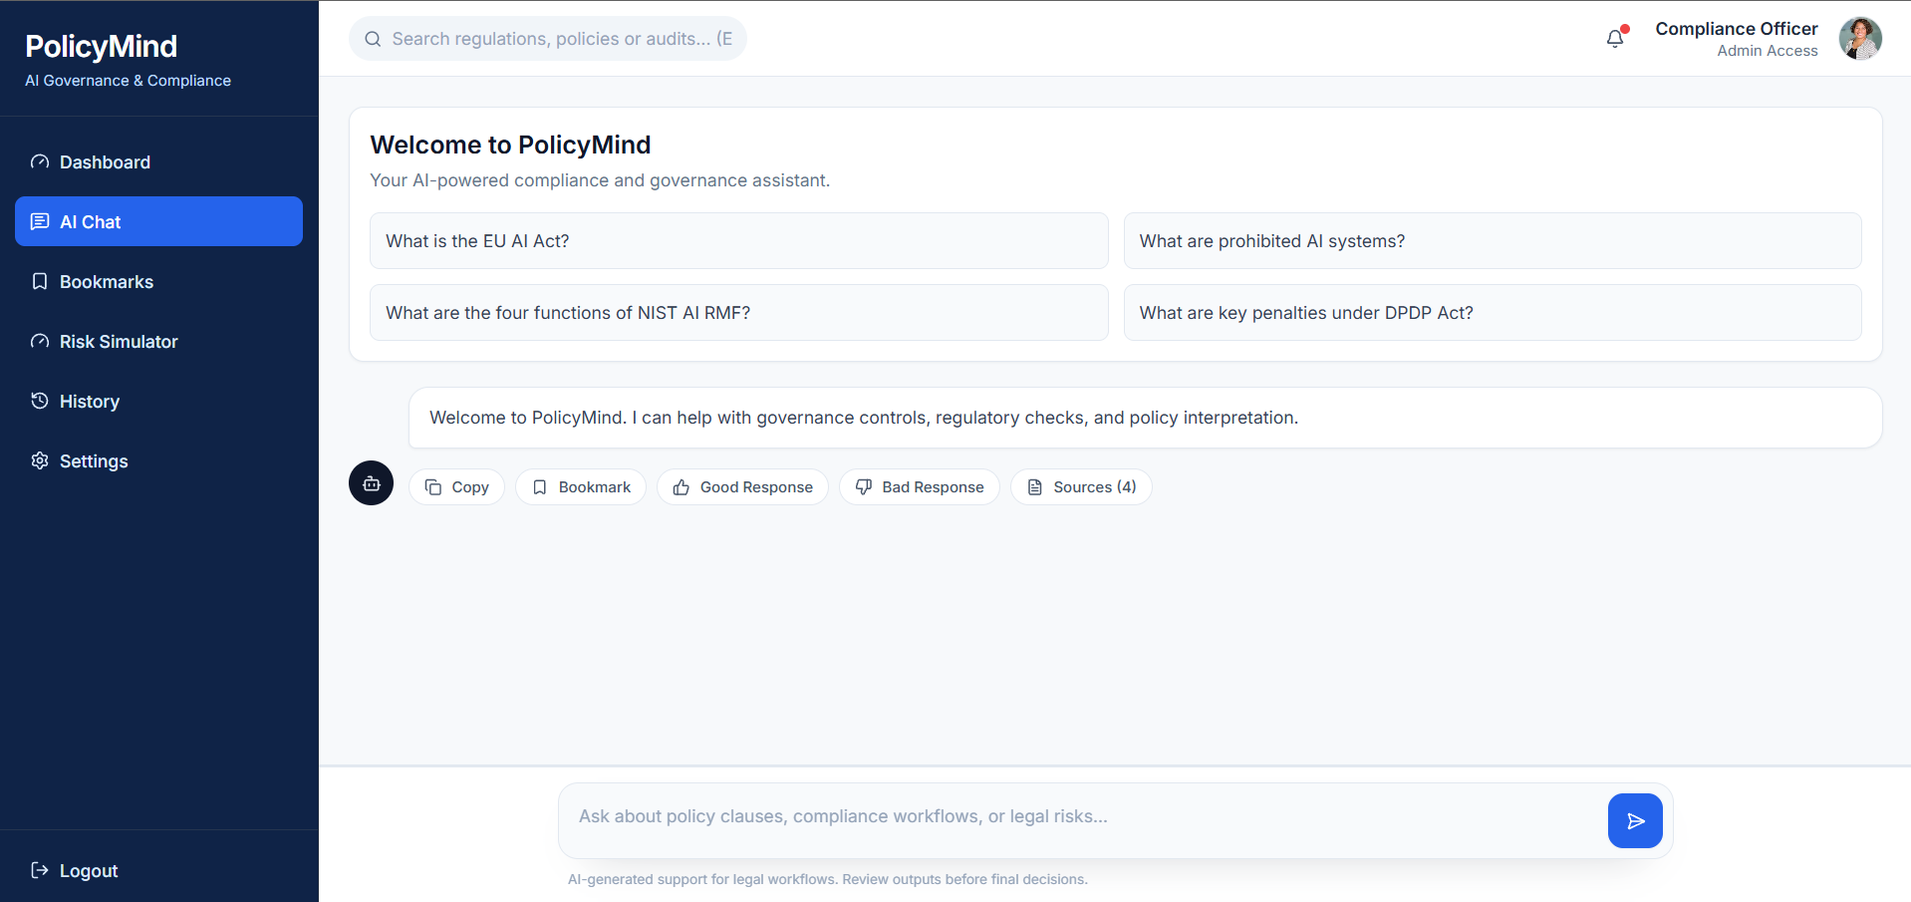

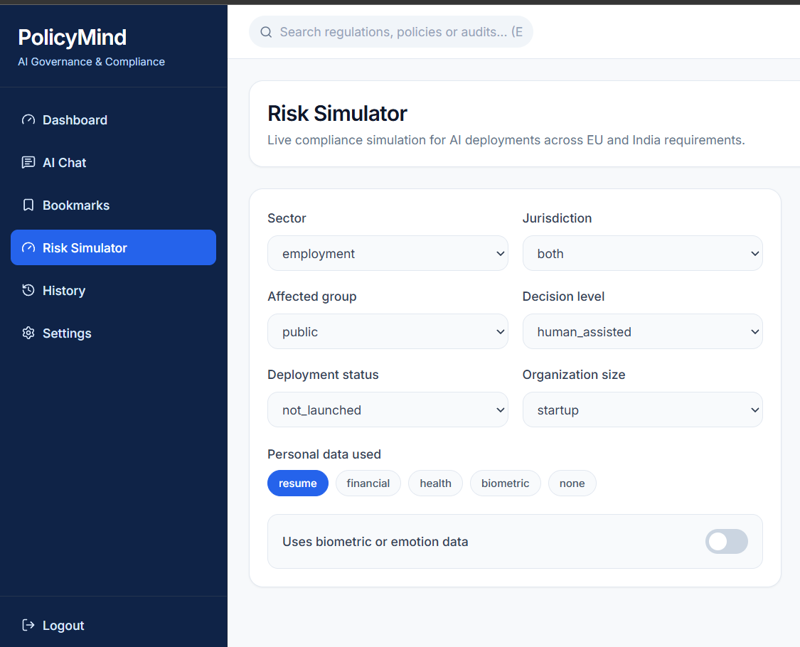

Github: https://github.com/sush159/VelChakaraX
Vercel(frontend): https://policy-mind.vercel.app/
Render(backend): https://policymind-backend.onrender.com

