# titanic is avaliable in your workspace

# 1 - Check the structure of titanic

str(titanic)

# 2 - Use ggplot() for the first instruction

ggplot(titanic,

aes(x = Pclass, fill = Sex)) +

geom_bar(

position = "dodge")

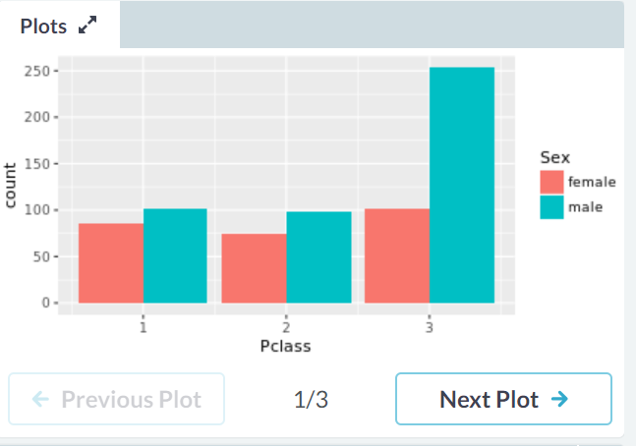

# 3 - Plot 2, add facet_grid() layer

ggplot(titanic,

aes(x = Pclass, fill = Sex)) +

geom_bar(

position = "dodge") +

facet_grid(. ~ Survived)

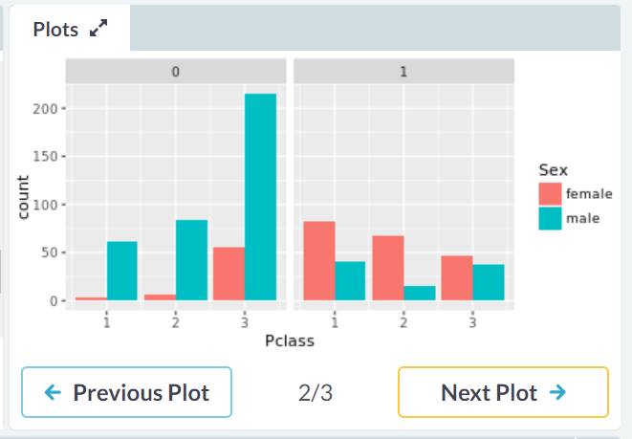

# 4 - Define an object for position jitterdodge, to use below

posn.jd <- position_jitterdodge(0.5, 0, 0.6)

# 5 - Plot 3, but use the position object from instruction 4

ggplot(titanic,

aes(x = Pclass, y = Age, col = Sex)) +

geom_point(

size = 3, alpha = 0.5, position = posn.jd) +

facet_grid(. ~ Survived)

