

A PROJECT REPORT ON

Online Recruitment System

SUBMITTED BY

Sushant S. chavan (4809)

IN PARTIAL FULFILLMENT OF THE BACHELOR OF COMPUTER APPLICATION

BCA SEM-V

Under The Guidance Of

ASSt. Prof. Arpita Makhamale

SUBMITED TO

SAVITRIBAI PHULE UNIVERSITY OF PUNE



HARIBHAI.V.DESAI COLLEGE

(ATRS, SCIENCE AND COMMERCE) PUNE-411002

Poona Gujrati Kelvani Mandal’s

**Haribhai V. Desai College Of Arts, Science & Commerce, Pune – 2**

**(Autonomous)**

**DEPARTMENT OF COMPUTER STUDIES**

**Academic Year 2024-25**

Project Certificate

This is to certify that Mr. “Sushant Chavan”(4850) has satisfactorily completed the project as required by Pune University for BCA (Science) Semester VI in the academic year 2024-2025.

Project Title :- Dream Hub – a car service website

Project Guide Head Of department

Internal examiner External Examiner

**ACKNOWLEDGEMENT**

We express our sincere gratitude to all those who have contributed to the successful completion of our project, "Dream Hub – a car service website," submitted as part of the BCA (Science) Semester VI curriculum for the academic year 2024-2025.

We extend our deepest appreciation to our Project Guide Arpita Makhamale for their expert guidance, insightful feedback, and unwavering support throughout the development of this project. Their direction has been pivotal in ensuring the quality and timely completion of our work.

We are also grateful to the Head of the Department for granting us the opportunity to undertake this project and for providing an academic environment that fosters innovation and learning. Our thanks extend to the faculty and staff of Haribhai V. Desai College of Commerce, Arts & Science for their valuable resources and assistance

Sushant Chavan (4809)

March 2025

**INDEX**

|  |  |  |
| --- | --- | --- |
| **Sr. No** | **Content** | **Page No** |
| **1** | **Abstract** |  |
| **2** | **Introduction** |  |
| **3** | **Scope of work** |  |
| **4** | **Feasibility Study** |  |
| **5** | **Need of System** |  |
| **6** | **Operating Environment-H.W/S.W** |  |
| **7** | **Proposed System**  **7.1 Objective to be fulfilled**  **7.2 User Requirement**  **7.3 Entity Relationship Diagram**  **7.4.1 Class Diagram**  **7.4.2 Use case diagram**  **7.4.3 Activity diagram**  **7.4.4 Component diagram**  **7.4.5 Deployment** |  |
| **8** | **Website Overview** |  |
| **9** | **Testing** |  |
| **10** | **Drawbacks** |  |
| **11** | **Future enhancement** |  |
| **12** | **Bibliography** |  |

**Dream Hub – a car service website**

**Introduction :-**

In today's rapidly evolving automotive industry, convenience and efficiency are key factors in customer satisfaction. Traditional car service booking methods, such as phone calls or in-person visits, can be **time-consuming, inefficient, and lack transparency**. To address these challenges, our project, **Dream Hub**, leverages modern web technologies to create a seamless and **user-friendly car service platform**.

**Dream Hub** is designed to simplify and enhance the process of booking car-related services, including **Paint Protection Film (PPF) application, car wrapping, detailing, modifications, and accidental repairs**. By integrating an intuitive interface with automated scheduling and real-time updates, this system ensures a **hassle-free and efficient experience** for both customers and service providers.

The platform offers several advantages, including:

* **Convenience**: Enables users to book services online anytime, anywhere.
* **Transparency**: Provides clear pricing details and service descriptions.
* **Efficiency**: Reduces manual intervention and streamlines appointment scheduling.
* **Customer Engagement**: Features customer reviews, service tracking, and personalized recommendations.

**Project Overview :-**

This project aims to **transform the traditional car service booking process** by introducing a **streamlined and user-friendly online platform**—**Dream Hub**. The system leverages modern **web technologies** to provide a **seamless service booking experience**, enabling customers to schedule **Paint Protection Film (PPF) application, car wrapping, detailing, modifications, and accidental repairs** with ease.

Dream Hub is designed to **eliminate inefficiencies** in traditional booking methods while enhancing **convenience, transparency, and customer engagement**. The platform ensures that users can access **reliable, high-quality automotive services** without the hassle of phone calls or in-person visits.

This solution is ideal for **car owners, automotive service providers, and businesses** looking to optimize **service management, customer interaction, and operational efficiency** in the automotive industry.

**Technology Used :-**

**HTML5, CSS3, JavaScript** : For structuring, styling, and adding interactivity to the website.

Bootstrap : For a responsive and visually appealing design.

**Django (Python Framework)** – Handles the core business logic, user authentication, and database interactions.

**SQLite/MySQL** – Used for storing user data, service details, bookings, and transactions securely.

**Scope of the Project :-**

**Dream Hub** is designed to provide a **comprehensive platform** for **car PPF, wrapping, detailing, modification, and accidental repair services**. The platform allows users to:

* **Browse and compare services** offered by verified professionals.
* **Find detailed information** on car protection and customization services.
* **Check service provider reviews and ratings** to choose the best option.
* **View service packages and pricing** for different car care solutions.
* **Contact service providers directly** for inquiries and appointments.

**2. User Scope**

The platform benefits:

* **Car Owners** who seek professional and reliable car protection and modification services.
* **Automobile Service Providers** who can showcase their expertise and services to a broader audience.
* **Admin Users** who manage the platform, verify service providers, and update service listings.

**3. Technical Scope**

* **Responsive Web Design** to ensure accessibility across devices (mobile, tablet, desktop).
* **Secure Authentication System** for user and service provider profiles.
* **Database Management** to store user profiles, service listings, and customer inquiries.
* **Scalability** to expand services to multiple locations in the future.

7.3 Entity Relationship Diagram

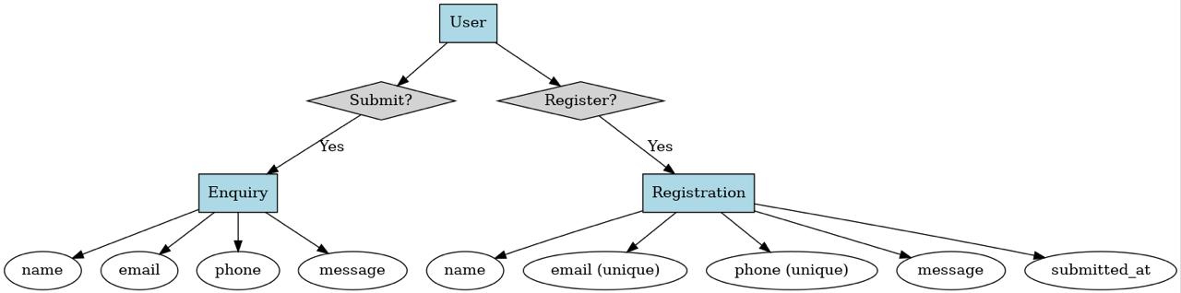

DFD Diagram:

Level 0

Level 1

Level 2

7.4.1 Class Diagram

7.4.2 Use case diagram

7.4.4 Activity diagram

7.4.5 Component diagram

7.4.6 Deployment

**Index page**

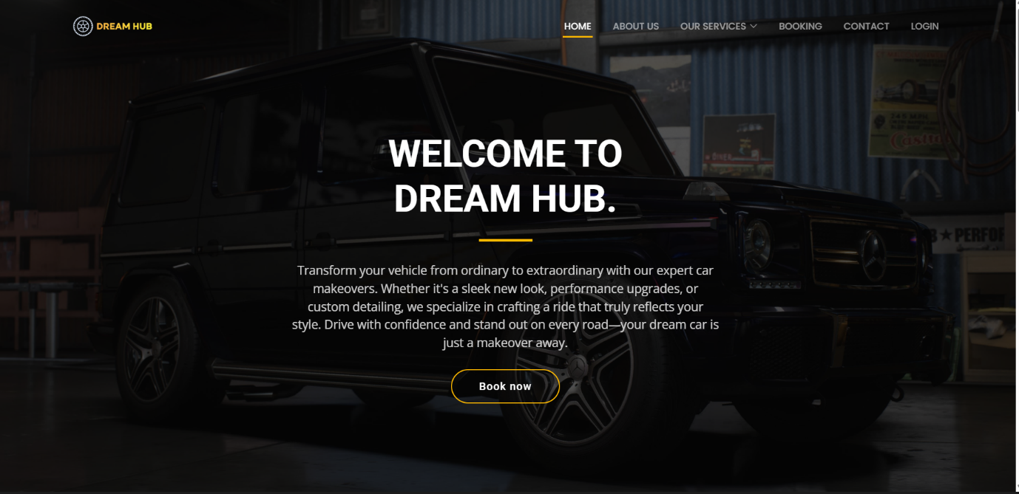

**About page**

**Service detail page**

**Service booking form**

**Contact Page**

**Admin login page**

**Testing**

**Drawback**

* **Missing Online Payment Method:** Users can’t make payments directly on the website, reducing convenience.
* **Lack of Colour Theme Consistency:** The design may lack a uniform colour scheme, making the UI look inconsistent.
* **No Smooth Animations:** The website might feel static due to the absence of modern animations or transitions.
* **No Search Bar for Services:** Users must manually browse services instead of quickly finding what they need.
* **Limited User Personalization:** No saved preferences or previous booking history for returning users.
* **No Service Price Estimator**: Users don’t get an estimated cost before booking, which may cause uncertainty.
* **Basic Contact Options**: No WhatsApp chat or instant support option, making it harder for users to ask quick questions.

**Future enhancement**

* **Integrate Online Payment Methods**: Add Razorpay, Stripe, or UPI support for secure payments.
* **Implement a Search Bar**: Allow users to search for specific services instead of navigating manually.
* **Improve UI with Modern Colour Themes**: Apply a consistent, visually appealing theme for better user experience.
* **Add Smooth Animations**: Use hover effects, page transitions, and loading animations to enhance engagement.
* **Introduce a Price Estimator Tool**: Users can select services and get an estimated cost before booking.
* **Enable User Accounts & Dashboard**: Allow users to track bookings, save services, and receive recommendations.
* **WhatsApp & Live Chat Integration**: Provide real-time assistance to users for quick queries and bookings.

**Bibliography**

**W3Schools** - *HTML, CSS, JavaScript, python, bootstrap*   
<https://www.w3schools.com>

**Geeks for Geeks** – *for Django frame work tutorials* <https://www.geeksforgeek.org>