A

Major Project

On

AUDIO TO SIGN LANGUAGE TRANSLATOR USING

MACHINE LEARNING

(Submitted in partial fulfillment of the requirements for the award of Degree)

BACHELOR OF TECHNOLOGY

in

COMPUTER SCIENCE AND ENGINEERING

By

  - Aparna(187R1A05C8)

A. Sushmitha (187R1A05D0) B.Lakshmi (187R1A0D3)

Under the Guidance of

G.POORNIMA

(Associate Professor)


DEPARTMENT OF COMPUTER SCIENCE AND ENGINEERING

CMR TECHNICAL CAMPUS

UGC AUTONOMOUS

(Accredited by NAAC,NIRF, NBA, Permanently Affiliated to JNTUH, Approved by AICTE, New Delhi) Recognized Under Section 2(f) & 12(B) of the UGCAct.1956,

Kandlakoya (V), Medchal Road, Hyderabad-501401.

2018-22

DEPARTMENT OF COMPUTER SCIENCE AND ENGINEERING

CERTIFICATE

This is to certify that the project entitled “AUDIO TO SIGN LANGUAGE TRANSLATOR USING MACHINE LEARNING” being submitted by AKULA APARNA(187R1A05C8),ANNAM SUSHMITHA(187R1A05D0)&BATTI LAKSHMI(187R1A05D3) in partial fulfillment of the requirements for the award of the degree of B.Tech in Computer Science and Engineering to the Jawaharlal Nehru Technological University Hyderabad, is a record of bonafide work carried out by him/her under our guidance and supervision during the year 2021-22.

The results embodied in this thesis have not been submitted to any other University or Institute for the award of any degree or diploma.

G.POORNIMA

Associate Professor

INTERNAL GUDIE

Dr.A.Rajii Reddy

DIRECTOR

Dr.K.Srujan Rao

HOD

EXTERNAL EXAMINER

Submitted for viva voice Examination held on

ACKNOWLEGDEMENT

Apart from the efforts of us, the success of any project depends largely on the encouragement and guidelines of many others. We take this opportunity to express our gratitude to the people who have been instrumental in the successful completion of this project. We take this opportunity to express my profound gratitude and deep regard to my guide.

G.POORNIMA, Assistant Professor for her exemplary guidance, monitoring and constant encouragement throughout the project work.The blessing,help and guidance given by her shall carry us a long way in the journey of life on which we are about to embark. We also take this opportunity to express a deep sense of gratitude to Project Review Committee (PRC)

Mr. J. Narasimha Rao, Dr. T. S. Mastan Rao, Mr. A. Uday Kiran, Mr. A. Kiran Kumar, Mrs. G. Latha for their cordial support, valuable information and guidance, which helped us in completing this task through various stages.

We are also thankful to Dr. K. Srujan Raju, Head, Department of Computer Science and Engineering for providing encouragement and support for completing this project successfully.

We are obliged to Dr. A. Raji Reddy, Director for being cooperative throughout the course of this project. We also express our sincere gratitude to Sri. Ch. Gopal Reddy, Chairman for providing excellent infrastructure and a nice atmosphere throughout the course of this project.

The guidance and support received from all the members of CMR Technical Campus who contributed to the completion of the project. We are grateful for their constant support and help.

Finally, we would like to take this opportunity to thank our family for their constant encouragement, without which this assignment would not be completed. We sincerely acknowledge and thank all those who gave support directly and indirectly in the completion of this project.

A. Aparna(187R1A05C8)

A. Sushmitha (187R1A05D0)

B.Lakshmi (187R1A0D3)

ABSTRACT

Communication via gestures is a visual language that is utilized by hard of hearing and almost deaf individuals as their first language, it is additionally utilized by hearing people, for example, the individuals who experience difficulty with communicated in language because of an incapacity or condition individuals.To the extent a hard of hearing individual is concerned, approaching sign language communication is significant for their social, enthusiastic and semantic development.This framework is to help hearing-hindered individuals in India cooperate with others as it makes an interpretation of English text to Sign language. This task depends on changing the audio signals into text using speech to text APIs like Google API and afterward utilizing the semantics of Natural Language Processing, Machine Learning, Artificial Intelligence and Python for coding. The “Indian Sign Language (ISL)” uses manual communication and body language (non-manual communication) to convey thoughts, ideas or feelings. ISL signs can be generally classified into three classes: One handed, two handed, and non-manual signs. One handed sign and two-handed signs are also called manual signs where the signer uses his/her hands to make the signs for conveying the information. Non-Manual signs are generated by changing the body posture and facial expressions. This system is to help hearing impaired people in India interact with others as it translates English text to Sign language.

i
LIST OF FIGURES/TABLES

FIGURE NO | FIGURE NAME | PAGE NO
Figure 3.1 | Project Architecture | 6
Figure 3.2 | Use case diagram | 8
Figure 3.3 | Sequence diagram | 9
Figure 3.4 | Activity diagram | 10
Figure 3.5 | Data flow diagram | 11

ii

LIST OF SCREENSHOTS

SCREENSHOT NO. | SCREENSHOT NAME | PAGE NO.
Screenshot 5.1 | Command prompt | 16
Screenshot 5.2 | home page | 16
Screenshot 5.3 | signup page | 17
Screenshot 5.4 | Login page | 17
Screenshot 5.5 | Animation page | 18

iii

TABLE OF CONTENTS

ABSTRACT |  |  | i
LIST OF FIGURES |  |  | ii
LIST OF SCREENSHOTS |  |  | iii
1. INTRODUCTION |  |  | 1
1.1 | PROJECT SCOPE |  | 1
1.2 | PROJECT PURPOSE |  | 1
1.3 | PROJECT FEATURES |  | 1
2. SYSTEM ANALYSIS |  |  | 2
2.1 | PROBLEM DEFINITION |  | 2
2.2 | EXISTING SYSTEM |  | 2
 | 2.2.1LIMITATIONS OF THE EXISTING SYSTEM |  | 3
2.3 | PROPOSED SYSTEM |  | 3
 | 2.3.1ADVANTAGES OF PROPOSED SYSTEM |  | 3
2.4 | FEASIBILITY STUDY |  | 3
 | 2.4.1 | ECONOMIC FESIBILITY | 4
 | 2.4.2 | TECHNICAL FEASIBILITY | 4
 | 2.4.3 | SOCIAL FEASIBILITY | 4
2.5 | HARDWARE & SOFTWARE REQUIREMENTS |  | 5
 | 2.5.1 | HARDWARE REQUIREMENTS | 5
 | 2.5.2 | SOFTWARE REQUIREMENTS | 5
3. ARCHITECTURE |  |  | 6
3.1 | PROJECT ARCHITECTURE |  | 6
3.2 | MODULES DESCRIPTION |  | 7
3.3 | USECASE DIAGRAM |  | 8
3.4 | SEQUENCE DIAGRAM |  | 9
3.5 | ACTIVITY DIAGRAM |  | 10
3.6 | DATA FLOW DIAGRAM |  | 11
4. IMPLEMENTATION |  |  | 12
4.1 | SAMPLE CODE |  | 12
 |  | iv

5.SCREENSHOTS |  |  | 16
5.1 | COMMAND PROMPT |  | 16
5.2 | HOME PAGE |  | 16
5.3 | SIGNUP PAGE |  | 17
5.4 | LOGIN PAGE |  | 17
5.5 | ANIMATION PAGE |  | 18
6.TESTING |  |  | 19
6.1 | INTRODUCTION TO TESTING |  | 19
6.2 | TYPES OF TESTING |  | 19
 | 6.2.1 | UNIT TESTING | 19
 | 6.2.2 | INTEGRATION TESTING | 19
 | 6.2.3 | FUNCTIONAL TESTING | 20
7. CONCLUSION & FUTURE SCOPE |  |  | 21
7.1 | PROJECT CONCLUSION |  | 21
7.2 | FUTURE SCOPE |  | 21
8. REFERENCES |  |  | 22
8.1 | REFERENCES |  | 22
8.2 | GITHUB LINK |  | 22

V

- INTRODUCTION

AUDIO TO SIGN LANGUAGE TANSLATOR USING MACHINE LEARNING

1.INTRODUCTION

1.1 PROJECT SCOPE

This project is titled as “Audio to sign language translator using machine learning”. This system provides interface for deaf people to communicate easily with normal people without need of third person. This project uses machine-learning methods. First, we use a machine learning algorithms for training dataset which is of natural language processing.

1.2 PROJECT PURPOSE

This has been developed for the purpose of the deaf people this model helps a communicate with normal people easily with the help of natural language processing in this text which spoken by normal people can translated into videos or gif’s so that the deaf people can easily understood this is purpose of project.The algorithms are applied on the given dataset.

1.3 PROJECT FEATURES

The main features of this project are as input and learning machines play complementary extended to incorporate the knowledge of facial expressions and body language complete understanding of the context interpreter or some visual communication roles Since deaf people are usually deprived of normal communication with other people, they have to rely on an interpreter or some visual communication. Now the interpreter can not be available always, so this project can help eliminate the dependency on the interpreter.The system can be extended to incorporate the knowledge of facial expressions and body language too so that there is a complete understanding of the context .

CMRTC | 1

2.SYSTEM ANALYSIS
AUDIO TO SIGN LANGUAGE TANSLATOR USING MACHINE LEARNING

2.SYSTEM ANALYSIS

SYSTEM ANALYSIS

System Analysis is the important phase in the system development process. The System is studied to the minute details and analyzed. The system analyst plays an important role of an interrogator and dwells deep into the working of the present system. In analysis, a detailed study of these operations performed by the system and their relationships within and outside the system is done. A key question considered here is, “what must be done to solve the problem?” The system is viewed as a whole and the inputs to the system are identified. Once analysis is completed the analyst has a firm understanding of what is to be done.

2.1 PROBLEM DEFINITION

The system uses machine learning algorithms, It can be used by a person who has full of
difficulties in speaking or by a person who can hear but could not speak and by normal people
communicate with hearing disabled people. As far as a deaf person is concerned, having access
to a sign language is very important for their social, emotional and linguistic growth. The Sign
language should be recognized as the first language of deaf people and their education can be
proceeded bilingually in the national sign language as well as of the national written or spoken
language.

2.2 EXISTING SYSTEM

The dumb people, sign language is the only way of communication. With the help of sign language, physically impaired people express their thoughts to the other people.It is difficult for common people to understand the specific sign language therefore communication becomes a difficult. The sign language recognition has become an empirical task, as it consists of various movements and gesture of the hands and therefore getting the right accuracy at a low-cost is a mammoth task.Existing solutions are we have physical devices and software which can convert audio to sign language but using Natural Language Processing we are improvising the tool. The word library can be expanded to include most of the commonly used words in english. Speech to text conversion can be made more accurate and text processing can be optimized using various NLP algorithms.

CMRTC 2

AUDIO TO SIGN LANGUAGE TANSLATOR USING MACHINE LEARNING

2.2.1 LIMITATIONS OF EXISTING SYSTEM

- Less efficient.

  - The currently available resources is that they are very limited.

  - They are not truly dependable taking into consideration of their accuracy

To avoid all these limitations and make the working more accurately the system needs to be implemented efficiently.

2.3 PROPOSED SYSTEM

The aim of proposed system is to develop a system of improved facilities. The proposed system can overcome all the limitations of the existing system. Initially,we take audio as input on a Personal Digital Assistant by utilizing the python PyAudio module. Next, we are convert the audio to text using the Google Speech API.Presently utilizing NLP i.e Natural is language processing we breakdown the text into smaller, simpler and understandable. To avoid all these limitations and use make the working more accurately the system needs to be implemented efficiently. We have with a reliance parser for analyzing the grammatical structure of the sentence and building up connection between words. Finally,we converted audio into Sign language.

2.3.1 ADVANTAGES OF THE PROPOSEDSYSTEM

The system is very simple in design and to implement. The system requires very low system resources and the system will work in almost all configurations. It has got following features

- To provide information access and services to deaf people in Indian sign language.

- To develop a scalable project which can be extended to capture whole vocabulary of ISL through manual and non manual signs.

- To improve the physical and mental well-being of the specially abled people and improve their overall quality of life.

2.4 FEASIBILITY STUDY

The feasibility of the project is analyzed in this phase and business proposal is put forth with a very general plan for the project and some cost estimates. During system analysis the feasibility study of the proposed system is to be carried out. This is to ensure that the proposed system is not a burden to the company.

CMRTC | 3

AUDIO TO SIGN LANGUAGE TANSLATOR USING MACHINE LEARNING

Three key considerations involved in the feasibility analysis are

- Economic Feasibility

- Technical Feasibility

- Social Feasibility

2.4.1 ECONOMIC FEASIBILITY

The developing system must be justified by cost and benefit. Criteria to ensure that effort is concentrated on project, which will give best, return at the earliest. One of the factors, which affect the development of a new system, is the cost it would require.

The following are some of the important financial questions asked during preliminary investigation:

- The costs conduct a full system investigation.

- The cost of the hardware and software.

- The benefits in the form of reduced costs or fewer costly errors.

Since the system is developed as part of project work, there is no manual cost to spend for the proposed system. Also all the resources are already available, it give an indication of the system is economically possible for development.

2.4.2 TECHNICAL FEASIBILITY

This study is carried out to check the technical feasibility, that is, the technical requirements of the system. Any system developed must not have a high demand on the available technical resources. The developed system must have a modest requirement, as only minimal or null changes are required for implementing this system.

2.4.3 BEHAVIORAL FEASIBILITY

This includes the following questions:

- Is there sufficient support for the users?

- Will the proposed system cause harm?

The project would be beneficial because it satisfies the objectives when developed and installed. All behavioral aspects are considered carefully and conclude that the project is behaviorally feasible.

CMRTC 4

AUDIO TO SIGN LANGUAGE TANSLATOR USING MACHINE LEARNING

2.5 HARDWARE & SOFTWARE REQUIREMENTS

2.5.1 HARDWARE REQUIREMENTS:

Hardware interfaces specifies the logical characteristics of each interface between the software product and the hardware components of the system. The following are some hardware requirements.

Processor | : | Intel core i5
Hard disk | : | 1TB
RAM | : | 5GB

2.5.2 SOFTWARE REQUIREMENTS:

Software Requirements specifies the logical characteristics of each interface between the software product and hardware components of the system. The following are some software requirements

1.Operating system | : | Windows 10
2.Languages | : | PYTHON
3.Tool | : | ANACONDA

CMRTC | 5

3.ARCHITECTURE
AUDIO TO SIGN LANGUAGE TANSLATOR USING MACHINE LEARNING

3.ARCHITECTURE

3.1 PROJECT ARCITECTURE

This project architecture describes how the application system is going to function.

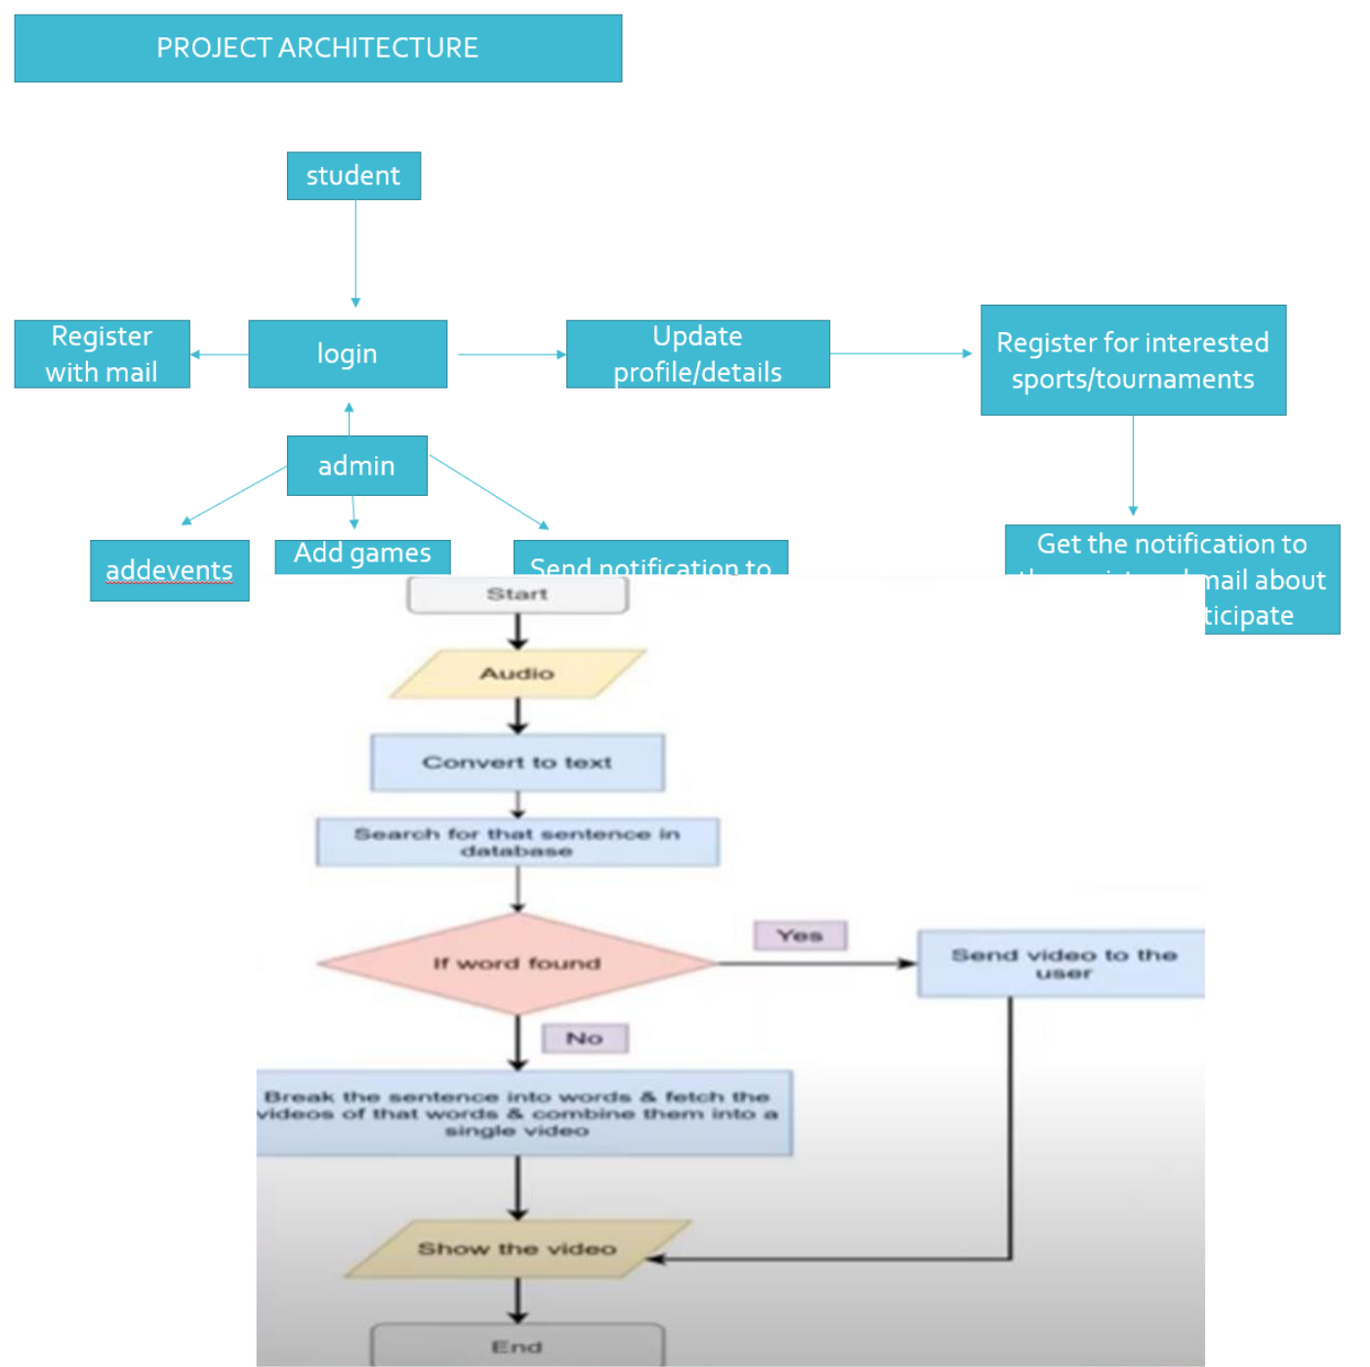

Figure 3.1: Project Architecture of Audio to sign language translator

CMRTC | 6

AUDIO TO SIGN LANGUAGE TANSLATOR USING MACHINE LEARNING

3.2 MODULES DESCRIPTION

1.User Module:

In this module user will register with application and login with valid name and password and view all features like speech to text and sign language prediction.

2.Speech Recording Module:

In this module google speech to text conversion library is used to convert voice to text and data is processed to next step for NLTK processing and text is displayed to user.

3. NLTK Module:

In this module text is pre-processed by removing stop words and collect required words and send to next step to get required stored video based on that key word from system.

4. Sign language Display Module:

Based on input from NLTK module text related videos are processed from the system and displayed to user when submit button is clicked.

CMRTC | 7

AUDIO TO SIGN LANGUAGE TANSLATOR USING MACHINE LEARNING

3.3 USE CASE DIAGRAM

we have basically three actors who are the microphone user and the monitor.
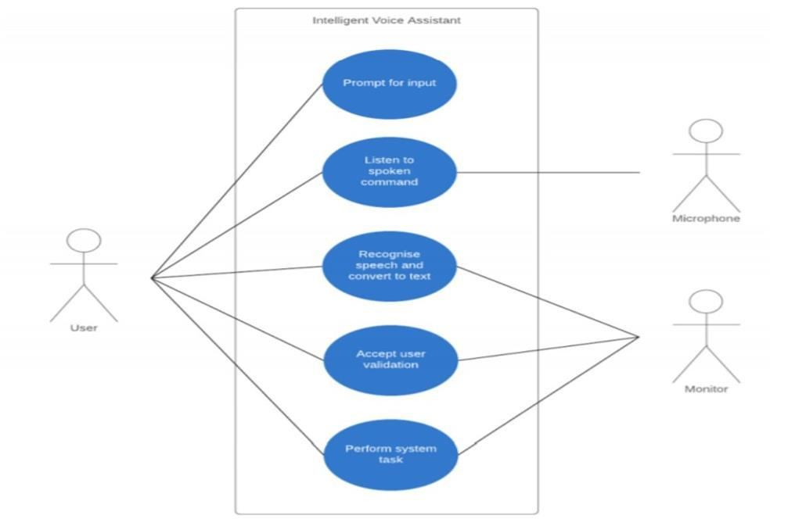

Figure 3.2: Use Case Diagram for Audio to sign language translator

CMRTC | 8

AUDIO TO SIGN LANGUAGE TANSLATOR USING MACHINE LEARNING

3.4 SEQUENCEDIAGRAM
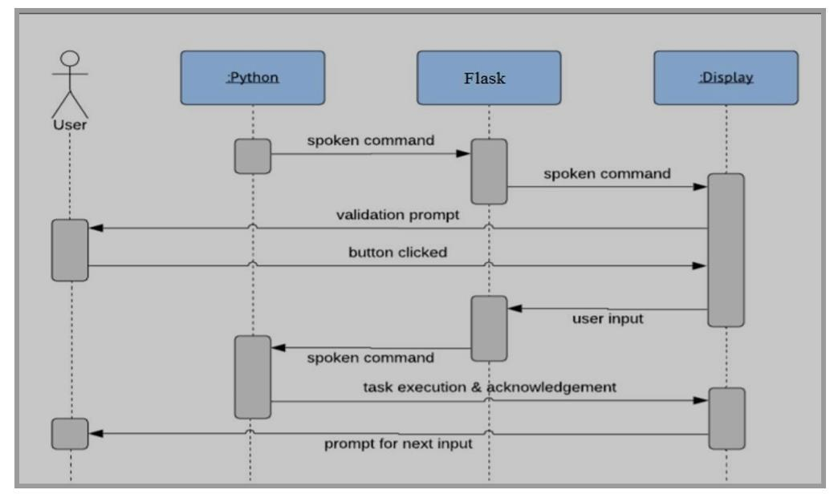

Figure 3.3: Sequence Diagram for Audio to sign language translator

CMRTC | 9

AUDIO TO SIGN LANGUAGE TANSLATOR USING MACHINE LEARNING

3.5 ACTIVITYDIAGRAM

It describes about flow of activity states.
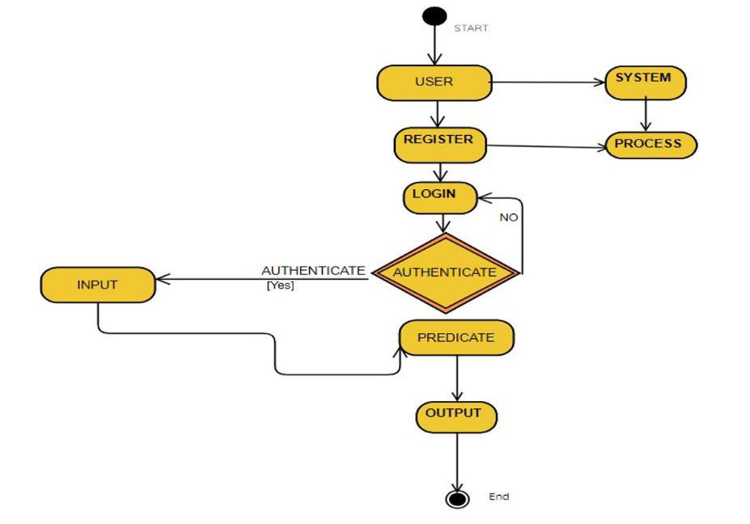

Figure 3.4: Activity Diagram for Audio to sign language translator

CMRTC | 10

AUDIO TO SIGN LANGUAGE TANSLATOR USING MACHINE LEARNING

3.6 DATA FLOW DIAGRAM
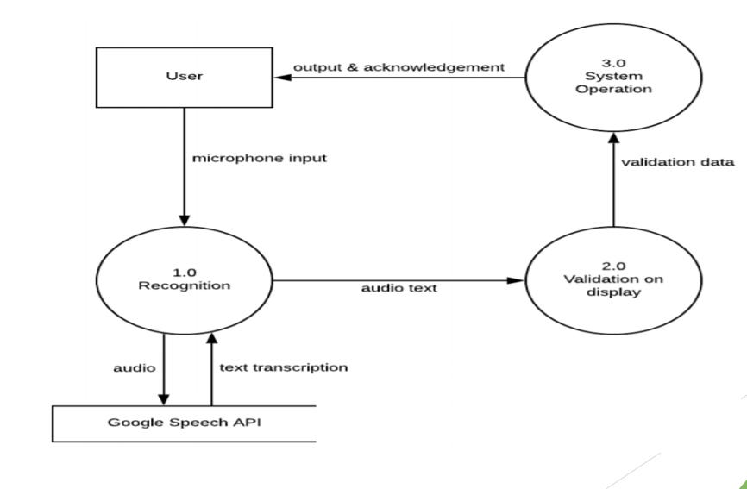

Figure 3.5: Data flow Diagram for Audio to sign language translator

CMRTC | 11

4.IMPLEMENTATION
AUDIO TO SIGN LANGUAGE TANSLATOR USING MACHINE LEARNING

4. IMPLEMENTATION

4.1 SAMPLE CODE

from django.http import HttpResponse

from django.shortcuts import render, redirect

from django.contrib.auth.forms import UserCreationForm, AuthenticationForm

from django.contrib.auth import login,logout

from nltk.tokenize import word_tokenize

from nltk.corpus import stopwords

from nltk.stem import WordNetLemmatizer

import nltk

from django.contrib.staticfiles import finders

from django.contrib.auth.decorators import login_required

@login_required(login_url="login")

def animation_view(request):

if request.method == 'POST':

text = request.POST.get('sen')

#tokenizing the sentence

text.lower()

#tokenizing the sentence

words = word_tokenize(text)

tagged = nltk.pos_tag(words)

tense = {}

tense["future"] = len([word for word in tagged if word[1] == "MD"])

tense["present"] = len([word for word in tagged if word[1] in ["VBP", "VBZ","VBG"]])

tense["past"] = len([word for word in tagged if word[1] in ["VBD", "VBN"]])

tense["present_continuous"] = len([word for word in tagged if word[1] in ["VBG"]])

#stopwords that will be removed

stop_words = set(["mightn't", 're', 'wasn', 'wouldn', 'be', 'has', 'that', 'does', 'shouldn', 'do', "you've",'off', 'for', "didn't", 'm', 'ain', 'haven', "weren't", 'are', "she's", "wasn't", 'its', "haven't", "wouldn't", 'don', 'weren', 's', "you'd", "don't", 'doesn', "hadn't", 'is','was', "that'll", "should've", 'a', 'then', 'the', 'mustn', 'i', 'nor', 'as',

CMRTC | 12

AUDIO TO SIGN LANGUAGE TANSLATOR USING MACHINE LEARNING

"it's", "needn't", 'd', 'am', 'have', 'hasn', 'o', "aren't", "you'll", "couldn't", "you're", "mustn't", 'didn', "doesn't", 'll', 'an', 'hadn', 'whom', 'y', "hasn't", 'itself', 'couldn', 'needn', "shan't", 'isn', 'been', 'such', 'shan', "shouldn't", 'aren', 'being', 'were', 'did', 'ma', 't', 'having', 'mightn', 've', "isn't", "won't"])

#removing stopwords and applying lemmatizing nlp process to words

lr = WordNetLemmatizer()

filtered_text = []

for w,p in zip(words,tagged):

if w not in stop_words:

if p[1]=='VBG' or p[1]=='VBD' or p[1]=='VBZ' or p[1]=='VBN' or p[1]=='NN':

filtered_text.append(lr.lemmatize(w,pos='v'))

elif p[1]=='JJ' or p[1]=='JJR' or p[1]=='JJS'or p[1]=='RBR' or p[1]=='RBS':

filtered_text.append(lr.lemmatize(w,pos='a'))

else:

filtered_text.append(lr.lemmatize(w))

#adding the specific word to specify tense

words = filtered_text

temp=[]

for w in words:

if w=='I':

temp.append('Me')

else:

temp.append(w)

words = temp

probable_tense = max(tense,key=tense.get)

if probable_tense == "past" and tense["past"]>=1:

temp = ["Before"]

temp = temp + words

words = temp

elif probable_tense == "future" and tense["future"]>=1:
if "Will" not in words:

CMRTC | 13

AUDIO TO SIGN LANGUAGE TANSLATOR USING MACHINE LEARNING

temp = ["Will"]

temp = temp + words

words = temp

else:Pass

elif probable_tense == "present":

if tense["present_continuous"]>=1:

temp = ["Now"]

temp = temp + words

words = temp

filtered_text = []

for w in words:

path = w + ".mp4"

f = finders.find(path)

#splitting the word if its animation is not present in database

if not f:

for c in w:

filtered_text.append(c)

#otherwise animation of word

else:

filtered_text.append(w)

words = filtered_text;

return render(request,'animation.html',{'words':words,'text':text})

else:

return render(request,'animation.html')

def signup_view(request):

if request.method == 'POST':

form = UserCreationForm(request.POST)

if form.is_valid():

user = form.save()

login(request,user)# log the user in return redirect('animation')

CMRTC | 14

AUDIO TO SIGN LANGUAGE TANSLATOR USING MACHINE LEARNING

else:

form = UserCreationForm()

return render(request,'signup.html',{'form':form})

if request.method == 'POST':

form = AuthenticationForm(data=request.POST)

if form.is_valid():

#log in user

user = form.get_user()

login(request,user)

if 'next' in request.POST:

return redirect(request.POST.get('next'))

else:

return redirect('animation')

else:

form = AuthenticationForm()

return render(request,'login.html',{'form':form})

def logout_view(request):

logout(request)

return redirect("home")

CMRTC | 15

5.SCREENSHOTS
AUDIO TO SIGN LANGUAGE TANSLATOR USING MACHINE LEARNING

5.SCREENSHOTS

5.1 Command prompt
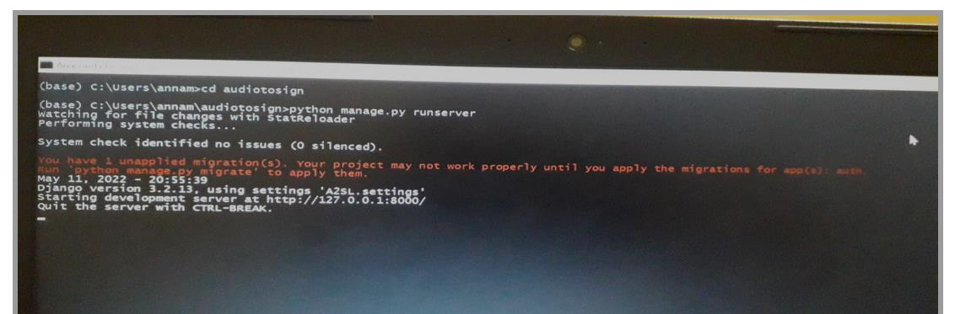

Figure 5.1:Screenshot of command prompt

5.2 HOME PAGE
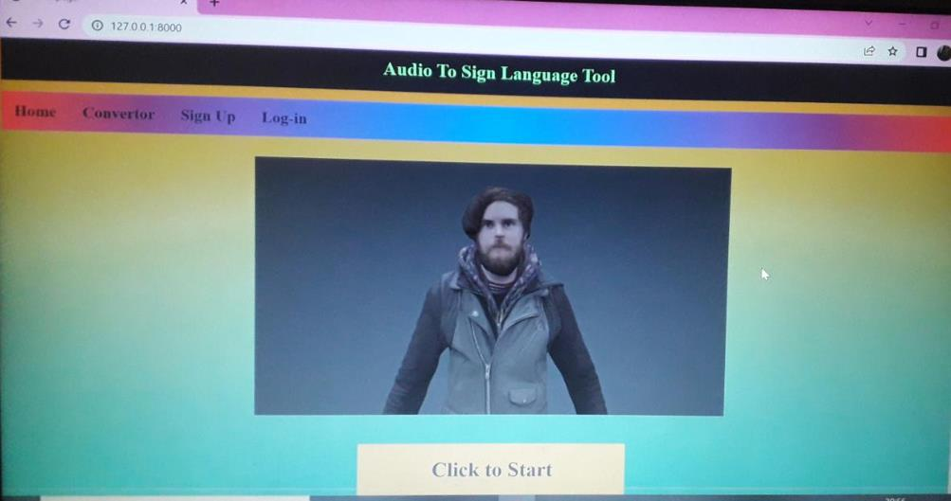

Figure 5.2:Screenshot of home page

CMRTC | 16

AUDIO TO SIGN LANGUAGE TANSLATOR USING MACHINE LEARNING

5.3 SIGN UP PAGE
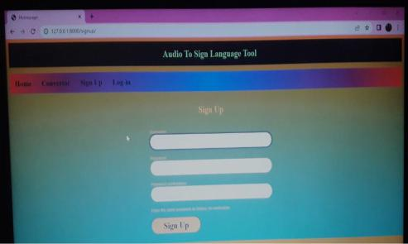

Figure 5.3:Screenshot of Signup page

5.4 LOGIN PAGE
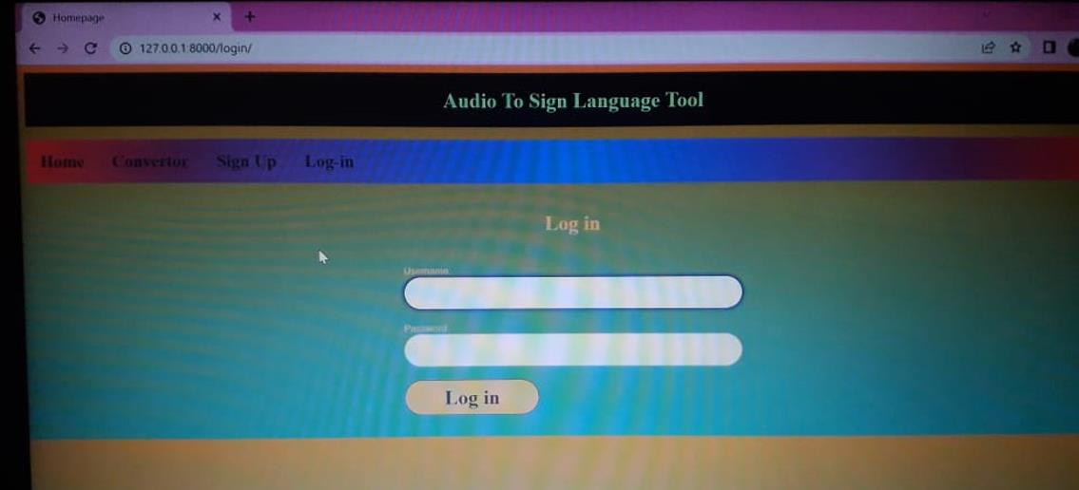

Figure 5.4:Screenshot of login page

CMRTC | 17

AUDIO TO SIGN LANGUAGE TANSLATOR USING MACHINE LEARNING

5.5 ANIMATION PAGE
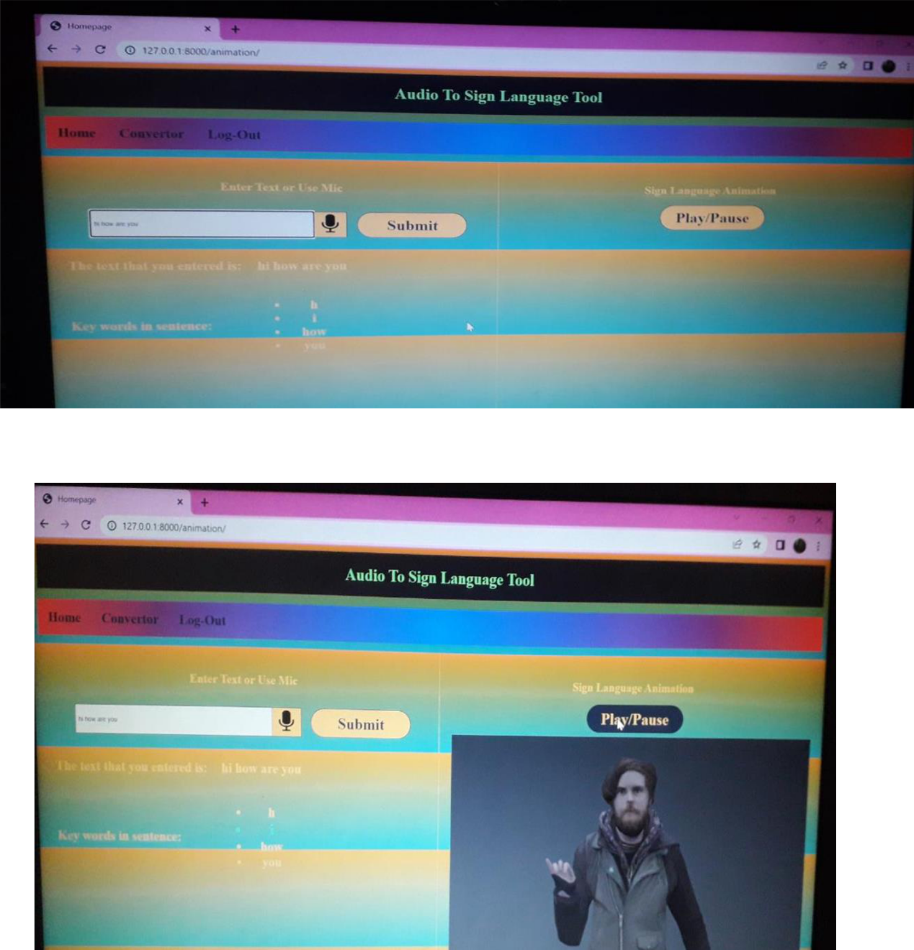

Figure 5.5:Screenshots of Animation page

CMRTC | 18

6. TESTING
AUDIO TO SIGN LANGUAGE TANSLATOR USING MACHINE LEARNING

- TESTING

6.1 INTRODUCTION TO TESTING

The purpose of testing is to discover errors.Testing is the process of trying to opened is

discover every conceivable fault or weakness in a work product.It provides a way to check the functionality of components, subassemblies, assemblies and/or a finished product.It is one the process of exercising software with the intent of ensuring that the Software system meets its a requirements and user expectations on requirements and does not fail in an unacceptable to a

There are various types of test. Each test type addresses a specific testing requirement.

6.2 TYPES OF TESTING

6.2.1 UNIT TESTING

Unit testing involves the design of test cases that validate that the internal program logic is functioning properly, and that program inputs produce valid outputs. All decision branches and internal code flow should be validated. It is the testing of individual software units of the application .it is done after the completion of an individual unit before integration. This is a structural testing, that relies on knowledge of its construction and is invasive. Unit tests perform basic tests at component level and test a specific business process, application, and/or system configuration. Unit tests ensure that each unique path of a business process performs accurately to the documented specifications and contains clearly defined inputs and expected results.

6.2.2 INTEGRATION TESTING

Integration tests are designed to test integrated software components to determine if actually run as one program. Testing is event driven and is more concerned with the basic of outcome of screens or fields. Integration tests demonstrate that although the components are were individually satisfaction, as shown by successfully unit testing, the combination of the components is correct and consistent.Integration testing is specifically aimed at exposing the problems that arise from the combination of components.

CMRTC | 19

AUDIO TO SIGN LANGUAGE TANSLATOR USING MACHINE LEARNING

6.2.3 FUNCTIONALTESTING

Functional tests provide systematic demonstrations that specified by the business

and technical requirements, manuals.

Functional testing is centered on the following items:

Valid Input : identified classes of valid input must be accepted.

Invalid Input : identified classes of invalid input must be rejected.

Functions : identified functions must be exercised.

Output : identified classes of application outputs must be exercised.

Systems/Procedures : interfacing systems or procedures must be invoked.

Organization and preparation of functional tests is focused on requirements,key functions, or special test cases. In addition, systematic coverage pertaining to identify Business process flows; data fields, predefined processes.

CMRTC | 20

7.CONCLUSION
AUDIO TO SIGN LANGUAGE TANSLATOR USING MACHINE LEARNING

- CONCLUSION & FUTURESCOPE

7.1 PROJECT CONCLUSION

Sign language translator is very useful in various areas. In schools, colleges, hospitals, universities, airports, courts anywhere anyone can use this system for understanding of a the sign language to communicate. It makes communication between a normal hearing a with person and a hard to hearing person easier. Understanding the requirements needed by the impaired community and finding a solution to them in making a difference.To the improve the physical and mental well-being of the specially abled people and improve their overall quality of life .

7.2 FUTURE SCOPE

The future work is to develop an application where in the news channels can use it while

giving news, in one corner of the screen it will be displayed in sign language for deaf people.

Write now only DD news is using this kind of presentation but they are using a human being

showing signs according to the speech of the person giving news live.So this will be better idea

which we can give to news channels. We look forward to expand the project by also including

facial expressions into the system.

CMRTC 21

8. BIBILOGRAPHY
AUDIO TO SIGN LANGUAGE TANSLATOR USING MACHINE LEARNING

8. BIBILOGRAPHY

8.1 REFERENCES

- Nair, A.V. and Bindu, V., “A review on Indian sign language recognition”, International

Journal of Computer Applications, 73(22),2013.

[2] Sailee Brahme, “READING THE SIGNS:SIGNS LANGUAGE”, April 21, 2017, available online at http://forreadingaddicts.co.uk/culture/reading-signs-sign- language/18395

[3] Republic World, Press Trust of India, "India’s First Sign Language Dictionary Released” , Mumbai, March 23, 2018

- Lucy Sweeney, “Gloves that convert sign language to speech ‘to empower the deaf community’ ”, ABC News, April 2016.

- Divyangjan,“Indian Sign Language Research and Training Centre (ISLRTC),Department

of Empowerment of Persons with Disabilities, Ministry of Social Justice & Empowerment, Government of India, online available at http://205.147.97.190/islrtcapp/

8.2 GITHUB LINK

[1] https://github.com/sush9381/majorproject

CMRTC 22

