Borrowed
A Peer to Peer Lending Platform
Software Engineering Project Report

Course | : | Software Engineering
Project Name | : | Borrowed — A Peer to Peer Lending Platform
Team Members | : | Sushama Roy (ID: 0112310376)
 |  | Ashique Imam Hossain (ID: 0112310374)
 |  | Shakib Hasan (ID: 0112310379)
Submission Date | : | 20 June 2026

1. Introduction
Borrowed is a website that helps people lend and borrow things to each other. This way people do not have to buy things they only need to use. They can just borrow what they need from people in their community. This helps people save money. It is also good for the environment because it reduces waste. It also helps create a community where people share things with each other.

People can list things they have. Do not use very often on the website. They can also look for things they need in their area and ask to borrow them. The website has a system that makes sure everything runs smoothly and safely. For example people have to verify who they are using their National ID. The website also has a system for sending messages and a way for people to rate and review each other. This helps build trust between the people lending and borrowing things.

The website is built using the technology, including Next.js and Node.js. It also uses MySQL and Tailwind CSS. This makes the website reliable and easy to use. There is also a team that oversees the website and makes sure everything is fair and safe. They look into any problems that are reported and make sure the website is a place for everyone.

This website is especially useful in Bangladesh because there is no website like it. Now people have to rely on their friends or Facebook groups to lend and borrow things.. These methods can be problematic because they do not have any rules or way to resolve disputes. Borrowed is a solution because it is safe and fair. It helps people share things with each other in a way that's good, for everyone.

1.1 Motivation
The growth of Borrowed depends on an important social, economic and tech factors:
• Many people have things like tools, electronics and sports gear that they do not use often. Borrowed helps people use these things by connecting those who have them with those who need them for a time.
• Buying things for short term use can be expensive. Borrowed offers an option, which is great for students, hobbyists and small businesses that need equipment but do not want to spend a lot of money.
• In Bangladesh there is no platform for borrowing and lending. People often use contacts or Facebook groups but these methods can be risky. Borrowed provides an organized way to borrow and lend using technology.
• The sharing economy is becoming popular worldwide. Borrowed is part of this trend, which favors using things without owning them. This trend has worked well for companies, like Airbnb and Uber. Borrowed aims to do the same.
• The idea of Borrowed is simple: people can borrow things they need and lend things they do not use often. This way Borrowed helps people save money and makes use of things people already own. value of shared resource models. Borrowed applies this principle to everyday item lending at a local level.
- Environmental Sustainability — Reducing unnecessary purchases leads directly to lower production demand and less waste. Borrowed encourages reuse over consumption, contributing to a more environmentally responsible community.
- Building Community Trust — By incorporating NID verification, user ratings and encrypted communication, Borrowed creates an accountable ecosystem where users can confidently lend to and borrow from one another, even among strangers.

2. Project Description
Borrowed has a lot of features. This part lists the most important ones, says what each of them does and shows how the main parts of the site work from start to finish.

2.1 List of Features
These are the main features of Borrowed:
- Account Sign up and Login
- Identity Check and Trust Score
- Listing and Browsing Items
- Smart Search
- Borrowing and Checkout
- Damage Check with AI
- Messaging
- Disputes
- Emergency (SOS) Borrow
- Mentorship
- Admin Panel
- Item Trail
- Ratings and Reviews
- Notifications
- Location and Maps

2.2 Feature Descriptions
Account Sign up and Login : People can make an account with their email and a password. They can also log in with their Google or Facebook account if they like. The password is kept safe with bcrypt so nobody can read it.

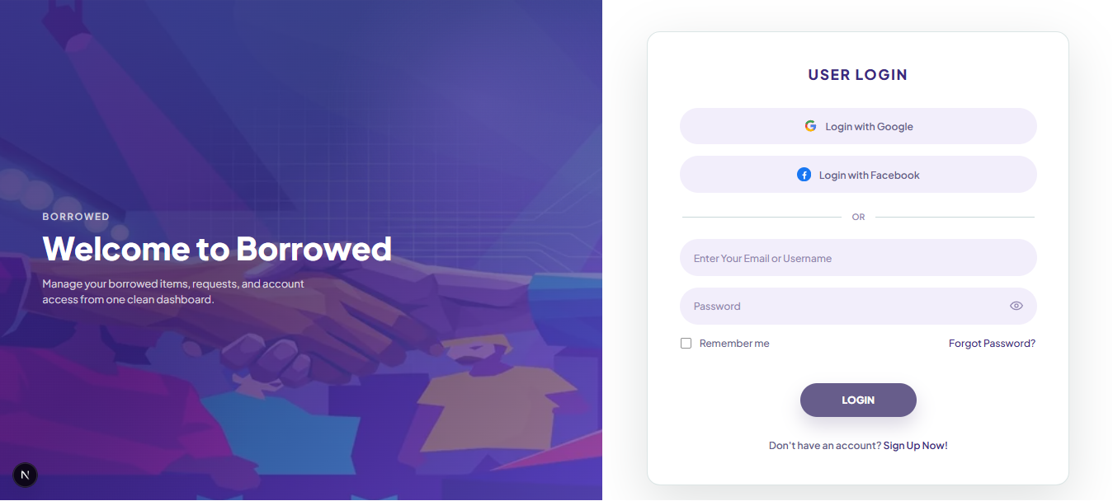

Identity Check and Trust Score : Before people are trusted on the site they have to prove who they are. They upload a photo of their National ID and take a selfie. The site checks if the two faces are the same person and gives a score. Each step a user finishes adds to their Trust Score, which goes from 0 to 100.

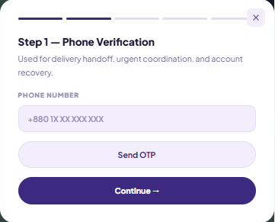
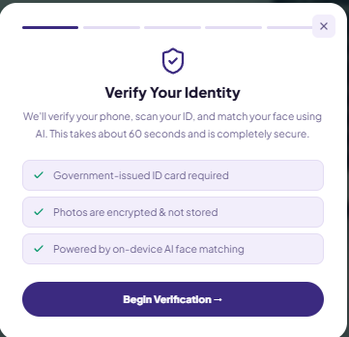

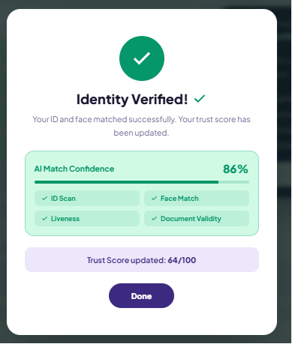
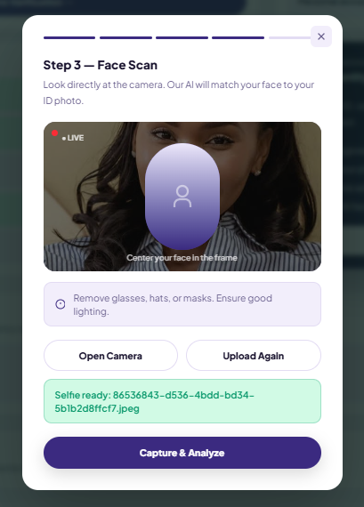
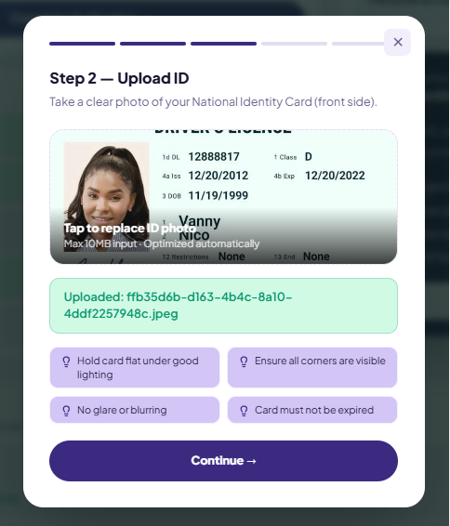

Listing and Browsing Items : People can put up the things they want to lend. They add some photos, pick a category and set the price per day and the deposit. Other people can look through all the items and find what they need.

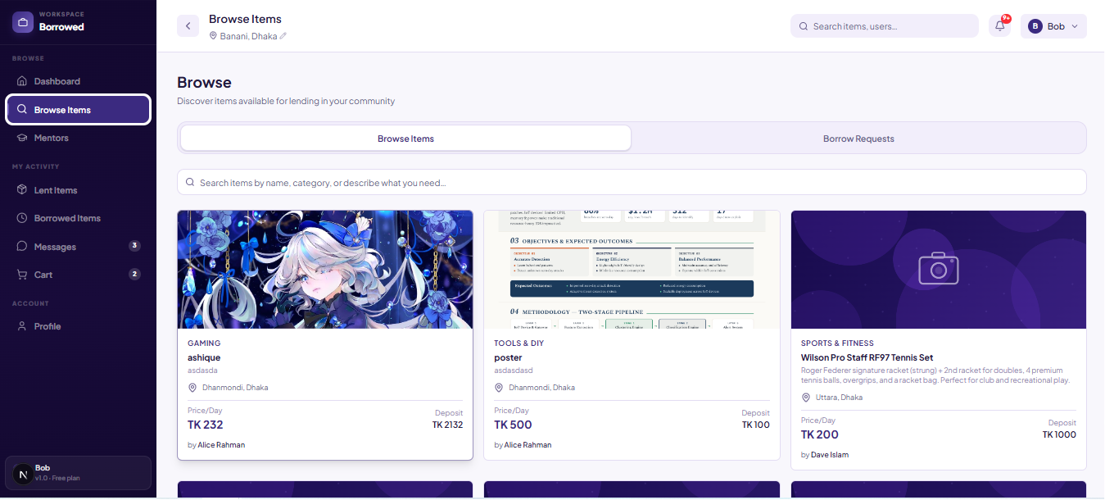

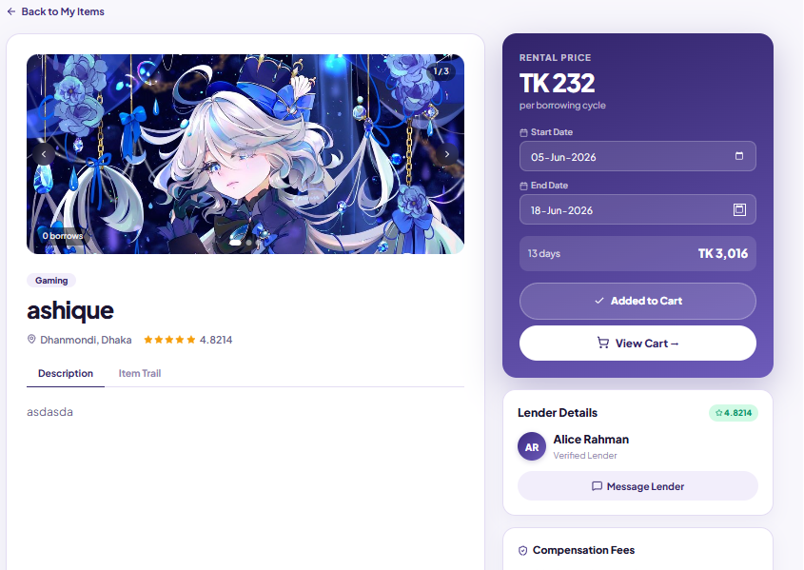

Smart Search : The search box understands normal questions. You can type something like "something to film a wedding" and the AI works out what you mean and shows items that fit. If the AI is down it just goes back to a normal keyword search.

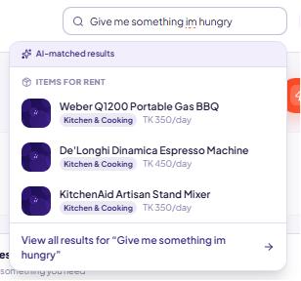

Borrowing and Checkout : When someone wants an item they add it to their cart and pick the dates. The site shows the deposit and a small service fee. They choose how to pay, like bKash, Nagad or card and then place the order.

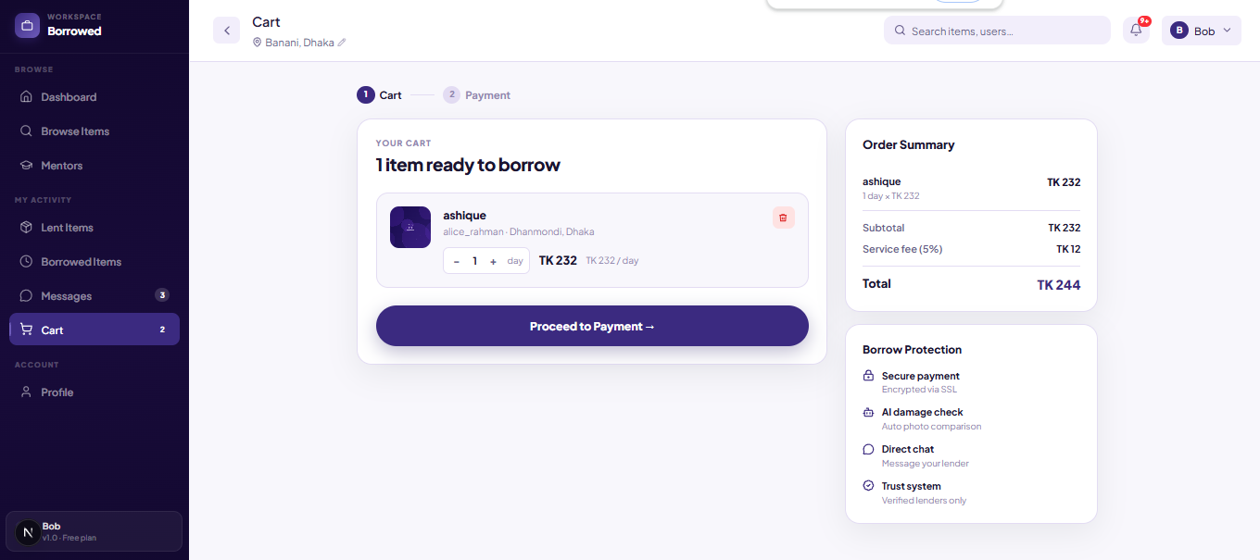

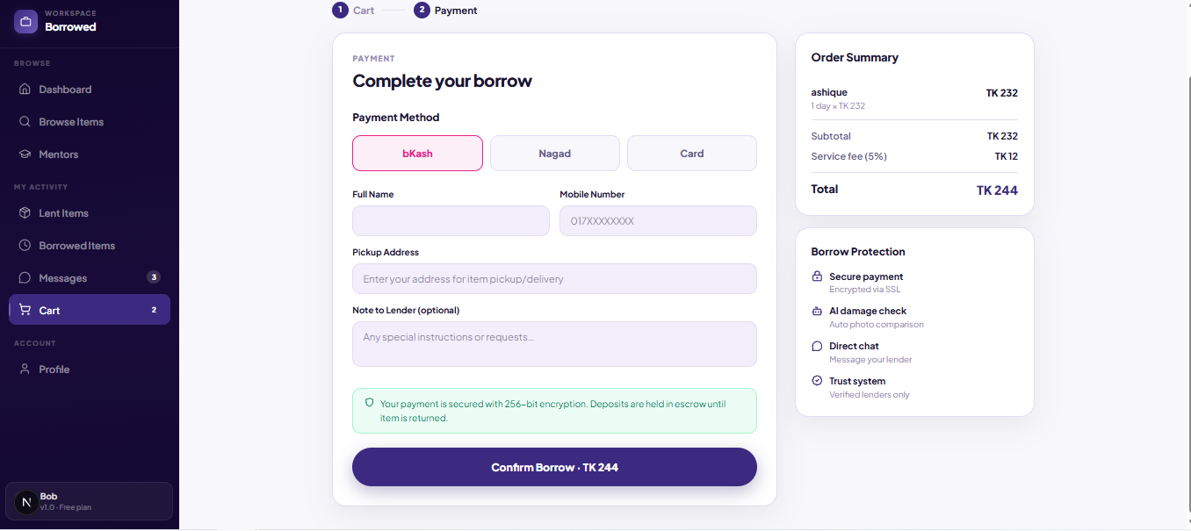

Damage Check with AI : The lender takes a photo of the item before they hand it over. When the item comes back the borrower takes another photo. The AI looks at the two photos and tells you if the item got damaged and how sure it is.
When the lender is accepting a borrow request :

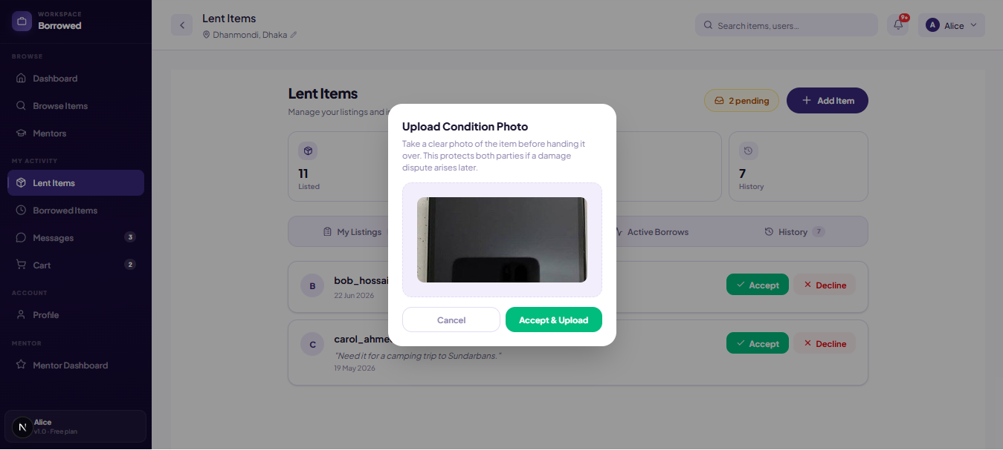

When the borrower is returning a borrowed item :

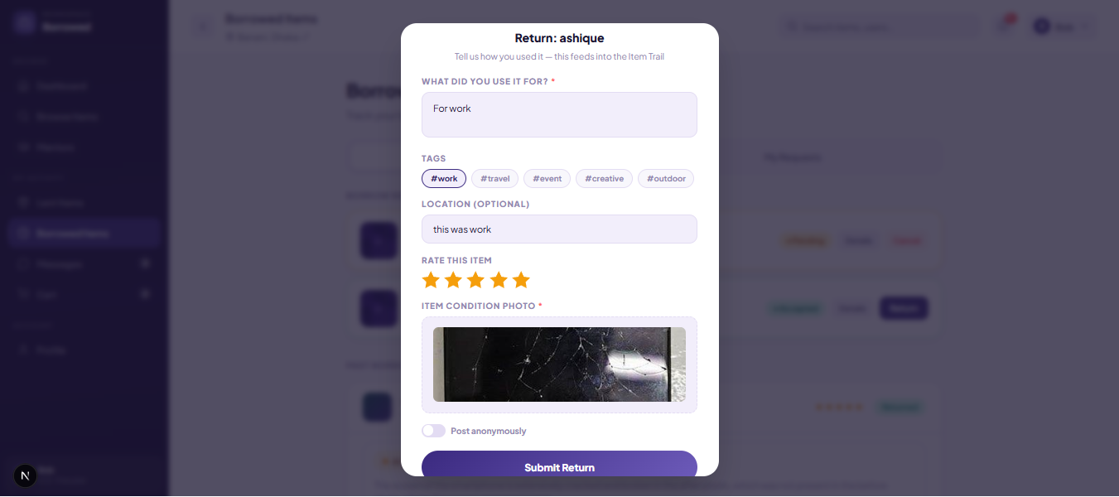

When The AI detects damage it flags it:

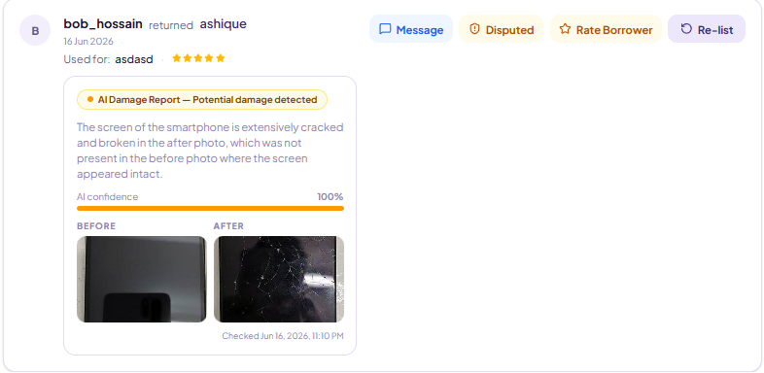

Here the lender can proceed to message the borrower or create a dispute to the admin panel

Messaging : Borrowers and lenders can chat with each other. Messages show up straight away. There is a limit so people cannot spam and you can share item cards inside the chat.

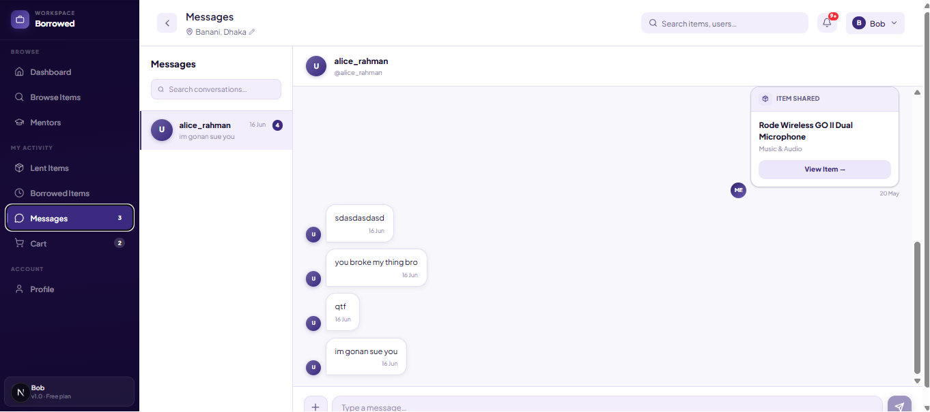

There is also specific options to request for items and shared listed items via personal chat
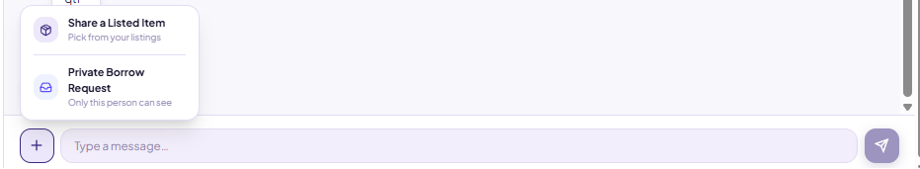

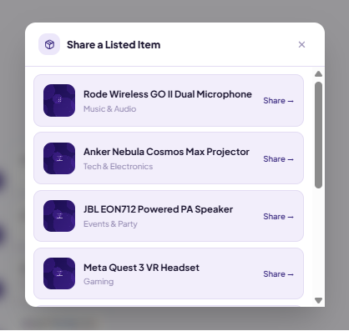
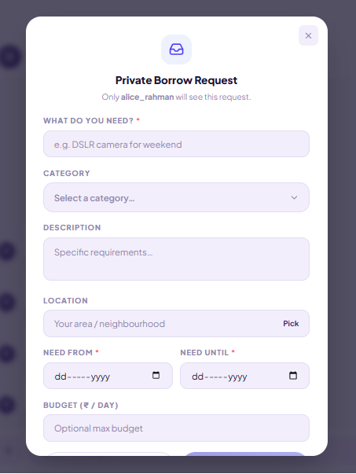
Disputes: If something is wrong with a returned item the lender can open a dispute. An admin then looks at the photos, the AI result and the chat and decides what happens to the deposit. A user can directly create dispute from the AI damge detection service,
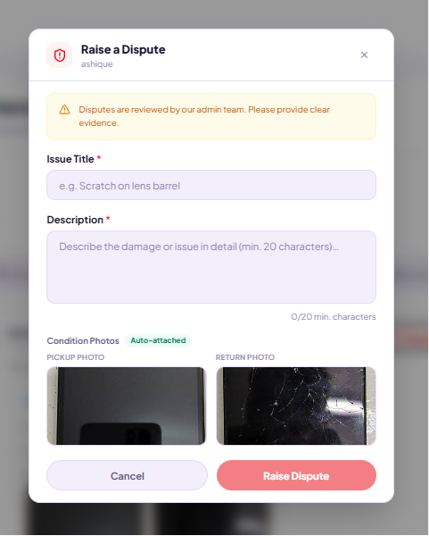

And this will go to directly the admin along side lender and borrower chats when the dispute happened

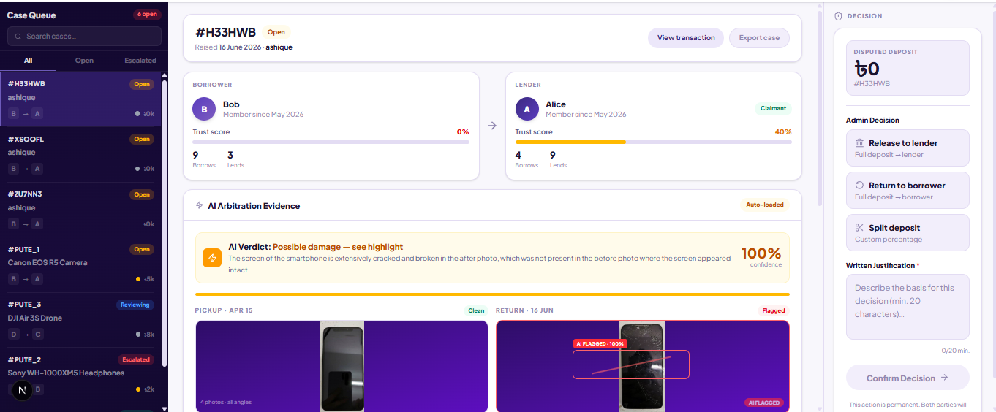

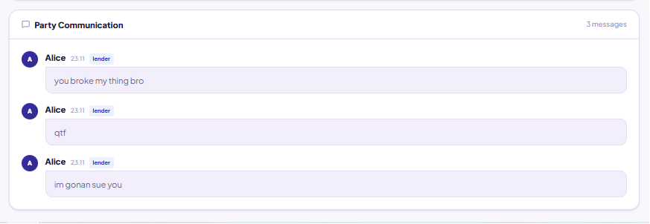

Emergency (SOS) Borrow : If someone needs a thing in a hurry they can send an SOS. The site uses their location to find lenders who are close by and lets those lenders know about the request. The emergency button is located at the top of the dashboard screen.

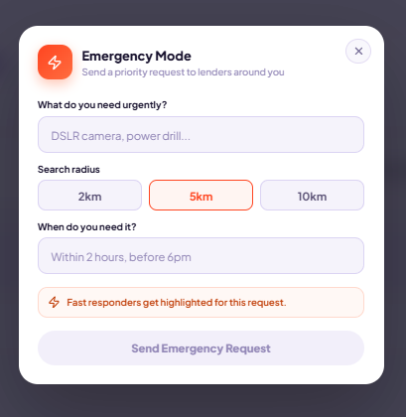

When emergency SOS is used it will send notifications to all nearby users.

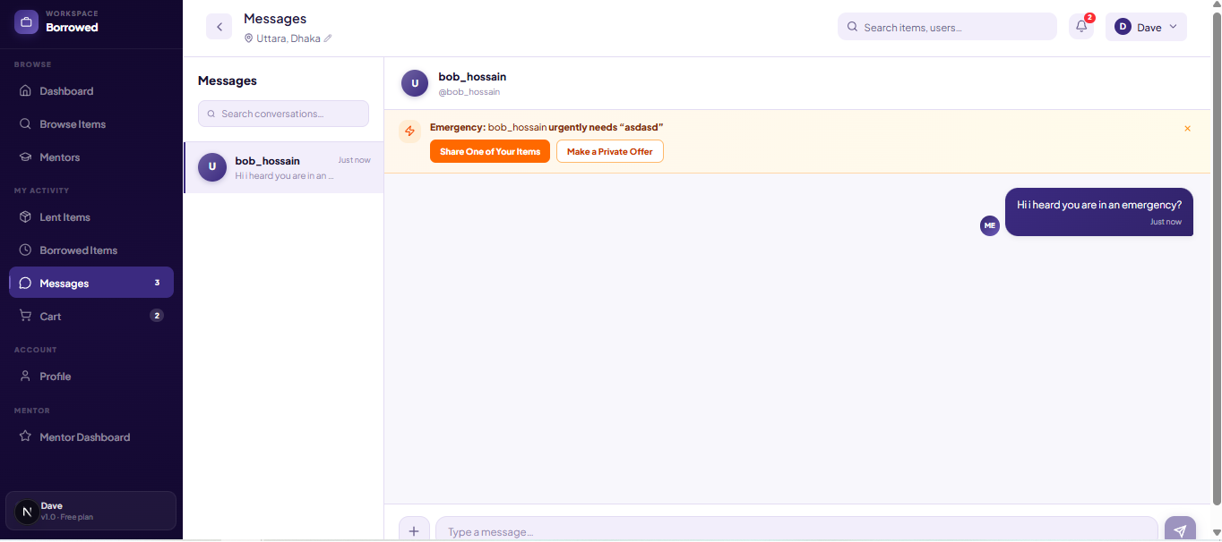
The users can choose to respond to it This will create a special event where the responder will be able to text the SOS sender, Here the person who responds can choose to share his already listed item or Create a new private listing for the SOS sender only

Mentorship : Verified users can become mentors. They make a profile with what they are good at, their price and when they are free. Other people can book a session with them, online or in person.
After a user is verified he can choose to become a mentor.

The user will get access to a unique mentor tab in the sidebar which only mentors can access.
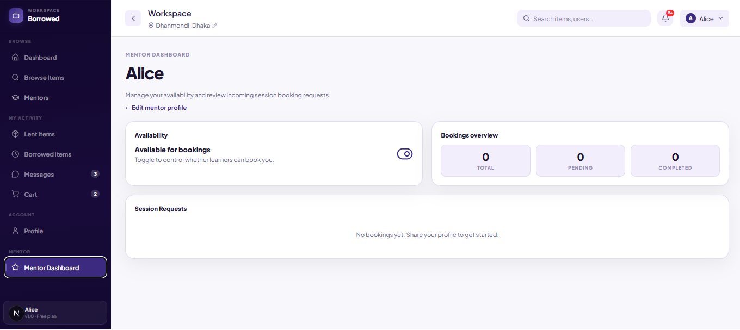

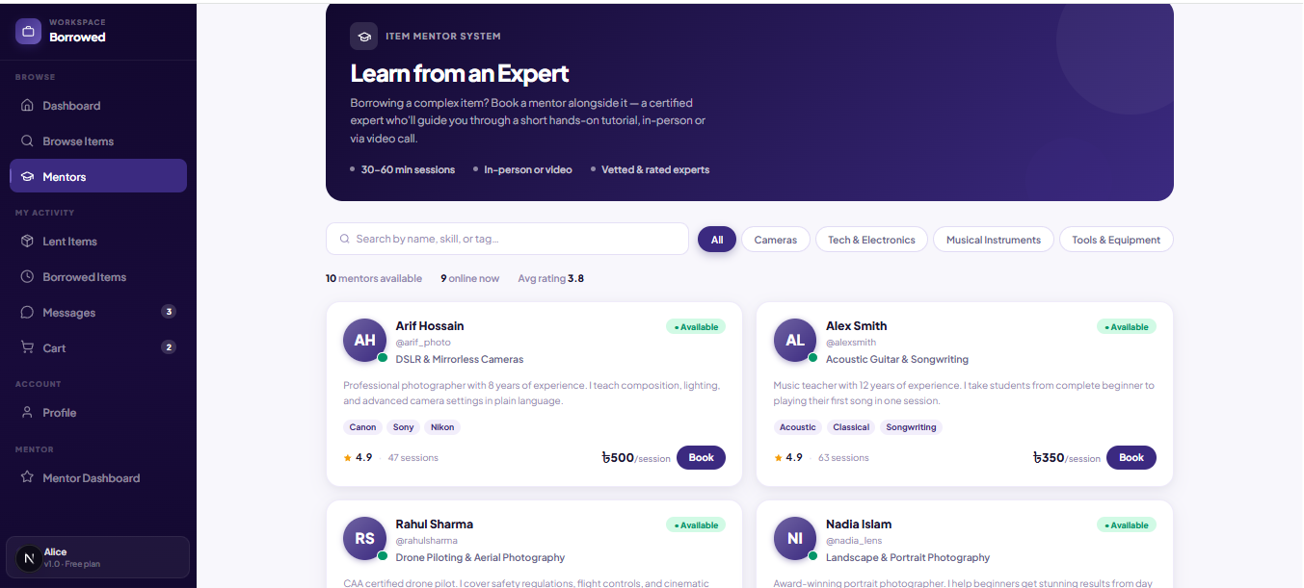
Other users can book sessions with mentors
Admin Panel : The team that runs the site has its own area. From there they can manage users and their verification, check products and reviews, settle disputes and go through the reports that users send in.

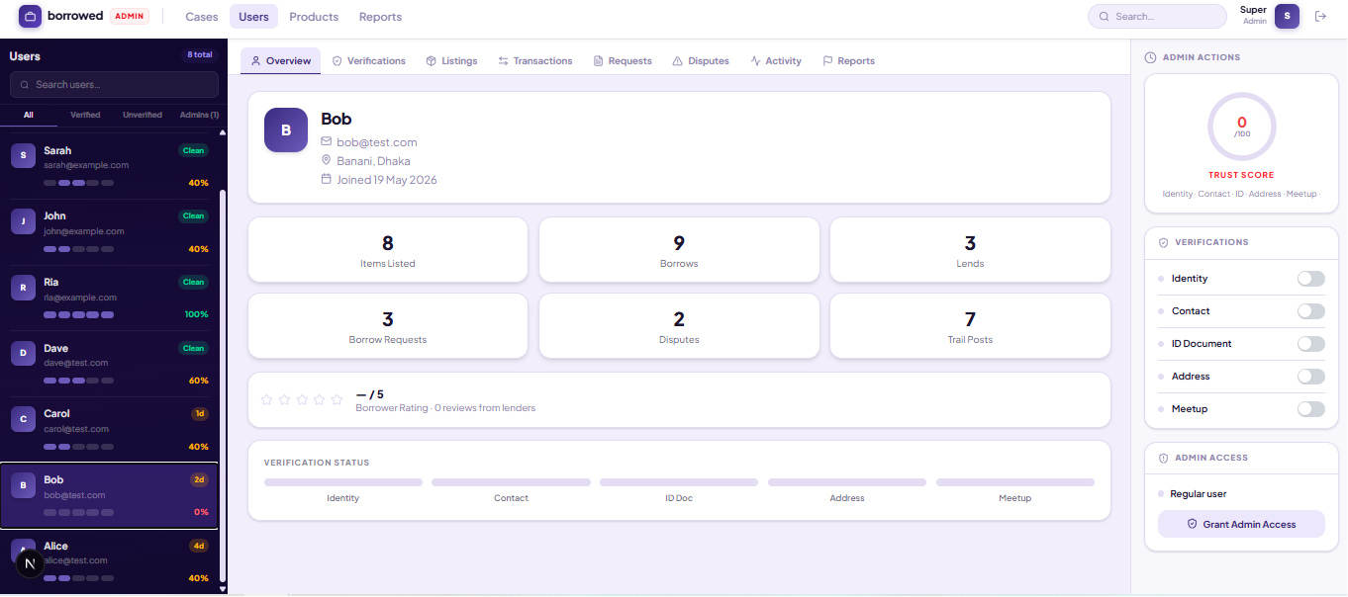

Item Trail : Every item keeps a history of where it has been. When a borrower gives an item back they can write what they used it for, where they used it and add a few tags. They can also give the item a rating. All of this builds a trail for the item. The next person who wants to borrow it can read the trail and see how it was used before. If a borrower does not want their name shown they can post it without their name.

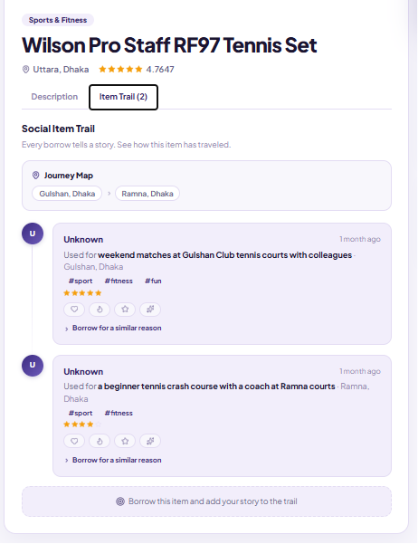

Ratings and Reviews: After a borrow is done both sides can rate each other. The borrower rates the item out of five stars. The lender rates the borrower and can leave a short comment. These ratings show up on the profiles. So before someone lends or borrows they can look at the ratings and see if the other person is good to deal with.

Notifications : The site lets users know when something happens. They get a notice when someone asks to borrow their item, when they get an offer, when an item is returned, when a new message comes in or when there is an SOS request nearby. All the notices sit in one place and the user can mark them as read.

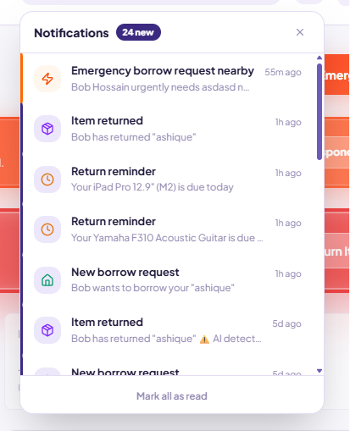
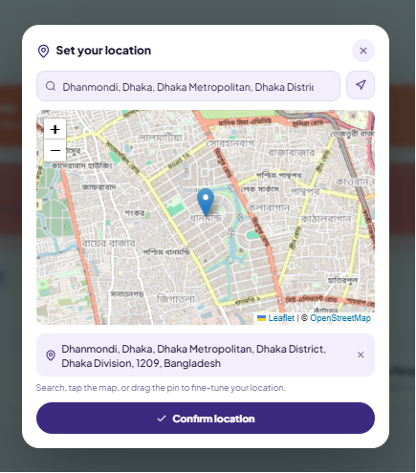
Location and Maps : Borrowed uses location to make things easier to find. Each user can set where they are on a map and the site saves that spot. When people look at items they can see how far away they are. The location is also used by the emergency borrow. There the site works out which lenders are closest and only shows the ones inside the distance the user picked.

2.3 Main Flows
These are the main things people do on Borrowed from start to finish.
Getting verified
1. The user signs up and opens their profile.
2. They upload a photo of their National ID and take a selfie.
3. The site checks if the face on the ID matches the selfie and gives a score.
4. If the score is high enough they get verified and their Trust Score goes up.
Borrowing an item
1. The borrower finds an item by browsing or searching and adds it to the cart.
2. They pick the dates, see the deposit and fee and place the order.
3. The lender gets the request. If they are happy they take a photo of the item and accept it.
4. The two meet and the item is handed over.
5. When the time is up the borrower returns the item and takes an after photo.
6. The AI compares the before and after photos and says if anything got damaged.
7. After that the lender and the borrower rate each other.
Settling a dispute
1. If the item came back damaged the lender opens a dispute.
2. The dispute goes to an admin.
3. The admin looks at the before and after photos, the AI result and the chat between the two people.
4. The admin decides what happens to the deposit. They can give it back, give it to the lender or split it.
5. Both people are told the result.
Emergency (SOS) borrow
1. The user sends an SOS with the thing they need and how far they are willing to go.
2. The site uses their location to find lenders who are nearby.
3. Those lenders get a message about the request.
4. A lender who has the item can reply and help out.

3. Similar Projects
Several peer to peer lending and sharing platforms exist globally, though none currently serve the Bangladeshi market:

Platform | Region | Description
Fat Llama | UK / United States | A popular P2P rental marketplace featuring identity verification, insurance coverage and secure payment protection for high value items.
Peerby | Netherlands | A community based app that connects neighbors to share and borrow everyday household items, emphasizing local trust and convenience.
Loanables | United States | A platform enabling local item rentals between individuals, focusing on accessibility and community driven sharing.
ShareTribe | Global (SaaS) | An open marketplace platform used by communities worldwide to build their own peer to peer rental and sharing services.

Gap in Bangladesh: Despite the growth of such platforms globally, Bangladesh currently has no dedicated P2P item lending solution. Informal methods — personal networks and Facebook groups — dominate, but they lack identity verification, structured dispute resolution and user accountability. Borrowed directly addresses this gap by combining the best practices of global platforms with features tailored to the local context.

4. Technology Stack
Borrowed is made with a set of tools that work well together and each one was picked for a reason. This part explains what we used for the front end, the back end, the database, login, the AI parts, the live chat and a few other things.

4.1 Frontend: Next.js and Tailwind CSS
The front end of Borrowed is built with Next.js, which is a framework that runs on top of React. We picked it because it loads the first page quickly and helps search engines find the site. It also makes the site feel smooth when you move between items or open a chat.
For the look of the site we use Tailwind CSS. It lets us style things quickly without writing a lot of separate CSS and it keeps the site looking the same on a phone, a tablet or a computer.

4.2 Backend: Next.js API Routes and Node.js
Borrowed does not use a separate backend server. Instead it uses the API routes that come with Next.js to do all the server side work. Every part of the site, like login, listing items, borrow orders, disputes, messages, SOS and mentorship, has its own set of REST endpoints and they all live in the /api folder.
On top of that we run a custom server built around Next.js. This same server also runs Socket.io, so the live features work without needing a second server just for them. Each endpoint checks the user's session on its own and makes sure the user is allowed to do what they asked before it does anything.

4.3 Database: MySQL and Prisma ORM
We use MySQL as the main database. It holds all the important data: user accounts, verification records, item listings, borrow checkouts, disputes, messages and notifications. A relational database like MySQL fits well here because all of these things are linked to each other.
To talk to the database we use Prisma. It gives us a safe way to write queries, change the database structure and run transactions. When a job needs more than one step, like accepting a borrow request, settling a dispute or handling a return, we wrap it in a Prisma transaction so the data never ends up half finished.
The item photos and the before and after condition photos are kept in the database itself as binary data and sent back to the browser through their own API routes instead of a separate file service.

4.4 Authentication: NextAuth.js and JWT
Login is handled by NextAuth.js. It looks after the user sessions and lets people sign in in more than one way. A user can sign up and log in with an email and password, which is kept safe with bcrypt or they can use their Google or Facebook account.
When a user logs in, NextAuth gives them a JSON Web Token (JWT). This token is sent with every request they make. It carries some basic information about the user, such as whether they are a mentor or an admin. Because of this the site can tell what a user is allowed to do without checking the database on every single request.

4.5 AI Models: Google Gemini and face api.js
Borrowed uses AI in three places and each one solves a different problem.
- Damage detection. When a borrower returns an item they upload an after photo. Google Gemini compares it with the before photo from the handoff and tries to ignore things like lighting, angle and background. It gives a result of damaged, no damage or unclear, a score from 0 to 100 and a few notes. If it finds damage the lender is told straight away and the result is added to any dispute.
- Smart search. The search box accepts normal questions like "something to film a wedding". Gemini turns these into useful keywords and categories so the results are better. If Gemini is not available the search falls back to a simple keyword match.
- Face check. When a user proves who they are they upload a photo of their National ID and a selfie. The face api.js library, which runs on TensorFlow.js, looks at the face in both photos and gives a score from 0 to 100 for how close they are. If the score is 70 or more the user is verified on the spot.
All of these AI parts are optional in a way. If the Gemini key is missing or a call fails, the rest of the site keeps working as normal.

4.6 Real Time Communication: Socket.io
The live chat between borrowers and lenders runs on Socket.io. It shares the same server as the rest of the site, so we do not have to keep asking for new messages and they show up right away.
The chat also has some limits to keep it sensible. A user can send at most 8 messages in 10 seconds and a single message cannot be longer than 1000 characters. It can carry more than plain text too, like item cards and dispute conversations, so people can share a listing or talk about a problem inside the chat.

4.7 External APIs and Services
Borrowed also uses a few outside services.
- Google OAuth. Lets people sign in with their Google account through NextAuth.
- Facebook OAuth. Lets people sign in with their Facebook account through NextAuth.
- Google Gemini. Powers the damage detection and the smart search.
- Geolocation and Maps. Used to show items near a user and to run the emergency (SOS) borrow. The SOS uses the Haversine formula to find lenders inside a radius the user picks, from 1 to 50 km.

4.8 Version Control: Git and GitHub
We use Git to keep track of every change we make and GitHub to store the project online. When we work on a new thing we make a separate branch for it, so we can all work at the same time without getting in each other's way. Before a branch goes into the main project another person on the team checks it first. We call this a code review. It keeps the project stable and lets us look back at how something was done.

4.9 Technology Summary
The table below sums up the main tools and what each one does.

Layer | Technology / Tool | Role in the Project
Frontend | Next.js (React) | Page rendering, routing, SSR and client side UI
Frontend | Tailwind CSS | Responsive, utility first visual styling
Backend | Next.js API Routes | All REST endpoints and server side business logic
Backend | Node.js + server.mjs | Custom server integrating Next.js with Socket.io
Database | MySQL | Primary relational data store
Database | Prisma ORM | Type safe queries, migrations and transactions
Auth | NextAuth.js | Session management, JWT issuance
Auth | bcrypt | Password hashing
Auth | Google / Facebook OAuth | Social login
AI | Gemini gemini 2.5 flash | Damage detection & natural language search
AI | face api.js + TensorFlow.js | NID face match identity verification
Real Time | Socket.io | Live 1 to 1 messaging (no polling)
APIs | Google & Facebook OAuth | Third party identity providers
APIs | Google Gemini API | Cloud AI inference for damage & search
Version Control | Git & GitHub | Source control, branching and collaboration

5. Future Works
Borrowed already works well and lets people lend and borrow things from each other. While we were building it we ran into a few hard technical problems and we also saw some things we could do better. This section goes over the problems we faced and how they can be fixed and then the upgrades and new features we would like to add later.

5.1 Problems We Faced and How to Fix Them
- AI speed and reliability. The calls to Gemini for damage detection and search were sometimes slow or failed and at first this could block the return step. We fixed it by always saving the after photo first and treating the AI result as an extra, not something the return depends on. Later we could run the AI calls in the background with a job queue like BullMQ or Redis Queue and save common searches, so the user never has to wait.
- Storing images in the database. Right now the item photos are kept inside MySQL as binary data. This is simple to set up but it slows the database down as the site grows, because it has to read big files. The fix is to move the photos to a storage service like AWS S3 or Cloudflare R2 and keep only a link in the database. That takes the load off the database and lets us serve the photos through a CDN, which is faster for users.
- Face model loading time. The face api.js models used for the ID and selfie match are loaded from disk when they are first needed, which can make the first check slow, especially after the server has just started. Loading the models when the server starts or running the face check in its own small service, would get rid of this delay.
- Scaling the live chat. The Socket.io setup we have now runs on a single server process. That is fine with one server, but if we add more servers the users end up on different ones and stop getting each other's messages. The fix is the Socket.io Redis Adapter, which passes the messages between all the servers so the chat keeps working no matter how many servers we run.
- Deposits and payments. At the moment the deposit is just a record in the database and the real money is handled outside the site. That adds risk and is not very smooth. If we connect a local payment gateway like bKash, Nagad or SSLCommerz, the deposit and rental fees could be taken, held and released inside the site itself, which builds more trust and cuts down on arguments.
- Judging disputes. When an admin settles a dispute they mostly go by the photos and the chat. When the AI is not sure about the damage, the call is harder to make. Better Gemini prompts, running the check a few times and averaging the scores and letting both sides add more proof like videos or receipts would make these decisions fairer and easier to back up.

5.2 Planned Upgrades and New Features
- Payment gateway. Add bKash, Nagad or SSLCommerz to collect deposits, take rental fees and give refunds or release the money based on how a dispute ends. This is the single biggest upgrade for building real trust on the site.
- Mobile app. Build a proper mobile app with React Native so people can use Borrowed on the go. It could send push notices for borrow requests and chat messages and let people take the condition photos straight from their phone camera.
- AI price and deposit suggestions. Add a Gemini feature that looks at an item's category, description and photos and suggests a fair daily price and deposit. This helps lenders who are not sure what to charge and keeps the deposit sensible for what the item is worth.
- Video condition checks. Let people upload a short video at handoff and return instead of just a photo. A video gives the AI more to go on and helps catch damage that a single photo would miss, like a fault that only shows when the item is used.
- GPS meetup check. The meetup step is done by hand right now. If both the lender and the borrower confirm the handoff spot through GPS in the app, this step could be automatic and could add to the Trust Score on its own.
- Subscriptions and premium tiers. Offer a free version for casual users and a paid tier for people who lend or borrow a lot. The paid tier could give lower fees, faster SOS responses, featured listings and some stats on how their items are doing.
- Community forums and group borrowing. Add a discussion board where people can talk, plan group borrowing like a neighbourhood tool library and team up on borrow requests. This would make the community stronger and pull more people in.
- More languages. Add Bangla to the site, including search and notifications. This would let a lot more people in Bangladesh use Borrowed, especially those outside the big cities who prefer their own language.
— End of Current Submission —

